 | executive summary  An analysis and critical evaluation of technological changes made in Tesco in year 2020/2021  Nelly Nyaundi Myles (1710690)  Leading and Implementing Workplace Change BMSW6103

1.1 Introduction
Brynach
I am still working on the document and researching I will use my 1-2-1 for discussion and clarification please. Thank you.

2.1 background of tesco

About Tesco
Tesco is a global British grocery and general products company based in Welwyn Garden City, England. It is the world’s third-largest retailer in terms of gross revenues and the ninth-largest in terms of net revenues.
It operates in seven countries across Europe, the United States, and Asia. The company is the grocery market leader in Ireland, Hungary, Thailand, and the United Kingdom. Some of the Countries Tesco operates are
- Tesco UK
- Tesco in India
- Tesco Malaysia
- Tesco Lotus Thailand
- Tesco Czech Republic
- Tesco Hungary
- Tesco Ireland
- Tesco Poland
- Tesco Slovakia
- Tesco China
OVERVIEW OF THE PRODUCTS AND SERVICES

Tesco is main revenue is from grocery and retail. It also has other product lines which are financial services e.g. Tesco bank,- credit cards and loans, savings
Pet, car and home and insurance, Travel insurance, travel ,money, pay+ International money transfer

Sustainability social responsibility

Helping community social responsibility
Supporting customers colleagues and communities during the pandemic
Social media presences

THE CURRENT MARKET POSITION

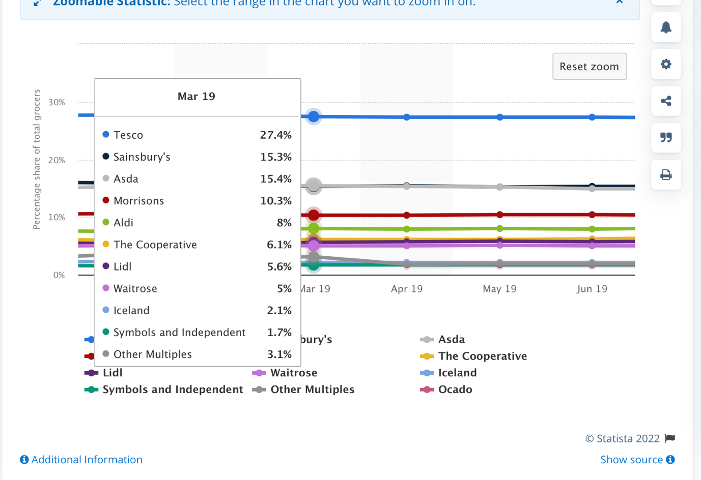

Tesco is the UK leader in the UK
The share price as at 28th January 2022 is 302.75
The FTSE 100 supermarket giant saw its share rise by 0.2% to 27.4% in February 2021, the first rise since December 2016 as it saw monthly sales jump 13.2%, according to market researcher Kantar. Compared to rival discount stores Aldi and Lidl 7.5% compared to 7.9%. This has largely been caused by panic buying by customers largely due to the pandemic. An overall of 215.2 bn grocery splurge . Due to inflation consumer trends have changed to discount stores like Lidl and Aldi .Resulting to price wars but considering the recourse base value (RBV) of Tesco it has managed to improve its competitive advantage by investing in technology and building capabilities with improved customer engagement and retention through social media , AI. and online .sales making them immune to treats.

The BCG MATRIX THE GROWTH SHARE MATRIX

Also the increase can be explained with the technological changes Tesco has implemented the constant improvement and introduction of product lines and services and using the BCG matrix the change can be emulated to the question marks quickly changing into stars increasing cash flow.
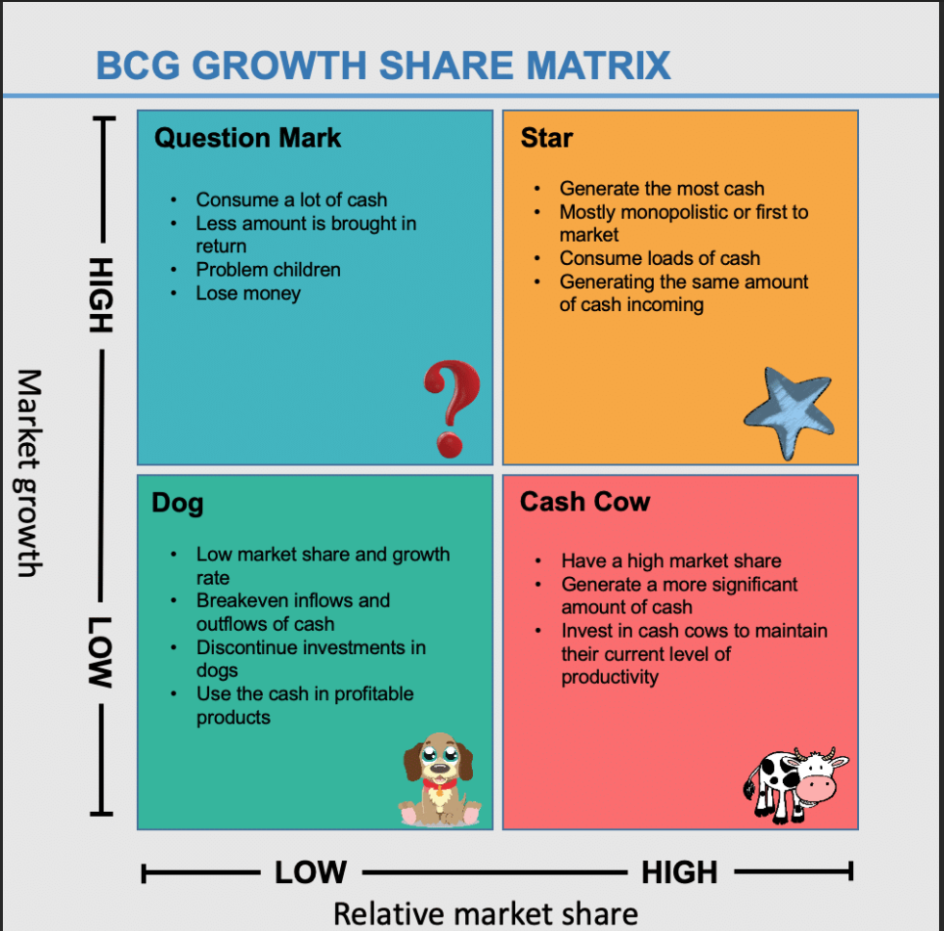
(Bing.com, 2022)

VRIO analysis which stands for the valuable, Rare, Inimitable and organisational focus shows that the core competencies (Jugdev, 2005) of Tesco are the huge market portfolio, brand, marketing , and technology

Potters 5 forces
DESCRIPTION OF THE CHANGE
MICRO AND MACRO ENVIRONMENT

Micro environmental factors Tesco’s mission and vision statement , culture and leadership are associated with the internal environment which in turn directly affect the business operations of the company. This factors affect the performance and decision making function of the firm. Leadership styles and culture of the organisation can affect change.
Macro environment External environment is the uncontrollable factors, forces, situations, and events outside the organization that affect its performance and strategies. Customers panic buying competitors ,suppliers ,shortage of supplies. Are some of the examples
This can be analysed using the pestle tool

2.2.You should state the reason for the change- Financial, Human Resource etc change and support this with a critical discussion of the influences of this area/s on change within organisations and specifically your organisation.

The change I want to talk about is
- self checkout services
- drone trial in scotland
- increased social media presence

- You should also demonstrate through the SWOT and PESTLE analysis discussion how internal and external factors influenced this change.

polishing the swot and pestle

External cause can be analysed using the pestle tool

POLITICAL
ON 31ST January 2019, the UK announced the withdrawal from the European Union with an extensions. Brexit finally happened in in 31st jan 2020. After lengthy negotiations. The political change afftected tesco in numerous ways.

ECONOMIC

SOCIAL
Consumer buying trends have changed which in return has made Tesco invest more online presence and social media platforms like Facebook, Instagram for more customer engagement. Animal right campaigns, vegan products, panic buying through covid.

TECHNOLOGICAL
More investment of Drone, AI, Self-checkouts

LEGAL

Brexit has resulted in more paper work
ENVIROMENTAL
Climate change

TESCO SWOT ANALYSIS

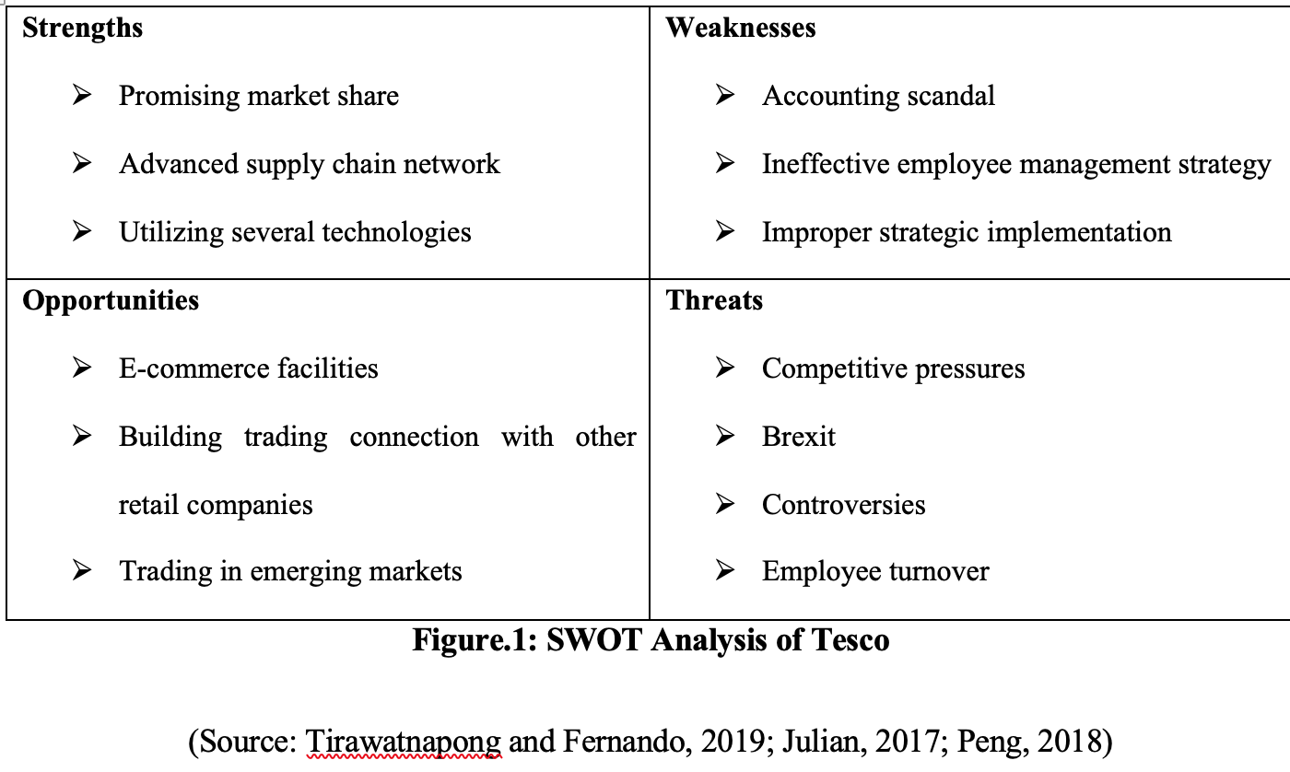
2.2 Discuss which ‘models’ of change were engaged with in the planning/implementation stage i.e Lewin, Kubler Ross etc.
Describe the benefits of using a change ‘model’ to help in the change process

I am going to use kubler ross

2.3 leadership management of complex areas
?

2.4. leadership in relation to change
culture
?

2.5 describe culture of the organisation.
handy ,hofstede
researching/discuss
2.5 change agents
clarifiy again please
  - conclusion
ok

  - recommendation
ok

