Detecting Phishing Attacks Using Machine Learning Techniques

Programme of Study: MSc in Cybersecurity and Digital Forensics
MSc Computing – Masters Project(ACFA7003)
Name: Sohanur Rahman
ID Number: 2434329
Abstract
Phishing is a major cybersecurity threat as suspicious websites and URLs may mimic authentic online services and persuade users to share sensitive information. This project explored the idea of machine-learning algorithms being able to correctly classify phishing and legitimate samples with the help of publicly available data regarding phishing. The research used a quantitative, experimental paradigm that relied on secondary sources and compared six classification algorithms: Logistic Regression, Decision Tree, Random Forest, Support Vector Machine (SVM), K-Nearest Neighbours (KNN) and XGBoost. The dataset consisted of 10,000 observations and 50 columns of which half (5,000) were legitimate ones and the other half (5,000) were phishing ones. Data preparation involved: structural inspection, exploratory analysis, whitelisting identifiers and constant features, 80:20 stratified train-test split and standardisation of features. All the classifiers were initially tested with a baseline configuration. Five-fold stratified cross-validation was then used, followed by the application of the GridSearchCV algorithm with F1-score as the optimisation criterion to systematically optimize the hyperparameters.
Finally, models were tested on the held-out test set with Accuracy, Precision, Recall, F1-score, confusion matrices and ROC-AUC. The findings indicated that the performance of the six models in classification was very high at all times. XGBoost obtained the best overall classification performance gaining 0.9870 in Accuracy, Precision, Recall, and F1-score. Random Forest had the best ROC-AUC of 0.9990 followed by XGBoost 0.9987. The results show that the ensemble-based methods were effective especially with regard to the chosen dataset. These are constrained by the reliance on datasets and the simulated experimental environment, excellent results on this dataset does not guarantee the same results on response to varying real-world phishing campaigns. The comparison design had also shown that that Hyperparameter tuning improved some models but had little effect on others. This is consistent with the nature of a controlled test amongst many complementary measures of performance perceived to be used to identify phishing.

Keywords: Phishing Detection; Machine Learning; Phishing Classification; XGBoost; Random Forest; Hyperparameter Optimisation; Cybersecurity; URL Features; ROC-AUC; Classification.

Table of Contents
Chapter 1: Introduction 9
1.1 Introduction and Research Context 9
1.2 Background to Phishing Attacks 9
1.3 Statement of the Problem 9
1.4 Research Rationale and Justification 10
1.5 Research Aim 11
1.6 Research Objectives 11
1.7 Research Questions 11
1.8 Overview of the Proposed Solution 11
1.9 Research Methodology Overview 12
1.10 Significance of the Study 12
1.11 Structure of the Report 13
Chapter 2: Literature Review 14
2.1 Introduction 14
2.2 Phishing Attacks: Nature, Evolution and Detection Challenges 14
2.3 Traditional Phishing Detection Approaches and Their Limitations 16
2.4 Machine Learning for Phishing Detection 17
2.5 Feature Engineering for Phishing Detection 19
2.6 Evaluation of Phishing Detection Models 21
2.7 Critical Comparison of Existing Studies 22
2.8 Research Gap and Justification for the Proposed Study 24
2.9 Chapter Summary 25
Chapter 3: Research Methodology 26
3.1 Introduction 26
3.2 Research Philosophy 27
3.3 Research Approach 27
3.4 Research Strategy and Methodological Choice 28
3.5 Research Methods 29
3.6 Data Collection and Dataset Selection 30
3.7 Data Preprocessing and Feature Engineering 31
3.8 Data Analysis and Model Evaluation 32
3.9 Research Design and Experimental Procedure 35
3.10 Validity, Reliability and Reproducibility 36
3.11 Ethical and Data Management Considerations 36
3.12 Methodological Limitations 37
3.13 Chapter Summary 37
CHAPTER 4: Design process 38
4.1 Chapter Introduction 38
4.2 Design Requirements and System Objectives 38
4.3 Overall Experimental System Architecture 39
4.4 Design Method Selection 41
4.5 Dataset and Data Preparation Design 42
4.6 Data Partitioning and Feature Scaling Design 42
4.7 Machine Learning Model Design 43
4.8 Hyperparameter Optimisation and Cross-Validation Design 45
4.9 Evaluation and Testing Design 46
4.10 Results Management, Reproducibility and Model Persistence 47
4.11 Chapter Summary 48
Chapter 5: Implementation and Result Evaluation 49
5.1 Chapter Introduction 49
5.2 Implementation Environment and Experimental Configuration 49
5.3 Dataset Implementation and Initial Data Analysis 50
5.4 Exploratory Data Analysis Implementation and Findings 51
5.5 Data Pre-processing and Feature Preparation Implementation 55
5.6 Initial Machine Learning Model Implementation 56
5.7 Initial Model Performance and Confusion Matrix Evaluation 57
5.8 Hyperparameter Tuning Implementation 60
5.9 Tuned Model Implementation and Final Evaluation 61
5.10 Final Confusion Matrix and Error Analysis 62
5.11 ROC-AUC Analysis and Model Discrimination 65
5.12 Comparative Evaluation of Initial and Tuned Models 67
5.13 Implementation Challenges and Solutions 71
5.14 Reproducibility, Model Persistence and Experimental Outputs 71
5.15 Chapter Summary 72
Chapter 6: Conclusion and Recommendation 73
6.1 Chapter Introduction 73
6.2 Overall Project Conclusion 73
6.3 Achievement of Research Aim 73
6.4 Achievement of Research Objectives 74
6.5 Answers to Research Questions 74
6.6 Overall Findings and Contribution 75
6.7 Limitations and Unresolved Issues 76
6.8 Recommendations 76
6.9 Suggestions for Further Work 76
6.10 Final Chapter Conclusion 77
Chapter 7: Reflection 78
References 82
Appendices 89
Appendix A — Baseline Model Training and Evaluation Code 89
Appendix B — Hyperparameter Tuning and 5-Fold Cross-Validation 90

List of Figures
Figure 3.1: Research Onion Framework 27
Figure 3.9: Flow Diagram of experimental procedure 35
Figure 4.3 Experimental system architecture from data acquisition through to model persistence 40
Figure 5.4.1: Legitimate versus Phishing Distribution. 52
Figure 5.4.2– Top Features Based on Class Mean Difference 53
Figure 5.4.3 — Box plot feature distribution by target class 54
Figure 5.5: Implemented Data Preparation Pipeline 56
Figure 5.7: Confusion Matrix of all baseline models 59
Figure 5.10 — Confusion Matrices for Final Tuned Models 64
Figure 5.11 — ROC Curves for All Tuned Models 66

List of Tables
Table 4.1 – Rationale for Selection of the Six Classification Algorithms 44
Table 4.8: Model-Specific Parameter Search 46
Table 5.4.1: Largest class differences in mean-comparison procedure 52
Table 5.6: Implemented Machine Learning Models and Initial Configuration 56
Table 5.7: Initial Model Performance 57
Table 5.8: Best Hyperparameters and Cross-Validation F1 60
Table 5.10: Final Tuned Model Performance 63
Table 5.12: Comparing Baseline and Tuned Model Performance of Models 67

Acknowledgement
I would like to thank all those people who helped me during the preparation of this project. To begin with, I would like to express my gratitude to my supervisor who was able to guide and provide constructive criticism in the research and development of this project and provided me with continuous support. Their recommendations assisted me in bettering the technical work as well as the academic quality of the dissertation.

I wanted to also take this opportunity to appreciate the teaching staff and the university as having helped me with the knowledge, resources and environment to carry out this work. This knowledge acquired during my course of studies offered a crucial background for doing this project. My family and friends supported me throughout the project, and I would like to thank them. Their insight allowed me to stay motivated towards the more demanding phases of the research and implementation. And lastly, I want to give my thanks to all the people who helped in completing this project either directly or indirectly.

Name:
Date:

Chapter 1: Introduction

1.1 Introduction and Research Context
Cybersecurity has gained significance with the increase in the usage of digital technology to serve as a medium of communication, financial transactions, sharing of information and provision of online services to individuals, businesses and organisations (Carvalho et al., 2023). The development of the internet has brought numerous advantages and it has enabled more cybercriminals to exploit users and organisations. Phishing is one of the most common and damaging types of attack. In phishing, forged messages, websites or links are used to entice victims to give out sensitive data or access malicious data. Phishing attacks are not easily detected since intended attackers continuously modify their attacks, designs and website URLs to evade normal security measures (Mosa et al., 2023). Signature-based and rule-based detection approaches might be ineffective in new phishing attacks or modified phishing attacks. Thus, the interest in applying machine learning to detect patterns that was able to discriminate between phishing and normal online actions is growing.

1.2 Background to Phishing Attacks
Phishing is a social engineering technique where attackers impersonate trusted persons or organisations to scam users into disclosing sensitive information or interacting with malicious content (Adu-Manu et al., 2022). The National Institute of Standards and Technology (NIST) defines phishing as an effort to access sensitive information using false electronic communications or other malicious websites. Phishing often works by using emails, messages or websites that prompt users to click a link, enter logins, download a file or enter financial information. To recognize phishing attacks, a number of attributes can be used. They can contain unusually long URLs, suspicious DNS records, dubious characters, substitution of domain names with IP addresses, abnormal redirections and suspicious terminology. Phishing may be converted into various types, such as email phishing, web-based phishing, spear phishing and URL-based phishing (Tanti, 2024). Spear phishing is more personalized and could involve the details of a particular individual or company.

1.3 Statement of the Problem
Phishing attacks remain a notable cybersecurity issue due to attackers constantly altering harmful URLs, sites, and social engineering techniques. These attacks are primarily used to make users think that a communication or a site is real. Since people are more reliant on online services, a successful phishing attack may result in the loss of login credentials, personal information and sensitive data (Carroll et al., 2022). The conventional approach to detecting phishing attacks is frequently based on known patterns, signatures, and familiarity with malicious websites or even web addresses. These schemes can be practical in detecting threats that are well established and they might fail when attackers come up with new or altered phishing tricks.
Phishing sites can be modified swiftly and it is extremely hard to detect new threats when using only well-known pattern-based security systems. This is what makes it necessary to have complex forms of detection that are able to detect movement not limited to rules. Machine learning offers a possible solution as it can pick up patterns in existing data and utilize other characteristics to categorize new cases (Rane et al., 2024). Results of applying various machine learning algorithms to the same phishing detection problem, however, may differ. The detection performance can be affected by the features selected, the dataset, preprocessing, and the model properties.

1.4 Research Rationale and Justification
Phishing detection has been a key focus of cybersecurity as phishing attacks have the potential to trigger serious issues for both individuals and organisations. Successful attacks can lead to password theft, loss of money, identity theft and unauthorized access to systems. Accordingly, more emphasis should be placed on enhancing the skills of detecting phishing attacks to mitigate such risks. Machine learning would be appropriate in this study since it can adapt to trends based on the existing data and employ multiple attributes to categorize new data (Theng and Bhoyar 2024). Characteristics of the URLs used, information on the domain and properties related to the website can be utilized to ascertain alterations in phishing and legitimate cases in phishing detection. Machine learning can also be able to offer a more adaptable solution compared to those that rely on preprogrammed rules and known patterns of attacks.
This study makes comparisons between six machine learning algorithms: Logistic Regression, Decision Tree, Random Forest, Support Vector Machine, K-Nearest Neighbours and XGBoost (Kurniawan and Megawaty, 2025). It is significant to compare a variety of algorithms since every model employs another method of learning and can result in various rates of detection. Comparing the models could thus give a better insight into which model better fits the chosen phishing detection activity.

1.5 Research Aim
The purpose of this study is to create and test machine learning algorithms to identify phishing attacks on the basis of publicly available phishing data. The study involves the comparison of the performance of Logistic Regression, Decision Tree, Random Forest, Support Vector Machine, K-Nearest Neighbours and XGBoost based on suitable performance measures to determine the best-performing model.

1.6 Research Objectives
- To critically examine current phishing detection methods, machine learning algorithms, pertinent data on phishing detection and test protocols in view of determining their applicability in phishing detection.
- To perform and experimentally compare potential Logistic Regression, Decision Tree, Random Forest, Support Vector Machine (SVM), K-Nearest Neighbours (KNN) and XGBoost in classifying phishing using a publicly accessible phishing dataset to achieve comparative phishing classification performance.
- To conduct a comparative analysis and validation of the experimental results. The models will be evaluated using accuracy, precision, recall, F1-score and ROC-AUC to provide a comprehensive comparison of classification performance.

1.7 Research Questions
- RQ1: What are some common machine learning methods and features used in phishing detection and what are their advantages and disadvantages?
- RQ2: How can a given set of machine learning algorithms identify phishing and legitimate samples using the chosen publicly available data?
- RQ3: How effectively do the selected machine learning models detect phishing websites in terms of accuracy, precision, recall, F1-score and ROC-AUC?

1.8 Overview of the Proposed Solution
This study develops a machine learning-driven solution to phishing attacks by analyzing a publicly available phishing dataset. Data collection is the initial stage in the research process, then data preprocessing and feature preparation. The ready data was then be separated into training and testing samples to develop the model. The implementations of logistic regression, decision tree, random forest, support vector machine, K-nearest neighbours, and XGBoost are the six machine learning algorithms to be implemented (Putri et al., 2024). Python was implemented with the assistance of Pandas, Scikit-learn and XGBoost. The models were tested and compared with measures to evaluate their performance based on cross-validation and relevant measures.

1.9 Research Methodology Overview
A positivist research philosophy was employed in this research since the investigation is about objective, measurable and quantitative findings. The deductive research method were used where the available information regarding phishing detection and machine learning was used to drive the experimental analysis of the chosen models (Do et al., 2022). The study takes an experimental approach to perform comparisons of various machine learning algorithms in similar conditions. A quantitative research method was used, based on secondary data obtained from a publicly available phishing dataset. The dataset was preprocessed and utilised to train and test the selected machine learning that have been selected. Accuracy, precision, recall, F1-score and confusion matrices were used as evaluation measures of their performance (Sujon et al., 2025). There was also be cross-validation where a good use is made of it in order to increase the reliability of the results. The reasons for selecting these methodological choices and the detailed research process are discussed in Chapter 3: Research Methodology.

1.10 Significance of the Study
The study is valuable due to the fact that phishing is a critical cybersecurity issue that can target individuals and organisations. The research gives insight into how a variety of machine learning models can be applied to identify phishing and legitimate cases. Logistic Regression, Decision Tree, Random Forest, SVM, KNN and XGBoost could be compared to each other so that it could offer some evidence regarding their performance in comparison with each other (Abbas et al., 2024). The results can also be applicable to real-life topics of cybersecurity like email safety, web blocking, cybersecurity monitoring and prevention of financial fraud. Nevertheless, the study was not state that it prevents phishing attacks entirely. Rather, the results can be used as evidence to direct future phishing detection systems and further studies.

1.11 Structure of the Report
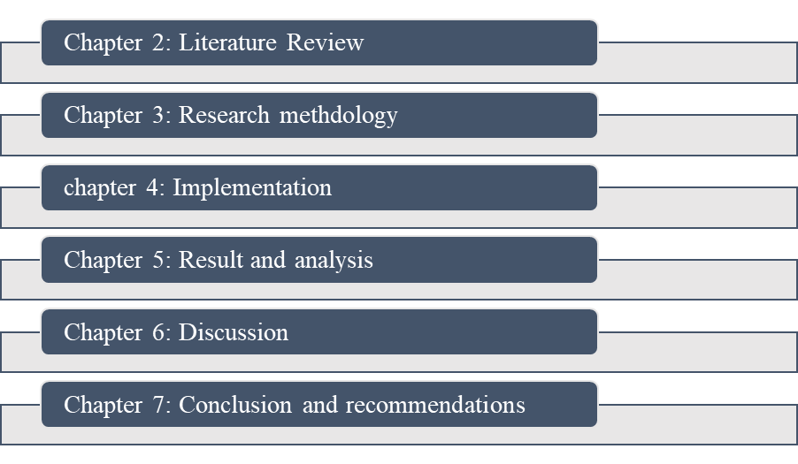
The dissertation is structured into seven chapters. Chapter 1 introduces the research problem, aim, objectives and questions. Chapter 2 reviews relevant literature on phishing detection and machine learning. Chapter 3 presents the research methodology. Chapter 4 explains the Design Process. Chapter 5 presents the Implementation and Result Evaluation. Chapter 6 provides the Conclusion and Recommendations. Chapter 7 presents the Reflection.
.

Chapter 2: Literature Review

2.1 Introduction
Phishing is one of the most significant cybersecurity threats where a malicious attacker tries to win the trust of a user to get in contact with corrupt sites, URLs or messages. Phishing detection is a research problem due to the growing number of people using online services. Nevertheless, phishing attacks keep progressing and are proving to be harder to spot by traditional security systems. Aljabri et al. (2022) emphasize that malicious URLs are constantly evolving, and more effective means of detecting them should be identified, whereas Sánchez-Paniagua et al. (2022) show the significance of investigating phishing web pages by considering various features of web browsers. Machine learning has become a significant solution since it is able to detect trends in the data concerning phishing and help with labeling suspicious and successful phishing cases. The previous studies reviewed various algorithms and datasets and attributes of features such as URL, HTML, semantic and web-technology features (Aljofey et al., 2022; Almomani et al., 2022; Mosa et al., 2023). Overall, this chapter critically analyses the research studies on phishing detection, conventional and machine-learning research, the features and dataset of phishing detection, the choice of the classification algorithm and their evaluation research.

2.2 Phishing Attacks: Nature, Evolution and Detection Challenges
Definition and characteristics of phishing:
Phishing is a type of cyberattack that involves deceiving the user into believing that a malicious message, site, or URL is genuine. This is usually done with the intention of getting classified information like usernames, passwords, financial data or any other account details. Phishing URLs and site attributes are considered especially necessary in the framework of website detection since scammers are able to make fraudulent websites look like real services.
Aljofey et al. (2022) show that URL and HTML settings may allow valuable insights to identify phishing sites and legitimate sites. Their research is valuable as it demonstrates that the detection of phishing cannot be done solely based on the on-screen appearance of a site. Rather, the URL and webpage characteristics can provide further evidence with regard to technical characteristics. On the same note, Sánchez-Paniagua et al. (2022) analyzed phishing websites with the help of web-technology features, which fortified the idea that various features can be used to detect it. Nevertheless, there is another difficulty mentioned in these approaches. Phishing websites may be purposely created by attackers so that they can look like legitimate websites; that is to say one feature is not necessarily enough information.
Evolution of phishing:
Phishing has evolved from a rather basic form of fraud into more advanced versions with copycat websites, malicious URLs and targeted fraud. The important issue is not simply the variety of phishing attacks, but the ability of attackers to change their methods and make malicious content appear increasingly legitimate. Sánchez-Paniagua et al. (2022) test this threat with their exploration of phishing URLs during a real-life login experience. According to their work, detection strategies must take realistic phishing behaviour into account and not just work with simplified examples. Aljabri et al. (2022) also list the need to alter malicious URL features as one of the challenges facing machine-learning-based detection research.
The development of phishing poses a challenge to traditional detection methods as historical features that one can identify might not be very useful when the attackers alter URLs, domains or webpage designs. To solve this problem, Aljofey et al. (2022) considered integrating both URL and HTML features and demonstrated that wider feature information may lead to better detection of phishing sites. This favors the thought that one should look at patterns in a set of characteristics as opposed to a single indicator.
Detection challenges:
One of the main challenges in phishing detection is the continuous change in attack characteristics. The attackers were able to alter URLs, domain and webpage layouts to circumvent any existing detection systems. The study by Aljabri et al. (2022) recognizes the evolving attributes of malicious URLs as a major research problem, whereas the focus of a review by Shrivastava et al. (2022) is on the increasing usage of machine-learning technologies as an alternative to a phishing URL detector. The fact that legitimate websites look similar to phishing sites is another challenge. An offsite can have a similar layout, branding or login design that was not be easily spotted due to visual identity. Sánchez-Paniagua et al. (2022) show that it is essential to consider realistic login URLs, and Almomani et al. (2022) explore semantic features to enhance the ability to distinguish between phishing and legitimate websites. These studies suggest that a combination of various types of information can be useful in detection. False positives and false negatives need to be taken into account in phishing detection, as well. A false positive can give a legitimate website a false positive result, and a false negative can permit a phishing site to go undetected. Hence, high accuracy does not give a full evaluation of a detection model.

2.3 Traditional Phishing Detection Approaches and Their Limitations
Blacklist-based detection:
Blacklisting is a phishing detection method that uses a database of reported malicious sites against a requested URL or domain name. The method is helpful as the identified threats can be detected fast without any complicated analysis. Nonetheless, its chief shortcoming is that it relies on threats detected before. An additional phishing URL that has been created was not automatically be on a blacklist during an attack. The finding of never-seen malicious URLs is reported by Aljabri et al. (2022) as a major threat, especially since the attackers can always invent and alter URLs. Equally, as shown by Aljofey et al. (2022), analysis of URL and HTML attributes is worthwhile instead of relying on known malicious addresses that are known. This implies that blacklist detection can be used effectively for known threats but not as a standalone technique of detecting new phishing websites.
Whitelist-based detection:
Whitelist-based detection is more of a reverse, where websites or domains that can be trusted, are detected. This has the potential to minimize exposure to known bad sites and can be reliable under controlled conditions. Nevertheless, this method may also limit access to legal sites that are new, unusual or are not mentioned in the list of trusted sites. Therefore, the approach involves frequent maintenance and it might not suit the massiveness and dynamism of the web. Aljabri et al. (2022) note the greater challenge of using fixed characteristics of websites at this time when malicious URLs and domains keep evolving. Thus, whitelisting is potentially useful, but it might be too restrictive as a primary detection algorithm.
Rule and signature-based detection:
Rule and signature approaches rely on pre-determined features in detecting suspicious behavior. These can be patternized URLs, domain attributes, security policies, or attack signatures that one has observed. Their key advantage is that they are easy to determine what to do and the causes of detection are usually relatively easy to comprehend. According to Shrivastava et al. (2022), there is a vast pool of characteristics involved in phishing URL detection, and fixed rules cannot be used to reflect every potential instance of phishing. Aljofey et al. (2022) also demonstrate that the utilization of URL and HTML characteristics can be useful in detecting phishing sites.
Limitations
Overall, traditional methods have tremendous advantages, such as the ability to detect fast, ease of implementation and effective identification of known threats. Blacklists and signatures rely on indicators that have been previously recognised, whereas whitelists might not be able to support legitimate websites that are yet to be trusted. More importantly, URL switching, domain features and web arrangements might decrease the power of fixed detection guidelines (Aljabri et al., 2022; Aljofey et al., 2022). These restrictions do not imply that the conventional methods are ineffective, instead, they prove the necessity that there should be corresponding methods that are capable of learning the patterns of various characteristics.

2.4 Machine Learning for Phishing Detection
Why machine learning?
Machine learning is able to recognize relationships between the input features and known categories, like phishing and legitimate websites. In supervised learning, the training of the model is based on labelled data, enabling the model to understand the pattern related to each of the classes. In phishing classification, the use of supervised learning would be especially appropriate due to the presence of labeled phishing and legitimate examples in datasets.
Aljabri et al. (2022) conducted a review of various machine learning methods to detect malicious URLs and discovered that URL-derived features can be used to provide valuable data for classification. Also, Almomani et al. (2022) examined semantic features using various machine learning classifiers and revealed the usefulness of feature information to learn the difference between phishing and legitimate websites. This justify the employment of supervised classification in this study. Nonetheless, the performance of models may rely on the features chosen, the dataset, and experimental procedure. Thus, it is important to compare various algorithms under consistent conditions as opposed to thinking that a particular model would definitely yield the best.
Single classifiers
Logistic Regression Logistic Regression can be helpful as a baseline in phishing detection, as it is relatively easy, computationally inexpensive and has a probabilistic meaning of classification outcomes. It tries to determine the likelihood of an instance being of a specific class. However, it is easy to interpret and can be useful to determine a benchmark with which more complicated models can be compared.
Another technique of supervised classification is Support Vector Machine (SVM), which attempts to determine a boundary of decision that separates various classes with a suitable margin. SVM can be made to exhibit more elaborate associations among the data points depending on the kernel functions. One of the machine learning methods named SVM was discovered by Shrivastava et al. (2022) to detect phishing URLs. It is relevant to phishing classification due to its functionalities in using complex and high-dimensional feature spaces. Nevertheless, the performance of SVM may be affected by the choice of parameters and the type of kernel, and when working with large datasets, training could become computationally expensive.

Ensemble methods:
Random Forest does not use a single decision tree and it uses a combination of several decision trees. It operates on random samples of the data and random selections of features in the creation of the trees. Random Forest additionally can give feature-importance data, which might assist in discovering features that play a high role in classification. According to Aljabri et al. (2022), ensemble-based methods are also adopted in malicious URL detection studies, which indicates their applicability to this issue.
XGBoost is another gradient boosting-based ensemble method. It builds the trees in a sequence unlike independent trees whereby the subsequent trees try to rectify the errors made by the previous ones. Mosa et al. (2023) examined tools of machine learning in the context of phishing URLs and showed that the issues apply to more challenging classification methods. Nonetheless, XGBoost is also hyperparameter sensitive and vary into overfitting unless the model is properly regulated.
Critical comparison
Logistic Regression has the advantage of being simple and easy to interpret, whereas it is linear and might lose the capacity to represent complex associations between features. SVM can generate required classification boundaries and exhibit capability in dealing with complex feature spaces, but tuning parametric parameters and computational aspects may be crucial factors. Random Forest can learn nonlinear interactions and can make strong predictions based on multiple trees and XGBoost can make powerful nonlinear modelling based on sequential boosting.
These distinctions are noteworthy since phishing data might have intricate correlations among URL, domain and website characteristics. Past literature also shows that features and classification method choice may be used to determine the performance of detection (Aljofey et al., 2022; Almomani et al., 2022; Bu and Kim, 2022). Thus, no algorithm can be presupposed to be better than the others prior to experimental testing. This problem is addressed in the current study where comparisons between Logistic Regression, SVM, Random Forest and XGBoost are made again with Decision Tree and K-Nearest Neighbours on the same data set, preprocessing steps as well as measures of measurement.

2.5 Feature Engineering for Phishing Detection

URL-based features:
The URL-based features are often utilized due to the availability of the URL prior to analysis of the entire webpage. Critical features are the length of URLs, number of dots, special characters and subdomains. Phishing URLs can possess an abnormally long length or multiple characters and subdomains in order to present the address as valid or conceal the destination. Another indicator of suspicious behavior can also be the presence of an IP address rather than a usual domain name.
Others such as suspicious words, weird characters, URL format and indicators of HTTPS are also relevant. Nevertheless, these characteristics are not to be regarded as clear-cut evidence of phishing. To illustrate, long URLs or multiple subdomains can also be used by legitimate websites. The findings of Aljofey et al. (2022) suggest that URL characteristics can be used to obtain valuable information that can be used to identify phishing websites, but the analysis also illustrates the importance of integrating information on URL characteristics with HTML characteristics. Bu and Kim (2022) also studied URL feature selection and found that useful URL characteristics are sometimes important to select to enhance detection.
Domain-based features:
Domain-based features give details about the domain that a site resides on. Some examples are domain age, registration information, DNS characteristics, registrar information and domain reputation. Domain lifetime and information relating to the registration can therefore contribute other information that is not possible to find by looking at the URL structure. But there are limitations to domain-based information. Not all datasets have all the features, and registration information or DNS information might need third-party services. This gives a challenge to reproducibility in case researchers rely on information that changes with time. Aljabri et al. (2022) note the significance of analyzing various feature types when coming up with strategies for detecting malicious URLs.
HTML and content-based features:
HTML are the number and type of hyperlinks, forms, external resources, iframes, scripts, and redirects. Phishing sites might have strange forms, and they are meant to capture users' names, passwords, or any other personal details. They also might make use of external content, embedded resources or scripts that are not similar to those that are typically used in legitimate websites.
Aljofey et al. (2022) specifically examined URLs and HTML characteristics and revealed that the combination of these sources of information could help identify phishing. Sánchez-Paniagua et al. (2022) included real-world login URLs as well, emphasizing the significance of analyzing URLs related to the web pages that might demand user credentials. Sanchez-Paniagua et al. (2022) went further to explore the web-technology features of a multipurpose dataset, which attests to the belief that webpage-level properties can deliver valuable information descriptive of the URL.
Feature selection and preprocessing:
The dataset should be properly prepared before machine learning models are trained. This can involve imputing missing values, eliminating repetitive records, coding categorical variables and scaling numerical features as needed. Irrelevant or repeated features must also be taken into account since they can contribute unduly to the complexity of the models. The relevance of feature selection is especially in the fact that having a large number of features does not necessarily give improved results. Bu and Kim (2022) examined the process of selecting optimised URL features and proved the significance of relevant feature selection when it comes to phishing detection. The process of preprocessing also needs to be very cautious not to leak information through which the model can be trained with the information of the test data. To illustrate this, training data should be used to fit feature selection or scaling and then used on the test data.
Critical evaluation of feature engineering literature:
The literature shows differences in the types of features used for phishing detection. There are studies with a particular focus on URL attributes and those that integrate URLs with HTML, semantic, or web-technology attributes. Aljofey et al. (2022) support the idea of the combination of URL and HTML data, whereas Almomani et al. (2022) prove the applicability of the semantic elements to machine learning classifiers. The importance of scrutinizing phishing URLs within the framework of a real case scenario of logging in can also be demonstrated by Sanchez-Paniagua et al. (2022). Such results indicate that the issue of phishing detection cannot be viewed as merely a simple URL-matching problem.
Nevertheless, more categories of features also present new challenges, such as missing information, preprocessing needs and variations among datasets. The current study was based on using the available characteristics of the selected open data and a uniform preprocessing and evaluation process. This enables the comparison of the chosen machine learning algorithms fairly and assists in determining whether the existing URL, domain and webpage-related information has any helpful evidence to be utilized to classify phishing.

2.6 Evaluation of Phishing Detection Models
Assessment is a significant constituent of phishing detection studies since a machine learning instance should not be evaluated based solely on whether it makes a multitude of correct predictions. Past research on phishing detection has demonstrated the significance of considering multiple performance metrics to compare machine learning models, which confirms the value of a multi-metric approach (Aljabri et al., 2022; Mosa et al., 2023).
Confusion matrix:
The confusion matrix has four types of evaluation. True Positive (TP), when a phishing example is recognized correctly; True Negative (TN), when a legitimate example is recognized correctly; False Positive (FP), when a legitimate example is mistakenly labeled a phishing one; and False Negative (FN), when a phishing example is mistakenly defined as a legitimate one. A false negative can enable a phishing site to pass without detection whereas a false positive lock down an authentic site unnecessarily.
Accuracy and Precision:
Accuracy can be defined as the total percentage of accurate instances. It gives a basic measure of overall classification performance, but can be inaccurate with imbalanced classes. So, the only measure of evaluation should not be accuracy. Precision is how many samples that are considered phishing are phishing. It is significant to study false alarms since low precision implies up to higher legitimate websites can be mistakenly recognized as phishing.
Recall and F1-Score:
Recall is a way of stating how well a model can identify real phishing instances. This is especially necessary as the inability to identify a phishing site can pose a security threat. F1-score is a combination of precision and recall which is measured in a single value and offers a compromise between false alarms and detection of phishing cases. Mosa et al. (2023) show the topicality of these measures in assessing machine learning methods to detect phishing URLs.

2.7 Critical Comparison of Existing Studies
Dataset Differences:
Previous works demonstrate that the performance of phishing detection is strongly tied to the data-set. Aljabri et al. (2022) provide an overview of malicious-URL research, which reveals differences in the data sets, URL patterns and experimental setup, which makes direct comparisons difficult. Similarly, Mosa et al. (2023) assess the machine-learning methods in a specific data set, and not on a common benchmark. So, better accuracy does not necessarily mean a better model if data sets have varied sizes, class distributions, collection time, source, and difficulty. This restricts external validity and reduces the ability to extrapolate from these good findings to newer and more challenging attacks.
Algorithm Comparison:
Several machine-learning classifiers such as SVM, decision trees and Random Forest are used in the literature. These approaches have been reviewed by Shrivastava et al. (2022) and shown to differ in performance in experimental settings by Aljabri et al. (2022) and Mosa et al. (2023). The performance of algorithms is also influenced by the feature representation, hyperparameters, class distribution and preprocessing, which makes it meaningless to compare scores across studies. Aljofey et al. (2022) also show that the effectiveness of the classifiers is related to the information given to them. Hence, a strictly better method of comparison is when models are using the same data, equally same preprocessing and evaluation protocol.
Feature-Set Differences:
Another performance factor that can vary greatly is a feature composition. Aljofey et al. (2022) demonstrate that one approach combining URL and HTML features is superior, as URL-based representations might not contain some of the relevant features. Aljabri et al. (2022) summarize various characteristics extracted from URL, Almomani et al. (2022) explore semantic information and Bu and Kim (2022) stress optimized feature selection. Hence, the reported improvements are not necessarily due to the classifier itself, but may also be due to the more informative and the more suitable features that were selected. For a comparison to be fair, it is critical to ensure that the classifiers’ features are represented uniformly so that any variation in the results could be attributed to the learning method.
Evaluation Differences:
Evaluation procedures make direct comparison impractical. Research has used different types of testing and training techniques, processing the data in different ways, and measuring the effectiveness of different systems. Aljabri et al. (2022) and Mosa et al. (2023) state that there are also different metrics used besides accuracy. This is necessary, since if there are a lot of false negatives, harmful material can be let through, and false positives would cause little disturbance in communication.
Direct Comparison of Existing Literature:
Overall, the research in the literature available gives some valuable but limited insights. More stable representations in terms of URL and HTML, also semantic information and diversity of algorithms and methodological peculiarities are discussed by Aljofey et al. (2022), Almomani et al. (2022), Bu and Kim (2022), and Shrivastava et al. (2022), correspondingly. Additionally, multiple machine-learning techniques are demonstrated to be applicable as seen by Mosa et al. (2023). While these studies provide a ranking of classifiers, however they do not make a strong case due to varying datasets, features and evaluation techniques. The present study fills this gap by doing a controlled comparison of Logistic Regression, Decision Tree, Random Forest, SVM, KNN and XGBoost algorithms with the same data, data pre-processing, feature representation and evaluation metrics. This design enhances the internal comparability and greater evidence of the relative performance of classifiers.

2.8 Research Gap and Justification for the Proposed Study
The gaps in the phishing detection research identified in the literature reviewed in Section are connected.
First, the existing studies have studied various machine-learning classifiers, but the results do not provide a foundation for selecting the best algorithm because classifiers are tested in various situations.
Secondly, there are differences in the features selected. Aljofey et al. (2022) use both URL and HTML features, Almomani et al. (2022) examine semantic features, and Bu and Kim (2022) study the optimised selection of URL features. This variant is problematic in terms of distinguishing the classifier from the features.
Third, there are differences between datasets further constraining direct comparisons across studies, as noted by Aljabri et al. (2022).
Fourth, methodological inconsistency exists due to the differences in pre-processing, validation and evaluation methods.
Finally, using accuracy as the metric might give an incomplete picture since phishing detection must also account for false negatives and false positives.
Based on the literature, it is apparent that the performance of the model is affected by algorithms combined with features, datasets and evaluation procedures. To solve this identified gap, this study compares the above-mentioned classifiers in a controlled manner by preparing the data in the same way and using the same criteria to evaluate them.

2.9 Chapter Summary
The literature review on phishing attacks and phishing detection using machine learning techniques was conducted in this chapter. Phishing is an ever-evolving attack that employs different domain names, page designs, social-engineering methods and URLs that make traditional detection methods difficult. Traditional approaches like blacklist, whitelist and rule based are effective against known threats, but are not effective against new or modified attacks. Machine learning offers a more adaptive method, learning phishing and legitimate patterns. The literature indicates that the choice of algorithm, feature sets, datasets, and preprocessing and evaluation procedures have an impact on the detection performance. The effectiveness of the model can be measured in a variety of ways, such as accuracy, precision, recall and F1-score. The non-consistency of the methods used in the various studies are sufficient to motivate a controlled comparative experiment. The next chapter research methodology tackled the identified gap and testing the selected machine-learning models under a uniform set of experimental conditions is therefore presented in the next chapter.

Chapter 3: Research Methodology

3.1 Introduction
This chapter outlines the process of tackling research goals and exploring the methods of detecting phishing attacks through machine learning procedures. The research follows a quantitative experimental method as per a publicly available phishing dataset. The implementation and comparison of six machine learning algorithms are provided: Logistic Regression, Decision Tree, Random Forest, Support Vector Machine (SVM), K-Nearest Neighbours (KNN) and XGBoost (Abbas et al., 2024). The training of the models and testing are conducted through systematic data-processing and testing. Accuracy, precision, recall, F1-score, and confusion matrices are used to evaluate their performance. This approach gives the methodological framework of finding and comparing successful phishing detection models.
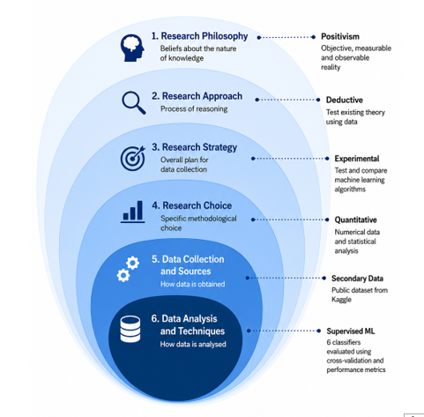

Figure 3.1: Research Onion Framework
Source: Self-created by Author (Taken from Saunders et al., 2023)

3.2 Research Philosophy
Research philosophy can be defined as beliefs and assumptions on which research is carried out on, conceptualization of knowledge, and assessment of evidence. In this study, the research philosophy is positivist because the research is founded on observable, measurable, and objective evidence.
Positivism presupposes that phenomena may be investigated in a systematic fashion and by measuring and empirically testing them (Ali, 2024). This would suit the current study since these attributes, namely URL length, domain attributes, and security features can be used to represent phishing and trusted URLs. Numerical results, such as accuracy, precision, recall, F1-score and confusion matrices, can also be used to objectively measure the performance of machine learning models.
Interpretivism is interested in the interpretation of human experiences, perceptions as well as social behaviour. It does not suit this research as this study does not examine the manner in which people perceive and react to phishing attacks. Pragmatism is more flexible and can justify quantitative and qualitative methods combination (Liu, 2022). Nonetheless, such flexibility is not essential since the investigation of the present day is articulate both in terms of its quantitative and experimental orientation. Hence, positivism has been viewed as the most suitable philosophy in realizing the goals of this research by objective measurement and empirical assessment.

3.3 Research Approach
This research uses a deductive approach. The deductive approach involves the test using evidence with preexisting knowledge, concepts, or theories (Fife and Gossner, 2024). On the other hand, an inductive approach begins with observations which it uses to form new ideas, concepts or theories. Deductive approach was fit in this study as the research were based on the prevailing knowledge on phishing attacks, machine learning, classification, supervised learning, and model evaluation.
The research uses a publicly available phishing dataset and apply six predefined machine learning algorithms: Logistic Regression, Decision Tree, Random Forest, Support Vector Machine, K-Nearest Neighbours, and XGBoost. Accuracy, precision, recall, F1-score, and confusion matrices were used as their performance metrics. An inductive approach would not be appropriate, since the aim of this study is not to come up with a new theory, but to experiment and compare the current machine learning techniques (Shu and Ye, 2023).

3.4 Research Strategy and Methodological Choice
The research study is based on an experimental research strategy since it tests and compares the performance of various machine learning algorithms in detecting a phishing attack. An experimental approach enables the researcher to have controlled processes and to objectively measure outcomes.
The experiment involves the use of one publicly available phishing dataset that has specified input features. Training of the models. The dataset was preprocessed using the same procedures and then trained. After this, six machine learning algorithms were trained and tested, they are Logistic Regression, Decision Tree, Random Forest, Support Vector Machine, K-Nearest Neighbours, and XGBoost. Accuracy, precision, recall, F1-score, and confusion matrices were used to quantify the performance of each of the models (Kurniawan and Megawaty, 2025). The primary independent variable can be taken to be the machine learning algorithm, whereas it can be seen that performance measures are the dependent results. The 80:20 split provides a sufficiently large training sample while retaining an independent test set for final evaluation. Stratification preserves the balanced phishing and legitimate class proportions in both subsets, making the comparison consistent across models.
A survey strategy was not appropriate because the study does not involve human participants. Interviews would also be inappropriate since the research aims at investigating the predictive ability of machine learning models and not the experiences or perceptions of people. Phishing in a single organisation could be explored with the help of a case study, but it is the task of the proposed research to compare a variety of algorithms with the aid of a representative dataset. It is applicable to development or design science since a detection framework is generated, but experimental evaluation is the primary focus of the given research.

3.5 Research Methods
Quantitative Method
The research adopts a quantitative approach since the primary aim is to generate and compare numerical outputs of machine learning models. The models categorize the URLs into phishing and legitimate. True positives, true negatives, false positives, and false negatives were the result. These values were used to calculate accuracy, precision, recall, and F1-score (Sujon et al., 2025). The results of classification was also be presented in the form of confusion matrices. Quantitative approach can give objective measurements and can be used to compare the performance of various algorithms in the same evaluation criteria (Amin et al., 2023). This method is appropriate when working with machine learning since big quantities of information can be run at low costs.
Nevertheless, the numbers fail to elucidate the reasons as to why individuals can be victims of phishing attacks. The results are also dependent on the quality and characteristics of the dataset. Also, it is not always true that good performance on one dataset implies good performance in an actual environment. The restrictions neither stop addressing the research goals since this research is specifically concerned with comparing the predictive ability of machine learning algorithms.
Supervised Machine Learning
The study follows supervised machine learning classification as the samples have labeled examples of phishing and valid URLs. The models are trained to acquire patterns among the input features and target class. Once it has been trained, every model is evaluated with data that it has never seen, and is tested to determine if a URL is phishing or legitimate. It is not expected that only one algorithm was selected, but six algorithms were compared. This offers a more reasonable analysis and assists in determining which strategy is most effective when working with the chosen data and characteristics.
Machine Learning Algorithms
There are six machine learning algorithms that were experimentally compared.
- Logistic Regression is a simple and computationally inexpensive classifier that is computationally cheap and offers a simple baseline that is interpretable (Kheni, 2025). However, its performance may be poor in case the features have complex relationships.
- Decision Tree uses a series of rules to classify data. Non-linear relationships are simple to grasp and can be modeled, yet an individual tree might get overfitted.
- Random Forest is a combination of decision trees to enhance better predictability and minimize the shortcomings of a decision tree. It is usually strong but needs additional resources to process computations.
- SVM Support Vector Machine (SVM) finds an appropriate boundary between classes and is capable of operating with high-dimensional data (Valkenborg et al., 2023). Its training may however be computationally costly to larger datasets.
- K-Nearest Neighbours (KNN) is a classification algorithm that uses a similarity to close examples to classify an instance. It is an easy implementation yet may demand much computation in the process of prediction.
- XGBoost is based on gradient boosting to create decision trees in series and is capable of having robust predictive performance. Nevertheless, it might need to be carefully selected in parameters and consume additional computing resources.
The combination of these algorithms covers a range of linear, distance-based and tree-based methods that could be used to make a comparison of the full value of the experimentation.

3.6 Data Collection and Dataset Selection
The dataset has 10,000 rows and 50 columns, with CLASS_LABEL being the binary target variable. The distribution of classes is evenly balanced with 5000 samples of each class: legitimate and phishing.
Source- https://www.kaggle.com/datasets/shashwatwork/phishing-dataset-for-machine-learning
The dataset has been chosen due to the achievement of the primary criteria of this study. It has labeled examples of phishing and legitimate websites, offers appropriate features to classify by machine learning, and has enough examples to compare various algorithms. There are numerous issues related to the utilization of a public dataset such as greater reproducibility, reduced costs, and easier access. The information could be affected by sampling bias or duplicate records, not representative classes, or had old phishing features. Patterns might also exist in the dataset which are specific to the source of the data and may not be reflective of actual real-life phishing attacks (Darwish et al., 2023).
The dataset combines three broad feature groups: URL-based features describing URL structure and length, address-bar/domain features describing hostname and domain characteristics, and HTML/content-related features describing webpage behaviour and embedded elements. Examples include UrlLength (numerical: URL length), NumDots (numerical: number of dots), HostnameLength (numerical: hostname length), NumDash (numerical: number of dashes), PathLength (numerical: path length), and HttpsInHostname (binary: HTTPS indicator). The dataset is attributed to Shashwat Work on Kaggle and is listed as a 2018 dataset; the underlying feature dataset is associated with Tan (2018). The dataset is distributed under a Creative Commons Attribution 4.0 (CC BY 4.0) licence, requiring appropriate attribution when reused.

3.7 Data Preprocessing and Feature Engineering
Before model training, the dataset was cleaned and made sure it is inspected. Missing values, repetition and inconsistent data types as well as invalid values were verified and addressed accordingly. This is a crucial step since low-quality data may decrease the precision and dependability of the machine learning outputs.
The preprocessing approach also involves the diagnostic analysis of the behaviour of these features prior to finalising the predictors. Negative values, constant values and potential outliers (those outside) Q1−1.5 (IQR) and Q3 +1.5 (IQR) are checked for numerical variables. The analysis is used to detect the negative observations in six variables, and to verify that HttpsInHostname is a constant feature. The removal of HttpsInHostname is justified as it offers no variation, while the removal of id is justified as it is an identifier and not a predictive characteristic. The predictor matrix has 47 features after removing CLASS_LABEL from it
The models were then prepared to use the relevant URL, domain and the content related features. In case the dataset is categorical, it was transformed into numbers such that they can be handled by the machine learning algorithms. An 80:20 stratified train-test split was used with random_state=42 to be repeatable. The 80:20 split provides sufficient training data for stable model learning while retaining a sufficiently large independent test set for final evaluation. Stratification preserves the class proportions in both subsets.
Standardisation is done with StandardScaler, which is fitted on the training predictors, and then applied to the test predictors. Scaling is not only crucial to algorithms like Support Vector machine, K-Nearest neighbours, and Logistic Regression, but it has been shown that algorithms may respond differently to changes in feature value and feature range. Decision Tree, Random Forest, and XGBoost are tree-based models that tend to not need feature scaling.

3.8 Data Analysis and Model Evaluation
The six classifiers were evaluated first without optimisation, with the baseline configuration. The baseline configuration for Logistic Regression is set to max_iter = 1000, for Decision Tree, random_state = 42, for Random Forest, n_estimators = 200, for SVM, an RBF Kernel, for KNN, 5 neighbours and for XGBoost, n_estimators = 200, max_depth = 6, learning_rate = 0.1, subsampling = 0.8, column_subsample = 0.8.

Classification Metrics:
Accuracy, precision, recall and F1-score were used to measure the performance of the machine learning models (Sujon et al., 2025). Accuracy is the ratio to the total number of classified URLs that are correctly classified. Precision tells the extent to which the predicted phishing URLs are phishing. Recall was used to denote the number of correct detections of phishing URLs. F1-score is used as the tuning metric because it combines precision and recall into one measure. F1-score was selected as the tuning metric because it balances precision and recall. This is relevant to phishing detection because false positives can block legitimate sites, while false negatives can leave phishing sites undetected; accuracy alone does not reflect this trade-off.
Phishing detection is related to the concept since incorrect classification of the legitimate cases as phishing cases or failure to identify phishing incidents has a direct impact on the practical detection capability. The GridSearchCV is selected since it conducts systematic and repeatable searches across the combinations of model parameters. The five-fold stratified validation tested the different configurations of parameters while accounting for the proportions of classes and not relying on manually set parameters. GridSearchCV was selected because the defined parameter spaces are moderate, allowing exhaustive evaluation of the specified combinations. Compared with RandomizedSearchCV and Bayesian optimisation, grid search provides a straightforward and reproducible optimisation procedure for this experimental design.
ROC-AUC measures the classifier's ability to rank phishing instances above legitimate instances across different classification thresholds. It complements F1-score by assessing discrimination independently of a single threshold. A higher ROC-AUC indicates stronger overall class separation.
Accuracy is calculated as
$\left(TP+TN\right)/\left(TP+TN+FP+FN\right)$,
precision as
$TP/\left(TP+FP\right)$,
recall as
$TP/\left(TP+FN\right)$,
and F1-score as
$2PR/\left(P+R\right)$.
These measures complement one another rather than relying on a single performance indicator.
Confusion Matrix:
A confusion matrix was used to provide a detailed view of classification results (Riehl et al., 2023). A true positive is an instance of a phishing URL that is rightly described as phishing, a true negative is a legitimate URL that is rightly described as legitimate. False positive is a legitimate URL that was marked as phishing. A false negative refers to a phishing URL that was not categorized as such. Such findings were used to determine the weak and strong part of each model.
Cross-Validation:
The hyperparameter optimization was performed using GridSearchCV with 5-fold StratifiedKFold cross-validation with random_state=42. The optimisation criterion is given as the F1 score. The search does not operate over a single space of parameters—it looks over the parameter space specific to the model. Logistic Regression has 4 C values to test; Decision Tree has the possible maximum depth and minimum sample split to test; Random Forest has the possible count of estimators and the possible depth; SVM has the possible C value and kernel; KNN has the possible number of neighbours between 3 and 11; and XGBoost has the number of estimators to test, the depth and the learning rate.
Comparative Analysis:
After optimisation, the best estimators make predictions on the untouched test set. Additionally, final evaluation can compute ROC-AUC from probability estimates or decision scores and ROC curves offer a threshold independent measurement of discrimination. The comparative table shows the results of accuracy, precision, recall, F1-score and ROC-AUC for all 6 tuned models.
Tools and Experimental Environment:
The implementation was conducted in Python using a notebook-based Google Colab environment. The workflow used pandas and NumPy for data processing, scikit-learn for preprocessing, modelling and evaluation, XGBoost for gradient boosting, and Matplotlib and Seaborn for visualisation. The specific Python and library versions, together with the available CPU and RAM configuration, were recorded to support reproducibility.

3.9 Research Design and Experimental Procedure
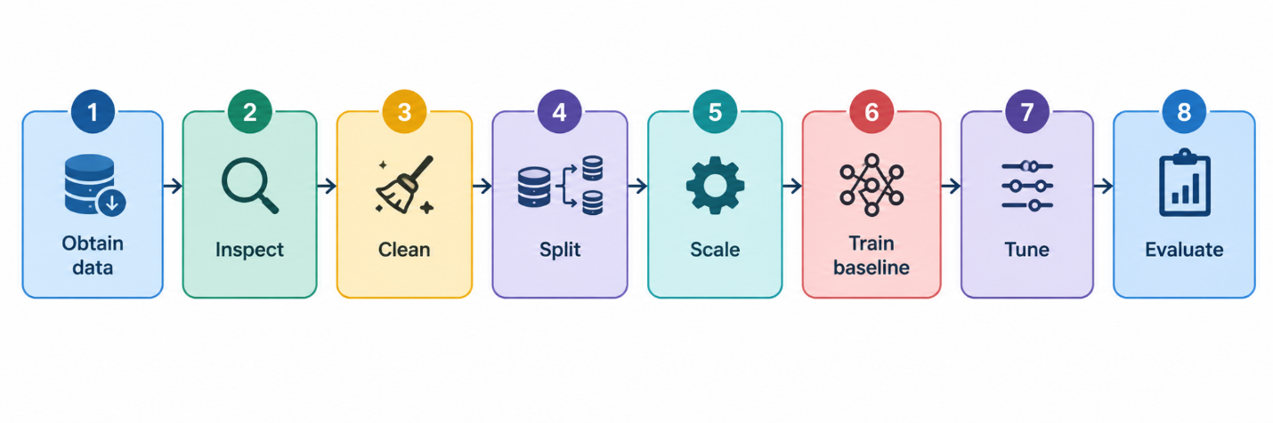

Figure 3.9: Flow Diagram of experimental procedure
(Self-created)
The experimental procedure follows eight sequential stages:
- Obtain data: download the selected public phishing dataset from Kaggle.
- Inspect: examine dimensions, data types, class distribution, missing values, duplicates and feature behaviour.
- Clean: remove id and the constant HttpsInHostname feature.
- Split: create an 80:20 stratified train-test partition using random_state=42.
- Scale: fit StandardScaler on the training data and transform both partitions (Miah and Islam, 2024).
- Train baseline: train the six classifiers using their defined baseline configurations.
- Tune: optimise model-specific parameters using five-fold StratifiedKFold and GridSearchCV with F1-score.
- Evaluate: assess the tuned models on the untouched test set using accuracy, precision, recall, F1-score, ROC-AUC and confusion matrices.

3.10 Validity, Reliability and Reproducibility
Internal validity: Internal validity is supported by separating the test set from model optimisation, using stratification during partitioning and fitting StandardScaler only on training data before applying it to the test set. The held-out test set was never exposed to scaler fitting, hyperparameter tuning, or model selection. StandardScaler was fitted on the training partition only and then applied to the test partition.
External validity: External validity is limited because the experiment uses one public dataset, so the findings may not represent newer phishing patterns or other datasets.
Reliability: Reliability is supported through random_state=42, stratified five-fold cross-validation, consistent preprocessing and identical evaluation procedures across all six classifiers (Sharifi et al., 2023).
Reproducibility: Reproducibility is supported through documented Python code, preprocessing decisions, model parameters, data source, library configuration and saved experimental outputs.

3.11 Ethical and Data Management Considerations
This study does not involve humans as it uses publicly available phishing data. No individual or special-category data was gathered or manipulated. The dataset is publicly available under its stated CC BY 4.0 licence and is used in accordance with its attribution requirements. No human participants or personally identifiable participant data are involved in this study. The research uses secondary public data and therefore does not involve participant recruitment or direct human-subject experimentation; any requirement for formal university ethics approval should follow the institution's research-ethics policy. Finally, phishing-detection research has a potential dual-use dimension because knowledge of detection features could also inform attempts to evade detection; therefore, the study focuses on defensive evaluation rather than operational phishing activity.
Data were stored in a secure manner on password-protected equipment with suitable backups of the research data. Data management was done based on UWTSD research data management requirements. The data was managed in a responsible manner and complying with the licence it has and the access terms. Data leakage is controlled by keeping the test set outside model selection and optimisation. Standardisation parameters are learned from the training data and then applied to the test data, preventing test observations from influencing preprocessing.

3.12 Methodological Limitations
There are some methodological limitations to this study. First, the findings rely on the chosen data set and might not be applicable to other phishing settings. Age of data can also be a factor of performance as phishing tricks keep on evolving. The performance of the models is affected by the chosen URL, domain, and content features (Kustiawan and Ghauth, 2025). Besides this, there is no single machine learning algorithm that can be ensured to excel in various datasets. Lastly, controlled experimental environments might not fully apply to real world performance in live email/ web-security systems. These limitations were handled by means of careful preprocessing, cross-validation, regular testing, and comparative evaluation of an array of algorithms.

3.13 Chapter Summary
The chapter identified the research methodology, which was founded on a positivist philosophy, a deductive method, a quantitative method and an experimental approach. Six machine learning algorithms were then used to preprocess a secondary phishing dataset and test it. Appropriate metrics were used to assess model performance and was backed by measures of validity, reliability and reproducibility. The following chapter is the implementation and development of the proposed models.

CHAPTER 4: Design process

4.1 Chapter Introduction
This chapter translates the methodology established in Chapter 3 into an experimental design for the phishing-classification system. It defines how the dataset, predictor variables, machine-learning models, optimisation procedures, and evaluation mechanisms are organised and implemented. The design focuses on a controlled and repeatable comparison of six classifiers supervised instead of an arbitrary coding exercise of model selection. Therefore, justifications are provided for the choices of dataset preparation, baseline model implementation, hyperparameter tuning strategies, and performance evaluation scores. The chapter also presents design controls to reduce contamination of test sets and to support subsequent analysis to allow for replication.

4.2 Design Requirements and System Objectives
Functional Requirements:
- Dataset Loading: The system has to load the dataset containing the CLASS_LABEL variable as the target variable.
- Data Preparation: The system should generate predictors and split the data into training and testing data sets.
- Model Training: Six classifiers have to be trained, and the system has to systematically optimize the parameters of these classifiers.
- Prediction and Evaluation: The system must predict and compute evaluation metrics.
- Model Comparison: The system should objectively compare the performance of classifiers.
- Output Management: Model and results need to be stored in the system.
- Directory Structure: Raw, Processed, Model, Result, Figure, and Documentation directories must be separated.

Non-Functional Requirements:
- Reproducibility: To allow for reproducible outcomes, the system should be configured with fixed settings and procedures, while the performance of phishing detection is dependent on the datasets and procedures to be used (Hannousse and Yahiouche, 2021).
- Reliability: Data-processing, training, and evaluation procedures should be maintained by the system.
- Computational Efficiency: Training, optimisation, prediction, and generation of results should be efficient within available resources.
- Interpretability: The system should be able to store the appropriate metrics and outcomes.
- Test-Set Isolation: The test data set cannot be used for training or optimisation, as this would cause data leakage and over-optimistic results (Kapoor and Narayanan, 2023).
- Methodological Control: Reproducibility, data isolation, and implementation consistency need to be requirements in the system.

4.3 Overall Experimental System Architecture
The methodology is translated into a machine-learning process through the architecture depicted as a series of steps: data preparation, model development, optimisation, evaluation, and persistence. Figure 4.3 illustrates the flow of data acquisition to inspection, target identification, feature cleaning, stratified partitioning, scaling, six model training, five-fold stratified cross-validation, GridSearchCV tuning, selection of the best model, untouched test-set evaluation, comparative analysis and persistence of the optimal model.
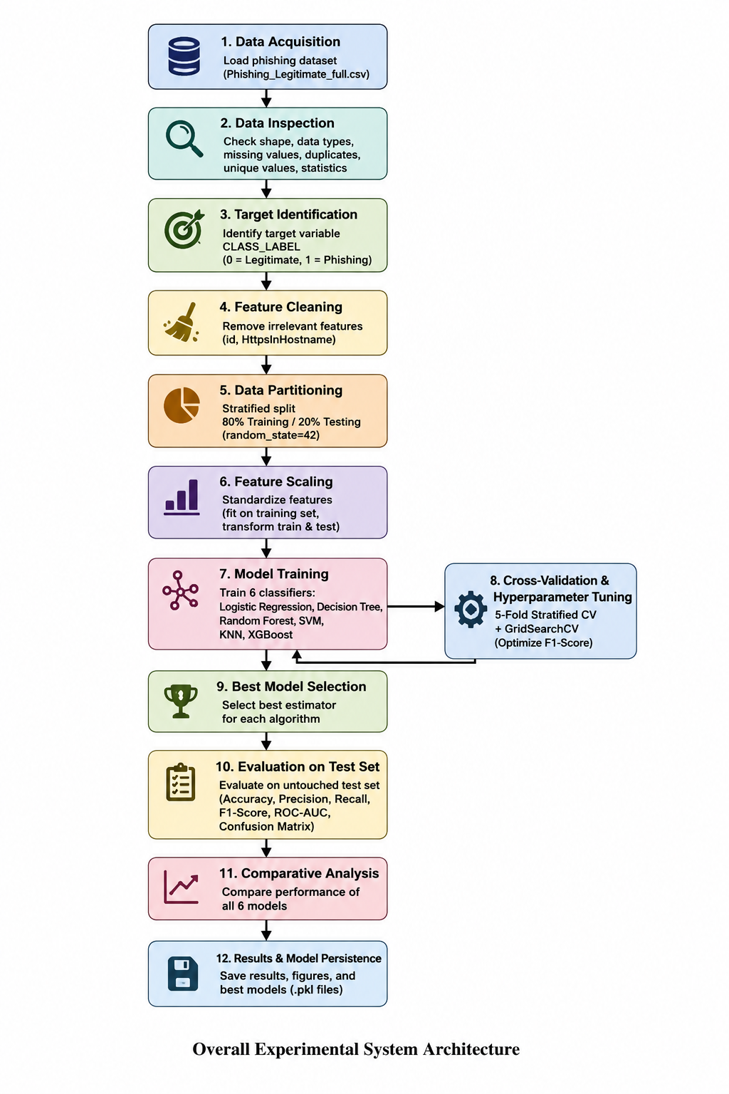

Figure 4.3 Experimental system architecture from data acquisition through to model persistence
Sources: Self-created by Author
The implementation loads the phishing dataset, finds CLASS_LABEL, removes id and HttpsInHostname, performs an 80:20 stratified split, standardises predictors, and models. Logistic Regression, Decision Tree, Random Forest, SVM, KNN, and XGBoost are trained on the training data. Tuned configurations are obtained by cross-validation and grid search. Metrics, confusion matrices, ROC-AUC analysis, and a results table are generated for the final predictions made using the test set. Each tuned estimator is serialised as a .pkl file for reproducible development.

4.4 Design Method Selection
Alternative Experimental ML Design Approaches:
Other models were investigated, such as single-model classification, simple train/test validation, manually selected parameters, and no systematic resampling validation. While these methods are simpler to implement, they provide less certainty about comparative model selection. One classifier cannot establish whether performance is model-specific, while manual tuning can make model selection subjective and irreproducible. K-fold cross-validation gives multiple training/ validation splits, and hyperparameter optimization eliminates a lot of trial-and-error configuration. Structured optimization can be used to influence predictive performance by the choice of hyperparameters (Bischl et al., 2023).
Selected Design Approach:
The chosen method is a comparative supervised machine learning design that consists of six classifiers, five-fold stratified cross-validation, and GridSearchCV optimisation. This is suitable as the phishing detection problem is a binary classification task, which should be compared between phishing learning assumptions. This separation is critical since if data leakage occurs, the results of machine learning can be misleading (Kapoor and Narayanan, 2023). The design is not optimized for one particular model, but it is robust, fair, and computationally feasible.

4.5 Dataset and Data Preparation Design
Dataset Loading and Structural Inspection:
The system loads the Phishing_Legitimate_full.csv file containing 10,000 observations and 50 columns, and then checks the dimensions, data types, data missingness, duplicates, unique values, and descriptive statistics before modelling. This is crucial because the effectiveness of phishing detection can vary depending on the composition of the dataset and the representation of features (Ahmad et al., 2024). Outliers (as defined by IQR), constant columns and negative values are also checked. These diagnostics only pinpoint data-quality issues, without altering observations. Outlier analysis is therefore a diagnosis and not transformative (Rehman and Belhaouari, 2021)..
Target Variable Design:
The target is CLASS_LABEL:
- 0 → legitimate websites
- 1 → phishing websites
Exploratory Data Analysis Design:
The class distribution, class-wise feature means, the 10 largest feature mean differences, and box plots of the top 5 features are examined. This is a focus on features that can be seen to have discriminatory separation and does not actually perform feature selection, but still maintains the entire predictor set for model comparison. This examination is consistent with the research of phishing, which considers feature relevance as a central factor in phishing classifier performance (Tang and Mahmoud, 2021).
Irrelevant Feature Removal:
Lastly, irrelevant predictors ‘id’ and ‘HttpsInHostname’ are eliminated. This is not extensive feature engineering, but rather feature cleaning and selection.

4.6 Data Partitioning and Feature Scaling Design
Stratified Train and Test Design:
Data Partitioning: 80:20 train/ test split.
Reproducibility: random_state=42 is used to make the data partitioning reproducible and consistent.
Class Balance: stratify=y; it helps to preserve the original class proportion.
For binary phishing classification, stratification is suitable since the size of the classes should not influence the evaluation. Using StandardScaler, the parameters are learned from the X_train, and then the transformation is applied to both training and test sets. This avoids the contribution of test observations to the scaling parameters. This isolation is crucial because these pre-processing transformations learned from validation and test data can introduce bias into the predictive evaluation (Moscovich and Rosset, 2022).
Standardisation Design:
Normalizes the values of different numeric predictors so that the predictors are put on the same scale. It leads to the efficacy of classifiers such as SVM, KNN, and Logistic Regression, which are affected by the differences in features’ values. It is not necessary to scale for tree-based models, but if it is kept, it is cleaner to have a consistent preprocessing pipeline throughout the comparative experiment.

4.7 Machine Learning Model Design
Logistic Regression:
Provides an interpretable linear baseline, with C tuned for performance and max_iter=1000 supporting convergence.
Decision Tree:
Captures nonlinear relationships but risks overfitting, so max_depth and min_samples_split are optimised.
Random Forest:
It extends tree learning with ensemble averaging, decreases the variance of individual trees, and incorporates the nonlinear relationships. It has an initial configuration of 200 estimators, with the number of estimators and the depth of the estimators being tuned.
Support Vector Machine (SVM):
SVM's classification is based on margin, and it tests different decision boundaries using linear and RBF kernels, the first one being RBF, and the other two being optimised.
K-Nearest Neighbours (KNN):
The neighbourhood size is set to 5, and n_neighbors is tuned, with a local perspective (KNN) that is distance-based.
XGBoost:
Gradient-boosted tree learning, a sequential process of combining weak learners using a nonlinear model, XGBoost repeatedly optimizes the values of the parameters n_estimators, max_depth, and learning_rate.
The model portfolio is linear, rule-based, bagging, margin-based, instance-based, and boosting. This heterogeneity enhances the interpretation of experimental results as it allows for the differences in the observed results to be traced to different learning mechanisms. Comparative phishing research also helps to evaluate various classifiers under the same experimental conditions (Choudhary et al., 2023; Kapan and Sora Gunal, 2023).

Table 4.1 – Rationale for Selection of the Six Classification Algorithms
Model | Design Role | Main Strength | Parameters Considered
Logistic Regression | Linear baseline | Interpretability | C
Decision Tree | Nonlinear learner | Rule-based decisions | max_depth, min_samples_split
Random Forest | Ensemble learner | Robust nonlinear classification | n_estimators, max_depth
SVM | Margin-based learner | Complex boundaries | C, kernel
KNN | Distance-based learner | Local patterns | n_neighbors
XGBoost | Boosting learner | Strong nonlinear modelling | n_estimators, max_depth, learning_rate

4.8 Hyperparameter Optimisation and Cross-Validation Design
Five-Fold Stratified Cross-Validation:
The optimizer scheme is StratifiedKFold(n_splits=5, shuffle=True, random_state=42), which generates 5 folds of the data for training and validation (with the same class proportions). This helps to minimize reliance on one validation partition and gives more consistent model selection.
Grid Search Design:
GridSearchCV systematically tests out a set of combinations of parameters instead of subjectively trying out a few combinations. This increase the transparency and reproducibility, but also the computational cost since the search space is growing. While noting this simple computational trade-off, Bischl et al. (2023) call grid search a “transparent baseline.”
Model-Specific Parameter Search:

Table 4.8: Model-Specific Parameter Search
Model | Search space
LR | C: 0.01, 0.1, 1, 10
DT | max_depth: None, 5, 10, 15; min_samples_split: 2, 5, 10
RF | n_estimators: 100, 200; max_depth: None, 10, 20
SVM | C: 0.1, 1, 10; kernel: linear, RBF
KNN | n_neighbors: 3, 5, 7, 9, 11
XGB | n_estimators: 100, 200; max_depth: 3, 6; learning_rate: 0.05, 0.1
Optimisation Criterion:
GridSearchCV scores are calculated using the F1-Score to consider precision and recall, not only accuracy. It is appropriate for phishing detection, as phishing attempts that are not detected and correct detections of legitimate sites both need to be considered, and precision and recall are also accounted for in recent phishing research.

4.9 Evaluation and Testing Design
Performance Metrics:
The final evaluation uses five complementary metrics: accuracy, precision, recall, F1-score, and ROC-AUC. These metrics give complementary evidence besides the accuracy (Kapan and Sora Gunal, 2023).
Accuracy measures overall correctness:
$$Accuracy=\frac{TP+TN}{TP+TN+FP+FN}$$
Precision measures the proportion of predicted phishing cases that are genuinely phishing:
$$Precision=\frac{TP}{TP+FP}$$
Recall measures the proportion of actual phishing cases detected:
$$Recall=\frac{TP}{TP+FN}$$
F1-score provides the harmonic balance between precision and recall:
$$F1-score=\frac{2\left(Precision\right)\left(Recall\right)}{Precision+Recall}$$
Confusion Matrix Design:
The confusion matrix shows True Positive (TP), True Negative (TN), False Positive (FP) and False Negative (FN) results. For phishing detection, FN is the number of times a phishing site was falsely identified as being legitimate. These mistakes are especially significant because they enable bad sites to get away with it and likely expose users to credential theft or other attacks.
ROC-AUC Design:
ROC-AUC assesses discrimination at each classification threshold by comparing the true positive and false positive rates. The code creates ROC for all of the six models tuned and provides a reference line for the random classifier.
Final Untouched Test Set:
Using the training data, cross-validation and tuning are carried out before each best_estimator_ is tested on the test set that has not been used in the training process. In this separation, generalisation is given a final evaluation.

4.10 Results Management, Reproducibility and Model Persistence
Reproducibility is achieved by fixed random seeds, structured output directories, documented hyperparameter grids, saved figures, comparisons, and persisted trained models. The random_state=42 is part of the deterministic data splitting and cross-validation configuration. The output file is final_comparative_model_performance.csv, which contains the six models' Accuracy, Precision, Recall, F1-score, and ROC-AUC. The six tuned estimators are also serialised as .pkl files, which allows them to be used later without re-training. They may improve computational reproducibility (Heil et al., 2021; Pineau et al., 2021).

4.11 Chapter Summary
This chapter presents a well-planned experimental procedure for detecting phishing by using supervised machine learning. The procedures include systematic preparation of data, train-test split based on strata, normalization of features, and architecture of six models employing different classification techniques. Optimization of the models is performed through a five-fold cross-validation technique along with the aid of GridSearchCV with F1 score being the main indicator for tuning. Finally, the performance is assessed through the analysis of confusion matrices and ROC curves with the application of different indicators such as precision, recall, F1 score etc.

Chapter 5: Implementation and Result Evaluation

5.1 Chapter Introduction
This chapter documents the implemented phishing-detection artefact and evaluates its behaviour through successive experimental stages. The implementation operationalised the machine-learning pipeline developed in Chapter 4, progressing from executable data inspection and baseline classification to model optimisation and final testing. In this chapter, six different classifiers (Logistic Regression; Decision Tree; Random Forest; Support Vector Machine (SVM); K-Nearest Neighbours (KNN); and XGBoost) have been used and tested. But instead of presenting output results descriptively, this chapter explain the differences in the effectiveness of the classification methods, locate reasons for classification errors and assess the abilities of discrimination of the methods used.

5.2 Implementation Environment and Experimental Configuration
Software and Development Environment:
The artifact was developed in Python in an execution environment that conforms to the style of a notebook, such as the Google Colab platform. The implementation used pandas and numpy for data operations, matplotlib and seaborn for visualisation, and Scikit-learn for preprocessing, classification, model selection and evaluation. XGBoost was used for gradient-boosting classification. The phishing dataset was directly loaded from the phishing dataset csv file Phishing_Legitimate_full.csv.
Experimental Configuration:
The execution parameters were:
- Fixed random_state=42,
- 80:20 stratified partition
- StandardScaler for the model input pipeline.
Five-fold stratified cross–validation was used to optimize the classifiers, and six classifiers were trained.
Output Management:
The implementation produced evaluation results, diagnostic figures, and comparative results.
final_comparative_model_performance.csv→ Saved the final results.
.pkl files→ saved six tuned model estimators for later reuse.

5.3 Dataset Implementation and Initial Data Analysis
Dataset Loading:
There are two steps to load the data:
- Load the phishing dataset into a pandas DataFrame
- Programatically split the dataset into a target (CLASS_LABEL) and predictors.
Before modelling, the dataset must be examined in order to create the usable analytical foundations and inspected for dimensions and structural characteristics.
Dataset Characteristics:
- Total no of observations: 10,000
- Total features: 50
- Target: Class_Label (50% Phishing, 50% Legitimate)
- 49 other features
Dataset Characteristics and Data Quality Results:
Check | Observed result
Observations | 10,000
Original columns | 50
Legitimate | 5,000
Phishing | 5,000
Class distribution | 50:50
Missing values | 0
Duplicate rows | 0
Data Quality Checks:
Programmatic inspection also included data types, unique value counts and descriptive statistics to ensure structural consistency for further processing and classification.

5.4 Exploratory Data Analysis Implementation and Findings
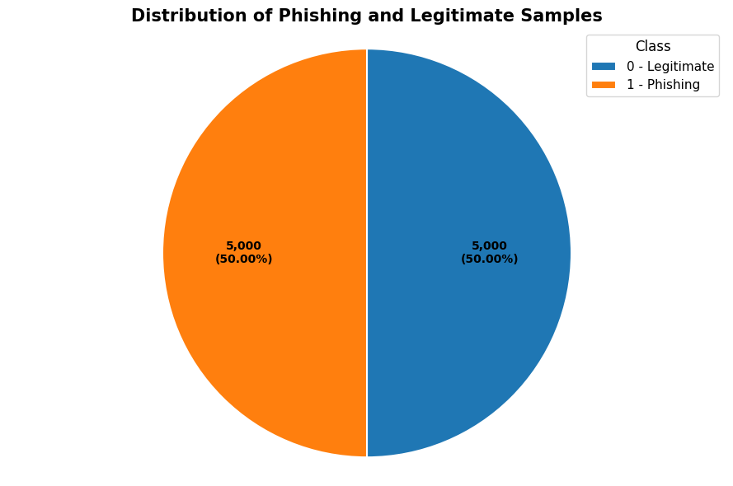

Figure 5.4.1: Legitimate versus Phishing Distribution.
The target-frequency analysis implemented resulted in exactly equal number of legitimate (5,000) and phishing (5,000) samples, or 50% in each class. This distribution is able to give a symmetry grounds for the following assessment of classification accuracy, which minimises the chance of the majority class dominating the accuracy figures in the aggregated result.

Table 5.4.1: Largest class differences in mean-comparison procedure
Feature | Difference
UrlLength | 4.9714
QueryLength | 3.9154
PathLength | 3.7434
HostnameLength | 2.7458
NumDash | 2.3124
PctExtNullSelfRedirectHyperlinksRT | 0.9706
PathLevel | 0.8550
NumDots | 0.7922
NumQueryComponents | 0.3964
FrequentDomainNameMismatch | 0.3814
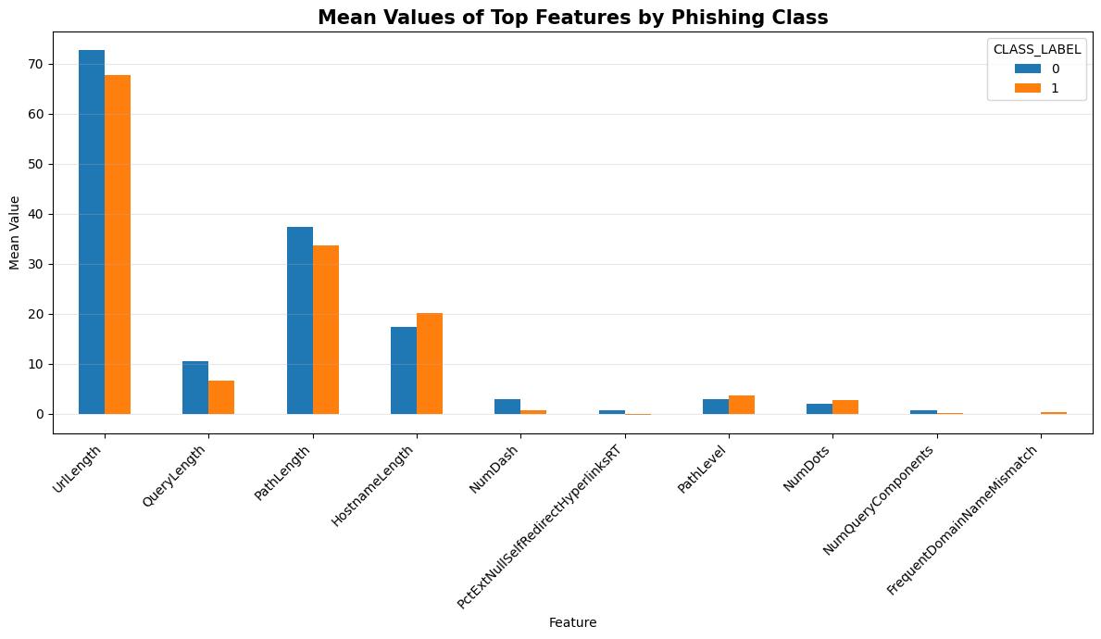

Figure 5.4.2– Top Features Based on Class Mean Difference
From Table 5.4.2 and Figure 5.4.2, it can be seen that UrlLength is the most important feature, followed by QueryLength and PathLength.
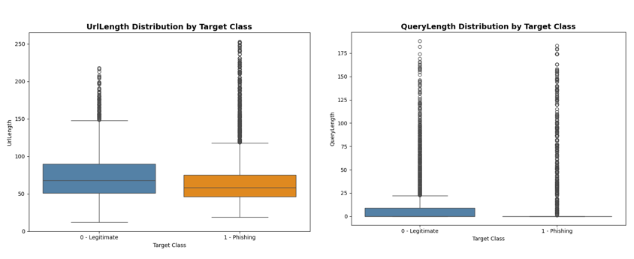
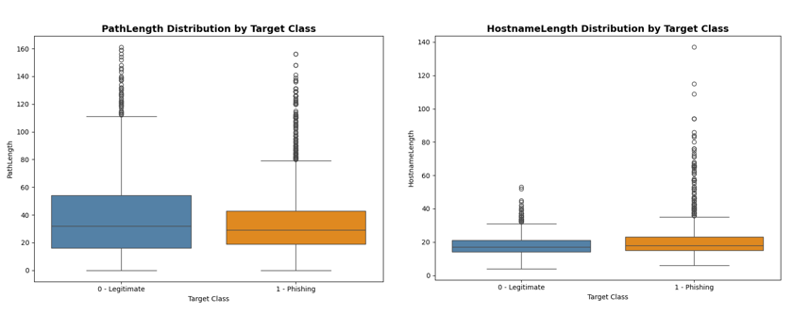
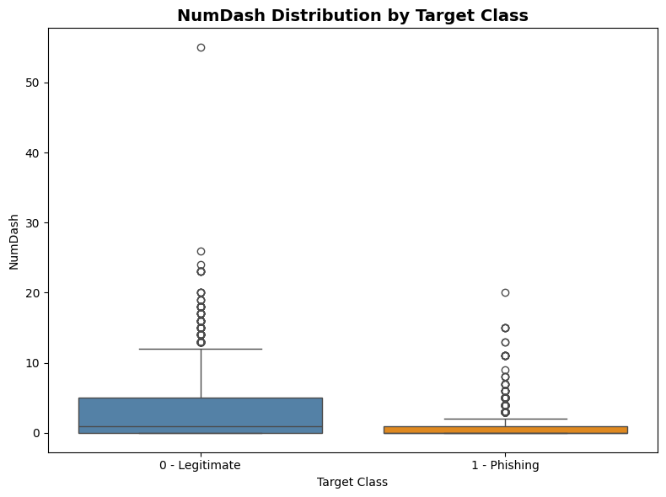

Figure 5.4.3 — Box plot feature distribution by target class
In Figures 5.4, the distributions of UrlLength, QueryLength, PathLength, HostnameLength and NumDash are shown by the five boxplots. As a group, they exhibit discernible class differences between legitimate and phishing samples, and have different intraclass variations and overlaps.
Data Anomalies Identified:
There were negative observations for each of 6 variables, ranging from 100 to 3,263. The only constant was a hostname, httpsInHostname. There were also a number of significant statistical outliers detected using the inspection of the IQR; these were not automatically removed but were diagnosed instead.

5.5 Data Pre-processing and Feature Preparation Implementation
Feature Removal:
After the structural checks were executed, the implementation removed HttpsInHostname and id. The former was constant and therefore accounted for no variation, while id was not identified as a predictive characteristic. The operation was done directly to the feature matrix without modifying the source data.
Feature and Target Preparation:
CLASS_LABEL was extracted into the target vector y, while the remaining columns in X were extracted. The modelling matrix had 49 columns in the initial predictor matrix, and after removing the two that were identified, the final matrix had 47 columns.
Train-Test Partitioning:
The training and testing partitions were generated using an 80/20 split; random_state=42 was provided to ensure that the same sequence of samples was used for both training and testing sets, and stratify=y ensured that the proportions of classes were preserved in both partitions.
Feature Scaling:
Prior to optimisation, the prepared feature matrix is tested with six classifiers to make the initial performance comparison. The models were chosen to give methodological diversity among the linear, tree, kernel, instance, and gradient-boosting types of models.
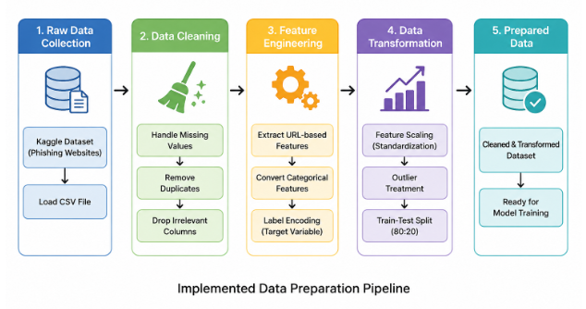

Figure 5.5: Implemented Data Preparation Pipeline
Source: Self-created by Author

5.6 Initial Machine Learning Model Implementation
Prior to optimisation, the prepared feature matrix is tested with six classifiers to make the initial performance comparison. The models were chosen to give methodological diversity among the linear, tree, kernel, instance, and gradient-boosting types of models.

Table 5.6: Implemented Machine Learning Models and Initial Configuration
Model | Initial implementation
Logistic Regression | max_iter=1000, random_state=42
Decision Tree | random_state=42
Random Forest | n_estimators=200, random_state=42, parallel execution
SVM | RBF kernel, random_state=42
KNN | n_neighbors=5
XGBoost | 200 estimators, depth 6, learning rate 0.1, subsampling 0.8
The portfolio offers additional decision-making mechanisms so that the differences in predictive performance can be evaluated prior to tuning. Logistic Regression is a linear baseline, and Decision Tree and Random Forest are evaluations of increasingly flexible tree-based learning. SVM brings the concept of nonlinear boundary modelling; KNN offers a distance-based option; XGBoost compares the performance of boosted trees. This diversity helps to make a better comparison and find candidates for later optimisation.

5.7 Initial Model Performance and Confusion Matrix Evaluation
Initial Performance Results:
These first models were tested on training and held-out test sets to get a baseline prior to optimisation. The test accuracy and F1 score values for each model are presented in Table 5.3. XGBoost had the best baseline accuracy (0.9865) and F1 (0.9865), followed closely by Random Forest (0.9850 for both accuracy and F1). XGBoost also had the highest test recall (0.9880), while Random Forest had a slightly higher test precision (0.9860).

Table 5.7: Initial Model Performance
Model | Train Accuracy | Test Accuracy | Precision | Recall | F1
Logistic Regression | 0.9443 | 0.9520 | 0.9449 | 0.9600 | 0.9524
Decision Tree | 1.0000 | 0.9655 | 0.9623 | 0.9690 | 0.9656
Random Forest | 1.0000 | 0.9850 | 0.9860 | 0.9840 | 0.9850
SVM | 0.9726 | 0.9690 | 0.9616 | 0.9770 | 0.9692
KNN | 0.9616 | 0.9615 | 0.9556 | 0.9680 | 0.9617
XGBoost | 0.9995 | 0.9865 | 0.9850 | 0.9880 | 0.9865
The high accuracy in the training set and lower accuracy in the test set suggest overfitting in Decision Tree and Random Forest models. XGBoost also has a small training-test gap, with good generalisation. On the other hand, KNN and SVM demonstrate more similar training and test behaviour. The ensemble methods perform better than the simpler classifiers, indicating that the patterns of the learned features (which are nonlinear and/or interacting) were beneficial for this dataset.
Initial Confusion Matrix Analysis:
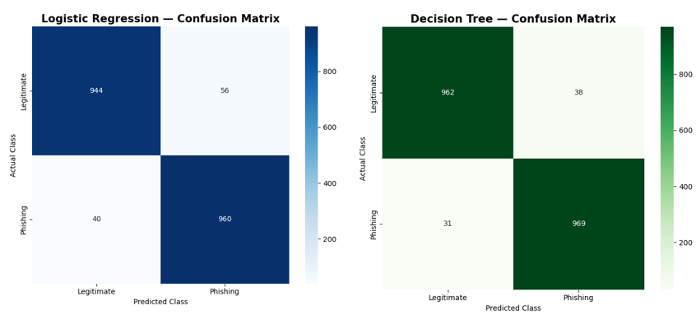
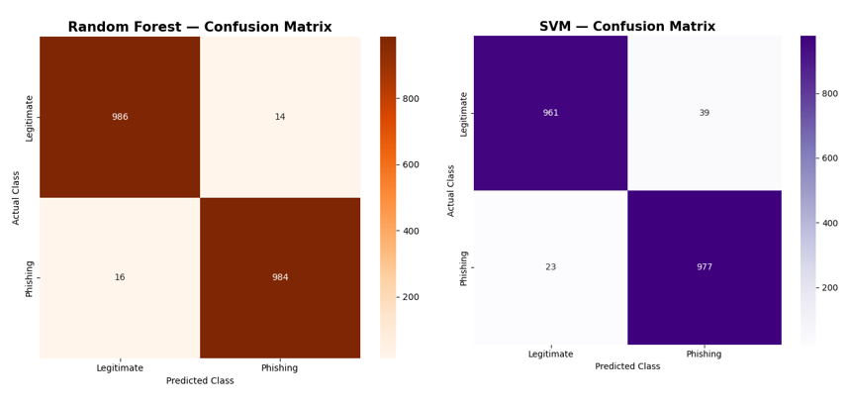
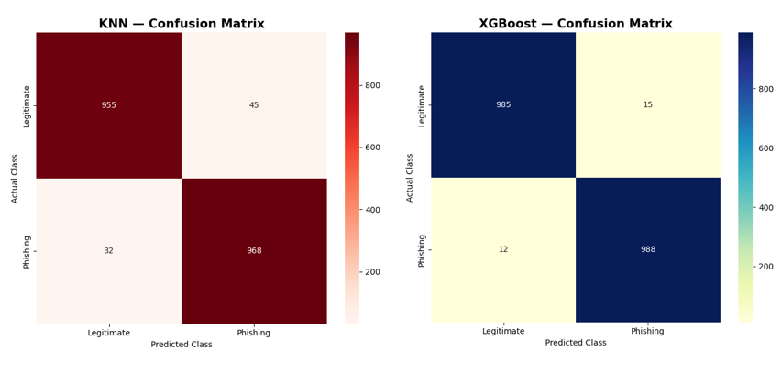

Figure 5.7: Confusion Matrix of all baseline models
The six baseline confusion matrices are shown in Figure 5.7. XGBoost showed the maximum number of TPs (988) and minimal FNs (12), which meant it had the best detection of phishing initially. Random Forest had the highest True Negatives (986) and the lowest False Positives (14). The other models had more misclassifications, with Logistic Regression having 56 false positives and 40 false negatives. However, the false negatives are the more obvious threat, as they are phishing samples that are misidentified as legitimate.

5.8 Hyperparameter Tuning Implementation
Cross-Validation Implementation:
These basic models were then cross-validated using five-fold StratifiedKFold. Random_state=42 was used to shuffle and control the folds, and stratification was used to maintain the relative class proportions between folds. This gave more stability in the selection of parameters than using a single validation partition.
GridSearchCV Implementation:
For each of the classifiers, a GridSearchCV was used, and the criterion to optimise was the F1-score. F1 was chosen for the following reason: Phishing detection must not only be accurate, but it must also be comprehensive; too many false positives means too few useful detections; too many false negatives means too many allowable phishing detections. The top estimator in every search was then kept for testing on the final test set.
Hyperparameter Search Spaces and Best Configurations:

Table 5.8: Best Hyperparameters and Cross-Validation F1
Model | Parameters | Search Values | Best Hyperparameters | CV F1
Logistic Regression | C | [0.01, 0.1, 1, 10] | C = 10 | 0.9422
Decision Tree | max_depth; min_samples_split | [None, 5, 10, 15]; [2, 5, 10] | max_depth = 10; min_samples_split = 5 | 0.9693
Random Forest | n_estimators; max_depth | [100, 200]; [None, 10, 20] | n_estimators = 100; max_depth = None | 0.9828
SVM | C; kernel | [0.1, 1, 10]; [linear, rbf] | C = 10; kernel = rbf | 0.9719
KNN | n_neighbors | [3, 5, 7, 9, 11] | n_neighbors = 3 | 0.9474
XGBoost | n_estimators; max_depth; learning_rate | [100, 200]; [3, 6]; [0.05, 0.1] | n_estimators = 200; max_depth = 6; learning_rate = 0.10 | 0.9859
The best CV result was achieved by XGBoost (0.9859), followed by Random Forest (0.9828) in the final evaluation.

5.9 Tuned Model Implementation and Final Evaluation
The resulting best_estimator_ for each classifier after using GridSearchCV was taken as the tuned classifier. This meant that the parameters used for the selected configuration were passed straight from cross-validation to the modelling step without having to re-enter them. The six estimators were then used to predict the untouched test set (as shown in the previous Table 5.8) using the scaled training data.
The search was made for Logistic Regression, and the value of C was chosen to be 10 (CV F1=0.9422). max_depth=10 and min_samples_split=5 (0.9693) were kept in the Decision Tree. Random Forest chose n_estimators=100 and an unrestricted depth of 0.9828. SVM selected C=10 with an RBF kernel (0.9719). KNN selected n_neighbors=3 (0.9474). XGBoost took 200 estimators, depth 6, and learning rate 0.10 (0.9859).
Each of the tuned models was then tested uniformly on y_test. Prior to computing accuracy, precision, recall, and F1-score, predictions were generated for each of the estimators. Where possible, probability or decision scores were also extracted to facilitate ROC-AUC calculation. These metrics became the basis for the final comparative evaluation, and predictions were also kept to perform a confusion-matrix analysis in the future.

5.10 Final Confusion Matrix and Error Analysis
Final Tuned Model Performance:
The last evaluation shows the classification performance of all the tuned models to be consistently good.

Table 5.10: Final Tuned Model Performance
Model | Accuracy | Precision | Recall | F1 | ROC-AUC
Logistic Regression | 0.9525 | 0.9449 | 0.9610 | 0.9529 | 0.9869
Decision Tree | 0.9650 | 0.9604 | 0.9700 | 0.9652 | 0.9670
Random Forest | 0.9855 | 0.9860 | 0.9850 | 0.9855 | 0.9990
SVM | 0.9730 | 0.9674 | 0.9790 | 0.9732 | 0.9964
KNN | 0.9655 | 0.9641 | 0.9670 | 0.9656 | 0.9818
XGBoost | 0.9870 | 0.9870 | 0.9870 | 0.9870 | 0.9987
XGBoost is the best overall classifier being the one with the highest accuracy, precision, recall and f1 score. The overall performance of other metrics is not that much different than XGBoost, with the slightly best performance being Random Forest with its ROC-AUC score (0.9990). Hence, the difference between the two ensembles is not an important one but an operational one.
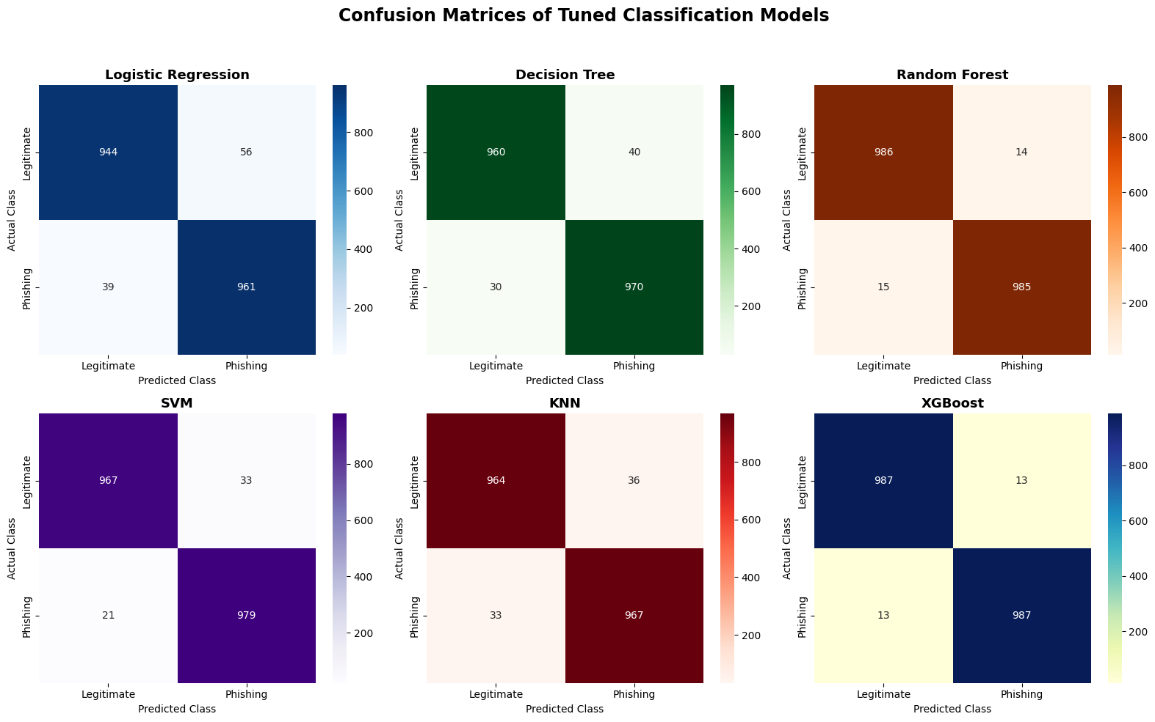

Figure 5.10 — Confusion Matrices for Final Tuned Models
Model | TP | TN | FP | FN
Logistic Regression | 961 | 944 | 56 | 39
Decision Tree | 970 | 960 | 40 | 30
Random Forest | 985 | 986 | 14 | 15
SVM | 979 | 967 | 33 | 21
KNN | 967 | 964 | 36 | 33
XGBoost | 987 | 987 | 13 | 13
Integration:
- TP (True Positive): Phishing emails that are correctly classified as phishing emails.
- TN (True Negative): Valid e-mail properly recognized as valid e-mail.
- FP (False Positive): Authentic e-mail messages misidentified as phishing.
- FN (False Negative): Phishing e-mails that were mistakenly identified as legitimate.
As shown in Fig 5.10, XGBoost has the best results in terms of TP and TN (987 each) and the worst results in terms of FP and FN (13 each). This means the most balanced classification results of the tuned models.
Security-Oriented Error Analysis:
FNs are more significant from a security point of view as phishing emails that are marked as legitimate can be delivered to users. XGBoost kept this risk at 13 cases; whereas Random Forest and Logistic Regression had 15 and 39, respectively. FP stands for “false positive” emails that are classified as spam when they are actually not, leading to user disruption. As a result, XGBoost is the best of breed for a balance of detection reliability and classification reliability—it is not simply the highest accuracy. XGBoost is the best choice for subsequent model development.

5.11 ROC-AUC Analysis and Model Discrimination
ROC curves compare the overall performance of every cclassifierin distinguishing phishing from normal traffic, and the AUC summarize the overall classification performance of each classifier.
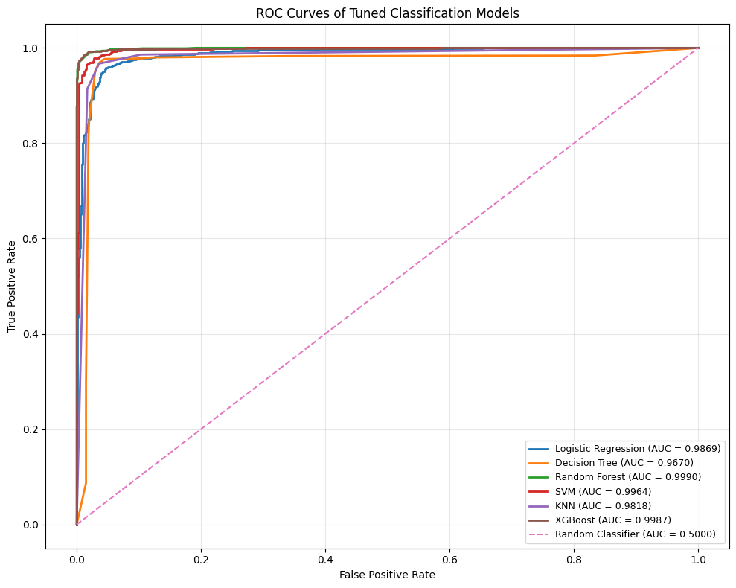

Figure 5.11 — ROC Curves for All Tuned Models
Model-by-Model ROC-AUC:
Random Forest has the highest AUC (0.9990), and XGBoost is very close at 0.9987. SVM also showed a good discrimination ability of 0.9964, whereas Logistic Regression and KNN showed 0.9869 and 0.9818, respectively. The lowest AUC value was found to be 0.9670 for Decision Tree. Continuous prediction scores were computed on the held-out test set, and the ROC-AUCs of each model were determined.
Comparative ROC-AUC Interpretation:
The AUC of 0.9990 for the Random Forest model shows very good separation between the phishing and legitimate observations at all possible thresholds. However, the difference of 0.0003 between XGBoost and logistic regression is very small and does not make much difference in the real world. It is important to note that AUC is a measure of ranking/ discrimination, while accuracy, precision, recall, and F1 are measures of classifications made at the selected decision threshold. Despite the slightly higher ranking measure, XGBoost still has the best scores on each of the four direct classification scores, making it the best overall model. However, this separation highlights the need that the choice of model should not be based exclusively on the AUC: the ideal phishing detector should not only be good at discriminating but also at making accurate final-class decisions.

5.12 Comparative Evaluation of Initial and Tuned Models
Table 5.12 shows comparison results indicating that optimization of hyperparameters affected classifiers differently and may not be responsible for the higher accuracy.

Table 5.12: Comparing Baseline and Tuned Model Performance of Models
Logistic Regression:
Metric | Initial | Tuned
Accuracy | 0.9520 | 0.9525
Precision | 0.9449 | 0.9449
Recall | 0.9600 | 0.9610
F1-Score | 0.9524 | 0.9529
ROC-AUC | — | 0.9869
Change in Accuracy | — | +0.0005

Decision Tree:
Metric | Initial | Tuned
Accuracy | 0.9850 | 0.9855
Precision | 0.9860 | 0.9860
Recall | 0.9840 | 0.9850
F1-Score | 0.9850 | 0.9855
ROC-AUC | — | 0.9990
Change in Accuracy | — | +0.0005

Random Forest:
Metric | Initial | Tuned
Accuracy | 0.9850 | 0.9855
Precision | 0.9860 | 0.9860
Recall | 0.9840 | 0.9850
F1-Score | 0.9850 | 0.9855
ROC-AUC | — | 0.9990
Change in Accuracy | — | +0.0005

SVM:
Metric | Initial | Tuned
Accuracy | 0.9690 | 0.9730
Precision | 0.9616 | 0.9674
Recall | 0.9770 | 0.9790
F1-Score | 0.9692 | 0.9732
ROC-AUC | — | 0.9964
Change in Accuracy | — | +0.0040

KNN:
Metric | Initial | Tuned
Accuracy | 0.9615 | 0.9655
Precision | 0.9556 | 0.9641
Recall | 0.9680 | 0.9670
F1-Score | 0.9617 | 0.9656
ROC-AUC | — | 0.9818
Change in Accuracy | — | +0.0040

XGBoost:
Metric | Initial | Tuned
Accuracy | 0.9865 | 0.9870
Precision | 0.9850 | 0.9870
Recall | 0.9880 | 0.9870
F1-Score | 0.9865 | 0.9870
ROC-AUC | — | 0.9987
Change in Accuracy | — | +0.0005
The largest improvements occurred for SVM and KNN, while Logistic Regression, Random Forest, and XGBoost changed only marginally. The Decision Tree had a minor reduction in its accuracy and F1. Thus, tuning the performance of each model separately does not necessarily improve its performance over all classifiers. Random Forest had the highest ROC-AUC, and XGBoost was the best overall classifier.

5.13 Implementation Challenges and Solutions
A number of implementation challenges were identified.
Data Quality and Feature Issues:
HttpsInHostname was a constant feature; there was no discriminatory variation in it so it was removed along with the identifier column. A few observations were also found to have negative values and possible outlier values determined by exploratory analysis in several of the variables. In this case, the implementation didn't drop observations without empirical justification, it was a conservative feature preparation approach that conserved the observations available.
Model Differences:
Different classifiers also had different implementation concerns: KNN is distance-based. It relies on scaled input; SVM performance also depends on kernel and regularisation parameters; tree-based classifiers needed different parameters for the structure. This was done by using model-specific preprocessing and parameter grids for these differences.
Computational and Experimental Management:
Lastly, it was important to be able to train six classifiers and perform 5-fold grid search experiments while maintaining the consistency of experimental management. Random states and systematic recording of results and organised output directories made controlled experimentation possible and reduced inconsistencies in the comparison of model evaluation results.

5.14 Reproducibility, Model Persistence and Experimental Outputs
Reproducibility:
It was sustained with constant experimental conditions. The train-test split, cross-validation, and classifiers used were obtained with a random_state = 42, and hyperparameter optimization was done maintaining class percentages with stratified five-fold cross-validation. The procedure of the experiments was also well documented by using explicit parameter grids and recorded evaluation metrics.
Model Persistence:
The six trained estimators were saved as .pkl files, which enabled the trained artefacts to be kept outside of the execution environment.
Results Management:
The results were systematically presented in the form of generated confusion-matrix figures, ROC curves, exploratory visualisations, and the final_comparative_model_performance.csv output. It provides evidence from the development of a model to final evaluation, which is traceable.
Reuse of the Artefact:
The persisted models and corresponding results are therefore not just created as a one-off, but are reusable machine-learning artefacts that can be reused for further testing, comparison or incorporation into a future phishing-detection application.

5.15 Chapter Summary
Chapter 5 provided the complete implementation and experimental evaluation cycle, which comprised dataset inspection and exploratory data analysis, data preprocessing, initial training of the model, obtaining the baseline measurement, tuning of the hyperparameters, and the final testing of the model. The evaluation of classification errors and the discriminating abilities of the model was undertaken in addition to the use of comparison matrices and ROC-AUC analysis results. The comparison results proved that the tuning does not guarantee universally positive results. XGBoost showed the best effectiveness in terms of accuracy, precision, recall, and F1. Random Forest was reported to have achieved the highest ROC-AUC score.

Chapter 6: Conclusion and Recommendation

6.1 Chapter Introduction
This chapter summarizes the project by synthesizing the key findings of the research, design, implementation and evaluation. It determine whether the research aim and objectives have been met and directly address the research questions. The chapter also determines the primary contribution of the project, project limitations, recommendations and potential directions of future research.

6.2 Overall Project Conclusion
This project examined phishing as a cybersecurity issue and tested machine-learning classification as a cybersecurity approach to differentiate between phishing and non-phishing. On the publicly available phishing data, six classifiers, namely Logistic Regression, Decision Tree, Random Forest, Support Vector Machine (SVM), K-Nearest Neighbours (KNN) and XGBoost were run to form part of an experimental pipeline. The steps followed data preparation steps and baseline evaluation, then proceeded to hyperparameter tuning and final testing so that it could be compared. Such a method demonstrates the significance of comparative assessment in phishing detection studies (Mosa et al., 2023). Overall, XGBoost achieved the highest Accuracy, Precision, Recall, and F1-score, whereas Random Forest achieved the highest ROC-AUC.

6.3 Achievement of Research Aim
The objective of the research was fulfilled by developing and evaluating a machine-learning model to detect phishing attacks over publicly available phishing data. There were six classifiers that were implemented and tested in the project which include: Logistic Regression, Decision Tree, Random Forest, SVM, KNN and XGBoost. The models have been trained, tested and optimised using hyperparameters through a systematic process, then compared by the use of various performance measures. The ultimate findings determined that XGBoost was the best overall classifier with the highest Accuracy, Precision, Recall and F1-score. Consequently, the project has achieved its objective which is creating and testing a comparative machine learning model to classify phishing and has not purported itself as giving entire and production-level protection against phishing attacks.

6.4 Achievement of Research Objectives
Objective 1 — Literature and Methodological Examination
Achieved. The project critically analyzed phishing detection techniques, the machine-learning algorithms applicable, types of features and evaluation techniques. Past studies indicate that the key factors that affect detection performance include features, datasets, and experimental procedures (Aljofey et al., 2022; Mosa et al., 2023).
Objective 2 — Experimental Comparison of Six Classifiers
Achieved. Implementation and comparison of several classifiers were done with the same dataset and under manipulated experimental circumstances to support a fair comparison of their classification capabilities: Logistic Regression, Decision Tree, Random Forest, SVM, KNN and XGBoost were employed.
Objective 3 — Comparative Validation
Achieved. Accuracy, Precision, Recall, F1-score, confusion matrices and ROC-AUC were the models that were used to validate them. Comparative results (baseline and tuned) were also made, which proved the relative efficacy and reliability (Sujon et al., 2025).

6.5 Answers to Research Questions
RQ1: Common ML Methods and Features
The analysis revealed that phishing is detected by using URL, domain, and webpage-related features. Available features of URLs include length, dots, dashes and query parts whereas domain and webpage features offer more information. Past studies indicate that feature types when combined can enhance detection, even though datasets vary on performance (Aljofey et al., 2022; Aljabri et al., 2022). The models are also dissimilar, the simplest types of models are linear models, linear non-line patterns are nonlinear models like tree and ensemble models, margin-based model is SVM, similarity model is KNN, and combining learners is boosting.
RQ2: Identification of Phishing and Legitimate Samples
The experiment reveals that labeled data can be used to train models to differentiate phishing and valid samples. CLASS_LABEL was used to label the two classes and preprocessing was used to prepare the predictors. Cross-validation was used to train, test and tune the six classifiers which were then evaluated using various measures. The findings show good classification on the chosen dataset, but cannot be extrapolated to novel phishing campaigns since dataset properties modulate performance (Mosa et al., 2023).
RQ3: Most Effective Algorithm
XGBoost performed best based on the four measures that are mentioned, having an Accuracy, Precision, Recall and F1-score of 0.9870. Random Forest had the largest ROC-AUC of 0.9990, over XGBoost which had 0.9987. Accordingly, XGBoost performed the best overall, whereas, the Random Forest was somewhat more discriminative.

6.6 Overall Findings and Contribution
The project provided a full and reproducible phishing-classification pipeline, transitioning to systematic tuning and final evaluation. The findings indicate empirically that ensemble algorithms showed excellent performance especially on the chosen dataset, with XGBoost returning the best overall classification performance and Random Forest returning the highest ROC-AUC. The results prove the usefulness of comparing the various learning approaches instead of using a single model (Abbas et al., 2024). Future phishing screening, website security and cybersecurity monitoring applications may be supported by the models implemented and saved results. The results, however, must be viewed within the context of the chosen set of data and controlled environment.

6.7 Limitations and Unresolved Issues
The results have a number of limitations. To start with, the findings are limited to the chosen public dataset and are unlikely to be reflective of all real-world phishing conditions. Phishing is constantly evolving, and this can mean that the data become outdated. The performance of the model is also determined by the presence of URL, domain and content features (Kustiawan and Ghauth, 2025). The experimental controlled environment might not be a true representation of live email or web-security systems. Lastly, a single algorithm cannot be expected to be the best in all datasets, which restricts the generalisation of the results.

6.8 Recommendations
Depending on the results, a number of recommendations are put forward. In the first instance, future research needs to test the models on bigger and more varied phishing datasets to see whether the measured performance can be observed to be consistent among various data sources or not. This is significant since the properties of a dataset can have a potent impact on detection (Aljabri et al., 2022). Second, the models need to be retrained and re-tested since phishing techniques and URL patterns constantly evolve (Kustiawan and Ghauth, 2025). Third, future considerations must use several measures of performance, such as precision, recall, F1-score and ROC-AUC, instead of using only accuracy (Sujon et al., 2025). Fourth, explainable machine learning ought to be explored to assist security analysts in interpreting model decisions. Lastly, XGBoost and random forest must undergo experimental processes in the real-life setting of an operation, like screening websites or emails, before they can be actually employed. The steps would enhance the stability and usefulness of future phishing-detection mechanisms.

6.9 Suggestions for Further Work
To test the models, future work ought to apply them to larger and more varied data sets gathered over different periods and sources to test their generalisation. Since phishing techniques continually change, regular model retraining should also be investigated (Kustiawan and Ghauth, 2025). Future studies may also look at real-time detection of phishing, where trained models are used to categorize detected URLs. Explainable AI might also be considered to offer the analysts of security with explanations of the model predictions. Furthermore, the persisted models might be transformed into a working prototype for deployment and assessed in real-world cybersecurity settings. Lastly, further machine-learning techniques might be contrasted with the six models applied in this work to find out whether it is possible to achieve similar performance in various datasets and conditions (Aljabri et al., 2022).

6.10 Final Chapter Conclusion
In general, the project has been successful in fulfilling its stated purpose in that it implemented and tested phishing detection machine-learning classifiers on six machines. XGBoost had the best overall classification performance and random forest had the highest ROC-AUC value. These results indicate that ensemble-based methods hold a promising future for classifying phishing and offer a considerable foundation toward exploring additional studies by means of larger datasets and within more realistic deployments.

Chapter 7: Reflection
This chapter reflects on my experience of completing the project using Gibbs’ Reflective Cycle. According to the model, six stages are taken into consideration: description, feelings, evaluation, analysis, conclusion and action plan (Gibbs, 1988). The reflection is concerned with the way I dealt with the project and the challenges I encountered, what I have learned about my working style, and how I might ameliorate my future work performance.

Description
This project implied the creation and testing of a machine-learning phishing detection system. I went through a number of steps, such as analysis of the dataset, preprocessing, application of six machine-learning models, baseline, hyperparameter optimization and refinements. I also tabulated the results of the experiment, such as performance tabulars, confusion matrices and ROC-AUC tabulars. The project involved the technical implementation as well as the academic writing and therefore I needed to do the two concurrently.

Feelings
At the outset, I was quite assured of the overall project concept but less assured when considering the whole of the machine-learning experiment. The more the implementation proceeded, the more comfortable I felt with the process. Yet, it was difficult to compare a few models and control their various parameters. Another thing that I discovered was that it took more concentration to write up the results critically rather than just give a numerical score. The successful completion of the experimental stages provided me with increased confidence that I can work on my own.

Evaluation
The good aspect of the project was that I came up with an entire experimental process as opposed to simply testing a single model. Viewing the comparison of baseline and tuned models assisted me to know what systematic evaluation is significant. A number of metrics also gave a more accurate perspective of the model performance.
There are areas though which should have been better managed. Organisation was important because there were a lot of projects and production in the project. I also might have thought about writing ahead as opposed to focusing on implementation initially. This would have given me time to review and make some improvements to the final work.
Analysis
The project has demonstrated that an effective technical project relies on both planning and coding. I learned that a modification of a model or parameter must have a clear rationale and a measurement with the help of suitable assessment. The tuning process also enabled me to realise that not all metrics of all the models are necessarily improved by optimisation. This assisted me in becoming more critical when dealing with the results of the experiment.
The second type of skills that I enhanced is my study skills since I was able to subdivide a massive project into smaller parts. The entire process was simplified by going through the dataset, models, evaluation, and writing independently. I discovered that it is essential to maintain the results of experiments in order to make the subsequent analysis and writing of the results precise.

Conclusion
On the whole, the project helped me to better plan, implement and evaluate a technical system. I also knew that I could work better when I see the tasks having definite patterns with clear outcomes. I also learnt to be more conscious that good academic work involves critical interpretation and not just a successful production.

Action Plan
In a future project, I would start with a more detailed schedule with research, implementation, testing and writing at the outset. I would document crucial choices and outcomes during development, instead of cataloging and arranging at the final point. I would as well give myself more time to review the work and work out whether all the conclusions are directly connected to the evidence on the experiments. These modifications would assist me in working effectively and deliver a more definitive and solid final project.

References
Abbas, F., Cai, Z., Shoaib, M., Iqbal, J., Ismail, M., Ullah, A.R.I.F., Alrefaei, A.F. and Albeshr, M.F., 2024. Uncertainty Analysis of Predictive Models for Water Quality Index: Comparative Analysis of XGBoost, Random Forest, SVM, KNN, Gradient Boosting, and Decision Tree Algorithms. Available at https://www.preprints.org/frontend/manuscript/f5976d2d7c1594c8e467fbda99ed34ff/download_pub
Abbas, F., Cai, Z., Shoaib, M., Iqbal, J., Ismail, M., Ullah, A.R.I.F., Alrefaei, A.F. and Albeshr, M.F., 2024. Uncertainty Analysis of Predictive Models for Water Quality Index: Comparative Analysis of XGBoost, Random Forest, SVM, KNN, Gradient Boosting, and Decision Tree Algorithms. Available at https://www.preprints.org/frontend/manuscript/f5976d2d7c1594c8e467fbda99ed34ff/download_pub
Adu-Manu, K.S., Ahiable, R.K., Appati, J.K. and Mensah, E.E., 2022. Phishing attacks in social engineering: a review. system, 12, p.18. Available at https://www.researchgate.net/profile/Richard-Ahiable/publication/372852282_Phishing_Attacks_in_Social_Engineering_A_Review/links/64ca65e5806a9e4e5cdfebcc/Phishing-Attacks-in-Social-Engineering-A-Review.pdf
Ahmad, S., Haque, M.A., Abdeljaber, H.A.M., Bokhari, M.U., Nazeer, J. and Mishra, B.K. (2024) ‘Phishing website detection: A dataset-centric approach for enhanced security’, Data and Metadata, 3, p. 223. Available at: https://doi.org/10.56294/dm2024.223
Ali, I.M., 2024. A guide for positivist research paradigm: From philosophy to methodology. Idealogy Journal, 9(2). Available at https://idealogyjournal.com/ojs/index.php/idealogy/article/view/596
Aljabri, M., Altamimi, H.S., Albelali, S.A., Al-Harbi, M., Alhuraib, H.T., Alotaibi, N.K., Alahmadi, A.A., Alhaidari, F., Mohammad, R.M.A. and Salah, K., 2022. Detecting malicious URLs using machine learning techniques: review and research directions. IEEE Access, 10, pp.121395-121417. Available at https://ieeexplore.ieee.org/abstract/document/9950508/
Aljofey, A., Jiang, Q., Rasool, A., Chen, H., Liu, W., Qu, Q. and Wang, Y., 2022. An effective detection approach for phishing websites using URL and HTML features. Scientific Reports, 12(1), p.8842. Available at https://www.nature.com/articles/s41598-022-10841-5
Almomani, A., Alauthman, M., Shatnawi, M.T., Alweshah, M., Alrosan, A., Alomoush, W. and Gupta, B.B., 2022. Phishing website detection with semantic features based on machine learning classifiers: a comparative study. International Journal on Semantic Web and Information Systems (IJSWIS), 18(1), pp.1-24. Available at https://www.igi-global.com/article/phishing-website-detection-with-semantic-features-based-on-machine-learning-classifiers/297032
Amin, A.A.H., Aladdin, A.M., Hasan, D.O., Mohammed-Taha, S.R. and Rashid, T.A., 2023. Enhancing algorithm selection through comprehensive performance evaluation: Statistical analysis of stochastic algorithms. Computation, 11(11), p.231. Available at https://www.mdpi.com/2079-3197/11/11/231
Atlam, H.F. and Oluwatimilehin, O., 2022. Business email compromise phishing detection based on machine learning: A systematic literature review. Electronics, 12(1), p.42. Available at https://www.mdpi.com/2079-9292/12/1/42
Bischl, B., Binder, M., Lang, M., Pielok, T., Richter, J., Coors, S., Thomas, J., Ullmann, T., Becker, M., Boulesteix, A.-L., Deng, D. and Lindauer, M. (2023) ‘Hyperparameter optimization: Foundations, algorithms, best practices, and open challenges’, Wiley Interdisciplinary Reviews: Data Mining and Knowledge Discovery, 13(2), e1484. Available at: https://doi.org/10.1002/widm.1484
Bu, S.J. and Kim, H.J., 2022. Optimized URL feature selection based on genetic-algorithm-embedded deep learning for phishing website detection. Electronics, 11(7), p.1090. Available at https://www.mdpi.com/2079-9292/11/7/1090
Carroll, F., Adejobi, J.A. and Montasari, R., 2022. How good are we at detecting a phishing attack? Investigating the evolving phishing attack email and why it continues to successfully deceive society. SN Computer science, 3(2), p.170. Available at https://link.springer.com/article/10.1007/s42979-022-01069-1
Carvalho, S., Carvalho, J.V., Silva, J.C., Santos, G. and Bandeira, G.S., 2023. Concerns about Cybersecurity: The Implications of the use of ICT for Citizens and Companies. Available at https://comum.rcaap.pt/entities/publication/d2d58394-6fa4-43bf-821f-64c1c227125a
Catal, C., Giray, G., Tekinerdogan, B., Kumar, S. and Shukla, S., 2022. Applications of deep learning for phishing detection: a systematic literature review: Catal et al. Knowledge and information systems, 64(6), pp.1457-1500. Available at https://link.springer.com/article/10.1007/s10115-022-01672-x
Cheong, H.I., Lyons, A., Houghton, R. and Majumdar, A., 2023. Secondary qualitative research methodology using online data within the context of social sciences. International Journal of Qualitative Methods, 22, p.16094069231180160. Available at https://journals.sagepub.com/doi/abs/10.1177/16094069231180160
Choudhary, T., Mhapankar, S., Bhddha, R., Kharuk, A. and Patil, R. (2023) ‘A machine learning approach for phishing attack detection’, Journal of Artificial Intelligence and Technology, 3(3), pp. 108–113. Available at: https://doi.org/10.37965/jait.2023.0197
Darwish, S.M., Farhan, D.A. and Elzoghabi, A.A., 2023. Building an effective classifier for phishing web pages detection: a quantum-inspired biomimetic paradigm suitable for big data analytics of cyber attacks. Biomimetics, 8(2), p.197. Available at https://www.mdpi.com/2313-7673/8/2/197
Do, N.Q., Selamat, A., Krejcar, O., Herrera-Viedma, E. and Fujita, H., 2022. Deep learning for phishing detection: Taxonomy, current challenges and future directions. Ieee Access, 10, pp.36429-36463. Available at https://ieeexplore.ieee.org/abstract/document/9716113/
Fife, S.T. and Gossner, J.D., 2024. Deductive qualitative analysis: Evaluating, expanding, and refining theory. International journal of qualitative methods, 23, p.16094069241244856. Available at https://journals.sagepub.com/doi/abs/10.1177/16094069241244856
Gibbs, G. (1988) Learning by Doing: A Guide to Teaching and Learning Methods. Oxford: Further Education Unit, Oxford Polytechnic.
Hannousse, A. and Yahiouche, S. (2021) ‘Towards benchmark datasets for machine learning based website phishing detection: An experimental study’, Engineering Applications of Artificial Intelligence, 104, 104347. Available at: https://doi.org/10.1016/j.engappai.2021.104347
Heil, B.J., Hoffman, M.M., Markowetz, F. et al. (2021) ‘Reproducibility standards for machine learning in the life sciences’, Nature Methods, 18, pp. 1132–1135. Available at: https://doi.org/10.1038/s41592-021-01256-7
Kapan, S. and Gunal, E.S. (2023) ‘Improved phishing attack detection with machine learning: A comprehensive evaluation of classifiers and features’, Applied Sciences, 13(24), 13269. Available at: https://doi.org/10.3390/app132413269
Kapoor, S. and Narayanan, A. (2023) ‘Leakage and the reproducibility crisis in machine-learning-based science’, Patterns, 4(9), 100804. Available at: https://doi.org/10.1016/j.patter.2023.100804
Kheni, N.H., 2025. Comparative Analysis of Linear and Logistic Regression Models (Doctoral dissertation, California State University, Northridge). Available at https://scholarworks.calstate.edu/downloads/h702qg721
Kurniawan, M.F. and Megawaty, D.A., 2025. Comparison of Logistic Regression, Random Forest, Support Vector Machine (SVM) and K-Nearest Neighbor (KNN) Algorithms in Diabetes Prediction. Journal of Applied Informatics and Computing, 9(5), pp.2154-2162. Available at https://jurnal.polibatam.ac.id/index.php/JAIC/article/view/9815
Kurniawan, M.F. and Megawaty, D.A., 2025. Comparison of Logistic Regression, Random Forest, Support Vector Machine (SVM) and K-Nearest Neighbor (KNN) Algorithms in Diabetes Prediction. Journal of Applied Informatics and Computing, 9(5), pp.2154-2162. Available at https://jurnal.polibatam.ac.id/index.php/JAIC/article/view/9815
Kustiawan, Y.A. and Ghauth, K.I., 2025. Evaluating the impact of feature engineering in phishing URL detection: A comparative study of URL, HTML, and derived features. IEEE Access, 13, pp.126756-126768. Available at https://ieeexplore.ieee.org/abstract/document/11031414/
Liu, Y., 2022. Paradigmatic compatibility matters: A critical review of qualitative-quantitative debate in mixed methods research. Sage Open, 12(1), p.21582440221079922. Available at https://journals.sagepub.com/doi/abs/10.1177/21582440221079922
Miah, M.R. and Islam, M.M., 2024. Data Preprocessing and Feature Engineering Strategies for Large-Scale Predictive Modeling Applications. Review of Applied Science and Technology, 3(01), pp.263-302. Available at https://rast-journal.org/index.php/RAST/article/view/104
Mosa, D.T., Shams, M.Y., Abohany, A.A., El-kenawy, E.S.M. and Thabet, M., 2023. Machine learning techniques for detecting phishing URL attacks. Computers, Materials & Continua, 75(1), pp.1271-1290. Available at https://www.sciopen.com/article/10.32604/cmc.2023.036422
Mosa, D.T., Shams, M.Y., Abohany, A.A., El-kenawy, E.S.M. and Thabet, M., 2023. Machine learning techniques for detecting phishing URL attacks. Computers, Materials & Continua, 75(1), pp.1271-1290. Available at https://www.sciopen.com/article/10.32604/cmc.2023.036422
Moscovich, A. and Rosset, S. (2022) ‘On the cross-validation bias due to unsupervised preprocessing’, Journal of the Royal Statistical Society: Series B (Statistical Methodology), 84(4), pp. 1474–1502. Available at: https://doi.org/10.1111/rssb.12537
Pineau, J., Vincent-Lamarre, P., Sinha, K., Lariviere, V., Beygelzimer, A., d’Alche-Buc, F., Fox, E. and Larochelle, H. (2021) ‘Improving reproducibility in machine learning research (a report from the NeurIPS 2019 reproducibility program)’, Journal of Machine Learning Research, 22(164), pp. 1–20. Available at: https://jmlr2020.csail.mit.edu/papers/v22/20-303.html
Putri, A.I., Husna, N.A., Cia, N.M., Arba, M.A., Aisyi, N.R., Pramesthi, C.H. and Irdayusman, A.S., 2024. Implementation of K-Nearest Neighbors, Naïve Bayes Classifier, support vector machine and decision tree algorithms for obesity risk prediction. Public Research Journal of Engineering, Data Technology and Computer Science, 2(1), pp.26-33. Available at https://www.journal.irpi.or.id/index.php/predatecs/article/view/1110
Rane, N.L., Paramesha, M., Choudhary, S.P. and Rane, J., 2024. Machine learning and deep learning for big data analytics: A review of methods and applications. Partners Universal International Innovation Journal, 2(3), pp.172-197. Available at http://www.puiij.com/index.php/research/article/view/144
Rehman, A. and Belhaouari, S.B. (2021) ‘Unsupervised outlier detection in multidimensional data’, Journal of Big Data, 8, 80. Available at: https://doi.org/10.1186/s40537-021-00469-z
Riehl, K., Neunteufel, M. and Hemberg, M., 2023. Hierarchical confusion matrix for classification performance evaluation. Journal of the Royal Statistical Society Series C: Applied Statistics, 72(5), pp.1394-1412. Available at https://academic.oup.com/jrsssc/article-abstract/72/5/1394/7217007
Sánchez-Paniagua, M., Fernández, E.F., Alegre, E., Al-Nabki, W. and González-Castro, V., 2022. Phishing URL detection: A real-case scenario through login URLs. IEEe Access, 10, pp.42949-42960. Available at https://ieeexplore.ieee.org/abstract/document/9759382/
Sánchez-Paniagua, M., Fidalgo, E., Alegre, E. and Alaiz-Rodríguez, R., 2022. Phishing websites detection using a novel multipurpose dataset and web technologies features. Expert Systems with Applications, 207, p.118010. Available at https://www.sciencedirect.com/science/article/pii/S0957417422012301
Saunders, M.N.K., Lewis, P. and Thornhill, A. (2023) Research Methods for Business Students. 9th edn. Harlow: Pearson.
Sharifi, S., Reuel, N., Kallmyer, N., Sun, E., Landry, M.P. and Mahmoudi, M., 2023. The issue of reliability and repeatability of analytical measurement in industrial and academic nanomedicine. ACS nano, 17(1), pp.4-11. Available at https://pubs.acs.org/ancac3/article-abstract/17/1/4/485389
Shrivastava, T., Bhatt, S., Roy, N.R. and Bhasney, A., 2022, December. Phishing url detection using machine learning: A survey. In 2022 4th International Conference on Advances in Computing, Communication Control and Networking (ICAC3N) (pp. 1992-1997). IEEE. Available at https://ieeexplore.ieee.org/abstract/document/10074337/
Shu, X. and Ye, Y., 2023. Knowledge Discovery: Methods from data mining and machine learning. Social Science Research, 110, p.102817. Available at https://www.sciencedirect.com/science/article/pii/S0049089X22001284
Sujon, K.M., Hassan, R., Choi, K. and Samad, M.A., 2025. Accuracy, precision, recall, f1-score, or MCC? empirical evidence from advanced statistics, ML, and XAI for evaluating business predictive models. Journal of Big Data, 12(1), p.268. Available at https://link.springer.com/article/10.1186/s40537-025-01313-4
Sujon, K.M., Hassan, R., Choi, K. and Samad, M.A., 2025. Accuracy, precision, recall, f1-score, or MCC? empirical evidence from advanced statistics, ML, and XAI for evaluating business predictive models. Journal of Big Data, 12(1), p.268. Available at https://link.springer.com/article/10.1186/s40537-025-01313-4
Sujon, K.M., Hassan, R., Choi, K. and Samad, M.A., 2025. Accuracy, precision, recall, f1-score, or MCC? empirical evidence from advanced statistics, ML, and XAI for evaluating business predictive models. Journal of Big Data, 12(1), p.268. Available at https://link.springer.com/article/10.1186/s40537-025-01313-4
Tang, L. and Mahmoud, Q.H. (2021) ‘A survey of machine learning-based solutions for phishing website detection’, Machine Learning and Knowledge Extraction, 3(3), pp. 672–694. Available at: https://doi.org/10.3390/make3030034
Tanti, R., 2024. Study of phishing attack and their prevention techniques. International Journal of Scientific Research in Engineering and Management, 8(10), pp.1-8. Available at https://www.researchgate.net/profile/Rajesh-Tanti/publication/385083853_Study_of_Phishing_Attack_and_their_Prevention_Techniques/links/6740533f868c966b9321bd05/Study-of-Phishing-Attack-and-their-Prevention-Techniques.pdf
Theng, D. and Bhoyar, K.K., 2024. Feature selection techniques for machine learning: a survey of more than two decades of research. Knowledge and Information Systems, 66(3), pp.1575-1637. Available at https://link.springer.com/article/10.1007/s10115-023-02010-5
Valkenborg, D., Rousseau, A.J., Geubbelmans, M. and Burzykowski, T., 2023. Support vector machines. American journal of orthodontics and dentofacial orthopedics, 164(5), pp.754-757. Available at https://www.ajodo.org/article/S0889-5406(23)00429-8/abstract

Appendices

Appendix A — Baseline Model Training and Evaluation Code
“
# Baseline Model Training and Evaluation

from sklearn.linear_model import LogisticRegression
from sklearn.tree import DecisionTreeClassifier
from sklearn.ensemble import RandomForestClassifier
from sklearn.svm import SVC
from sklearn.neighbors import KNeighborsClassifier
from xgboost import XGBClassifier

from sklearn.metrics import (
accuracy_score,
precision_score,
recall_score,
f1_score
)

# Define baseline models
models = {
"Logistic Regression": LogisticRegression(
max_iter=1000, random_state=42
),

"Decision Tree": DecisionTreeClassifier(
random_state=42
),

"Random Forest": RandomForestClassifier(
n_estimators=200,
random_state=42,
n_jobs=-1
),

"SVM": SVC(
kernel="rbf",
random_state=42
),

"KNN": KNeighborsClassifier(
n_neighbors=5
),

"XGBoost": XGBClassifier(
n_estimators=200,
max_depth=6,
learning_rate=0.1,
subsample=0.8,
colsample_bytree=0.8,
objective="binary:logistic",
eval_metric="logloss",
random_state=42,
n_jobs=-1
)
}

# Train and evaluate all baseline models
baseline_results = []

for model_name, model in models.items():

model.fit(X_train_scaled, y_train)

y_pred = model.predict(X_test_scaled)

baseline_results.append({
"Model": model_name,
"Accuracy": accuracy_score(y_test, y_pred),
"Precision": precision_score(
y_test, y_pred, zero_division=0
),
"Recall": recall_score(
y_test, y_pred, zero_division=0
),
"F1-score": f1_score(
y_test, y_pred, zero_division=0
)
})

baseline_results_df = pd.DataFrame(baseline_results)

display(baseline_results_df.round(4))
”

Appendix B — Hyperparameter Tuning and 5-Fold Cross-Validation
“
# Hyperparameter Tuning using 5-Fold
# Stratified Cross-Validation

from sklearn.model_selection import GridSearchCV, StratifiedKFold

# 5-fold stratified cross-validation
cv_strategy = StratifiedKFold(
n_splits=5,
shuffle=True,
random_state=42
)

# Models and parameter grids
tuning_config = {

"Logistic Regression": (
LogisticRegression(
max_iter=1000,
random_state=42
),
{"C": [0.01, 0.1, 1, 10]}
),

"Decision Tree": (
DecisionTreeClassifier(
random_state=42
),
{
"max_depth": [None, 5, 10, 15],
"min_samples_split": [2, 5, 10]
}
),

"Random Forest": (
RandomForestClassifier(
random_state=42,
n_jobs=-1
),
{
"n_estimators": [100, 200],
"max_depth": [None, 10, 20]
}
),

"SVM": (
SVC(random_state=42),
{
"C": [0.1, 1, 10],
"kernel": ["linear", "rbf"]
}
),

"KNN": (
KNeighborsClassifier(),
{
"n_neighbors": [3, 5, 7, 9, 11]
}
),

"XGBoost": (
XGBClassifier(
objective="binary:logistic",
eval_metric="logloss",
random_state=42,
n_jobs=-1
),
{
"n_estimators": [100, 200],
"max_depth": [3, 6],
"learning_rate": [0.05, 0.1]
}
)
}

# Perform Grid Search for all models
best_models = {}

for model_name, (model, param_grid) in tuning_config.items():

grid_search = GridSearchCV(
estimator=model,
param_grid=param_grid,
cv=cv_strategy,
scoring="f1",
n_jobs=-1,
return_train_score=True
)

grid_search.fit(X_train_scaled, y_train)

best_models[model_name] = grid_search.best_estimator_

print(f"\n{model_name}")
print("Best Parameters:", grid_search.best_params_)
print(f"Best CV F1-score: {grid_search.best_score_:.4f}")
”

