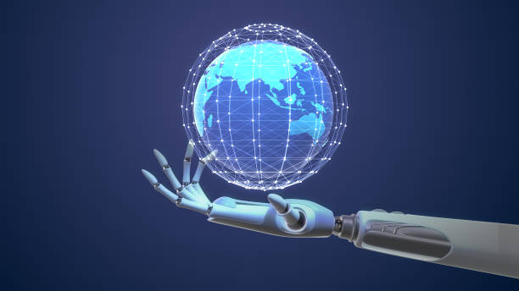
(Welsh Government, 2016)

The Rise of the Machines

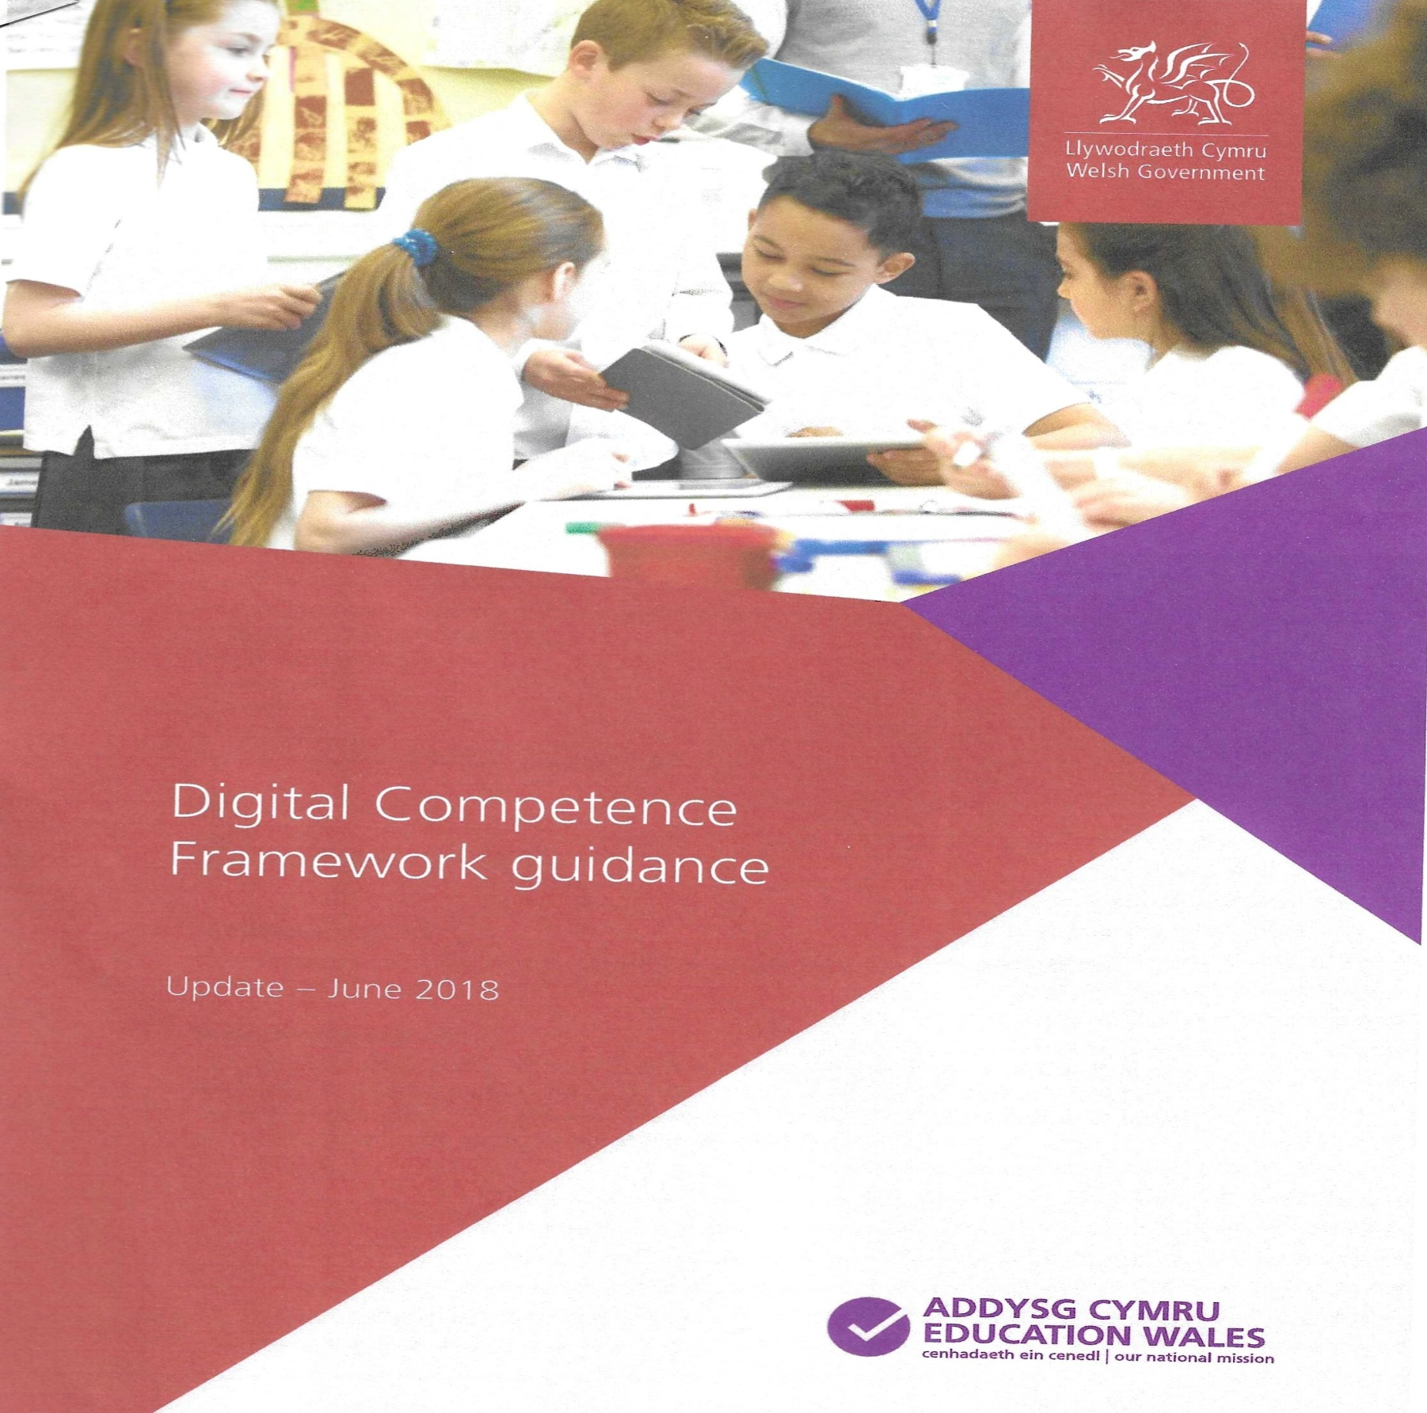
Wojcicki (2023)

The old expression states that “Time flies” and when you are young, you cant help but think that this expression is absolute NONSENSE and to some extent, you are right, but to a young (ish) man like myself, the rise and evolution of technology has happened so quickly that it feels like time truly does fly. I remember when I was in primary school, there was ONE computer for the entire student body to use! Even that was just for games and occasional typing and that was it. Today however, machines (by that I mean laptops, mobile phones and tablets, not cyborgs…not yet) have truly taken over our society, so much so that governments around the world have HAD to incorporate digital competency and ICT into their curriculums. Yes, ICT has been taught for over 20 years, but ‘digital competency’ is a whole different ball game. It is becoming more and more essential for students to learn how to use new technologies competently and efficiently. They simply have to, because that is the way the world is heading, totally digital.
In this paper, I am going to explore the Welsh Governments ‘Digital Competency Framework’ (DCF) which was released in 2016 (updated in 2018) and pick out two of the areas, or ‘strands’ and have a look about how they are being incorporated in schools, because even in our little country of Wales, the machines have risen and they are here to stay. (Welsh Government, 2016)


Figure 1 (a red robotic dragon)

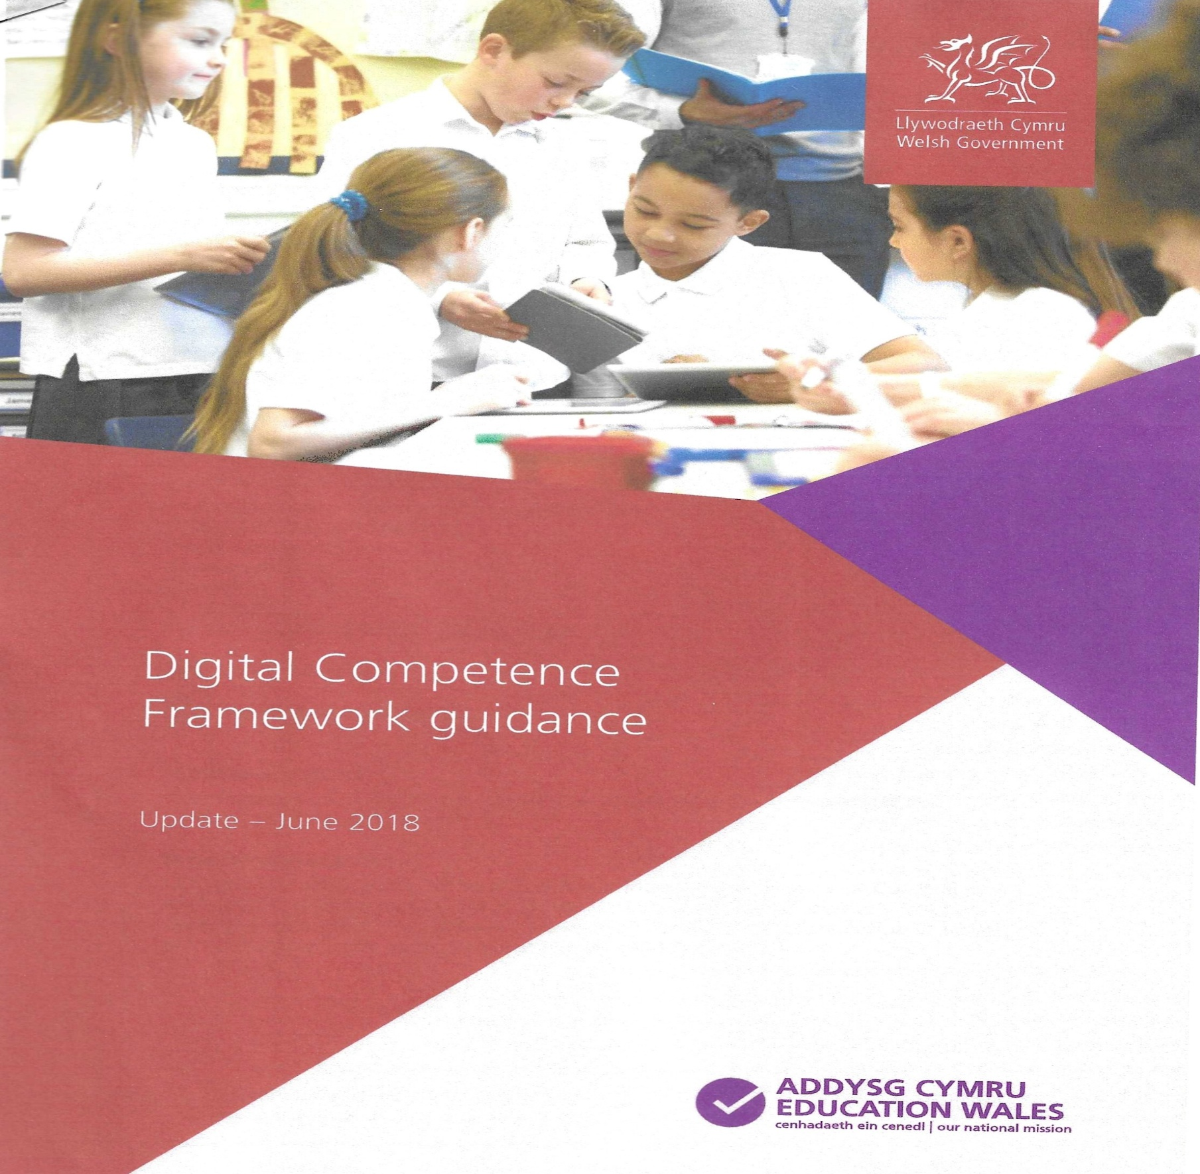
Interacting and Collaborating

The Welsh Governments DCF states that it is essential for learners today to ‘explore both formal and informal methods of electronic communication and determine which are suitable for different context’ (Welsh Government, 2016). This was never more important than when a nasty little virus sprung up in China that stopped the whole world in 2019 and the geniuses (clowns) in downing street closed all the schools! Schooling then became completely online, and learners of all ages had to communicate with classmates and teachers digitally. If learners weren’t taught in school which programmes were good for this or how to use them, they would not have been able to participate in online lessons with teachers or communicate with their classmates. Also, if their teachers made resource packs for their learners and they couldn’t access them from home, then the work that was set by the teacher, would not be completed.
Platforms such as ‘Google classrooms’® (Google, 2024) have appeared recently and have become quite prominent in education within mainstream schools both in Wales and throughout the UK. The program enables learners to access the work set by the class teacher by using their own personal logins on digital devices. Some schools have even adopted ‘loaning out’ digital devices to students so they can access and save their completed work on their own personal drives. The class teacher can also monitor what each learner is doing on their devices, so the days of passing notes between you and your mates slating the teacher (or so I’ve heard) are over. This is just one example of the learners being able to interact and collaborate their work and schools meeting the requirements of the Welsh governments DCF.
Citizenship

The ‘Citizenship’ strand of the DCF focuses on developing a learner’s ability to be safe, responsible and be positive contributors to the digital world. With social media being so prominent in today’s world, this strand is all about teaching learners about the impact of what they put online, both positive and negative, and teaching them that it doesn’t go away. Its PERMANENT! A simple search of their names could show everything they have ever posted online. Even potential employers could use this to determine if they are suitable for a job. I would be gutted if I didn’t get a job I really wanted all because of something I found funny 10 years ago! Learners today need to be taught that their digital footprints will be with them for life, whether they want it to or not, so they need to be careful with what they put online.
Another part of this strand is making learners aware of the harm that online bullying (cyberbullying) can cause. In a completely negative way… Bullying has evolved along with the technology it is being done on. Home was a safe space from bullies years ago. If you were being bullied in school, you knew that once you got home, you were safe from the bullies. It really is not the case today! With mobile phones and social media featuring heavily, bullying has become easier for the bullies. To help combat this, schools teach learners the impact that cyberbullying can cause. Cyberbullying awareness is part of UK schools annual ‘Anti-bullying week’ (Anti-Bullying Alliance (ABA),2025) which is held from 10th November to 14th November every year. The purpose is to encourage learners and their families to create positive change, speak up and build kindness when being online. Schools in Wales have powers to enforce punishments in the cases of cyberbullying including detention or isolation for minor incidents and for repeated incidents even EXCLUSION from the school.

These are just two examples of how the Welsh Government are trying to incorporate digital competencies for all learners. The other two strands are:
- Producing - ensures that learners develop the skills in which to be creative in the modern world and prepare them for new technologies which might appear in the future.
- Data and computational thinking – develop the learners’ skills in problem solving and management of data/information in this digital world.
All of this is to ensure that schools in Wales prepare this generation of learners for the digital explosion that is happening now and for future evolutions in technology. The younger generation can then help us old timers in navigating the brand-new developments and to help us keep safe, because in the end these machines will continue to rise and we (as the older generation) are going to need all the help we can get.

References

(2022). Figure 1 (a red robotic dragon) Available at: https://creator.nightcafe.studio/creation/(Accessed: 11 December 2025).
Anti-Bullying Alliance (2025) Anti-Bullying Week 2025: Power for Good. Available at: https://anti-bullyingalliance.org.uk/anti-bullying-week-2025 (Accessed: 10 December 2025).
Google (2024). Available at: classroom.google.com
Welsh Government (2016) Digital Competence Framework. Cardiff: Welsh Government. Available at: https://hwb.gov.wales/api/storage/3d9a0df8-533c-42c4-ae5a-b922f9e5f51d/dcf-years-10-to-11-211117.pdf (Accessed: 7 December 2025).
Wojcicki, A (2023). Available at: https://www.trevipay.com/resource-center/(Accessed:11 December 2025)

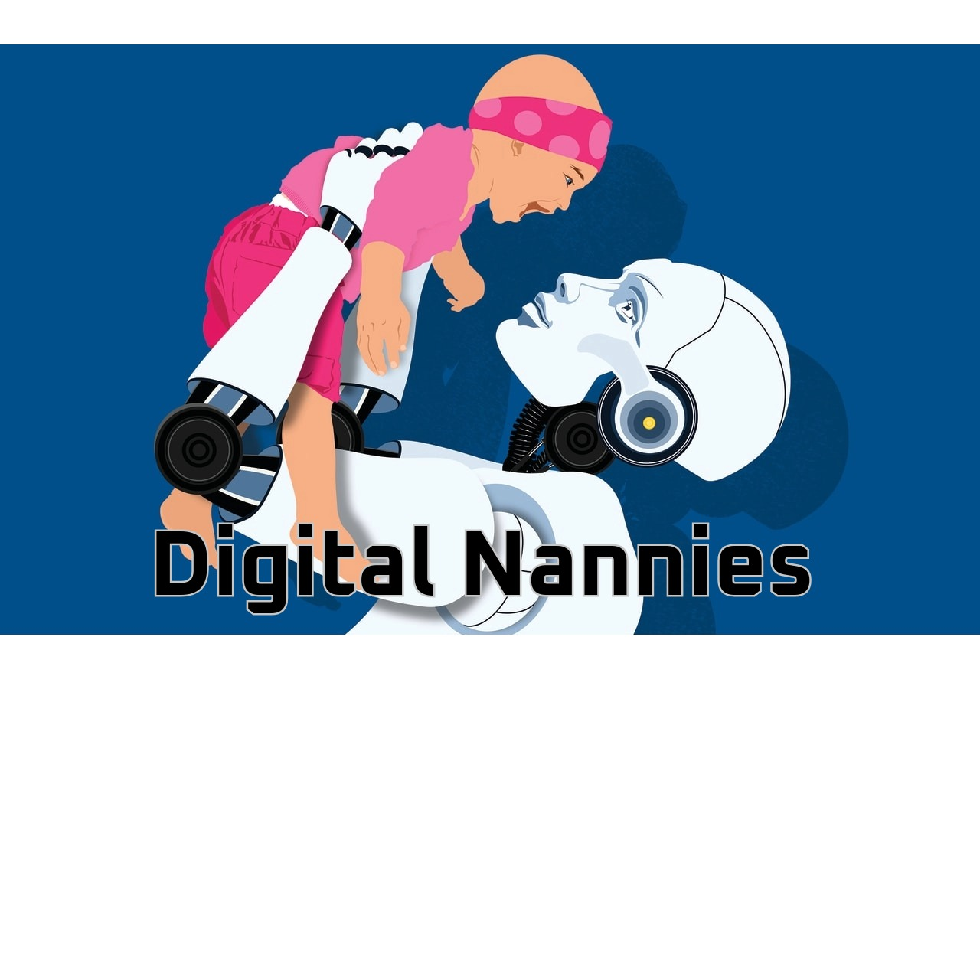

Garland, (2023)
Mobile phones, tablets, laptops and games consoles… All can connect to a huge digital world from the comfort of your own home. Anything can be learned by you online, from baking a cake to fixing your car’s engine (I wouldn’t recommend that one mind you), but it can be done. What about helping to raise your children? Can that be taught online? Is allowing your child constant and unlimited access to the World Wide Web beneficial or harmful to them? In this paper I plan to put forward some arguments FOR young people having access, and some arguments AGAINST allowing young people/children to have access. Are these machines good or bad digital nannies?
Learning in the fast lane (if you want to)
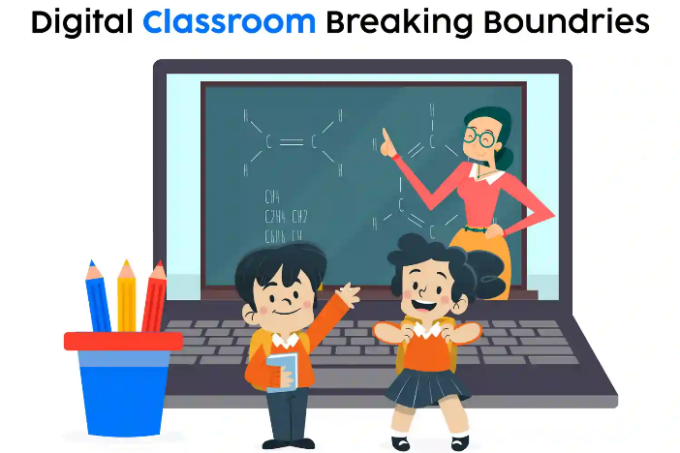
(lankun212, no date)
Ok, lets be honest here… Having access to soooo much information at the click of a button can be majorly beneficial! That is one reason why the education sectors of government have embraced digital learning so much today. The sheer number of resources, online courses and platforms there are to choose from is unreal. Learners can access the necessary information they need and digest it at their own pace instead of feeling rushed as they would in a classroom.
Fred Keller was a behavioural psychologist who believed that learners who can move through their work at their own pace are more likely to achieve higher levels in that subject. His theory was referred to as ‘The Keller Plan’. He wrote in his seminal paper ‘Good-bye teacher’ about ‘The Five Essential Elements’, one of the five elements is about ‘self-pacing’ which means that a student can move through their subject at a speed that matches their ability. So today that would mean accessing the work digitally via by a phone or tablet, completing it at their own pace and sending it digitally. This method was implemented during the COVID-19 outbreak, though teachers designed and uploaded the necessary work, it was up to the students to complete it and send it digitally. (Keller, 1968)
Kellers theory does have some critics though. One such critic of ‘The Keller Plan’ is an American author/lecturer named Alfie Kohn, who argues that this method of learners being able to access their learning when and where they want, ignores the social aspect of learning and makes teachers become facilitators of software rather than teachers. You can see his point actually, if learners aren’t going into classrooms and engaging with other students, how are they developing the social skills needed in life? Also, his point about teachers is somewhat justified. If teachers were just facilitators of software, what use is a teacher? (Kohn, 2023)
Hello, is it me you’re looking for?
Hello… is it me you’re looking for?
Socialising is a major part of life. Being able to create bonds and build relationships is essential in order to navigate through life. For the youth of today, this has never been easier. Staying connected with friends and family who could live thousands of miles away with a simple touch of a button is actually quite remarkable. I remember when I had to telephone my uncle who lives in Perth, Australia using a landline telephone (yes I’m old) and having to dial in SO many numbers! It hurt your finger by the end of it! Now… I just use my mobile telephone or messenger service and there’s no hassle, apart from the time difference occasionally.
Being able to communicate at such speed and ease is definitely a major positive for the youth of today, but being widely accessible online can also have a very dark side.
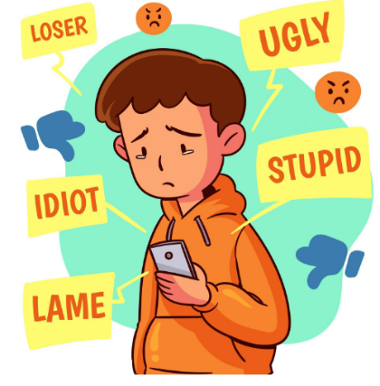
Cyberbullying is a major issue in the UK today. It is estimated that 19-31% of children and teenagers have experienced some form of cyberbullying in 2025, The research was compiled by the UK government using some academic institutions and charities such as Ofcom, the office for national statistics (ONS) and the Anti-Bullying Alliance (ABA). Unfortunately, in the early part of 2025 (January-July) there were 887 suspected suicides of people aged 10-24 in England. That is 10% of all suicides in that period (ONS, 2025). Though cyberbullying cant be determined definitively as the causes for these suicides, it is widely accepted that it could in fact be a factor. With children and young people having unregulated access to social media platforms and messaging services, it is easier now for bullies to prey on their victims and for the parents to be completely unaware. In most cases the children don’t confide in trusted adults and suffer in silence.
freepik, (2025)
So… What does this all mean?
There is very little doubt that technology can be a useful tool in our day to day lives, whether its online shopping or online banking even buying bus tickets without even getting on the bus. For adults, it can be a major help, but for the youth of today? The jury is still out for me. Children today will be growing up in a completely digital world and to see four-year-olds being able to navigate through their parents’ mobile phones and tablets with ease to find exactly what they want, is a little bit scary. I have pointed out the advantages/disadvantages with this digital age from an education point of view and from a societal point of view. Can teachers indeed become obsolete? Will ALL learning be online in the future? Time will tell, but in terms of the societal point of view, more needs to be done to protect our children from online hate and bullying in my opinion. Young people should not feel that suicide is there only way out when they have their whole lives ahead of them.
I guess that having ‘Digital nannies’ is becoming increasingly prominent, but I’m not completely sold that it is the best for our youth.

References

Garland, P. (2023) The AI nannies in your baby's future [Illustration]. In: The Wall Street Journal, 11 August. Available at: https://www.wsj.com/health/wellness/the-ai-nanny-in-your-babys-future-999d0e50 (Accessed: 15 December 2025).
https://www.freepik.com/free-photos-vectors/cyberbullying-cartoon
Keller, F.S. (1968) 'Good-bye, teacher...', Journal of Applied Behavior Analysis, 1(1), pp. 79–89. doi: 10.1901/jaba.1968.1-79.
Kohn, A. (2023) ‘The Sneaky Conservatism of Ed Tech’, Education Week, 27 September. Available at: https://www.alfiekohn.org/article/tech-conservatism/ (Accessed: 30 December 2025).
lankun212 (no date) Happy students presenting their school project [Illustration]. Available at: https://www.freepik.com/premium-ai-image/happy-students-presenting-their-school-project_347643120.htm (Accessed: 15 December 2025).
Office for National Statistics (2025) Risk factors for suicide in children and young people in England: 2025. Available at: www.ons.gov.uk (Accessed: 15 December 2025).

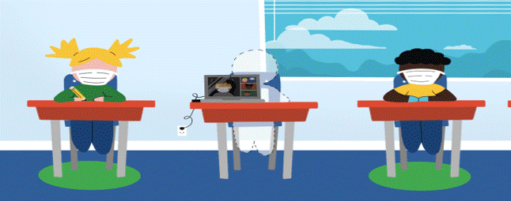
(lankun212, n.d.)
Covid and SEN

As an LSA (Learning Support Assistant) in a special educational needs school (SEN), I don’t come across a lot of ‘digital learning’. Some students who are lucky enough to be able to save their work to a computer is about all they can really manage. Some students can type on a writing program, but very little. My school focuses more on the use of symbols and a basic numeracy/literacy program. Life skills are the main focus in our school, physically going shopping, washing clothes, cooking etc, there isn’t any digital learning by mainstream standards such as being assigned devices in which to work on, accessing work uploaded by the teacher to complete and completing said work. As staff, we do almost everything digitally in communicating through email, making class resources and communicating with parents, but not the students, their learning is more physical rather than digital. The only time I can think of, where some sort of digital learning occurred (out of necessity more than choice) was during the Covid-19 pandemic. In this blog I am going to describe what my school had to incorporate to make sure our students still had a feeling of being in school and trying to replicate some sort of routine for them, during those dark days of lockdown.
A bit of context

When the UK government decided to close schools in March of 2020 (Department for Education, 2020), it caused some panic within my school, as I’m sure it did for many if not ALL schools. As our school is a SEN school, we have many students who have severe medical needs so they immediately got categorized as ‘vulnerable’ and could not attend school. As we were a ‘hub school’ we were open (on a limited timetable) to students whose parents were key workers. The children who were in school were catered for when it came to schoolwork. I, as a senior LSA, along with the class teacher, prepared work packs so that the students had activities to do throughout the day. They were able to interact with one another, granted under strict guidelines and limited in number, but they still came to school, saw some friends and had familiar staff around them. Their routine had changed slightly, but it was still a routine for them and for SEN students, routine can be vital for their overall wellbeing. For those who were stuck at home, this became a different challenge altogether. Some may have not known what was happening and why, all they understood was one day they were going to school and the next, they weren’t. Their routines had been completely upturned. As a school, we needed to ensure that those at home still felt a part of the school, work packs were one way we could help but what about the social interaction aspect of school? We felt we needed to do something for them.
Operation home learning

After it was decided that all children who were confined to being home, had to complete school tasks while at home, we sent home ‘work packs’ via mail but a system had to be devised that would allow the student to communicate with both their teachers and their classmates. It was agreed between the school and parents, that a ‘daily check-in’ was to be done digitally using Google Meet® (Google, 2025). Some students didn’t have access to communication devices at home in which to be able to join in the scheduled meetings. This is an example of Vygotsky’s ‘Sociocultural theory’. The ‘collaboration’ part of his theory explains how a child develops a sense of belonging by being active participants in dialogues with teachers, parents and their classmates (Vygotsky, 1978). Those students without devices wouldn’t be able to access the daily check-in and therefore might feel a sense of isolation on top of what other fears they may have had.
With that in mind, the school decided that the students with the greatest of need, be loaned I-Pads® (Apple, 2024) from the school’s inventory. Parents would have to sign an agreement that once the lockdown was over; the devices would be returned to the school. For a select few in our school who had access to devices at home and was confident enough to use them, not only could they access the meetings, but there were online literacy/numeracy programmes that the school used that they were familiar with, programs like Reading eggs© (3P Learning, 2025) and Purple Mash© (2Simple, 2025). The students who were familiar with them could access and complete them at home. The school just provided the parents with their personal login details for each programme. Also, included in each pack was some life skill activities the students could do at home, art projects, recipes for cooking etc. Operation home learning was launched, now we just had to see if it helped the students.
A big difference

Once all the preparation was complete and everything was in place, it was time to see if our students would indeed log on to the daily check-ins, everyday at 1pm. I am sorry to report that not all the students within our school did join the meetings, but I am also happy to report that 75% of my class did. The teacher and I alternated between leading the sessions. We had quizzes and stories and just general chit chat. Some of the students even showed us items that they had made at home using the work packs. They seemed genuinely happy to see us and though they were on digital devices, it was like we were altogether in class once again. Some of the higher-level students in the school even emailed their teachers and gave a daily report on what they were doing and how they were. They did in fact go online and complete learning games on the programmes they were familiar with. So, overall though our school doesn’t focus on digital learning a great deal, for these truly dark days of lockdown, having access to our students digitally not only helped us, but helped the students know they weren’t alone, and the school was still there (School X (2025).

References

2Simple (2025) Make the most of Purple Mash. Available at: https://www.2simple.com/blog/make-the-most-of-purple-mash/ (Accessed: 30 December 2025).
3P Learning (2025) Reading Eggs. Available at: https://readingeggs.com/ (Accessed: 30 December 2025
Apple (2024) iPad Pro 11-inch (M4) [Apparatus]. Available at: www.apple.com (Accessed: 23 December 2025).
Department for Education (2020) Actions for schools during the coronavirus outbreak. Available at: https://www.gov.uk/government/publications/actions-for-schools-during-the-coronavirus-outbreak (Accessed: 23 December 2025).
Google (2025) Google Meet. Available at: meet.google.com (Accessed: 23 December 2025).
https://www.ipsos.com/en/back-school-person-vs-remote-learning-challenges-facing-parents-teachers-and-governments
lankun212 (n.d.) Happy students presenting their school project. Available at: https://www.freepik.com/premium-ai-image/happy-students-presenting-their-school-project_347643120.htm (Accessed: 30 December 2025).
School X (2025)
Vygotsky, L.S. (1978) Mind in society: the development of higher psychological processes. Edited by M. Cole, V. John-Steiner, S. Scribner, and E. Souberman. Cambridge, MA: Harvard University Press.



Symbols of education

(yahya okab, 2025)
,2025.)

Being able to read and write are essential skills to learn in life. Without being able to read, how can you gather information, identify dangers or recognise documents relating to you? Trying to work out how essential being able to read is, is difficult because I CAN read and write, I take it for granted. I don’t recognise when and why I’m doing it, I just am doing it. But what if I were non-verbal and didn’t have the capacity to understand written words due to a cognitive issue? If every time I looked at a word it was jumbled up or I couldn’t, no matter how hard I tried, I simply could not fathom what the word meant? This is a challenge that many of the students I have in my school face. I work in a Special Educational Needs (SEN) school. Many, if not most of the students battle with this everyday of their lives and me as an LSA, have to do everything I can in which to help them gain some sort of understanding as to what is being asked of them.
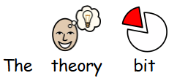
Something I have found that really helps just enough for my students to understand the day-to-day happenings while they are in school and what is required of them, is the use of symbols. The online program myself and my colleagues use is called ‘Symwriter’©. For me, this program helps create the symbols needed for my students’ educations.
(Widgit Software, 2026)
,2025.)
The theory bit…

Jerome Bruner’s theory of ‘Constructivism’ speaks about how he theorized that children construct new ideas based on their current and past experiences (Bruner, 1966). One of his ‘Three Modes of Representation’ (which he directly linked with reading and writing) was the mode of ‘Iconic’ which he believed that children store information as mental pictures, so according to this theory, the child will recognize pictures before being able to decode text. Makes sense, doesn’t it? But what if the child doesn’t have the capacity to EVER decode text?
Critics of this theory argue that children with SEN could find it difficult to associate a symbol with a specific meaning. For example, studies by Fougnie and Alvarez showed that some of their subjects in their case study (all subjects had SEN) remembered individual parts of the symbol presented to them such as the colour of the symbol, rather than what the symbol represented (Fougnie and Alvarez, 2011).
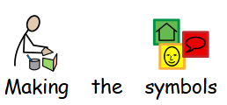
Their findings do in fact make interesting observations. However, as someone who has worked with SEN, and has done so for 14 years and their study was conducted in laboratory conditions, which the trials they conducted lasted merely seconds, I have seen, that repetition of symbol use can in fact aid a student in learning and understanding what each symbol means. As an example, if the symbol for ‘lunch’ is used everyday with a student, at a specific point during the day, and once the symbol has been shown, they have their lunch time meal, they can in fact learn what that symbol means and what is required of them. Over time, SOME students may begin to remember the word associated with the symbol, so you no longer need it, they have learned the word. But for a vast majority in my school, if you took the word away, but left the symbol, they would still understand what it meant. The word would not be required. This could also be evidence of ‘Associated Learning’ (Skinner, 1938).
(Widgit Software, 2026)
,2025.)
Making the symbols

Symwriter© is an online program that enables us as education staff, to create symbols quickly and easily. It also provides some online templates in which to make other resources that we may need like core boards (a board made up of pictures/symbols of the activities the student may encounter throughout the day) which is ideal for a ‘Now and Next’ program. It can also help you make flash cards with the symbol and word below it; this is ideal for teaching students objects (Widgit Software, 2026).
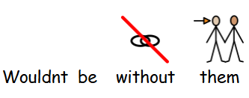
The concept is a simple one, you type a word, the symbol appears with the word below it, you can change the size of the symbol/text to suit your need, the colour of the text or even the symbol itself. The program gives you an option of alternatives so you can choose the best symbol for your purpose. There is a function that is IDEAL if you would like to teach certain words in a different language (this would be primarily for the higher-level learners of the school), Welsh for example! Once again let’s use ‘Lunch Time as an example (I’m not obsessed with lunch but it’s the only real one I can think of that would be used school wide, that and Toilet) when you type in ‘Lunch’ and the symbol appears, you can use a function that allows you to change the text below the symbol to what ever you want, so in this case (Please be right) I would type in ‘Amser Cinio’. Over time, when you show the symbol and say the word, the students will begin to associate ‘Amser Cinio’ when it is said, as lunch time.
(Widgit Software, 2026)
,2025.)
Wouldn’t be without them

I can only speak from my own experiences when I say this, but symbols are most efficient way to teach lower-level students in my school. I have seen students react to them and understand their meanings so many times. In my class for example, we have every cupboard labelled with a symbol, so that when we are cooking, you can ask students where a certain item is kept and using the symbols, they find them. I have also seen symbols become non-verbal students’ voice. Communicating to us when they need the toilet or if there is something physically wrong with them, Some students actually use Symwriter© when they want to type out their work, the symbols show them what they have typed and if it doesn’t match what they are trying to say, they will amend it until the symbol mirrors what they intended. Symwriter© allows us to give them that voice and yes, sometimes making the symbols is a pain staking process, but for me, it’s completely worth it School X (2026).

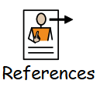
References
(Widgit Software, 2026)
,2025.)

Bruner, J.S. (1966) Toward a theory of instruction. Cambridge, MA: Belknap Press of Harvard University Press.
Fougnie, D. and Alvarez, G.A. (2011) 'Object features fail independently in visual working memory: evidence for a probabilistic feature-store model', Journal of Vision, 11(12), article 3, pp. 1–12. doi: 10.1167/11.12.3.
School X (2026)
Skinner, B.F. (1938) The behavior of organisms: an experimental analysis. New York: D. Appleton-Century Company.
Widgit Software (2026) SymWriter 2 (Version 2.x) [Computer program]. Available at: www.widgit.com (Accessed: 2 January 2026).
yahya okab (2025) Education and science items on chalkboard background. Available at: https://pngtree.com/freebackground/chalkboard-of-educational-symbols-and-supplies_18486008.html (Accessed: 2 January 2026).

