Strategic Management for SMEs
BMSW6104

Module Teacher: Bente Fatma
Student Name: Alexandru Dragomir
Student Id: 2007576

Contents
Introduction 1
Current Practical Approach 2
Environmental Analysis 3
PESTEL Analysis 3
SWOT Analysis 6
Stakeholder Analysis 7
Strategic Growth 9
Recommendations 10
Conclusion 12
References 13

List of Figure
Figure 1 Stakeholder Analysis 7
Figure 2 Diversification 9

Introduction
SMEs fall below a certain criterion regarding revenue, possessions, or personnel. Business demographic forecasts for the UK and the surrounding areas in 2022 estimate that there would be around 5.4 million SMEs in the whole nation, making up 99.9 percent of all privately owned enterprises in the country. To put it another way, there are approximately 5.47 million firms classified as "micro" with zero to forty-nine employees, and 35,900 businesses classified as "medium-sized" with fifty-nine employees to two hundred and forty-nine (Shaw, 2020). In this report, one SME CaféPod Coffee Co. will be evaluated. Collaborative members on London's riverbank are opening their coffeehouse. The collective set out to offer coffee connoisseurs with strong, interesting tastes. The company decided to produce high-quality coffee to maintain its successful business model of meeting the needs of its customers. The primary concentration of the report is on CafePod's strategic management.

Current Practical Approach
Strategic planning pertains to the systematic formulation of action plans that a corporation must undertake to advance toward its envisioned future state and achieve its predetermined objectives. It facilitates the ability of executives and entrepreneurs to effectively communicate with workers on the importance of their duties and their contribution towards achieving the company's goals. The company's major objective is to increase the quality of its premium coffee output while still meeting the demands of the marketplace. Peter and Brent started the mentioned company to create more flavorful and interesting roasted coffee. The need for consistent operating efficiency and the need to adapt to shifting customer tastes informed the assessment of the product's general excellence.
Mission: The creation of a superior coffee taste by the associated firm is crucial to the company's goal of empowering individuals to achieve success. A company's mission statement helps it meet societal needs and continue to run smoothly (Johan, 2022). In this case, enhancing the quality of life for residents has an unbreakable connection to the company's objectives.
Innovation: The company's innovative business model and coffee tastes give it an edge over competitors. It was determined that the organization's 2018 revenue was $6 million. The above firm attracts both coffee professionals and bold-tasting coffee drinkers with its wide range of items. The firm has effectively tailored its broad product portfolio to consumer needs to boost its competitive edge (Johan, 2022). Scholarly experts feel that the level of rivalry companies face across different economic areas significantly affects their willingness to adapt. Thus, to keep a competitive edge despite rising market competition, ongoing R&D initiatives that allow inventive solution innovation are essential. Because R&D helps generate fresh ideas repeatedly.
Strategies: The breadth and depth of a company's offerings are crucial to the company's ability to set itself apart from rivals in the competitive marketplace. The exceptional quality of their coffee has helped them successfully attract their prospective customers. According to HUSSEY (2021), to keep operations running smoothly and keep customers happy, the company used many cutting-edge methods from the realm of processing expertise. Organizations must constantly examine client needs and wants and adopt any necessary alterations to remain competitive in the multiple foreign marketplaces in which they undertake business. However, the company's worth is conditional on the results of a survey measuring customers' preferences for coffee with strong, unique flavorings (Kim, 2020). Because of this, the company has cornered a significant portion of the marketplace in the UK. However, CafePod has placed restrictions on its ability to expand into new geographic areas. Because of this, the company has been unable to grow as quickly as it would want and has struggled to compete successfully in foreign markets. It's harder to keep things running smoothly and bring in new customers when a company can't expand as much as they'd want. As a result, the absence of suitable growth plans has endangered the business's ability to maintain operational effectiveness in this climate.
Because more and more people in the UK are consuming coffee, the company has a far larger pool of potential customers to draw from. A recent poll found that the vast majority (87%) of UK customers choose product quality above quantity and price. As a result of increased high-quality coffee and novel roasting procedures, the relevant company has proven enabled to meet customer demands in a wide range of worldwide economies (Zimmerman and Blythe, 2021). However, the company was ahead of the competition because it employed proprietary IML innovation to manufacture capsules for coffee. The worried company had a hard time keeping its supplier relationships on good terms because of a lack of communication. The company's formerly tight grip on inventory management has loosened. To ensure continued viability and efficiency in business operations, the organization plans to promote the use of appropriate communication strategies.

Environmental Analysis

PESTEL Analysis
Conducting PESTLE research may be beneficial for philanthropic organizations operating on a worldwide basis since it allows for the evaluation of possible external factors that might impede their operations. Based on the PESTLE a system that offers a systematic approach to evaluating diverse outside influences that may influence specific situations or surroundings, this type of research is conducted. Possibly, the study's findings might give a company insightful information to help evaluate the possible consequences of entering a possibly untapped market.
Political Factors: Although the United Kingdom is a highly developed country, its political security index in 2017 was just 0.26, suggesting a high level of instability. This refers to Britain's stable political situation. The Brexit issue and political instability were major contributors. A rating of 0.4 was assigned to the total level of political equilibrium, which was determined to be relatively low. In 2017, the UK government scored 1.41 for productivity. The UK's economy may benefit from a more powerful and productive governing body. Thus, it is predictable that the degree of corruption is significantly lower than in other wealthy countries. Improving regulations protecting small and medium-sized businesses is crucial for equal entrance to economic prospects. Providing equal commercial opportunities to all corporations is crucial. The present market is incredibly beneficial for a variety of companies, regardless of size or ability to join the UK market. Thus, CafePod Coffee Co. possesses great potential to expand in the UK.
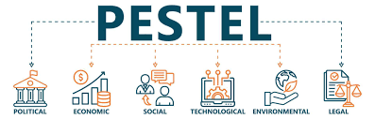
Economic Factors: Majorities of people all around the globe agree that the UK is considered to be one of the most advanced and progressive countries in the world. Thus, one of the foremost unique aspects of doing enterprise in the UK has become the abundance of business prospects. Thus, this is a major attraction for UK companies. A little rise to 106.8 percentage points during the starting portion of 2019 shows a steady and modest tendency for the UK's inflation index. It seems that inflationary forces have been restrained. The spike may be due to increases in energy and food prices. A prosperous market might assist a firm in growing its client base and revenue. It is crucial to remember that UK inflation is 2.5% per year as well and the authorities closely monitor it (Sun, 2022). Remember that competent administration helps maintain stable prices. This must always be remembered. The standard of UK expenditure rose 7.93% last year. CafePod Coffee Corporation is well-positioned to enter and gain popularity in the UK due to its robust economy and technological advances.
Social Factors: It is widely believed that population patterns significantly influence the formation of social networks and can result in profound consequences for the strategic objectives of the corporate sector. Competitiveness significantly influences the prospects of new business entities in the UK economy. The presence of diverse faith-based customs significantly impacts the strategic decisions made by CafePod Coffee Co. regarding the accommodation of different religious organizations. Prosperous enterprises frequently perceive a substantial portion of the marketplace as a competitive edge. CafePod Coffee Company will find the UK market to be an excellent environment in which to propagate its ideas of inventiveness and motivation due to the multicultural diversity and vitality that distinguish the UK market.
Technological Factor: The British economy is known for its technological progress. The UK government aggressively promotes sophisticated technology among businesses to create new entrepreneurial ideas. Thus, private companies prioritize the development and implementation of advanced technology to maximize market supremacy. The audiences where enterprises are located are interested in company organizational technology (Hamilton and Webster, 2023). This involves creating a durable foundation for environmentally responsible businesses and using technology to do it. The incorporation of innovative technology aims to create a sustainable business infrastructure that optimizes CafePod Coffee's effectiveness. This will assist local communities and businesses while giving CafePod Coffee Co. another strategic chance to capitalize on the competitive landscape.
Environmental Factor: The UK accomplished notable advancements in mitigating the adverse environmental impacts associated with business operations. Multiple stakeholders, including governmental bodies, municipal governments, publications, charitable organizations, and other entities, have implemented several measures aimed at enhancing consciousness about the environment and mitigating the adverse consequences associated with financial growth (Adedoyin and Zakari, 2020). The organization derives benefits from this particular facet of its operations.
Legal Factor: The development of politics in the UK is rich and illustrious. It has a well-developed court system and a rich tradition of protecting civil liberties. In terms of protecting and promoting freedoms for individuals, it is a world pioneer (Sun, 2022). The laws designed to protect workers' rights are becoming more stringent. Adherence to the increasingly stringent wellness and security rules is crucial. The organization gets advantages from this aspect of its operation.
According to the PESTEL study, the business situation for CafePod Coffee appears secure. However, the business continues to make use of possibilities while also reacting to outside pressures to stay competitive. Businesses have chances when political and technological concerns are taken into account. The corporation is vulnerable to dangers stemming from both the economy and the surrounding environment.

SWOT Analysis
Strengths: The Cafepod Coffee Co. has ambitious growth plans, with the ultimate goal of becoming the UK's seventh-largest roasting and ground espresso brand. Furthermore, the business's purpose is congruent with providing clients with high-quality coffee. As a bonus, LML technological advances contribute to creating higher-quality coffee and unique capsules that contain coffee.
Weaknesses: A variety of problems have arisen as a result of the organization's unreliable relationships with its suppliers. This has led to serious inconsistencies in the company's first supply, which will have repercussions for both stock and R&D efforts. It is also thought that Cafepod Coffee Co. might struggle if it used an ascending taking decisions method since this would limit employee input. The company's inability to create novel products is exacerbated by its outdated technical infrastructure. As a result, the creation of products at Cafepod Coffee Co. is hampered.
Opportunities: Despite the company potentially encountering specific obstacles, the burgeoning and expanding coffee sector in the United Kingdom presents possibilities. In light of the robust consumer demand, one could contend that Cafepod Coffee Co. is presented with an exceptional prospect to expand its customer base. By integrating effective innovation strategies with market expansion, an organization can maintain its market orientation. With a steady provision of basic materials, ingenuity on the component of the organization, and the support of its providers, the marketplace continues to present prospects for growth. Additionally, it is possible to enhance its efficiency.
Threats: The extreme competitive characteristics of the UK marketplace constitute one of the greatest concerns. The number of businesses seeking entry into the very profitable UK coffee industry has increased recently. The unique clientele of Cafepod Coffee Co. makes it difficult for the company to maintain its commercial concentration. Thus, expanding the range of its products via the implementation of creative ideas and placing a premium on reliability is the most significant thing that Cafepod Coffee Co. can do to gain a competitive edge. Companies in the UK are less nimble than they might be due to labor organizations and significant government involvement.
Both consumer interest in coffee and increased technological usage provide substantial opportunities for the sector. Significant obstacles to the company's continued existence have been posed in the form of increasing commodity prices and increased market rivalry.

Stakeholder Analysis
Stakeholders are better understood at the outset of a project when a thorough stakeholder analysis has been carried out to determine their needs, wants, and primary requirements. In this context, "stakeholder" refers to any person or group that the undertaking will influence (Missonier, 2020). A variety of people and organizations may be considered stakeholders, including sponsors, advisers, financiers, collaborators, and potential or existing clients.

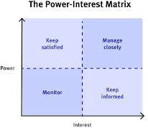
Figure 1 Stakeholder Analysis
Source: (Missonier, 2020).
These are some of the most frequently encountered kinds of significant parties that are engaged with CafePod Coffee Co.
Employee: The performance and achievements of a company might potentially influence the remuneration, employment stability, financial well-being, and other perks provided to its employees. A staff member can be regarded as an important stakeholder when their role is crucial to the business's prosperity and they stand to lose financially if the business fails (Alwis, 2020). Because of this, they may make significant contributions to the outcomes and developments of a business's efforts and operations. The worker exhibits not just considerable impact but also a deep dedication to the job. Companies should make employee happiness a primary priority.
Investors: Investors play an essential function as crucial stakeholders since there is a direct correlation between their personal or organizational financial objectives and the accomplishments of a firm. Concurrently, the stability of shareholders' financial backing may have a significant bearing on your business's ultimate achievement. Although investors have a lot of influence, they tend to not be genuinely concerned. The business must provide updates to every stakeholder.
Competitors: While rivals might provide difficulties for the enterprise, they are regularly important players in the company. Having a rival in the marketplace that provides comparable goods or services might have an impact on the way the company operates and strategic choices.
Vendors: Many businesses rely on their suppliers to carry out their day-to-day operations and finalize their initiatives. In another way, these vendors depend on financial support from their business. Vendors include anybody who provides goods or services to a company but not directly to employees. Vendors have high power.
Customers: The Cafe Pod Coffee Co. must accommodate client preferences if it is to grow its brand reputation. Customers give a lot of weight to the products, costs, level of service, consistency, knowledge, standing, geographical location, appearance, and perception of Cafe pod Coffee Co. A customer might be regarded as a major player if they have a significant role in the company's new initiative's conception or implementation.
Community: A company's operations and decisions may be affected by the surrounding community. Consider how an organization's standing in one area might have repercussions outside its borders. Cafe Pod Coffee’s community has high interest.

Strategic Growth
Businesses finance a range of expansion initiatives to maintain their edge over their rivals. The ability of firms to implement changes is contingent upon an evaluation of their competitiveness and the challenges they encounter. The firm has produced a diverse range of goods to meet the demands of the market (Meadows, 2023). Nevertheless, the company's survival was jeopardized by the absence of effective technical advancements in its business processes and the increasing competition in the industry.
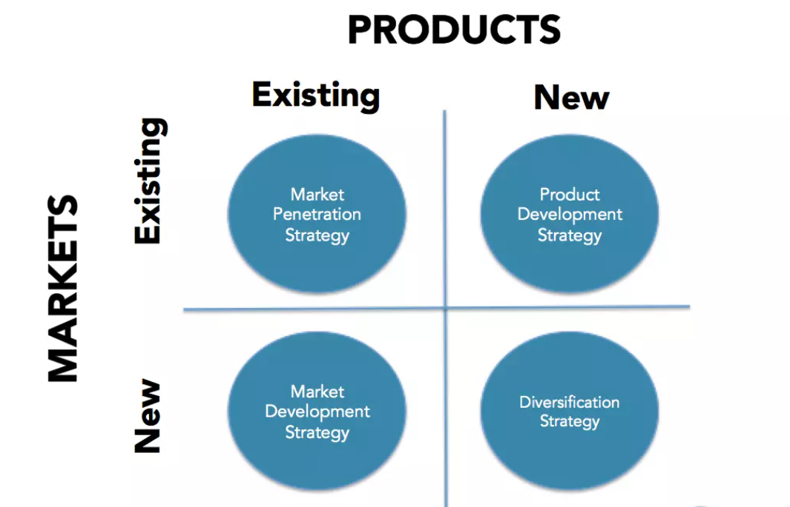
Figure 2 Diversification
Source: (Meadows, 2023).
Diversification
The company's approach to developing new products ensures that the company's existing services are going to continue to be successful. In this scenario, the relevant firm has to do more to expand its coffee product lineup. Manral and Harrigan (2022), said that this strategy phase is necessary for successfully adjusting to the needs and interests of customers when market dominance has been attained. Initially, the company catered to actual customer wants and requirements. Diversification provides a great way to mitigate risk in the current environment of business competition. The corporation may assist new business endeavors beyond what it now offers. If it is possible to successfully adopt this approach, the company may retain or enhance profit and effectiveness even during slumps in the economy, sluggish or industrial shifts (Dringoli, 2021). The problem here is that the firm in question only offered a limited assortment of products, thus reducing the number of potential customers it might attract. However, the corporation in question could implement strategies to expand product variety by making use of appropriate technology, therefore attracting a new customer base. The right company in this situation has to react by providing a wide variety of coffee items on the counters that correspond with the preferences of their customers.
Conversely, the concerned company could employ EPS containers to maintain the efficiency of its distribution network while simultaneously creating new products. The existence of a varied selection of items will provide the organization with an edge of competitiveness over other participants in the market as a whole. The company's current product line is distinguished by a wide spectrum of tastes. However, the wide range of customer preferences and desires affected the company's ability to acquire an advantage over rivals. Through innovation in products, the corporation may increase the number of local customers it serves. Businesses may ensure the achievement of their new product creation plan by supplementing the funding allocated to their scientific and technological departments. The relevant business in ensuring the continued success of the services they provide in educating a broad audience. Therefore, the numerous taste and regularity advancements throughout the product range would help the particular company keep its operations efficient in keeping with the needs of creating a committed customer.
In light of what has been discussed up to this point, it should come as no surprise that establishing a product approach for expansion will contribute to CafePod Coffee's operations more effectively.

Recommendations
The potential exists for the organization to encounter challenges throughout the implementation of a new growth strategy. Several recommendations are offered to address these challenges and facilitate the further expansion of the organization.
Technology: The firm currently uses in-mold tagging (IML) tech to customize coffee roasts to particular client preferences. However, if quality assurance guidelines are not properly executed, the business may have problems. Technological advances may affect a company's reputation, which is concerning. However, the firm may offer caffeine in EPS (expanded polystyrene) vessels that insulate it. The company will be more efficient and meet consumer demands as manufacturing and shipping elements improve (Nganga, 2022). Due to the unstable offer, the organization may have problems managing its supply chain. However, the corporation may deploy EPS solutions to maintain supply chain efficiency.
Leadership structure: To execute the new plan, several employees will be responsible for creating an efficient and effective measurement system. Marketers are responsible for ensuring the campaign's success. The most important tasks of the executive team are gathering marketing information as well as creating effective marketing plans. To finance project progress, funds are available and hazards are assessed. Additionally, the CEO will evaluate the whole process. The CEO of a firm should embrace changed leadership, which involves initiating new initiatives and shifting the business viewpoint of the market (Pournasir, 2023). The company must be more forceful to satisfy client requests as economic conditions accelerate and agility is needed. By increasing departmental involvement for the CEO, the transformational approach will help progress the development of business strategy.
Funding: The organization will strategically allocate its financial resources. To ensure the seamless functioning of the plans while assisting in the mobilization of funds, the pertinent firm will distribute short-term shares to a variety of prospects. The company may also opt to obtain short-term funding from banks to execute the overall strategy. Financial resources required to implement the proposed ideas will be generated through a range of promotional activities and events coordinated by the pertinent association in collaboration with multiple non-governmental groups.
The maintenance of profitable development in highly saturated markets may be achieved by the top executives of the respective firm by adhering to the rules outlined above.

Conclusion
When it comes to revenue, assets, or headcount, SMEs are below the cutoff. CafePod Coffee is a small to medium-sized enterprise (SME) in the United Kingdom. Peter and Brent established the aforementioned company to meet the need for tastier, more interesting roasted coffee. The necessity for continual operating efficiency and the need to adapt to changing customer tastes both played a role in the assessment of the item's overall quality. According to CafePod Coffee's PESTEL study, the company's operating environment is neutral. The company's survival depends on its ability to adapt to changing market conditions and seize new possibilities. Several solutions are proposed to address these problems and boost the company's development. If the relevant company's top executives adhere to the aforementioned guidelines, they may be able to sustain profitable growth in highly competitive markets.

References
Adedoyin, F.F. and Zakari, A. (2020) ‘Energy consumption, economic expansion, and CO2 emission in the UK: The Role of Economic Policy Uncertainty’, Science of The Total Environment, 738, p. 140014. doi:10.1016/j.scitotenv.2020.140014.
Alwis, A.C.D. (2020). Stakeholders' Influence on Successful Business Succession. International Journal of Business Administration, 7(4). doi:https://doi.org/10.5430/ijba.v7n4p79.
Dringoli, A. (2021) ‘Product diversification strategies’, Corporate Strategy and Firm Growth [Preprint]. doi:10.4337/9781781005675.00010.
Hamilton, L. and Webster, P. (2023) ‘The Technological Framework’, The International Business Environment [Preprint]. doi:10.1093/hebz/9780198804291.003.0010.
HUSSEY, D. (2021) ‘Strategic management to strategic change?’, Strategic Management, pp. 599–602. doi:10.1016/b978-0-7506-3849-4.50034-3.
Johan, W. (2022) CafePod. Available at: https://www.cafepod.com/ (Accessed: 30 October 2023).
Kim, J. (2020) ‘The importance of spatial agglomeration in product innovation: A microgeography perspective’, Journal of Business Research, 78, pp. 143–154. doi:10.1016/j.jbusres.2017.05.017.
Manral, L. and Harrigan, K.R. (2022) ‘Corporate advantage in customer-centric diversification’, Academy of Management Proceedings, 2016(1), p. 11902. doi:10.5465/ambpp.2016.11902abstract.
Meadows, M. (2023) ‘Strategies for growth’, Strategy [Preprint]. doi:10.1093/hebz/9780192845399.003.0014.
Missonier, S. (2020). Stakeholder analysis and engagement in projects: From stakeholder relational perspective to stakeholder relational ontology. International Journal of Project Management, 32(7), pp.1108–1122.
Nganga, K. (2022) ‘Influence of process innovation on the performance of Coffee Cooperatives’, Journal of Strategic Management, 7(3), pp. 1–10. doi:10.47672/jsm.1250.
Pournasir, S. (2023) ‘Key success factors of strategic management implementation in SMEs in Iran’, JOURNAL OF INTERNATIONAL STUDIES, 6(2), pp. 65–78. doi:10.14254/2071-8330.2013/6-2/6.
Shaw, T. (2020) ‘UK SMEs and business students: An investigation into perceptions of employability for entry-level positions in SMEs’, Fields: journal of Huddersfield student research, 6(1). doi:10.5920/fields.678.
Sun, Y. (2022) ‘UK-based external business environment analysis of outdoor adventure clothing using the Pestel Tool and its future outlook’, 2014 International Conference on Information Technology Systems and Innovation (ICITSI) [Preprint]. doi:10.1109/icitsi.2014.7048283.
Zimmerman, A. and Blythe, J. (2021) ‘Product strategy and product development’, Business to Business Marketing Management, pp. 185–218. doi:10.4324/9781003164036-11.



