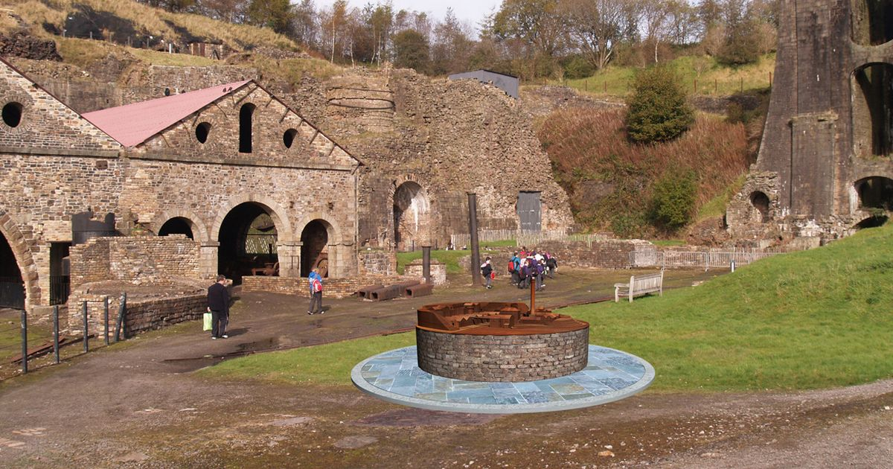
Blaenavon Industrial Revelation
Distinctness and Regeneration
Jenna Jackson:1907875
The purpose of this assignment is to illustrate the distinctiveness of Blaenavon located in the upper end of Avon Llwyd, the valley’s of South Wales. Which is famously known as ‘big pit’. Which hold s such historical significance and its famous famously legacy, which Blaenavon’s historical coal mine is located, with such significance of historical legacy of it’s old coal and iron production workshops, These were known as the world's most famous coal and iron production in the 18th and 19th century and 20th century, the history behind its mining production is rather intriguing. The shafts at pig pit were originally known as Kearsley's pit, which was 200ft deep, this is where ‘Big pits’ name was originated back in 1880’s, because of its unusually large elliptical shaft size.
The major preserved sites of Blaenavon ironworks and big pit is now the national mining museum of Wales, which hold such significant historical evidence of its history from the nineteenth century dwellings, these include such fascinating historical objects, evidence and information about its history, this includes such interesting facts and insights learning projects that are rather inspiring and most enjoyable.
The historical museum and the mining exhibition facilities captivates a journey around a selection of its original underground mine, enabling visitors to explore the underground tour of the original mining, with insights of the minors daily shift down at the coal mines, exploring the underground mining exhibition and understanding how the mine was operated, These facilities enable the public and tourists to have the experience to explore the history of the underground mine, going 300 feet down into the coal mine leaded which is directed by a qualified miner who talks you through the tour explaining all its history, what life was like for those miners who worked down in the big pit coal mine back in the nineteenth and twentieth century.
The visitors who participate in the underground tour must follow important safety rules and understanding the safety before the tour begins, this includes wearing all safety equipment provided by personal minor participant leader, the safety equipped gear for each person includes a safety helmet, a cap lamp, safety belt, battery and a self-rescuer which was used by the minors who worked there years ago.
The tour around big pit, was such darkness, pitch black barley seeing your next movement clearly, this it was a rather frightening experience, unknowing the dangers ahead, this was such a dangerous working environment for the minors, with such cramped surroundings, unknowingly what was approaching ahead due to such darkness, unaware of any dangers, which accounted daily, as tragedies’ would result In death.
It was accepted by the management that children of ages 5-7 years old were required to work there and were acceptable as part of the mining workplace at big pit, with parental acceptance, children were sent to work down the dangerous mines, with such little attention paid to the children's health and safety risks, many got badly injured and killed from underground explosions, roof falls and run over by underground carts, such sadness. The Adults and children who worked in the mine worked so hard, leaving so early in the mornings in darkness, and would return home in darkness after their long hard shift.
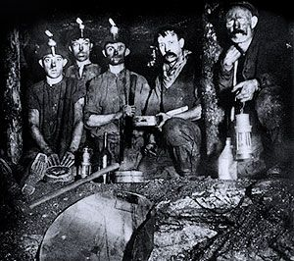Blaenavon ironworks and coal mining started in the late eighteenth early nineteenth century, it became the development of the coal mines, quarries and housing of workers.
The iron ore was first extracted on the mountains of Blaenavon, supplied to the forge with big iron and coal which was transported via tram roads, which were vital use back then. The improvement of transportation links was an essential role to the industrial revolution this was it’s key for the success of its coal and iron industries.
These structure still remain, such as the coal mines, quarries, the primate railway systems, furnaces and the workers homes, also the social infrastructure of Blaenavon's community. Blaenavon's is the major preserved historic landmarks which still remains since the late 18th centaury along with the furnaces came later on during the 19th century, these are the best reserved in the United Kingdom. Above the furnaces is a range of ruined kilns which was calcined or roasted, also the cast iron pillars and brackets which carried blast pipes and furnaces which still survive today. Blaenavon’s coal and iron mass production industrial production, made them the largest empire in history. During the industrial revelation Blaenavon became the most powerful richest nation in the world back in the 19th century, achieving the same historical records as the great wall of china and the Egyptian pyramids. Blaenavon's development of the industrial revelation, was one of the finest surviving examples in the world of its landscape created by the coal mining and its iron making in the nineteenth century, it’s parallel developments of these industries was the main dynamic of the world's first industrial revelation.
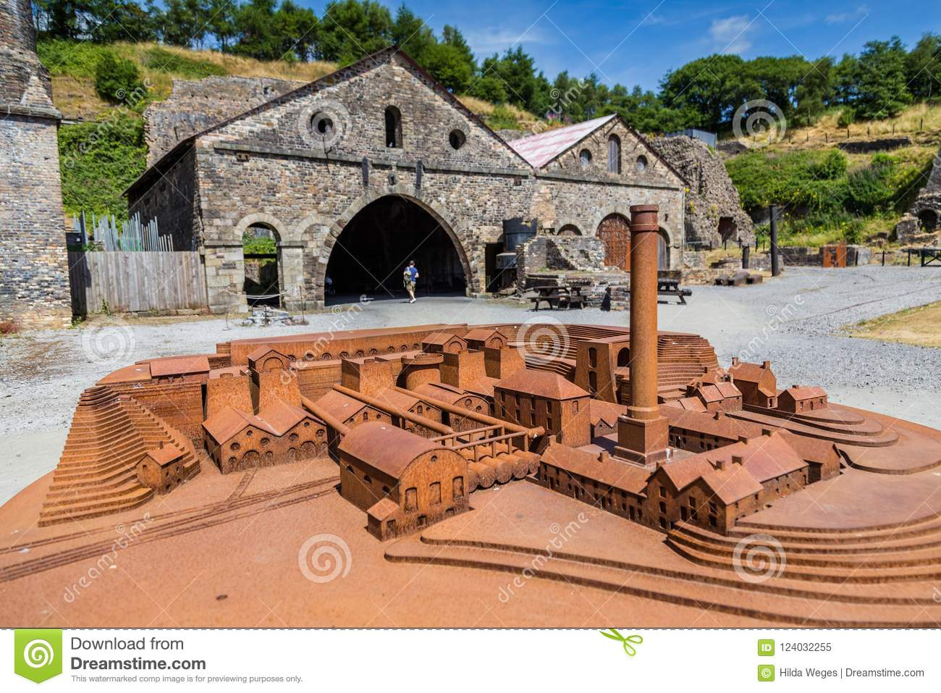
P. Carradice, (2012) Wales History, the iron ore was first extracted on the mountains of Blaenavon Located on the Brecon beacon hill which were enriched with coal, iron and limestone which became the start of industrial revelation. It also provides exceptional testimony to the areas international importance of the industry. Blaenavon was the Birthplace of the iron/steel industry, which made Britain become the most powerful country in the world as it was the welsh who started manufacturing railways lines, bridges and ships, dated 1989 Blaenavon iron work which then started the process of the power of steam to blow air into its large blast furnaces. A Gentleman named Gilchrist Thomas, was the first person who transformed the world’s steel industry by inventing new methods to remove the phosphorus from its iron ore, so Blaenavon iron works was the first to harness the power to blow air into its huge blast furnace.
Blaenavon’s historic themes and background, (1788) The Lord Abergavenny leased out the common lands, to three entrepreneurs named Mr Thomas Hill, Mr Thomas Hopkins and Mr Benjamin Pratt.
These entrepreneurs saw great potential and opportunity to build new ironworks at Blaenavon with practice of the industrial revolution in a new and resource-rich settings, the ironworks consisted the major blast furnaces utilising the steam power making them the largest ironmaking company in the world, producing around 5,400 tons of iron a year.
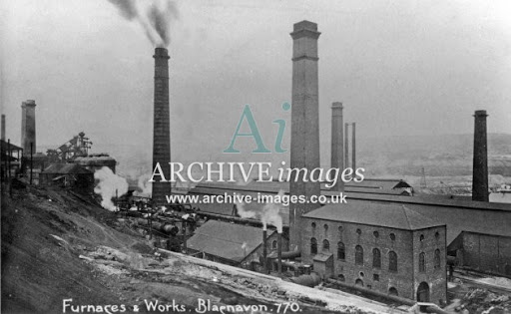
The community of Blaenavon were in decline, since the iron works ceased its working production in 1904 which then began the slowdown in the community economy, which then became the closure of Blaenavon's big pit which then rapidly started to diminish. From then on, the local town became all boarded up in 2000 its community population decreased this then became Blaenavon's climacteric. The community suffered bad with their health due to the air pollution causing serious health issues like lung diseases and cancers.
The industrial revolution in wales,
Chapter 15: The industrial revolution (part 2)
The coal Became a nationalised industry, the British mines were unprofitable, coal mining was ready for repositioning. Margaret Thatcher’s right hand man the Conservative government in the 1980s, . In the earlier 1980s, the national Union of miners had strong links to the Labour Party, which had no threat against the industrial action. Then in 1981 became a threat of strike when the big pits closure was at its end but the government had to back down as they did not have a strong enough position for this.
The 1983, Margaret Thatcher appointed Ian Macgregor the head of the national coal boards, known for cutbacks and closures from his previous role with the British Steel industry. By the end of 1983 the War won a mandate for that years general election, which then Margaret Thatcher’s position then able to negotiate with the unions. The struggle over the mining industries would define her status.
The minor struck, (2018) Wales history stated that in 1984 it was formally Announced that the closures of 20 pits leaving 20,000 jobs losses which was decided by the government for the industrial action. The British had to stock up on coal, for Britain to last over the winter period. As the strikes continued, the stress and strains heightened, leaving workers no earned money, and were unable to claim benefits. Some were lucky, as the industrial unions. Leaving many men unemployed in the area, south wales suffered by with its community’s breakdown, and deprivation having long lasting effects for years on it became the ghost village in the Blaenavon valleys.
Restoring it’s history
Since the Nation Lottery funded the town £8.7 million as an investment restoring the town prosperity, history and their pride. Enabling restoration of big pit and the town centres shops and the Bethlehem chapel which is in current process of it’s restoration.
References
Blaenavon, (2020) Blaenavon world heritage. Cited online: https://www.visitblaenavon.co.uk/en/worldheratigesite/the blaeavonstory.
Big pit national museum, (2019) The national library of wales. Cited online: https://whelprimosbx.hosted.exlibrisgroug.com/principle/explore/search.com/.
Hordern, J. (2013). Evaluation and implementation: two regeneration programmes. International Journal of Public Sector Management, 26(4), pp.298-308.
Jones, C. Monday, M. (2001) Regional Studies. Cited online: https://scholar.google.co.uk/scholar=research+of+bleavon.com/.
Jones, P. and Evans, J. (2012) Rescue Geography: Place Making, Affect and Regeneration. Urban Studies, 2012, Vol.49(11), pp.2315-2330.
Jones, C. Monday, M. (2001) Regional Studies. Cited online: https://scholar.google.co.uk/scholar=research+of+bleavon.com/.
Laun, J. (1979) Industrial Archaeology Review 3, (3), 258-275,1979. Cited online: https://scholar.google.co.uk/Scolari?q=research+of+blaenavon.com/.
L. Kitson, (2017) Global Subsidies Initiative, Cited Online: https://moodle.uwtsd.ac.uk/pluginfile,php/402532/mod-resources/content/i/end-of=coal-mining-south-wales-lessons-learning/.com
Laun, J. (1979) Industrial Archaeology Review 3, (3), 258-275,1979. Cited online: https://scholar.google.co.uk/Scolari?q=research+of+blaenavon.com/.
Mah, A. (2012). Industrial Ruination, Community and Place: Landscapes and Legacies of Urban Decline Paperback University of Toronto Press.
The minor strike, (2008) cited online://https://www.bbc.co.uk/wales/history/sites/themes/society/industry_coal06.shtml
O’Brien, D. and Matthews, P. (eds.) (2015). After Urban Regeneration: Communities, Policy and Place (Connected Communities) Policy Press.
Preferred Strategy, (2008) Tarfaen county borough council. cited online: https://scholar.google.co.uk/Scolari?=thedistinctiveness+of+Blaenavon.com/.
Powe, N., Pringle, R. and Hart, T. (2015). Matching the process to the challenge within small town regeneration. Town Planning Review, 86(2), pp.177-202.
P. Carradice, (2012) Wales History, cited online://https://www.bbc.co.uk/wales/history/sites/themes/guide/ch15_part2_industrial_revolution.shtml
Welsh News Papers, (1866) Monmouthshire merlin. Cited online:https://newspapers.libary.wales/view/3402276/3402279.co.uk/.
(1788) Lord Abergavenny, Blaenavon’s historic themes and backgrounds, cited online://http://www.ggat.org.uk/cadw/historic_landscape/blaenavon/english/Blaenavon_Features.htm

