
University of Wales Trinity Saint David
School of Computing
ACCA7002
Data storage investigation
Database Systems
By Nathan Morris (2222137)
Wordcount excluding Coverpage, table ot content and Bibliography: 3261

Contents
1. Abstract 3
2. Introduction 4
3. Main Report 5
3.1 NoSQL - Document 5
3.2 NoSQL Graph 6
3.3 NoSQL Key Value 8
3.3 NoSQL Wide-Column 9
3.4 When to use a NoSQL database 10
4. Conclusion 13

Abstract

This report aims to compare four different types of NoSQL database for Abertawe Entertainment and debate where to use a NoSQL database against a traditional relational database. The report concludes that each database type has advantages and disadvantages when compared against a relational database and the different types of NoSQL databases. Each database type has particular use cases where the advantages outweigh the disadvantages, it becomes beneficial to use one type of database compared to the others available. The report concludes that an entity can use more than one database type where its requirements cannot be met by one type. The report advises Abertawe Entertainment of potential solutions that could help the entity when scaling its activities.

Introduction

This report sets out to analyse, compare and highlight use cases of four different types of NoSQL databases. The report splits each database into its own sub section; Document, Graph, Key-value and Wide column which describes each database type and describes its use cases. Each database is evaluated against a traditional relational database with advantages and disadvantages discussed. The report then moves on to describe where a NoSQL database should be used compared to a relational database.

Main Report

3.1 NoSQL - Document

A NoSQL document database is a database where data is stored within a database as a ‘document’.

“Documents store data in field-value pairs. The values can be a variety of types and structures, including strings, numbers, dates, arrays, or objects. Documents can be stored in formats like JSON, BSON, and XML.” [1]

These documents are organised into ‘collections’ where documents with similar attributes are included within a collection. Finally, the database is made up of different collections.
Documents are usually formatted as a JSON or BSON file which contain the attributes and data. See below example of a JSON document which contains information about a person.

{
"id": 1,
"name": {
"first_name": "Orville",
"last_name": "Devennie"
},
"email": "odevennie0@blogtalkradio.com",
"gender": "Male"
}

Documents can contain any number of attributes, documents within the same collection can include the same or a different number of attributes (which makes the document stores polymorphic). See below example of JSON document which has been created within the same collection as the first JSON document.
{
"id": 1,
"email": "caarons0@google.com.au",
"gender": "Agender"
}

Note that the second JSON object does not include a name field but is still acceptable within the schema. The ability to vary the attributes within a collection makes document databases highly flexible as the database user is not limited to a pre-determined or a difficult to change database schema. The flexible schema is the main advantage of document databases, use cases included situations where data attributes are known to be different or will change over time. Document databases are structured so that data is stored as key value pairs. This can enhance the speed in which some queries are performed when compared to a non-relational database. The paper Comparison of Relational Database with Document-Oriented Database (MongoDB) for Big Data Applications concludes that MongoDB performs CRUD updates consistently faster than a MySQL relational database [2].
One use case for this type of database is for a product catalogue. Within a product catalogue there might be many items with similar attributes such as size and dimensions. There will also be attributes that are only relevant to some items, for example some items might contain batteries. The flexibility of the schema allows for items with similar and different attributes to be added to the same collection and then also queried. The main advantage for catalogue items being placed in a document database is that if a new item is added to the catalogue with a new type of attribute, the item can be added to the database as easily as any other item. No changes to the schema would need to be applied.
The main difference between a document database and that of a relational database is the flexibility of the schema. This is due to the differences in how the two databases are structured. Relational databases are structured in set tables and columns with defined data types that constrains the datatype in each column. Document databases are structured into collections which can have no constraints on datatype and are not organised into defined columns or attributes. With each NoSQL database types there is a trade off with the functionality of the database against the key ACID properties used in to guarantee the integrity of transactions in a database. The main trade off that document databases are subject to compared to the relational databases is the consistency of a transaction. In a relational database the pre-defined tables and columns ensures that the data entered is consistent, i.e. if there is no column for number of batteries, the data cannot be entered. In this instance, there is no data on the number of batteries, but the data is consistent throughout the database. In the case of a document database, the flexibility of the schema means that some items can have data on number of batteries and other items do not. The data held in the document database is not as consistent as the data within the relational database. However this trade-off results in a more flexible database.

3.2 NoSQL Graph

“A graph database stores nodes and relationships instead of tables, or documents. Data is stored just like you might sketch ideas on a whiteboard. Your data is stored without restricting it to a pre-defined model, allowing a very flexible way of thinking about and using it.” [3]
Graph databases are composed of two main parts, nodes, and edges. Nodes can be described as entities or instances, edges are where the relationships are stored. Graph databases are used to identify relationships between nodes using other cluster of node relationships. An example of graph functionality is provided below [4].
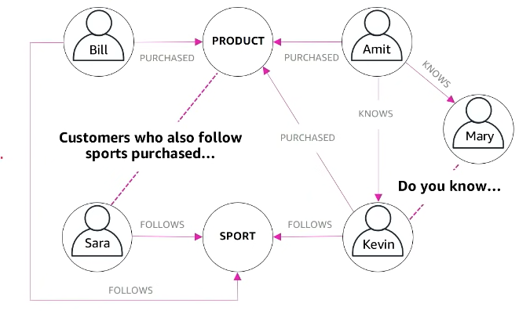
The example above highlights the type of relationships graph database are used to identify. The example shows that Kevin and Amit purchased the same product, so there is a potential relationship link between Kevin and Mary via Amit. It also shows that Sarah might have an interest in a product due to the relationship ties to the product that other people have who also follow sport. At a small scale, this kind of information is available to extract via a relational database. However, as a database increases in size the more complex the queries become and the slower the database performs. Graph databases are design so that performance for these types of queries does not degrade as the database increases in size. In the paper SQL Database with physical database tuning technique and NoSQL graph database comparisons Wisal Khan et al. conclude that a graph database outperforms a relational database under certain conditions where the nature of data is large and connected. The paper also concludes that the performance of the graph database increases when compared to a relational database as the data size and number of joins increases. [5]
The use cases for graph databases can be found where information on relationships is a key requirement for output. One common use case is within a social media site where friends or pages are recommended to the user by the provider, based on other users’ connections and interest. The websites use common relationships between users to try and determine potential relationships with other users i.e. a friend suggestion based on other mutual connections. A different use case can be found where retail entities try to recommend products based on other customers mutual or similar purchases. For example, a customer who has a hammer in their shopping basket might get a recommendation to buy nails based on the data of other customers who also bought a hammer and nails at the same time.
The main difference between a graph database and relational database is that the information about relationships in a graph database is stored as data whereas in a relational database it is not. Relational databases are centred around the relationships between its columns in tables whereas a graph database concentrates on the relationships between different pieces of data. Like document databases, the schema structure of a graph database is also more flexible than a relational database. In Graph databases each entity doesn’t have to have all the same attributes and these attribute types are not defined like they are in a relational database. As mentioned in the section about document databases there is a trade-off between the consistency of the data and having the flexibility to use the database to prioritise the relationships between data at scale.

3.3 NoSQL Key Value

“the data are represented by a pair of key and value, where the key designated to uniquely identify the value, which can be of any data type (string, integer, Json file, etc.). The querying of this type of NoSQL data is the simplest and the fastest via the key” [6]
A key Value database is a database that uses a Key-Value method to store data. The key is used to keep track of an object (the location of) which is known as the data value. See below example of a simple key-value data store. [7]
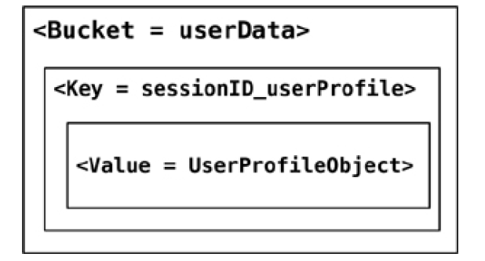

The purpose of key-value database is to ensure that the latencies of data read and writes is maintained when the number of transactions are scaled massively. Similar to the other NoSQL databases already described, a key-value database has no set schema meaning each key can have different attributes within a value attached to them.
Key value databases are used when there are high volumes of data read and writes, usually due to high volumes of users. One use case where key value a Key value database are used is for online retailers shopping baskets. Online retailers have large amounts of different products, all with their own product information data which can be access simultaneously by potentially millions of users. Each user could potentially be viewing, adding and deleting products to or from their basket, which requires constant read requests from a database. The Large amounts of read requests can be handled due to the structure of the database. Some online retailers sell many different products that can have a variety of attributes, the flexibility of the schema allows this information to be stored without affecting the performance of the database.

Similar to the other NoSQL databases the main difference of a key value database is the structure. Key value databases are set up as collections of key value pairs, with the key value pairs being stored as individual items of data. There is no pre-defined structure where columns have a data type, the value object has no defined form and can be a string or an integer. Key value databases are structured in such a way that filters cannot be applied on value fields so the data can only be filtered on the Key. This is different to relational databases where any piece of data within any table or column can be filtered. In Key value databases the ACID principles are also traded off for performance, in this case for faster performance on a large scale. Key value databases are designed in such a way that triggers and functions that would normally be stored and actioned in a relational database database must be written in the code of the software. This adds to the complexity of the code and becomes more tedious when the code needs maintaining.

3.4 NoSQL Wide-Column

“Column families can be used to group related columns for convenience, to optimize disk IO by co-locating columns that are frequently accessed together on disk, or to create a multidimensional structure that can be used for more complex data.” [8]

A wide column database is a database structure that stores its data in rows and columns. However, it does not store data in rows and columns in the same way that a relational database does. The schema of a wide column database is more flexible than a relational database. If an item in a row contains a new attribute, it can be added within the column for that row only. See example below of wide column database with multiple column attributes. [8]
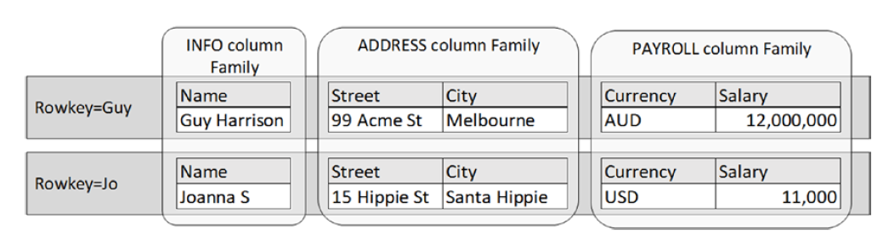
In a relational database the column would have to be added to the whole database. The structure of a wide column database is set up so that each column is saved as a separate file or disk. Columns with similar rows can be split up into column families and saved on the same diskspace to speed up queries. By separating out the column families on to separate diskspace the queries run on each column use less memory than running against every column. The use cases for wide column databases are more geared towards situations where there are extremely large amounts of data. One of the use cases is financial data which is recorded on a time series. For example, stock market price data is recorded every second. The structure of wide column databases enables large amounts of writes to be made to the database constantly without being detrimental to the performance of the database. The ability for column families to be split also allows the columns to be distributed amongst multiple servers. By being split in this way the data has high availability which is also a requirement for financial information.
Wide column databases are optimised for querying data within each column or column family. This is where they differ from relation databases, wide column databases are not able to perform well with joins or complex queries on multiple columns. The schema is flexible, meaning that columns are not restricted by the number of attributes that contain or the value types. Wide column databases are not efficient when updates are being applied due to their design, therefore these databases are used for one off time series data that are not updated, the database is then used to analyse the data rather than change it.

3.5 When to use a NoSQL database

Each of the NoSQL database types have advantages and disadvantages when compared to a relational database and when compared to other types of NoSQL databases. Each database type has different use cases and perform better in different situations.
Generally, relational databases are a good ‘all-rounder’ database that cater for many requirements. Relational databases have actively been used for over 50 years and have ‘stood the test of time’. (First mentioned in a paper by computer scientist Edgar F. Codd in 1970). They are particularly good at storing robust accurate data that conforms to the ACID principle, which is particularly important in situations like banking and finance. Relational databases can perform the functions of most NoSQL databases; however, NoSQL databases are optimised to perform these operations faster, especially when at scale. Relational database performance starts to degrade under certain situations, this is where the NoSQL databases are used.
NoSQL databases have become more popular over time due to the rise of the internet. In some instances, there is a requirement for massive amounts of data to be processed with ultra-low latency. See chart below which shows the increase in trend towards NoSQL databases since 2013 [9]
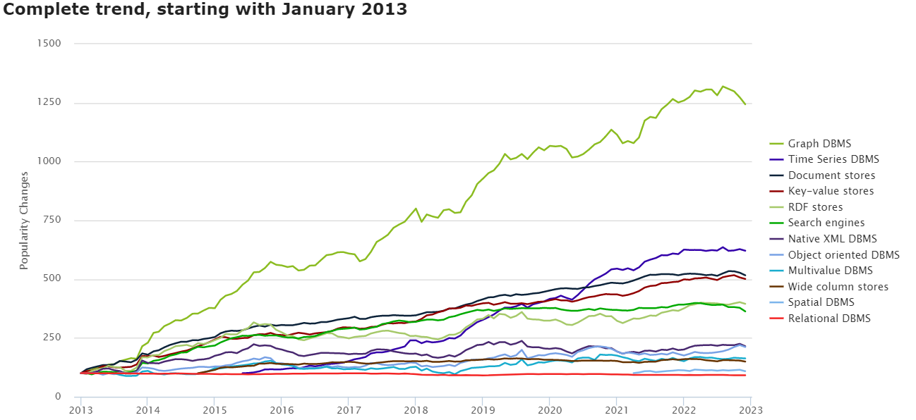

Document store databases have flexible schemas which are used in environments where data and attributes need to be flexible such as product catalogues. They perform better than relational databases in this situation as many columns would need to be added to include these attributes, slowing down the database as more joins are then required.
Graph databases focus on relationships between entities, complex joins are required in relational databases to achieve the same output as s a simple query in a graph database. The complex joins and queries quickly degrade the speed of a relational database especially when done on a massive scale. The use case is particularly useful in instances where online retailers offer product recommendations at scale. Some retailers have millions of users and offer hundreds of thousands of different products. Graph databases can easily produce relationship data to recommend products to customers that would not be achievable through a relational database.
Key Value databases are used in situations where there are large amounts of simple read and writes required. Under these circumstances, relational databases performance starts to degrade due to the volume of requests. Where this is the case, Key value databases should be used rather than a relational database to ensure the database performance is maintained as the number of requests is scaled. Key Value databases such as Redis cache database are used to store temporary data such as customer shopping baskets for online retailers. The Key value database can withstand the millions of requests that are required to store information of peoples shopping baskets.
The final type of NoSQL database discussed is the wide column database. These databases perform well against relational databases where there is a requirement to organise certain data so that I can be queried faster and can be easily distributed. Each column holds similar data, this data can then be distributed to its own disk space or server so that queries made on the data are faster than they would be querying a whole database. Wide column databases are good at recording time series information such as financial information, for example, stock market prices.
As each database type has its own strengths and weaknesses. An entity does not have to pick one database that suits the needs of the entire entity, different types of databases can be used to fit the different requirements. Many large-scale companies use multiple types of databases to fit their requirements. See below example of how Airbnb use different databases for different requirements. [10]

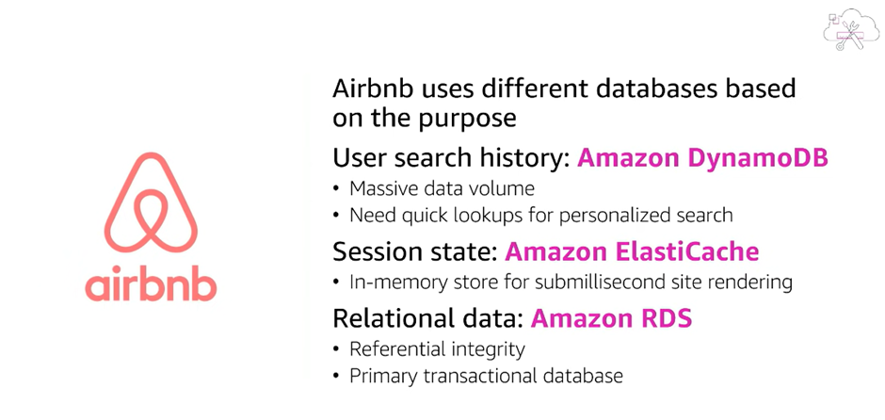
Airbnb have selected DynamoDB which is a document NoSQL database as their database to handle their search history, ElastiCache which is a key value database for the online session states and a relational database for its primary transactional data.
In summary each database type serves a different purpose, one organisation can use many different database types so that it can meet the need of its customer without trading off performance for quality and integral data. In the case of Abertawe Entertainment, a relational database would suite the requirements of the day-to-day transactional processing such as recording sales, purchases and customer information. If Abertawe Entertainment scales further, they could consider implementing different databases for individual functions. MongoDB could be used to store information on the book catalogue. The schema is flexible, it can easily be changed without having to add more tables or having to reorganise the database. If required, more information on books could easily be added, such as number of pages, releases and ISBN numbers. This is particularly helpful with attributes such as ISBN number as not all digital books and audiobooks will have an ISBN number. If the company scales further, a key value cache database such as Redis could be used to store online user’s basket information.

Conclusion

The report compares four types of NoSQL databases and highlighted use cases for each. Each type of database has differences, advantages and disadvantages when compared to a traditional relational database. These differences were used to debate when to use a NoSQL database opposed to a relational database. The report highlights that if a particular entity has several requirements, these requirements will not always be met with a single database type. Larger organisations that operate at scale use different database types for each requirement. The report advises Abertawe Entertainment how it could use multiple database types to satisfy the different requirements of the organisation.

Bibliography

[1] | [Online]. Available: https://www.mongodb.com/document-databases.
[2] | A. G. A. K. Satyadhyan Chickerur, "Comparison of Relational Database with Document-Oriented Database (MongoDB) for Big Data Applications," Institutue of Electrical and Electronic Engineers, pp. https://ieeexplore-ieee-org.ezproxy.uwtsd.ac.uk/document/7433067) , 2015.
[3] | neo4j, [Online]. Available: https://neo4j.com/developer/graph-database/. [Accessed 2022].
[4] | AWS, [Online]. Available: https://aws.amazon.com/nosql/. [Accessed 23 12 2022].
[5] | W. A. B. L. E. A. Wisal Khan, "SQL Database with physical database tuning technique and NoSQL graph database comparisons," Institute of Electrical and Electronics Engineers, no. https://ieeexplore-ieee-org.ezproxy.uwtsd.ac.uk/document/8729264, 2019.
[6] | M. S. N. Aicha Aggoune, "A Method for Transforming Object-relational to Document-oriented Databases," Institute of Electrical and Electronics Engineers, no. https://ieeexplore-ieee-org.ezproxy.uwtsd.ac.uk/document/9047011, 2020.
[7] | M. F. Pramod J. Sadalage, NoSQL Distilled A Brief Guide to the Emerging World of Polyglot Persistence, Addison-Wesley, 2013, pp. Figure 8.1 (P89 Electronic copy, page might vary to actual book).
[8] | G. Harrison, "Next Generation Databases: NoSQL, NewSQL, and Big Data," Apress, 2015, p. 151.
[9] | db-engines.com, [Online]. Available: https://db-engines.com/en/ranking_categories. [Accessed 28 12 2022].
[10] | Amazon Web Servics, "AWS re:Invent 2018," [Online]. Available: https://youtu.be/-pb-DkD6cWg. [Accessed 23 12 2022].

