

University of Wales

Trinity Saint David

Project Initiation Document

Project Management and Research Methods

Ryan Lee Morgan

Software Engineering
1706559
Sue Maw

Hand-in Date
3rd December 2019

Contents

1.0 Background 2
2.0 Project Objectives 2
3.0 Scope 2
3.1 MoSCow 2
3.2 Project Sponsors 2
4.0 Constraints 3
5.0 Resources 3
6.0 Authority 3
6.1 Project Manager 3
6.2 Stakeholder Analysis 3
7.0 Teams and Responsibilities 3
7.1 Team Member Roles 3
7.2 Responsibilities 4
8.0 Life Cycle 5
8.1 Gantt Chart 5
8.2 Pert Chart 6
9.0 Bibliography 7

1.0 Background

The number of drivers on the road today continues to increase each year [1] and with it the concern for road safety. Cark-E provides a secure way to unlock and start a vehicle using biometric technology. Using this technology could reduce car crime, increase road safety and provide accountability where it matters.

2.0 Project Objectives

The aim of the project is to develop a working prototype, alongside a web application, for the Cark-E. It should allow the user to register to the system and gain functionality of the key by allowing locking/unlocking of the vehicle via a finger-print scanner. The device should provide vital information in the event of an accident to aid emergency responders.

3.0 Scope

3.1 MoSCow

Must Have |  | Should Have
- Finger-Print Recognition  - Bluetooth Connectivity  - Mobile / Web App  - User Database  - Device Prototype |  | - Display Light Indicator  - GPS, Tracking  - Charging Capabilities  - LCD Module
Could Have |  | Won’t Have
- Medical Information  - Security Feature  - Police / DVLA Api [2]  - Insurance, Black Box  - WiFi Connectivity |  | - ECU Connectivity  - Voice Recognition

3.2 Project Sponsors

The nature of the product could be appealing to certain organisations such as the police, or the DVLA, while the technology would work well with automotive companies who could utilise the service in their manufacturing process. The team will look to approach several potential sponsors in the interest of further mentoring or funding.

4.0 Constraints

To ensure the project meets its deadline, the team will adopt a timed-scale approach to ensure the development stages remain on target. Certain constraints should be considered in the project planning stage for unexpected delays; i.e. part-order details, funding, sickness or adverse weather conditions [3].

5.0 Resources

The resources needed include mentoring during certain aspects of the project cycle, funding for vital components and the use of a 3D printer to design and produce the prototype housing.

6.0 Authority

6.1 Project Manager

The whole team will assume the role of project manager to ensure steady running of the project. The overall role of the manager is to ensure work is distributed equally throughout the team, while monitoring and updating the time-scale to ensure important deadlines are met.

6.2 Stakeholder Analysis

Delivering the final product is solely the responsibility of the team, however mentoring and some funding will be required. The current stakeholders of this project are James Williams, Sue Maw and Kaplian Radhakrishnan, head of school.

7.0 Teams and Responsibilities

7.1 Team Member Roles

Antony Smith |  | Web Design, Database Management, 3D Printing
Daniel Algie |  | Web Design, Database Management, Marketing
Martin Dunn |  | Software Engineering, Prototype, Marketing
Nathan Morgan |  | Software Engineering, Prototype, Marketing
Ryan Morgan |  | Web Design, Database Management, 3D Printing

7.2 Responsibilities

Web  Developer |  | Design and implement a web application, with the functionality to allow users access to their online accounts. Users should be able to register personal details and configure settings for the device remotely.
Database Technician |  | Implement a backend database that will link user information to the device. The database should include biometric data of the user while storing personal details such as; contact, medical and driver information.
3D Design  Technician |  | Design and produce a prototype of the device using CAD or other 3D design tools of the technician’s preference. The model should be to scale and suitably house the components of the device.
Software  Engineer |  | Develop the software using a management approach of choice, i.e. Waterfall, Agile. Meet at regular intervals with both Electrical Engineers and Database Technicians to ensure a working prototype.
Electrical  Engineer |  | Design and acquire the necessary components to produce a working prototype of the product, implement all functionality. Ensure continuity with Software Engineers for compatibility.
Marketing  Team |  | Organise surveys to provide feedback from potential users, identify key areas of improvement and its unique selling points. Develop a brand image and produce a suitable marketing campaign.

8.0 Life Cycle

8.1 Gantt Chart

The Gantt illustrates the project schedule and identifies the start and finish times of each task required, to develop the Cark-E. Using the Gantt system provides both team and stakeholders with a platform to record and monitor the progress of the project at any point within its lifecycle [4].

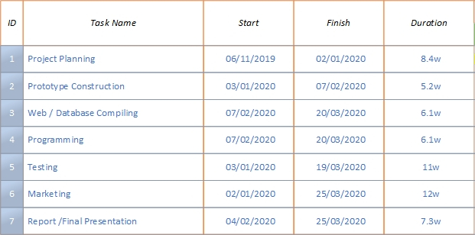

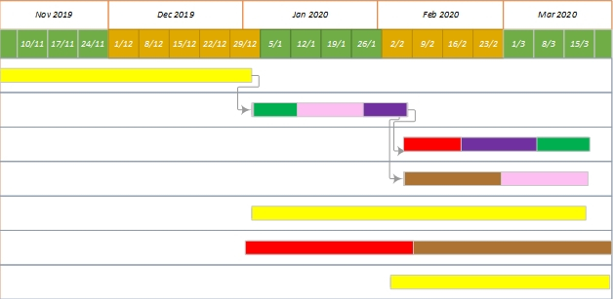

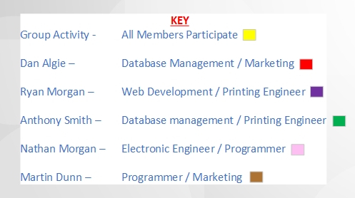

8.2 Pert Chart

The activity network diagram can display where any extra time, or resources will be required to help keep the project on track. Critical paths can be identified to accelerate the development process, while highlighting any problems that could occur.

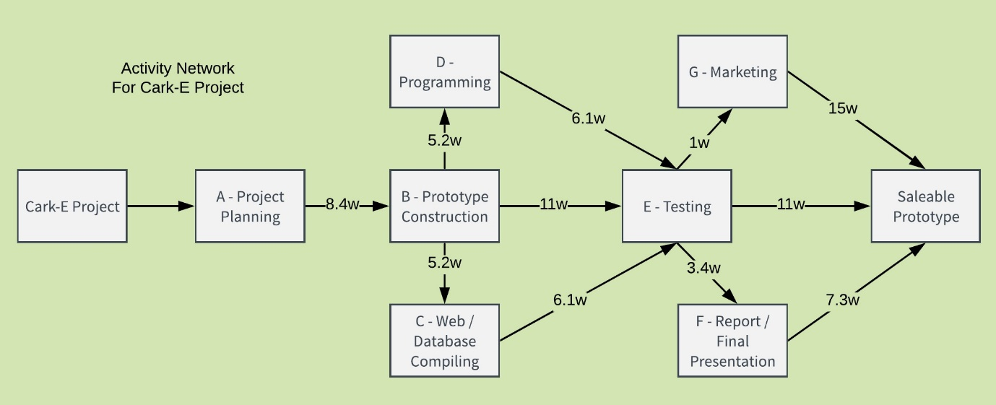

9.0 Bibliography

[1] A. Rowlatt, “Understanding the drivers of road travel : current trends in and factors behind roads use,” London, 2015.

[2] “DVLA Data Sharing Strategy,” Swansea, 2017.

[3] “Manage Project Delays: Proactive Steps to Minimize the Unexpected,” i.t.TOOLKIT, 2018. [Online]. Available: https://www.ittoolkit.com/articles/manage-project-delays%0D. [Accessed: 27-Nov-2019].

[4] A. Trainer, “Profile of Henry Gantt & the History of the Gantt Chart,” Silicon Beach Training, 2012. [Online]. Available: https://www.siliconbeachtraining.co.uk/blog/profile-of-henry-gantt-history-of-gantt-chart. [Accessed: 27-Nov-2019].

