Student Name: Emmanuel Mihai Cotovanu  Student ID: 2222469  Module Title: Foreign Languages and Cultural Awareness  Module Code: 5003  Lecturer: Lisa Bassler  Date: 7.02.2024 | 
ASSIGNMENT 1: PORTFOLIO
(4 Components)

Component 1: Professional Reflection (500 words +/- 10%)

Weighting: 25%
It was Thursday evening, and there was only one check-in left to do at the front desk where I was doing my placement as a receptionist at Ibis Hotel Plymouth. I was waiting for Mr. John Harvey, which for some reason was a few hours late. Around 7PM, a gentleman walks into reception area, looking quite tired. He came at the desk to check in. I could say by his accent that he is from United States of America. After I greeted him and asked how his journey was, I handed the keys and mentioned that his room is on the 2nd floor, first room on the right hand side and he left. About five minutes later I see him coming back, quite determined and visibly annoyed and started to complain that I’ve sent him to the wrong room, as the key didn’t work, and even worse the guest in the room opened the door disturbed by his attempt to open it. Confused, I was trying to understand how that was possible and I offered to show him to the room. As I was going to his room, he stopped me at 1st floor and asked me why I am going to 3rd floor. I understood then that were the problem was and explained how a building’s levels are counted in UK, apologizing for the inconvenience, and offered a complimentary drink at his dinner as compensation (Harvey, 2023).
Reflecting on the previous situation, I realised that I’ve done a cultural misstep by not giving enough attention to his cultural background. Compared to the UK, in United States they label floors differently and they start from 1st floor not ground floor, creating confusion for him. Unfortunately, my standard directions t was perceived as a misdirection due to the guest background, causing discomfort and even embarrassment (Bryand, 2021)
To avoid similar cultural confusions in the future, I need to develop my cultural awareness and cultural nuances. This will need additional researching and familiarising myself with customs and norms of different cultures. It is very important to understand cultural practices and norms as they can have a major impact on how people perceive and respond to the service we offer. In addition, we should communicate with the guests, asking where they are from, about their preferences, cultural practices or customs and any cultural issues that they may have. This displays genuine care to provide a comfortable experience customised to their needs (Tomalin and Stempleski, 2014).
Furthermore, continuing training and courses on cultural awareness might help me negotiate and facilitate different encounters more effectively. By remaining informed and adopting an attitude of continuous development, I can guarantee that I am better prepared to hand our guest’s different cultural expectation, leading to a more inclusive and welcoming atmosphere at the hotel, and increase guest satisfaction leading to increased business levels and less compensations offered to the guests in case of cultural misunderstandings (Lapaquette, 2021).

References:
Bryant, S. (2021) ‘6 Ways a lack of cultural awareness impacts workplace productivity everyday’ Available at: https://www.countrynavigator.com/blog/6-ways-a-lack-of-cultural-awareness-impacts-workplace-productivity-everyday/ (Accessed at: 29.01.2024).
Harvey, M., (2023) ‘UK vs USA Culture guide – Transitioning to America’. Available at: https://www.shipit.co.uk/blog/uk-usa-culture-comparison (Accessed: 29.01.2023)
Lapaquette, L (2021) ‘Cultural differences’ Available at:https://lindsaylapaquette.com/cultural-differences/ (Accessed: 29.01.2024).
Tomalin, B. and Stempleski, S. (2014) Cultural awareness. Oxford: Oxford University Press.

Component 2: Training Plan (500 words +/- 10%)

Weighting: 25%

Identified cultural misunderstanding (in a few words) :
In the above situation we could witness a cultural misunderstanding based on difference of cultural background and norms, USA in this case. In the hotel industry, this can have a massive impact on the guest as it can put him in discomfort and stressful situations (Harvey, 2023).

Training plan (Why/What//Who/Where/When):
In the hotel industry, as a business, you can have guests from all over the world. Having guests with a such diverse cultural background, it is very important to have trained staff members who are able to deal efficiently with guests that may be confused on various situation because of their cultural difference. Having staff members with high cultural awareness skills, will make the guests feeling welcomed and appreciated, leading to increased guest satisfaction, and setting up a positive mood of their stay. For those reasons a comprehensive and interactive cultural awareness and sensitivity it is strongly recommended for the hotel employees to gain insight into the different cultures and habits of the guests, nurturing curiosity, inclusivity, and positive relationships (Lacalle, 2021).
The first step of the training is a general introduction to cultural awareness and sensitivity where the impact of cultural differences on guest perceptions and expectations are discussed in an interactive presentation where employee engagement is encouraged. After a general overview of the cultural differences, we will continue the training with a more in-depth cultural awareness workshop on the major cultures identified on our usual hotel guests. This workshop will focus on providing insights into different traditions, norms and manners. A simulation that will reflect possible real-life circumstances using role-playing exercises will be operated to stimulate employee engagement and create a fun environment during the workshop session (Simon, 2022).
On top of the regular workshops conducted regularly in the hotels events room to keep cultural awareness at a high standard, additional training will be offered on the online platform with a refresher course every 6 months. The training module on cultural awareness will include notes about the importance of clear and respectful communication with everyone, not just the guests, and highlight the value of active listening in understanding guest’s requirements and expectations. The module is also offering language instructions guidelines that will help prevent cultural misunderstandings and increase the inclusivity for the guests. Another aspect that the training module will cover is body language and gestures. The module has designed training programmes that will teach the employees how to greet, address and interact with guests of different origins. Lastly, but equally important, a feedback collection system will be implemented to analyse the information related to cultural interactions. This feedback will help the company to discover areas that require improvements and recognise successful interactions (Reynolds, 2017).
I believe that implementing and constantly evaluating this comprehensive cultural sensitivity and inclusion training, the Ibis hotel will develop a culture among the staff that supports and celebrates diversity, while it is ensuring that everyone is correctly prepared to deal efficiently with the guests different cultural background (Globibo, 2023).

References:

Globibo (2023) ‘What is Cross-Cultural training and why is it important?’ Available at: https://www.linkedin.com/pulse/what-cross-cultural-training-why-important-globibo-pte-ltd/ (Accessed: 29.01.2023)
Harvey, M., (2023) ‘UK vs USA Culture guide – Transitioning to America’. Available at: https://www.shipit.co.uk/blog/uk-usa-culture-comparison (Accessed: 29.01.2023)
Lacalle, E. (2021) ‘What is cultural diversity and why is it important in hospitality’ Available at: https://www.mews.com/en/blog/cultural-diversity-in-hospitality-industry (Accessed: 29.01.2023)
Reynolds, K. (2017) ‘How cultural differences impact international business in 2017’ Available at: https://www.hult.edu/blog/cultural-differences-impact-international-business/ (Accessed: 29.01.2023)
Simon, S. (2022) ‘Four types of Cross Cultural training & Example’ Available at: https://www.simonandsimon.co.uk/blog/four-types-of-cross-cultural-training-examples (Accessed: 29.01.2023)

Component 3: Student Self-Reflection (500 words +/- 10%)

Weighting: 25%
The hospitality sector is an industry marked by an extensive list of guests types that can differed based on their origins and cultural background. My experience in the hotel industry has taught me that an in-depth awareness on the cultural differences is necessary to deliver outstanding customer service. My personal development in this domain has been defined by a transforming process of recognising the vital significance of cultural sensitivity and awareness. Reflecting on myself through Kolb’s learning cycle, I analyse my thinking progress, evaluate changes in my approach, and discuss the importance of adopting cultural sensitivity in the hospitality area. (Mcleod, 2024).
My start of hospitality career was marked by delivering service based on standardised practices and trainings. The initial encounters with guests from diverse backgrounds were challenging at the initial times. I noticed subtle signs of discomfort or disappointment from the guest due to my cultural misunderstanding and lack of awareness. As mentioned in the case of Mr. John Harvey, the vague and light cultural knowledges I possessed at the time lead to an embarrassing and disappointing experience for the guest. Following this experience a desire of change has began to grow into me in order to avoid in the future similar experiences. Reflecting and observing on this experience it came to me that is much needed to improve my cultural awareness in order to offer a better service. My mindset moved from simply offering a standards service to a vision where I was adapting my service based on the guest’s diverse needs and expectations (Mills, 2020).
It is widely known that cultural awareness and multilingualism is a valuable strength for employees in hospitality and not only because it gives insight to new cultures and countries. In the theoretical concept, have those skills will increase the guest satisfaction and his general experience during the stay at the hotel. Being cultural aware is not just about recognising the cultural differences, but also it involves understanding the fundamental ideas that influence the guest perception, preferences and behaviour. This framework of cultural sensitivity lead me to actively experiment my new cultural insights into my daily activities at the hotel. This also involved gathering information about cultural differences around the world, change in my communication style or habits, like learning greetings or commonly used phrases in various languages, and adjusting my service based on the guest’s cultural background (Lobertreau, 2023).
The journey of embracing cultural sensitivity and understanding it became very important in the global trend of hospitality. It has a direct impact on the guest satisfaction, experience and can drive loyalty by building a relationship with them. Guests will feel valued and acknowledged personally when their cultural background is sensibly taken into account. Cultural awareness also promotes a friendly and inclusive environment in the hospitality. It improves the interactions with the guests but with co-workers as well and creates a sense of belonging with both. We can conclude that in today’s globalised world, cultural awareness is no longer a bonus or a simple skill but a mandatory need for the both local and global hotels. Hotels that prioritise and encourage cultural understanding an sensitivity gain a competitive advantage by appealing a more diverse type of guests (Mkono, 2021).

References:
Lobertreau, B. (2023) ‘The best languages to learn for business and hospitality indursty’ Available at: https://hospitalityinsights.ehl.edu/languages-to-learn-for-business (Accessed: 3.02.2024).
Mcleod, S. (2024) ‘Kolb’s learning styles and experiential learning cycle’ Available at: https://www.simplypsychology.org/learning-kolb.html (Accessed: 3.02.2024).
Mills, F. (2020) ‘5 Benefits of developing diversity in customer service’ Available at: https://www.techtarget.com/searchcustomerexperience/tip/5-benefits-of-developing-diversity-in-customer-service (Accessed: 3.02.2024).
Mkono, M. (2010) ‘Cultural Awareness and The Global Hospitality Business’ Available at: https://www.researchgate.net/publication/233647540_Cultural_Awareness_and_the_Global_Hospitality_Business (Accesed: 3.02.2024).

Component 4: Training Presentation (6 Slides)

Weighting: 25%
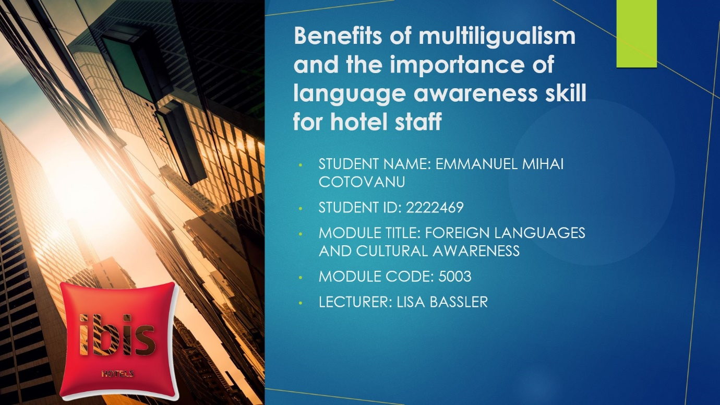
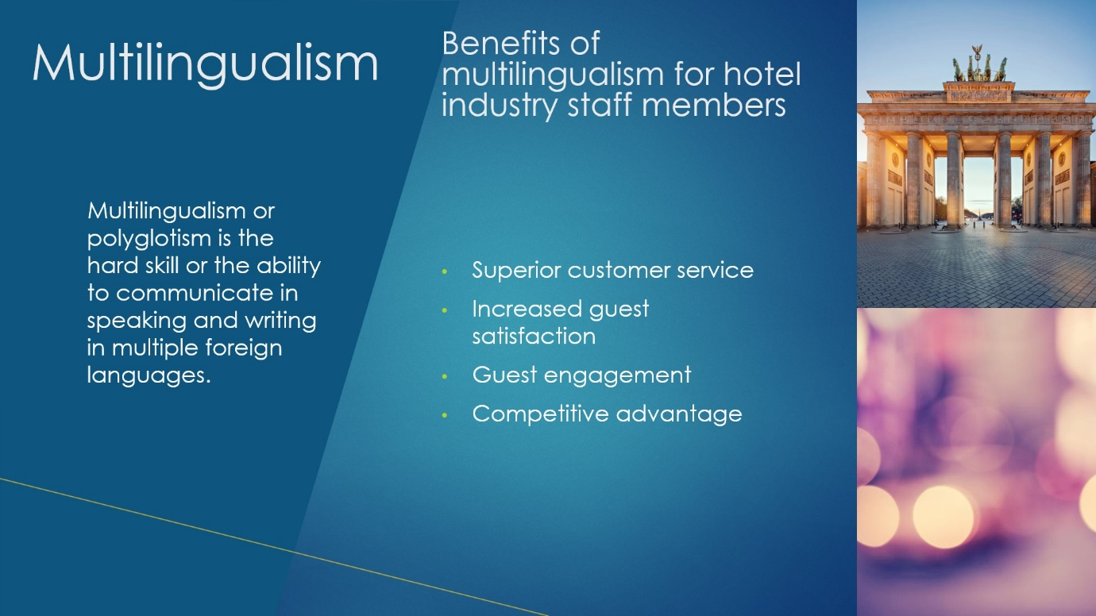
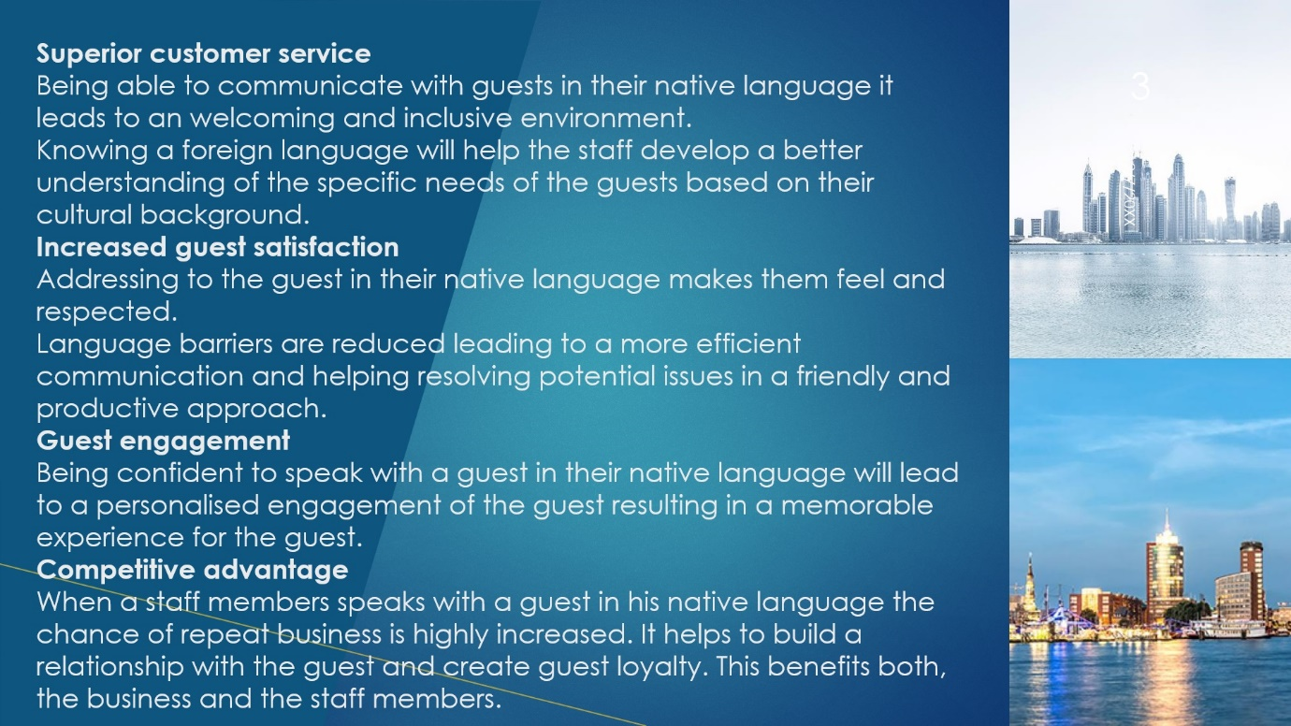
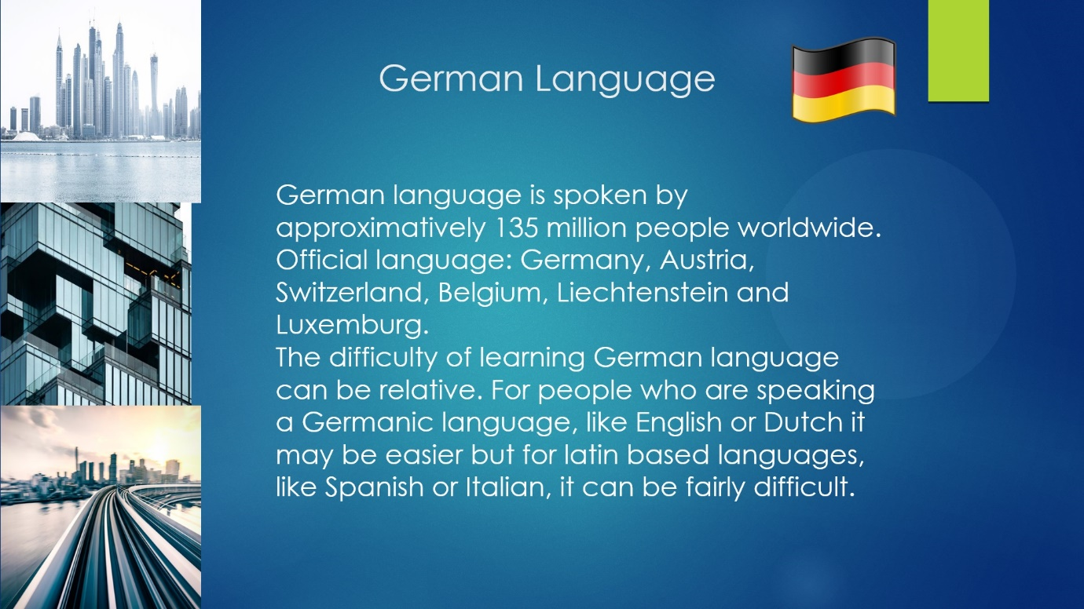
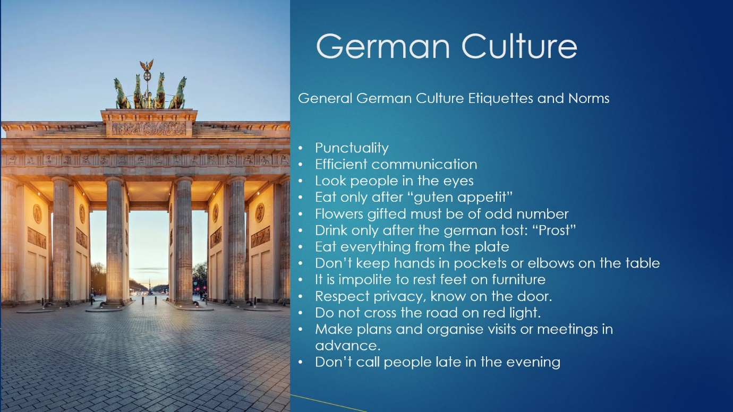
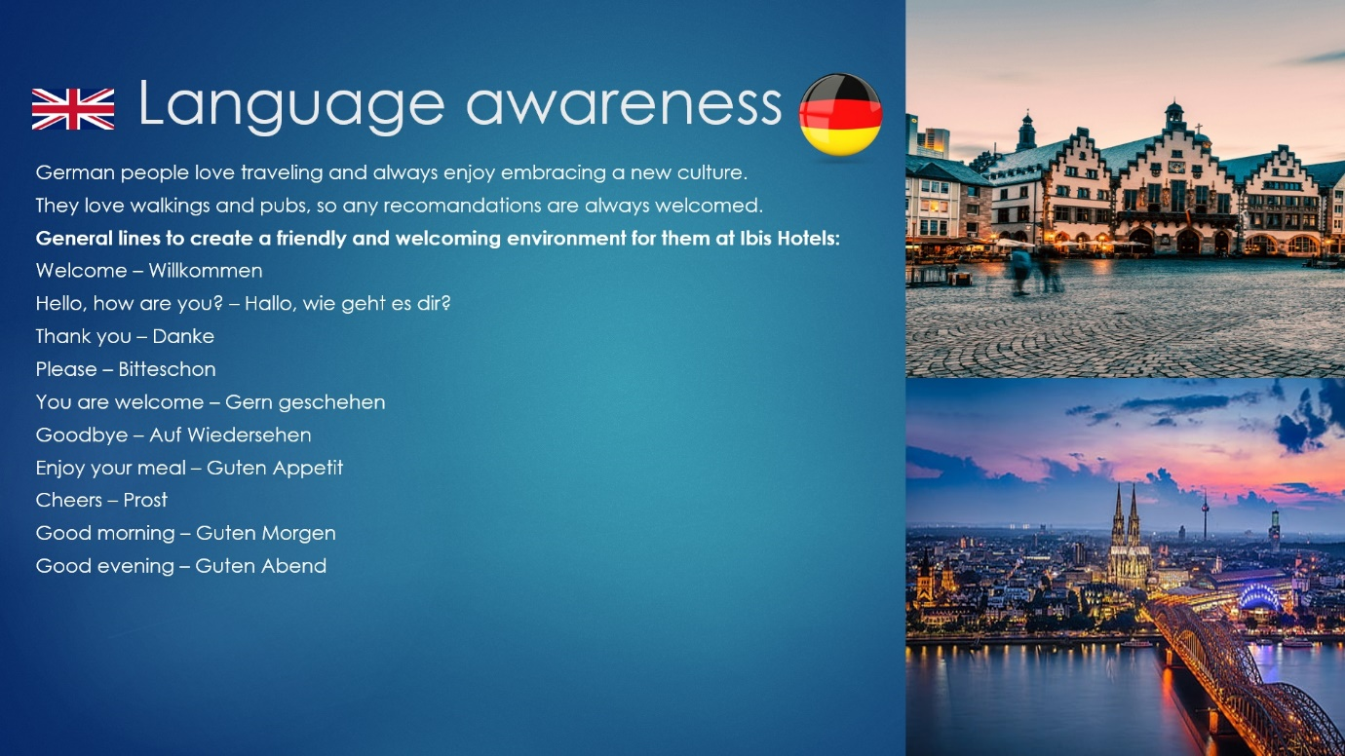
References (no screenshots):

Allen, T. (2023) ‘German speaking countries around the world’ Available at: https://preply.com/en/blog/german-speaking-countries/ (Accessed: 6.02.2024).
Amandson, B. (2022) ‘Basic German Words for Travelers’ Availablet at: https://www.tripsavvy.com/essential-german-phrases-1520017 (Accessed: 6.02.2024).
HospitalitySearchInternational (2024) ‘Benefits of being multilingual’ Available at: https://hospitalitysearch.co.uk/benefits-of-being-multilingual/ (Accessed: 6.02.2024).
Martinez, M. (2022) ‘Exploring a world of opportunities in the hospitality sector with your language skills’ Martinez, Available at: https://www.languagetesting.com/blog/exploring-a-world-of-opportunities-in-the-hospitality-sector-with-your-language-skills/ (Accessed: 6.02.2024).
Stilou, A. (2017) ‘Is multilingualism a necessity in your industry?’ Availablet at: https://cudoo.com/blog/is-multilingualism-a-necessity-in-your-industry/ (Accessed: 6.02.2024).
Wegner, A. (2024) ‘Why language learning is a must in hotel industry’ Available at: https://www.babbelforbusiness.com/us/blog/why-babbel-is-a-must-in-the-hotel-amp-hospitality-industry/ (Accessed: 6.02.2024).

