International Business Plan

for Expansion of Askonas Holt Ltd in the U. S. A.

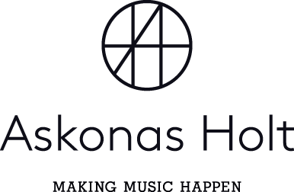

International Business Module SBMA7122D – Assignment 2

Lecturer: Anthony Burns

Master of Business Administration (MBA)

University of Wales Trinity Saint David

Mark Stone

Student Number: 1601851

20th April 2018

INTERNATIONAL BUSINESS PLAN

FOR EXPANSION OF ASKONAS HOLT LTD IN THE U. S. A.

CONTENTS

1 Executive Summary ……………………… 3

2 Corporate Global Vision and Goals ……………………… 4

3 Foreign Market Research ……………………… 5

4 Risk Assessment ……………………… 6

4.1 Hofstede’s Six Dimensions ……………. 6
4.2 Steeple Analysis ……………. 7
4.3 Porter’s Five Forces ……………. 8
4.4 Swot Analysis ……………. 8
4.5 Tows Matrix ……………. 9
4.6 Porter’s Diamond ……………. 9
4.7 QUEST ……………. 10

5 International Business Strategy ……………………… 11

5.1 Exporting ……………. 11
5.2 Licensing and Franchising ……………. 11
5.3 International Joint Venture ……………. 12
5.4 Acquisition of Existing Business ……………. 12
5.5 Set Up a New Fully-Owned Subsidiary ……………. 12

6 International Business Organisational Structure ……………………… 14

6.1 Foreign Subsidiary Structure ……………. 14
6.2 Product Structure ……………. 15
6.3 Geographic Structure ……………. 15
6.4 Matrix Structure ……………. 16

7 Financial Forecasts ……………………… 18

7.1 Six-Year Financial Forecast ……………. 18
7.2 Payback Period ……………. 19
7.3 Discounted Cash Flow ……………. 19
7.4 Monthly Cashflow Forecast ……………. 19

8 International Marketing Plan ……………………… 22

8.1 Standardised vs. Adapted ……………. 22
8.2 Product ……………. 22
8.3 Place ……………. 22
8.4 Price ……………. 22
8.5 Promotion ……………. 23
8.6 Effects Leading to Standardisation ……………. 23
8.7 Effects Leading to Adaptation ……………. 24
8.8 International Marketing Plan ……………. 24

9 International Human Resource Strategy ……………………… 25

9.1 Different Approaches ……………. 25
9.2 Convergence and Divergence ……………. 25
9.3 The Best Fit for Askonas ……………. 26

10 Recommendations ……………………… 27

11 Appendices ……………………… 29

11.1 Askonas Holt Limited Profit and Loss for the Year
Ended 31 December 2013 ……………. 29
11.2 Askonas Holt Limited Balance Sheet for the Year
Ended 31 December 2013 ……………. 30

12 References ……………………… 31

1 EXECUTIVE SUMMARY

Askonas Holt Limited (“Askonas”) is one of the leading classical music agencies in the U. K. It works for international clients, representing them around the world with the geographical split of its income being 34% U. K., 39% Europe and 28% elsewhere (Askonas Holt Limited, 2014).

This business plan sets out the prospects for Askonas expanding into the U. S. A. by opening a New York office. It proposes a vision for the company, considers the market and risks, sets out a business strategy, organisational structure, projects financial details, and suggests appropriate marketing and human resource policies.

It recommends:
- A two-day QUEST process to analyse outcomes and develop strategies;
- Full research of U. S. opera market and artists;
- Setting up a New York subsidiary;
- Organising group in a matrix structure;
- Target an eighth of the U. S. classical market within five years;
- Adapting marketing to reflect the cultural differences in New York;
- Engage American personnel aid cultural fit, communication, and compliance; and
- Develop training programmes and inter-office secondments.

2 CORPORATE GLOBAL VISION AND GOALS

The proximity of continental Europe, the similar time zones and the linguistic abilities of staff makes working with clients and promotors across this region a relatively straightforward exercise for Askonas. Beyond Europe, as demonstrated by the lower proportion of income earnt, there are more barriers to undertaking business.

Whilst it is possible for Askonas to work with American promotors, the time difference, the cost of travel and the lack of personal contact means that this is generally limited to a few key concert halls and opera houses. Similarly, Askonas represents a number of high profile American musicians, but does not have the breadth and depth that exists in its U. K. roster.

Askonas already has a worldwide reputation as a London-based classical music agency. This plan sets out a vision for Askonas to become a truly global agency, starting with opening an office in New York. Such a venture will allow the company to better understand the U. S. classical music market, and to become an integral part of the New York opera scene, rather than merely exporting talent across the Atlantic. In this way it could capitalise on its existing expertise and benefit from being a local company in America with the strongest European connections. This would enable it to attract the best American talent, which in turn would strengthen its relationships with U. S. promoters.

As Chinese tastes for Western classical music increase (Vanderklippe, 2017), the potential of a huge market opening in Asia in the future is a real possibility, and Askonas’ expansion to the U. S. A. and representing itself as a global enterprise could make it uniquely positioned to take advantage of an expanding Chinese market.
3 FOREIGN MARKET RESEARCH

Stone (2018d) explains that it would be of great benefit to Askonas to explore this American market, to increase its U. S. A. income and improve its resources and reputation globally.
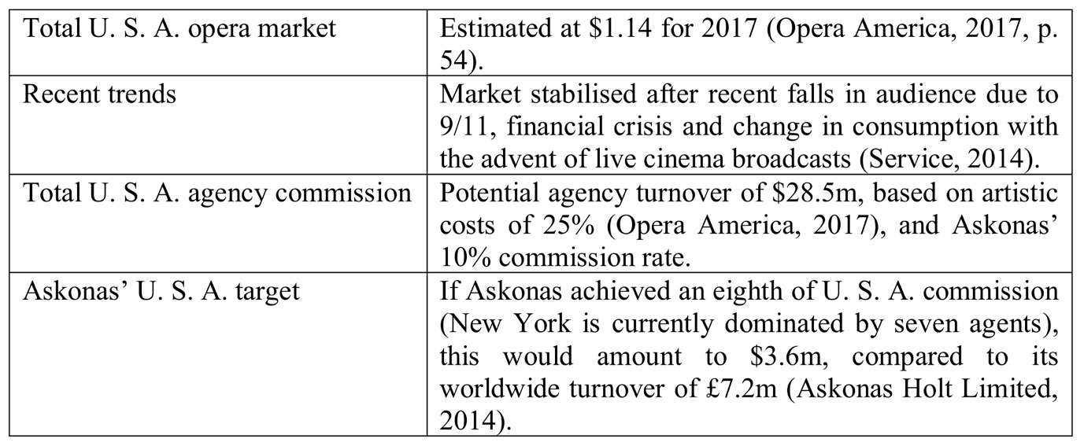
Source: Stone (2018d)
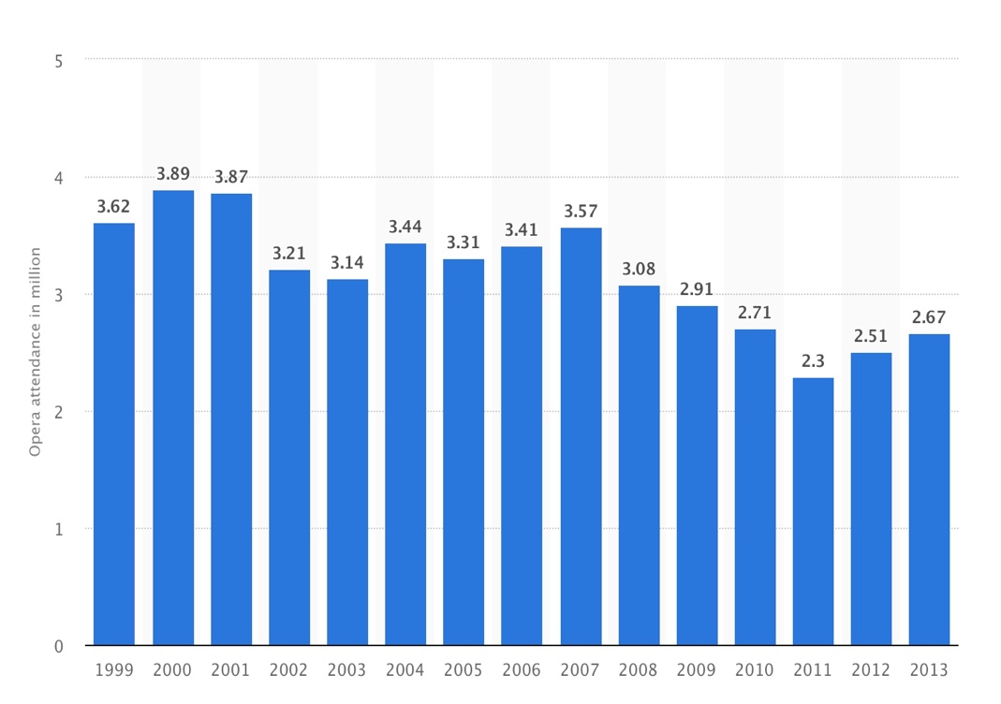
Source: Statista (n.d.)

4 RISK ASSESSMENT

4.1 Hofstede’s Six Dimensions
Although the data collection and generalisation raise concerns over this analysis (De Cieri, 2008), Hofstede (1984) shows the six cultural dimensions of comparison for the U. K. and America.
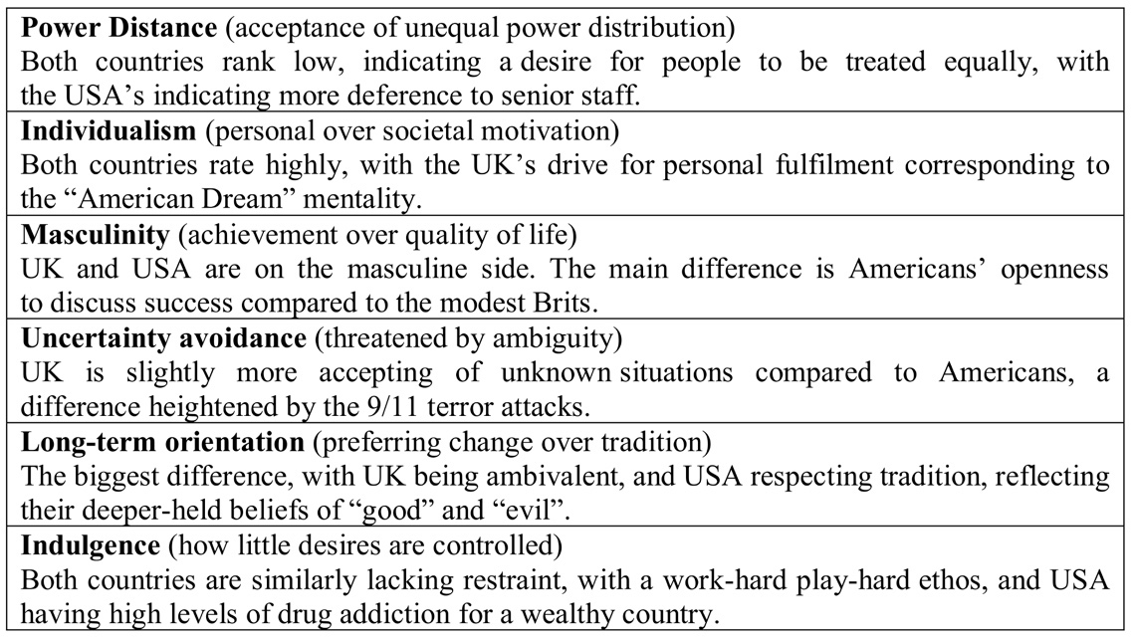
Source: Stone (2018d)
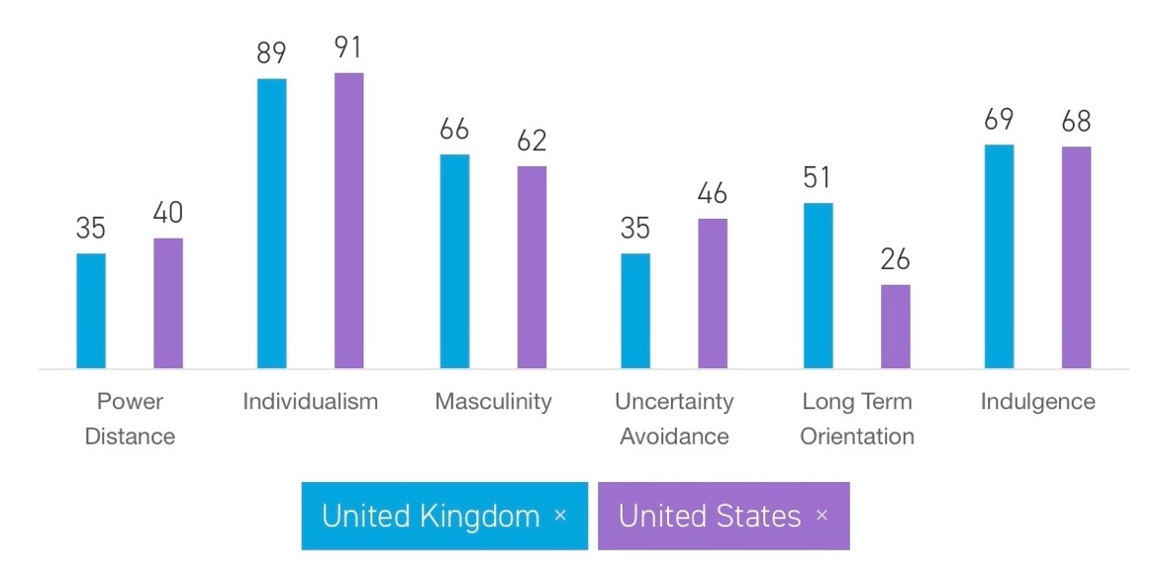
Hofstede Insights (2018)

4.2 STEEPLE Analysis
The STEEPLE environmental analysis (Kew & Stredwick, 2008, p. 6), which although needing to be continually updated (Analysis, 2016) highlights the following factors:
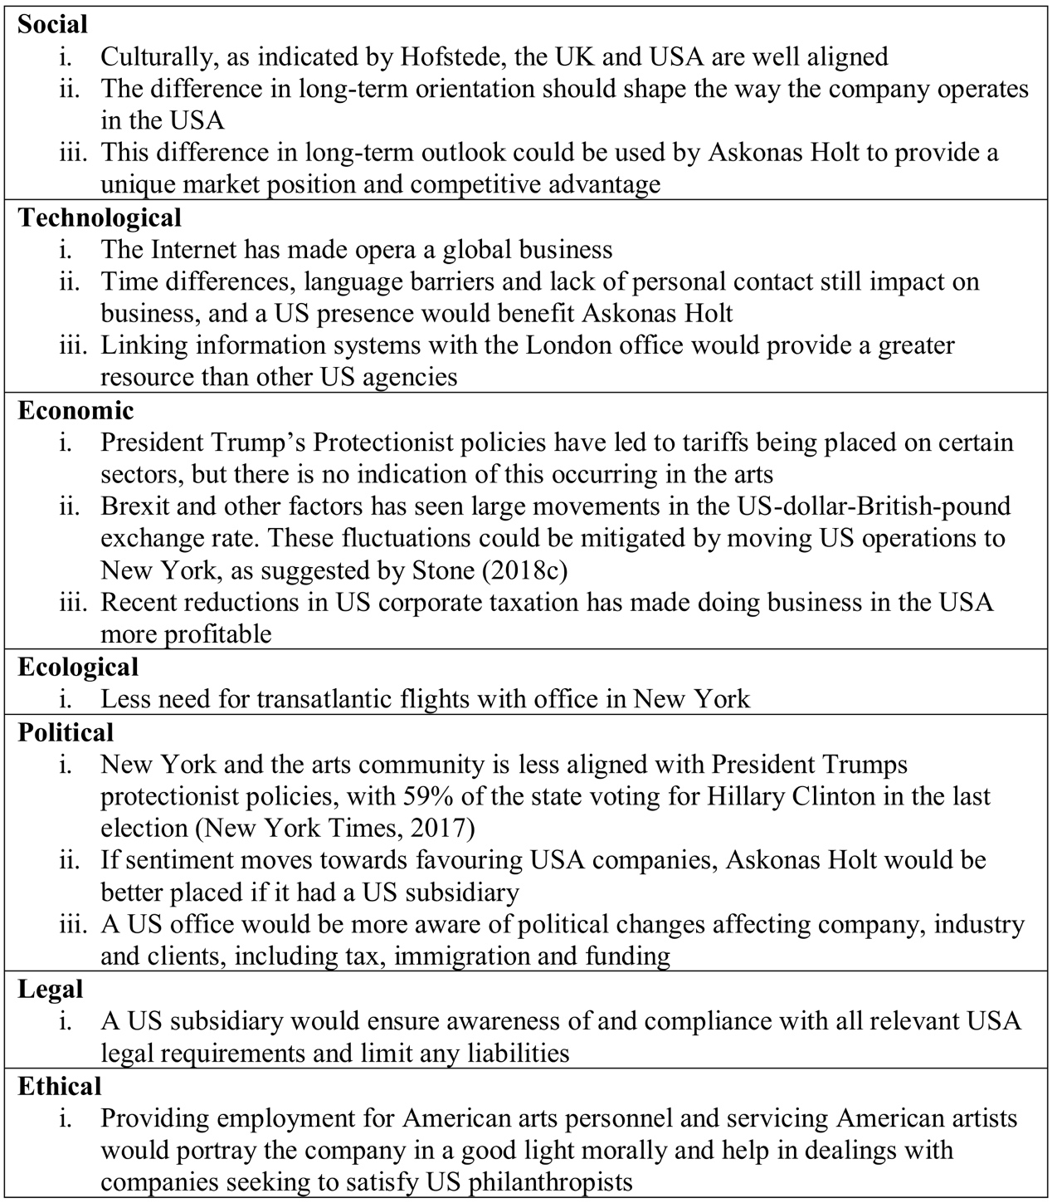
Source: Stone (2018d)

4.3 Porter’s Five Forces
Porter (2008) outlines the five forces of competition that shape strategy, although consideration of these five forces does not guarantee an inviolable and sustained competitive advantage (Dälken, 2014).
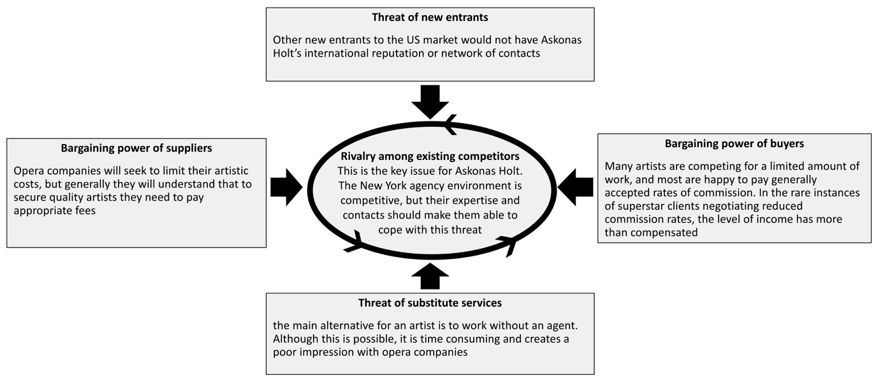
Source: Stone (2018d)

4.4 SWOT Analysis
Despite SWOT analysis providing little insight into unstable and volatile situations (Hill & Westbrook, 1997), it helps understand the internal and external environment (Doyle, 2011).
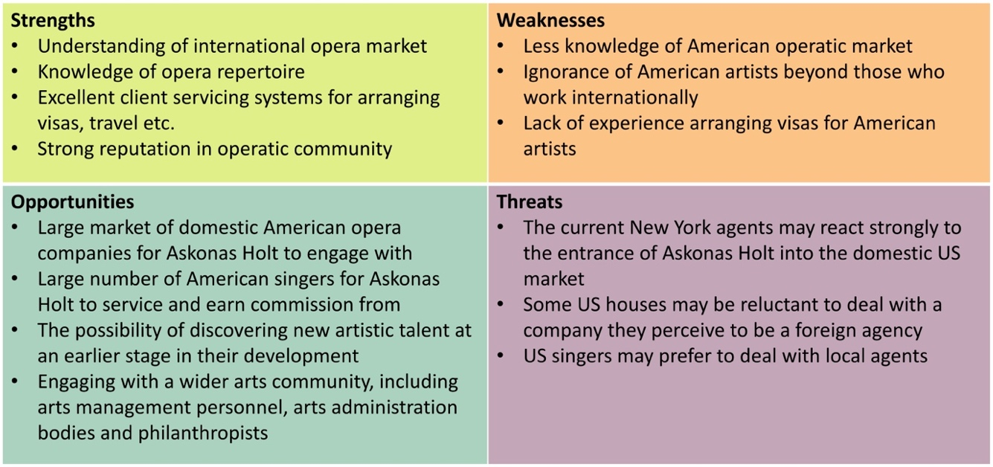
Source: Stone (2018d)

4.5 TOWS Matrix
Weihrich (1984) explains how SWOT analysis summarising the internal and external situation is used to formulate strategies in a TOWS matrix. As this is based on the results of SWOT analysis, it is subject to the same limitations.
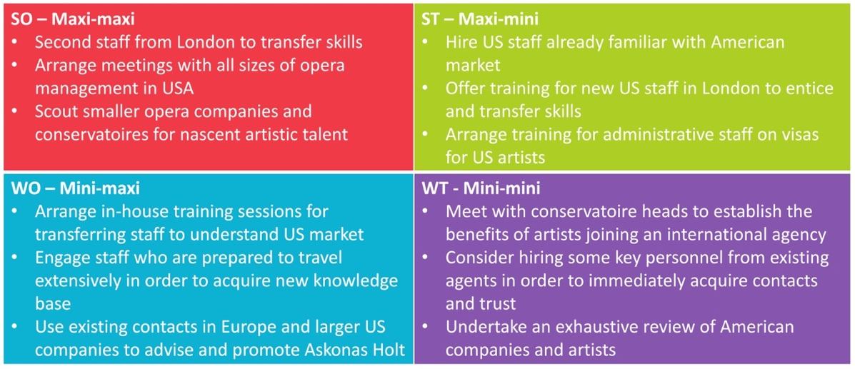
Source: Stone (2018d)

4.6 Porter’s Diamond
Porter’s theory, although criticised for its generalisation (Hill & Hult, 2017), proposed that four national attributes affect competitive advantage.
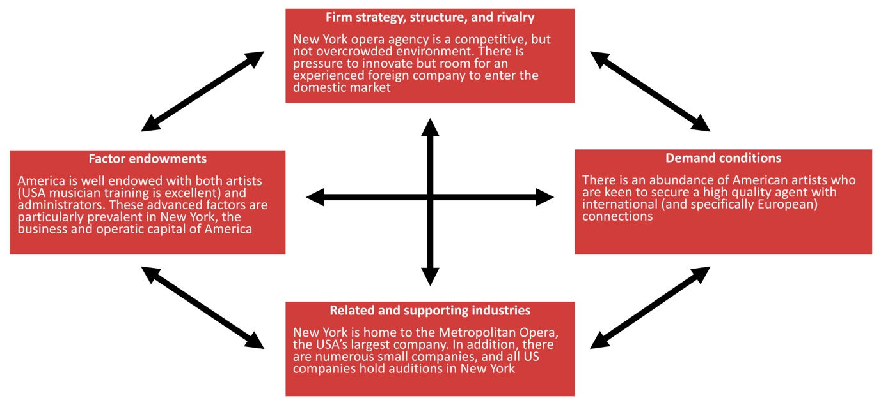
Source: Stone (2018d)
4.7 QUEST
Quick Environmental Scanning Technique should also be undertaken (Du Toit, 1993), involving four stages: preparation; divergent planning; scenario development; strategic options identification. Such a two-day process, exploring possible options, is essential to the success of the organisation in an uncertain and changing environment.

5 INTERNATIONAL BUSINESS STRATEGY

There are many methods of engaging in international business, as outlined by Deresky (2017, pp. 257-264).

5.1 Exporting
Askonas currently works as an exporter of services to the American market, both in terms of working for American clients and servicing the American opera industry. As Deresky (2017, pp. 257-258) points out, this is a relatively low-risk, low-cost method of accessing a foreign market. The disadvantages are that the involvement with the U. S. market is less engaged and, as such, Askonas is viewed by many Americans as a foreign entity. Bartlett & Beamish (2011) elaborate, stating that a true multinational enterprise is one that has “substantial direct investment in foreign countries and actively manage[s] and regard[s] those operations as integral parts of the company, both strategically and organizationally”. This highlights the advantages to expanding the company’s operations: greater investment of resources could reap greater rewards for the company.

5.2 Licensing and Franchising
These options, explained by Deresky (2017, p. 258) are unlikely to be appropriate for Askonas, or improve the profitability of the company. Both strategies would involve earning income from the use of the Askonas brand. However, this could be seen as a dilution of the corporate expertise, or cashing-in on the company’s reputation. Although the income provided would be immediate, it would be limited, and could prevent further expansion by other means in the same territory.

5.3 International Joint Venture
Establishing an international joint venture with an existing agency of similar size and scope would be a method of exploring a greater level of opportunities, but with a greater level of investment and risk (Deresky, 2017, p. 263). Such collaborations already form part of the day-to-day operations of the agency on an informal level, when dealing with some European territories. There are two possibilities for such a strategy. One would be to join forces with another European agency to open a joint operation in New York. This would be an effective way of sharing the costs of such a venture, but it could lead to complications when business is referred back to Europe. Alternatively, a joint venture could be entered into with a New York agency that allowed both companies to earnt profit from each other’s territories. However, international joint ventures often fail, as reported by Nielsen (2002), for reasons such as differences in strategic motivation.

5.4 Acquisition of Existing Business
Acquiring an existing agency in New York could be a short cut to establishing a functioning business, as was the case in the beer industry when the Australian company Foster’s was acquired by South African company SABMiller (Deresky, 2017, p. 264). This would have staff that were already well-versed in the U. S. classical music scene, and it would come with a list of clients ready to service. On the down side, if the agency had a good reputation, the cost of the business would be likely to be high, and if the price was not high then Askonas could be acquiring a business with a poor reputation, staff and client base.

5.5 Set Up a New Fully-owned Subsidiary
The most straight-forward strategy, although one that would require significant investment and risk, is the setting up of a fully-own subsidiary in New York. As with acquisition, this would give Askonas complete control and allow it to realise all revenues of the U. S. venture. Given the nature of the business, and the cash resources currently possessed by Askonas, this would appear to be the best way to proceed. A separate subsidiary would ring-fence any losses for the new company, thereby limiting liability to the parent. It would also help work around any barriers to entry that are put in place, given the current political environment in the U. S. A. and President Trump’s protectionist policies (Libertypen, 2015).

6 INTERNATIONAL BUSINESS ORGANISATIONAL STRUCTURE

The organisation of a multinational enterprise can be arranged in a number of ways dependent on the nature and size of the business.

6.1 Foreign Subsidiary Structure
The simplest option for many businesses when expanding abroad is to treat the new territory as subsidiary to the parent company. Dividing off the international business in this way is often as the result of companies manufacturing at home for foreign sales (Hill & Hult, 2017, p. 400) This ensures that the parent has complete control over all aspects of the business, with finance, operations, marketing and human resources all dictated by head office. However, the foreign enterprise can be over-reliant on home-country managers and resources (Wild & Wild, 2016, p. 315). For Askonas this is unlikely to be the most appropriate. Organising the New York office in this way will give little advantage to the existing set-up and will make the U. S. company appear to be a British company trying to muscle in on the American market. It gives little opportunity for the U. S. office to adapt to local conditions and to establish a culturally appropriate method of doing business.
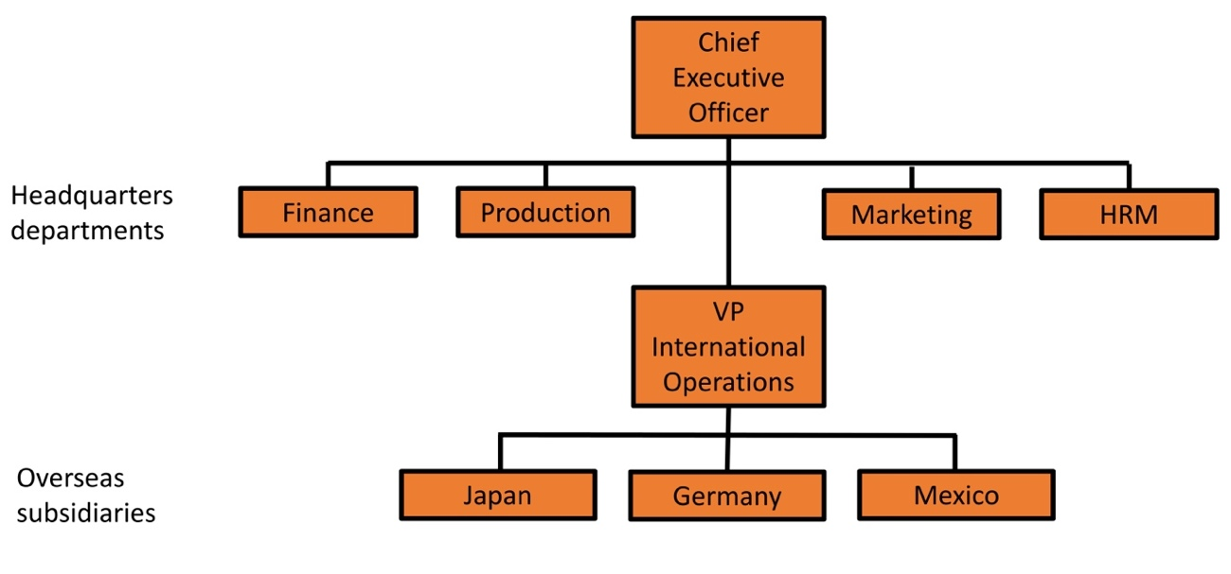
Source: Deresky (2017, p. 310)
6.2 Product Structure
The company could split its operations and manage them globally. This method is often employed by businesses who have domestic structures based on product divisions (Hill & Hult, 2017, p. 403), such as Askonas who divide their work between artist management (earning commission for work secured for clients) and projects (running tours for orchestras and similar groups). There is some benefit to operating tours on a global basis, but difficulties may arise when trying to effectively manage operations in two geographical locations.
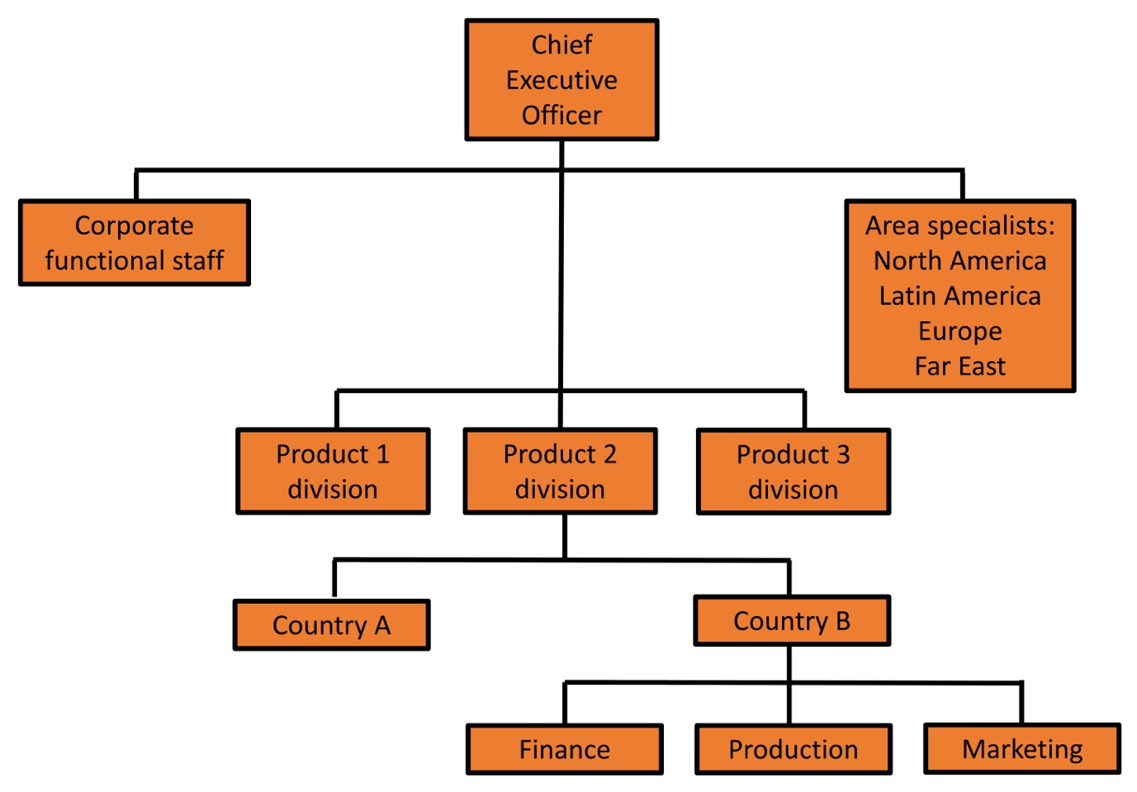
Source: Deresky (2017, p. 311)

6.3 Geographic Structure
Described by Deresky (2017, p. 311) as “the most common form of organizing foreign operations”, this structure seeks to address the problems outlined above by allowing each region to manage its own operations and is “favoured by firms with a low degree of diversification” (Hill & Hult, 2017, p. 402). For Askonas this could prove problematic. Wild & Wild (2016, p. 316) suggest that this method “is best suited to companies that treat each national or regional market as unique”, but classical music is a global industry, and the reason for expanding to the U. S. would be to utilise its already-considerable European expertise in the American market. By running the American business autonomously, it would, at least partially, negate the considerable advantages of cross-fertilisation between London and New York.
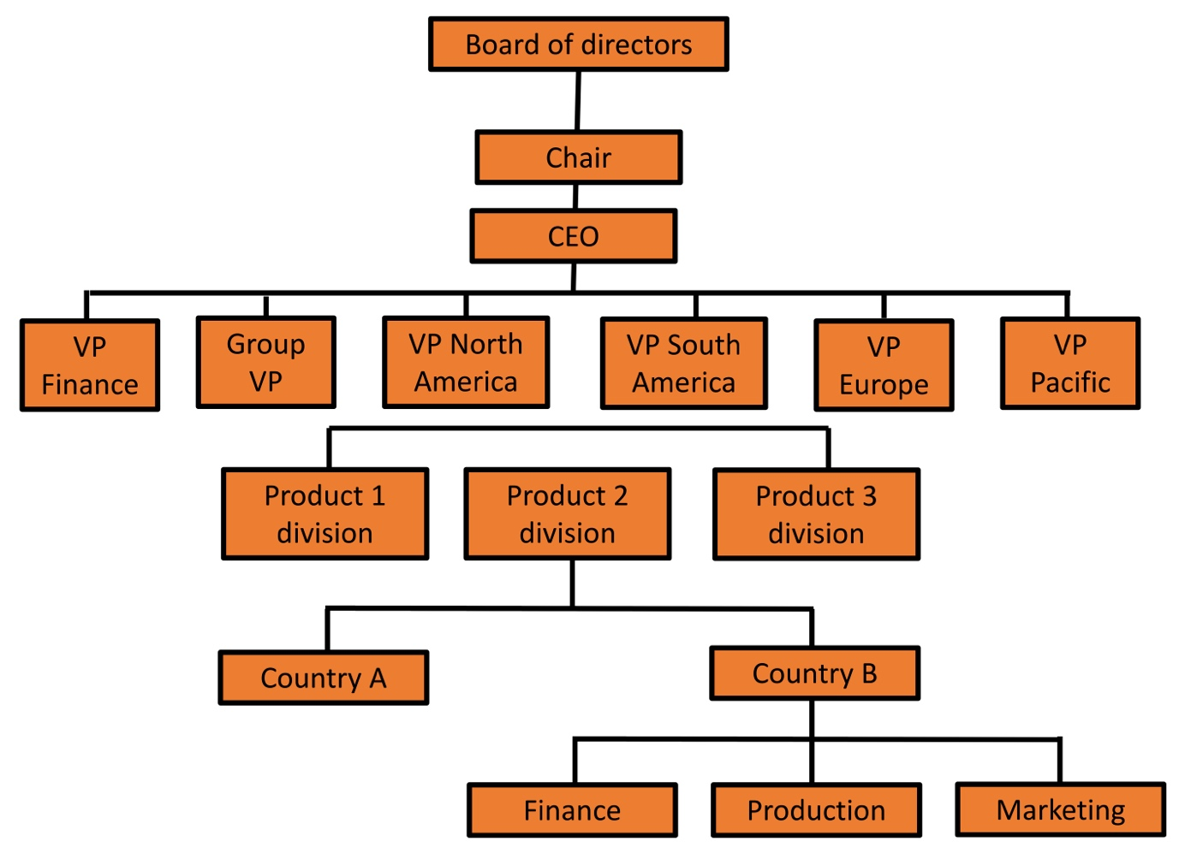
Source: Deresky (2017, p. 311)

6.4 Matrix Structure
In a matrix structure, “responsibility for operating decisions pertaining to a particular product should be shared by the product division and the various areas of the firm” (Hill & Hult, 2017, p. 404), which can “increase coordination while simultaneously improving agility and local responsiveness” (Wild & Wild, 2016, p. 317). By instigating this type of organisation, Askonas could get the best of both worlds. It could allow some degree of autonomy and adaptation for the local market conditions whilst maintaining a strong company ethos and communication across the group. Deresky (2017, p. 312) warns that the overlapping of horizontal and vertical management “often brings confusion, communication problems, and conflict”, however, a company the size of Askonas should be able to counter these effects with regular contact and training.
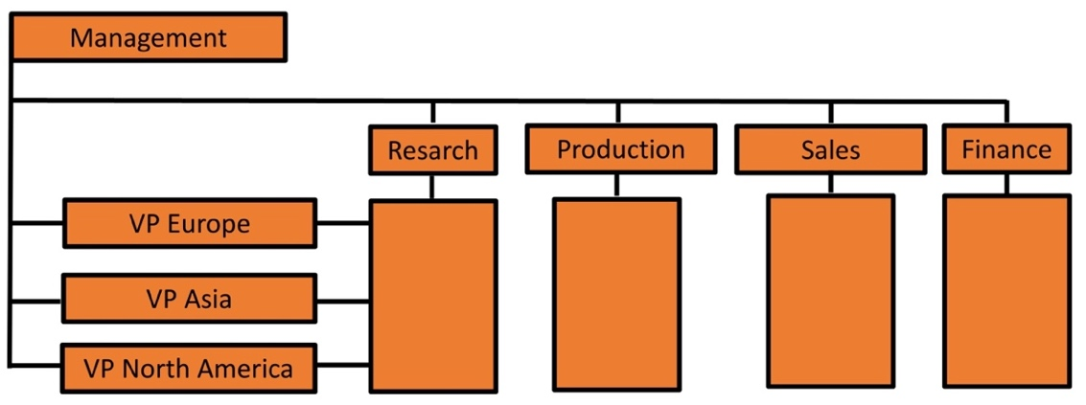
Source: Deresky (2017, p. 312)
Adapting this model to the specifics of Askonas’ business shows a combination of local management of artists and projects with a global reach that provides both economies of scale and an overview of the entire industry. The following outline indicates the organisation, with the possibility of future expansion to Asia:
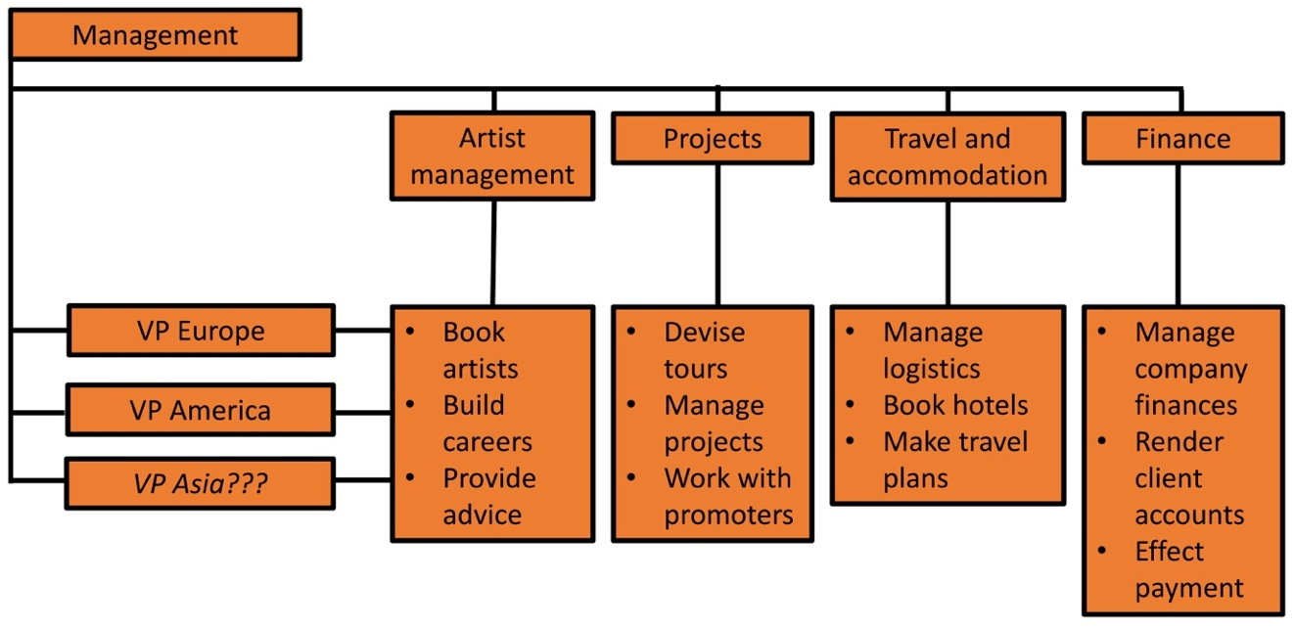
7 FINANCIAL FORECAST

7.1 Six-year Financial Forecast
A forecast for the profit and loss account of the New York office is as follows:
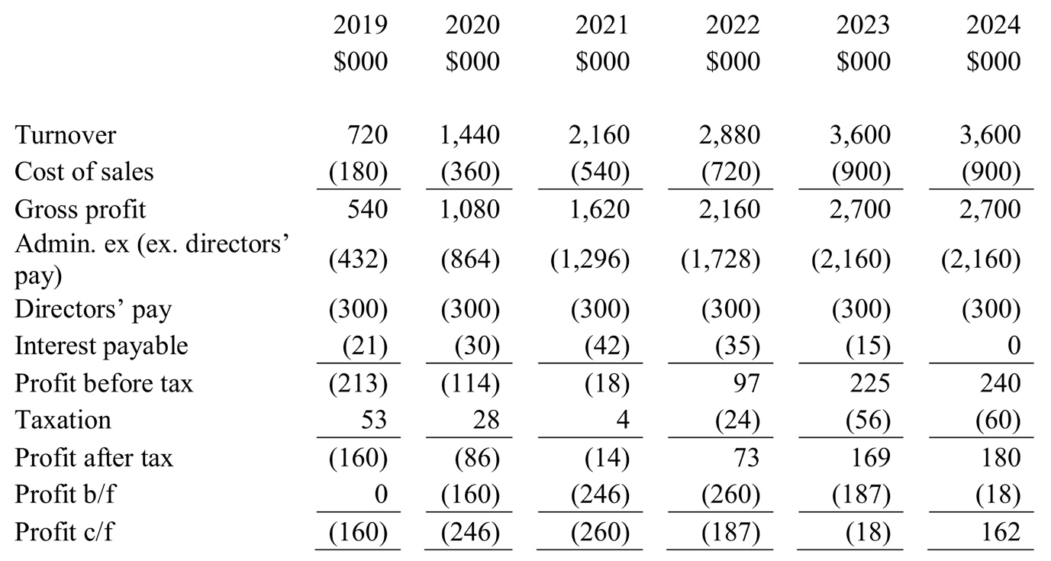
This is based on the following assumptions:
- Turnover will achieve the target of $3.6m in five years;
- Cost of sales is based on 25% of sales as per last published profit and loss account of London office (Askonas Holt Limited, 2014);
- Administrative expenses (excluding directors’ pay) is based on 60% of sales as per last published profit and loss account of London office (Askonas Holt Limited, 2014);
- Director’s pay is estimated as two directors in the U. S. A. office at $150,000 each comparable to pay of London directors (Askonas Holt Limited, 2014);
- Interest payable is based on 10% of negative cash balance; and
- Tax is calculated at 25% of profit based on current estimates of U. S. A. corporate tax rates (Michel & Bowman, 2018).
7.2 Payback Period
Based on this five-year forecast, and the cumulative profit figures we can evaluate the payback period to be between years five and six (Atrill & Mclaney, 2015, p. 365). The number of months into the sixth year that payback is expected is calculated as:
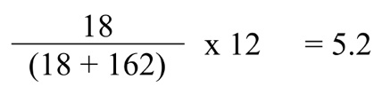
Therefore, the payback period is 5 years and 1 month.

7.3 Discounted Cash Flow
Based on a rate of return of 10%, the Net Present Value (Atrill, 2017, p. 151) is calculated as follows:
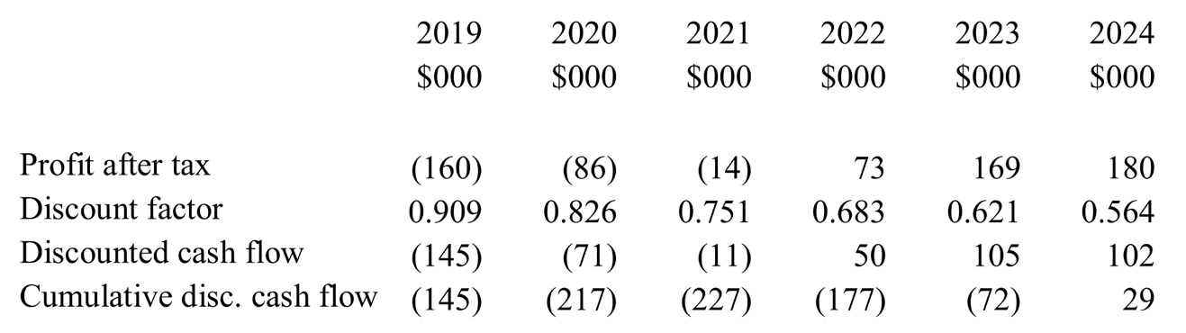
As the NPV of the first six years’ profits are $29,000, and it is anticipated that positive cashflows will exist after this period, there is evidence to suggest that the project is viable.

7.4 Monthly Cashflow Forecast
In order to calculate the amount of capital required to start up the New York office (Collier, 2015, p. 345), monthly cash flows for the period prior to payback have been calculated as follows:
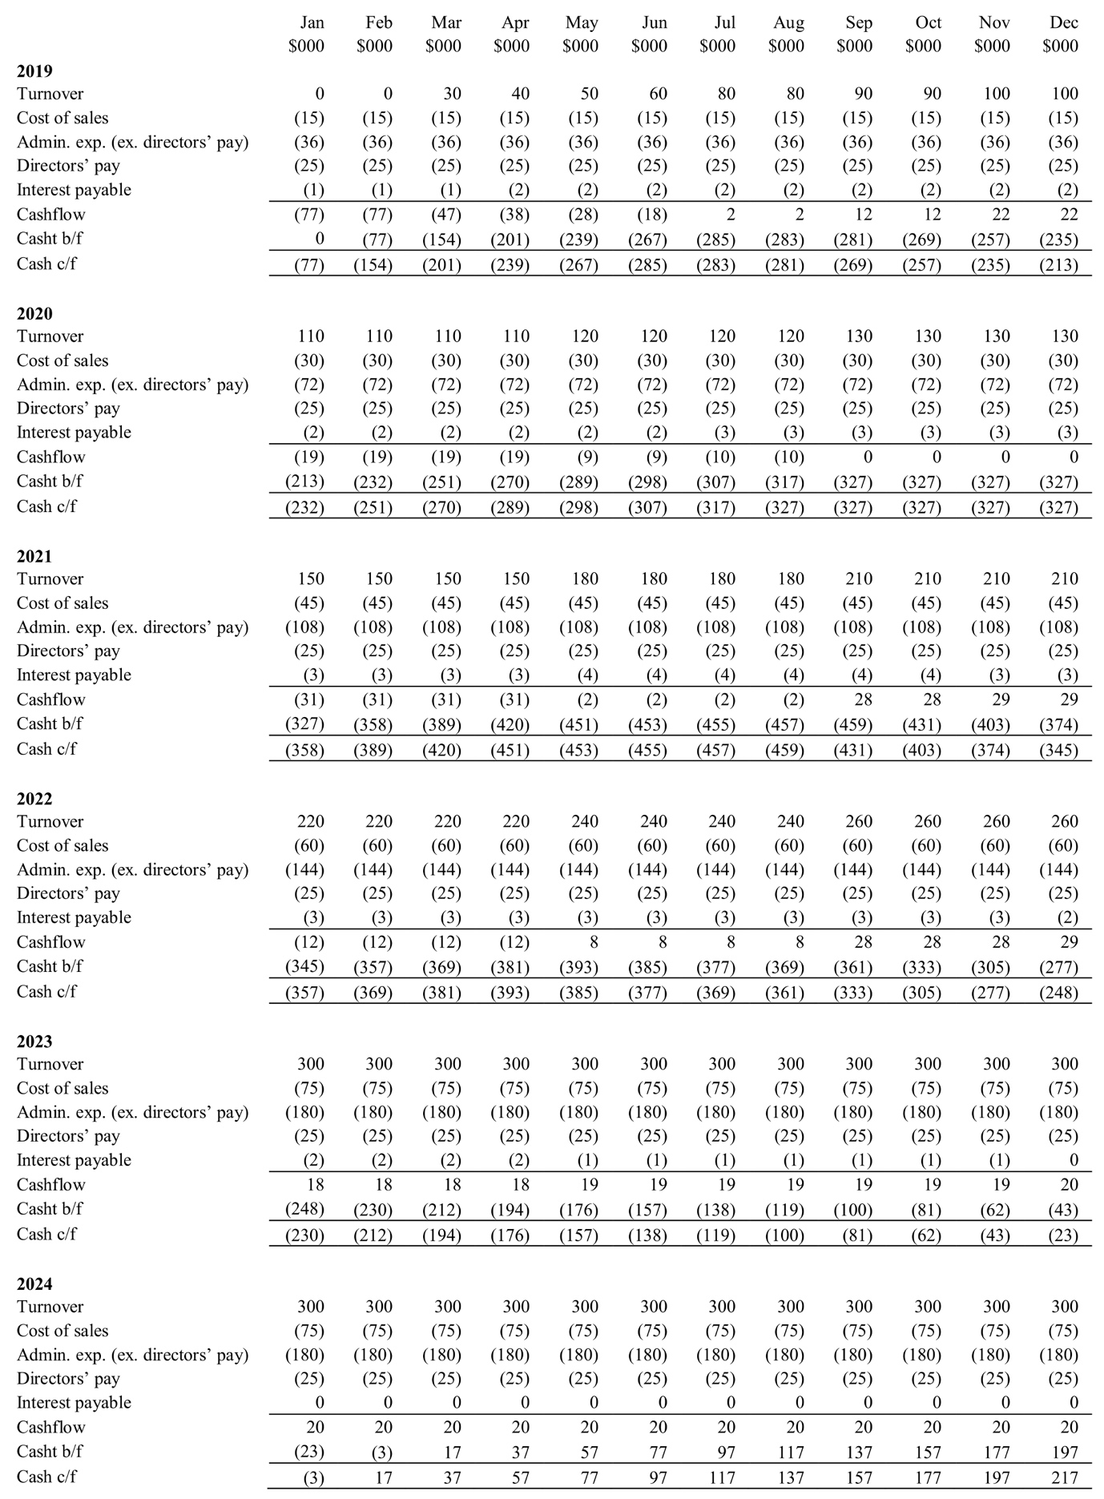

These forecasts are based on the following assumptions:
- Turnover will increase quarter by quarter to reach the estimated annual figure;
- Cost of sales, administrative expenses, directors’ pay and interest payable are spread evenly over the year.
It shows the maximum capital required by the business estimated at $459,000, and so a borrowing facility of $500,000 should be arranged. Askonas Holt Limited (2017, p. 1) shows a cash balance of £498,520 at 31 July 2016, indicating that part of this requirement might be funded from the company’s existing resources. External capital could be raised by bank loan, or by issuing further share capital. The latter is something that could be offered to the new US-based directors of the company.

8 INTERNATIONAL MARKETING PLAN

8.1 Standardised vs. Adapted
One of the key marketing issues is deciding how much the marketing plan for the New York office should replicate that of London. Schewe & Hiam (1998, p. 78) describe the possibility of a global marketing strategy, selling the same thing, the same way everywhere in the world, as opposed to adapting to reflect local needs (Wade, 2016). In order to make this decision, we must consider the “Four Ps”.

8.2 Product
The product (or in this case service) that the company would provide in New York would be very similar to that it provides in Europe, namely the representation of artists and arranging tours for larger groups. The American operations would expand to include the whole spectrum of the American classical music business, rather than just the top end, but in this way it would more closely mirror its current U. K. business.

8.3 Place
American agents provide their services from a central office (often in New York) making visits to individual performing centres for shows and meetings with artists and promotors. There is no difference between this and the way that Askonas currently operates in London.

8.4 Price
American agents are a little more expensive that U. K. agents. Typically, a U. K. agent charges 10% for opera work and 15% for concert work. In America these amounts tend to be 10% and 20% respectively. Whilst it would be possible to charge this higher rate in America this could cause problems across the organisation, with American clients feeling hard done by compared to their European colleagues and European artists facing a price rise for their American work. Despite the prevailing market conditions, it would make sense to have a standard pricing policy across the group, and this should probably reflect the existing commission rates charged in London.

8.5 Promotion
Promotion offers some scope for adaption, due to the slight cultural differences between America and the U. K. The main difference on the Hofstede analysis (see 4.1 above) of the two countries was long-term orientation. This suggests that when discussing careers projections and castings with artists and managements, the focus should be brought closer to the present. In addition, despite the similarity in Masculinity, this characteristic is expressed in different ways. As Hofstede (2018) suggests, “a key point of confusion … lies in the apparent contradiction between the British culture of modesty and understatement which is at odds with the underlying success driven value system in the culture”. American masculinity is more open and direct, and as such promotion can be more up front.

8.6 Effects Leading to Standardisation
A standardised approach is more economical, as existing procedures can be transferred from the London office. The market conditions are similar in London and New York, with classical music being a global market and many customers and suppliers doing business across national borders. The competition is largely local, with exception of IMG artists which operates in America and Europe.

8.7 Effects Leading to Adaptation
There are sociocultural and political differences that imply a different way of doing business would be more effective. More direct communication, aggressively marketing artists to promotors would not be out of place in the way that it would in the U. K. and would be expected. The majority of agents in New York are local rather than global. This suggests that Askonas should ensure it undertakes business in a manner effective to the local environment, and that it could achieve a competitive advantage by being one of the few international agencies. The high level of service involved in the nature of Askonas’ work also suggests that it should interact with its clients in a manner appropriate to the American environment.

8.8 International Marketing Plan
Classical music is a global industry and as such, Askonas should to a large extent adopt a marketing plan that is uniform across the group. The products it supplies, the places it supplies it and the price it charges should be the same in New York and London. Promotion, however, should be adapted to local conditions as is done by many multinational enterprises (Yin, 2014). Askonas should emphasise the advantages to suppliers and customers of working with an international agency, thereby achieving a unique market position and a resultant competitive advantage. By charging slightly lower London commission rates in New York, it could undercut the local competition. Adapting its style of doing business to a more overtly aggressive and direct method of communication, employing local staff, would reduce the risk of culture clashes and ensure that it quickly attains its growth potential.

9 INTERNATIONAL HUMAN RESOURCE STRATEGY

As with marketing, the management of human resources can be undertaken in a number of ways:

9.1 Different Approaches
An ethnocentric policy would see human resource practices transferred from the London office to the New York office, with expatriates managing the subsidiary. This has the advantage of economies of scale and transferring knowledge. However, it could mean that the new office is viewed as a foreign entity by the market and, with President Trumps increasingly protectionist stance, the organisation may find itself at a disadvantage.

A similar approach is geocentrism, whereby the organisation adopts single policies across the group that are applicable to all offices. The disadvantage with this one-size-fits-all approach is that there is inevitable compromise and the HR policies will not be exactly right for any location.

Two alternatives are polycentrism and regiocentrism, which allow each subsidiary or region to develop its own human resource polices. This allows the company to fit precise to the needs of the market, although it could cause problems if one office considered itself to be getting less beneficial treatment than another.

9.2 Convergence and Divergence
Evidence shows that in multinational enterprises there is variation in HR practices across different countries (Henderson, 2011, p. 216). Although there are some practices that could be viewed as universally best practice, often the cultural differences in a given country mean there is a necessity for some degree of variation and, if not a completely divergent set of policies, at least some form of strategic choice.

9.3 The Best Fit for Askonas
Although the world of classical music is small, there are still cultural differences that exist between New York and London. At its heart is the significant level of public subsidy that exists in the arts in Europe compared to the negligible amounts that exist in America. This moves arts in the U. S. A. firmly into the realm of commercial business, even though many are run as not-for-profits. Coupled with the inherent cultural differences in New York society compared to London, HR policy should be tailored slightly to allow the company to attract and retain the best talent. Ex-patriate postings between offices could be of great benefit if undertaken strategically, increasing knowledge of both markets and facilitating easy communications between the offices.

10 RECOMMENDATIONS

Based on the above report, the following recommendations are made:
- Undertake a two-day internal QUEST process to analyse possible outcomes of and alternative strategies for a New York subsidiary of Askonas. This will equip the management team for the inherently volatile and unpredictable nature of setting up a new office in New York.
- Fully research the U. S. opera market and artists to add to the already-considerable in-house knowledge. The current U. S. business focuses on the top level of the industry, and this knowledge base needs to be deepened.
- Set up the American business as a newly-formed subsidiary. This will limit liability and protect against future moves by the U. S. A. towards protectionism.
- Organise the enlarged group in a matrix structure. This is ideal for Askonas, given the level of division between projects and commission and the global nature of the industry.
- Aim to achieve an eighth of the U. S. classical market within five years. This is an achievable goal and one that would see the New York office approaching breakeven in the same time frame.
- Marketing should be similar to that of the London office but adapted to reflect the cultural differences in New York. Whilst reflecting the global nature of the industry it is important to understand the important cultural differences between the countries.
- Engage a number of American personnel for the New York office to aid cultural fit, communication and compliance. This too will help counter both explicit and implicit protectionism in America, and it will ensure that the company is best suited to the local environment.
- Develop programmes for staff development and inter-office secondments to ensure an effective and aligned work environment. Broadening the possibilities for staff will not only improve their skillsets but act as an aid to recruitment.
[3,890 words]

11 APPENDICES

11.1 Askonas Holt Limited Profit and Loss for the Year Ended 31 December 2013*
 | £ | £ | £ |  | £ | £ | £
Turnover:
Artist management | 4,497,339 |  |  |  | 4,031,039
Project management | 2,740,659 |  |  |  | 4,337,292
Sundry | 8,560 |  |  |  | 10,140
U. K. |  | 2,455,261 |  |  |  | 2,089,943
Europe |  | 2,790,428 |  |  |  | 3,093,437
R.O.W. |  | 2,000,869 |  |  |  | 3,195,091
 | 7,246,558 | 7,246,558 | 7,246,558 |  | 8,378,471 | 8,378,471 | 8,378,471
Cost of sales |  |  | (1,748,997) |  |  |  | (3,194,482)
Gross profit |  |  | 5,497,561 |  |  |  | 5,183,989
Administrative Expenses:
Depreciation of owned fixed assets |  | (65,358) |  |  |  | (66,801)
Depreciation of leased fixed assets |  | 0 |  |  |  | (27,375)
Profit/loss on disposal of fixed assets |  | 24,412 |  |  |  | (1,986)
Loss on foreign exchange |  | (27,164) |  |  |  | (32,376)
Operating lease rentals |  | (215,757) |  |  |  | (215,757)
Plant and machinery |  | (4,033) |  |  |  | (4,451)
Auditor fees |  | (21,504) |  |  |  | (21,504)
Directors' pay |  | (1,047,052) |  |  |  | (927,003)
Other staff pay |  | (2,551,344) |  |  |  | (2,438,928)
 |  | (1,444,762) |  |  |  | (1,286,595)
 |  |  | (5,352,562) |  |  |  | (5,022,776)
Other operating income |  |  | 10,669 |  |  |  | 7,945
Operating profit |  |  | 155,668 |  |  |  | 169,158
Investment income |  |  | 0 |  |  |  | (102)
Interest receivable |  |  | 3,403 |  |  |  | 2,007
Interest payable (lease charges) |  |  | 0 |  |  |  | (12,444)
Profit before tax |  |  | 159,071 |  |  |  | 158,619
Tax |  |  | (58,071) |  |  |  | (58,664)
Profit after tax |  |  | 101,000 |  |  |  | 99,955
Dividends |  |  | (60,000) |  |  |  | (50,000)
 |  |  | 41,000 |  |  |  | 49,955

Source: Askonas Holt Limited (2014)
* The last published accounts to include a full profit and loss account
11.2 Askonas Holt Limited Balance Sheet for the Year Ended 31 December 2013

 | £ | £ |  | £ | £
FIXED ASSETS:
Tangible Fixed Assets:
Computer equipment | 47,877 |  |  | 56,427
Fixtures and fittings | 15,300 |  |  | 12,679
Motor vehicles | 0 |  |  | 5,937
 |  | 63,177 |  |  | 75,043
CURRENT ASSETS:
Debtors:
Trade debtors | 730,404 |  |  | 626,437
Other debtors | 64,425 |  |  | 37,926
Prepayments and accrued income | 308,691 |  |  | 329,334
Deferred tax asset | 12,846 |  |  | 17,256
 |  | 1,116,366 |  |  | 1,010,953
Cash |  | 939,508 |  |  | 1,058,263
 |  | 2,055,874 |  |  | 2,069,216
CURRENT LIABILITIES:
Creditors:
Trade creditors | (334,084) |  |  | (502,534)
Corporation tax | (35,806) |  |  | (52,433)
Other taxes and social security | (316,485) |  |  | (308,277)
Directors' current accounts | (118,092) |  |  | (365)
Other creditors | (104,389) |  |  | (73,868)
Accruals and deferred income | (115,278) |  |  | (152,865)
 |  | (1,024,134) |  |  | (1,090,342)
 |  | 1,094,917 |  |  | 1,053,917
CAPITAL AND RESERVES:
Share capital |  | 179,116 |  |  | 179,116
Premium |  | 83,580 |  |  | 83,580
Other reserves |  | 62,005 |  |  | 62,005
Profit and loss account |  | 770,216 |  |  | 729,216
 |  | 1,094,917 |  |  | 1,053,917

Source: Askonas Holt Limited (2014)

12 REFERENCES

ASKONAS HOLT LIMITED (2014) Annual Report for the year ended 31 December 2013, Companies House. Available at https://beta.companieshouse.gov.uk/company/ [accessed 10 April 2018].
ASKONAS HOLT LIMITED (2017) Annual Report for the period ended 31 July 2016, Companies House. Available at https://beta.companieshouse.gov.uk/company/ [accessed 12 April 2018].
ATRILL, P. (2017) Financial Management for Decision Makers, 8th edition. Pearson: Harlow.
ATRILL, P. & MCLANEY, E. (2015) Accounting and Finance for Non-specialists, 9th edition. BARTLETT, C. A. & BEAMISH, P. W. (2011) Transnational Management: Text, Cases, and Readings in Cross-Border Management, 6th edition. McGraw-Hill: New York.
BEATTIE, A. (2016) The Pitfalls of Porter’s 5 Force, Investopedia. Available at https://www.investopedia.com/articles/investing/103116/pitfalls-porters-5-forces.asp [accessed 24 February 2018].
COLLIER, P. M. (2015) Accounting for Managers, 5th edition. Wiley: Chichester.
DÄLKEN, F. (2014) Are Porter’s five competitive forces still applicable? A critical examination concerning the relevance of today’s business, University of Twent. Available at http://essay.utwente.nl/65339/1/Dälken_BA_MB.pdf [accessed 25 February 2018].
DE CIERI, H. (2008) Transnational Firms and Cultural Diversity, Oxford Handbooks Online. Available at http://www.oxfordhandbooks.com/view/10.1093/oxfordhb/9780199547029.001.0001/oxfordhb-9780199547029-e-25?print=pdf [accessed 25 February 2018].
DERESKY, H. (2017) International Management: Managing Across Borders and Cultures. Pearson: Harlow.
DOYLE, C. (2011) A Dictionary of Marketing, 3rd edition. Available at http://www.oxfordreference.com.ezproxy.uwtsd.ac.uk/view/10.1093/acref/9780199590230.001.0001/acref-9780199590230-e-1085# [accessed 23 February 2018].
DU TOIT, A. S. A. (1993) Significance of the Quick Environmental Scanning Technique (QUEST) for information services, University of South Africa. Available at https://www.researchgate.net/profile/Adeline_Du_Toit/publication/260807929_Significance_of_the_Quick_Environmental_Scanning_Technique_QUEST_for_information_services/links/5587d89208aef58c03a06003/Significance-of-the-Quick-Environmental-Scanning-Technique-QUEST-for-information-services.pdf [accessed 24 February 2018].
HENDERSON, I. (2011) Human Resource Management for MBA Students, 2nd Edition. Chartered Institute of Personnel and Development: London.
HILL, C. W. L. & HULT, G. T. M. (2017) International Business: Competing in the Global Marketplace, 11th edition. McGraw Hill Education: New York.
HILL, T. & WESTBROOK, R. (1997) SWOT Analysis: It’s Time for a Product Recall, Long Term Planning, Vol. 30, No. 1, pp. 46-52, 1997. Available at https://pdfs.semanticscholar.org/2391/d179adcfa511bf2ff57f1b89a837ffcf4f92.pdf [accessed 25 February 2018].
HOFSTEDE (1984) Cultures Consequences: International Differences in Work-Related Values. Sage Publications: Newbury Park.
HOFSTEDE INSIGHTS (2018) Country Comparison, Hofstede Insights website. Available at https://www.hofstede-insights.com/country-comparison/the-uk,the-usa/ [accessed 15 February 2018].
KEW, J. & STREDWICK, J. (2008) Business Environment: Managing in a Strategic Context. Chartered Institute of Personnel and Development: London.
LIBERTYPEN (2015) Trump vs Friedman – Trade Policy Debate, YouTube. Available at https://www.youtube.com/watch?v=7DhagKyvDck [accessed 20 April 2018].
MICHEL, A. & BOWMAN, L. (2018) America Is Competitive Again, Thanks to a Lower Corporate Tax Rate, The Heritage Foundation. Available at https://www.heritage.org/taxes/commentary/america-competitive-again-thanks-lower-corporate-tax-rate [accessed 10 April 2013].
NEW YORK TIMES (2017) New York Results, New York Times. Available at https://www.nytimes.com/elections/results/new-york [accessed 22 February 2018].
NIELSEN, B. (2002) Why Do International Joint Ventures Fail? A Strategic Mismatch Explanation, Copenhagen Business School. Available at https://www.researchgate.net/publication/5092998_WHY_DO_INTERNATIONAL_JOINT_VENTURES_FAIL_A_STRATEGIC_MISMATCH_EXPLANATION [accessed 12 March 2018].
OPERA AMERICA (2017) Annual Field Report, Opera America. Available at https://www.operaamerica.org/files/oadocs/financials/FY16_AFR.pdf [accessed 16 February 2018].
PESTLE ANALYSIS (2016) Potential Limitations to the PEST Analysis and How to Address Them, Pestle Analysis website. Available at http://pestleanalysis.com/limitations-of-the-pest-analysis/ [accessed 24 February 2018].
PORTER, M. E. (2008) The Five Competitive Forces That Shape Strategy, Harvard Business Review, January 2008. Available at https://s3.amazonaws.com/academia.edu.documents/32580687/HBR_on_Strategy.pdf?AWSAccessKeyId=AKIAIWOWYYGZ2Y53UL3A&Expires=1519390921&Signature=I5WrvWC9QkO4oZ0yfFsTTBWFD9Y%3D&response-content-disposition=inline%3B%20filename%3DHBR_on_Strategy.pdf#page=25 [accessed 23 February 2018].
PSLIDES (n.d.) Free TOWS Matrix for Powerpoint, Pslides website. Available at https://pslides.com/templates/tows-matrix-powerpoint/ [accessed 24 February 2018].
SCHEWE, C. D. & HIAM, A. (1998) The Portable MBA in Marketing, 2nd edition. John Wiley & Sons, Inc.: New York.
SERVICE, T. (2014) Opera in cinemas: is it creating new audiences? Available at https://www.theguardian.com/music/tomserviceblog/2014/may/30/opera-in-cinemas-creating-new-audiences [accessed 22 February 2018].
STATISTA (n.d.) Attendance at opera mainstage performances in the United States from 1999 to 2013, Statista website. Available at https://www.statista.com/statistics/193053/attendance-at-opera-performances-in-the-us-since-1999/ [accessed 16 February 2018].
STONE, M. (2018a) What does international business mean to you?, eMBA International Business 2018, Curatr, Step 2.1. Available at https://uniwales.curatr3.com/courses/emba-international-business-copy-6338/home#object/221670 [accessed 25 February 2018].
STONE, M. (2018b) Benefits of Trade | United States Trade Representative, eMBA International Business 2018, Curatr, Step 2.5. https://uniwales.curatr3.com/courses/emba-international-business-copy-6338/home#object/221674 [accessed 25 February 2018].
STONE, M. (2018c) Exchange rate theory, eMBA International Business 2018, Curatr, Step 3.6. https://uniwales.curatr3.com/courses/emba-international-business-copy-6338/home#object/221683 [accessed 25 February 2018].
STONE, M. (2018d) Foreign Market Research and Risk Assessment for Expansion of Askonas Holt Ltd in the USA, University of Wales Trinity Saint David. Available at https://moodle.uwtsd.ac.uk/mod/turnitintooltwo/view.php?id=60409 [accessed 17 April 2018].
VANDERKLIPPE, N. (2017) Available at https://www.theglobeandmail.com/news/world/china-is-classical-musics-new-frontier/article14881218/ [accessed 10 April 2018].
WADE, T. (2016) The Global Marketing Mix – Internationalisation – Global Marketing, YouTube. Available at https://www.youtube.com/watch?v=vRTuaTg0V5c [accessed 13 April 2018].
WEIHRICH, H. (1982) The TOWS Matrix – A Tool for Situational Analysis, Long Range Planning, Vol.15, No. 2, pp. 54-66, 1982. Available at https://s3.amazonaws.com/academia.edu.documents/54127095/weihrich1982.pdf?AWSAccessKeyId=AKIAIWOWYYGZ2Y53UL3A&Expires=1519469988&Signature=XNR79gpkU4RPAdNrG2Dl3LNI9v0%3D&response-content-disposition=inline%3B%20filename%3DThe_TOWS_Matrix_A_Tool_for_Situational_A.pdf [accessed 24 February 2018].
WILD, J. J. & WILD, K. L. (2016) International Business: The Challenges of Globalization, 8th edition. Pearson: Harlow.
XE (2018) XE Currency Charts: GBP to USD. Available at http://xe.com/currencycharts/?from=GBP&to=USD&view=10Y [accessed 22 February 2018].
YIN, M. (2014) Localization Strategy – SOM354, YouTube. Available at https://www.youtube.com/watch?v=TOhEOT1Xf9Y&feature=youtu.be [accessed 13 April 2018].

