Ad from Coca-Cola’s Christmas branding campaign
“The holidays are coming”

The three levels of signification can be applied to this ad given additional insights into its significance from a design, social and ideological perspective.
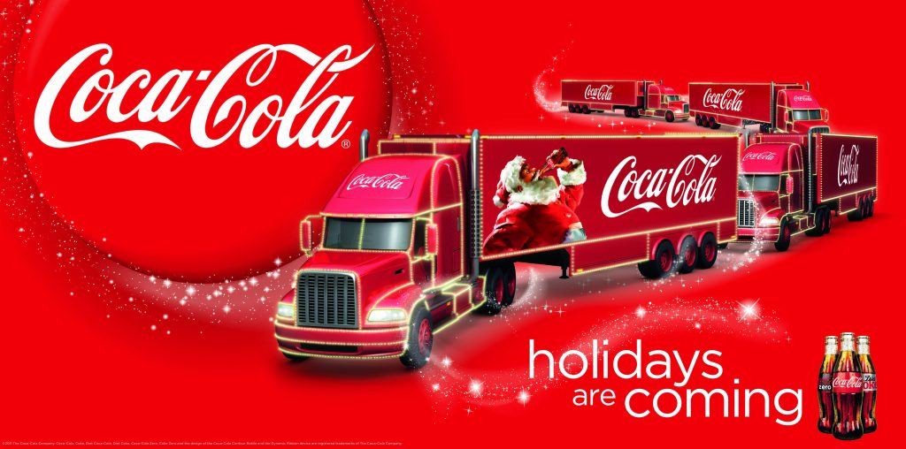
Denotative Meaning of “The holidays are coming” ad
Denotative Meaning | Analysis
 | This ad is an image which portrays a red transport truck with white lights, surrounded by swirling stars, and featuring Santa Claus enjoying a Coca-Cola beverage. The tagline “Holidays are coming” is present, along with three soda bottles. Red and white colours dominate the image, and the words “Coca-Cola” are prominently displayed.

Connotative Meaning of “The holidays are coming” ad
Connotative Meaning | Analysis
Cultural Meanings or Associations | The swirls of stars suggest the magic and wonder of the holidays, evoking feelings of excitement and anticipation associated with the festive season. Santa Claus symbolizes the spirit of generosity and goodwill traditionally linked with Christmas, tapping into nostalgic emotions and cultural traditions surrounding gift-giving and family gatherings. The use of red, a colour traditionally associated with Christmas, symbolizes warmth, passion, and vitality, contributing to the festive atmosphere and creating a sense of joy and excitement.
Societal Values or Meanings | The advertising reinforces the cultural significance of holiday traditions, emphasizing the importance of togetherness, generosity, and shared experiences with loved ones. The ad promotes consumerism by associating Coca-Cola with cherished holiday moments, suggesting that purchasing and consuming the beverage can enhance the holiday experience and create lasting memories. The use of familiar holiday symbols like Santa Claus and red imagery appeals to societal ideals of tradition, nostalgia, and emotional connection, reinforcing the brand’s connection with consumers during the holidays.
Personal Interpretation | As a viewer, I interpret the advertisement as invoking a sense of warmth, joy, and nostalgia associated with the holiday season. The imagery of Santa Claus and the vibrant red colour scheme evoke fond memories of past holidays and create a festive atmosphere that resonates with me emotionally. The ad suggests that Coca-Cola is not just a beverage but a symbol of holiday cheer and togetherness, prompting feelings of anticipation and excitement for the upcoming festivities. Overall, the combination of visual elements evokes a sense of holiday magic and reinforces the idea of Coca-Cola as an integral part of the holiday tradition, fostering a personal connection with the brand and its message

Mythic Meaning of “The holidays are coming” ad
Meaning | Analysis
How do the visual elements convey messages that reflect dominant social values and norms about what you should want and how you should feel? | The advertisement portrays Coca-Cola as a symbol of joy, togetherness, and holiday cheer, aligning with dominant social values that prioritize happiness and celebration during the festive season. It suggests that consuming Coca-Cola products is desirable and integral to experiencing joy and celebrating holidays, reflecting societal norms around consumerism and the commercialization of festivities.
What power dynamics or social hierarchies are implicit in the representation of these symbols? Whose perspectives or experiences are being centred or marginalized? | The advertisement centres the perspective of individuals who can afford and access Coca-Cola products, reinforcing power dynamics that privilege those with economic resources. It marginalizes perspectives from communities with limited access to healthcare and nutrition education, overlooking the potential negative impacts of sugary beverage consumption on public health. Also, the association with Santa Claus perpetuates Western cultural narratives that prioritize consumerist ideals and materialism, potentially marginalizing alternative cultural perspectives.
Are there any underlying biases or stereotypes embedded in the portrayal of these symbols? How do they contribute to the construction of social identities or cultural narratives? | The portrayal of Coca-Cola as synonymous with joy and happiness perpetuates biases that equate consumption with fulfilment and well-being, reinforcing consumerist narratives that prioritize material possessions over genuine human connection. This contributes to the construction of social identities that associate happiness and status with the consumption of Coca-Cola products, perpetuating stereotypes about the link between consumerism and personal happiness. The association with Santa Claus may perpetuate stereotypes about Western cultural dominance and the universalization of Western holiday traditions.

This example, explored in some detail by Hodgson (2017), illustrates a look at all three levels of signification can be quite revealing, evidencing the use of Barthes concepts.

