
University of Wales Trinity Saint David
Wales Institute of Science & Art

Engine Performance Characteristics
Vehicle / Motorsport Technology
ACHA4003/4004/4012

Dylan Brierley
2304450
03/2024

Contents
1 Introduction 3
2 Test Equipment and Methodology 4
2.1 Engine Dynamometer 4
2.2 Test Method 5
3 Dyno Results Table 6
4 Graphical Analysis 7
4.1 SFC against Engine Speed 7
4.2 Torque against Engine Speed 9
4.3 Brake Power against Engine Speed 11
5 Test Conclusions 12
6 Evaluation 13

Introduction

The aim of this test is to understand further the application of an engine dynamometer including the calculations and analysis of the data taken from the test. Looking at the data in this detail will be able to show how the engine is performing in the different measurements, for example, torque, power, fuel efficiency and mean pressure.

Test Equipment and Methodology

Engine Dynamometer

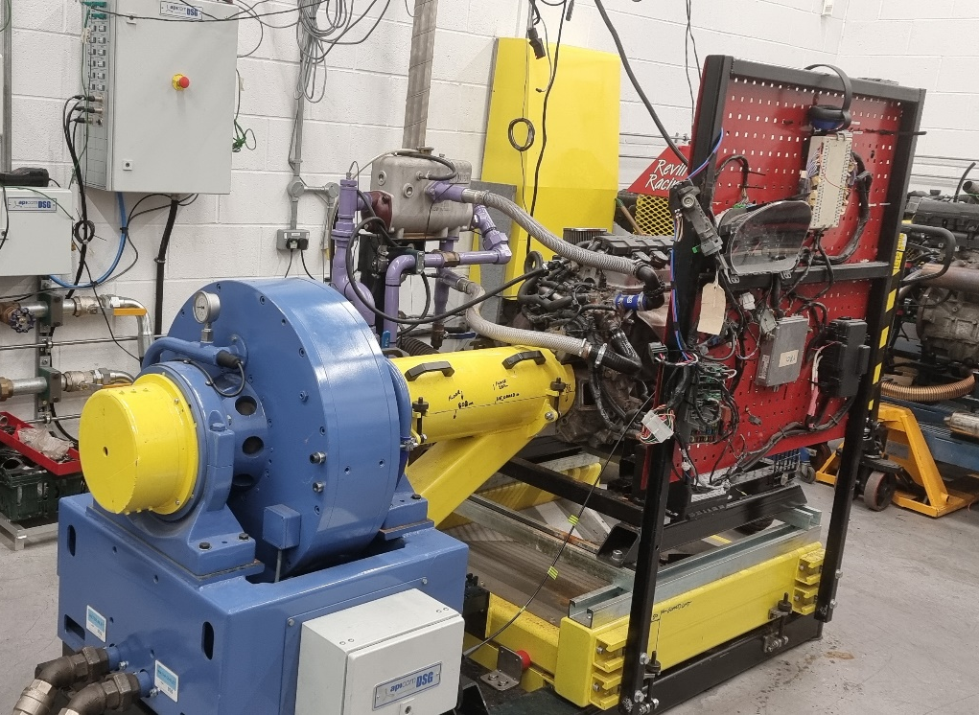
Figure 1
Shown in figure 1 is the engine dynamometer used for our test. This is the W230 Schenck which is an eddy-current dynamometer. This means that the rotating teeth and gaps change the magnetic circuit and therefore change the magnetic field of the cooling chamber. The varying magnetic field induces a tension in the front areas of the cooling chambers. The currents generated by that are called eddy currents (Dadt, H.J. 2001). This specific model is limited to a maximum of 10000 revolutions per minute and 230 kilowatts of power.
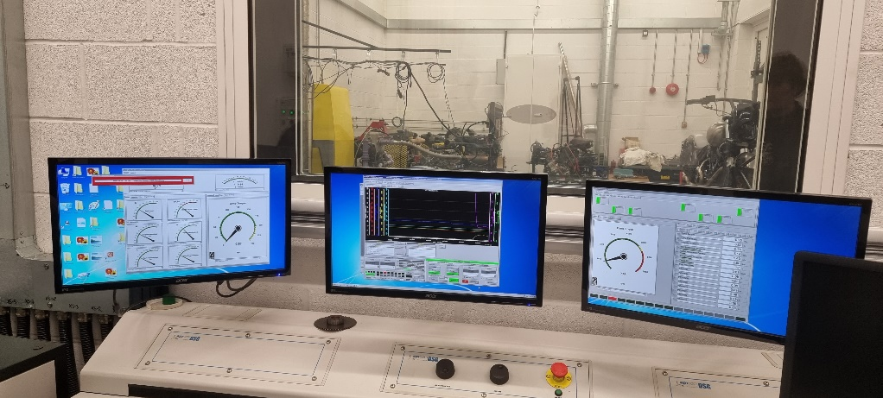
Figure 2
Shown in figure 2 is the second room to the engine dynamometer test rig, this is where the test is controlled from and where the data is collected from. This dyno can be run manually with the two dials on the control panel, the right directly controls engine speed, and the left increases the load acting on the engine from the dyno. The higher the load from the dyno the more the engine must compensate and work harder to push back against. This allows us to see the limits of the engine when it can no longer overcome the dyno load. The software on the computer can also control the dyno, as we ran a program automatically for this test. Important readings are displayed for the dyno user including torque and speed readings, oil pressure, fuel level and coolant readings. These are monitored throughout to make sure everything is running correctly, however, limits are set within the software in case anything goes wrong, meaning it would shut off before the situation gets worse.

Test Method

Step 1: Firstly, we ran through the checks needed before starting the dyno, this meant checking everything was plugged in, and the engine was all together. We also ensured that the coolant was flowing round the dynamometer making sure there wouldn’t be any issues with overheating from the unit itself. We also made a note of the radius that the load was acting upon (0.815776 metres) which would be used for further calculations.
Step 2: We moved to the control room to begin setting up the software to begin the dyno run. This test was carried out with an automatic, preprogrammed run, which tested the engine with a certain input to give the desired data. In this specific test, the engine is run within 1000-5500 revolutions per minute.
Step 3: We then turned the fuel supply on and ignited the engine. Then the software auto button was clicked which ran the engine on the dyno giving us the live data through the graphs allowing us to see how the engine is performing in real time.
Step 4: Now the program was complete, we let the engine return to idle and shut off ignition. Then we made sure the fuel pump was off and the engine had no fuel going to it. This completed the test, and the data was then saved ready for further calculations.

Dyno Results Table

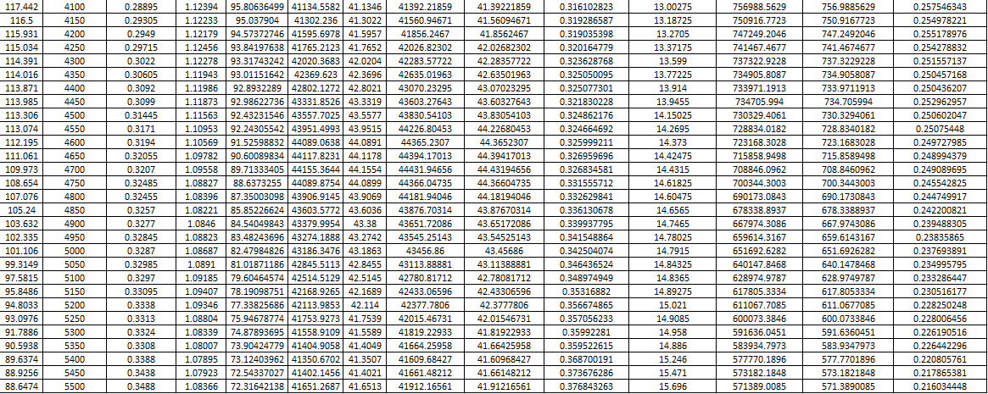
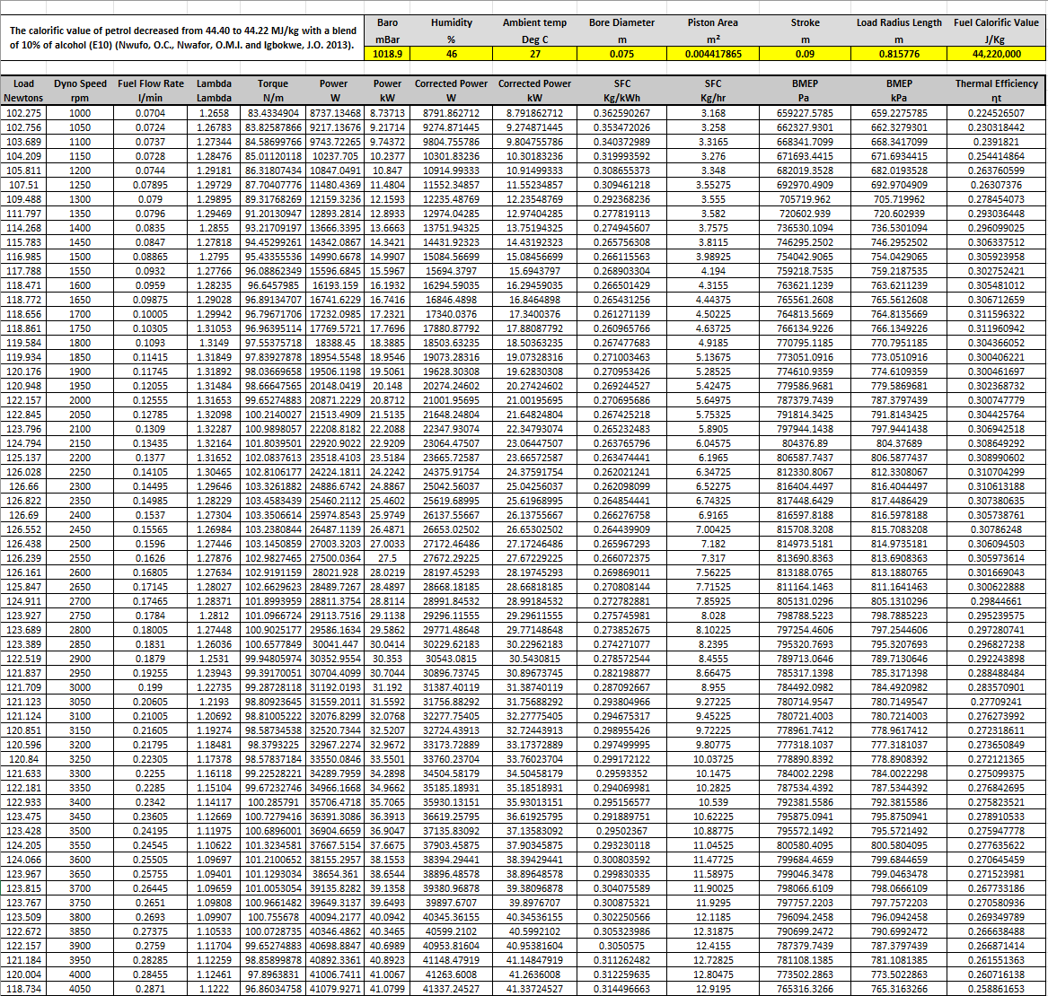

Fuel Calorific Value - The calorific value of petrol decreased from 44.40 to 44.22 MJ/kg with a blend of 10% of alcohol (E10) (Nwufo, O.C., Nwafor, O.M.I. and Igbokwe, J.O. 2013).

Graphical Analysis

SFC against Engine Speed

The specific fuel consumption graph shows that the consumption drops quickly before flattening out and then increases with higher engine speed. This means that there is a low consumption spot for this engine around the 1500rpm to 2500rpm area where the engine uses less fuel than at idle or at high rpm.
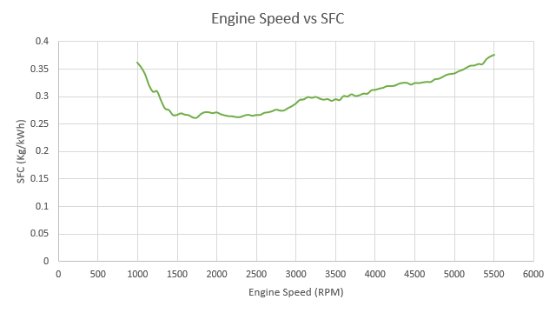
An explanation for this variance would be how this links to the thermal efficiency of the engine. The SFC graph has a nearly identical opposite trend to the fuel consumption, therefore suggesting that the heat factors of the engine influenced consumption. This is shown in the comparison below:

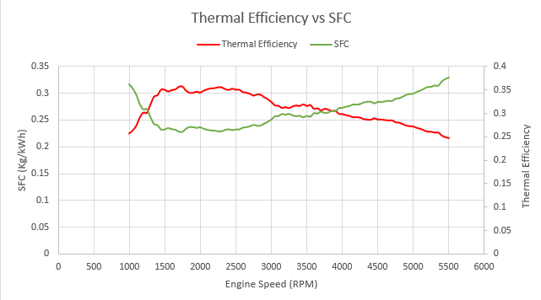

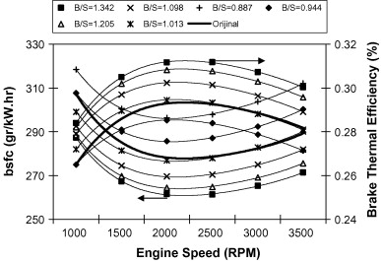
Figure 3 (Ozcan, H. Yamin, J.A.A. 2008)
Figure 3 shows a test completed which was comparing the effect of the bore/stroke ratio on the brake specific fuel consumption and thermal efficiency. From this graph we can observe that the thermal efficiency does have an opposite trend to the fuel consumption and that the engines bore, and stroke design have affected the BSFC.

Torque against Engine Speed

The torque graph against engine speed shows how it increases with rpm from idle until a certain point past 3500rpm where it begins to drop off.
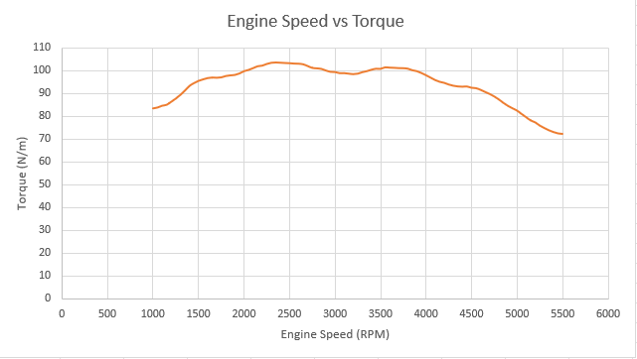
An explanation for the engines drop in torque at higher rpm would be that the brake mean effective pressure drops off. This is most likely due to the correct air/fuel mix not being able to get into the combustion chamber quick enough before the inlet shuts. Therefore, the torque and pressure both decrease as there isn’t optimal combustion possible at higher rpm.
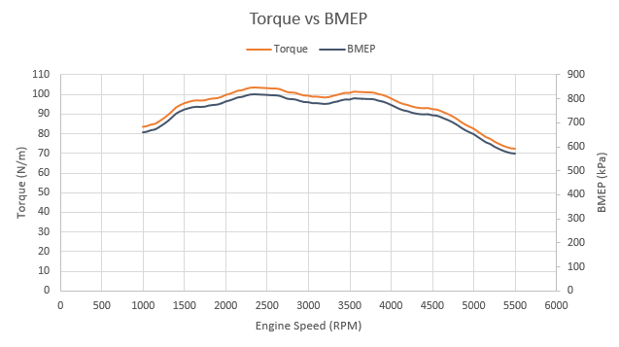
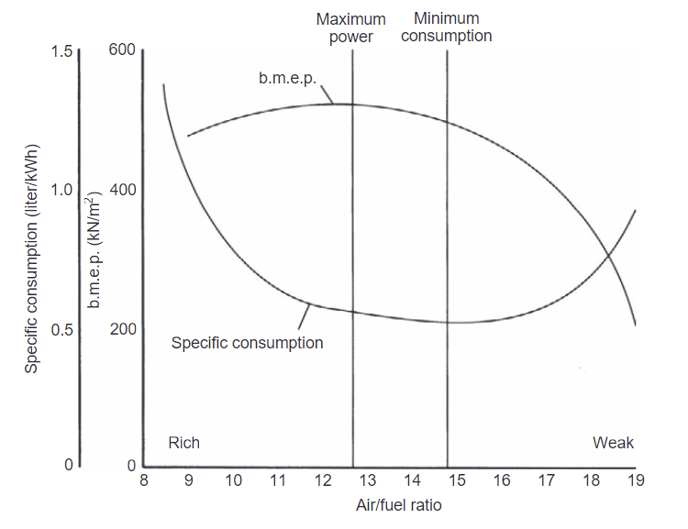
Figure 4 (Martyr, A. and Plint, M.A. 2012)
This graph (figure 4) demonstrates the effect of the air fuel ratio on the pressure, clearly showing how the pressure drops off as the mixture becomes too lean. This lack of air fuel could be due to the valve timing or restrictions of the valvetrain.
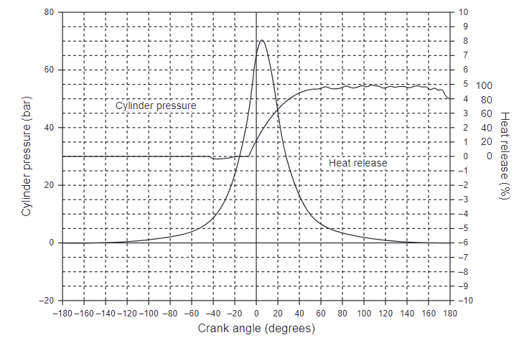
Figure 5 (Martyr, A. and Plint, M.A. 2012)
Figure 5 plots the cylinder pressure against the crank angle which helps to see how the valve timing would affect the pressure. We can see there is a peak pressure just after top dead centre (crank angle 0 degrees) where the mix would need to be ignited and any where other than this would be lost pressure. If the fuel mix wasn’t timed correctly there will be low pressure and a large drop.

Brake Power against Engine Speed

The brake power against engine speed graph displays how the power increases over the rev range as expected. This reaches a peak power at just past 4500rpm before tailing off.
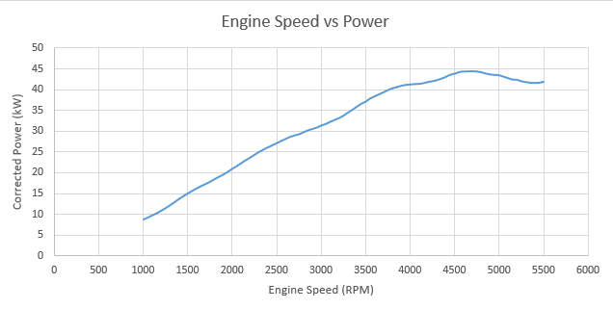
This loss of power at the top of the rev range could be due to frictional losses which are much higher at increased rpm, therefore absorbing the engines energy and power. Under mixed driving conditions for a passenger vehicle, between one-third and one-half of the power developed is dissipated through frictional, engine related losses (Martyr, A. and Plint, M.A. 2012).
Other than frictional losses, the valve timing has a strong effect on power at higher rpm. This could be due to the valve overlap of intake and exhaust becoming too large. Meaning that when the intake valve is open the exhaust valve could also be slightly open still, leading to unburnt air/fuel mix escaping out the exhaust port. Not only would this not be good for fuel consumption/efficiency it would also provide less combustion potentially equalling less power.

Test Conclusions
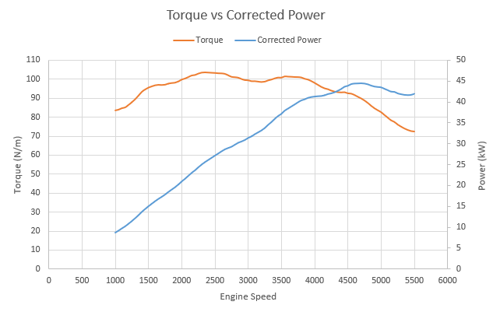
There are a few conclusions which can be drawn from this dynamometer test run. One conclusion is that the engine is running smoothly as the increases in power and torque curve across the rev range look normal and match the expectations. However, the engine is displaying torque and power figures below what the engine was specified to have when it had left the factory. This could be due to aging of the engine components meaning the engine might have lost compression or the tolerances are no longer optimal due to wear. Some of this power and torque loss could also be from varying engines from the manufacturer, as a certain engine is given a power and torque spec which is meant to cover every model that is produced. The variance between each engine produced is down to the build quality and manufacturing tolerances, there would be a small difference between each engine even with the best quality manufacturing.
Another conclusion brought from this test is that the fuel consumption and thermal efficiency are still strong. Despite being an older engine it achieved under 0.3kg/kWh specific fuel consumption for nearly the entire rev range. The thermal efficiency was also around 25% to 35% which is a good result due to expecting two thirds of the power to be lost in heat related energy.

Evaluation

To evaluate this test, I feel that I completed the tasks set successfully and had a good understanding of what was going on throughout the test. However, I think I could have been more involved, meaning that checking engine components or taking measurements could have made the test more useful. Although, I was able to control a test run manually using the load and rpm dials which was helpful to understand what the dyno does to get the data readings for the engines.
I think the investigation as a whole could be improved through plotting graphs and making calculations on multiple sets of data taken from multiple dyno runs. Multiple dyno runs with more data would give an average for the engine to avoid a biased reading. It would also provide data on how soon the engine starts to heat soak or lose power which is important information on the thermals of the engine.

Reference List

Dadt, H.J. (2001) ‘Technical Specification Eddy-Current Dynamometer W Series’, in.
Heywood, J.B. (1988) Internal Combustion Engine Fundamentals. Singapore: Mc Graw Hill International Editions.
Martyr, A. and Plint, M.A. (2012) Engine testing: The design, building, modification and use of Powertrain Test Facilities. Oxford: Butterworth-Heinemann.
Nwufo, O.C., Nwafor, O.M.I. and Igbokwe, J.O. (2013) ‘Effects of blends on the physical properties of bioethanol produced from selected Nigerian crops’, International Journal of Ambient Energy, 37(1), pp. 10–15. doi:https://doi-org.ezproxy.uwtsd.ac.uk/10.1080/01430750.2013.866907.
Ozcan, H. and Yamin, J.A.A. (2008) Energy Conversion and Management Vol 49. Available at: https://www.sciencedirect.com/science/article/pii/S0196890407002993.

