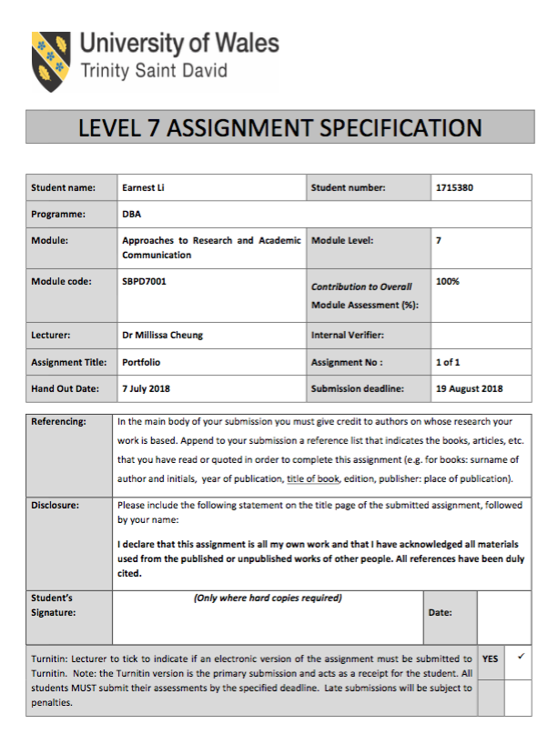
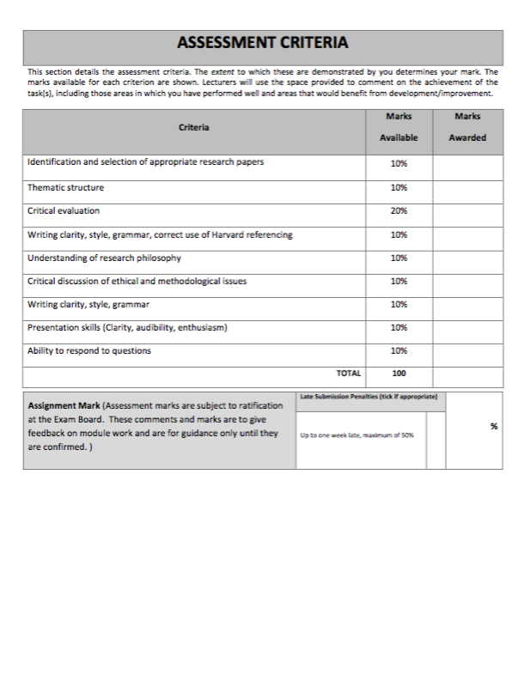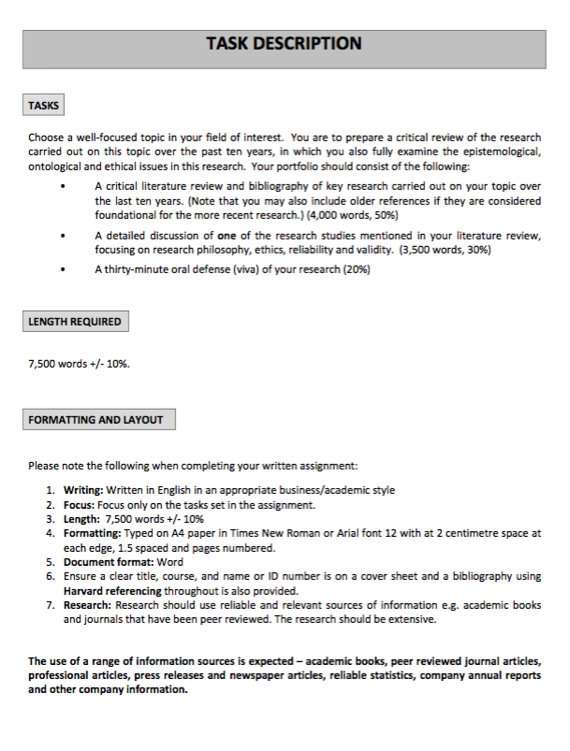

A literature Review of 10 research papers studying the mediating and moderating factors that influencing innovative work behavior in the past ten years

Abstract
In the future, the competitive advantage of successful companies will be based on the quality of technology and human resources (Steers, Mowday and Shapiro, 2004). It is the vision of Lester Thurow (MIT economist) after observing ten years. In 2014, a report states there is need of innovation leadership (Horth and Buchner, 2014). Such kind of leadership will stimulate employees and teams to perform innovative behavior. In this paper, the author selects and reviews 10 research papers studying innovative work behavior (IWB). Among the papers, researchers address the mediating and moderating roles of different factors including leader-member exchange, psychological empowerment, and knowledge sharing that will influence the outcomes of IWB. To theoretical implication, the studies fill the gap in the literature of leadership and innovation theory. To practical implication, the studies help practitioners to pay attention and take action to create a workplace encouraging employees, teams, and organizational innovative behaviors. It also helps top management to rethink providing what kind of staff training and implementing what kind of recruitment strategy to strengthen the competitive advantage of human resources.

Keywords: transformational leadership, innovative work behavior, leader-member exchange, psychological empowerment, knowledge sharing, organizational innovation climate, team structure, perceived organizational support

Introduction
Today, Innovation leadership is a key learning for leaders to operate organizations with innovative systems, tools, and thinking to sustain under challenging and unpredictable environment according to the white paper published by the Center for Creative Leadership (Horth and Buchner, 2014). It means many organizational leaders have lost their crystal ball visioning the future. Some leaders feel difficult to develop new process, innovative product, and game-changing service to create long-term competitive advantages. This paper reviews 10 papers in the past ten years focusing on the links of leadership style, social behavior, organizational behavior and innovative behavior. The authors conducted surveys in Asian countries and cities include Mainland China, Taiwan, Korea, and Malaysia with private and public corporations. Types of industry include manufacturing (electrical, electronics, automotive), construction, telecommunication, financial and insurance firms, innovation companies.

Why innovation leadership is matter to the practitioners in Asian countries and cities? In 2008, financial crisis happened. The Guardian (2008) described this global economic earthquake using three weeks to change the world. Since the Great Depression of 1929, it is the most “tragic” economic disaster (The Balance, 2018). In contrast to the Western economy, China’s economy has demonstrated high economic performance and contributed much to world GDP growth (Yang, 2013). From observation, the competitive advantages of Chinese companies are not only obtained by cheap labor cost, but also the change of leadership style and innovative behavior. In March 2013, Xi Jingping has become China’s president leading the country to experience a new wave of economic reforms. Private firms are encouraged to play a greater role in economy (CNBC, 2013). According to the 2016 Global Manufacturing Competitiveness Index (Deloitte, 2016), China and South Korea have been ranked top five countries. Besides, Malaysia has been called “Mighty” Five showing her potential economic power.

What have been done?
Based on the literature review of the 10 papers from 2012 to 2018, the authors study the cases in Greater China (Mainland China, Hong Kong and Taiwan) are interested in the topics of transformational leadership and innovative behavior (Shunlong and Weiming, 2012; Afsar, Badir and Bin Saeed, 2014) learning goal orientation and innovative behavior, knowledge sharing and innovative behavior (Yu et al., 2013), person-organization fit and innovative behavior (Afsar and Badir, 2016). Regarding to the cases of Korea (East Asia), the authors are also interested in the relationship between transformational leadership and innovative behavior (Choi, Kim, Ullah and Kang, 2016). Besides, they study the links of organizational structure and innovative behavior, as well as empowerment and innovative behavior (Rhee et al., 2017; Dedahanov et al., 2017). Study about the situation of Malaysia (Southeast Asia), the author is interested in the area of innovative organizational climate and innovative behavior (Ibrahim, Mohamad and Shah, 2018). Apart the selected 10 papers, other researchers are also interested in the area of motivation, communication and leadership effectiveness. Leader behavior and effectiveness in implementing changes are important factors to create organizational competitive advantages (Gilley et al., 2009). To achieve the goal, leader plays the role as a change agent to communicate with followers by coaching, motivating, rewarding, and promoting teamwork. Consistently creating, sharing, and using new knowledge will lead a company to win in the business world (Rani and Sania, 2016). Facing global competition, both leaders and followers need to learn multidimensional set of skills and knowledge to strengthen their competences. It explains why researchers are interested to study the field of the leadership-innovation link.

What have been under-researched?
All selected papers show researchers find research gaps of leadership behavior and employee innovative behavior from the past studies. Nine of ten selected papers pay effort to examine the mediating role of leader-member exchange (LMX), psychological empowerment, employee work engagement, knowledge sharing in the links of leadership style and the outcome of innovative behavior. To further understand how organizational factors playing the role of moderator to influence innovative work behavior (IWB), researcher study the areas of organizational innovation climate, team structure and perceived organizational support (POS). Moreover, over half of the papers show the researchers conduct the surveys with cross-level or cross-industry to collect more data for wider and deeper understanding of the research areas in different regions of Asia.

Great China Region: Mainland China and Taiwan
Shunlong and Weiming (2012) state China experiencing the situation of industrial restructuring. The authors point out past studies focusing on the direct relationship between leadership behavior and employee innovation. However, the “black box” of the research area is not yet opened. It is the mediating factor of LMX influencing leadership behavior on employee innovation process. Apart from LMX, psychological empowerment is another mediating factor influencing the links of transformational leadership and IWB. Afsar, Badir and Bin (2014) found the impact of transformational leadership has been under-researched. Not much systematic attention is paid to study the effect of transformational leadership on IWB. Two years later, Afsar and Badir (2016) extended the study of the mediating role of psychological empowerment with the relationship between person-organization (P-O) fit and IWB. This research issue is not frequently explored by researchers. In the same year, the research paper preparing by Yang, Qian and Zhang (2016) use the angle of cross-level interaction to study how individual and situational factors influence innovative behavior in organizations. The authors found this research area is underdeveloped that can be further explored. Besides, the team context including employee creativity, LGO, and shared understanding that will influence IWB.

Other than mediating factor, the authors find the past studies do not pay much attention to collect data with cross-level and cross-industry approach to widen and deepen the understanding of related research issues. It shows the past studies pay effort to study how leader behavior influences employee behavior with a “top-down” angle and a single factor. Among the five papers studying the cases in the Great China region, one paper makes effort to investigate the impacts of cross-level factors on IWB in Taiwan’s public financial and insurance corporations (Yu et al., 2013). The authors find little studies investigating how employee behavior is influenced by cross-level factors including knowledge sharing and organizational innovation climate.

East Asia: Korea
Some researchers also find little papers studying cross-level factors that encourage or discourage knowledge sharing. This area is poorly studied and understood. Choi, Kim, Ullah and Kang (2016) conduct the survey with Korean electronics and automotive manufacturing companies to investigate the relationship between knowledge sharing and IWB as well as the mediate factor of perceived organization support (POS). Other authors found prior research ignoring the cross-industry approach to study the determinants that stimulate IWB, and the past studies on this area is not completed (Park, Song, Yoon and Kim, 2014). The authors suggest making effort to examine the logical links between work engagement and employee's innovative behavior. In addition, the authors of the selected papers point out the research gap of examining “empowerment” as a mediating role in the connection between IWB and organizational factors including centralization and formalization (Rhee, Seog, Bozorov and Dedahanov, 2017). One of the authors, Rhee (2017) works with Dedahanov, Rhee and Yoon contributing to examine the links between structural factors and innovative behavior. Researchers suggest not to ignored the factors of centralization and integration stimulating the outcome of IWB.

Southeast Asia: Malaysia
The World Bank Group report (2015) describes Malaysia ranking to be one of the best 20 economies in the world for doing business. From the eyes of researchers and practitioners, they found the past studies do not cover much on innovation and innovative practices in Malaysia’s multinational companies (Ibrahim, Mohamad and Shah, 2018). The authors mention the lack of technological innovation will have the results of declining value-added products, low productivity, and low income. Moreover, the authors predict if lack of IWB, organizational effectiveness and competitive advantage of a company will be lowered. Managers of such company will lose the sense of direction meeting the future demand. It shows why researchers suggest studying more with different angles to examine the structural factors and the links with innovative behavior.

Comments on research directions
Regarding to the directions of the selected ten research papers, the authors explore the mediating and moderating factors that will influence the outcomes of innovative working behavior. Kotter (1995) states 8-steps change model for leaders as a way to transform their organizations effectively. The author suggests leaders have to form a powerful group working as a team to lead the change. Moreover, leaders have to use different ways to communicate the vision and strategies with the team as well as teaching them new behaviors. Furthermore, leaders have to remove the obstacles of resistance to change, and empower followers to take risk for auctioning. Under this perspective, Shunlong and Weiming (2012) set a right direction to study the mediating role of leader-member exchange (LMX) in the links on transformational leadership innovative behavior. To achieve positive organizational change, it needs effective cross-level interaction enabling leaders and followers working as a team with the same vision. They can free from the feeling of fear to generate ideas and convert ideas into strategies and solutions. By synthesizing the research directions of the other selected nine papers, the mediating and moderating factors can be summed up as the impact of psychological and organizational climate (Glick, 1985).

Psychological empowerment and organizational innovation climate
Afsar, Badir and Bin Saeed (2014) study the impact of psychological empowerment as intermediary on the connection between transformational leadership and innovative working behavior (IWB). It is a right research direction for other researchers and practitioners to understand the behavior of a follower with regards to his or her self-concept and identity on the links of transformational leadership and IWB. The authors pay attention to widen the perspective of this research area by exploring the mediating role of employee’s self-construct. They examine how the level of independent and interdependent self-construal influence on the outcomes of IWB. For example, if the level of independent self-construal is high, the level innovative behavior may be low. It shows this employee does not have or share the same organizational vision goal. How can he or she can contribute more for idea generation and implementation? Although the authors make effort to explore this research area with a multilevel and cross-industry approaches, they do not satisfy and explore another angle to study the mediating role of psychological empowerment influencing the relationship between person-organization (P-O) fit and IWB (Afsar et al., 2016). Researchers believe P-O fit can influence employees and team to be a high performing workforce because employees will be motivated by a flexible and inspirational organizational environment. It shows the authors set a right direction to analyze cognitive and affective factors that will have impact on IWB.

In addition to studying the mediating role of psychological empowerment in the links between transformational leadership and IWB, Rhee, Seog, Bozorov and Dehdahanov (2017) address the role of organizational structure including centralization and formalization in influencing empowerment. It is a right direction to investigate the impact of organizational structure on IWB. If we believe employees should understand cultural forces, aware to learn and adapt organizational life for survival, otherwise they may become victims (Schein, 2010).
Centralized and formalized organizational structure will limit the breadth and depth of employees’ IWB. If a leader wants to encourage followers of his or her team to generate new ideas to improve product or service, they may perform “negative” innovative behavior under the environment of centralization and formalization. To encourage leaders and followers work together for idea generation and implementation, top management of a company has to aware the limitation of centralized and formalized organizational structure, and allocate resources to change the organizational structure to create a workplace and climate really promoting “positive” IWB and will have the outcomes on innovative behavior.

One of the selected papers study the moderating role of organizational innovation climate on the relationship between knowledge sharing and innovative behavior (Yu et al., 2013). It is a right direction to explore this moderating factor. The authors state innovation is an effective tool that will help a company to survive and sustain. Innovation is a kind of social interaction with multi-level knowledge sharing to understand competition, new trend, new skills, and company goal as well as objective. It will have impact on personal, team and organization innovation. From the study, researchers find that organizational innovation climate does not have a moderating effect in Taiwan’s public financial and insurance corporations because of the negative factors such as great pressure and heavy workload. It makes both leaders and members have mental tension which may limit the outcomes of innovative behavior.

Schein (2010) state socialization process and shared learning experience will help to build organizational culture. How organizations’ learning and employee engagement can be utilized to create a workplace encouraging multi-level innovation? Park, Song, Yoon and Kim (2014) address the mediating role of employee work engagement in the links of learning organization and innovative behavior. This study helps practitioners especially leaders of human resource departments to explore effective intervention to create a climate of learning organization. Followers or employees are not robot. Leaders cannot send a command and they can learn and perform innovative behavior resulting good business outcomes. Yang, Qian, Tang and Zhang (2016) investigate the moderating role of team structure on the relationship between learning-goal orientation and innovative behavior. The authors set a right direction to study the factor of employees’ innovative behavior will strengthen organizational effectiveness and create competitive advantage. They use a cross-level approach to collect the evidence to examine team structure as a moderating factor. Ibrahim and Mohamad (2018) set a research direction to study the connection between support for innovation and innovative behavior. The authors state the factors of organizational culture including competitiveness and performance orientation will have positive influence on innovative behavior. It shows organizational innovation climate is a key of promoting and encouraging leaders and members’ innovative behavior to create competitive advantage.

Overall impression of the selected 10 papers
To my understanding, the structure of a research paper will include abstract, introduction, theory and hypotheses, methodology, results, discussion, and limitation. Among the ten papers, half of them use sub-headings including “Purpose”, “Design/methodology/approach”, “Findings”, and “Originality/value” in the part of “Abstract” (Afsar et al., 2014; Afsar et al., 2016; Choi et al., 2015; Dedahanov et al., 2017; Park et al., 2013). Such kind of presentation helps me to get the overall impression of the research paper and quickly understand the key points of the study. It makes a better clarity during the process of selecting 10 papers to review for this assignment. Although headings or sub-headings are not a “must-have” items, three out of ten papers have not put the headings of “Abstract” and “Introduction” (Yu et al., 2013; Rhee et al., 2017; Shunlong et al., 2012). I think it is better to put the headings of “Abstract” and “Introduction” to provide a better impression of academic writing. In additional to headings and sub-headings, diagram is a way to show theoretical framework for audience to identify variables, relationship of variables, and roles of variables (mediating or moderating). However, two papers do not provide diagram to display the theoretical framework (Rhee et al., 2017; Shunlong et al., 2012). Shunlong and Weiming (2012) study the mediating role of leader-member exchange on the relationship between transformational leadership style and employee innovative behavior. I think it is not difficult to draw a diagram to display the theoretical framework. According to the research conducted by Rhee, Seog, Bozorov and Dedahanov (2017), they try to examine the mediating role
of empowerment in the links of centralization, formalization, and employee innovative behavior in organization. I think it is better to draw a diagram to show the theoretical framework. In the same year, Dedahanov, Rhee and Yoon (2017) conduct research to study organizational structure, employee innovative performance, and innovation performance with similar variables including centralization, formalization, and integration. The authors provide a diagram to display the theoretical framework shown as below.

Diagram (captured from the selected paper)

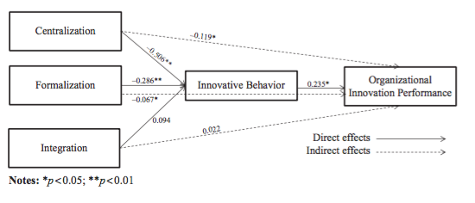

We can see the variables of centralization, formalization and integration to be the factor of organizational structure, and innovative behavior as the mediating factor in the link between organizational structure and organizational innovation performance. Besides, I think the authors are ambitious to propose seven hypotheses. The first three hypotheses are studying the negative relationship between centralization and innovative behavior, the negative relationship between formalization and innovative behavior, the positive relationship between integration and innovative behavior. The fourth hypothesis is about the positive link of employee innovative behavior and organizational innovation performance. The last three hypotheses are studying the mediating role of innovative behavior in influencing the relationship between centralization and organizational innovation performance, the link between formalization and organizational innovation performance, the link between integration and organizational innovation performance. The authors state it is the first study to examine innovative behavior as the mediating factor in connection with organizational structure and organizational innovation performance. It explains why the authors are ambitious to propose seven hypotheses.

Among the ten papers, I would pick the presentation style of the paper written by Afsar, Badir and Bin Saeed (2014). Headings of this paper include “Abstract”, “Introduction”, “Thematic framework”, “Research method”, “Data analysis and result”, “Discussion”, “Theoretical implication”, “Practical implication”, and “Limitation and recommendation”. Such kind of structure helps me easily to identify the research area, significance of the study, literature review, methodology, and result. Detailed review of this paper is presented as below.

Detailed discussion of one research paper
The research paper studying transformational leadership and innovative work behavior (IWB) is selected to have detailed discussion. The authors try to investigate the mediating factor of psychological empowerment (PE) in the links between transformational leadership and IWB (Afsar et al., 2014). Moreover, they try to test self-construal as a moderating factor in influencing transformational leadership and IWB positively or not.

Research area – What is the ontology of the study? The subject or issue about the effect of transformational leadership on employees’ IWB is under-developed. The authors make effort to explore the influential process or psychological processes with the factors of follower psychological empowerment and self-concept in the links of transformational leadership and IWB. It is valuable for leaders of China’s companies to predict the level of subordinates’ IWB with different and related variables including transformational leadership style, psychological empowerment, interdependent and independent self-construal. Under global competition, China’s companies especially manufacturing and innovation companies cannot use cheap labor cost to compete with other countries. They need innovation, organizational and employees’ innovative behavior to generate new ideas and turn ideas into action to produce products and services to win the competition. In business world, managers know they need to obtain innovation for building sustainable competitive advantage, but they face the problem of motivating employees’ innovative behavior with positive results. How to solve it? The authors pay attention to explore the area of mediating factor of psychological empowerment and moderating factor of self-construal, and it is the first study focusing on such research issue with China’s innovation companies. According to the white paper of the Center for Creative Leadership (Horth and Buchner, 2014), leadership for organizational innovation requires organizational encouragement and leadership encouragement to provide a culture and support innovation. If we can understand the factors of PE and self-construal, it will help leaders to obtain organizational effectiveness. Therefore, this research area is valuable.

Perspective – The authors use a wide-angle approach to explain the context of IWB and explore the mediating and moderating factors that influencing the relationship between transformational leadership and IWB. They provide researchers and practitioners two more angles to examine the connection between leadership style and innovation. One angle is the mediating role of psychological empowerment. Another angle is the moderating role of self-construal. With regards to this factor, the authors state two dimensions: independent and interdependent. The authors try to test the condition of high level of interdependent self-construal and low level of independent self-construal will strengthen the relationship between transformational leadership and IWB. Regarding to the context of IWB, the authors try to define innovative behavior with the concept of idea generation and idea implementation. Practitioners and other researchers can think wider and deeper about the elements of innovation which consist of not only creativity but also converting idea into action with economic return.

Research significance – What is the axiology of the paper? In the selected paper, the authors state their study provide three contributions to the theory of leadership and innovation (Afsar et al., 2014). First, the study examines the influence of transformational leadership on two areas of employees' IWB including idea generation and idea implementation. Second, the study pay effort to investigate the mediating impact of PE on the relationship between transformational leadership and IWB. Third, the study explores the moderating factor of employees' self-construal including two dimensions: independent and interdependent. To academic contribution, this research study conducts in-depth investigation and adds IWB literature. Moreover, the authors see lack of academic research to measure the impact of PE. The selected paper contributes to the growing literature on empowerment by developing and validating measure of PE in working environment. Furthermore, the authors conduct a survey in China to test the mediating role and moderating role connecting to transformational leadership and employees’ innovative behavior. To practitioners, this study provides a certain extent of knowledge for managers to predict subordinates’ innovative behavior, and to re-think how to create a workplace to encourage innovation. It also helps organizational leaders to solve the managerial problem of recruiting “right” people, and motivate talents to display innovative behavior. Cultural difference between China collectivism and Western individualism may have different impact on the mediating role of PE. It is worth for other researchers to develop to widen the knowledge of PE, and leadership-innovation link. From the survey results, it shows TL has the positive impact on IWB, and the TL-IWB link will be stronger when employees have high interdependent self-construal and low independent self-construal.

Research question – Management is a matter to deal with people and human institutions with social discipline (Drucker, 2012). Facing fast-paced and environment and digital age, how can a manager make the ‘right’ decision to lead the team and followers to create sustainable competitive advantage? How can a manager effectively motivate subordinates with organizational vision and goal to generate new ideas and make them happen to survive and sustain? Why some leaders fail to engage and empower employees to work as a team to make transformation successful? The authors of the selected paper try to provide answers with the research question to explore and investigate the mediating role of PE and the moderating role of self-construal on transformational leadership-IWB link. The research questions of the selected paper are sensible to other researchers and managers to understand more on leadership-innovation link to explore new angles to predict individual and organizational behaviors while implementing transformation.

Theory – What is the epistemology of the study? In this selected research paper, the authors pay attention to the theories of IWB, transformational leadership, psychological empowerment, and self-construal. Among four theories, PE is a key of mediating a positive impact on the relationship between transformational leadership and IWB. It is a kind of employee autonomy. PE plays a cognitive role to strengthen intrinsic task motivation, and perception of competence. It will have positive impact on self-determination to initiate employee’s creativity and implement work behaviors. The authors pick the right theory that helps the study to examine and explore the transformational leadership-IWB link. Conger and Kanungo (1988) state empowerment process will go through five stages including conditions, managerial strategies and techniques, self-efficacy information, results in empowering experience, and behavioral effects. Conditions are a kind of organizational factor, and such conditions will allow subordinates or talents of a company participate management process. He or she will obtain self-efficacy information to learn new knowledge and skills as well as perceiving self-construal in the company. Talents may experience positive results of empowerment and encourage them to maintain and strengthen behavioral change. In order to create positive empowerment experience, several context factors have to be considered including organizational factors, supervisory style, reward system and job design. The selected paper has mentioned about it.

Without organizational culture encouraging and executing empowerment, employees will behave as powerless minority group, and they will not actively display their ideas and innovative behaviors. Though past studies have covered the field of empowerment, some researchers find our understanding of the construct on empowerment or PE is limited and confusing. Most managers treat empowerment as managerial tool and have not address its nature or the processes behind the construct of empowerment as well as leadership-innovation link. Spreitzer (1995) agree empowerment will increase one’s intrinsic task motivation with a set of four cognitions including meaning, competence, self-determination, and impact. It shows employees or talents can play active role rather passive role under the organizational climate that promoting PE and encouraging innovative behavior. The author also agrees the viewpoint of employee initiative and innovation will strengthen competition. Apart from the theory of PE, other selected research papers use LMX theory or the theory of knowledge sharing. Shunlong and Weiming (2012) study LMX as a mediating factor in the link between transformational leadership and innovative behavior. Choi, Kim, Ulla and Kang (2016) conduct research to study the mediating role of knowledge sharing on leadership-innovation link. Based on the context of China collectivism, it is an appropriate approach to use PE theory to examine transformational leadership-IWB link.

Diagram – The selected paper shows a diagram displaying the theoretical framework of the research issue (figure 1). It clearly indicates the relationship between four factors: transformational leadership (TL), IWB, PE, self-construal. The authors use solid line to show the direct effect of TL on IWB, and PE as the mediating role in the link between the two factors. Dotted line is used to show the moderating role of interdependent and independent self-construal.

Figure 1 (captured from the selected research paper)

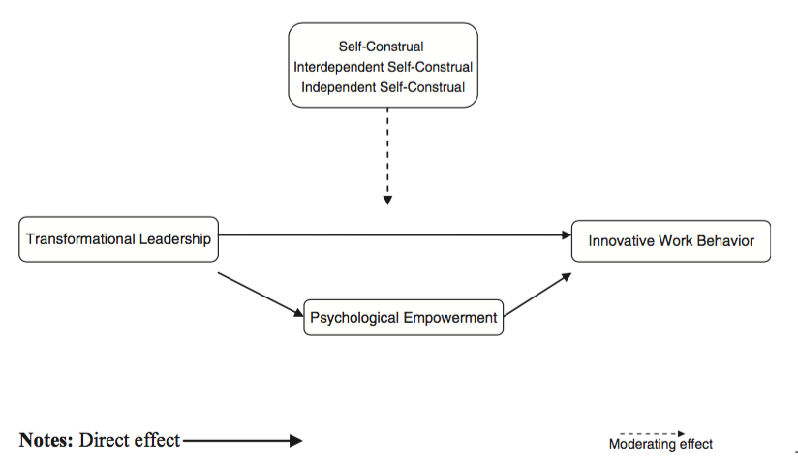

With regards to the presentation of survey results, the authors use charts to display the moderating effect of different level of independent self-construal on the TL-idea generation link and the TL-idea implementation link. They use blue solid line to stand for low independent self-construal and red dotted line standing for high independent self-construal. It is a clear way to understand the survey results.

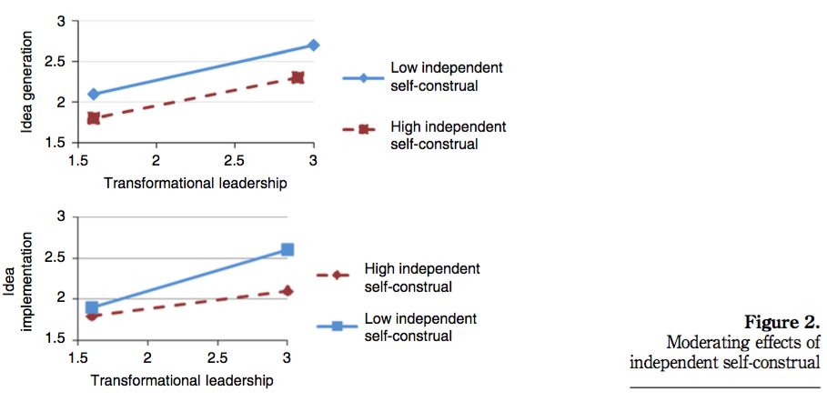

Presentation of the moderating effects of interdependent self-construal on TL-idea generation link and TL-idea implementation link is maintaining consistency to use blue solid line standing for low interdependent self-construal, red dotted line standing for high self-construal.

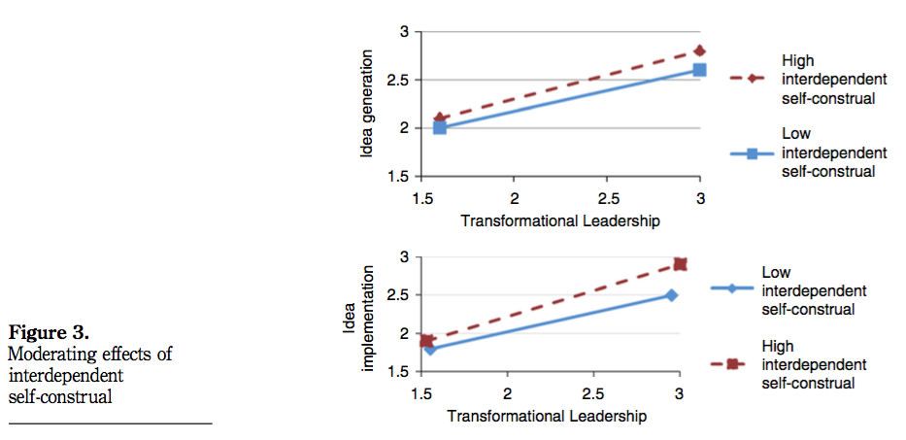

Literature review – From the reference listing of the selected paper, over 159 papers and articles from 1963 to 2014 are collected. The authors sort out the key ideas of related theories of single factors including IWB, transformational leadership, PE, and self-construal. In additional to single factors, the authors also state the perspectives of the past studies on transformational leadership-IWB link, PE-IWB link, the mediating role of PE, and the moderating role of self-construal on transformational leadership-IWB link. To show the background and reasons of conducting the research on leadership-innovation link, the authors use updated articles and papers to indicate the need to understand the mechanisms and processes connecting transformational leadership and employees’ creativity enhancement behavior. According to the introduction of the selected paper, the authors use related theories to point out the key factors including PE as a mediating role and self-construal as a moderating role. They also criticize the weakness of the past studies paying little attention on systematic approach to study the impact of transformational leadership on IWB.

Regarding to the part of theoretical framework of the selected paper, the authors make use the concepts of different research papers and articles to explain the context of each variable and factor. For instance, the authors state the difference between IWB and creativity as well as idea generation (Mumford and Gustafson, 1988; King and Anderson, 2002). Researchers point out the importance of understanding psychology of individual and teams at workplace to manage innovation and organizational change (King et al. 2002). It explains why the authors of the selected paper define IWB with two dimensions: idea generation and idea implementation. TL will have direct effect on IWB. The authors use the concept of Burns (1978) and Bass (1985, 1991) to highlight four dimensions of a transformational leader who will act as a role model to display intellectual stimulation, individualized consideration, and inspirational motivation to encourage followers to achieve organizational goal.

The study of selected paper uses cross-sectional survey and questionnaires are distributed by department heads and company email to collect data from employees and leaders of different departments. It is a kind of self-report in organizational research. The authors aware the problems of dyadic approach and decide to collect data from different sources to avoid artificial bias according to the article written by Podsakoff and Organ (1986). Sampling of the research is drawn from multiple industries including Baidu (computer services), Henan Shaunghui Investment (food processing), Tencent Holdings (computer services), Kweichow Moutai (beverage), China Oilfield Services (oil services and equipment). These five companies are selected from Forbes 2013 ranking. A table is made to show the selected company name, type of industry, and location of headquarter. It helps audience of this paper to get more information about the sampling.

Research design
Ethical issues
Authors of the selected paper make effort to ensure anonymity and confidentiality. Participants of the survey use company and employee identification codes to reduce the pressure of participants especially followers. If followers need to put his or her real name to complete the questionnaires, some of them may fear to share their real thoughts to avoid damaging the leader-member relationship and job security. Some participants may reject to fill the questionnaires. It is important to pay attention to ensure anonymity and confidentiality. Besides, the survey requires participants agree and commit to do self-report questionnaires. Researchers make the appointment with top-level managers of the companies and request them announcing the purpose of the survey to the employees. It helps to gain the trust and commitment from participants.

Choice of construct
The authors of the selected paper use five directions to construct the study. First, they formulate TL with direct and positive effect on IWB including idea generation and idea implementation. Second, authors formulate the hypothesis of TL positively influencing PE. Third, authors formulate the hypothesis of PE positively influencing IWB. To test the mediating role of PE and moderating factors of self-construal on TL-IWB link, the authors set two angles and formulate the hypothesis of high level of interdependent self-construal influencing on TL-IWB link, and low level of independent self-construal on TL-IWB link.
Concept of the study is clearly stated with regards to the hypothesis. Theoretical framework of the selected paper shows clearly it is a descriptive study and it tries to explain the relationships among variables of TL, IWB, PE, and self-construal. Other than descriptive study, audience can identify it is also a casual study how the variable of TL influencing IWB.

Number of variables
Four variables including TL, IWB (idea generation and idea implementation), PE, and
self-construal (independent and interdependent) are investigated. To conduct a systematic research on the mediating and moderating factors on the TL-IWB link, the authors set the variables with measurable items. A 20 items scale referencing Multifactor Leadership Questionnaire Form 5X is taken to measure TL. Measurement of IWB is adopted the ten-item scale. The 12-item Empowerment at Work Scale is used to measure PE. The 16-item scale measuring interdependent and independent self-construal is used. Audience of this selected paper can check the sources of measurement from the reference list.

Number of sample
Stratified random sampling with is a kind of probability sampling is applied in the research study, and the way is mentioned in the paper. The authors select a limited number of followers and leaders from employees of five innovation companies in China. Advantage of this kind of sampling helps minimizing the biasness in selecting the sample. It can ensure no any section of followers and leaders are underrepresented or overrepresented. This method provides high level of precision and high level of accuracy can be achieved by using a small size of sample. Regarding to the number of respondents, 1,100 questionnaires are distributed. 639 followers and 87 leaders filled out the questionnaires. Compared with simple random sampling, stratified random sampling requires more administrative work and it can be time consuming job. It explains why the authors hire five research assistants and each helps one companies.

Representative
To execute the research, the authors choose to collect data with cross-industry sampling to study the mediating role of PE, and the moderating role of self-construal on the TL-IWB link in multiple industries. They picked the five most innovative companies in China ranked by Forbes in 2013. Authors state the reasons in the paper. First, leaders of these companies faced intense competitive pressure in tumultuous environment. Second, these companies experienced some sort of organizational changes. To ensure equal representation of the five companies, the authors use the method of stratified random sampling. Surveys are distributed to employees from marketing, administration, HR, IT, operations, and customer care departments. Followers, supervisors and leaders are invited to participate the survey. It is because the authors use cross-industry, cross-section and cross-level approaches to collect data to explore the research issues. Reviewing the representative of location, the research is conducted in Beijing, Hebei, Henan, Guizhou, and Guangdong which are northern and southern provinces of China. Eastern and western provinces are not covered in this research. It is because the authors select to collect data from five most innovative Chinese companies ranked by Forbes in 2013.

Reliability and Validity
Pilot study
Appropriate question content is one of the reliability requirements to be considered. Pretesting of questionnaire helps to improve survey results by discovering errors before distributing to the participants. The authors point out they have conduct pilot study to verify the content of questionnaire whether satisfying the requirements or not. A two-step procedure is applied to ensure high degree of reliability. First, the authors discuss the pilot questionnaire with experts including four professors, one top-level managers and two subordinates from each company. Then, 9 mangers and 36 employees are invited to test the pilot questionnaire, and provide comments and suggestions to improve the survey. Another angle to evaluate the reliability and validity of research design is the way of interacting with the participants. With regards to the procedure stated by the authors, leaders of the selected companies to my extent support the survey. Leaders of the participants agree to announce the purpose of the survey to employees, and they provide email addresses for research assistants to send email to participants. Besides, participants fill in the questionnaires with company and employee identification codes to avoid the organizational identity threat affecting validity.

Test of method variance and control variables
The authors of the selected paper are aware the issue of common method variance, because all measurement scales of the research are self-reported. They use two techniques including Harmon’s single-factor test and Widaman procedures to identify common method variance. Extra step is taken to examine construct validity. Authors use Confirmatory factor analysis (CFA) to test the variables including TL, IWB, PE, and self-construal. They also pay attention to sort out control variables including age, educational level, gender, firm type and job tenure based on the past studies.

Back-translation
To ensure the reliability of the research, the authors hired two bilingual researchers to support the process of back-translation. One is familiar with conducting research in human resource management. Another one is an independent researcher. Two-step procedure is adopted to translate the original questionnaire from English into Chinese, and translated back into English. During this process, the questionnaire is modified to local context and better clarity. It helps the participants from five Chinese companies to have better understanding of the questions and provide better answers.

Conclusion
In sum, this selected paper is a good research paper. First, the purpose of the study is clearly defined with the introduction. Three contributions to the leadership-innovation theory include examining the impact of TL on idea generation and implementation, investigating PE as the mediating factor on TL and IWB, exploring the moderating role of interdependent and independent self-construal in TL-IWB link. We can see authors state theoretical and practical implications to audience. They also mention the contribution of the study which is the first cross-industry and cross-level study to examine the mediating factor of PE and moderating factor of self-construal in TL-IWB link at the end of the research paper. Second, detailed research process is taken to conduct pilot study and back-translation to test the reliability and validity of questionnaire. Extra step is taken to examine the issue of common method variance and construct validity. Third, research design is planned to get the authorization of five companies to participate the survey by announcing the purpose of the research to subordinates and selected the leaders, supervisors and followers who agree to participate the survey. Questionnaires are collected three weeks after distribution the surveys. Fourth, limitations of the research are frankly revealed. Authors state the study cannot build causality of PE whether it can enable employees to display more innovative behaviors and willingness to innovate. Moreover, authors suggest other researchers to study the same research issue in western countries to increase generalizability. Fifth, a certain extent of ethical standard is applied. We can see the research design showing the consideration of anonymity and confidentiality. Instead of writing their names on questionnaire, participants fill the questionnaires with company and employee identification codes. In short, it is worth for researchers to read this paper to understand how PE as a mediating factor and self-construal as a moderating factor influence TL-IWB link. Practitioners can get insight to rethink how to do better staff training and implement better recruitment strategy.

References
Afsar, B., & Badir, Y. (2016). The mediating role of psychological empowerment on the relationship between person-organization fit and innovative work behavior. Journal of Chinese Human Resource Management, 7(1), 5-26.

Afsar, B., F. Badir, Y., & Bin Saeed, B. (2014). Transformational leadership and innovative work behavior. Industrial Management & Data Systems, 114(8), 1270-1300.

Amadeo, K. (2018). ‘2008 Financial crisis: the causes and costs of the worst crisis since the Great Depression’, The Balance, 2nd August.

Bass, B.M. (1985), Leadership and Performance Beyond Expectations, Free Press, New York, NY, 350-413.
Bass, B.M. (1991), “From transactional to transformational leadership: learning to share the vision”, Organizational Dynamics, 18(3), 19-31.
Choi, S. B., Kim, K., Ullah, S. E., & Kang, S. W. (2016). How transformational leadership facilitates innovative behavior of Korean workers: examining mediating and moderating processes. Personnel Review, 45(3), 459-479.

Conger, J. A., & Kanungo, R. N. (1988). The empowerment process: Integrating theory and practice. Academy of management review, 13(3), 471-482.

Dedahanov, A. T., Rhee, C., & Yoon, J. (2017). Organizational structure and innovation performance: Is employee innovative behavior a missing link?. Career Development International, 22(4), 334-350.

Drucker, P. (2012). Management challenges for the 21st century. Routledge.

Gilley, A., Gilley, J. W., & McMillan, H. S. (2009). Organizational change: Motivation, communication, and leadership effectiveness. Performance improvement quarterly, 21(4), 75-94.

Glick, W. H. (1985). Conceptualizing and measuring organizational and psychological climate: Pitfalls in multilevel research. Academy of management review, 10(3), 601-616.

Horth, D., & Buchner, D. (2014). ‘Innovation Leadership: how to use innovation to lead effectively, work collaboratively, and drive results. Center for Creative Leadership.

Ibrahim, H. I., Mohamad, W. M. W., & Shah, K. A. M. (2018). Organizational Innovative Climate as a Predictor of Innovative Behavior among Engineers in the Electrical and Electronic Manufacturing Industry. Review of Integrative Business and Economics Research, 7, 1-14.

King, N. and Anderson, N. (2002), Managing Innovation and Change: A Critical Guide for Organizations, Thomson, London, 277-299.
Kotter, J. P. (1995). Leading change: Why transformation efforts fail. Harvard Business Review, March-April 1995, 59-67.
McCloskey, M. W. (2015). What is transformational leadership. Retrieved May, 15.
Mumford, M.D. and Gustafson, S.B. (1988), “Creativity syndrome: integration, application, and innovation”, Psychological Bulletin, 103(1), 27-43.
Park, Y. K., Song, J. H., Yoon, S. W., & Kim, J. (2014). Learning organization and innovative behavior: The mediating effect of work engagement. European Journal of Training and Development, 38(1/2), 75-94.

Podsakoff, P.M. and Organ, D.W. (1986), “Self-reports in organizational research: problems and prospects”, Journal of Management, 12(4), 531-544.
Ranasinghe, D. (2013). ‘China’s economic reforms: what you need to know’, CNBC, 18th Nov.

Rani, S. C., & Sania, K. (2016). Case Study: Impact of Knowledge Management on Organizational Performance.Advances In Management, 9(5), 9.

Rhee, J., Seog, S. D., Bozorov, F., & Dedahanov, A. T. (2017). Organizational structure and employees' innovative behavior: The mediating role of empowerment. Social Behavior and Personality: an international journal, 45(9), 1523-1536.

Shunlong, X., & Weiming, Z. (2012). The relationships between transformational leadership, LMX, and employee innovative behavior. Journal of Applied Business and Economics, 13(5), 87-96.

Spreitzer, G. M. (1995). Psychological empowerment in the workplace: Dimensions, measurement, and validation. Academy of management Journal, 38(5), 1442-1465.

Steers, R. M., Mowday, R. T., & Shapiro, D. L. (2004). The future of work motivation theory. Academy of Management review,29(3), 379-387.

The Guardian (2008). ‘Three weeks that changed the world’, 28th December.

The World Bank (2015). ‘Malaysia among top 20 best economies and first among emerging East Asia economies for ease of doing business’, 28th October.

Yang, F., Qian, J., Tang, L., & Zhang, L. (2016). No longer take a tree for the forest: A cross-level learning-related perspective on individual innovative behavior. Journal of Management & Organization, 22(3), 291-310.

Yang, L. (2013). China’s Growth Miracle: Past, Present, and Future. United Nation Research Institute for Social Development,7.

Yu, C., Yu, T. F., & Yu, C. C. (2013). Knowledge sharing, organizational climate, and innovative behavior: A cross-level analysis of effects. Social Behavior and Personality: an international journal, 41(1), 143-156.

