Component 2 - Research Report
Student Name: Crista Grigore
Student Number:2118246
Lecturer Name:
BMSW4003_BIRM
Digital Skills and Research Methods.

Contents
1. Introduction 3
2. Research design 3
2.1. Research Question 3
2.2. Method 3
2.3. Ethical Considerations 3
3. Results in 3
4. Discussion 3
5. Conclusion 3
6. Reference List 3
7. Appendix A – A blank copy questionnaire. 3

Introduction
In today's world of communication and information technology, which is quickly changing, digital abilities and research methodologies are essential components. (ICT). Enhancing the efficacy and efficiency of study techniques requires strong digital skills. This study investigates the use of digital abilities in research methodologies and how these skills can be enhanced to raise the standard of research.
This report is important because it emphasises the value of digital research skills and how they can be used to improve research outcomes. Additionally, the report will offer suggestions for improving digital literacy and discuss how the findings of the study may affect future research in different fields.
This study also seeks to add to the ongoing conversation about how to incorporate digital skills into the classroom and the workplace. The results of this study can help educational institutions and organisations understand the value of investing in the development of digital skills to improve the standard of research and achieve a competitive advantage. The report also addresses ethical issues related to using digital tools for research and offers suggestions on how to protect participants' confidentiality and privacy. Overall, this study provides people and organisations looking to enhance their research practises through the incorporation of digital skills with an invaluable resource (Anjilvelil, 2020).

Research design

Research Question

What function do digital skills play in research methodologies, and how can that they grow for productive research? Is the research topic addressed in this document?
Digital skills are essential for researching because they make it possible to access and process massive amounts of data swiftly and effectively. In the current digital era, researchers must be equipped with the skills needed to successfully conduct research using digital tools and resources. In order to stay competitive in their areas, researchers must stay up to date with the most recent technological developments. The growth of digital abilities is a continuous process. In order to ensure successful and effective results from research, the research question seeks to examine the role of digital abilities in study techniques and identify ways that these abilities can be developed (Choi, Dekkers and le Cessie, 2023).

Method

An online survey was carried out with participants from a range of industries, including business, education, and health, to get the research query answered. The questionnaire asked questions about research techniques, digital skills, and their suitability for conducting research. The poll was sent via email, and the participants were found on social media sites like Facebook and LinkedIn. The outcomes of the analysis done on the survey responses are outlined in the report's results section.
In addition to the online survey, focus group interviews with a small group of participants were also carried out to better understand their viewpoints and experiences. Using a focus on the survey answers, the participants for the focus group interviews were chosen (Hewitt, 2017).
Online video conferencing tools were used during the focus interviews in groups to facilitate participants from various locations. Open-ended questions in the semi-structured interviews enabled subjects to expand on their perspectives and experiences concerning technological abilities and research methodologies. The purpose of the questions was to find out how the participants felt about the use of digital abilities in study techniques and how successful they were at it.
Several ethical decisions were made in order to guarantee that the study was carried out in a morally and professionally sound way. Informed consent forms with information on the study's goals, the steps involved, and participants' right to withdraw at any moment were given to each participant. Additionally, participants were told that their involvement was optional and that their answers would be kept private and anonymous (Ghomi and Redecker, 2019).
The study also adhered to strict data security guidelines, and all information was stored securely with only authorised personnel having access to it. Participants received guarantees that their private information wouldn't be shared with outside parties and that the information gathered would only be utilized for study.
Overall, this study collected information on digital abilities and research methodologies using both internet polls and focus group interviews. To guarantee that the investigation was carried out morally and professionally, ethical decisions were made at every stage of the research process. The results of the survey and discussions in focus groups will be laid out in the part that follows (Kordbacheh et al, 2018).

Ethical Considerations
While conducting the study, ethical issues were considered. Before taking part in the questionnaire, all participants gave their informed permission, and their confidentiality and privacy were maintained. All participants had the option to leave the research at any time, and the survey was carried out morally and competently.
Any research endeavour must include ethical considerations as a critical component. It is crucial to make sure that study participants are respected and that their confidentiality and privacy are protected. We will go over the ethical decisions that were made throughout the research procedure in this section (Baker, McQuilling and King, 2016).
- Results
The survey's findings showed how important digital abilities are to research techniques. Participants with greater levels of digital proficiency performed research more successfully than those with lower levels of proficiency.
The results indicate that in order to stay competitive in their fields, people must constantly improve their digital skills. Researchers must remain current with the newest technological advances and methods due to the rapid advancement in technology and the growing reliance on online resources and tools in research. The findings also emphasise the significance of including digital skill development in organisational training programmes and courses for higher education in order to give people the abilities they need for efficient research (Johnston et al, 2016).
The study also highlights the importance of people being conscious of the security, moral, and legal implications of using digital research methods. To ensure that study methods are applied appropriately and ethically, it is necessary to comprehend the moral consequences of information gathering within the bigger picture of data protection.
The findings of this study suggest that digital literacy is essential for the success of study methodologies. To maintain their level of competitiveness in their industries, uphold ethical research procedures, and enhance the calibre of research outputs, people, schools of higher education, and organisations should prioritise developing and integrating digital skills. Understanding the descriptions of information, data, knowledge, understanding, and insight offered by Prof. Russell Ackoff can also help with the successful interpretation and analysis of data (Ikram et al, 2020).
For people to be proficient in the effective organisation and leadership of files and folders, numeracy, knowledge, and reasoning must be integrated into most job areas, including basic statistics.

Discussion

The results of this study are in line with the existing literature, which emphasises the value of digital research abilities. Better research outcomes are produced as a result of the incorporation of digital abilities into research methodologies. The findings also demonstrate that in order to stay competitive in their disciplines, researchers must constantly improve their digital literacy.
This study's conclusions include the need for higher education schools to incorporate digital training into their curricula in order to give students the knowledge and abilities needed for successful research.
For people to be proficient in the effective organisation and leadership of files and folders, numeracy, expertise, and reasoning must be integrated into most job areas, including basic statistics.
Online learning tools, workshops, and training courses can all be used for this.
A further consequence of this study is that companies that conduct research ought to invest in the training of their staff in digital skills in order to boost the calibre of their work and obtain an advantage over rivals.
Furthermore, for students to gain digital skills that apply to the workplace, they must explore contemporary workplace communication systems like email and social networking. Effective communication over social media and correspondence is essential in today's digital world (Davis, 2020).
Today's workplace efficiency and collaboration depend heavily on effective email and online communication. Due to their quick and simple access to resources and information, online and mobile application usage also offers possibilities for enhancing workplace productivity and employability.
But using these tools also brings up moral and security concerns, like data security and privacy. In order to guarantee that they are utilising these tools ethically and securely, students must develop a grasp of the moral and legal ramifications of collecting and handling data in the workplace (Abouelmehdi et al, 2017)
Students can conceptualise the significance of efficient information analysis and the conversion of that analysis into knowledge by comprehending Prof. Russell Ackoff's descriptions of information, data, knowledge, understanding, and wisdom. Pupils may acquire critical thinking abilities and the capacity to make choices based on data that is accessible by investigating possible sources for data to address issues at work.
This subject also places a strong emphasis on the necessity of numeracy, expertise, and reasoning in the majority of job fields. Students will develop an understanding of how basic statistics can be used to evaluate and analyse data, which is essential for making decisions that are supported by evidence in the workplace. Students will also be equipped by developing their fundamental numerical handling skills and their ability to efficiently organise and manage their files and folders (Puccio, 2017).
Students will also acquire the practical skills necessary for workplace efficiency if they become proficient in fundamental numerical dealing and the effective management and organisation of files and folders.
The learning and teaching approach for this subject combine scheduled and autonomous learning, with scheduled learning activities like lectures, workshops, and workshops accounting for 20% of the study time. Students are required to participate in independent learning activities like reading and research during the remaining 80% of class time (Alipichev et al, 2016).
Two coursework assignments that each account for 50% of the final score will serve as the basis for this module's assessment. The tasks call for students to show that they can assess how modern technologies should be used to increase workplace productivity and employability.
The tasks require students to show competency in workplace data handling, identify and efficiently evaluate a variety of information sources, and evaluate the right application of modern technology to improve productivity at work and employability (Van Laar et al, 2017).
In summary, the Digital Abilities and Study Methods module is essential for giving students the digital skills they need for productive study and the workplace. The suggested course material for the module includes a wide range of subjects, such as contemporary communication at work systems, online and mobile apps, legal and ethical concerns, Prof. Russell Ackoff's definitions for data, information, knowledge, comprehension, and wisdom, potential information sources to address workplace issues, numeracy, knowledge, and logic. A mix of scheduled and self-directed instruction is used in the teaching and learning strategy,
with an emphasis on creating practical skills applicable to the workplace, the learning and teaching approach combines scheduled and independent learning. Students must show their understanding and use of the module's material in two homework tasks that serve as the basis for the assessment. The findings of this study have consequences for higher education organizations and institutions that want to stay competitive while raising the standard of their research and increasing productivity at work (Walsh et al, 2020).

Conclusion
The significance of digital skills in conducting studies and their role in boosting the effectiveness and effectiveness of research are highlighted in this report's conclusion. The survey's results demonstrate that having strong digital skills is essential for undertaking research and that in order to stay competitive, researchers must constantly improve their digital proficiency. The results of this study have important ramifications because they highlight the importance of investing in the advancement of digital skills by higher education schools and organisations.
The study also emphasises the importance of taking ethical issues into account when conducting research. Conducting an ethical study requires ensuring that participants' informed permission, privacy, and confidentiality. This report offers a thorough grasp of how digital skills fit into research methodologies, which can be useful to organizations, educators, and researchers. Individuals can improve their employability by including the development of digital abilities in courses and training programmes. Individuals can improve their research skills and offer significant contributions to their disciplines by integrating digital skills development into curricula and training programmes. In the end, incorporating digital skills into research methodologies can produce superior research results, which will benefit society as an entire. To improve research results in the future, we must recognise the importance of digital skills and work to encourage their development.

Reference List

- Abouelmehdi, K., Beni-Hssane, A., Khaloufi, H. and Saadi, M., (2017). Big data security and privacy in healthcare: A Review. Procedia Computer Science, 113, pp.73-80.
- Alipichev, A.Y., Khalevina, S.N., Trubcheninova, A.A. and Fedulova, A.N., (2016). Practical solutions to foreign language training courses implemented using distance learning tools. International Electronic Journal of Mathematics Education, 12(1), pp.59-68.
- Anjilvelil, J.G., (2020). On the Character of Organisation Development: An Interview with Prof Vijay Padaki. NHRD Network Journal, 13(3), pp.383-397.
- Baker, H.B., McQuilling, J.P. and King, N.M., (2016). Ethical considerations in tissue engineering research: Case studies in translation. Methods, 99, pp.135-144.
- Choi, J., Dekkers, O.M. and le Cessie, S., (2023). Tying research question and analytical strategy when variables are affected by medication use. Pharmacoepidemiology and Drug Safety.
- Davis, K. (2020). The value of digital competencies in today's employment. According to Forbes, the importance of digital skills in the contemporary workforce is discussed on September 8, 2020.
- Ghomi, M. and Redecker, C., (2019), May. Digital Competence of Educators (DigCompEdu): Development and Evaluation of a Self-assessment Instrument for Teachers' Digital Competence. In CSEDU (1) (pp. 541-548).
- Ikram, M.A., Brusselle, G., Ghanbari, M., Goedegebure, A., Ikram, M.K., Kavousi, M., Kieboom, B.C., Klaver, C.C., de Knegt, R.J., Luik, A.I. and Nijsten, T.E., (2020). Objectives, design, and main findings until 2020 from the Rotterdam Study. European Journal of Epidemiology, 35, pp.483-517.
- J. Hewitt. (2017). A survey of researcher attitudes and abilities in connection to digital skills in research.
- Johnston, L.D., O'Malley, P.M., Miech, R.A., Bachman, J.G. and Schulenberg, J.E., (2016). Monitoring the Future national survey results on drug use, 1975-2015: Overview, key findings on adolescent drug use. Institute for Social Research.
- Kordbacheh, T., Honeychurch, J., Blackhall, F., Faivre-Finn, C. and Illidge, T., (2018). Radiotherapy and anti-PD-1/PD-L1 combinations in lung cancer: building better translational research platforms. Annals of Oncology, 29(2), pp.301-310.
- Puccio, G.J., (2017). From the dawn of humanity to the 21st century: Creativity as an enduring survival skill. The Journal of Creative Behavior, 51(4), pp.330-334.
- Van Laar, E., Van Deursen, A.J., Van Dijk, J.A. and De Haan, J., (2017). The relation between 21st-century skills and digital skills: A systematic literature review. Computers in human behaviour, 72, pp.577-588.
- Walsh, P., Owen, P.A., Mustafa, N. and Beech, R., (2020). Learning and teaching approach promoting resilience in student nurses: an integrated review of the literature. Nurse education in practice, 45, p.102748.

Appendix A – A blank copy questionnaire.
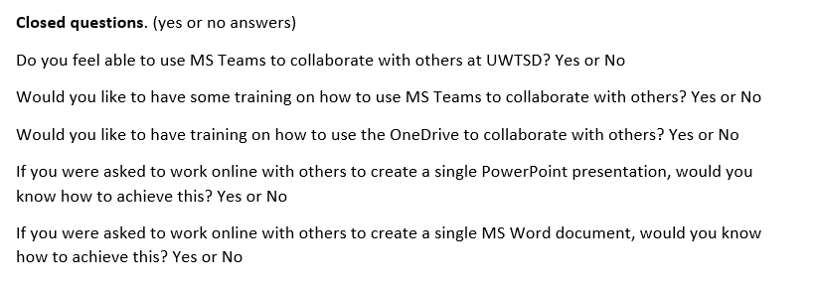
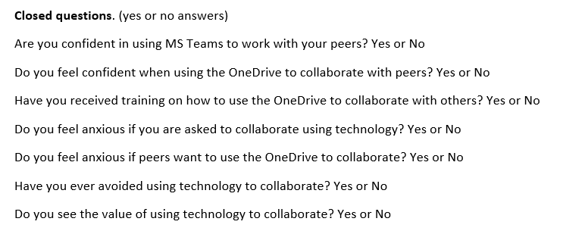
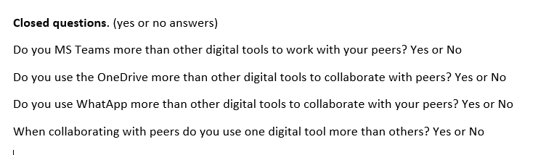

Question Bank for the research question:
- Which digital tool is most used for collaboration at UWTSD?

Closed questions. (Yes or no answers)
Do you MS Teams more than other digital tools to work with your peers? Yes, or no?

Do you use the One Drive more than other digital tools to collaborate with peers? Yes, or no?

Do you use Whakapapa more than other digital tools to collaborate with your peers? Yes, or no?

When collaborating with peers do you use one digital tool more than others? Yes, or no?

Rank Order questions – arrange words in rank order.
Rank these applications in order according to how frequently you use them to collaborate with others. (Most frequent at the top)
MS Teams
One Drive
MS Word
What Sapp
Moodle

Rank these applications according to how frequently you use them to collaborate with others on One Drive (Most frequent at the top)
MS PowerPoint
MS Word
MS Excel
MS Streams
MS Forms

Liker Scale questions.

I use MS Teams most frequently to collaborate with others.
Strongly Agree Agree Disagree Strongly Disagree.
(Circle one response)

I use One Drive more than I use MS Teams to collaborate with others.
Strongly Agree Agree Disagree Strongly Disagree.
(Circle one response)

I use WhatsApp more than I use MS Teams to collaborate with others.
Strongly Agree Disagree Strongly Disagree.
(Circle one response)

I do not use any digital tools to collaborate with peers.
Strongly Agree Disagree Strongly Disagree.
(Circle one response)

I use a range of different digital tools to collaborate.
Strongly Agree Agree Disagree Strongly Disagree.
(Circle one response)

There is no digital tool that I use more frequently than others.
Strongly Agree Agree Disagree Strongly Disagree.
(Circle one response)

I use both MS Teams and OneDrive equally often when working with others.
Strongly Agree Agree Disagree Strongly Disagree.
(Circle one response)



