Ways of Thinking

Task 1- Manifesto writing 550 words
Task 2 – Observational writing 504 words
Task 3- Practice-based writing 516 words

Task one
- Find beauty in the unnoticed.
- Colour is not just decoration but emotion.
- Affirm a beauty in art that is sustainable.
- Create to awaken appreciation and awareness.
- Find true luxury in the quality of time.
- Design for the senses.
- Value the imperfections of the handmade.
- Create not to impress but to connect.

9. Find beauty in the unnoticed
Details in our everyday lives are often ignored but play a big part in the overall aesthetics made up of larger objects, as shown in Figure 1, using a simple arrangement of a basket of apples to create the still life painting. Berger (1972, p. 7) states, “it is seeing which establishes our place in the surrounding world,” so overlooking key aspects of design can limit our understanding. Creating awareness of our surroundings is important: “we surround ourselves with objects we believe are necessary for our existence” (Zucotti, 2015, p. 3). Everyone’s life is unique, so the unnoticed plays a part in our own narratives. In order to tackle this in design we need to become present: “the entire personality and body of the designer becomes the site of the design task and the task is lived rather than understood” (Pallasmaa, 2009, p. 15). When we are present we live in the detail; when lost in our minds it all becomes a blur.

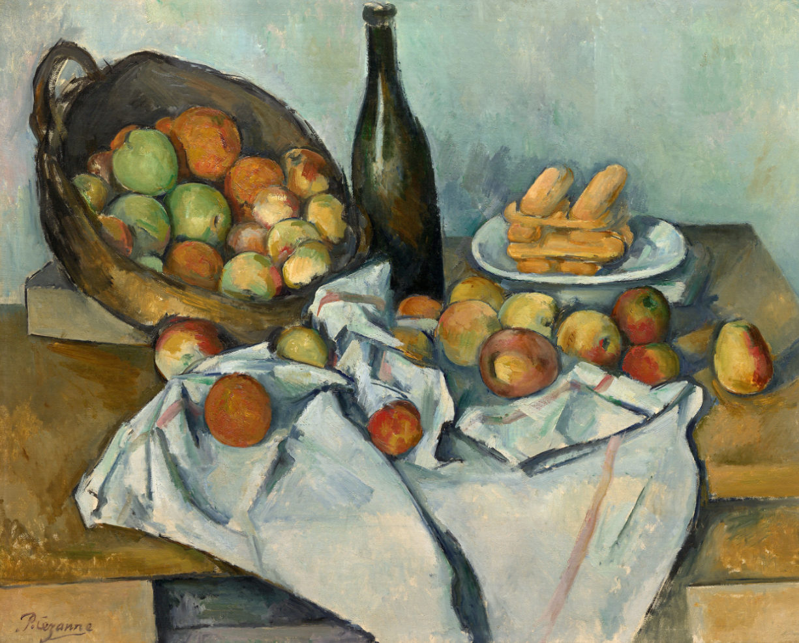

Fig 1. (Cezanne, 1893, Basket of apples)

2. Colour is not just decoration but emotion
Designing with colours comes from the involvement of emotions and invoking experiences and memories. According to Fetell Lee (2018, p. 16), when you think of joy you make associations with objects and places that are bright with intensive colours. Creating with colours in mind allows the designer to bring forward the feelings they want the viewer to experience. For example, love and anger are both symbolised by red. Colour opens interpretation of art as everyone has different experiences and connections which link to nostalgia and memory. Throughout history, colour has had a “vital significance in this social language—dull earthy colours like russet were explicitly confined to the meanest rural peasants, while bright saturated ones like scarlet were the preserve of the few” (Clair, 2016, p. 31). Colours have always created impact, from country flags to political statements: “as colours came to take in meanings and cultural significance within societies attempts were made to restrict their use” (Clair, 2016, p. 30).
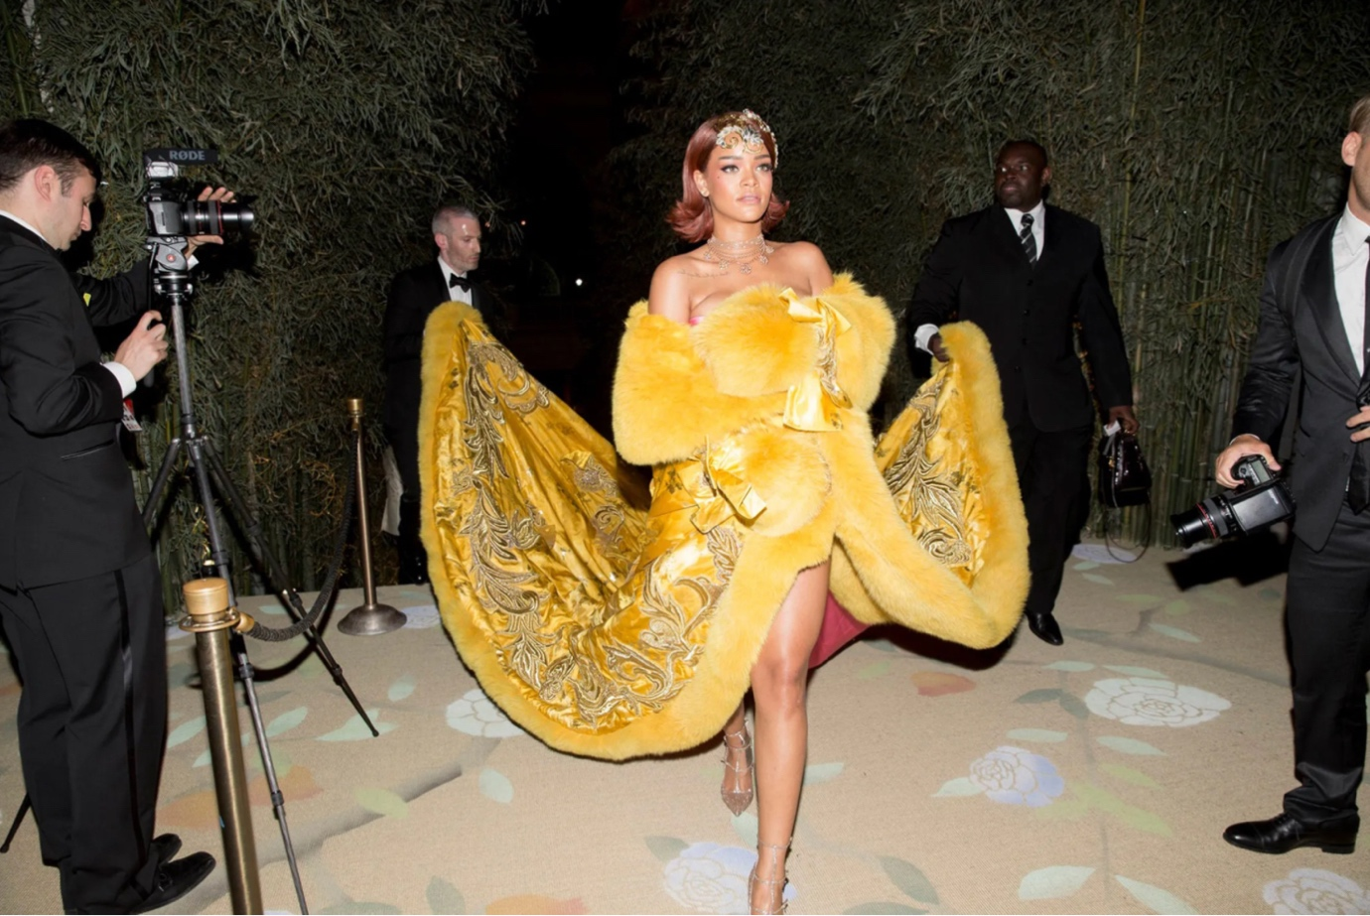

Fig 2. (Tachman, 2015, Rihanna at Met Gala wearing Guo pei, Vogue)

7. Value the imperfections of the handmade
Nowadays, there is a big divide between handmade goods and mass-produced ones, with handmade items being more expensive and considered luxury. With technology many turn to faster, cheaper production: “it robbed the craftsman of joy in work well done and denied the public the life enhancing pleasure of living in an environment that had been shaped with both skill and love” (Whitford, 1984, p. 16). In the West we are prone to preferring perfection, while in Japan they appreciate the unique imperfections of the hand in the concept of Wabi Sabi, as seen in Figure 3. Yanagi (2018, p. 150) states that intentional distortion is an “expression of unhindered freedom.”. The Tate (2025) states that Walter Benjamin believed that “Even the most perfect reproduction of a work of art is lacking in one element: its presence in time and space.” A piece of work created by a craftsman carries their story in it, whereas a mass-produced piece created by machine may not have the same appeal. As artists, being authentic in our work is a core value we should maintain to preserve artistic style.

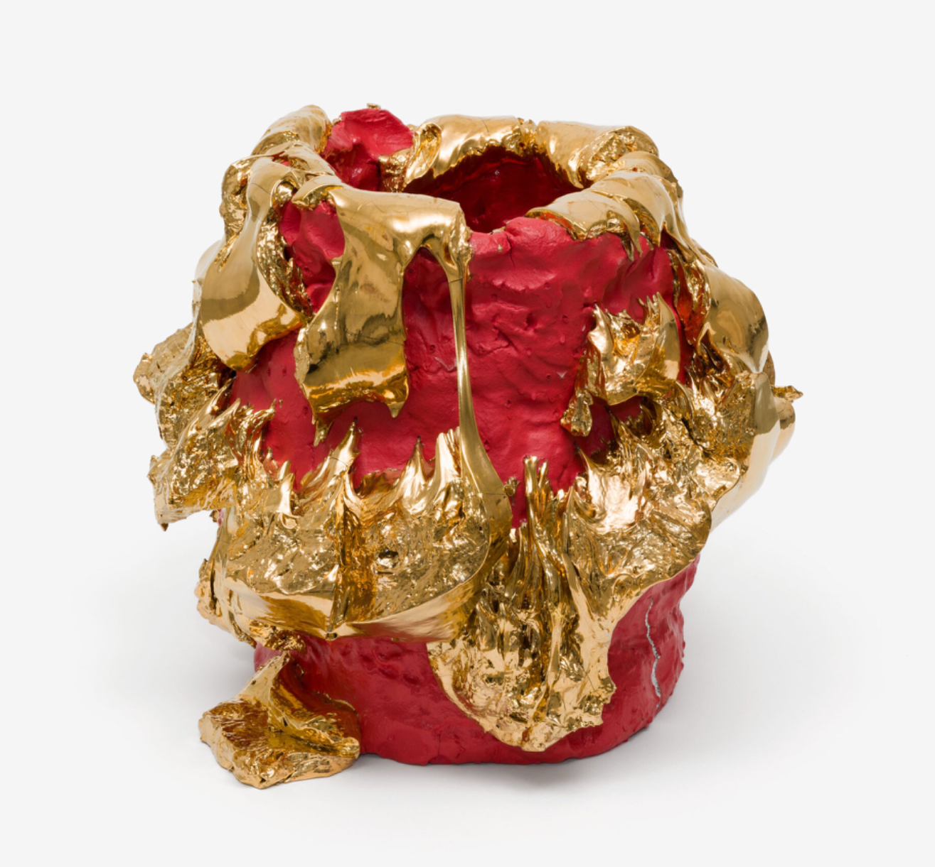

Fig 3. (Kuwata, 2024, Tea bowl)

Task two
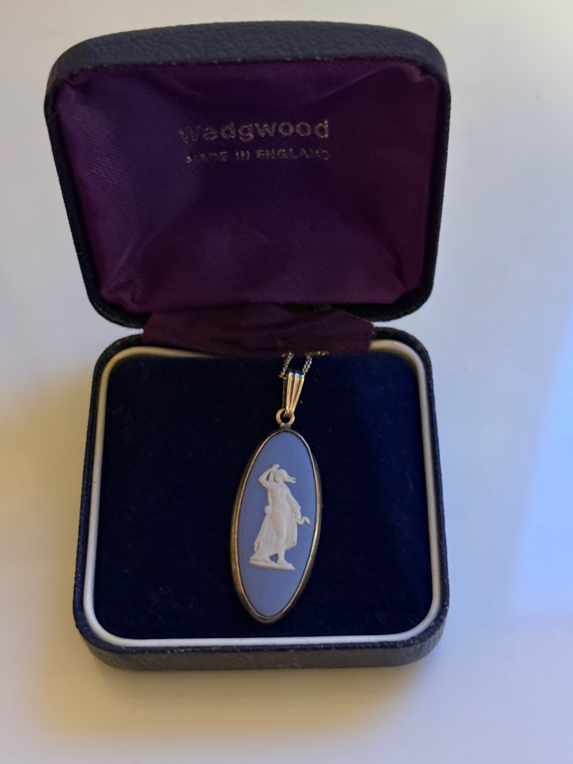

Fig 4. (Wedgwood, c. 1960s–1980, Blue jasper ware cameo necklace)

The Wedgwood pendant can be seen as a symbol of class, history, and femininity. Its meaning is conveyed through the colour and imagery, which can be analysed using semiotic theory. The piece was created by Josiah Wedgwood using porcelain and silver. Traditionally, cameo pendants were worn by the upper classes to display wealth and create a particular social image. As Roland Barthes (1968, p.26) notes, “the language of fashion does not emanate from the 'speaking mass' but from a group which makes the decisions and deliberately elaborates the code.” In this sense, the pendant acts as a deliberate marker of social status.

The pendant features a white relief cameo transfer of a female draped in cloth, gazing into the distance—a neoclassical image of femininity. The elongated shape of the pendant could also signify elegance, as it has become a delicate piece of jewellery. Semiotically, this could allow those from different cultures to come together through shared classical imagery and ideals. The traditional Wedgwood blue background enhances the image; blue is often associated with wealth and luxury, so it could signify elegance over boldness. The contrast of the white figure against the blue may suggest innocence and refinement, hinting at the lady’s privileged social standing. The distinctive “Wedgwood blue” also functions as a sign of brand identity and British cultural heritage (Jones, 2023). This combination of colour and imagery is a recognisable element of Wedgwood design, reflecting elegance and social distinction.

To reinforce this, the use of porcelain can also denote delicacy and class due to the nature of the clay. As a wearable object, the necklace could be seen as a social sign. When worn, it communicates knowledge of history, appreciation of classical art, and refined taste. Semiotically, it functions not just as decoration but as a cultural statement embedded with meanings of femininity, status, tradition, and historical continuity (Barthes, 1968). The simplicity of the pendant further creates a traditional Wedgwood look. While it could symbolise wealth, it could also be read as a symbol of quiet luxury. As Barthes (1968, p. 26) writes, “fashion clothes (as written about) are the language at the level of vestimentary communication and speech at the level of verbal communication.” This shows that refinement and personal style are communicated through choice, rather than logos or overt branding. The pendant exemplifies quiet wealth, signalling sophistication subtly, rather than through conspicuous display.

Viewed through a semiotic lens, the pendant reflects cultural ideas of wealth and privilege. During the Victorian era, when class distinctions were particularly pronounced, such a piece would signal social awareness and status, understood by those familiar with these codes. This reinforces the idea that objects such as jewellery, operate within shared social systems of meaning, where understanding the codes determines how the object is read. The pendant functions both as personal adornment and as a symbol of historical taste. However, Wedgwood was a pioneer of early mass-production techniques, enabling classical aesthetics to be distributed more widely while still retaining an appearance of exclusivity and craftsmanship (Jones, 2023).

Task three

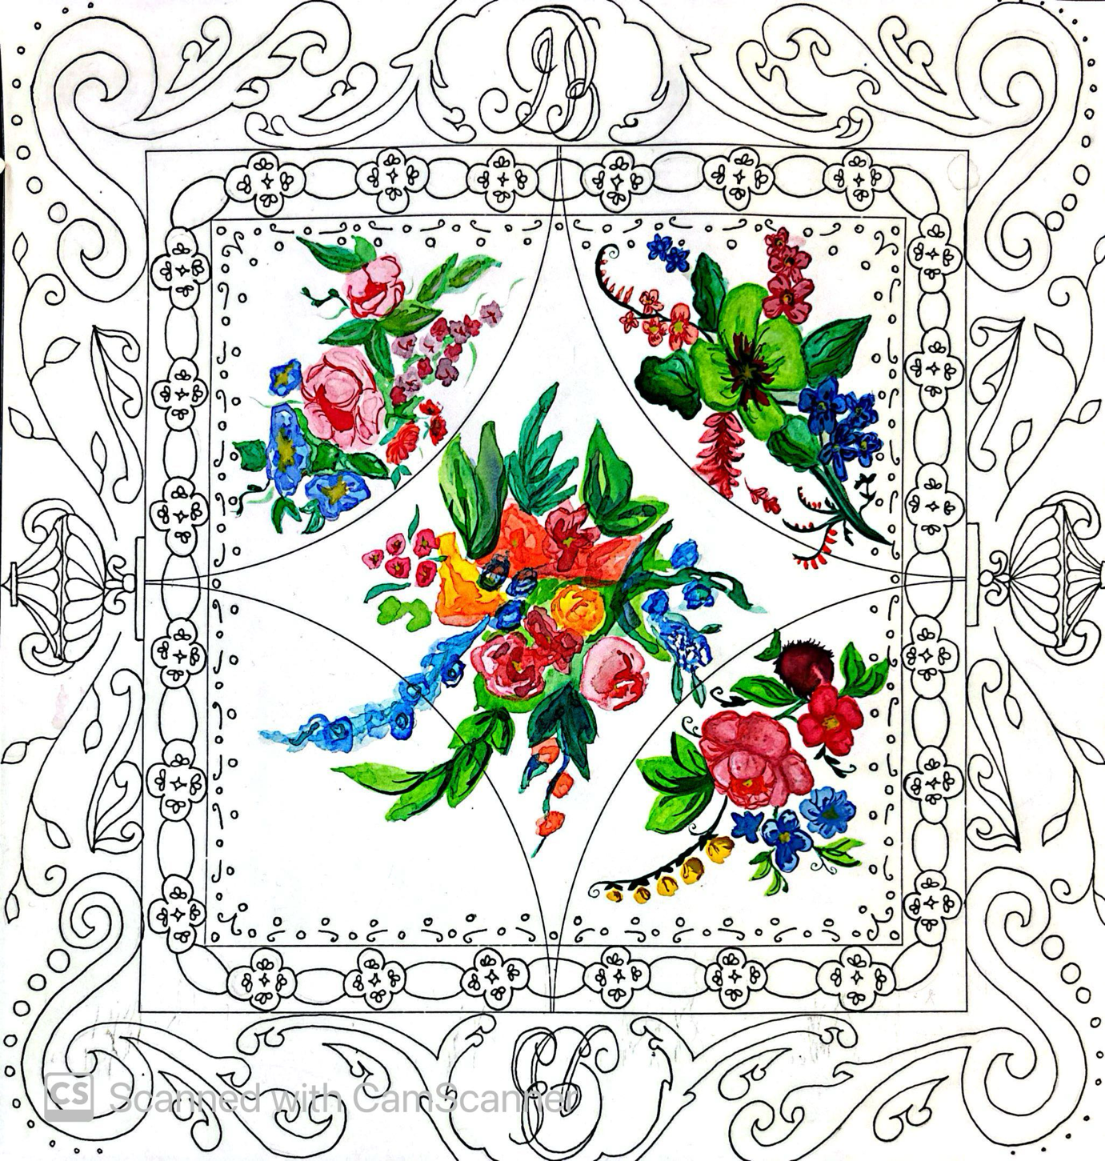
Fig.5 (silk scarf design using watercolour paint and fine liner)

According to Gibbs (1988), there are six stages to reflection: description, feelings, evaluation, analysis, conclusion and action plan. Reflective writing allows us to create a wider understanding of our own work, as being able to look back on something introduces critical thinking about the experience and outcome. The piece to reflect on is an observational drawing for a square scarf design.

This design was created in the Glynn Vivian, inspired by their collection of Swansea pottery and porcelain for a project. I started using just a fine liner but then switched to watercolour to add depth and tonal aspects after I was advised by my lecturer to try a different medium, keeping the concept of no outline on the flowers, just like on the ceramics. At first, I was hesitant, but trying the watercolour allowed me to explore techniques I had not considered before.

This trip was useful for the project, as I was able to collect primary research and gain understanding of the design involved. At the time I felt deeply challenged, as I was uncomfortable doing observational drawing whilst standing. However, I found it interesting and explorative, achieving unexpected results, such as the flowers on the scarf turning out better than anticipated, which I preferred to my fine liner drawings. Since then, I have adapted my techniques and only use fine liner when appropriate. I learnt I need to manage my expectations and try new things before forming an opinion. I have learnt that coming out of my comfort zone can produce the best results, and “have been associated with a sense of achievement and personal growth, self-expression, the development of both physical and cognitive skills” (Castle et al, 2022).

Also, at the time, the combination of colours for a palette became increasingly important. At the gallery, I was limited to just a small travel-sized watercolour palette, with limited space to mix colours. I managed to overcome this by observing the ceramics and trying to recreate the depth of colour they displayed. This was something I had never done before but really enjoyed the outcome. I also observed how the colours on the ceramics interacted with light, which helped me adjust the tones on the scarf.

Upon reflection, I will develop it further by creating a print and screen printing the scarf. Already, I have taken elements into Photoshop to create a repeat print using the watercolour flowers. I now understand that I do not need a line to define a design and that using shade and tone to create depth can give a high-quality look. It was an amazing start to my project, as I was able to learn and reflect on a piece I originally did not want to complete. I want to continue experimenting with mediums and managing my expectations to allow creative excitement in my work, as it is important to enjoy the experience as well as the result. Reflecting on this experience has shown me that persistence and experimentation can transform a challenging task into a successful learning opportunity.

Bibliography

Barthes, R. (1968) Elements of Semiology. Newyork: Hill and Wang

Berger, J. (1972) Ways of Seeing. London: Penguin Books.

Castle, C., Engward, H., Kersey, T. And Kirk-Partridge, L. (2022) “The mystery Arts Boy Project: a qualitative exploration of the delivered art and craft project: for British veterans with visual impairment” BMJ Military Health. Available at: https://www.proquest.com/docview/2711583363?accountid=130472&parentSessionId=g%2FRRxU7FM%2FKbQvsyNyCshRvWVSMekBcwN%2FVMSCs1irc%3D&pq-origsite=primo&sourcetype=Scholarly%20Journals (Accessed: 2 January 2026)

Clair, K. (2016) The Secret Lives of Colour. London: John Murray (Publishers).

Fetell Lee, I. (2018) Joyful. London: Penguin Books.

Gibbs, G. (2013) Learning by doing. Oxford centre for Staff and Learning Development: Oxford Brooks university

Jones, C. (2023) Wedgwood: Craft and Design. London: Thames and Hudson Ltd.

Pallasmaa, J. (2009) The Thinking Hand. Hoboken: Wiley.

Tate (2026) Aura. Available at https://www.tate.org.uk/art/art-terms/a/aura (Accessed: 12 December 2025)

Whitford, F. (1984) Bauhaus. London: Thames and Hudson Ltd.

Yanagi, S. (2018) The Beauty of Everyday Things. London: Penguin Books.

Zuccotti, P. (2015) Everything We Touch. London: Penguin Books.

Figure list

Figure 1: Cezanne, P. (1893) Basket of Apples. Available at: https://www.artic.edu/artworks/111436/the-basket-of-apples (Accessed: 13 November 2025)

Figure 2: Tachman, T. (2015) Rhianna at Met Galla wearing Guo Pei. Available at: https://www.vogue.co.uk/article/rihanna-met-gala-looks (Accessed: 14 November 2025)

Figure 3: Kuwata, T. (2024) Tea bowl. Available at: https://alisonjacques.com/artists/takuro-kuwata
(Accessed: 15 November 2025)

Figure 4: Artist own image, Wedgwood necklace.

Figure 5: Artist own work, Silk scarf design.

