
Skills for the Workplace
Module Assignment Submission
Student Name: | Abigail Hetherington
Student Number: | 2025084
Module No: | BMSK4002
Module Title: | Effective Team Working and Communication  Part 2

Statement of Confirmation of Authenticity
By the act of making this submission, the student declares that this is the work of the student named above. The work has not, in whole or in part, been knowingly presented elsewhere for assessment, or where assessment has been built on a previous assessment, this has been identified. Where materials have been used from other sources it has been properly acknowledged. If this statement is untrue, the student acknowledges that an assessment offence has been committed.
Attention is drawn to the plagiarism and unfair practice policies of both the University and of ILM.

Table of Contents
Part 2 Communication 3
1.0 3
Communication Cycle & Models and Workplace Communication 3
2.0 7
Assessing Own Communication Skills as a Manager 7
Gap Analysis 8
PDP 8
Personal Development Plan to Improve own Communication Skills 8
References 9
Appendix A 10

Part 2 Communication

1.0

Communication Cycle & Models and Workplace Communication

To understand communication and its benefits I think we must first look at what IS communication. In simple terms, according to The Oxford English Dictionary [Online 2021] communication is ‘the activity or process of expressing ideas or of giving people information’

The first known research of communication was done by Aristotle before 300 B.C. It is believed to be the most widely accepted model for oral communication and is considered the first of its kind. Bajracharya (2018) writes that Aristotle wrote the model with the speaker and speech as the centre. This can then be split in to 5 broad elements: Speaker, Speech, Occasion, Audience and Effect. With this model, a speech can be prepared and delivered to a group of people and they then must decide whether they have been persuaded or influenced by the speech, the speaker can adjust his speech depending on the target audience but as far as returning communication, there is none. The audience’s participation is not of importance as he has no mention of feedback or any action from the listener. Communication of this sort is considered to be one-way therefore this model is more suited to public speaking and not interpersonal interactions.

In 1948, Aristotle’s model was developed by Claude Shannon and Warren Weaver when they came together and wrote the article ‘A Mathematical Theory of Communication’ for the ‘Bell System and Technical Journal’ (CommunicationAndTheorists.org, 2021). In this method, the five elements of communication are: Sender, Encoder, Channel, Decoder, Receiver. Where Aristotle’s method lacked any communication failure, Shannon and Weaver have added ‘Noise’ to their theory. This would be a factor at the ‘Channel’ stage of the communication process. At the time of the development model, ‘Noise’ was a reference to any literal noise that could interrupt or misinterpret the transmission of the information being sent from Sender to Receiver (See image below). In today's method, Noise is believed to be any form of disruption to the transmission of information. This is believed to be one of the simplest and widely used theories of communication today and although it was originally developed to improve technical communication, it is now widely applied to the field of communication in general and has been adapted and expended upon by several other scholars and theorists.

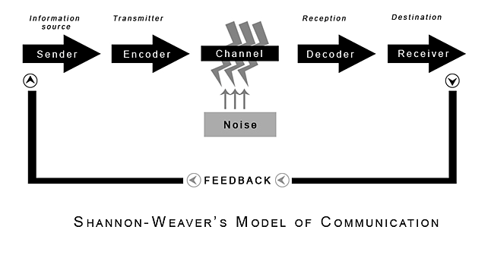
Juneja (2015) writes that in 1954 Wilber Schramm proposed a similar model to the Shannon- Weaver model. However, Schramm’s model emphasizes that communication cannot really occur unless the sender receives feedback from the receiver. Schramm believed that communication is a two-way process between the sender and the receiver. This differs from Aristotle’s model from 300 B.C. Juneja also suggests that Schramm considers that the most important part of the communication process is the encoding and the decoding stages, as without those, the information will never be shared.

In 1960 another development of the original Shannon-Weaver Communication Cycle was expanded, this time by David Burlo, an American communications theorist. Burlo created the SMCR Model of Communication and Janse (2018) summarises that Burlo’s model is one of the simplest to understand (see diagram below). It has four components and each element can be influenced by different factors. However, to ensure the information is sent as clearly and concisely as possible, the sender and receiver must be on the same page but also make allowances for cultural differences and variances of attitudes or knowledge. Other factors such as noise and technical disturbances may also disrupt the physical sending of the information if the message is being sent via technology, such as email or telephone.

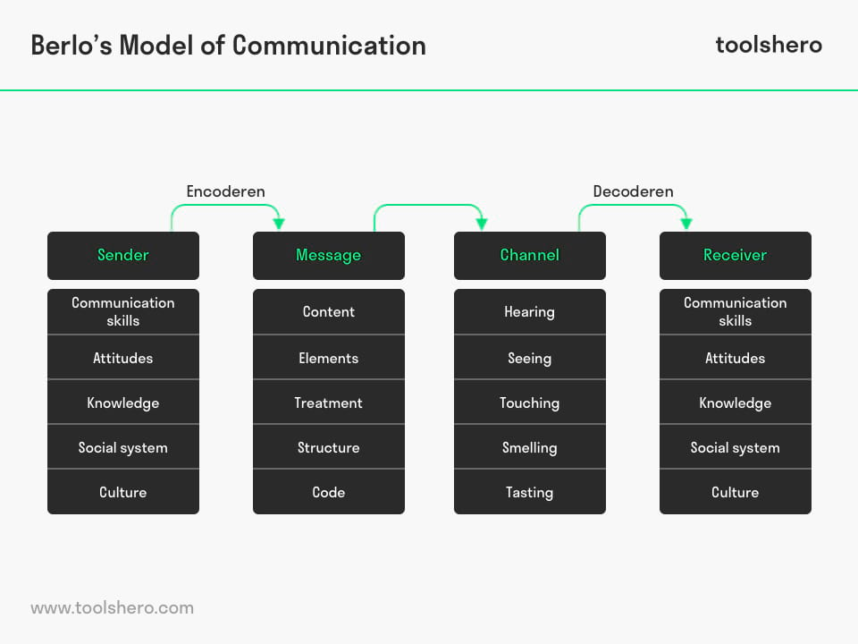
Communication In the Workplace

I’m a self-employed electrician and I have recently employed an apprentice to help me day-to-day. Four weeks into this role, I felt that it was the correct time from a staff development perspective to hold an in person, one-to-one meeting, in order to provide some constructive feedback. I arranged a time so that we could meet privately to discuss how I felt he was progressing and if there was anything he needed to discuss with me. I started by welcoming him and thanking for his time and everything he had done for myself and my company so far, I then went on to ask him if he was enjoying and how he felt he was getting on. He confirmed that he felt that he was progressing well and noted that he enjoyed working for myself and my partner. I asked if there was anything he felt we could do better as employers and he concluded that there wasn’t. I then went on to discuss a few problems I had encountered with his work, a few instances where he was late and perhaps not giving the work his full attention. He explained about a few personal problems he was having at home and issues getting to and from work. I believe that this gave him the opportunity to be open and honest about his progress and I believe that this helped me understand his situation better and assist in finding a solution to the problem. To conclude the meeting, I talked about all the things I was really pleased with and gave a few examples of the times that I was really impressed with the standard of work he was producing and his work ethic. I made notes throughout the whole of the meeting and got my apprentice to read through them with me at the end, we both agreed that the notes I had made were a true reflection of the meeting that took place. I then emailed a copy of the notes to him so that we both had a copy and if I needed to refer back to them at a later date, I could do so.
During the meeting I felt that I was an active listener and I felt that my apprentice was too. We both maintained good eye contact and were participating fully on what was being said. We were both giving the meeting our full attention and that’s why I believe it resulted in a positive outcome. I had agreed to check-in with my apprentice again in another four weeks and make sure the problems from this meeting were resolved or at the very least, improving. It would also be a good opportunity to discuss any other issues that might arise and to make sure the well-being of my apprentice was the best it could be. I felt that this interaction was an appropriate course of action, with a mutually beneficial outcome.

I have also experienced a miscommunication in the workplace that has resulted in some mistakes being made. I had instructed my apprentice to change over a light fitting in the living room area of a customer’s property. I assumed that the apprentice had the skills, experience and knowledge to suitably undertake the task, in particular in the context that he was in his second year of college. When it came to checking his work, the light was permanently on and would not work on the switch. If I had checked with my apprentice prior to instructing him to fit the light, I would have known that he did not know how to install the light properly and I could have explained to him how to do it beforehand. Luckily no damage was done, but I felt that this was a good lesson for both myself and the apprentice in moving forward. In future, I will now ask how comfortable he is performing the task before I send him off to do it, but also encourage him to speak up if he lacks knowledge of a particular task that I am asking him to complete. I’ll try my best as a manager to make my apprentice feel at ease and let him know that I will answer any question he has for me. I will show patience and understanding when I’m showing him the correct way to install and fit things and make sure I emphasise the importance of safety.

2.0

Assessing Own Communication Skills as a Manager

To understand my communication skills better I completed an online communication quiz on MindTools.com (2021). In the quiz I received a score of 48 out of 75. I feel this is a good score however, there is clearly room for improvement (Appendix A).

When looking at my own communication skills I feel that I am very helpful, encouraging and open-minded when speaking with my colleagues and staff about things that I am interested in. I do feel that I need to improve this when the topic moves to something that I am either not familiar with or something that does not interest me, especially if I cannot see that this benefits me in any way. The information I’m being told could benefit me in the future and I should not disregard it so quickly. This is perhaps not a problem socially, but professional I feel this could be an issue.
The feedback I received during my recent presentation (Appendix A) has been quite positive about the way it was delivered, I believe this is because I was well prepared and interested in the subject topic I was presenting. I felt everything I had researched could and would benefit me, so I was eager to talk about it. The feedback also showed that I spoke clearly and loud enough for others to hear and I feel that my apprehensiveness didn’t affect my presentations quality. Some negatives that I received were about the look of my presentation itself, some felt that I put too much information on a few of my slides, which made it quite difficult to read and wasn’t as visually appealing as it could have been. A similar criticism was that I didn’t use enough visual aids to make my presentation look interesting enough. I believe this is something that is easily rectified and will be sure to keep in mind for my next presentation.

After researching the models of Aristotle, Shannon and Weaver, Schramm and Burlo I now realise that my communication skills may need improving in other areas, depending on whom I am dealing with. I had never considered cultural differences before my research; I now feel that this is something I have overlooked in the past and will make sure that I'm mindful of this in the future.
I had always assumed that if I work in the same place as my colleagues that they would have had the same experiences as myself, especially as we all must go to college and learn our trade. After experiencing a workplace miscommunication, I now realise that just because I had experienced something by a certain point in my training, it doesn’t necessarily mean that my apprentice would have had the same experience.

Gap Analysis

Objective | Current Position | Deficiency | Action
What do I want to do? | What can I already do? | What am I lacking? | How do I fix this?
Understand the needs of my staff by understanding the amount of training they’ve received | Speak with them and listen to any concerns of theirs. | Knowledge of their specific training and experiences they have gained. | Ask them about the training they’ve received and if they need any support in workplace training outside of work.
Support my staffs’ health and wellbeing. | Speak with them and listen to any concerns of theirs. | Understanding of their background and any personal problems they may be having. | Have regular ‘check-ins' with my staff members and check that they’re doing OK personally as well as professionally.

PDP

Personal Development Plan to Improve own Communication Skills

Objectives | Tasks | Success Criteria | Time Frame | Resources
List your Goals. | What do you need to do to achieve these goals? | How will you identify your success? | When do they need to be done by? | Who or what do you need to help you?
Understand my staffs’ workload and training better by meeting with them fortnightly instead of 4 weekly. | Block time off in my work calendar to ensure I have enough time to facilitate the staff meetings. | I will take minutes of each meeting and refer to them at every meeting going forward. I will also create PDPs for my staff members to track their progress and development. | 2 weeks. After 3 months I will assess the meetings as a whole and see if they are successful. | I need to make sure I follow the steps I have set myself and that my staff feel comfortable enough to speak honestly with me.

References

Bajracharya, S (2018) Aristotle’s Model of Communication [Online]
Available at: https://www.businesstopia.net/communication/aristotles-model-communication.
Accessed: May 29 2021

Blenkinsop, P. (2010) The Communication Cycle. [online]
Available at: http://manyana-education.blogspot.com/2010/10/communication-cycle.html Accessed: 21 May 2021
MindTools (2021) How good are your communication skills? [online]
Available at: https://www.mindtools.com/pages/article/newCS_99.htm
Accessed: 21 May 2021
Janse, B. (2018). Berlo’s SMCR Model of Communication [online]
https://www.toolshero.com/communication-skills/berlos-smcr-model-of-communication/
Accessed: May 20 2021

Juneja, P (2015) Schramm’s Model of Communication [online]
https://www.managementstudyguide.com/helical-model-of-communication.htm
Accessed: May 20 2021

Shannon, C. and Weaver, W. (1949) The Mathematical Theory of Communication.
Urbana: University of Illinois Press.

Appendix A



