1701257
Dylan Howlett

What helps me learn language and mathematics?: An analysis of a child’s learning in mathematics and language with recommendations for ensuring progress.

This essay will be exploring and analysing various pieces of data, research and experience in order to discuss how a child learns, what they believe helps them learn, as well as recognising what can be done to ensure that the learner and the learning progresses.

The data that will be discussed has been collected from a large Primary school in a largely deprived catchment area in South West Wales. The school is both a Pioneer and Rights Respecting school that has over 700 pupils at present. The data was collected using ‘The Mosaic Approach’ created by Clark and Moss in which various pieces of data and evidence are collected in order to gain clear perspectives of how children learn. The approach evidences “the bringing together of different pieces or perspectives in order to create an image of children’s worlds” (Clark and Moss, 2011, p.13). This explains that the collective evidence creates one whole picture of the children’s learning experience. The data includes observational notes, photographs, an interview with the learner, as well as samples of work. All data was collected after being granted permission by the school using the relevant paperwork (Appendix 1).

The child discussed in this essay, referred to as Child A, is a girl from a Year 2 class of 30 children. In this class, Language was originally set in attainment but was changed to mixed attainment groups for the final 2 weeks of the Personal Teaching Experience (PTE). Cohen, Manion and Morrison (2004) assert that mixed ability groups avoids negative labelling for children and that it prepares the children for the social mix in the real world. This can then be linked to one of Donaldson’s four purposes to become “ambitious, capable learners ready to learn throughout their lives” (Donaldson, 2015). This sets them up to work alongside people that can perform better or worse than them and help them identify how they could adapt their learning techniques to assist others while performing to the best of their ability. In regards the Mathematics, the topic changed weekly as did the groupings which were determined by a ‘Flipped Learning’ introductory lesson at the beginning of the week where the children decided themselves what group to be placed in.
Further reading and research will be used to create a detailed and appropriate analysis of the child’s learner and used alongside current Curriculum documents to reach a suitable conclusion on how the learning can develop.

Analysis of the learner: Literacy

Welsh Government introduced the Literacy and Numeracy Framework (LNF) in all schools in 2014 with the aim to help all learners “develop excellent Literacy and Numeracy skills” by providing a clear continuum setting out annual expectations. (Welsh Government, 2016, p. 6). This followed the 2010 PISA report that showed a “deterioration in Wales’ performance relative to other countries in the three areas of reading, maths and science.” (Dauncey, 2013, p. 1). Following this, Literacy and Numeracy became a priority in schools (Estyn, 2017, p. 18), hence the LNF formation. Within the LNF, Literacy has been divided into 3 strands: Oracy, Reading and Writing with various elements within each strand. This allows you to identify what strand a child may struggle with, and what specific elements can be completed to improve their standard. Estyn state that “good literacy skills are essential in ensuring that young people can communicate effectively and make sense of the world around them.” As well as needing it in order to access the whole curriculum (Estyn, 2017, p. 18). This, again, links with Donaldson’s (2017) Four Purposes as competent oracy is imperative in being a confident individual, while competency in reading and writing is commonly crucial in playing a full part in life and work.
The analysis of Child A’s literacy will be structured using the ASK model which when used provides insight on the child’s attitude, skills and knowledge (Nottingham, 2015). Chris Watkins (2015) claims that when teachers support children notice more about their own learning and reflect on it, they see better development in the children. Therefore, constant feedback on lessons and feelings was a continuous priority throughout PTE. Literacy in the Year 2 class was entitled ‘Future Learning’ (FL) for its apparent links to Successful Futures document, as well as the cross curricular approach the school adopted, delivering Literacy skills at every appropriate opportunity. This disguised Literacy as a subject as Future Learning became anything but Maths in terms of work. Whilst on placement to gain insight to Child A’s attitude towards her learning, an interview was conducted (Appendix 2). Child A was positive in response to the question whether she enjoyed FL, but when questioned on whether she preferred reading, writing or speaking; it was apparent that writing was much inferior. Child A appeared most enthusiastic about oracy in the curriculum, stating that she enjoyed activities in front of the green screen and creating their own videos, giving examples of an exercise video and news report activity. One online article claims that “Oracy is a crucial skill – we’re in danger of producing a generation unable to speak in public” (Williams, 2018). Having read this article previously, it was of interest to see Child A’s response when posed with the question of whether she believes she could speak in a whole-school assembly, she confidently affirmed that she could, but she would be nervous. Estyn (2018) state that typically children’s oracy skills upon entry to the school is significantly below expectation. This highlights the importance of encouraging children’s oracy at every possible opportunity, to create confident individuals. Following this, I questioned Child A on her relationship with reading. Children in the class and throughout the school were encouraged to read at home every night, as Free School Meal (FSM) children were prioritised by staff when in school. This child wasn’t FSM, but due to the class’s nature learners were listened to frequently, both individually and in group guided reading sessions. Reading is taught by the children doing, rather than observation, the children in the school were allowed to select their own books, suitable to their reading level which was colour coded, and could choose from fiction and non-fiction. This links to Dewey’s belief that children should be independent thinkers who are led by curiosity, therefore by choosing a book that they are interested in may encourage them to read more (Pound, 2014). However, Child A also declared her frustration at times with guided reading sessions due to some of the other children in her group being less able to read fluently, preventing her from reading at her own pace, despite being grouped in reading ability. In contrast to Child A’s opinion, an online article claims that being grouped in ability “helps to take the stress out of reading and can build confidence” (Williams, n.d). This suggests that peers act as a relief of the pressure of reading, rather than an obstacle as Child A sees. McLeod (2018) states that Vygotsky also supported this theory through his beliefs that children learn from communicating with someone with a greater understanding. Although, Child A sees the sessions as a normal reading session rather than the intended objective to understand and respond to the text read. Lastly, Child A was asked about writing work, she explained that she didn’t enjoy writing due to spelling and making mistakes with punctuation. It was apparent that the fear of making mistakes meant she was apprehensive when writing and therefore couldn’t fully be expressive through writing. Henry Perkinson explains Piaget’s belief that “Disequilibrium” leads us to “accommodation”, or as Perkinson simplifies: problems or mistakes lead us to creating a new theory in order to correct it (Perkinson, 1979, p. 42). This suggests that by Child A being faced with a problem, for example spelling, she would be able to develop different strategies to get around this problem, such as segmenting or spelling them phonologically, as she declares. Following this, it was ensured that Child A was encouraged to make mistakes in written work and they were discussed at every possible opportunity. To conclude the interview, Child A was used to take photographs of resources or provisions in the class that help her with literacy (Appendix 3). One photograph contains the ‘Synonym Wall’ that had pots of topic specific vocabulary in the shape of lollipops, to fit the Charlie and the Chocolate Factory theme. This was a provision accessible to all children during any writing task. Child A commonly used the synonym wall to improve her description of characters from the story. By integrating the resource in the classroom environment as part of the display, children were able to become pro-active and independent learners. However, this only became routine after teacher intervention when first introduced. This could be linked to the Skinner’s Behaviourist approach, as children recognised what words triggered the response of visiting the ‘Synonym Wall’ as they were fewer exciting words. After a while, the children were able to actively improve their work without being facilitated by the teacher (Pound, 2014, p. 56). Child A also claimed that she could use Dictionaries and Thesauruses in a similar way when ‘polishing’ her work. Once pieces of work are completed, they are marked, and children are given the opportunity to go over any mistakes and ‘polish’ them. This links with Piaget’s theory, previously mentioned, as the children are made aware of their mistakes without being judged for them and given the opportunity to correct them, thus learn from them. Child A is able to identify different word types in text, as evidenced in Appendix 4, specifically adjectives. Child A identified and highlighted the adjective from an extract independently, with the teacher only reading the extract aloud. This links to the Comprehension aspect in the Reading strand of the LNF, where it states that pupils in Year 2 should be able to identify key words and information in texts (Welsh Government, 2014). Child A also shows that she is able to structure sentences correctly, using mostly accurate punctuation (Appendix 5). This is evidenced in her ‘Hot Task’ to write a descriptive paragraph about Willy Wonka, using skills developed in prior learning, like Alan Peats’ 3ed Sentences and Pie Corbett’s Boxing Up. This shows that she is able to remember key features of stories to include in her own work, as well as using strategies to improve it. “Young writers imitate their reading without knowing it.” (Pie Corbett, 2008, p. 3). However, this is to an extent, Child A received the target to use capital letters accurately, so despite having read the story and other extracts, they were unable to imitate the grammar. As she stated in the interview also she struggles with spelling and that is shown in the writing. This work also fits with the Year 2 skill in the writing strand to “write text that makes sense to another reader, which may include details and pictures” (Welsh Government, 2014).

Analysis of the learner: Mathematics

“Numeracy is an essential life skill that enables learners to apply their numerical facts, skills and reasoning to real-life problems” (Estyn, 2017, p. 21). Again, this has strong connections to Donaldson’s four purposes (2015) as it highlights the cruciality that children have these skills that they will have the opportunity to apply in their futures. In the LNF (2014), numeracy has been split into 4 strands: developing numerical reasoning, using measuring skills, using number skills and using data skills. Within these strands there are various elements such as estimating and checking, managing money, time and temperature etc. “We use numeracy every day in all areas of our lives. Our confidence and ability with numbers impacts us financially, socially, and professionally. It even affects our health and wellbeing.” (Schleicher, n.d). This shows that numeracy is an important aspect of life and needs to be developed in order to meet Donaldson’s purposes. This is why developing children’s concept of time, temperature etc. at a young age may be beneficial as their livelihood could depend on it.
Following the ASK model (Nottingham, 2015) again to gain a detailed insight to Child A’s attitude towards numeracy, as well as her skills and knowledge, commencing with an interview with her. Estyn’s Chief Inspector asserts that “a strong pupil voice has clear benefits for both schools and learners.” (Estyn, 2016). This supports the importance of understanding a pupil’s perspective of their education in specific lessons and in general, which encouraged reflection and frequent accumulation pupil opinion. In the interview, Child A’s attitude was mainly positive where she mentioned her enjoyment for the most part, which is lost when she doesn’t understand. She mentioned feeling nervous and stupid when she didn’t understand work, but her peers did. Dr. Cockcroft states that even the most “simple and straightforward piece of mathematics could induce feelings of anxiety, helplessness, fear and guilt” (Cockcroft, 1982). This highlights some of the emotions that may be felt when challenged in schools, so although they learn from mistakes as mentioned previously; the fear of mistakes may actually prevent them from reaching their full ability. When the different aspects had been explained, Child A was asked whether there was an area of numeracy that she preferred, she said that she didn’t like anything in particular and enjoyed different areas of numeracy. Mathematics lessons were taught through the 20/20/20 method, allowing 3 groups 20 minutes with the teacher, teaching assistant and working independently within the hour. The class teacher explained that the intention of this approach was to ensure that all children had time with class teacher every day for numeracy lessons, hopefully resulting in a greater understanding. Following the introductory ‘Flipped Learning’ lesson mentioned in the introduction, the children chose gold, silver or bronze group themselves depending on their confidence and understanding. Grossman (n.d.) states that Fromberg and Maxim both believe that children are more committed to learning when they’ve made an autonomous decision, and it maximises their learning. However, from experience it’s clear that giving the children the autonomy to decide for themselves could result in lying in order to appear higher attaining or to be close with friends, resulting in work being too challenging and therefore obstructing the child’s engagement. Child A alternated between silver and gold and claimed to be honest when selecting the appropriate group. She mentioned her mixed emotions about 20/20/20, explaining that she feels like there is not enough time and by the time you start, you have to stop again. “Pacing is present in every decision in the day-to-day practice of the classroom, since it’s a constant element of the class.” (Goldsmith, 2009, p. 30). This highlights the importance of pacing in every learning experience, yet 20/20/20 may be practical in theory, it may not always be the most beneficial approach in practice. Towards the end of the interview, Child A was asked whether she felt confident in certain elements of numeracy. Child A declared she felt confident in working with money, due to the shop role play accessible in class, time, addition, subtraction and multiplication. However, she explained that she felt less confident with fractions. To conclude the interview, Child A gathered photographs of resources that helped her with numeracy in the classroom (Appendix 7). Child A photographed both Numicon and Base Ten to show they support her when learning numeracy, as they provide a visual and concrete example. The use of visual aids in numeracy meets the ‘Language Model’ which connects language, symbols and materials. Furner and Worrell (2017) state that in 1992, Ball asserted that manipulating materials to represent Mathematics is an effective way of teaching. However, they also assert Piagetian theory states that using concrete materials should result in the children reflecting on the action, rather than what they’ve learned. In this case, Child A found the concrete material beneficial and assisted her in a attaining a clear understanding. She also photographed a ‘110 Club’ sheet that was completed weekly, where children would complete a set amount of multiplication questions determined by their ability and if all were answered correctly, they would progress to the next level- up to 110. She explained that this helped her with multiplication. Appendix 8 evidences that Child A is able to use concrete materials and divide a whole into halves and quarters, as an introduction to fractions. She did this by cutting the Wonka Bars into two equal parts for halves, and four equal parts for quarters. This supports Froebel’s approach of child-centred learning where the children learn by doing (Pound, 2014, p. 17). This also provided the opportunity for Child A to apply problem solving and communicative skills as she overcame any obstacles and had the opportunity to work with peers to find the answers. The topics of fractions then progressed to finding the fraction of numbers (Appendix 9) where Child A is shown to find halves and quarters of numbers, this can be linked to Bloom’s Revised Taxonomy where Child A had to remember work that she had completed days prior and the rules, and then apply them to a new, more difficult, context (Anderson and Krathwohl, 2001). These activities meet the Year 2 skill of “finding halves and quarters in practical situations” from the Using Number Skills strand of the LNF (2014). Lastly, Child A was able to use Singapore Maths Bar Method to solve written addition and subtraction questions (Appendix 10). Child A drew the bars with the amount inside next to each other when adding to represent the two bars becoming a whole, she also then put the smaller bar underneath the larger bar for subtraction questions to represent that the answer was the part of the bar after the smaller bar. This allowed Child A to problem solve, communicate with her peers and solve one-digit and two-digit addition and subtraction questions.

Future Progress

As mentioned, Child A enjoyed Literacy (FL) and her standard of reading, writing and speaking appeared good, however in order to develop Child A has some improvements. In regard to oracy, she should avoid colloquialisms and explore a wider range of vocabulary, this could be explored through dictionaries, thesauruses, peers or teachers. Alexander (2012) claims that one of the reasons for the decline in oracy skills is the increase in “chatter” rather than standard English. Following this, she should maintain eye contact when speaking directly as this is something that she will use in later life, whether in interviews or day-to-day conversation. Moreover, Child A should include more expression when reading aloud and acknowledge punctuation to increase fluency and accuracy when reading. Additionally, encouraging Child A to read to understand, rather than to be fluent, is a next step for development, this could be done by skimming and scanning, highlighting the main ideas and summarising text to ensure she has understood what she has read. Furthermore, Child A could use segmenting, dictionaries or phonetical sounding to improve her spelling when writing, additional guidance is needed to ensure she can use punctuation accurately, specifically full stops and commas, as others will be covered in future years. Child A should also continue to integrate sentence structures like 2aa sentences and 3ed sentences to present a variety of structures in her writing, but perhaps use thesauruses to include a wider range of nouns, verbs and adjectives. Taking inspiration from texts read would also result in writing development as she can mirror different sentence types or words. “Good writers read” (Corbett, 2008). She could also use reading to help her with capital letter accuracy, spelling and punctuation. In the LNF (2014) the next steps for her are to “write for different purposes” and different types of text, i.e. factual, action or first-person text.

In Mathematics, Child A will benefit from using free time and the independent slots of her lessons to practise 110 Club sheets in order to progress to the next club and therefore progress with her multiplication questions. Estyn (2016) claim that by children being responsible for their own learning, they have a greater idea of what they are learning and why. By the children being responsible in choosing whether to practise or not, they are aware that if they do practise it will result in progressing to a higher stage. Also, Child A’s next step in regard to fractions, is to find thirds and fifths in practical situations. This could then be developed by finding fifths and thirds of numbers, similar to the work based on halves and quarters. The curriculum states that the next step is to “use halves and quarters” and to “find fractional quantities linked to known multiplication facts” (Welsh Government, 2014). These are Year 3 skills but could be introduced early to provide her with an initial basis of the topic. In addition, with Singapore Bar Method, Child A could develop their addition and subtraction skills by using the method with larger numbers, perhaps progressing on to 3-digits questions or completing the questions independently. “Being able to think and act independently remains one of the most important skills that a student can learn” (Gershon, 2014). This sets them up for future life as they will not always have a peer or teacher there to assist them in solving problems, therefore once they are capable it may be beneficial to allow children independence to ensure they understand fully. Reversing the method and using the inverse to check their answers would be an extremely advantageous as they are able to learn whether their answer is correct immediately, allowing them time to improve their work.

To conclude, Child A had an enthusiastic and positive outlook on Mathematics and Literacy for the most part. She favoured activities that included speaking in a range of different contexts, from news reports to exercise videos but needs to focus on improving her standard English. She also states that she enjoyed reading at her own pace but is unable to see the benefits of guided reading, despite it helping her understand what she has read. She liked writing the least, fearing spelling words incorrectly, however was able to display some knowledge of punctuation and a good understanding of word types. To guarantee future development, Child A should use a suitable strategy to help her spell words and learn where to use capital letters. Additionally, Child A asserted that she enjoyed Mathematics when she understood the work but struggled when she did not. To ensure future progress, she should continue to practise her times tables regularly and use the inverse to check her answers before moving on. Both Literacy and Mathematics prove a crucial part in a child’s development and prepare children for their future school experiences, careers and everyday life, and should therefore be covered every day in an interesting and engaging manner.

Reference List

Alexander, R. (2012) Improving Oracy and Classroom Talk in English Schools: Achievements and Challenges. England. University of Cambridge. Available at: https://www.robinalexander.org.uk/wp-content/uploads/2012/05/DfE-oracy-120220-Alexander-FINAL.pdf [Accessed on 2nd April 2019]

Anderson, L. W. and Krathwohl, D. R. (2001) A Taxonomy for Learning, Teaching and Assessing: A Revision of Bloom’s Taxonomy of Educational Objectives. New York. Longman.

Clark, A and Moss, P. (2011) Listening To Young Children: The Mosaic Approach. 2nd ed. London. National Children's Bureau.

Cockcroft, W.H. (1982) Mathematics Counts. London. Her Majesty’s Stationery Office.
Cohen, L. Manion, L. and Morrison, K. (2004) Advantages of Mixed Ability Groups. RoutledgeFalmer.
Corbett, P. (2008) Good Writers. The National Strategies. Available at: https://www.foundationyears.org.uk/files/2011/10/Good_Writers1.pdf [Accessed on 26th March 2019]

Dauncey, M. (2013) Literacy and Numeracy in Wales. Cardiff. National Assembly for Wales. Available at: http://www.assembly.wales/Research%20Documents/Literacy%20and%20Numeracy%20in%20Wales%20-%20Research%20paper-03062013-246762/13-039-English.pdf [Accessed on 19th March 2019]
Donaldson, G. (2015) Successful Futures. Cardiff. Welsh Government.
Estyn. (2016) ‘Pupil Voice’ Benefits Pupils and Helps Schools to Improve. Cardiff. Estyn. Available at: https://www.estyn.gov.wales/news/‘pupil-voice’-benefits-pupils-and-helps-schools-improve [Accessed on 28th March 2019]

Estyn. (2016) Encouraging Independent Learners. Wales. Estyn. Available at: https://www.estyn.gov.wales/effective-practice/encouraging-independent-learners [Accessed on 2nd April 2019]
Estyn. (2017) Annual Report: 2016 – 2017. Wales. Estyn. Available at: https://www.estyn.gov.wales/sites/default/files/documents/Estyn_Annual%20Report_2018_English_Accessible.pdf [Accessed on 19th March 2019]
Estyn. (2018) Rapid development of pupils’ oracy skills. Cardiff. Estyn. Available at: https://www.estyn.gov.wales/effective-practice/rapid-development-pupils’-oracy-skills [Accessed on 22nd March 2019]
Furner, J. M. and Worrell, N. L. (2017) The Importance of Using Manipulatives in Teaching Math Today. USA. Nova Southeastern University. Available at: https://nsuworks.nova.edu/cgi/viewcontent.cgi?article=1013&context=transformations/ [Accessed on 1st April 2019]

Gershon, M. (2014) How to Develop Independent Learners. England. TES. Available at: https://www.tes.com/sites/default/files/tes_strategies_to_develop_independent_learners.pdf [Accessed on 2nd April 2019]

Goldsmith, J. (2009) Pacing and Time Allocation at the Micro- and Meso- level within the Class Hour: Why Pacing is Important, How to Study it, and What it Implies for Individual Lesson Planning. Spain. Autonomous Univerity of Barcelona.

Grossman, S. (n.d.) Offering Children Choices: Encouraging Autonomy and Learning While Minimizing Conflicts. USA. Michigan University. Available at: http://www.earlychildhoodnews.com/earlychildhood/article_view.aspx?ArticleID=607 [Accessed on 1st April 2019]

Infrastructure, Curriculum, Qualifications and Learner Support Directorate. (2016) National Literacy and Numeracy Programme – a strategic action plan. Cardiff. Welsh Government. Available at: https://learning.gov.wales/docs/learningwales/publications/160316-national-literacy-and-numeracy-programmes-en.pdf [Accessed on 19th March 2019]

McLeod, S. (2018) Lev Vysgotksy. Simply Psyhcology. Available at: https://www.simplypsychology.org/vygotsky.html [Accessed on 28th March 2019]
Nottingham, J. (2015) Challenging Learning. London. Routledge.
Perkinson, H. J. (1979) Learning from our Mistakes. Institute of General Semantics. Available at: https://www.jstor.org/stable/42575890?read-now=1&seq=6#metadata_info_tab_contents [Accessed on 25th March 2019]
Pound, L. (2014) How Children Learn. London. Practical Pre-school Books.
Schleicher, A (n.d) Why is Numeracy Important? National Numeracy. Available at: https://www.nationalnumeracy.org.uk/why-numeracy-important [Accessed on 28th March 2019]
Watkins, C. (2015) When Pupils Talk About Their Learning. The London Centre of Leadership in Learning. Available at: https://chriswatkins.net/wp-content/uploads/2015/07/9-When-pupils-talk-about-learning.pdf [Accessed on 26th March 2019]
Welsh Government. (2014) Literacy and Numeracy Framework. Cardiff. Welsh Government. Available at: https://learning.gov.wales/resources/browse-all/nlnf/framework?lang=en [Accessed on 17th March 2019]
Williams, A. (n.d) What are the Advantages and Disadvantages of Guided Reading? Synonym. Available at: https://classroom.synonym.com/advantages-disadvantages-guided-reading-8405104.html [Accessed on 25th March 2019]
Williams, Y. (2018) Oracy is a crucial skill – we’re in danger of producing a generation unable to speak in public. England. TES. Available at: https://www.tes.com/news/oracy-crucial-skill-were-danger-producing-generation-unable-speak-public [Accessed on 4th January 2019].

Appendix 1
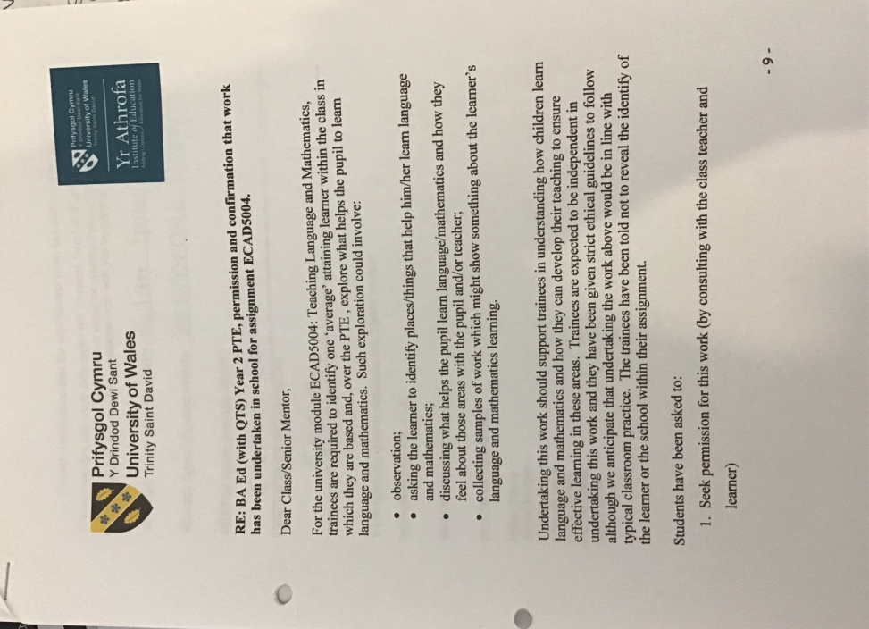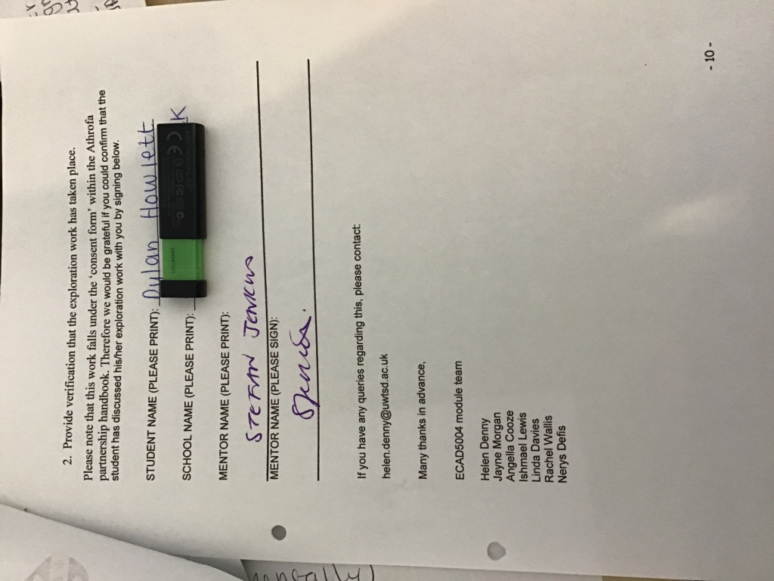

Appendix 2

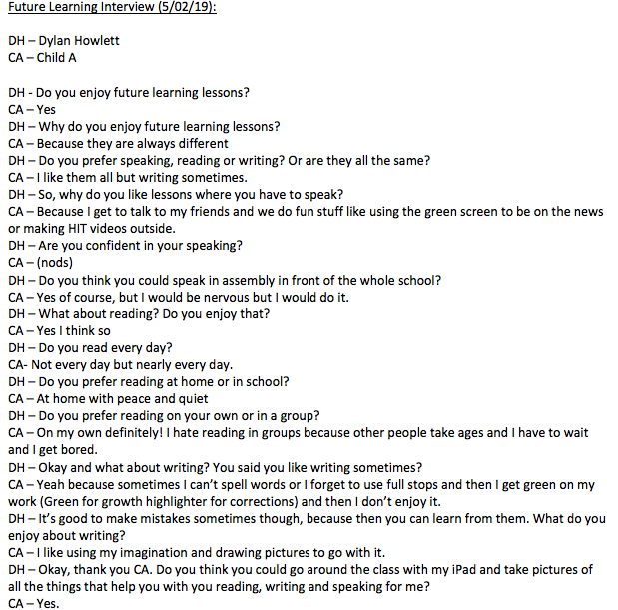

Appendix 3

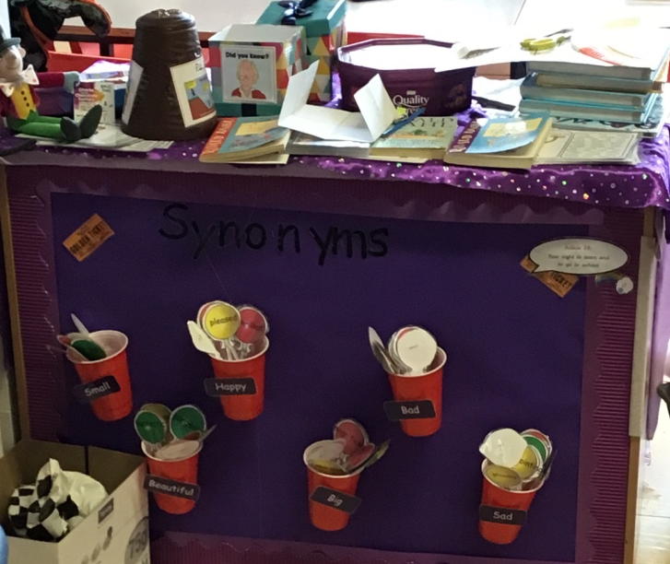
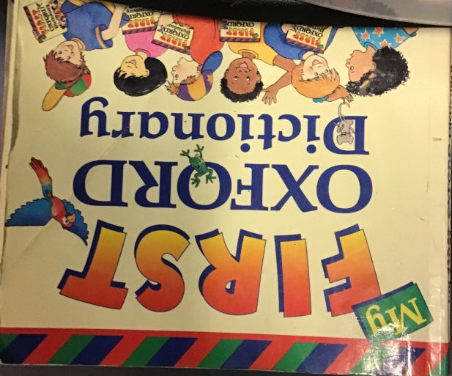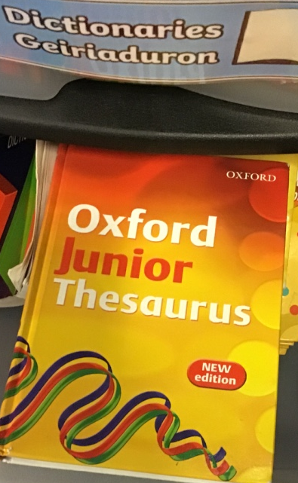

Appendix 4
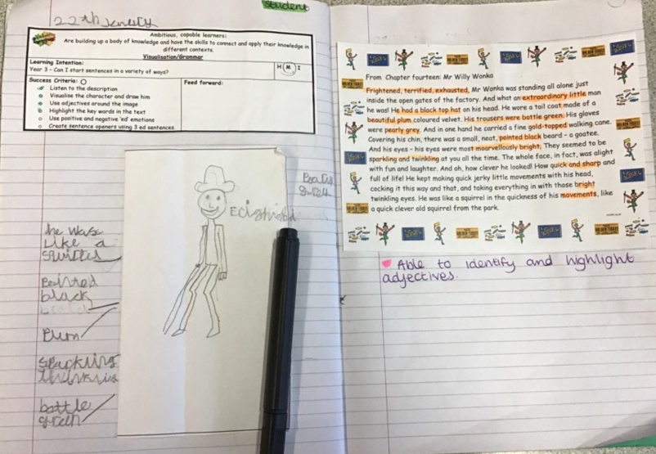

Appendix 5

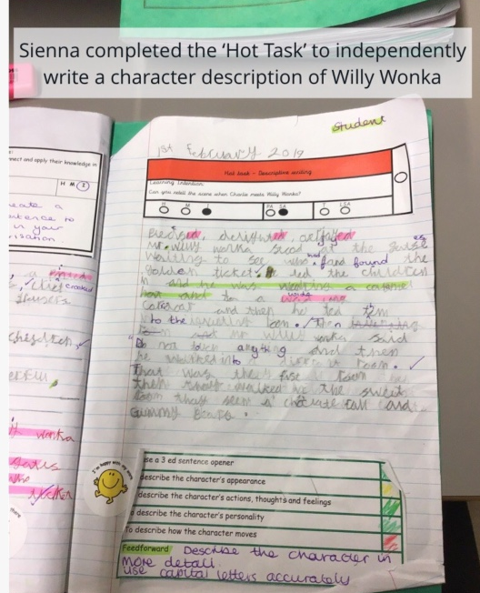

Appendix 6

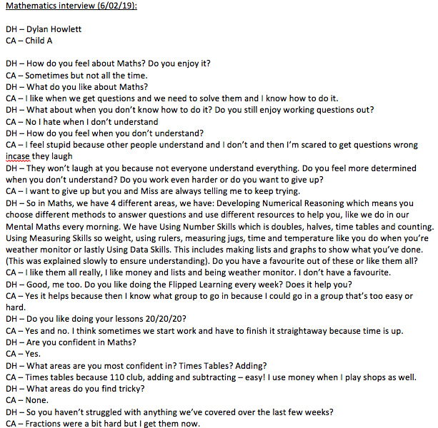

Appendix 7

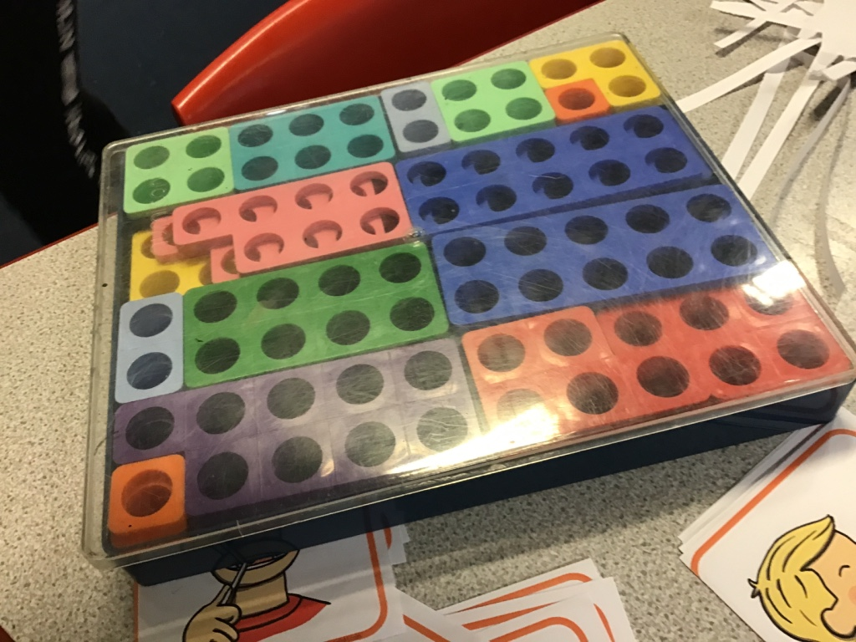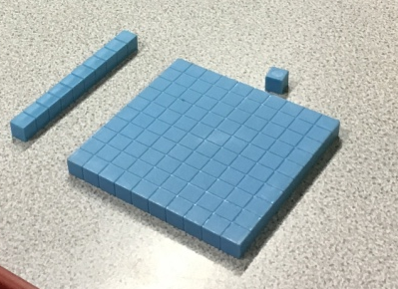
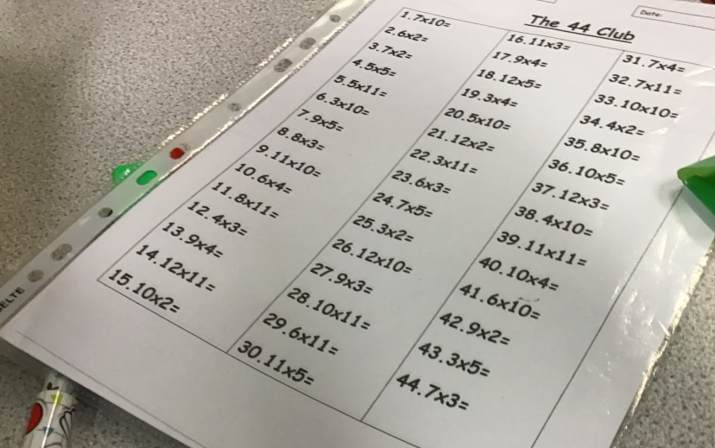

Appendix 8
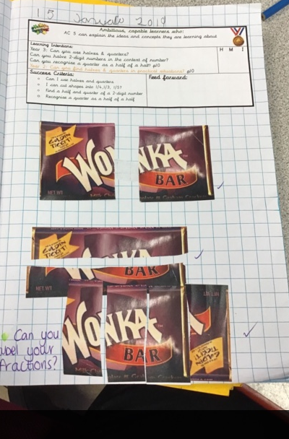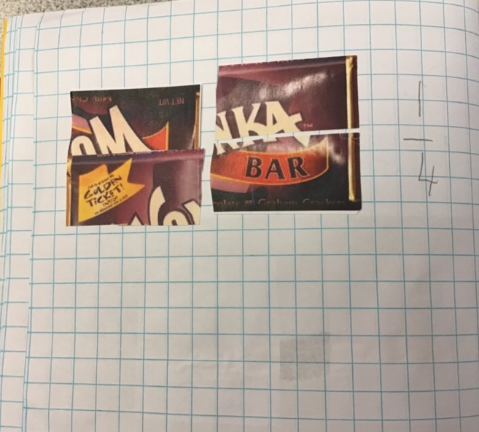
Appendix 9

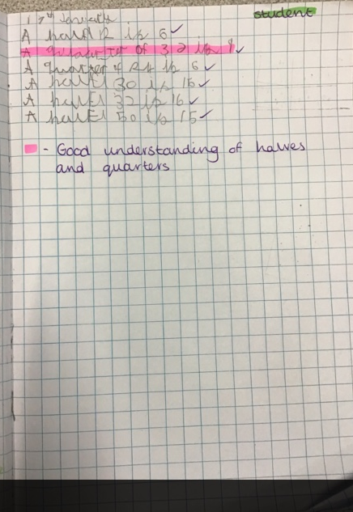

Appendix 10



