Being Minoan, Becoming Mycenaean

Zapher Papoura (plan)
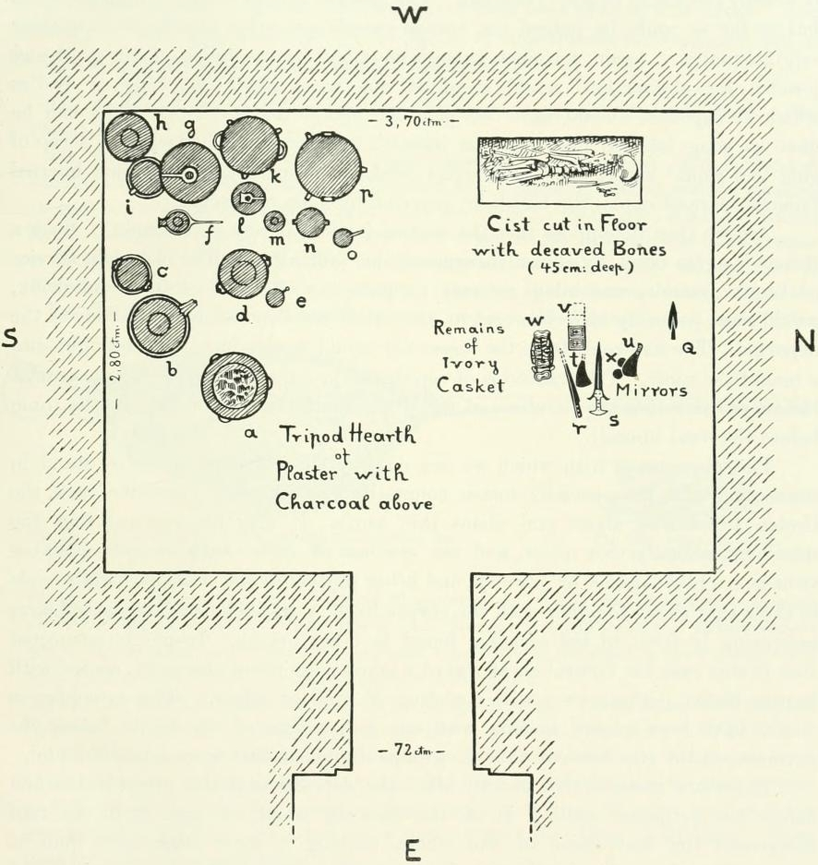

Zapher Papoura (finds)
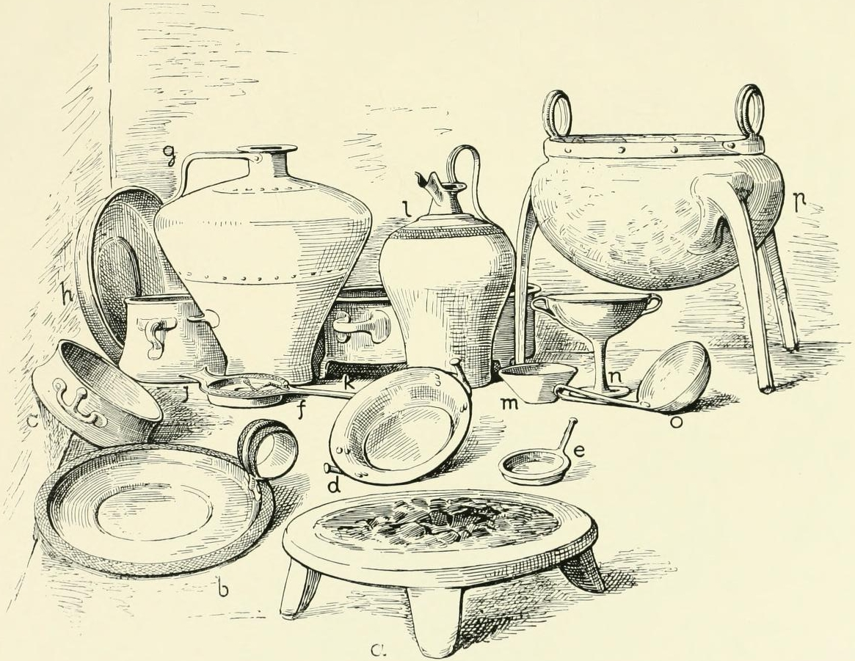

Sellopoulo Tomb 4

