

Marketing Fundamentals

Assessment 1: Blogging to communicate

Student Name:- Sahil Girishbhai Bhuva
Student Number:- 2127449
Module Leader:- Dr. Tushara Balendran
Module Code:- LCBB4004
Table of Contents
Background/ History 3
Blog 1: Flight services 3
Blog 2: Visa process 4
Blog 3: Safe Travelling 5
Blog 4: Luxury and comfortable stays 6
Blog 5: Cab services and guidance 7
Blog 6: Travel Insurance 8
Blog 7: Attractive travel options and policies 8
Blog 8: Airport lounges booking 9
References 10

ACE Travel Management London

Background/ History
The ACE Travel Management London is a London-based company. Its trading name is KMG travel management limited. It was founded in 1992 and provides travel management services. It is an independent travel management company that is run by the CEO of the company Sarah Wilson. The company has over 300 travel clients in a wide range of sectors. It provides travel that ranges from £50000 to £2 million.

Blog 1: Flight services
The ACE Travel Management London is a London-based company that ensures that you reach the right place, at the right time. ACE Travel Management London provides business flight services and ensures that you have and safe and comfortable journey. If you don't want the hassle to search for the best flight for you and your family then you are at the right place, because ACE Travel Management London provides you with the cheapest business flights available to reach your destination. The business person who is short of time and does not want to waste their time searching online has the opportunity to save valuable time because ACE Travel Management London is at their rescue. Just log in to their website and book the desirable business class flights that are both comfortable and convenient. The company specializes in taking care of your in-flight needs and has collaborations with all the major airlines that operate globally(Ferrell, et al., 2021). This is also a very good offer for senior citizens who don't want the hassle while traveling and therefore can conveniently book their flight with them. The company also provides customer service round the clock to assist the passenger who booked with them. The company provides flight services to Portugal for just £619. Visit their website for details https://www.acetravel.co.uk/flights . Hence, fasten your seatbelts and get ready to fly with ACE Travel Management London (Baker, 2017).
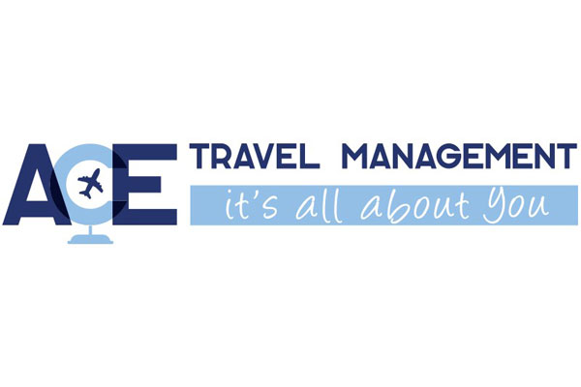
(Source: Businesstravelsnewseurope, 2022).

Blog 2: Visa process
Applying for a visa is often a time-consuming process that is not convenient for many students or working professionals who are short of time. Nowadays even normal tourists don't want the hassle of visa regulations. Thus, the visa regulations cause inconvenience for many sections of the population. Here is good news for all those people who want to avoid the inconvenient visa process and want to save valuable time. ACE Travel Management London is providing passport and visa services for all people who want to travel abroad. ACE Travel Management London will ensure that there are no obstructions in clearing your visa and issuing your passport. This is also a very good offer for senior citizens who don't want the hassle while applying for a visa or passport and therefore can conveniently avail of our services to get their visa and passport issued in a hassle-free manner. The company also provides customer service round the clock to assist the passenger who booked with them. The company has a collaborative partner who has over 50 years of experience in issuing visas and passports for citizens. The company provides beach stay in Australia at just £3429. Visit their official website for details https://www.acetravel.co.uk/visa-and-passport . So get ready to travel the world with us and explore the world (Kingsnorth, 2022).

Blog 3: Safe Travelling
Reaching the destination with safety is the priority for any passenger. Hence, here at ACE Travel Management London, they ensure that this concern of the passengers traveling with them is fulfilled and they reach safely on time. They provide tracking applications and software that can be installed on the devices of passengers and their loved ones. This will give the passengers updates regarding their journey and will ensure that they reach without any hassle (Mothersbaugh, et al., 2020). This is an immense relief for the parents of minor children traveling alone or the relatives of senior citizens concerned about them. This application will give all the updated and required information relevant to the journey and will give additional information if asked. The company provides customer service round the clock to assist the passenger who booked with them. The passengers can call or mail their queries about their journey and they will get a reply at the earliest. ACE Travel Management London works tirelessly and prioritizes the safety and comfort of its clients. Your safety is their priority. You may log in to their official website for more information https://www.acetravel.co.uk/ . So don't think twice, avail their services to enter a safer and more comfortable world. Get updated and get informed about your every move (Patrutiu-Baltes, 2016).
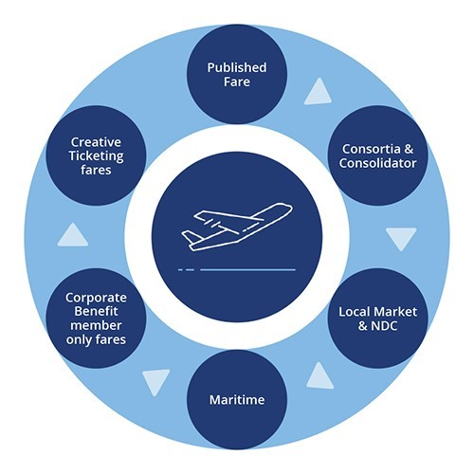
(Source: ACETRAVEL, 2022).

Blog 4: Luxury and comfortable stays
While traveling our biggest concern is to find a comfortable place to stay. This is especially true when traveling with friends and family. This often takes up a lot of time and energy for the passengers and tourists when they search for hotels online for an unknown destination. Since the destination place is unknown to them, It takes up a lot of their time. So it is a pain for them. But now all of the travel freaks need not worry as ACE Travel Management London is at their rescue. Now plan your travel and book hotels hassle-free with ACE Travel Management London. They will ensure you a comfortable stay away from home. The company also provides corporate hotel stays. Since the corporate meetings need to take place at prime locations and with all the required amenities, the company takes care of the hassle and is therefore reliable in arranging corporate hotel stays for business persons. The bookings are confirmed instantly so the travelers don't need to wait for their confirmation. The company also provides customer service round the clock to assist the passengers who booked with them. You may visit their official site for bookings https://www.acetravel.co.uk/hotels . So get ready to move to your new home away from home (Mandal & Joshi, 2017).
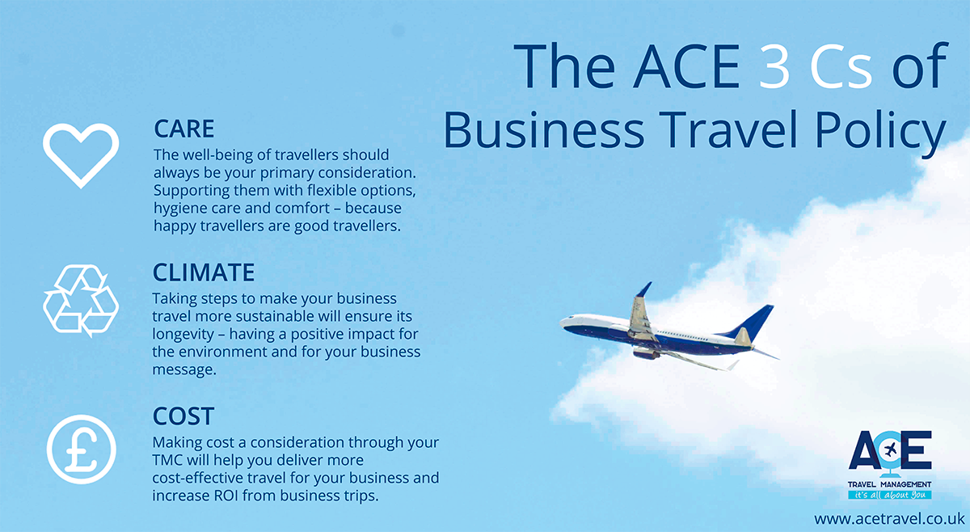
(Source: ACETRAVEL, 2022)

Blog 5: Cab services and guidance
We have all faced problems with commuting to a new place when visiting a new city. This is especially true if we move to a new city or town. The students, working professionals, and even tourists find it difficult to commute to a new city that they are unfamiliar with. No need to worry folks now ACE Travel Management London is at your rescue. The company is proving affordable car hire that is affordable to all the sections of the population so they can hire their car services. People can select from the wide range of cars that are available at their locations. The cars that suit their personality and budget can be hired by the people for commuting hassle-free around the town. The cars are provided with affordable rates that are well within reach of any ordinary citizen. The vehicles provided have GPS service that enables the new commuters to travel in the new city without hassle. Commuters have the option to use Google Maps services in case they want to find a place or are lost. The company also provides drivers along with vehicles if required. The company also provides customer service round the clock to assist the passengers who booked with them. You may visit their website to check out the rental for various vehicles https://www.acetravel.co.uk/car-hire . So get ready to roam the city with style (Chaffey & Ellis-Chadwick,2019).

Blog 6: Travel Insurance
All travelers know that business trips are very different from regular vacations. Business trips are more frequent and contain more travel when compared to other travels. This requires better planning and more effort in execution. Hence, ACE Travel Management London does this work for you. They provide business travel insurance that will take care of your needs and requirement in the event of any loss or mishap. They have designed an extensive covid19 cover for business travelers. This will cover all the losses faced by the passenger during the pandemic (Moravcikova & Kliestikova,2017). It covers the passengers even against the worst of the events that could occur in the event during the pandemic. They have collaborated with Campbell Irvine in providing insurance against the Covid19, booking which gives peace in uncertain times. Reaching the destination with safety is the priority for any passenger. Hence, here at ACE Travel Management London, they ensure that this concern of the passengers traveling with them is fulfilled and they reach safely on time. The company has earned a trusted name in travel insurance. It provides customer service round the clock to assist the passenger who booked with them. The passengers can call or mail their queries about their journey and they will get a reply at the earliest. You may also visit their official website for more information https://www.acetravel.co.uk/business-travel-Insurance . So feel safe and secure every time you travel (Villas,2016).

Blog 7: Attractive travel options and policies
Searching for a good travel partner is very difficult nowadays. It takes up a lot of time going through different websites and portals and reading reviews of various customers. Most of the passengers who travel don't want to go through this pain and want to save their valuable time. This problem is solved by ACE Travel Management London which offers attractive travel options and has a customer prioritizing travel policy. Helping the passengers reach their destination safely is their priority. Their travel policy consists of 3Cs that are care, climate, and cost (Blakeman, 2018). Care means the well-being and safety of passengers which is their topmost priority when arranging or booking travel plans. The second is the climate that is providing them support and proper hygiene while making their travel easy. The third is cost. It is providing affordable services for passengers by making their travel cost-effective. They provide customer service round the clock to assist the passenger who booked with them. The passengers can call or mail their queries about their journey and they will get a reply at the earliest. So feel safe and secure every time you travel. Visit their official website for details https://www.acetravel.co.uk/business-travel-policy-planning .So choose a good travel partner to make your travel memorable (Kuang-Jung, et al., 2015).

Blog 8: Airport lounges booking
We all have waited in the waiting halls in the airports while waiting to board our connecting flights. This is a tiring and time-consuming job to wait for hours at an inconvenient place. Also booking lounges after reaching the pace is sometimes hectic and can be inconvenient if the place is at its full capacity. This problem is now solved with the Lounge pass offered by ACE Travel Management London which is offering the facility to book airport lounges before travel to avoid any inconvenience during travel. The company has collaborative partners in all the airports worldwide(Kim & Chao,2019). This is good news for all the travelers who don't want to wait in the airport waiting for the area when traveling for long hours. Students and working professionals can avail of this opportunity and travel with convenience throughout the world. A business person who wants a comfortable journey can also book in advance to avoid inconvenience later. Senior citizens and unaccompanied minors should book with us to have a comfortable and convenient stay between the connecting flights. Visit the official website of ACE Travel Management London for more information. Visit their website for bookings https://www.acetravel.co.uk/lounge-pass . So, fly with style and wait with comfort (Latif, et al., 2014).

References
ACETRAVEL. 2022. Business travel policy planning. [Online]. Available at: https://www.acetravel.co.uk/business-travel-policy-planning [Accessed on 6th August, 2022].
ACE TRAVEL. 2022. Flight booking services. [Online]. Available at: https://www.acetravel.co.uk/flights[Accessed on 6th August, 2022].
Baker, M.J., 2017. Marketing strategy and management. Bloomsbury Publishing. https://books.google.co.in/books?hl=en&lr=&id=DSRIEAAAQBAJ&oi=fnd&pg=PP1&dq=marketing+strategy&ots=uZv9a3_ufJ&sig=WPqEzBZMGm35pon3YiGTnOfKmPk&redir_esc=y#v=onepage&q=marketing%20strategy&f=false
Blakeman, R., 2018. Integrated marketing communication: creative strategy from idea to implementation. Rowman & Littlefield.https://books.google.co.in/books?hl=en&lr=&id=m-1DDwAAQBAJ&oi=fnd&pg=PR3&dq=communication+in+marketing&ots=REKosyqmTt&sig=pdUwC7jlulvn9WR2vIVHBXuPhD8&redir_esc=y#v=onepage&q=communication%20in%20marketing&f=false
Businesstravelsnewseurope. 2022. Ace travel management at business travel. [Online]. Available at: https://www.businesstravelnewseurope.com/Management/ACE-Travel-Management-at-Business-Travel-Show-for-the-first-time [Accessed on 6th August, 2022].
Chaffey, D. and Ellis-Chadwick, F., 2019. Digital marketing: strategy, implementation & practice. Pearson UK. https://books.google.co.in/books?hl=en&lr=&id=-1yGDwAAQBAJ&oi=fnd&pg=PT17&dq=marketing+strategy&ots=XiUt8WoM2_&sig=OyammCcoMy1VkKEVVlqMKbpndT4&redir_esc=y#v=onepage&q=marketing%20strategy&f=false
Ferrell, O.C., Hartline, M. and Hochstein, B.W., 2021. Marketing strategy. Cengage Learning. https://books.google.co.in/books?hl=en&lr=&id=SewfEAAAQBAJ&oi=fnd&pg=PP1&dq=marketing+strategy&ots=PgTCzBKl3b&sig=XEBOp2Is0Yi8RD-xflmIPNDd3LE&redir_esc=y#v=onepage&q=marketing%20strategy&f=false
Kim, R.B. and Chao, Y., 2019. Effects of brand experience, brand image and brand trust on brand building process: The case of Chinese millennial generation consumers. Journal of International Studies, 12(3). https://jois.eu/files/1_670_Kim_Chao.pdf
Kingsnorth, S., 2022. Digital marketing strategy: an integrated approach to online marketing. Kogan Page Publishers. https://books.google.co.in/books?hl=en&lr=&id=acdsEAAAQBAJ&oi=fnd&pg=PP1&dq=marketing+strategy&ots=Ztfs71IGoL&sig=TZxo0aN0yS2DSJUVkEObKOiYuI8&redir_esc=y#v=onepage&q=marketing%20strategy&f=false
Kuang-Jung, C., Mei-Liang, C., Chu-Mei, L. and Chien-Jung, H., 2015. Integrated marketing communication, collaborative marketing, and global brand building in Taiwan. International Journal of Organizational Innovation (Online), 7(4), p.99. https://www.ijoi-online.org/attachments/article/44/FINAL%20ISSUE%20VOL%207%20NUM%204%20APRIL%202015.pdf#page=99
Latif, W.B., Islam, M.A. and Noor, I.M., 2014. Building brand awareness in the modern marketing environment: A conceptual model. International Journal of Business and Technopreneurship, 4(1), pp.69-82. https://www.researchgate.net/profile/Md-Aminul-Islam-2/publication/272161898_Building_Brand_Awareness_in_the_Modern_Marketing_Environment_A_Conceptual_Model/links/5832c63b08ae102f073478f6/Building-Brand-Awareness-in-the-Modern-Marketing-Environment-A-Conceptual-Model.pdf
Mandal, P. and Joshi, N., 2017. Understanding digital marketing strategy. International journal of scientific research and management, 5(6), pp.5428-5431. https://d1wqtxts1xzle7.cloudfront.net/53578258/11_ijsrm-with-cover-page-v2.pdf?Expires=1659595657&Signature=GBKo0nnxIFLiY9-wrqwgfyHQRJYygieLc3We-ISyAVIeNUXMc0zC979Aehbps6EheRt9XPZSU8DPbX~y~Hz082eyJWY7egejq2jFm~~w9-0L7qqBaxE0KAa6Cyj8uoPO60U0xPc7F~t~HMloswuCqs6BogoxDjNoLiiOsyKU5WKCQVp1-tyquO4RWks51NiVT22fwQ~BtkeDpRJULWXu7~pL-ajLvlZnQjfIOTC0HfOxrz-8K-XRWQObbL-6qiQQu5Poxc-yyk5LIYzPSHChyPMG1rz1xaggg7CAeO1A~uGUvyEAdyfxANIAyBReQQgetPdF8jc2NJk2SZbOpNcygw__&Key-Pair-Id=APKAJLOHF5GGSLRBV4ZA
Moravcikova, D. and Kliestikova, J., 2017. Brand building by using digital marketing communication. Journal of Economics, Business, and Management, 5(3), pp.148-153. http://www.joebm.com/vol5/503-MM0025.pdf
Mothersbaugh, D.L., Hawkins, D.I., Kleiser, S.B., Mothersbaugh, L.L. and Watson, C.F., 2020. Consumer behavior: Building marketing strategy. New York, NY, USA: McGraw-Hill Education. http://ecommerce-prod.mheducation.com.s3.amazonaws.com/unitas/highered/changes/mothersbaugh-consumer-behavior-14e.pdf
Patrutiu-Baltes, L., 2016. Inbound Marketing-the most important digital marketing strategy. Bulletin of the Transilvania University of Brasov. Economic Sciences. Series V, 9(2), p.61. http://webbut2.unitbv.ro/bu2016/Series%20V/BULETIN%20I/07_Patrutiu_Baltes.pdf
Villas, F., 2016. The international marketing of travel and tourism: A strategic approach. Bloomsbury Publishing. https://books.google.co.in/books?hl=en&lr=&id=_yFIEAAAQBAJ&oi=fnd&pg=PR9&dq=travel+agency+marketing+&ots=H5U8WoP5WT&sig=qALSjZX_a7A9_idnqnEwegAteZY&redir_esc=y#v=onepage&q=travel%20agency%20marketing&f=false

