University of Wales Trinity Saint David
Wales Institute of Science and Art

Six Sigma Green Belt (ACMA6002)
Discrete Event Simulation
Emily Thomas
2418089
September 2026

Contents
1. Introduction 2
2. Literature Review 3
3. Process Description and Data Collection 4
4. Arena Model Development 5
5. Waste Identification 8
6. Value Analysis 9
7. Simulation Results and Analysis 10
8. Lean Improvement Opportunities 12
9. Conclusion 13

Introduction
Industry 4.0 has increased the use of automation, digital technologies and data-driven decision making within modern manufacturing. As production systems become more complex, simulation provides a useful way to analyse processes and identify opportunities for improvement without disrupting the actual system.
Discrete Event Simulation(DES) is used to model systems where events occur at specific points in time. In manufacturing, it can be used to analyse process flows, throughput, resource utilisation, waiting times and bottlenecks. It also allows potential improvements to be tested before actually being introduced to the real production system which can introduce time delays to production or can cost money for it to not work as planned.
This study used DES and Arena software to analyse the CP Laboratory automated manufacturing system. The aim is to evaluate the systems performance and identify where improvements can be made. This includes the development and analysis of the simulation model, looking at key performance indicators, identifying waste and bottlenecks, and carrying out analysis on value adding and non-value adding activities, whilst also recommending improvements in line with Lean Improvement principles.

Literature Review

DES – definition, applications, advantages, manufacturing examples
Lean Manufacturing – lean philosophy, continuous improvement, customer value
Waste – introduce TIMWOOD ( transport, inventory, motion, waiting, overproduction, overprocessing, defects
DES & Lean integration – discuss how simulation supports improvement projects

Process Description and Data Collection
The manufacturing system that is analysed in this report is based on the CP lab automated production line within University of Wales Trinity St David. The process starts with parts entering the system from a robot assembly station (RAS) before undergoing optical inspection. The parts are then routed to the drilling station where either 2 or 4 holes are drilled depending on the product type. The parts then proceed through to top cap dispensing, hydraulic pressing and label printing before reaching the output station.
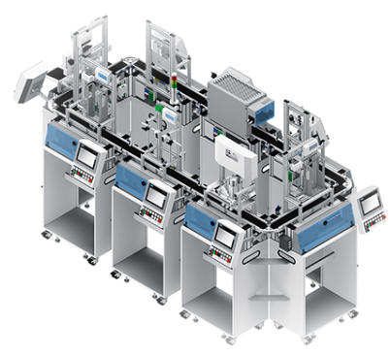

Process data
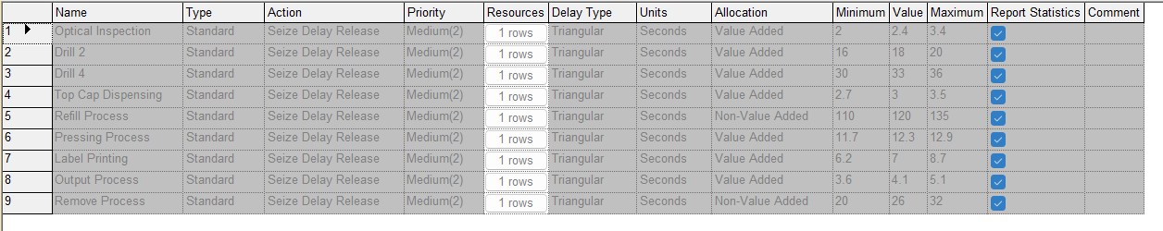

The input data provided for this case study is represented using triangular probability distributions within Arena

Arena Model Development
The model blocks all have a different purpose:
Create Module is used for the arrival of parts, the process modules are used for inspection, drilling, dispensing, pressing, labelling and the outputs. Through this module you can specify the logic of process, what variables are used and the timings for example a ‘seize delay release’ logic, where one operator is nominated, and triangular timing meaning that a minimum, maximum and average time to complete the process can be specified. The decide module is used for a decision, this can be based on a condition or chance for example, 2-way chance 60/40 where it is 60% chance of being true. This dispose module ensures that parts leave the system.
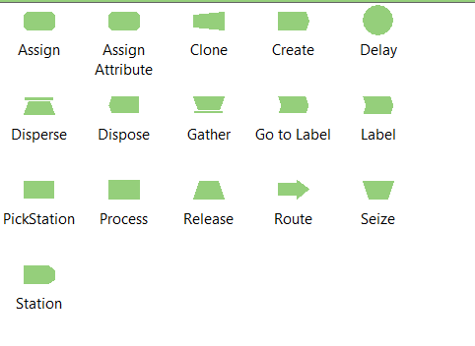
I used these process blocks following the below instruction regarding timings
Pic of table from case study

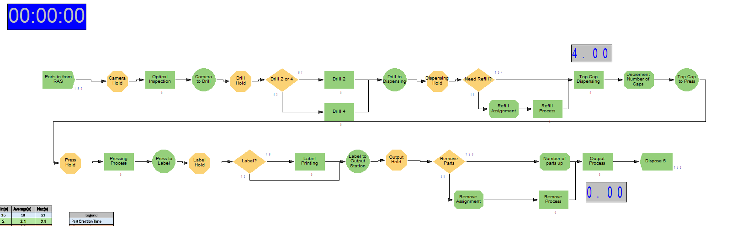
Process Function | Min(s) | Average(s) | Max(s)
1.Parts in From Robot Assembly | 15 | 18 | 21 |  | Legend
2.Automated Optical Inspection | 2 | 2.4 | 3.4 |  | Part Creation Time
Camera to Drilling |  | 8.2 |  |  | Movement times
3.Drilling (2 Holes) | 16 | 18 | 20 |  | Process Times
3.Drilling (4 Holes) | 30 | 33 | 36
Drill to Dispensing |  | 7.3
4.Top Cap Dispensing | 2.7 | 3 | 3.5
4.Refill (every 10x cycles) | 110 | 120 | 135
Mag Back to Press |  | 7.3
5.Hydraulic Press | 11.7 | 12.3 | 12.9
Press to Label |  | 8.2
6.Label Printing | 6.2 | 7 | 8.7
Label to Output Station |  | 8.2
7.Output Station | 3.6 | 4.1 | 5.1
7.Remove Parts (Every 4x Cycles) | 20 | 26 | 32
The discrete event simulation model was developed using Arena software to represent how components move through the CP laboratory production system. Entities are created using a create module and then move through a series of process modules. These represent the different stages of the process, including inspection, drilling, dispensing, pressing, labelling and the final output.
A decide module was also used to represent the different product types within the system. Based on the case study data, 60% of the products go through the 2-hole drilling operation, while the remaining 40% go through the 4-hole drilling route. Triangular probability distributions were used within the process modules to account for the variation in the time taken for each operation.
Resources were allocated to each workstation to reflect the limitations of the actual manufacturing system. When a resource isn’t available, a queue was formed, allowing waiting times and potential bottlenecks within the system to be identified. Once an entity had completed all stages of the process, it was passed to a dispose module to represent the completion of the production process.
Overall, the arena model provides a representation of the CP laboratory production system and allows its performance to be analysed without affecting the actual manufacturing process. The simulation can be used to assess key performance measures such as throughput, resource utilisation and waiting times, which can then be used to identify where any improvements could be made.
Resource | Purpose
Camera | Inspection
Drill station | Hole Drilling
Dispensing unit | Top cap dispensing
Hydraulic Press | Pressing operation
Labelling station | Labelling of product
Operator | Refilling and output removal

Waste Identification
The simulation results show that waiting is the main source of waste within the production system. On average, entities spent 11.44 minutes waiting, compared to a total system time of 13.24 minutes . This means around 86.4% of the overall lead time was spent waiting rather than parts being processed.
Inventory waste can also be seen from the build up of work in progress before the drilling station. The drill hold queue had the largest build up in the system, reaching a maximum of 43 entities for (for the limited time and maximum entities involved). The level of accumulation can increase overall lead times and have a negative effect on the flow of the process.
Transportation waste is also present, as components have to be moved between several workstations throughout the production process. Although these movements are currently necessary, they do not add direct value to the product from the customers point of view. The inspection stage could also be considered overprocessing from a lean perspective, as it does not physically change the product. However, inspection is still important as it helps to maintain product quality and ensure customer requirements are met.
Waste Type | Evidence
Waiting | Queue before drilling
Inventory | Work in progress accumulation
Transport | Conveyor movements
Overprocessing | Inspection activities

Value Analysis
Value analysis was carried out to distinguish the difference between value-adding, business value adding and non-value adding activities within the process. Drilling, dispensing, pressing and labelling were classed as value adding activities because they directly change the product.
Inspection was classed as business value adding because although it does not physically change the product, it is required to ensure the product meets the required quality standard. Waiting, transportation and queue delays were classed as non-value adding because they do not directly add value to the final product.
The simulation results showed and average value-added time of 50.26 seconds compared to a total lead time of 13.24 minutes. This gives a value-added ratio of approximately 6.33%. This shows that only a small proportion of time spent in the system is actually adding value to the product, highlighting potential areas where the process could be improved using lean methods.

Simulation Results and Analysis
The simulation processed a total of 150 entities due to a limitation within the student version of the software used, where all 150 parts were processed through the system. All parts were processed due to the fact it was given 24 hours to run; this shows that there were no remaining entities within the system, but this does not show that the process is capable of satisfying demand because the entire demand was not modelled.
The resource utilisation results show that the drilling station had the highest level of 4.21%. This indicates that the drilling process has most influence on the entire process, furthermore, is the likely source of delays operationally. The operator was the second highest utilisation level of 3.19% and the press being utilised the least at a rate of 2.14%. The rest of the resources were negligible levels of utilisation.

Analysis of the queue statistics also supports this point. The drill hold queue has the longest average waiting time of 0.1488 hours and for this 150-entity limited simulation the highest number of parts held in the queue at one time was 43. When comparing this to other hold queues such as the output hold queue, the queue length there was a maximum of 11 parts on hold at one time, and for the dispensing hold the maximum number of parts was 7. This indicates that there is an imbalance between drilling capacity and the flow of incoming parts. As drilling is towards the start of the process, and this is where the main bottleneck is this means that the rest of the process is continuously delayed throughout. This increases wait times and then parts continue to build up within the system.
Based on these observations regarding queues and resources, the drilling station is easily identified as the most prevalent bottleneck within this process. The operation of drilling shows the highest utilisation and has the greatest waiting time, along with he highest number of queued parts at one time. The process of drilling requires more time than other processes, especially if a part follows the 4-hole drilling pathway which requires more processing time than the 2-hole process. This means the rate of incoming arrival parts exceeds the rate at which the drilling process is completed meaning that the flow efficiency is low.
The results discussed for this simulation show that the process is heavily dominated by waiting times and bottlenecks. Lean manufacturing principles identify the non-value adding activities such as waiting times should be minimised. As parts spend a significant amount of time waiting within the system, the process would benefit greatly by minimising some of these waiting times in order to improve performance. Furthermore, the low value added ratio of 6.33% highlights the large difference between productive processing time and the overall lead time. The high level of waiting within the system is closely linked to bottlenecks, particularly at the drilling station where the drill hold queue reached a maximum of 43 parts. This build up suggests that the drilling process is restricting the flow of parts and causes additional waiting times. Although all parts were processed, reducing the bottleneck will improve the balance between workstations which can in turn lead to a reduction in waiting times and overall improve process efficiency.

Lean Improvement Opportunities
Several improvements opportunities were found
Reduce Drilling Bottleneck
The main area of improvement is the drilling station due to the drill hold queue reaching a max of 43 parts within the system making it the largest queue. This shows that drilling is acting as the main bottleneck and is restricting process flow. Another route for improvement within this process would be to add another resource such as an extra machine so that there can be multiple parts processed at a time.
Improve Refill Process
There is also an opportunity to improve the refill process, as the need for regular refilling also slows down the process. One possibility would be to increase the storage capacity at the dispensing station as this would mean that interruptions caused by waiting on the refill process would be reduced and the process would be able to continue for longer without pausing. This would also reduce wait times and increase the process flow rate.
Improve Output Handling
The simulation also identified a period of waiting at the output stage with the output hold queue which reached a maximum of 11 parts at one time, if this buffer was increased in capacity then there would be more space for completed parts and reduce any restriction within the process.

Conclusion
The analysis demonstrated that discrete event simulation is an effective tool for evaluating manufacturing system performance. The drilling station was identified as the primary bottleneck due to its extended processing time and high utilisation. Lean improvements focused on bottleneck reduction, improved replenishment activities and better output handling offer significant opportunities for performance enhancement.

