

Geographical information system: Assignment One
By: Ricky Jenkins

submitted as part of the requirements for the award of BSc (Hons) Applied Computing

Jan 2019

Table of Contents
1 Introduction 3
2 General GIS 3
3 socio demographic / Census boundary data 4
4 visual perception 4
5 SDSS / Spatial decision support system 5
6 Pneumococcal Meningitis 5
7 Map info 6
8 Other GIS Applications 7
9 Health data 8
10 Health informatics 8
11 Analysis 9
11.1 Map Info practical findings 9
Bibliography 18

1 Introduction

In this case study, I will be discussing the uses of geographical information systems, viewing data within maps and using the data to estimate and get valid data.

2 General GIS

[1][2]GIS (Geographical information system) is a technology that software uses to view data in different forms. GIS allows the use of gathered data and displays It within a map, the data needs to be linked to some location or area. This will allow other data to link to this location such as the population of said location.

[3]We use GIS to map out data visually to better understand the raw data. For example, this means a map can display the population of wales and show a heat map of the population. With this visual data, we can balance the population by setting up more towns and cities within the low population area, maybe adding more attraction areas or better accessibility to these areas.

GIS is used everywhere, this technology allows companies, governments and the public to gain knowledge of their surroundings and what is happening. Companies can analyse the data to predict changes, display data to users that use their software/apps etc. Governments can use GIS technology to manage change and events that occur within the country. One of the main uses for GIS is for the users of the software/technology is to understand trends, patterns, events and can-do analysis, visualize and edit data.

Behind a GIS system, a database holds all data that is someway linked to the map within the software, this is done by using primary or foreign keys. Data can be linked differently depending on the map and data, some is linked via postcodes, area numbers etc. However, most are used through a Geo-Code.

People that are not in a field for Health informatics or use GIS in a professional manner still uses GIS technology. GIS is in a lot of our day to day activities.
Google Map – Google map is a system that uses GIS to draw the world and locations within countries, cities, towns etc.

3 socio demographic / Census boundary data

[4]Socio demographic is characteristics of the population of a area. Characteristics such as the age, gender, ethnicity, location, house-hold income, qualification level etc. These are important to understand while assessing data via GIS. There is many different variables that can come into play while assessing data or using the data to speculate an event.

[5]Census data comes into play with socio demographic due to census data statistics being from households or number of people. Census data is used within GIS to get basic information about the area, population, employment, age etc.

4 visual perception

When it comes down to a large amount of data, people may struggle to understand the data and maybe be presenting in a way that people may misunderstand. However, GIS is a very important technology that has been used for years. [6]GIS uses visual perception of data within maps. This allows large amount of data to be collected and stored and shown within a map that allows the user to view it with better understanding.

5 SDSS / Spatial decision support system

[7]SDSS is a (Spatial decision support system) is a system that allows users to assist with their decision making and from that being able to solve spatial problems. This system aids the user to make better decisions and try to find the most possible efficient planning path. SDSS works with other types of technologies and computer-based systems such as GIS (Geographical Information System), DBMS (Database Management System) and DSS (Decision Support System). SDSS will allow the user to assess the situation correctly from the data gathered and displayed within GIS for the best cause of action and the best planning path that will be done. SDSS generally applies more for the planning on land scape.

GIS links up land scape with data, this allows a visual aspect of viewing data within the landscape and being able to assist SDSS on the decision making that will need to be performed. There is a big different and outcome whiling looking at different data such as raw data, GIS data, graph data etc. Some and more able to be understood and assess than others. GIS isn’t the end all be all to understanding data, however when assessing large amounts of data via areas, groups, data from landscape etc. GIS comes a very important asset

6 Pneumococcal Meningitis

[8]For the practical part of this case study, I used [9]UK data service data about the usage of the maps and [10]HealthMapWales for the Pneumococcal meningitis injections also called ‘pneumococcal’ between 2014-2018. The pneumococcal meningitis can be a serious illness for any age and can be fatal to anyone that hasn’t had the jab that catches the virus. The pneumococcal meningitis can affect anyone however there is more risk for adults over 65 and babies. Within my practical aspect of the case study I looked at data from 2014-18 for babies aged from 1-2 years old for second and third jab.

[8][11]The pneumococcal meningitis should be given to babies between 8 weeks, 16 weeks and 1 year old. However, adults over 65 years old only need one jab. There are a few different symptoms such as Headache, being sick, high temperature, discomfort with bright lights. The virus can be shared via people kissing, sneezing, coughing, sharing items that both go into each other’s mouths.

7 Map info

[12]MapInfo is a software that uses GIS technology to able to visualize data using maps. [13]MapInfo has many tools and features that can apply to generating visual content and editing the data. MapInfo allows people in different fields such as; analyst, engineers, managed environment and more, however most people use GIS without even knowing. MapInfo is designed to be simple to use while being very powerful, this allows users to generate maps with data to be able to analysis, visually see the data and to assume the cause of the data. There is a number of features that MapInfo supplies such as[13];
- Easy to understand interface
- Easy results sharing
- Location intelligence suite
- Layers and themes for different visual results
- Powerful raster GIS analysis
- Flexible visualization options
- Data creation and editing
- Geo-Coding
Not only does this software run on windows, but also runs on Mac and can be used via a web-based solution. MapInfo is known for the easy to use interface and features. It follows common trends with other software such as a ribbon-based navigation, easy to get to feature, generate data and layers with wizards.

8 Other GIS Applications

MapInfo isn’t the only GIS software out there, there is several different solutions that can be used, and some are more tailored to different usage. Software such as[14][15];
- ArcGIS
- CARTO
- Mapbox
- QGIS
- TerraSync
- MapInfo Pro
- GRASS GIS
- FME Hub
- MapViewer and more.
ArcGIS contains features such as;
[16]3D Imagery, Map Creation, Map Sharing, Census Data Integration, Spatial Analysis and more.
[17]CARTO contains features such as;
Map Creation, Map Sharing, Spatial Analysis, Labelling, Internet Mapping, Interoperability, Geocoding, Image Exporting and more.

9 Health data

There is a large archive of health data that can be used to visually be displayed on a map, health data can be downloaded from the NHS and other services that work with the NHS. This data being collected is important to understand the health state of groups of people depending on where they live and the general location.

I downloaded health data for the pneumococcal meningitis jabs from [10]HealthMapswales where I will be using it to create a theme over a [18]MSOA map of wales. This theme will be used to have a geo visualization of the areas with the different colour density (lighter red- darker red)

10 Health informatics

[19]Health informatics is very useful within the medical/health field. Companies and groups use health informatics to analysis data and be able to understand people and the area’s better. [20]Health informatics assesses a large amount of data from people living in the area and general information about the area. This information can be used to help professionals give better aid, support and knowledge to people that needs it.

11 Analysis

11.1 Map Info practical findings
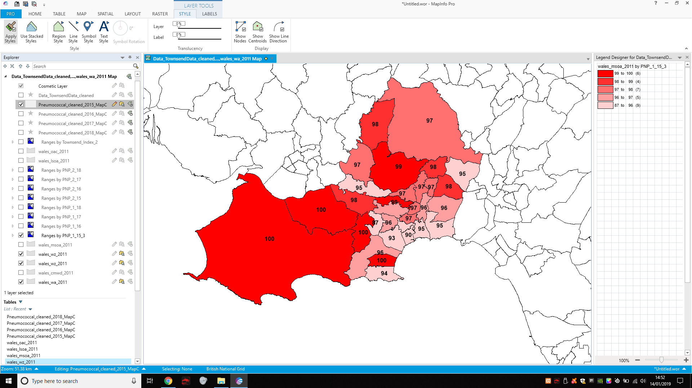
- 2014-15 second jab
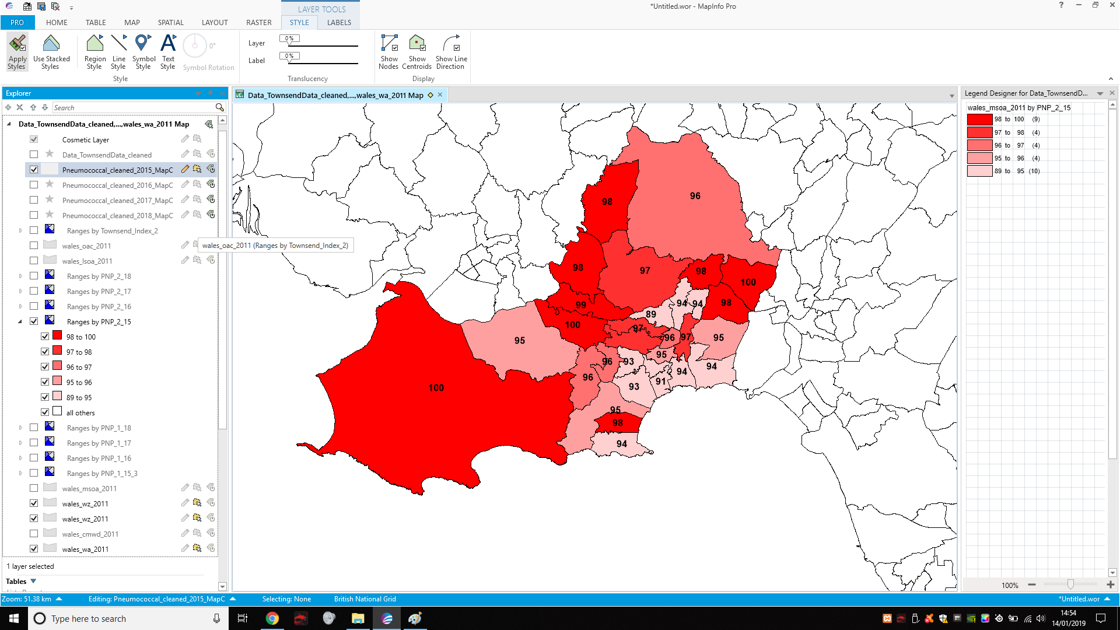
- 2014-15 third jab.

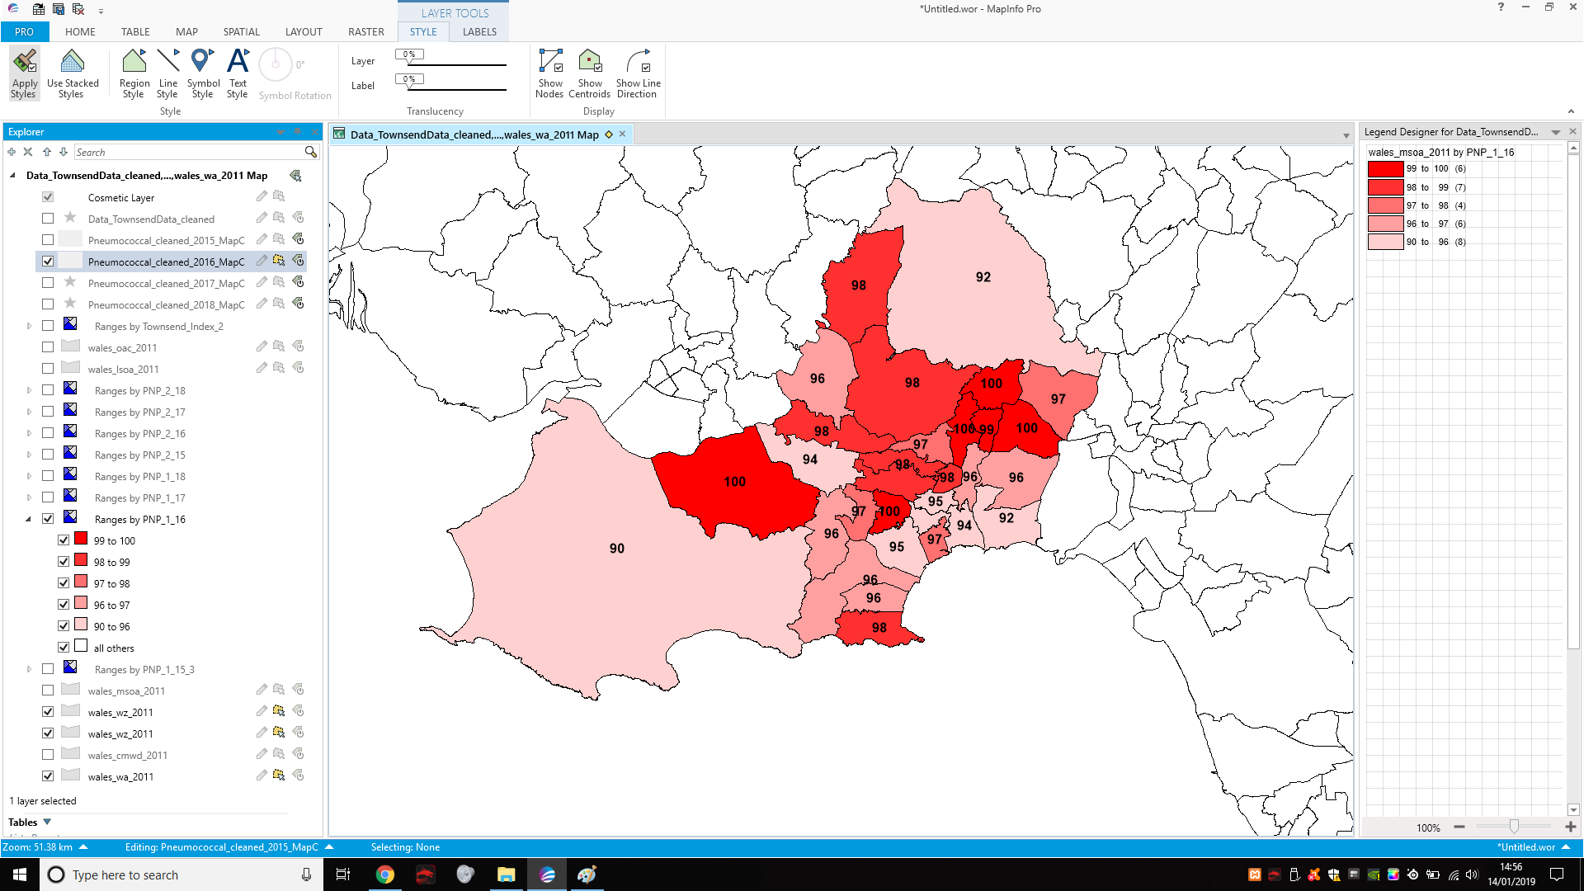
- 2015-16 second jab

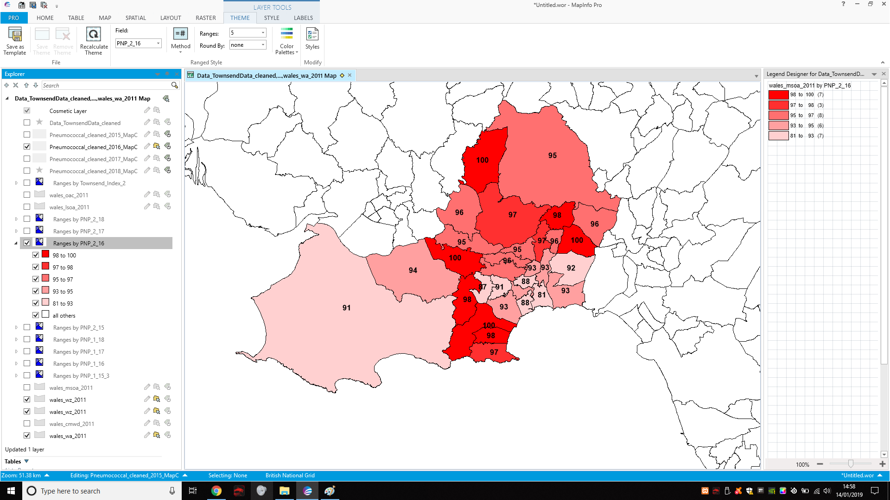
- 2015-16 third jab
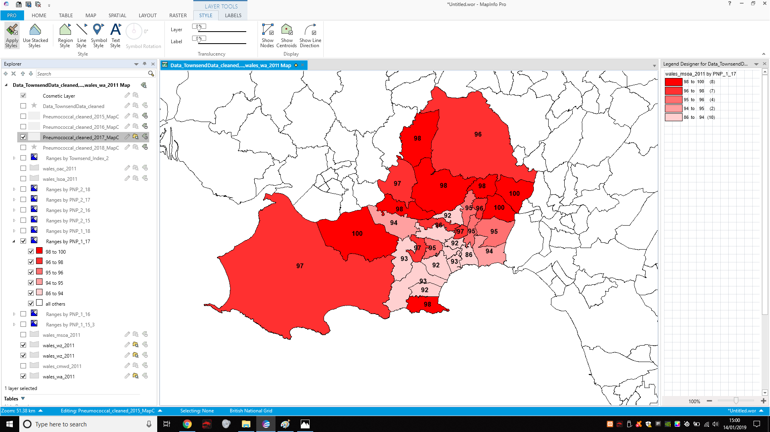
- 2016-17 second jab
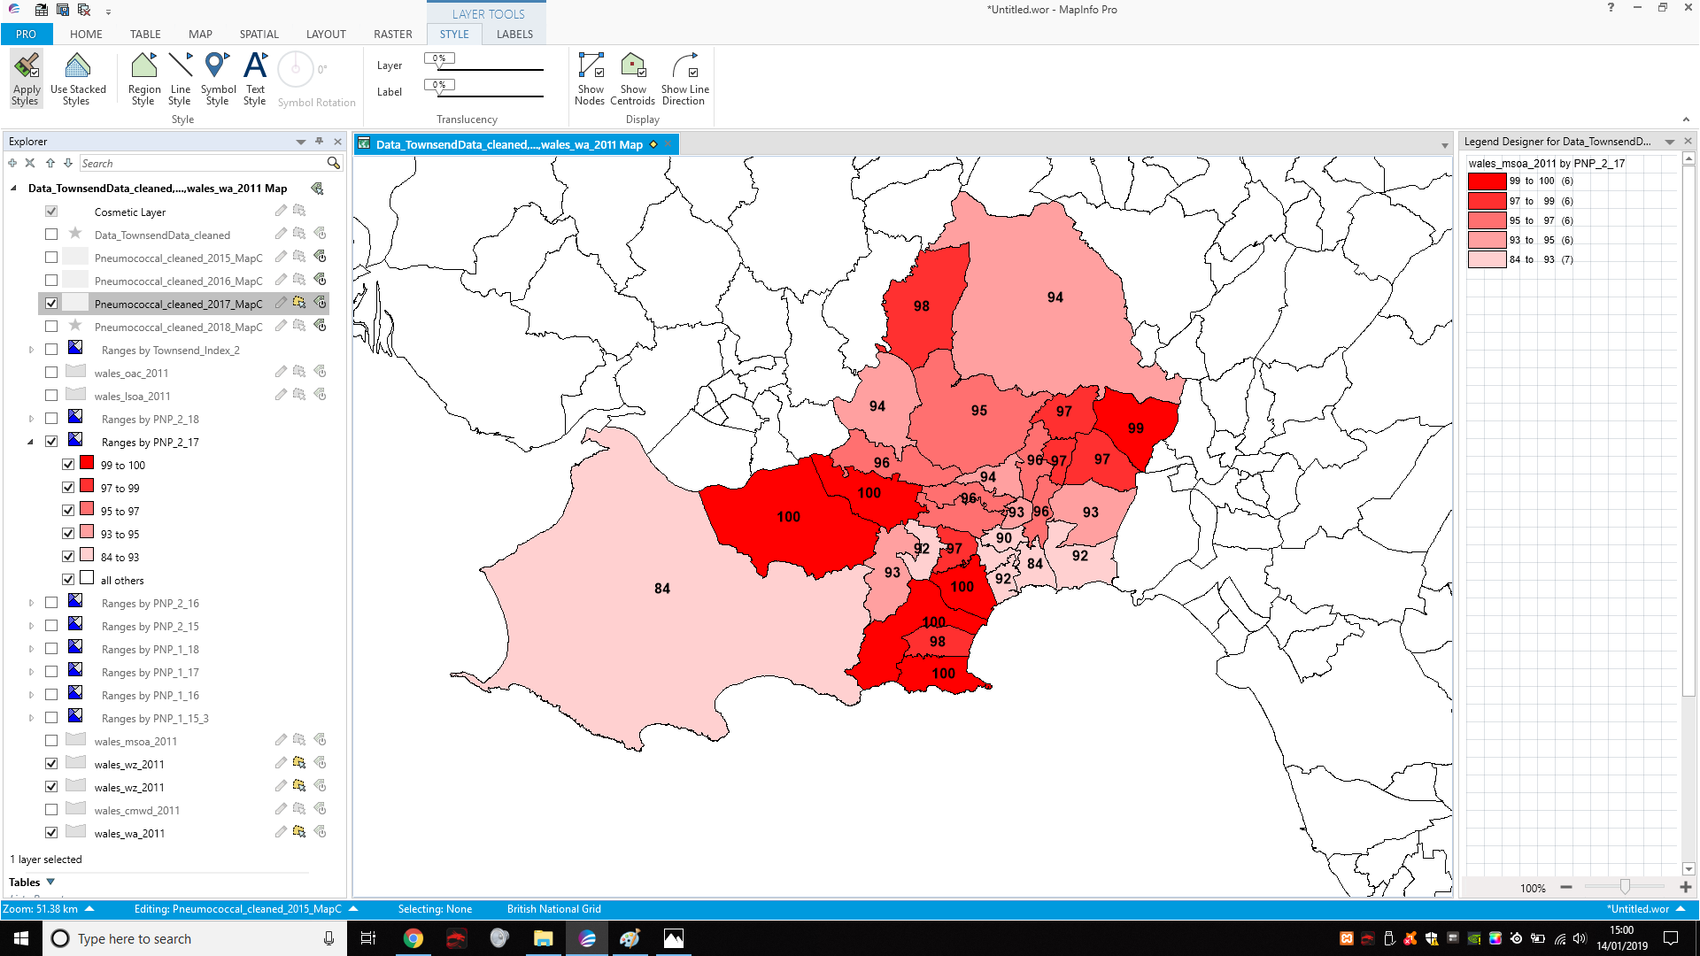
- 2016-17 third jab
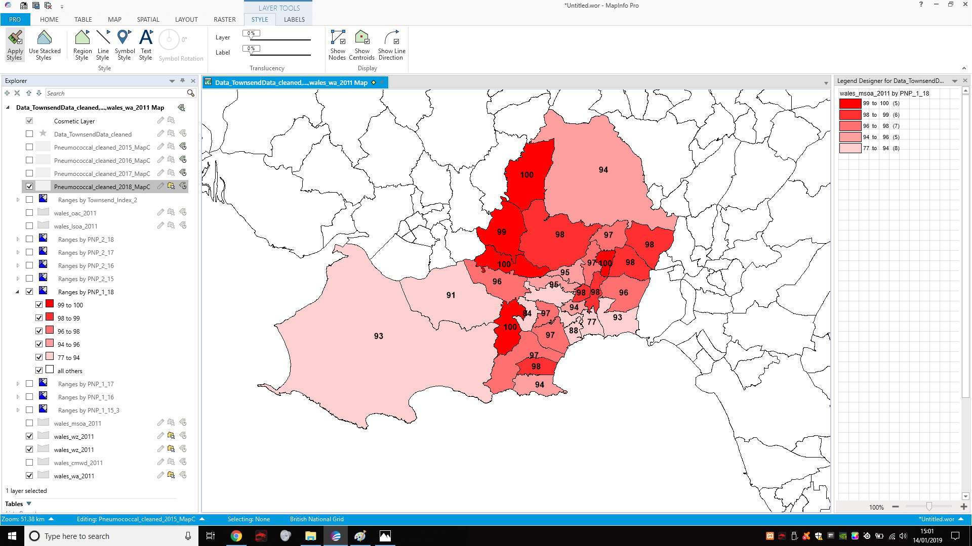
- 2017-18 second jab
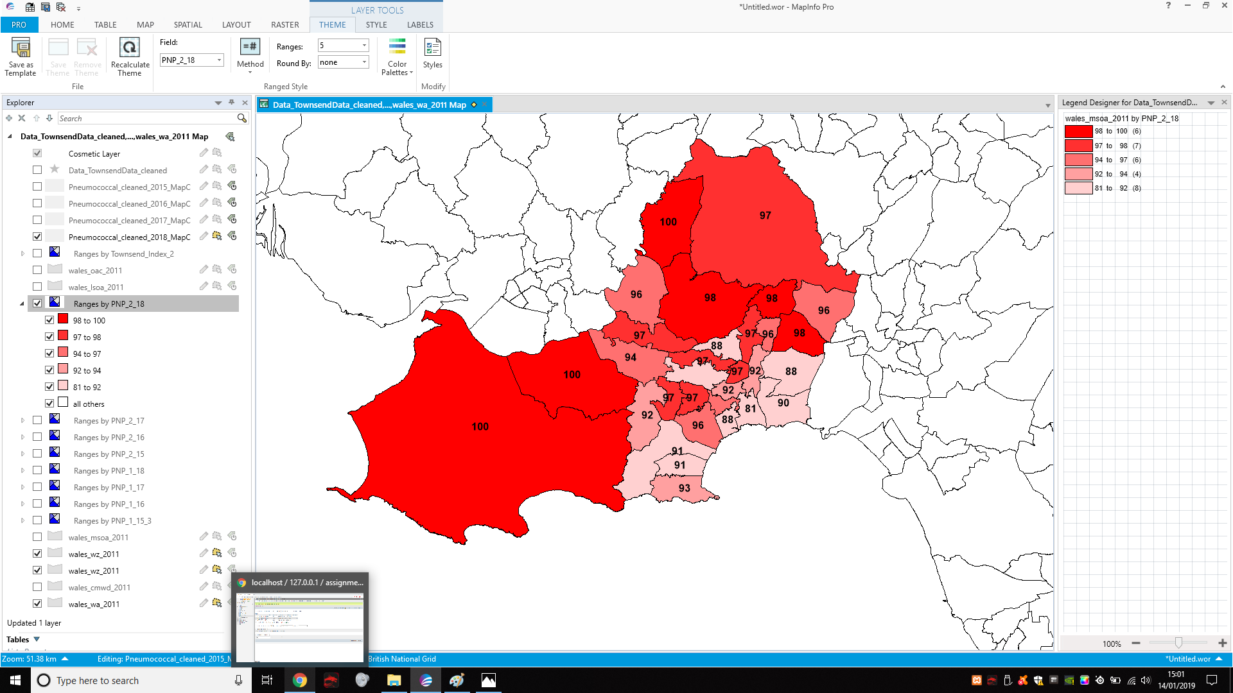
- 2017-18 third jab

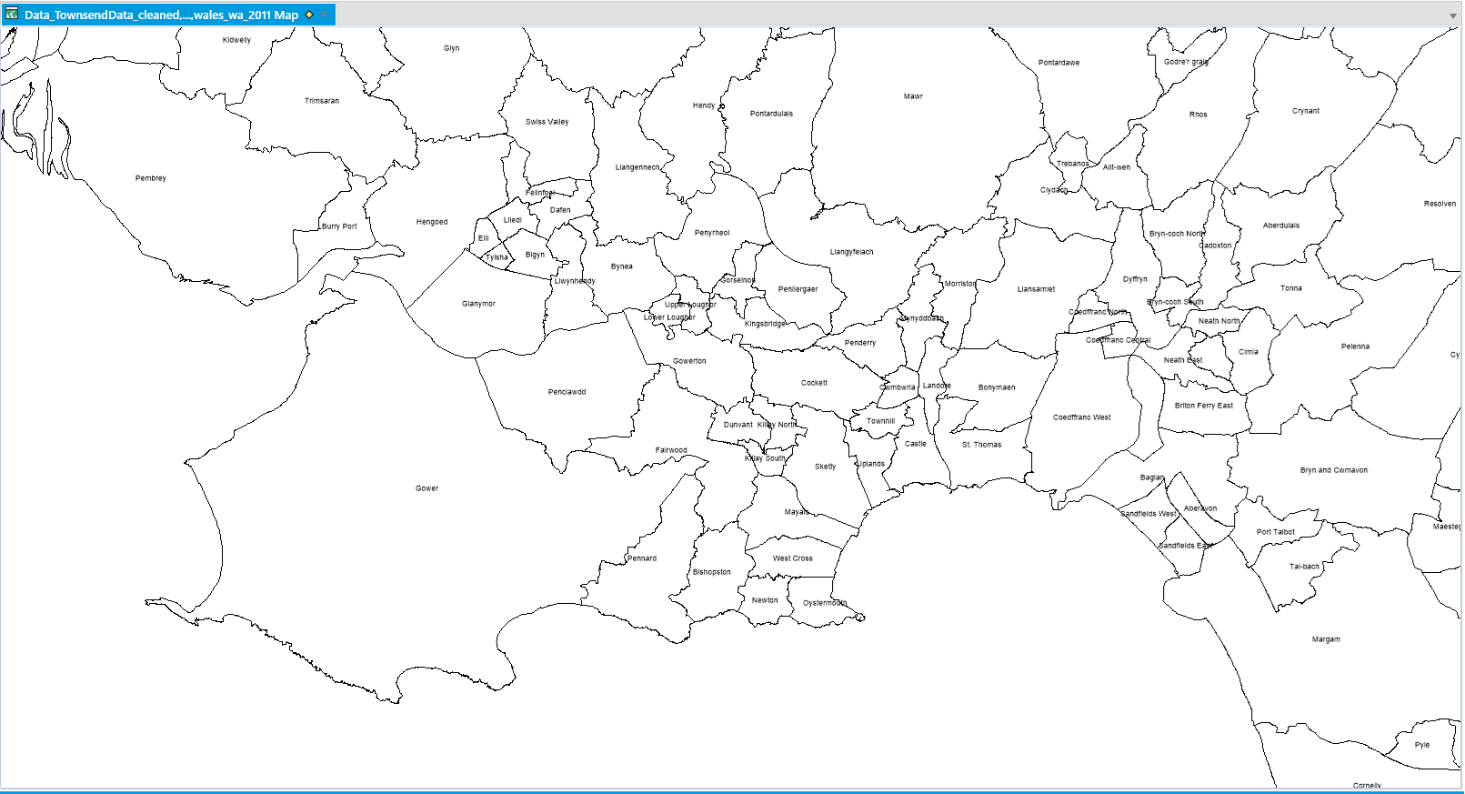

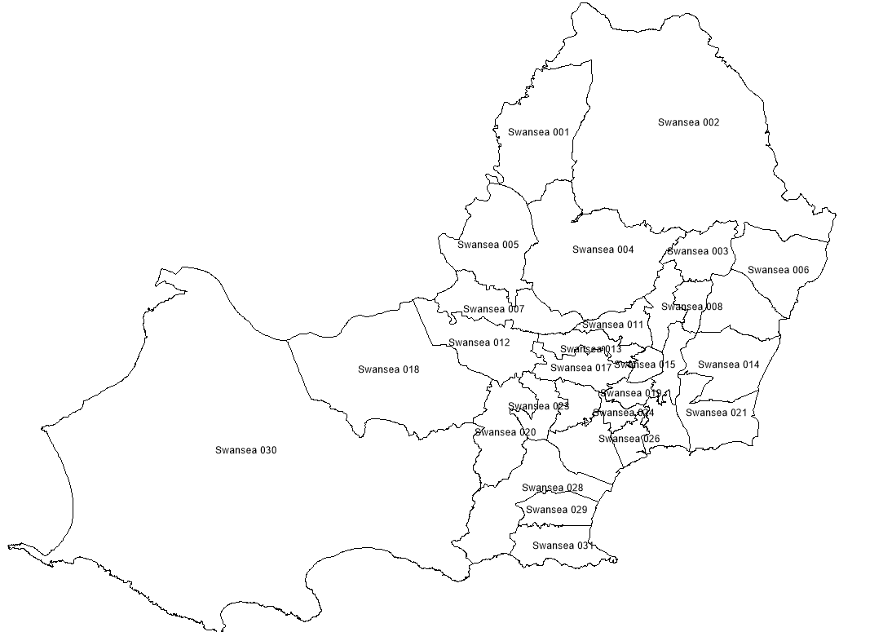

As seen in the images above, you can see a display of percentages based from 0% to 100% within the map. 100% meaning everyone if vaccinated within that location and 0% no one vaccinated.

Based on the statistics and that were given from the map data, we can create a presentable graph to show the data;

Please refer to the image below due to the scaling of this graph due to not being able to understand from importing it from excel.

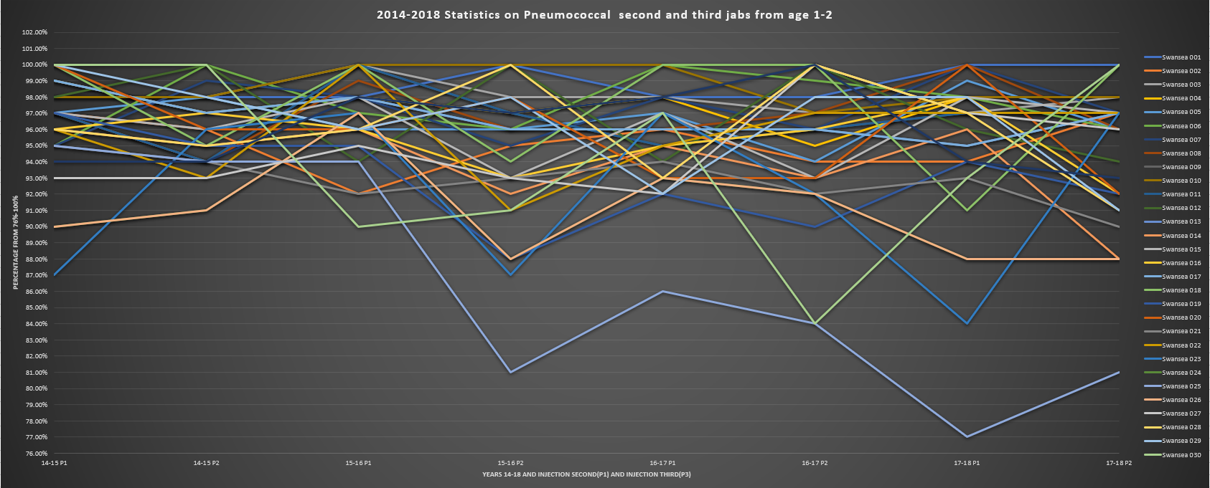
From the data I have collected from that map theme and data that I downloaded from [10]HealthMapswales. I generated a line chart within excel to display the data for another aspect of viewing it.

As you can see, most area’s within wales has a strong acceptance of the pneumococcal vaccine however when percentages get too low, this spikes a reason for concern. The lower spikes of the graph could have different possibility of the reason why, this could be as such;
- People unsure about the pneumococcal vaccine
- People not trusting the pneumococcal vaccine
- People not knowing or being aware of the pneumococcal vaccine
- People not being able to gain access to the pneumococcal vaccine
These are a few reasons why the data spikes lower, however there is multiple reasons that could occur and more that I listed. There isn’t a reliable factual way of understanding the lower rates of people not getting the pneumococcal vaccine however professionals can assess the data and speculate. These speculations can be backed up questioning people that didn’t take the pneumococcal vaccine etc.

A concern within this graph would be the light blue spiking down Swansea 025 (Castle Swansea). This isn’t a huge concern due to them not going under 70% however the NHS and government can give better aid to this area.

This data can and will be used within the government and medical professions. Companies such as the NHS and the government will assess the data and find lower spikes within the graph, investigate the possible reasons of the lower spikes within these area’s and try to combat the issue by giving people more advice, more knowledge of the vaccine, better accessibility and more. By using GIS technology and graphs to assist understanding of the data, governments and companies will be able to assess the data and respond to the events or data correctly. In general, GIS has will allow us to be better informed about the data we collect and execute better solutions of problems that occur.

When gathering the data for the case study for the practical aspect, There was a number of steps that were made to ensure correct importation of the data.

First the data downloaded was for a [18], [21]MSOA(Middle layer super output area) map. I choice the data to go over this map layer because MSOA is used for reporting data within small area’s and show statistics detailed enough to get a good understanding of what is happening without being too vague or to detailed.
After downloading the content from 2014-15 to 2017-18 I sterilize the data that was downloaded, the first action was to remove all other vaccines that were downloaded, note: the download contains several different vaccines and has more data that is needed. After removing the other vaccines, I also removed unwanted data that was also within the excel sheet that was downloaded. After sterilizing the data, I added simple and direct headings to then be imported into MapInfo.
I had to convert the file type so that MapInfo can read the data correctly, after this. I imported the sheet into a new browser and created each theme from each of the files downloaded from 2014-18.

When health originations see spikes below 70% this a problem due to the lower it goes, the more chances of a out break that could occur. The lower it does with an outbreak, the more people that could be possibility infected. GIS analysis is important in a lot of the health scene as it can analyse and assess the data and perform actions depending on the issue or the event that will or has occurred. When it comes to analysing the data, a fair bit of speculation comes into play. If the percentage of a area drops below X% the government and NHS needs to analyse the reasons why and give correct aid depending on the outcomes that they came up with. The government can fix these issues but giving better education on the injections, better accessibility, using methods like ads, social media etc. to bring up concern the technology age of users.

Bibliography

[1] GISGeography, “What is Geographic Information Systems (GIS)? - GIS Geography,” gisgeography, 2019. [Online]. Available: https://gisgeography.com/what-gis-geographic-information-systems/. [Accessed: 20-Jan-2019].
[2] esriuk, “What is GIS? | Geographic Information System Mapping Technology,” esriuk.com, 2019. [Online]. Available: https://www.esriuk.com/en-gb/what-is-gis/overview. [Accessed: 21-Jan-2019].
[3] OrdnanceSurvey, “Understanding GIS | Support | Ordnance Survey,” OrdnanceSurvey.co.uk, 2019. [Online]. Available: https://www.ordnancesurvey.co.uk/support/understanding-gis/. [Accessed: 18-Jan-2019].
[4] Alexander Dobronte, “The importance of socio-demographics in online surveys,” checkmarket.com, 2013. [Online]. Available: https://www.checkmarket.com/blog/socio-demographics-online-surveys/. [Accessed: 21-Jan-2019].
[5] ukdataservice, “UK Data Service Census » Census boundary data,” ukdataservice.ac.uk, 2018. [Online]. Available: https://census.ukdataservice.ac.uk/use-data/guides/boundary-data. [Accessed: 19-Jan-2019].
[6] G. R. (Gary R. . Lock and I. NATO Advanced Research Workshop on Beyond the Map: Archaeology and Spatial Technologies (1999 : Ravello, Beyond the map : archaeology and spatial technologies. IOS Press, 2000.
[7] Sugumaran, Ramanathan, Degroote, and John, “Spatial Decision Support Systems Principles and Practices.”
[8] NHS, “Pneumococcal vaccine - NHS,” Nhs.uk, 2016. [Online]. Available: https://www.nhs.uk/conditions/vaccinations/pneumococcal-vaccination/. [Accessed: 20-Jan-2019].
[9] uk dataservice, “UK Data Service,” ukdataservice.ac.uk, 2019. [Online]. Available: https://www.ukdataservice.ac.uk/. [Accessed: 17-Jan-2019].
[10] HealthmapWales, “Home | InstantAtlas Server,” HealthmapWales.wales.nhs.uk, 2019. [Online]. Available: https://www.healthmapswales.wales.nhs.uk/IAS/. [Accessed: 19-Jan-2019].
[11] nhs, “Meningitis - NHS,” nhs.uk, 2016. [Online]. Available: https://www.nhs.uk/conditions/meningitis/. [Accessed: 18-Jan-2019].
[12] Map Info, “MapInfo® Pro - Desktop GIS | GIS Mapping | Pitney Bowes,” pitneybowes.com, 2019. [Online]. Available: https://www.pitneybowes.com/us/location-intelligence/geographic-information-systems/mapinfo-pro.html. [Accessed: 17-Jan-2019].
[13] Finances Online, “MapInfo Pro Reviews: Overview, Pricing and Features,” financesonline.com, 2018. [Online]. Available: https://reviews.financesonline.com/p/mapinfo-pro/#what-is. [Accessed: 20-Jan-2019].
[14] finances online, “Best GIS Software Reviews List &amp; Comparisons | Expert’s Choices for 2019,” financesonline.com, 2019. [Online]. Available: https://gis.financesonline.com/. [Accessed: 19-Jan-2019].
[15] capterra, “Best GIS Software | 2019 Reviews of the Most Popular Systems,” capterra.com, 2019. [Online]. Available: https://www.capterra.com/gis-software/. [Accessed: 19-Jan-2019].
[16] capterra, “ArcGIS Reviews and Pricing - 2019,” capterra.com, 2019. [Online]. Available: https://www.capterra.com/p/93333/ArcGIS/. [Accessed: 18-Jan-2019].
[17] capterra, “CARTO Reviews and Pricing - 2019,” capterra.com, 2019. [Online]. Available: https://www.capterra.com/p/140192/CartoDB/. [Accessed: 17-Jan-2019].
[18] data govUk, “Middle Layer Super Output Area (MSOA) Boundaries - data.gov.uk,” data.gov.uk, 2016. [Online]. Available: https://data.gov.uk/dataset/2cf1f346-2f74-4c06-bd4b-30d7e4df5ae7/middle-layer-super-output-area-msoa-boundaries. [Accessed: 17-Jan-2019].
[19] healthcareers nhs, “Health informatics | Health Careers,” healthcareers.nhs.uk, 2018. [Online]. Available: https://www.healthcareers.nhs.uk/explore-roles/health-informatics. [Accessed: 18-Jan-2019].
[20] e-lfh, “Health Informatics - e-Learning for Healthcare,” e-lfh.org.uk, 2019. [Online]. Available: https://www.e-lfh.org.uk/programmes/health-informatics/. [Accessed: 19-Jan-2019].
[21] datadictionary nhs, “Supporting Information: Middle Layer Super Output Area,” datadictionary.nhs.uk, 2018. [Online]. Available: https://www.datadictionary.nhs.uk/data_dictionary/nhs_business_definitions/m/middle_layer_super_output_area_de.asp?shownav=1. [Accessed: 19-Jan-2019].

