Student Name: Mashuda Begum  Student ID: 2119256  Module Title: Foreign Languages and Cultural Awareness  Module Code: BMIH5003  Lecturer: Lisa Bassler  Date: 29/02/24 | 
ASSIGNMENT 1: PORTFOLIO
(4 Components)

Component 1: Professional Reflection (500 words +/- 10%)

Weighting: 25%
Scenario
As a staff in Premier INN, I need to serve different customers from different cultures and languages. Not having too much expertise in multilingualism I fall sometimes into trouble which becomes embarrassing to me. In meeting a group of Spanish guests in our dining lounge I make greetings to them hello but they had the cultures of making handshaking. So, I felt shy when the guests raised their hands to shake with me (Chamberlain, 2019). Then they have the essential things slices of bread which need to be served while having the meal. But I did not serve them any bread which was disappointing to them. And lastly in our hotel there we may have the usual tradition of getting tips. So, at the time of providing the bill, I demanded a few tips which was offensive to them.
Cultural misunderstanding
As there I have a cultural misunderstanding with their greeting approaches where they like to shake hands with the particulars they meet. Then they have the culture of taking bread with the sauce or mayonnaise during the time of taking a meal which was not known to me (Berthele and Udry, 2021). While working in this prestigious hotel, I always tried to ensure my full efforts and dedication to ensuring the customer's satisfaction. But I was not aware that they have a culture of not giving any extra money for tips. Moreover, here I also realized they have a culture of making divided in the bill and paying equally by everyone.
Reflection by using Kolb’s reflective learning cycle
- Concrete Experiences: This is the stage where I have realized I have to make mistakes while serving the Spanish guests and feel like learning about multilingualism.
- Reflective observation: It’s the stage where I get the reflection on my actions as I get embarrassed while I expected tips from them as it was far from their culture.
- Abstract conceptualization: Here I have felt the importance of bringing changes in my actions and making better plans for the future. I have decided here to make learning in different languages like Spanish, German, French, and Italian and equipped their cultures (Kolb, 2014).
- Active experiment: This is the stage of making implications where I will try to serve different customers according to their cultures and communicate in their languages.
Recommendation for overcoming this challenge
After being here in this cultural diversity, I have realized that the following initiative I need to take as soon as possible.
- Being Multilingualism: As in my profession, it’s the most valuable skill if I feel expertise in a different culture and language which will boost my capabilities and encourage me to perform well.
- Adaptive: It’s necessary for career growth to get continuous learning and take lessons from the experience to make the right adoption (I Lkhagvasu̇rėn, Konagaya and Kokuritsu Minzokugaku Hakubutsukan, 2014). So, I will be always eager to learn from the situation and focus on my performance.
- Flexibility: In making the right actions there I must have the mindset to accept changes and adopt different approaches at any time and any place.
- Polite: There in serving the guests it’s essential to learn their characteristics and cultures to make the services in the right norms and be polite.

References:
Berthele, R. and Udry, I. (2021). Individual differences in early instructed language learning The role of language aptitude, cognition, and motivation. [s.l.]: Language Science Press.
Chamberlain, D. (2019). Reflection. London: Macmillan.
I Lkhagvasu̇rėn, Konagaya, Y. and Kokuritsu Minzokugaku Hakubutsukan (2014). Oirat people : cultural uniformity and diversification. Osaka: National Museum Of Ethnology.
Kolb, D. (2014). Experiential Learning: Experience as the Source of Learning and Development. 2nd ed. Upper Saddle River, New Jersey: Pearson Education, Inc.
Component 2: Training Plan (500 words +/- 10%)

Weighting: 25%

Necessity of training
After getting the fault and lacking of the skills I have realized to take learning from professional and experienced people. So, here I have consulted with my seniors and they have advised me to take training on multilingualism and communication skills. As there the ability in multilingualism will help me to develop the senses in the different languages which will allow me to serve different region customers appropriately (Turner and Springerlink, 2019). Communication skills in the tourism sector are essential as we have to interact with the guests rapidly and we have to understand their needs and serving criteria.
Training plan
•Why: To acquire the ability to serve different customers from different regions I have to get the skills where I can be skilled in using different languages and understanding their needs. As Premier INN is a popular hotel where we serve without dedication and perfection. So, as a staff in the dining if I had the knowledge of which customers have which culture it would be helpful to me to offer them appropriately.
•What: In this training session I will focus on multilingualism and communication skills which will allow me to make the right performances for the future. Moreover, here in the communication learning, I will also learn how to make polite behaviour and show gentle approaches to satisfying the customers. In different languages here languages like Italian, Japanese, German, and French will get the priority.
•Who: Here in getting the right implication and right performances, the training program will be trained by a skilled and experienced professional (Kirsch and Duarte, 2020). Moreover, these issues have become serious issues where the reputation and the values of the organisations are dependent. So, here in the time of training, all the front employees will be involved in this situation.
•Where and When: There the training session will be arranged in the company lounge and conference rooms. Moreover, in making the learning session more effective there the training session will be ruined for immediately one month where the weekend the classes will be conducted. Moreover, in evaluating the performances here the employees will be kept under the supervision of the top employees.
Training method
Here the training session will be conducted as a workshop where different professionals will come here and try to share their experiences with the employees to make them skilled (Tanji, 2016). Moreover, in making practical implications here the training session will be advised to make more realistic where all the employees will be practically using those learning and making right performances.
References
Kirsch, C. and Duarte, J. (2020). Multilingual approaches for teaching and learning: from acknowledging to capitalising on multilingualism in European mainstream education. Abingdon, Oxon: Routledge.
Tanji, H. (2016). Hotel Room Service Training Manual. Createspace Independent Publishing Platform.
Turner, M. and Springerlink (Online Service (2019). Multilingualism as a Resource and a Goal : Using and Learning Languages in Mainstream Schools. Cham: Springer International Publishing.
Component 3: Student Self-Reflection (500 words +/- 10%)

Weighting: 25%
Self-reflection learning
Working in the hospitality industry requires a lot of senses and experience in interacting with the customers and serving them efficiently. So, here being involved in this industry I have to face different situations where different learning may be learned by me. Here in this serving time, I get an embarrassing situation when serving the Spanish customers. I was not aware of their culture, which created these embarrassing tasks for me (Brockbank, Mcgill and Beech, 2019). Here I made make mistake while greeting them and negatively I expected a tip from them. This behaviour has made them often as they are paying service charges which were added to their bill. So, they asked me why then again tip as they are not willing to this culture to pay more. So, this situation has forced me to learn and acquire different cultures to make proper service to the guests.
Discoll’s reflective learning
Here in experiencing the situation and reflecting on my performance, I need to use the right tools which will indicate to me the planning of making the self-development. So, here Discoll’s reflective learning is effective which will make my row to making the development more effective.
Stage 1: What?
It refers to the steps where it needs to understand what happened and how I reacted or felt at that time. So, here in the time serving the Spanish customers as I was not aware of their culture put me in an embarrassing situation (Hall and Simeral, 2015). After that situation, I felt the necessity of learning multilingualism so that I might get the ability to serve in different situations. Working in the hotel industry here I have to be involved with customer satisfaction where I need to make maximum positive performances.
Stage 2: So, What?
After realizing my lack in the performances here I have strongly focused on the forces where I have to improve. So, here at the beginning, I have planned to become skilled in multilingualism which will help me to serve in different languages and understand their different need. Moreover, it will also create a good impression in the company which will help me to grow (York-Barr et al., 2016).
Stage 3: Now, What?
This refers to the current action planning which refers to making the decisions and equipping the actions which will be taken to make the development (Bassot, 2023). So, in the beginning, I have targeted to acquire the Spanish languages and cultures within the next two months. After that, I will also learn German, Japanese, and Italian languages.
References
Bassot, B. (2023). The Reflective Practice Guide. Taylor and Francis.
Brockbank, A., Mcgill, I. and Beech, N. (2019). Reflective learning in practice. Aldershot, Hants, England ; Burlington, Vt: Gower.
Hall, P.A. and Simeral, A. (2015). Teach, reflect, learn : building your capacity for success in the classroom. Alexandria, Va: Ascd.
York-Barr, J., Sommers, W.A., Ghere, G.S., Montie, J. and Costa, A.L. (2016). Reflective practice for renewing schools : an action guide for educators. Thousand Oaks, California: Corwin.

Component 4: Training Presentation (6 Slides)

Weighting: 25%

Appendix:
Presentation:
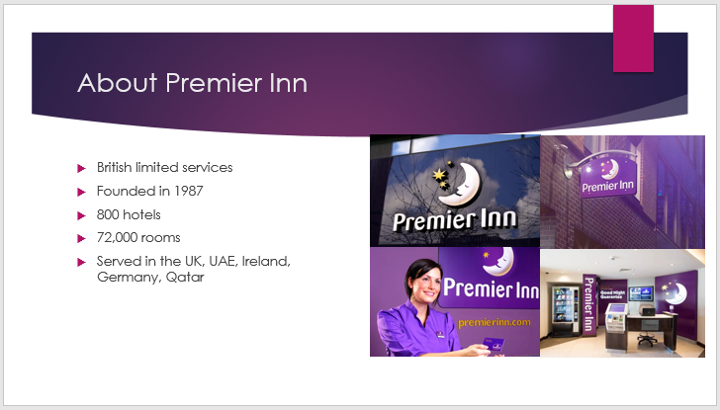

This is the company in the Hospitality industry which is operated by British limited services. It was founded in 1987 by Whitbread. Currently, it operates with 800 hotels and 72,000 rooms. They are now Serving in the UK, UAE, Ireland, Germany, and Qatar.
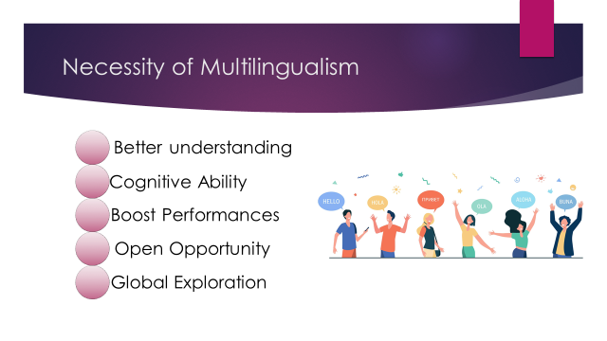
Better understanding: Multilingualism will help the staff to serve from different languages and different cultures. It will give them a way of communicating according to the customer's needs and serving appropriately.
Cognitive ability: It refers to relating the mental process with continuous learning to perform in a better way. Knowing multilingualism will benefit in serving confidentially to the other guests and giving them satisfaction.
Boost performances: If the staff feel confident while serving the overseas people through knowing about their language and culture it will help them in their performances and ensure the ability to make better interactions (Edwards, 2012).
Open opportunity: In the industry of tourism multilingualism will add extra advantages while serving the guests as it will create an opportunity to get better positions and be highlighted to getting growth.
Global exploration: Those employees can be performed all over the world and meet every challenge regarding culture and language diversification.

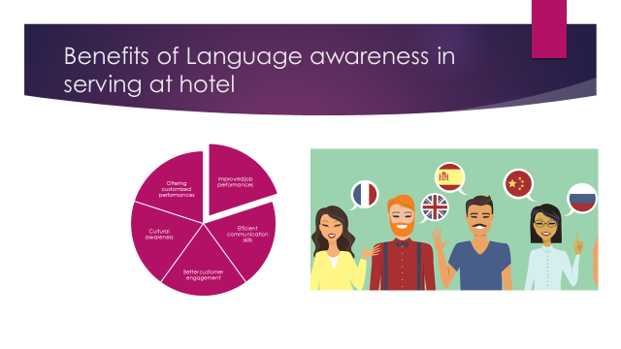
Offering customized performances: Knowing about the multiple languages and cultures here the staff will get the opportunity to make customized services to the guests according to their needs.
Improved job performances: As the employees have a sense of their choices and interests so here they might make better performances while serving the guests.
Cultural awareness: Different regions, may have different cultures where the staff need to make performances according to their practices (Fairclough, 2016). It will increase customer satisfaction and make loyalty.
Efficient communication skills: Knowing different languages will add value and professionalism in communication which will encourage to making better communication.
Better customer engagement: As the customers are getting all the services they need and are satisfied through hospitality it has the chance to make customers loyal to the company.

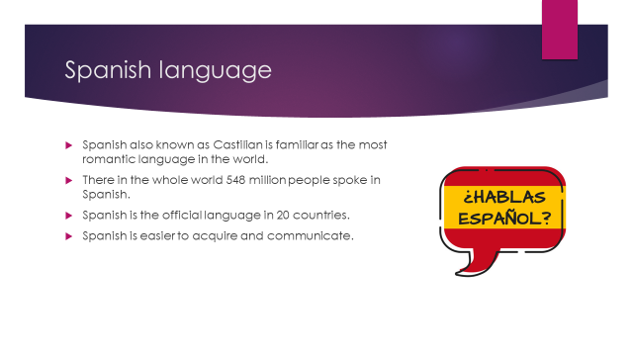
Spanish also known as Castilian is familiar as the most romantic language in the world. In the current world, Spanish is one of the most important languages. There in the whole world, 548 million people spoke in Spanish. Spanish is the official language in 20 countries. Among the 20 countries there 18 are from Europe, one is from America and another is from Africa. Spanish is easier to acquire and communicate.

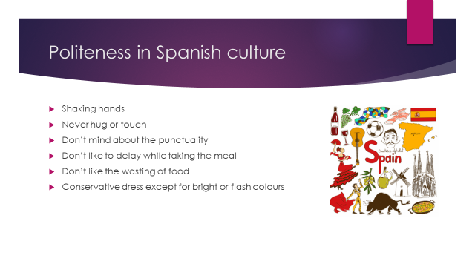
In the time of getting they shake hands but don’t like to hug or touch. In the Spanish culture time maintenance is not so crucial as they don’t mind punctuality (Pountain, 2016). But during the time of taking meal they don’t prefer delaying or maximum 15 minutes they can wait. They don’t like the wasting of food. In the dress-up sense, they prefer conservative dress except for bright or flash colours.

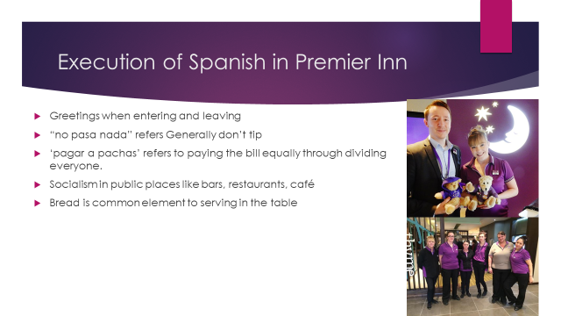
The staff should be made Greetings when entering and leaving. The staff need to not expect any tips “no pasa nada”. They have cultures to pay the bill equally by dividing everyone (Jean Claude Musoni, 2018). They prefer socialism in public places like bars, restaurants, café. Bread is a common element to serving on the table.

References
Edwards, J. (2012). Multilingualism. Bloomsbury Publishing.
Fairclough, N. (2016). Critical language awareness. London New York Routledge, Taylor and Francis Group.
Jean Claude Musoni (2018). Linguistic Communication Challenges Encountered by Tourists Visiting Musanze District. GRIN Verlag.
Pountain, C.J. (2016). Exploring the Spanish Language : An Introduction to Its Structures and Varieties. London, United Kingdom: Routledge.

