Emmie Porter
2206236
Appendices relevant to ECAD5010

Contents of appendices:

Appendix A: Full ethics form. (P.2- 4)
Appendix B: School consent letter. (P.5)
Appendix C: Blanket consent form template. (P.5)
Appendix D: Interview questions for the pupils focus group interviews. (P.6)
Appendix E: Happy and sad place cards for interview assent. (P.6)
Appendix F: Pupils focus group 1 transcript. (P.7)
Appendix G: Pupils focus group 2 transcript. (P.8)
Appendix H: Introduction to the staff questionnaire. (P.8)
Appendix I: Preview of questionnaire. (P. 9)
Appendix J: Replies to questionnaire- Q.5. (P.9)
Appendix K: Replies to questionnaire- Q.7. (P.10)
Appendix L: Replies to questionnaire- Q.3. (P.10)
Appendix M: Replies to questionnaire- Q.6 (P.11)

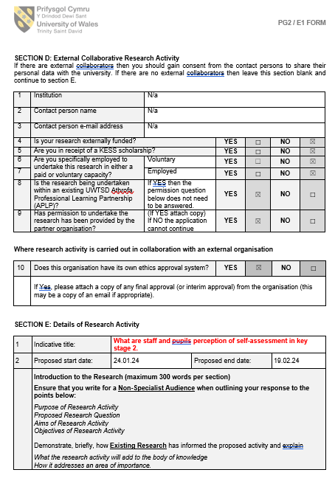
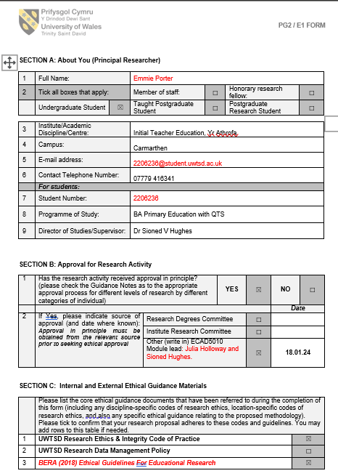
Appendix A: The full ethics form completed prior to the research study.

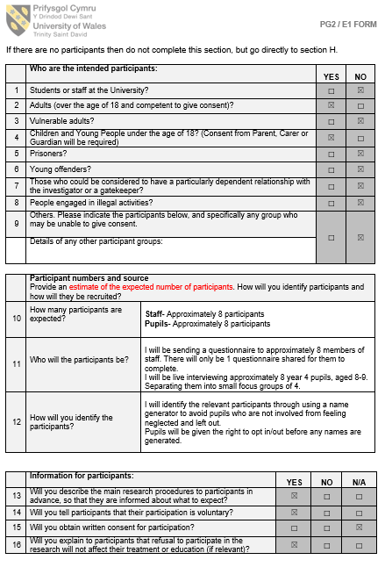
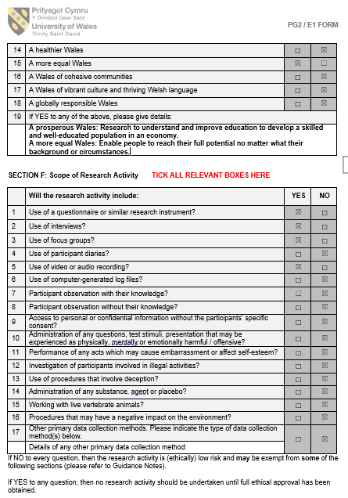
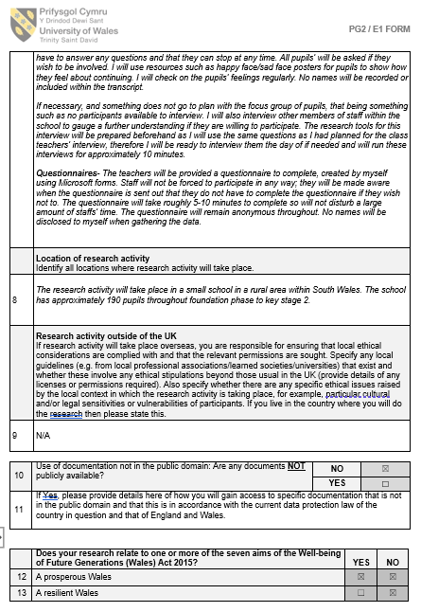
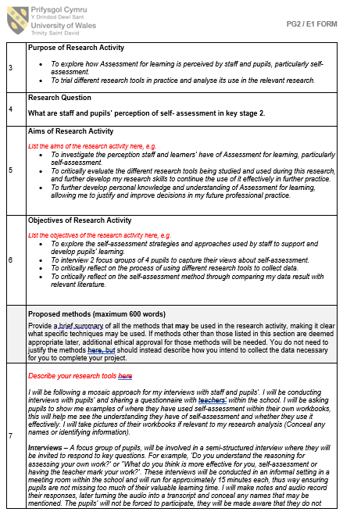
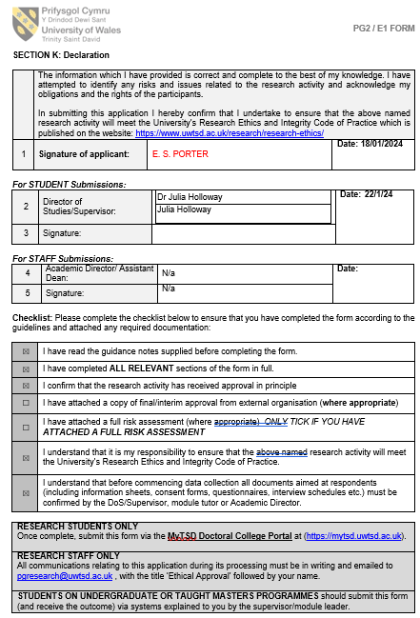
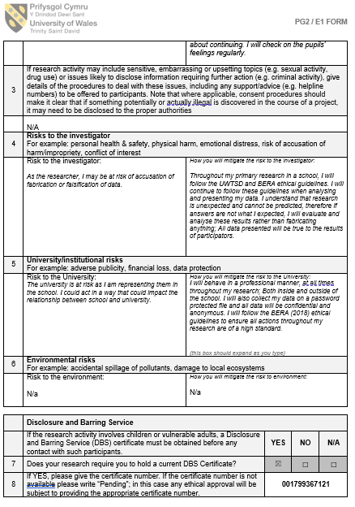
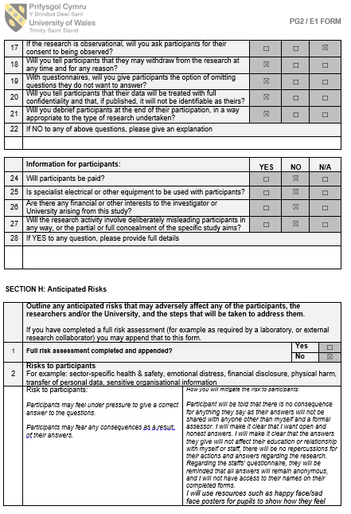
Appendix B: The consent letter informing school x of the rationale of the research study.
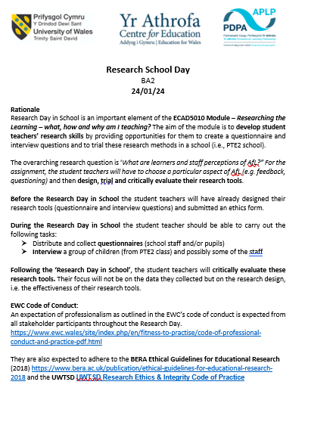

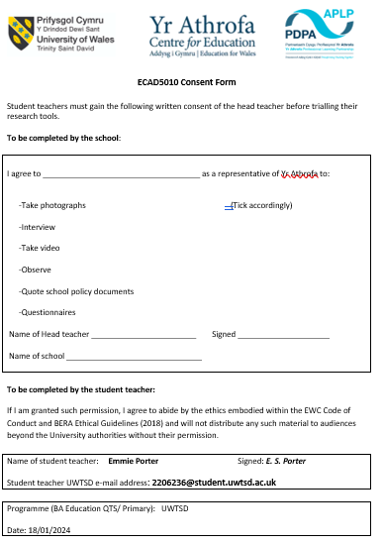
Appendix C: The blanket consent form template sent to school x to be completed by the head teacher.

Appendix D: Semi-structured Interview questions and prompts created for the pupils focus group interviews.
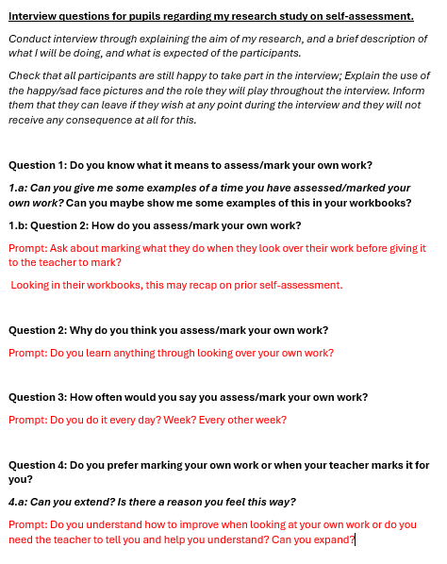

Appendix E: Happy/sad face place cards used to obtain pupil’s assent.


Appendix F: Pupils interview transcript from focus group 1.
Yellow- Pupils rely on teacher input and support.
Green- How often self-assessment is used.
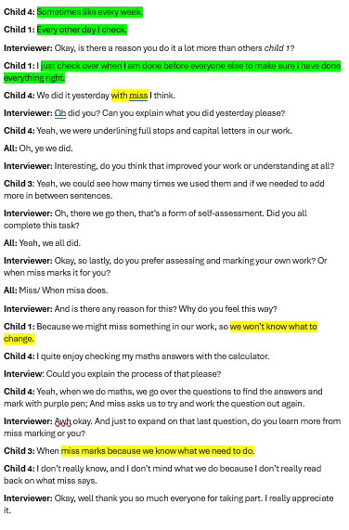
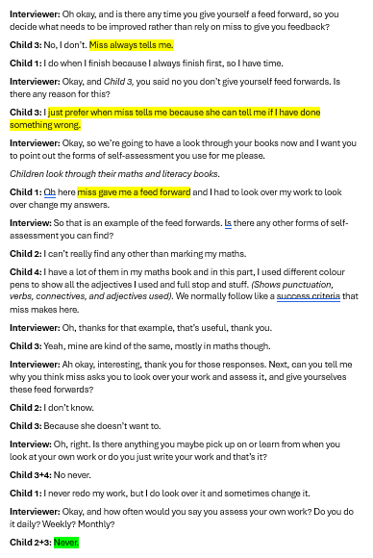
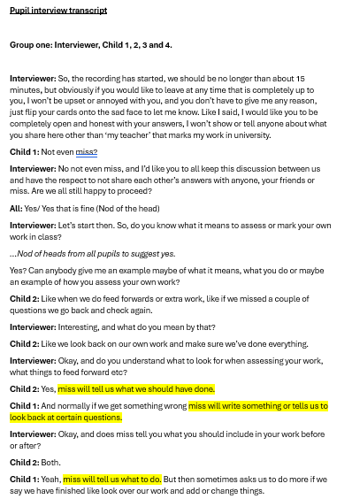
Appendix G: Pupils interview transcript from focus group 2.
Blue- Candid definition.
Green- How often self-assessment is used.
Purple- Example of a self-assessment strategy used.

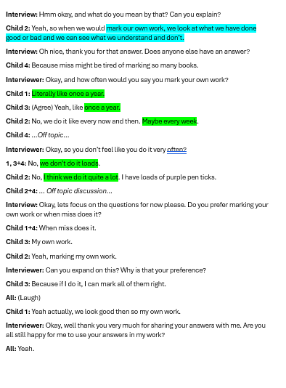
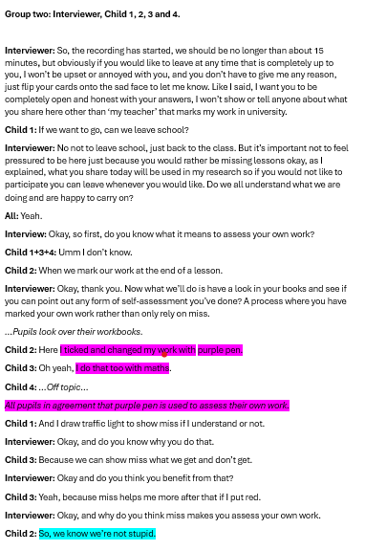

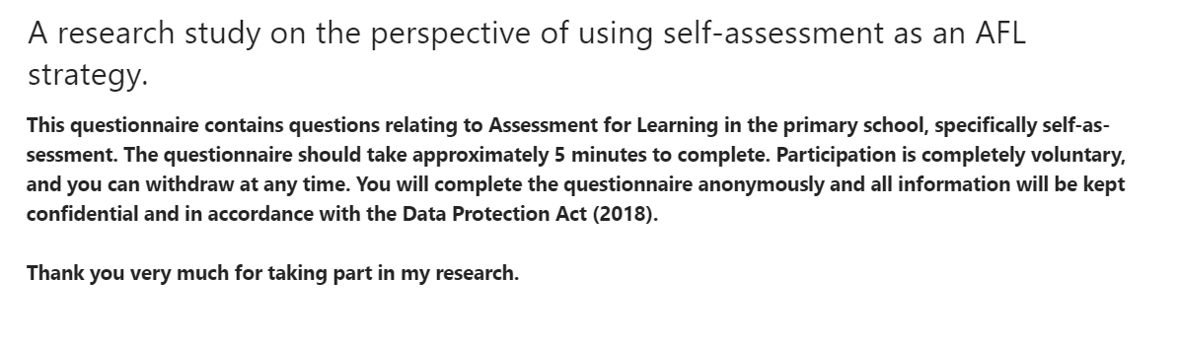
Appendix H: An introduction to the staff questionnaire.

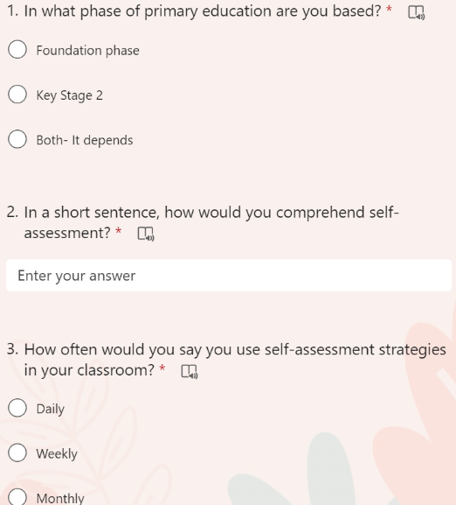
Appendix I: Preview of the questionnaire sent to all teachers at school x.
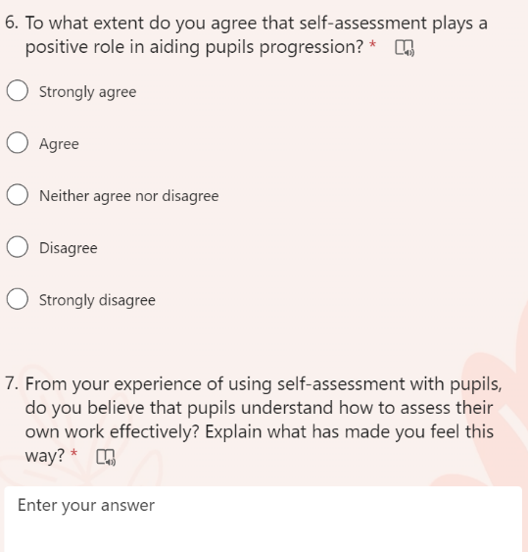

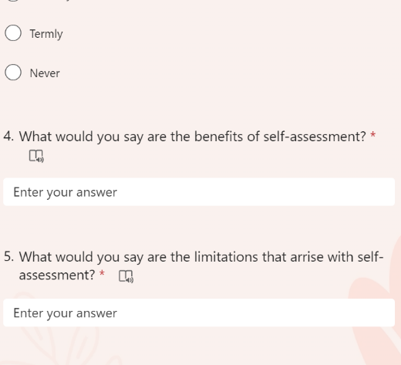

Appendix J: Staff replies to question 5- Limitations of self-assessment in classrooms.
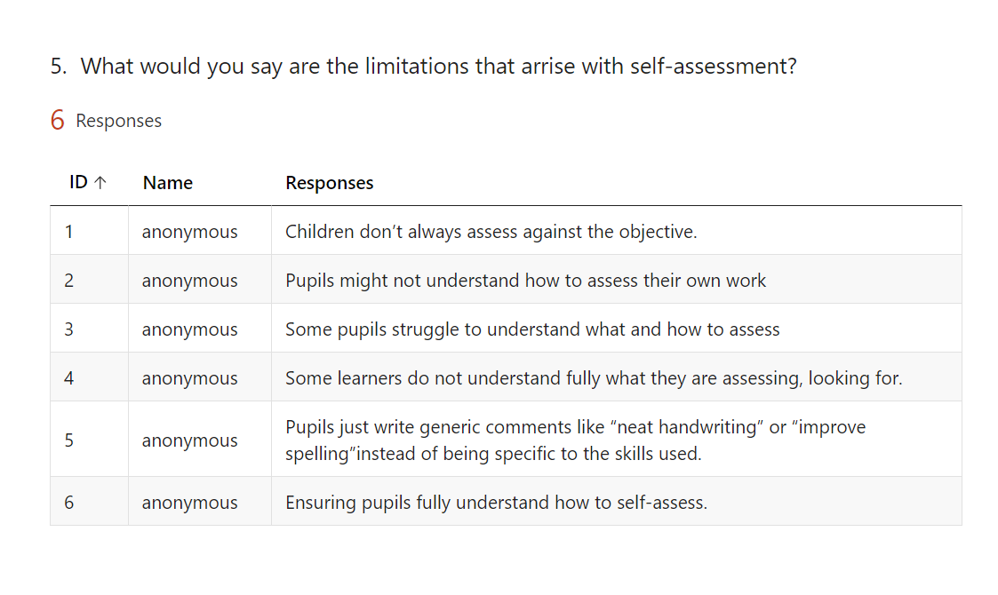

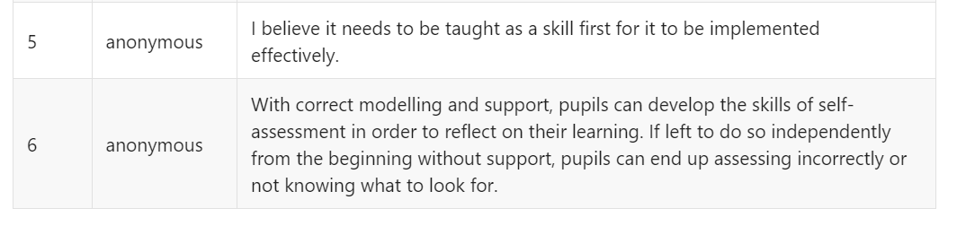
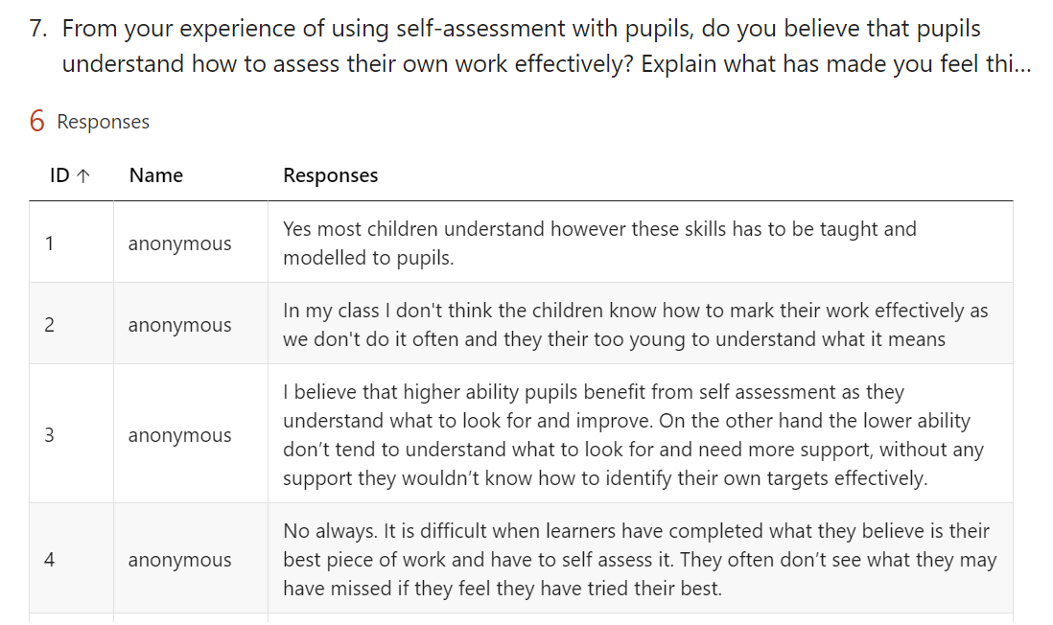
Appendix K: Teacher replies to the questionnaire, question 7- Explaining their experience with using self-assessment strategies in their classroom.

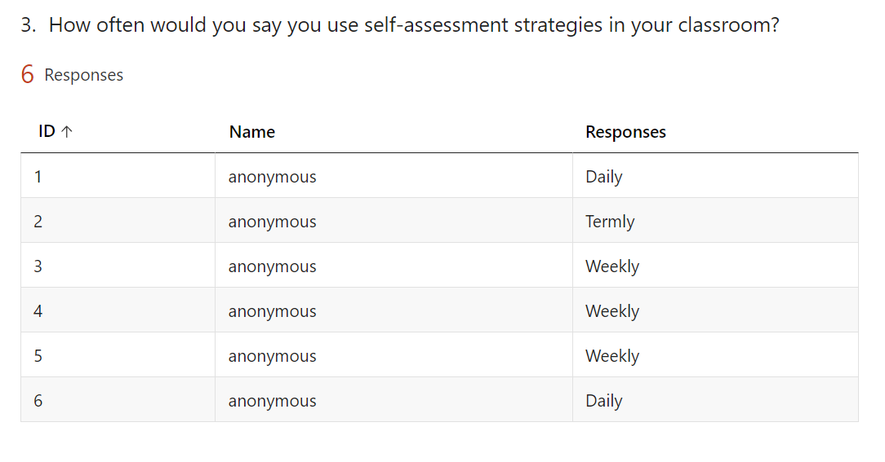
Appendix L: Staff replies to question 3- How often they use self-assessment strategies in their classroom.

Appendix M: Staff replies to the questionnaire, question 6- To what extend they agree that self-assessment plays a positive role in aiding pupils’ progression.


