

Consultancy Management – M7X00585 By - Ashley Calvert
Student No 1706782

Feasibility Study for Haverfordwest Castle

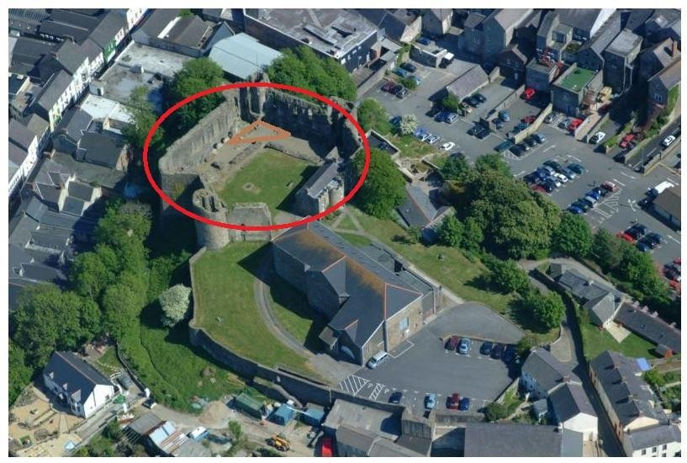



Prepared by Ashley Calvert - May 2018

Contents

- Executive Summary 5
- Introduction 8
- Methodology 9
- History of the site 9
- Current Use of the Site 9
- Ownership of the Site 11
- Aims 11
- Market Research & Demand 11
  - Population of Pembrokeshire with 2015 estimates. (https://statswales.gov.wales 2018) 12
  - Population of Haverfordwest (https://statswales.gov.wales 2018) 12
  - Frequency of attendance at events in Pembrokeshire 13
  - Specific activities attended in Pembrokeshire 14
  - Local Market Analysis 17
- Best Practice 18
  - Pembroke Castle 18
  - Manorbier Castle 18
  - Carew Castle 18
  - Cardigan Castle 18
  - Chepstow Castle 19
- Options for Haverfordwest castle 20
- Events analysis 23
- Roof Options 27
  - Architects preferred solution 27
  - SaddleSpan 27
  - Stretch Tent 28
  - Inflatable 29
  - Orbit Stage 29
- Tiered Seating options 30
  - Mobile Tiered Seating 30
  - Clam Seating 30
  - Grandstand seating 31
- Other factors to be considered 31
- Potential Funding Sources 31
- Key observations 32
- Recommendations 33
- SWOT Analysis 36
- STEEPLE analysis 38
- Event cost Assumptions 39
- Concluding comments 40
- References 42
- Appendix 45
  - Appendix 1 46
  - Appendix 2 49
  - Appendix 3 50
  - Appendix 4 53
  - Appendix 5 55

Executive Summary

This feasibility study looks at the potential of establishing Haverfordwest castle as a site for hosting regular activities; a key idea to facilitate this was to install a dome roof over the Castle. The purpose of the roof is to create a useable all weather space for events to take place in.
The Stone Castle of Haverfordwest dates to 1220. The useable space of the Castle (for the scope of this feasibility study) is the remaining 3 walls and side of the town Museum as highlighted by the red circle in the image below. The area surrounding the old jail house is not included in this study.
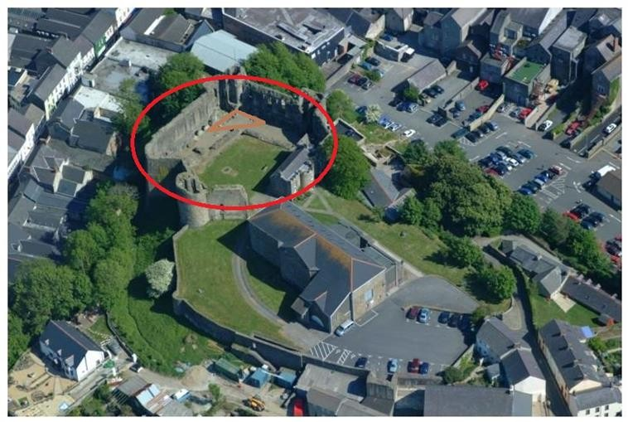

The architectural elements of this study have been undertaken by Acanthus Holden, who have published an accompanying report. (Appendix 5)
Working within the constraints of Cadw’s guidelines (http://cadw.gov.wales 2018) it

was quickly established that the overall vision of a dome covering the ground below and, when lit, acting as a beacon over the Castle would not be possible (No fixtures or fitting to be attached to the castle walls). The architects have offered a solution to

this, which meant positioning the roof below the top level of the walls rendering it invisible from outside the Castle. Alternatives to the main architect’s solution have also been explored and the indicative costs outlined where possible. The potential of a range of events and alternative temporary roofing options are contained within this study with our preferred solution being a stretch tent as it offers a temporary structure with minimal interference to the ground and foundations. A stretch tent is additionally easily assembled and dismantled.
The Population of Pembrokeshire is approximately 123,000 (https://statswales.gov.wales 2018) and the population of Haverfordwest is 11,500
(https://statswales.gov.wales 2018). Using these figures and data from the Arts council of wales it is possible to approximate likely attendances for a range of events from live music to markets to art festivals.
From the analysis, events that offer a likely audience are outdoor cinema, plays, other live music, carnivals, food/beer festivals and a range of markets.
Some of the preferred events can be eliminated due to infrastructure costs. For example to set up a quality live music event with staging, engineers, artistes, security, will cost approximately £8000. The capacity within the walls of the castle is 500, if a ticket cost is £15 it becomes clear that making a profit is not possible (£15 x 500 =
£7500).

Events that drive a high (changing) footfall without exceeding the capacity guidelines such as food/beer festivals have the potential to make a profit. This is because the infrastructure costs are significantly lower and revenue can be gained by selling stalls/pitches prior to selling entrance tickets to the public.

It is suggested within this study that consideration is given to including the whole site as one project as the adjacent, and currently redundant jail house would provide ideal storage space for any equipment purchased.

Introduction

Landsker Business Solutions Ltd (hereafter called Landsker) was appointed via a tendering process to undertake a feasibility study for Mr. Richard Jones. Mr. Jones is actively involved in the staging of events at Haverfordwest castle and is keen to research its potential to become a venue for appropriate events.
The purpose of this feasibility study is to provide interested parties with an objective, independent and analytical view of the potential to establish an all-weather space in the castle of Haverfordwest.

The brief from the client was to assess the feasibility of how contemporary activities could be staged at the castle. An idea tabled by Mr. Jones was to install a clear dome like roof structure to provide a cover and backdrop for events and provide some shelter from the changeable Welsh weather. Other development ideas should fall within the guidelines of Cadw’s “conservation principles” (http://cadw.gov.wales 2018) and not unduly impact the site.

Landsker has been appointed to assess the commercial feasibility of the project (i.e. that in the longer term it becomes financially sustainable) whilst Acanthus Holden Conservation architects will assess the project’s feasibility from an architectural, heritage and conservation permissions perspective.

Best practice and comparable sites locally and elsewhere in Wales have been appraised to provide benchmark information on what is already on offer and how that offer is presented. Can Haverfordwest castle host similar events or is there an

opportunity to offer something new and ground breaking without creating any displacement effects from other local businesses?

Methodology

Analysis has been undertaken to assess the feasibility of Haverfordwest castle becoming an all-weather covered space. This has been done by “desk research” (Jackson, P., 1994), “netnography” (La Rocca, A., Mandelli, A. & Snehota, I., 2014) seeking out best practice (http://www.businessdictionary.com 2018) within Wales and consultations with Architects, the local Fire safety officer, various public/private venue technicians, sound and stage engineers, artistes agents and industry experts, who are involved in the organisation of events.
Information from the public domain regarding population and potential event attendance figures has come from Pembrokeshire County Council (https://www.pembrokeshire.gov.uk/ 2018) and the Arts Council of Wales “Arts in Wales” survey 2010 (http://www.arts.wales 2018). Data has then been analysed to
assess the viability of a range of events, likely audience attendance figures and the financial risk involved.

History of the site

A brief outline of the history of the site is available at Appendix 1

Current Use of the Site

The castle operates as an open space for people to take their dogs, a play area for children and families and some bench tables allow people to eat their lunch or picnic during fine weather. The site also has the town museum and the former jailhouse.

The town museum is closed for 5 months of the year and open weekdays from 2nd April to 31st October (http://www.haverfordwest-town-museum.org.uk/ 2018).

Key information relevant to this feasibility study includes:

  - Anecdotal evidence from local residents outlined the castle to be a popular (but not overused) site especially in fine weather.
  - The site has been used for the annual Haverfordwest Beer & Cider Festival (facebook.com 2018) now in its 11th year, an annual Jazz concert organised by the Museum committee.
  - Approx. 6000 visitors to the museum and castle per year (http://www.westerntelegraph.co.uk 2013)
  - Museum committee members outlines that the Sealed Knot Society will be appearing in 2018.
  - An event called Core in the Castle was organised for 22nd August 2015 and then postponed until 5th September 2015 (Facebook.com 2018) due to complications with Pembrokeshire County Council (PCC) (security, fencing, erosion of the ground, knocking in pegs). The event was eventually cancelled due to low ticket sales.

Ownership of the Site

Two main bodies are to be consulted over the use of Haverfordwest Castle.

Pembrokeshire County Council (PCC) – PCC are the owners of the site and are responsible for the maintenance and upkeep of the site plus any planning applications etc.
Cadw - Cadw (http://cadw.gov.wales 2018) is the Welsh Government’s historic environment service working for an accessible and well-protected historic environment for Wales. They are to be consulted on all aspects of the physical property and grounds.

Aims

The aims of this feasibility study are to

- Evaluate & explore the market demand for events in the county / Haverfordwest

- Outline alternative temporary roofing options

- Explore best practice within similar settings

Market Research & Demand

This section shows the population of Pembrokeshire from 2009 and the estimated population figures for 2015. The 2015 estimates have already increased and a further 3% is added to the total population. This section also details attendance figures for a range of events in Pembrokeshire and the likely attendance figures for events in the castle of Haverfordwest.

  - Population of Pembrokeshire with 2015 estimates. (https://statswales.gov.wales 2018)
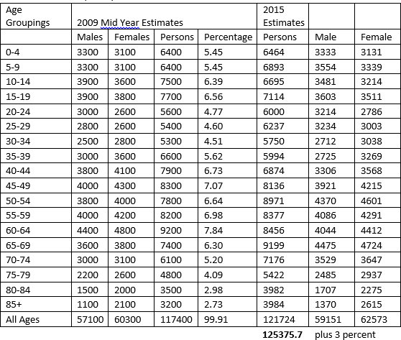

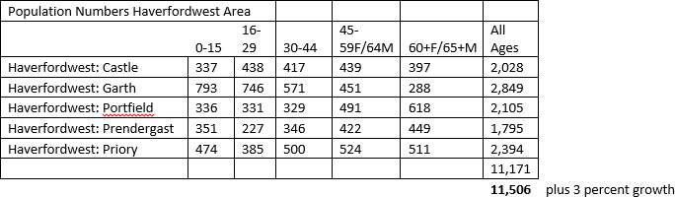
  - Population of Haverfordwest (https://statswales.gov.wales 2018)

  - Frequency of attendance at events in Pembrokeshire

These figures come from the Arts in Wales 2010 survey – available online at - http://www.arts.wales/research/research-archive/arts-in-wales-survey-2010 the
figures are specific for Pembrokeshire.

Chart 1 – Attendance across Pembrokeshire
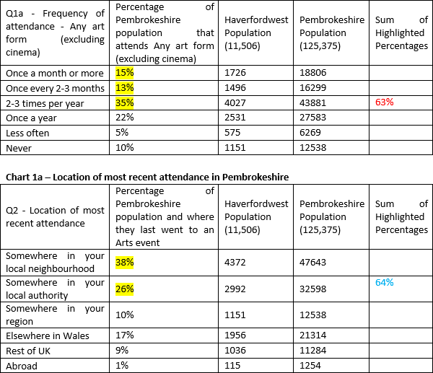

As can be seen from the two charts above a total of 63% of the county’s population attend an art event excluding cinema 2 or 3 times a year or more. Additionally, it can be seen that 64% of the population of Pembrokeshire attend an event in their local neighborhood or local authority.

  - Specific activities attended in Pembrokeshire.

These figures come from the Art in Wales Survey 2010 available at www.arts.wales and are specific to Pembrokeshire. Potential local audience figures have been calculated based on the 63% of the county’s populations attending an event and then of that 63%, the 64% that attend an event locally 2 or 3 times a year or more. This gives us our best assumptions for the attendance at various types of events.

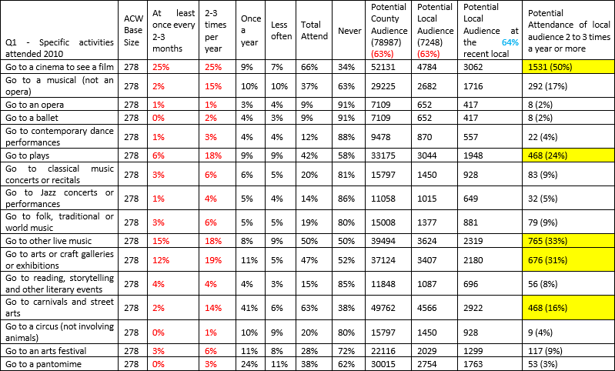

For information on how these figures have been calculated please see Appendix 2

  - Local Market Analysis

- What else is locally available?

In Haverfordwest town centre

  - Labyrinth (Live music, Bar), Pembrokeshire college (Film Society & Theatre), Eddies (Night Club), H’West Rugby Club (live music), St Mary’s Church (choral music)

Large Venues In the county

  - Torch Theatre (Milford Haven) – Capacity 297 (Main House) 102 (Studio Theatre) (www.torchtheatre.co.uk/ 2018)
  - Theatr Mwldan (Cardigan) Mwldan 1 auditorium seats 146, Mwldan 2 auditorium seats 250, Mwldan 3, a studio space, seats a maximum of 60. (www.mwldan.co.uk/ 2018)
  - The Queens Hall (Narberth) – Capacity 428 (standing) 214 (seated) including all staff and performers (www.thequeenshall.org.uk/ 2018)

Best Practice

– When looking at Best Practice, other local sites that offer a similar experience are:

  - Pembroke Castle

Pembroke castle has been putting on events for a number of years. In recent years a change in management has meant that the castle has expanded its programme of events. Recent large scale events include Only Men Aloud (http://www.onlymenaloud.com 2015), Jools Holland (http://www.pembroke- today.co.uk 2015) and a couple of higher level Tribute bands (Abba & Rolling Stones). These have been mostly provided by Orchard Entertainments (http://orchardentertainment.co.uk/ 2018), Wales largest events providers.
  - Manorbier Castle

In recent times the castle has been used as a film location for “I Capture the Castle” 2001. Recent events have seen a change in Management, which has expanded its activities, including the hosting of Weddings and Functions, Vintage & Wedding Fairs, Outdoor theatre, Fetes and some low level music events.
  - Carew Castle

Carew Castle has recently benefited from a grant that enabled it to re-establish the roof on the Lesser Hall (http://cadw.gov.wales 2014). This is another castle space that organises Christmas fairs, Family events and occasional Theatre productions.
  - Cardigan Castle

In 2015 Cardigan Castle reopened as a heritage attraction, restaurant, accommodation and events venue, after a £12m restoration project (http://cadw.gov.wales 2015). The Plan is to host everything from open-air theatre, live music events and comedy re-enactments, to foodie/wedding/Christmas fairs and

children’s entertainment. As part of the restoration project Cardigan Castle and Theatr Mwldan were able to purchase a Saddle Span Tent (see section 12.2), a temporary structure that provides all weather cover in the castle gardens and all the associated events equipment (Sound, Lights, Staging, etc.)
  - Chepstow Castle

Holds an annual outdoor theatre festival with 11 performances and 4 / 5 Big gigs per

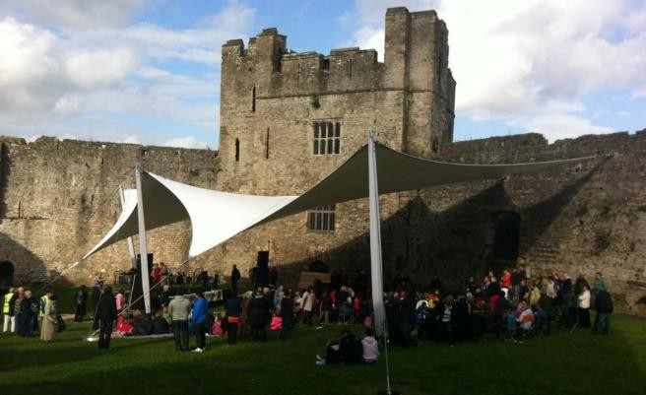
year mostly tribute acts (chepstowfestival.co.uk 2018). Chepstow castle have achieved the installation of a Temporary Roofing system to hold the outdoor theatre under.
This took five years to achieve, and relied on “political favours and clout” according to

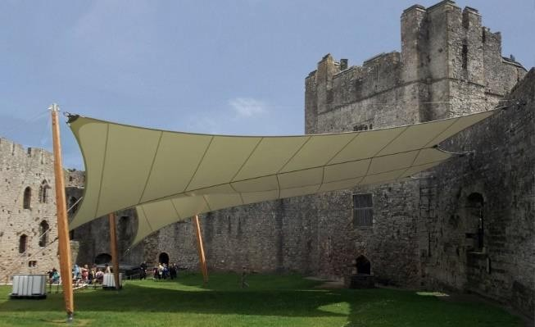
one of the main organisers Mr Ned Heywood (who was Mayor at the time). They had to prove that events had happened there in the past and indeed they had up until 1890 when a run of bad
weather stopped them. Having spoken to Mr. Heywood, he outlined that they would have designed it differently if the opportunity came again and make use of ground supports and not the current mixture of ground and wall support. The main reason for not wanting wall supports/fixings in a future project was cost and expense. He also advised that a water runoff system needs to be designed in from the beginning.

Options for Haverfordwest castle

The following table outlines the pros and cons for the project

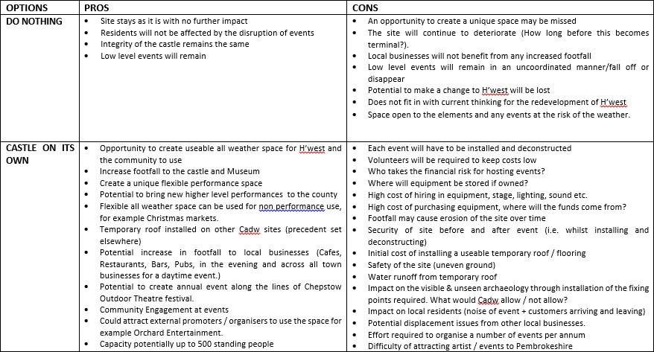

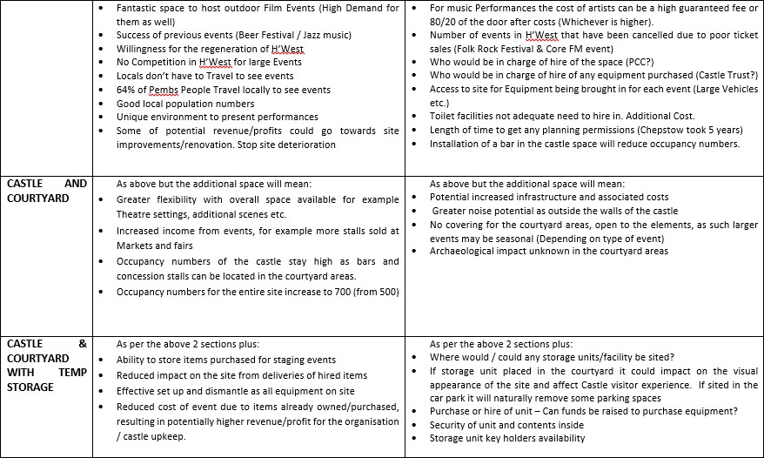

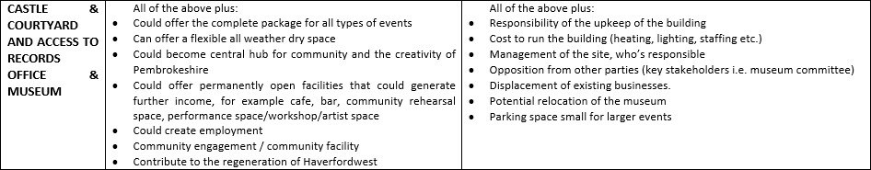

Events analysis

When reading the following table it is important to realise that the cost of hiring in any Temporary roofing structure or bleacher seating has not been included (Cost for seating are shown with examples in section 13). The cost for equipment for an event has been based on figures provided by Magnum Sound (http://www.magnumpa.com/ 2018). It has additionally assumed the lowest cost of a performer is £800, based on information provided by Span Arts (http://www.span-arts.org.uk/ 2018). Cost for security are not included as this could be provided by volunteers.
Event’s costs can be very fluid and dependent on many variables. Performers’ costs can vary wildly, some events are based on a flat fee, others are based on the performer working a door split percentage of 80/20 after costs. Calculations can be seen in section 20 of this document.

11.1 Event attendance calculations table
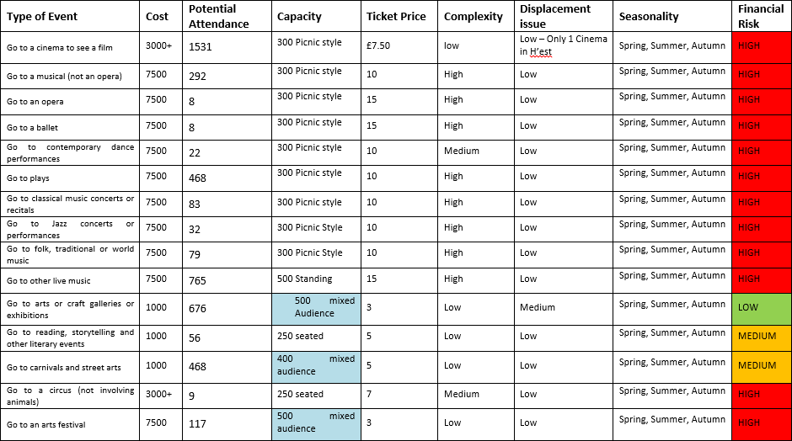

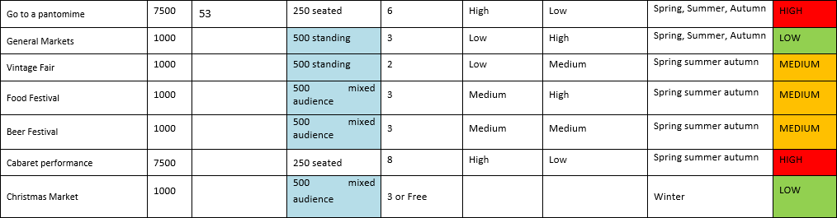

From the information outlined in the event attendance calculations table, it can be seen that events can be classified as High, Medium or Low Risk. The risk has been assessed from a financial position and effectively means the likelihood of an event having a HIGH risk of losing money or conversely a LOW risk of losing money. For clarity calculated attendance figures for a contemporary dance performance is 22, at a ticket price of £15 means a total of £330 would be taken. This figure does not cover the cost of infrastructure or performers.
As can be seen the cost of hosting any kind of market is Low and a low ticket price and healthy anticipated attendance figures make this kind of event possible. At the other end of the spectrum events that involve performance involve high infrastructure costs, broadly speaking a ticket price of £15 is seen as affordable in Pembrokeshire and therefore capacity issues mean that not enough tickets can be sold to cover the infrastructure costs.
Cinema is an attractive offer but after speaking with the director of the Torch Theatre, Mr Peter Doran, who have organised outdoor cinema nights, the cost of hiring the projector is £2,000 plus other costs, making one off evening events high cost.
In essence it all depends of the level of performer / performance. A higher ranked event will require a setting that reflects this. Low level tribute acts or school plays will require less professional infrastructure but this will also reflect on attendance numbers and repeat audience numbers.
To Hire the SaddleSpan tent from Cardigan Castle /Mwldan would be in the region of

£4,000 to £5,000. A meeting with Sion Williams the technical manager for Theatre Mwldan outlined that hire of all their kit to host an event would be in the region of

£10,000 to £12,000 - this does include all assembly and deconstruction and operation of equipment.

Roof Options

  - Architects preferred solution
From the brief given to Acanthus Holden the preferred solution is indicated in this

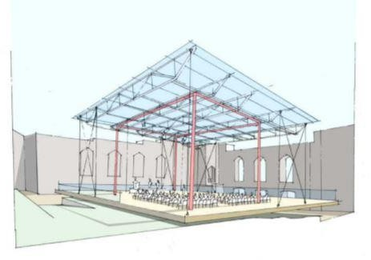
diagram. It shows a lightweight structure that best meet the design constraints detailed within their report entitled
“Haverfordwest castle – Understanding heritage values and assessing significance”. (Appendix 5)
In essence the report proposes 2 potential outcomes.

- “to create a lightweight high-level transparent, horizontal plane positioned below the level of the outer castle walls”. No indicative costing have been provided.
- The creation of a removable level surface located above the current topography.

  - SaddleSpan

A SaddleSpan tent is the ideal concert and festival structure where space is at a premium. This single unit can be branded and installed on grass or hard-standing (ballasted) and comes in two configurations – Canopy and Concert. As a Canopy the

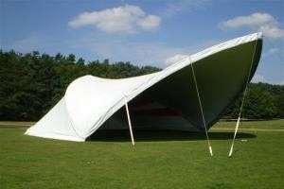
S2000 SaddleSpan is open at both ends, perfect as a smaller stage cover or audience shelter. As a Concert tent, the S2000 SaddleSpan is closed at one end, providing back-line and equipment protection yet still leaving a connection with the surrounding
countryside and audience.

This style of tent does need to have fixings to the ground so some disturbance to the flooring of the Castle is required. This may link into the foundations or the 19th century women’s jail within the walls of the Castle.
Available – (http://www.tentnology.com/ 2018) Hire from – (http://www.amazingtent.co.uk/ 2018)
  - Stretch Tent

Stretch tents are the new and affordable alternative to hiring a traditional marquee.

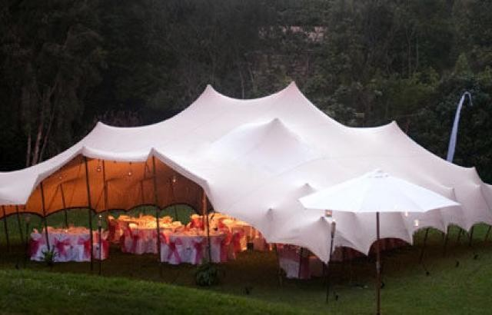
These freestyle structures are architecturally stunning and flexible enough to fit any area, to any size, cover uneven ground, become part of a building and can be configured in countless ways. Freedom
to choose the exact location, size, form and even the colour means that the space is only limited by your imagination.
These tents need to have fixings in the ground that can be up to 90cms deep, potentially wall fixings and potentially tension created by water ballast
Available from (http://www.stretchevent.co.uk/ 2018) or local to Pembrokeshire – (http://threadform.com/ 2018)

  - Inflatable

There are many variants on this type of inflatable dome / Spider tent. They can

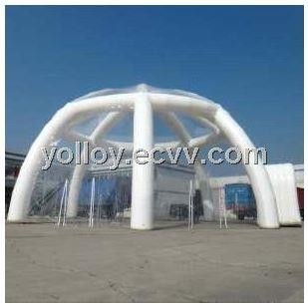
accommodate up to 500 people. One of the major advantages is ease of erection, it’s additionally very portable, durable and convenient. The one featured here comes from China and would require all the relevant UK safety inspection certificates. Indicative cost for
an inflatable dome is $5200 (US Dollars). (www.ecvv.com 2018)

It should be noted that on a hot sunny day the temperature inside the dome could become excessive and uncomfortable.

  - Orbit Stage

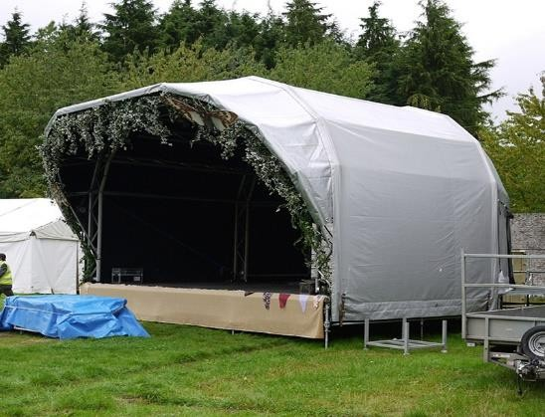
An orbit stage does not need a flat surface to build the stage. So sloping ground and rough terrain are not an issue. They do not need a crane to erect so are the industry standard for working in tight spaces or where the ground needs to be preserved. Ultimately an Orbit stage gives the
covered space and is strong enough for any demanding lighting and sound requirements. (8 Meter Orbit stage illustrated)

Tiered Seating options

  - Mobile Tiered Seating
A flexible system that can be brought onto any site. Can be towed behind a large four

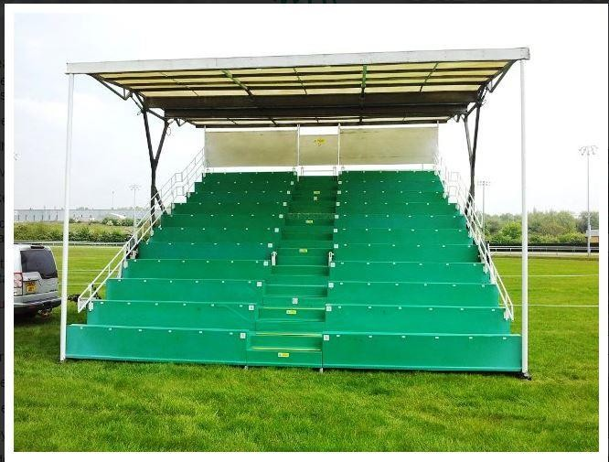
wheeled drive vehicle and can effectively be placed anywhere the vehicle can go.
Seats 132 people Cost £1200 + VAT Cost £10.90 per seat.
Available from – (www.a3events.com 2018)

The cost per Seat makes this an unviable option for events at the Castle.

  - Clam Seating

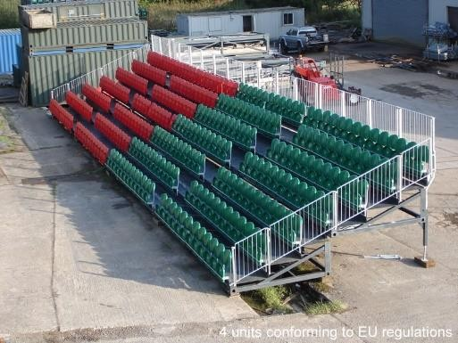
This system is collapsible. All seats fold down and then the back half folds towards the front. It can be supplied with wheels to manoeuvre around. To purchase a system would cost in the region of £100 per seat. This image shows 4 clam systems in
operation. Each part seats approx. 84 people.

As an indicative cost this equates to £8,400 per section. David Howell from Grandstands worldwide has indicated that they will be able to provide a system that 2 people could construct.
Available from – (www.grandstandsworldwide.com 2018)

  - Grandstand seating

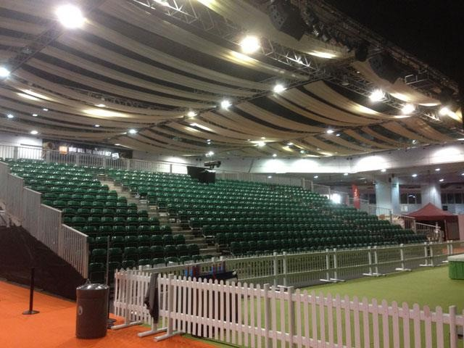
Professional seating options for an event. Preferably to install for a period of time. Has to be delivered via an articulated truck which will not fit on the Castle site.
Seats Unlimited - Cost £15 to £20 per seat

Cost advised by Wernick events (www.wernick.co.uk/ 2018)

The Cost per seat and access issues makes this an unviable option for events at the Castle.

Other factors to be considered

A number of key factors will need to be taken into consideration with the project including, Water Run off, Cleaning of a clear roof, Greenhouse effect (Heat) etc. More information on these and other subjects are available in the appendices (Appendix 3)

Potential Funding Sources

An outline of the grants available at the time of writing are included within the appendices (Appendix 4)

Key observations

Based on our research and discussions Landsker offers the following high level observations:
- A permanent clear roof on the castle is just not feasible under current Cadw legislation and the architect’s recommendations. A clear roof would also be a sun trap in hot weather, a clear roof would additionally have to be cleaned regularly to stop the build up of dirt.
- The acoustics of any permanent clear roof would have to be assessed, building the roof and then finding the acoustics were terrible would be a disaster, furthermore the sound of rain hitting a un-insulated roof can be deafening.
- Previous performance events in Haverfordwest have not been well attended or have been cancelled, however, in 2015 the first HaverFoodWest food festival saw over 4000 people attended the 1 day event with 48 stalls (entry £2) (http://www.westerntelegraph.co.uk 2015). Proposals were made to make it a 2 day event in 2016.
- Bringing most performance event to the Castle will be a high cost / low return risk but that said, bring the right event, to the right place, with the right environment, at the right price and people will come.
- Chepstow Castle has been able to set a precedent with the construction of a covered area within the Castle that has been approved by Cadw.

Recommendations

- Work needs to be done to finally establish the exact numbers that the Castle and grounds can accommodate. A capacity figure of 700 standing has been given as an estimate for the whole Castle grounds by the local fire officer. However, due consideration must be made into the capacity of the inner Castle area.
- Further work is required into the cost of hosting an event. We have given costing figures that will act as a guide but as mentioned within this report, these will vary with the type and style of performer / performance or event.
- Many performers agents consider that Wales ends at Cardiff. One solution to this is to team up with a Welsh Promoter who has been specifically targeted to route a tour into Wales. Pembroke Castle has teamed up with Orchard Entertainments (Wales's biggest independent live music promotion company) and been able to put on High level names like Jools Holland, Only Men Aloud, Jamie Lawson, and high end tribute acts. (www.orchardentertainment.co.uk/
2018)

- To put on a series of events, potentially 12 per year would involve a large degree of financial risk. It is not clear who would be responsible for providing financial backing to the events, or who would receive any surplus funds generated. Many events in Pembrokeshire have resulted in the organisers making significant losses for a number of years, this must be factored into any projected forecasts.
- Volunteer fatigue is a concern, as the effort of 12 events per annum will take its toll. In essence it’s either one event per month or 6 x 2 day events over the

fairer weather months. It will require a team to assemble and deconstruct any equipment, seating, staging.
- Any roofing structure or flooring will have an impact on the archaeology of the castle. For Landsker the Stretch tent or Canvas alternative would be the best option for the Castle if a temporary structure were to be used. Permanent holes 90cms deep would be required to fix the tent to the ground. Such holes could be drilled into the existing foundations which have little or no architectural value. This option would have the minimum impact of the ground.
- To keep costs down it is recommended that an application for funding to purchase equipment, staging, stretch tent, lighting etc is considered. It is additionally recommended that an application to include part of the Old Jail house. This would allow for storage of equipment and offer up additional usage
for;

  - A flexible all weather dry space

  - A central hub for community and the creativity of Pembrokeshire

  - A permanently open facility that could generate further income, for example cafe, bar, community rehearsal space, performance
  - Engage with the Chepstow Festival Committee and their appointed architects to understand their experience of a successful temporary structure in a castle setting.- The successful architects were Architen –(www.architen.com 2013).

SWOT Analysis

Within the following table is a SWOT analysis (Marian Burk. Wood 2003) for the project
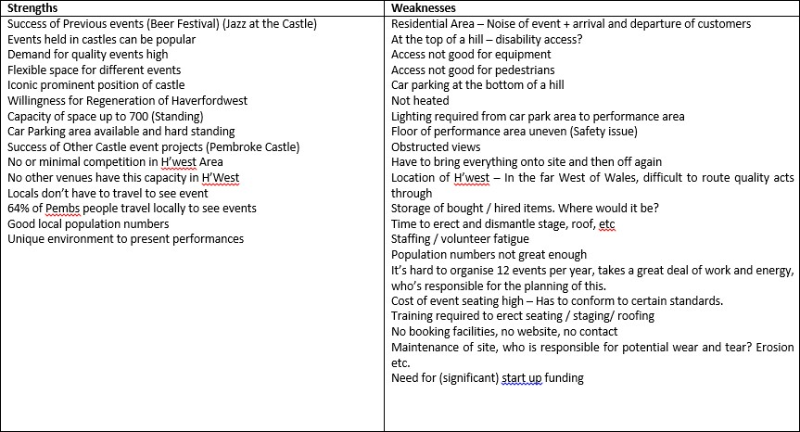

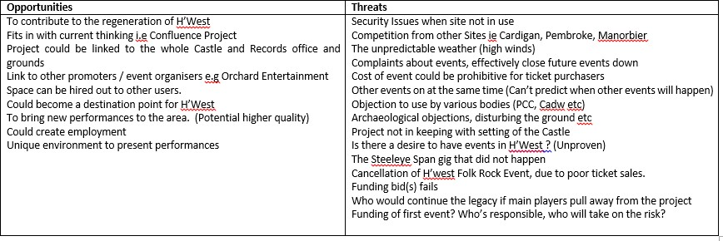

STEEPLE analysis

Outlined below is a STEEPLE analysis (www.pestleanalysis.com 2018) for the project
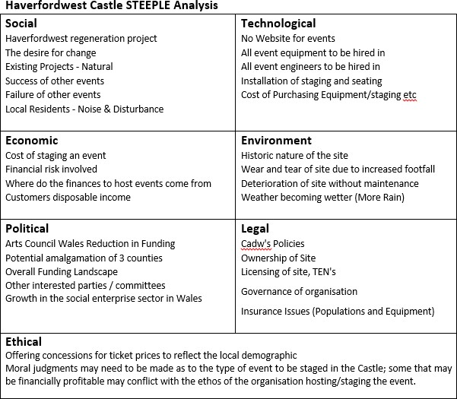

Event cost Assumptions

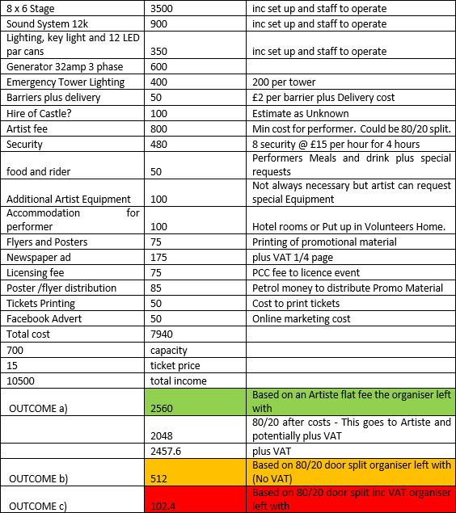
The following costs have been gathered from indicative costs quoted by staging and sound engineers, agents, performers and security firms. It can be seen that outcome a gives the most favourable outcome, working off a straight flat rate artiste fee.
The people used to outline realistic costs are:
- Philip Hughes from Magnum Sound
- Gareth Dean from Wired West Wales
- Jodie Marie – Artiste, Sarah Howells Artiste (Paper Aeroplanes & Bryde)
- Agent – Zac Peters from DMF music

Concluding comments

Quite quickly it was established that any permanent roofing structure that was higher than the Castle walls and would effectively alter the visual impact and historical nature of the Castle would not be approved. This moved the feasibility study into looking at temporary canopies, structures.
Consideration has been given to the real need to quickly transpose, install and remove any canopy / canopies at short notice and ensure as much of the canopy and ancillary structural components can be removed to comply with local PCC and Cadw’s stringent planning requirements.
Best practice and comparable local sites have been appraised to provide information on what is already on offer and how that offer is presented. It is possible for Haverfordwest castle to host events and to offer something new and potentially ground breaking without creating any displacement effects from other local businesses. However, much of this will come down to the Castle’s maximum capacity and the physical number of tickets available for sale. Will the tickets sold cover the infrastructure and associated costs?
Analysis of the viability of various events and the numbers permitted in the space has been analysed within this feasibility study.
Events that have a low infrastructure cost and associated low ticket price have been shown to be popular. Events like Food festivals can have significant footfall.
It cannot be understated that, to get good quality recognisable performers it will be:

- Difficult to get them to come to Pembrokeshire (Artistes agent rarely route an artiste this way)

- If they are routed by the agent this way, artistes will be expensive

- The infrastructure to host an event is then comparatively expensive, as quality artistes will require quality equipment and surroundings.
The use of local artistes will require lower infrastructure costs and subsequently a lower ticket price. However, it must be considered that local artistes play around the county for free in all the pubs and clubs. It is a leap of faith to get the general public to pay for something they can see for free elsewhere.
Costs for alternative roofing options need to be explored and a suitable storage solution found. The former jail house provides the perfect solution to the storage issue. Therefore a project / funding application/feasibility study that includes all or part of the former records office is advised.
In conclusion, we believe that it is possible to host events at Haverfordwest castle and that there is positive energy for performances to happen. The right team needs to be in place to host 12 events a year and they must understand the effort involved in committing to this.

Reference/Bibliography

A3events.com. (2018). A3 Events - Mobile Grandstands. [online] Available at: http://www.a3events.com/mobile-grandstands/ [Accessed 10 May 2018].
Amazingtent.co.uk. (2018). Marquee Hire For Events & Festivals | Amazing Tent. [online] Available at: https://www.amazingtent.co.uk/ [Accessed 10 May 2018].
Architen Landrell. (2013). Chepstow Castle - Architen Landrell. [online] Available at: http://www.architen.com/projects/chepstow-castle-festival-canopy/ [Accessed 10 May 2018].
Arts.wales. (2018). Arts Council of Wales | Arts in Wales Survey 2010. [online] Available at: http://www.arts.wales/research/research-archive/arts-in-wales-survey- 2010 [Accessed 10 May 2018].
BusinessDictionary.com. (2018). What is best practice? definition and meaning. [online] Available at: http://www.businessdictionary.com/definition/best-practice.html [Accessed 10 May 2018].
Cadw.gov.wales. (2014). Heritage Tourism Project restores Carew Castle's heart. [online] Available at: http://cadw.gov.wales/about/news/9418217/?lang=en [Accessed 10 May 2018].
Cadw.gov.wales. (2015). Cardigan Castle to throw open its doors after multi-million pound restoration work. [online] Available at: http://cadw.gov.wales/about/news/cardigan-castle-project-update/?lang=en [Accessed 10 May 2018].
Cadw.gov.wales. (2018). Conservation Principles. [online] Available at: http://cadw.gov.wales/historicenvironment/conservation/conservationprinciples/?lang=en [Accessed 10 May 2018].
Cadw.gov.wales. (2018). Conservation Principles. [online] Available at: http://cadw.gov.wales/historicenvironment/conservation/conservationprinciples/?lang=en [Accessed 10 May 2018].
Catalog, P. and tent, i. (2018). Large Clear Roof Inflatable Igloo Tent with Tunnel Entrance purchasing, souring agent | ECVV.com purchasing service platform. [online] Ecvv.com. Available at: http://www.ecvv.com/product/4057224.html [Accessed 10 May 2018].
Chepstowfestival.co.uk.websitebuilder.prositehosting.co.uk. (2018). Home. [online] Available at: http://chepstowfestival.co.uk.websitebuilder.prositehosting.co.uk/home [Accessed 10 May 2018].
Contributor, P. (2015). Difference between STEEP and STEEPLE Analysis. [online] PESTLE Analysis. Available at: http://pestleanalysis.com/steep-and-steeple-analysis/ [Accessed 10 May 2018
En-gb.facebook.com. (2018). Haverfordwest Beer & Cider Festival. [online] Available at: https://en-gb.facebook.com/BeerCiderFestival/ [Accessed 10 May 2018].
Facebook.com. (2015). Core In The Castle. [online] Available at: https://www.facebook.com/events/805328076202492 [Accessed 10 May 2018].
Grandstand Seating Purchase | Grandstands Worldwide Limited. (2018). Grandstand Seating Purchase | Grandstands Worldwide Limited. [online] Available at: https://www.grandstandsworldwide.com/#! [Accessed 10 May 2018].
Haverfordwest-town-museum.org.uk. (2018). Haverfordwest Town Museum. [online] Available at: http://www.haverfordwest-town-museum.org.uk/ [Accessed 10 May 2018].
Jackson, P., 1994. Desk research, London: Kogan Page.
La Rocca, A., Mandelli, A. & Snehota, I., 2014. Netnography approach as a tool for marketing research: the case of Dash-P & G/TTV. Management Decision, 52(4), pp.689–704.
Magnum Sound. (2018). Magnum Sound | Sound, Lighting Audiovisual Services. [online] Available at: http://www.magnumpa.com/ [Accessed 10 May 2018].
Mwldan.co.uk. (2018). Mwldan. [online] Available at: http://www.mwldan.co.uk/ [Accessed 10 May 2018].
Onlymenaloud.com. (2015). Only Men Aloud at Pembroke Castle on July 5th. [online] Available at: http://www.onlymenaloud.com/news/2015/07/02/only-men-aloud-at- pembroke-castle-on-july-5th/ [Accessed 10 May 2018].
Orchardentertainment.co.uk. (2018). Orchard Entertainment. [online] Available at: http://orchardentertainment.co.uk/ [Accessed 10 May 2018].
Pembroke and Pembroke Dock Observer. (2015). Jools Holland sells out Pembroke Castle.[online] Available at: http://www.pembroke- today.co.uk/article.cfm?id=102246&headline=Jools%20Holland%20sells%20out%20 Pembroke%20Castle&sectionIs=news&searchyear=2015 [Accessed 10 May 2018].
Pembrokeshire.gov.uk. (2018). Pembrokeshire County Council. [online] Available at: https://www.pembrokeshire.gov.uk/ [Accessed 10 May 2018].
Span Arts. (2018). Span Arts - Community Arts Pembrokeshire. [online] Available at: http://www.span-arts.org.uk/ [Accessed 10 May 2018].
stretchevent. (2018). stretchevent. [online] Available at: http://www.stretchevent.co.uk/ [Accessed 10 May 2018].
Tentnology.com. (2018). Buy Event Tents, Party Tents, Commercial Tents, & Fabric Structures. [online] Available at: http://www.tentnology.com/ [Accessed 10 May 2018].
Thequeenshall.org.uk. (2018). Queens Hall Narberth |Pembrokeshire Music Venue, Conference Venue, Meeting Centre West Wales. [online] Available at: https://www.thequeenshall.org.uk/ [Accessed 10 May 2018].
Threadform.com. (2018). Threadform | Bespoke Canvas Shelters. [online] Available at: http://threadform.com/ [Accessed 10 May 2018].
Torchtheatre.co.uk. (2018). Torch Theatre Pembrokeshire, Wales. [online] Available at: https://torchtheatre.co.uk/ [Accessed 10 May 2018].
Wernick. (2018). Modular Buildings UK, Portable Buildings Hire, Temporary Buildings | Wernick. [online] Available at: https://www.wernick.co.uk/ [Accessed 10 May 2018].
Western Telegraph. (2013). Haverfordwest castle village green status could £20,000 [online] Available at: 20_000/ [Accessed 10 May 2018]
Western Telegraph. (2015). 4,000 food lovers flocked to first ever Haverfoodfest. [online] Available at: http://www.westerntelegraph.co.uk/news/12944963.4_000_food_lovers_flocked_to_fi rst_ever_Haverfoodfest/ [Accessed 10 May 2018].
Wood, M.B., 2003. The marketing plan : a handbook, Upper Saddle River, N.J.: Prentice Hall.

Appendix

1 - History of The Castle, site features and facilities 2 - Calculation of figures
3 - Other factors to be considered 4 – Potential funding sources
5 – Architects document

23.1. Appendix 1

History of the Site

The shell of the castle dominates Pembrokeshire’s principal riverside town, which huddles around its base. Although the Castle’s façade is quite impressive when viewed from the riverside, very little remains other than the outside wall.
- It is first mentioned by Giraldus Cambrensis as one of the places he visited in 1188 with Archbishop Baldwin. The castle, then, was only an earth and timber construction.
- The castle was probably a strong stone castle by 1220, when it withstood an attack by Llewelyn the Great, who had already burned the town.
- It was acquired by Queen Eleanor (wife of Edward I) in 1289, who immediately began building on a large scale.
- In the 14th century the castle was held by a series of owners, including Edward, the Black Prince, from 1359-67.
- In the hands of the crown from 1381-85, the castle was repaired. It was strong enough to repulse an attack in 1405 during Owain Glyndwr's War of Independence.
- By the 16th century, however, the castle was derelict, but was hastily re-fortified during the Civil War. It was occupied successively by Royalists and Parliamentarians, changing hands four times.
- Cromwell ordered the castle destroyed in 1648. Copies of his letters are on display in the town museum, which is inside the keep. The demolition was only partially successful.

- Part of the castle was converted to a prison in the 18th century. This building over time became the Records office for Pembrokeshire County Council. The building is now empty and unused.
The Site has the following features

- Well preserved shell of the inner ward and curtain wall.

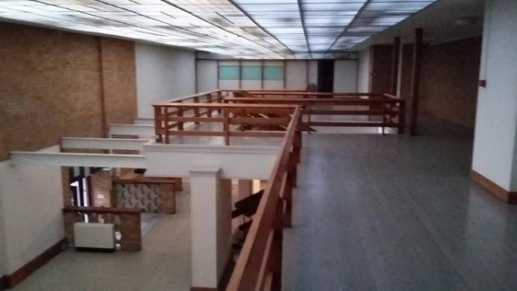
  - Several towers on the south east and south west corners are still standing but there's no access to the ramparts.
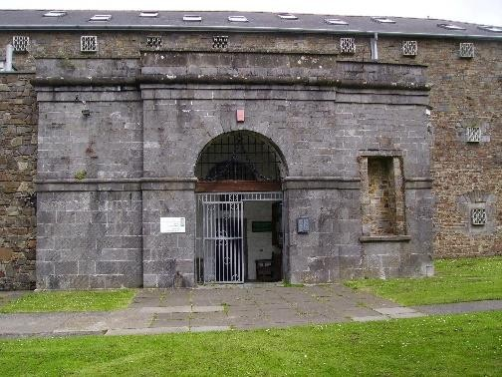
  - A small postern gate in the south east tower allows access to a grassy terrace outside the walls.
- The old prison/jailhouse, which was built inside the outer ward.
- The town museum occupies an interesting bow fronted building also inside the outer keep.
- Within the Walls of the Castle are the buried foundations of the 19th Century Women’s Jail.
And the following Site Facilities

- Small car park inside the outer ward (Residents parking only), for approximately 10-15 cars). Access via Barn street and Church street. Shops, cafes and restaurants in the town below the castle.
- Access for pedestrians can be made via:

- Queens square leading to Castle street or

- Up some steep concrete stairs that lead from Hayguard lane or

- Castle Lake cark park or Castle square, both of these make use of the steep walkway (Castle Back) that zig zags up to the castle.
- The Town museum, when open, has public conveniences, at all other times no conveniences are present on site.

How the figures have been calculated

For clarity this is how the figures have been calculated:

- The local population of Haverfordwest is 11,506. Of which 63% attend an event 2/3 times a year or more which equals 7,248.
- Of the 7,248 local population who attend events 64% of them attend an event locally.
- This figure has been broken down into specific events. We use the “Go to live Music” as an example.
- It can be seen that the total attendance of this category is 50%, therefore 3,624 go to live music.
- Of the 3,624 that go to live music 64% attend an event locally. Therefore, approximate, available audience for local live music is 2,319.
- Finally, when drilled down to specifically music, it can be seen that 33% go at least once every 2 to 3 months. Giving us an audience of 765 people to target locally.

Other Factors to be considered

Water Run off – With any covered area proposed consideration must be given to when it rains, the resultant water runoff and ultimately where that runoff goes. Will it in itself cause localised on site flooding? Where will the water run if guided to the outer walls of the Castle and down the slope of the Motte? Will erosion be a factor, all need to be considered.

Clear Roof - A clear roof has been proposed as part of one solution. Consideration must be given to how this solution will look after a couple of weeks/months. Leaf litter, bird droppings and eventually the accumulation of dirt and mould will have to be factored into this solution as ultimately somebody will be responsible for climbing onto and cleaning the clear roof. Additionally a clear roof in a sunshine environment could act like a mini Greenhouse, perfect for the growing of tomatoes but not ideal for watching a community event.

Noise on Roof – With a flat uninsulated roof consideration must be given to the noise of heavy rain falling on it. This sound can be extremely loud and has the potential to spoil any performance.

Audio Sound – Within the confines of any proposed structure consideration must be given to the eventual acoustics of the space. Sound can bounce off walls and ceilings and effectively destroy a performance. Even the Royal Albert Hall had to install acoustic mushrooms to eliminate echoes from the ceiling -

http://www.royalalberthall.com/about-the-hall/our-history/explore-our-

history/building/acoustic-diffusers-mushrooms/

Storage of items – Unless all items used for a performance are directly hired in, consideration must be given to where items will be stored and the associated costs for storage. The following list is not exhaustive but outlines some of the larger items that need to be potentially stored, Chairs, Large Tent Poles, Canvas Tent, Clam Seating, Stage and its component parts, Speakers, Lighting, Sound desk, Lighting desk, Sound Equipment cables etc), Generator, Power Cables.

Residential Area – This is a residential area and although anecdotal evidence shows that local residents will be broadly supportive of events in the castle, it must not be underestimated what the noise of an event and the noise of people coming and going will have on the residents. How will the residents feel about an increased number of events per annum? It only takes a couple of complaints from residents for licences to be revoked or applications for Temporary Entertainment Notices (TENs) becoming harder to get approved.

Fire Safety officers’ checklist for events - Any event must adhere to the Fire Safety Officers checklist. This is a useful working document that can highlight/prompt essential elements to be considered/factored into hosting any event.

Fire Officers observations – In the centre of the grassed area is a metal grid covering a hole. The grid needs to be assessed to understand what weight limit can be applied to it, especially when people may be standing on it at an outdoor event. The same is

true of the catacombs in the far left hand side as you walk into the Castle space. The catacombs need to be assessed to ensure that they do not collapse under the weight of several people at an event.

What else is happening in the county? – Often overlooked is the proliferation of events in the county. It is also extremely difficult to predict what other venues are programming or indeed what other independent promoters are hosting. For example, to book an artiste it may be required to book them 9 to 12 months in advance. It is impossible to know what is happening locally that far in advance and large events in Pembrokeshire often clash or directly affect ticket sales of one or both of the events.

  - Appendix 4

Funding Sources

If the project is deemed feasible and it proceeds and a new business is set up then there may be various funds/grants available that can be accessed to help finance the project.
Arts Council Wales – For funding towards projects, festivals, events or certain capital expenditure which promotes the arts
Heritage Lottery Funds - (for small projects) – If strong links to local heritage and heritage appreciation can be made
RDP - Rural Community Development Fund – if a beneficial impact on the local community can be demonstrated
Cadw (to preserve/protect the Castle where it interfaces with the activities)

Visit Wales - Tourism Investment Support Scheme who may contribute small amounts to the staging of “distinctive” and publicity worthy events which raise tourism footfall to Haverforwest.
NOTE: We have not been explicit on the levels of funding awards available nor the eligibility criteria as such details are subject to regular change.

Other funding

Obviously and ideally it would be preferable that any business set up and capital investment costs are fully funded through grants, however, if there were a funding shortfall then the “new” organisation may have recourse to other “commercial” funds. The new business may be eligible for support from other areas, depending on its projected financial performance (and that it will be profitable). Other interest free or low interest loan sources include:

- The Pembrokeshire Lottery (35% of project costs for a maximum interest free loan, repayable over 5 years, providing there will be permanent job creation)
- Welsh Government business start up loan – Each director may be eligible for

£25,000 at 6% interest but the amount must be repayable within 5 years

- WCVA – loans of around 4% interest rate.

It is also possible that corporate income may be gained by way of sponsorship (eg to name events) or to help purchase big capital items, wherein “naming rights” may be given – eg “the Valero lighting stage”. Also if the newly constituted organisation chooses to use a large number of volunteers then a timebank system could be established working with an organisation such as Spice (www.spice.org) whereby
committed time is captured and measured with that volunteer time having a financial value which can be used as match funding for grants that may not offer 100% funding support.

  - Appendix 5

Architects Document – Acanthus Holden

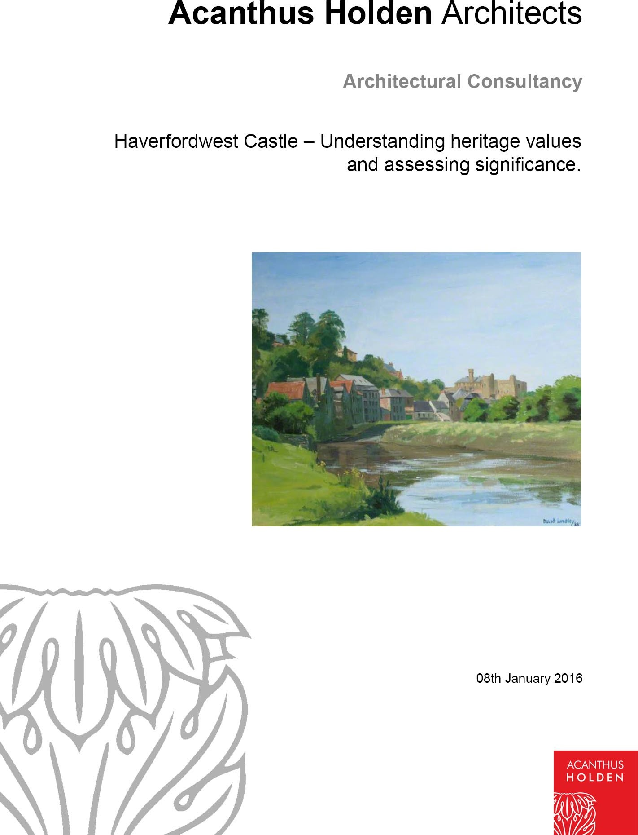

Contents

    - Haverfordwest Castle – Understanding heritage values and assessing significance.

    - WAG Conservation Principals – Haverfordwest Castle and its significance.

    - Analysis of Historic Fabric – Layers built upon over time significance.

    - 1964 Works – Report and analysis of visible structure

0.5 Archeological Investigation – Trial holes and archeological dig
- Vision for the Castle Development - Haverfordwest Improvement Project
- Design parameters in relation to significance – Parameters dictating the development in relation to the WAG Conservation Principals.

- Feasibility Design considering ‘Design parameters in relation to significance’ – Feasibility design for sheltered community function space.

Appendix

Reference A - Aerial Photographs Reference B - 1964 Works Photographs Reference C - 1964 Works Drawings Reference D - 1888 Survey Drawings Reference E - Paintings
Reference F - 2015 Diagrams Reference G - 1960’s Photographs
Reference H - Archeological Investigation

- Haverfordwest Castle – Understanding heritage values and assessing significance.

This report sets out the evidential, historical, aesthetic and community value of Haverfordwest castle in relation to the castle’s current and future uses.

The report has been commissioned by Haverfordwest Improvement Project who are currently using the castle for community events throughout the year and have a vision to improve the space. Improving the building will enable greater use and generate a sustainable income for the upkeep of the castle ensuring its long-term future.

This report will highlight the multiple values of the site and analyze the development of an appropriate scheme, which will fulfill Haverfordwest Improvement Project’s brief and vision for the building.

- WAG Conservation Principals – Haverfordwest Castle and its significance.

There is a wealth of documented information regarding the history of Haverfordwest Castle some of which is referenced in this report.

The current castle stands on a superb, naturally defensive position at the end of a strong, isolated ridge with a sheer cliff on the east and visually dominates the town below.

The present form of the castle, divided into two wards, probably reflects that of the original 12th-century castle. The plan is a little difficult to make out as the formed prison & county records office lies in the center of the outer ward, while the former prison governor's house lies on the site of the inner ward gatehouse. The medieval castle was converted to a prison in the 18th century, but the buildings of the inner ward and outer defences can still be appreciated.

The inner ward has round towers on the North-west and south-west corners, while the south-east corner has a square tower with an additional projecting turret. The entrance lay on the west, protected by a gatehouse of which no trace survives. The remains of a spacious hall lie on the south, with large windows built high enough in the exterior wall to be safe from attack by besiegers. The South-west and south-east towers have three storeys, the latter with a basement equipped with a postern gate to allow access to a small terrace. The wall-walk, carried on a row of corbels on the east of the tower, is a well-preserved feature on the inside, and from the outside of the castle the tower's remaining lights and arrow slits can be seen.

The last extensive consolidation works were carried out in 1968, these repairs to the structure still stand today and are in good condition.

The significance of this important historic asset has been defined not only by the cultural heritage values that people associate with it, but also by investigating the following component values;

Evidential value – Although now in a ruined state the castle structure still provides strong evidence of past human activity. Much of the visible fabric of the medieval castle is in good condition and is clearly viewed from both the town and from within the grounds of the castle. In addition to the visible historic structure, records show that there are buried remains beneath the current ground level within the castle walls. Exploratory digs were completed in 2008 and revealed sections of the 1888 structural foundations buried within the grounds. The combination of historical records in the form of paintings and drawings combined with the structures revealed by the 2008 survey all build a picture of how the castle was built, what it was used for and how it has changed over time. Evidence for mediaeval structure within the inner & outer ward is however very limited.

Historical value – Haverfordwest Castle has strong historical value. Originally constructed as an Norman fortress, first established by Gilbert de Clare, earl of Pembroke in the mid-12th century, and remained an English stronghold throughout much of its history. It is first mentioned by Giraldus Cambrensis as one of the places he visited in 1188 with Archbishop Baldwin.

Evidence suggests the castle withstood an attack by Llywelyn the Great who had already burned the town. In later years it was acquired by Queen Eleanor (wife of Edward I) in 1289, who immediately began building there on a large scale, to judge from the considerable sums of money recorded as being spent on "the Queen's castle at Haverford." Much of the existing masonry is late 13th-century in style and may well have been undertaken during the one year before her death in 1290.

In the 14th century the castle was held by a series of owners, including Edward, the Black Prince, from 1359-67. In the hands of the crown from 1381- 85, the castle was repaired. It was strong enough to repulse an attack in 1405 during Owain Glyndwr’s war of Welsh independence. By the 16th century, the castle was derelict, but was hastily re-fortified during the Civil War.

Medieval Haverfordwest was defended by town walls around the high ground near the castle, which were later extended, as the town rapidly became an important market and trading place. Nothing remains of these town walls, although the three medieval churches of Haverfordwest do survive.

Aesthetic value – The aesthetic value of the Castle is incredibly important. The monolithic structure dominates the skyline of the town and has become a significant part of the town’s identity. Almost every significant archived painting of the town includes the castle in some form. Clearly visible from much of the surrounding area, the medieval walls with tall openings and corner towers the Castle is loved by the people of Haverfordwest and invokes

a sense of place and pride for the town. It is one of the few publicly accessible green spaces in the centre of town.

Communal value – Although originally created as an oppressive military stronghold strengthening the English rule over the Welsh, the Castle as it stands today is a popular asset to the town and is viewed by the local population as an important landmark and communal events space.

- Analysis of Historic Fabric – Layers built upon over time.

Using archived record documents and current GPS surveying equipment we have complied a series of drawings indicating different periods in the Castles history. It is imperative to understand and preserve this historic asset as it provides us with valuable information about past human activity. There is much visible and easily accessible historic fabric, which forms a large part of the attraction of the castle. In addition to the visible fabric, records show that there are numerous buried remains within the castle walls. The combination of built fabric, buried remains and historic records provide the primary evidence for when and how this historic asset was built, what it was used for and how it has changed over time.

The earliest accurate scale drawing of the castle dates back to 1888. A scale ground floor plan of the castle walls and internal prison buildings illustrates the footprint of the outer structure. This drawing correlated with the 2015 GPS survey, indicated by the right-hand diagram below.
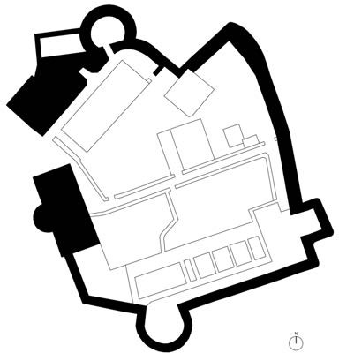
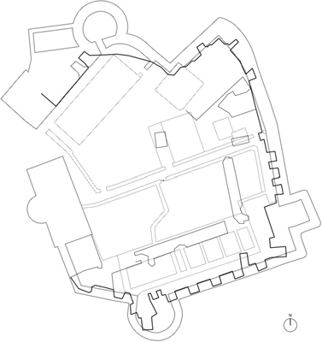

- 1964 Works – Report and analysis of visible structure

The inner ward enclosed a complex of Prison buildings erected in the 18th and 19th Centuries. Most of these structures had fallen into decay by the time they were demolished in 1964. The demolition works were carried out to facilitate the investigation and renovation of the early medieval work of the castle. The

outer ward contained, in the main, a three-story prison building completed in 1820, used until 1877 as the County Jail. The 19th century jail block was recently converted and used as the County Museum and Record Office. The present day museum in located in the Governors house.
When the 18th Century prison buildings in the inner ward of the Castle was removed it allowed for the first time in over two hundred years the clear viewing of the inside face of the medieval castle walls. There are still remains much of the prison buildings foundation below ground, as these were not removed during the 1964 demolition works. The inner grounds of the castle have been cleared for excavation to expose the remains of the medieval buildings, which were built around the outer castle walls. During the removal of the prison buildings it became clear that the 1888 structures had caused considerable damage to the medieval work and it presented difficulties for the 1964 restoration team to discover the layout and history of the original castle.
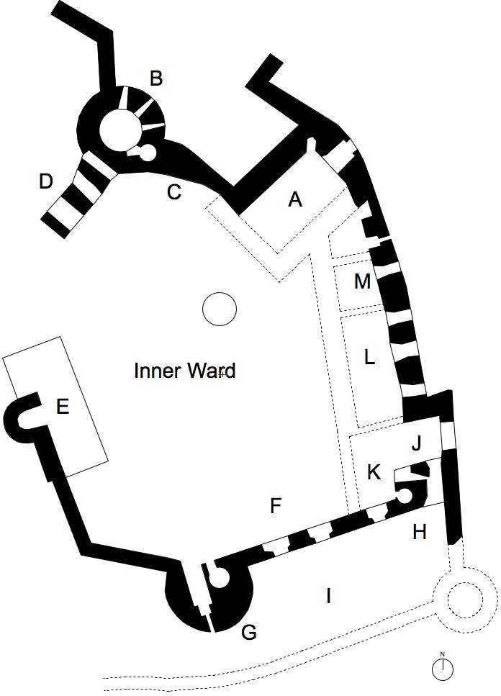
The 1960 works statement lists other factors that contributed to the spoiling of the once magnificent fortress and dwelling. It appears that in approximately 1532 the Castle and dwelling fell into disuse. A survey on the 14th May entitled ‘1577 The Castle and Lordship of the West Haverford’ was carried out by Robert Davey the Deputy of John Herbert Esq. the Queens surveyor for South Wales. In it he writes ‘Although the same hath bene a verie proper pyle buylt open a rocke and hath the one in older tyme on the North side thereof, but the towne now flourishing well neere on the South of it, the gateways and later inhabited parts of the Castle are utterlie decayed’.

In 1648 the Castle was ordered to be dismantled by Oliver Cromwell in a letter dated the 12th July of that year and although the local inhabitants do not appear to have turned to the task with any great degree of zest no doubt a certain amount was destroyed and for some years after parts of the castle especially the outer and inner gates and inner walls of the dwelling portion, formed a quarry for local building in the town. A further survey was made in 1653 which describes it as a ‘ruinous Castle’.

The 1964 archaeological study that preceded the works stated that ‘despite the historic demolition there remains a great deal of the fine Norman and transitional stonework in the curtain walls and towers of the inner ward.’ This was due to the location of the structure situated on rock, which rises from the level of the Western Cleddau.

Photographs of the structures that existed within the medieval walls of the Castle prior to the major demolition works of the 18th and 19th centuries, taken in 1964 are enclosed in appendix B.

In reference to diagram F6, the 1964 survey determined that the Castle originally consisted of a defended tower (Marked A on diagram F6) and a strong round defensive tower (Marked B on diagram F6). The latter may have been constructed slightly before the former. These two towers were built of stone quarried from the cliff face to which they were attached. There is evidence that entry to the round tower was at high level, reached probably by a staircase supported on piers which from the core of the thick skinned wall (Marked D on diagram F6), entry to the rectangular tower or dwelling would have had a basement storage and two or three storeys above. These two buildings were linked together after they were built with a wall (Marked C on diagram F6) forming added enclosure and defense.
Many writers have attributed the building of Haverfordwest Castle to Gilbert de Clare (died 1115) the descendant a race of Norman Barons who invaded Ceredigion in 1111 and arranged the building of Aberystwyth Castle and the renovation of Cilgerran.

The built style of the visible medieval rampart between towers A and B and work to the top of tower B appear to differ in workmanship with the lower portions of the Castle. It is therefore possible that the first Gilbert de Clare initiated the extension of the first defensive Castle and the work progressed over a number of years.

The remainder of the outer walls and towers of the inner ward as we see today, appear to be all more or less of one date with the possible exception of parts of the house (Marked E on diagram F6) and the windows of the Hall/ Great Chamber, these may have been enlarged at a later date.

It is known that all main rooms of the residence were at first floor level and these consisted of a Great Hall facing South (Marked F) with a screen at the West end and the entrance probably located behind the screen.

Appendix F6 provides an illustration of the medieval layout.
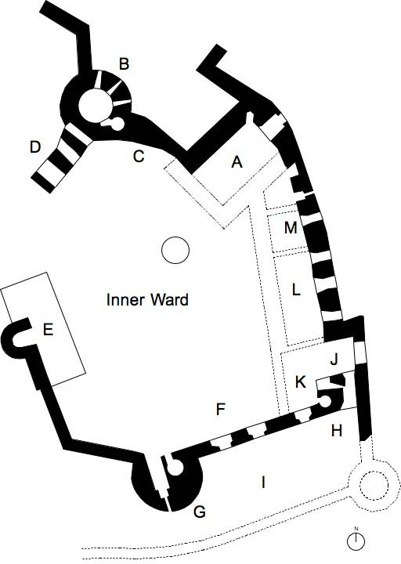

0.5 Archeological Investigation – Trial holes and archeological dig
An archeological evaluation commenced on 14 January 2008. Three trenches (Ref H), 2m wide by 5m long, were laid out approximately in the location illustrated on the diagram below. The conclusion of this evaluation has confirmed that archaeological features survive just below the ground surface. The bedrock in the north of the site is also not far below the current ground surface, but further south there appears to be a large drop, probably into former cellars relating to the castle. Therefore, it is probable there will be considerable archaeological implications for the development of this site, primarily in areas not disturbed by the 1964 development.
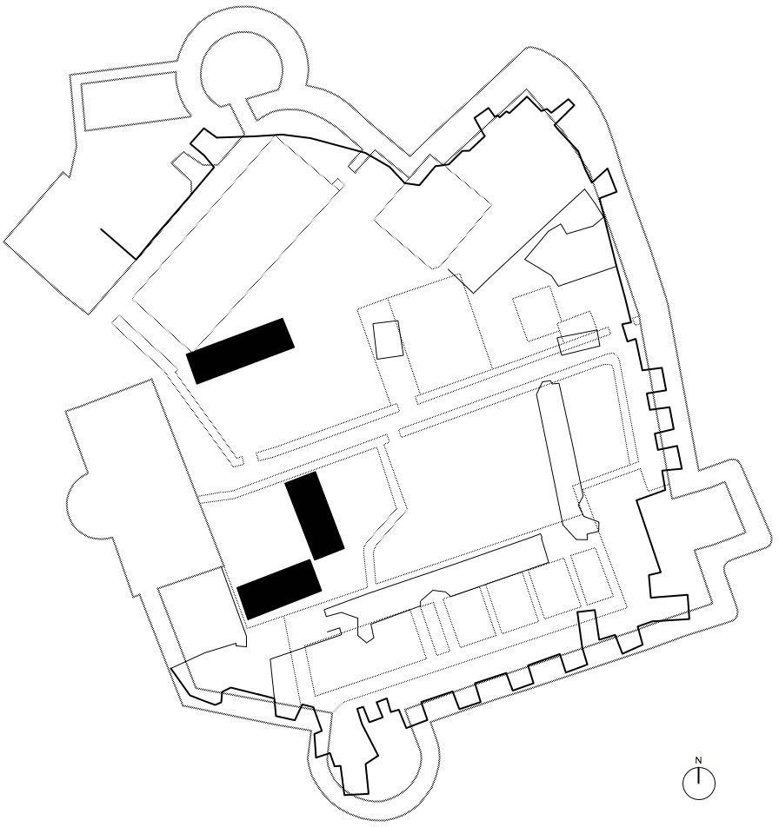

- Vision for the Castle Development - Haverfordwest Town Council’s Brief

The brief for this feasibility study is to gain a thorough understanding of the multiple values of the site through the examination of historic records, trial hole investigations and analysis of the current structure that stands today on the site.
Once this information has been correlated then the development of an appropriate scheme to roof over the inner ward, providing a level weatherproof activity space can be considered.

The current medieval structure draws interest as a historic relic, however in more recent years the castle has been more widely used as a space for community events. Its central location, car parking provision and iconic local status make it an excellent site to host events. The current inner ward provides good shelter from prevailing winds and provides a visually stimulating environment.

In the last 5 years Haverfordwest Improvement Project have organized a series of popular events and used the Castle as the location. These open-air events have proved enormously successful despite the unpredictable weather in the UK. Given the popularity of the events the organizers envisage expanding the current schedule and incorporating larger functions.

To aid the ambitions of the Haverfordwest Improvement Project, Acanthus Holden have been commissioned to complete this feasibility study presenting options for the future development of the site.

- Design parameters in relation to significance – Parameters dictating the development in relation to the WAG Conservation Principals.

Evidential value – Following the 1964 renovation works, much of the visible fabric of the medieval castle is now in good condition and is clearly viewed from both the town and from within the grounds of the castle. Reasonably accurate records exist of the 19th century buildings. The foundations of these buildings in all likelihood exist below ground and could be easily located using modern non-intrusive survey equipment.

Archaeological investigations suggest that bedrock exists in the Western portion of the inner ward close to the surface. However most of the area has not been excavated in any detail and any new intrusive structures would have to be the subject of further excavation.

Reconnecting to this sensitive medieval structure would likely result in damage to the important historic fabric and would again have a large visual impact. In addition to the visible historic structure, records show

that there are buried remains, beneath the current ground level within the castle walls. As previously mentioned, exploratory digs were completed in 2008 and revealed sections of the 1888 structural foundations buried within the grounds. Any future development within the walls of the castle would need to be carefully considered and positioned to avoid damage to the historic fabric and remains, whether visible or hidden. As far as possible it should be reversible and should not prejudice the possibility of future archaeological investigation or interpretation.

Historical value – Haverfordwest Castle has strong historical value. The building is central to the history of Haverfordwest town and the wider county of Pembrokeshire. Historic archived documents have connected the castle with various notable people throughout its history. Although these associative values of the castle may be viewed as less tangible than the evidential values, they offer a connection to past people, events and aspects of life within the present age. Proposals for this structure should be mindful of its past uses and associations. Any future development on this site could be designed to incorporate information relating to the historical associations of the castle, strengthening this important aspect of the buildings value.

Aesthetic value – There is a wealth of information regarding the aesthetic value of the castle. Almost every significant archived painting of the town includes the castle in some form. The castle is clearly visible from much of the surrounding area, with its medieval walls with tall openings and corner towers.

Retaining the dramatic views of this important medieval structure from both the inside and outside the castle walls is of paramount importance. The Castle has become the centrepiece of the county town and as the highest point in the area, the medieval structure creates an iconic skyline. Altering this skyline would have a large visual impact not only on the setting of the historic structure but also on the town of Haverfordwest. The visible impact of the visible historic walls is equally significant on the inside of the castle. As this report highlights there were once structures connected to the outer walls, however for the much of the last century these walls have been exposed.

To ensure this aesthetic value remains any future development should be contained within the walls and not permanently protrude beyond the upper reaches of the outer walls. Internally, the visual impact of the large windows within the curtain wall should be preserved.

Communal value – Despite its historic associations the castle is viewed by the local population as an important landmark and communal events space. The castle is currently open to the public throughout the year and is a popular tourist attraction asset. To maintain the positive communal value of this historic asset, future development to should ensure the current public access is maintained, if not improved.

- Feasibility Design considering ‘Design parameters in relation to significance’ – Feasibility design for sheltered community function space.

This valuing and assessment process has given us a clearer understanding of the significance of this important historical asset. Following this analysis process we attach sketches of options, which in our view best meet the design constraints contained within this report. The sketches indicate a scheme for creating a covered events space within the walls of the castle. The proposal is to create a lightweight high-level transparent, horizontal plane positioned below the level of the outer castle walls.

To build on the success of the Haverfordwest Improvement Project events, the brief for the design team included the following;

  - Significant of Haverfordwest Castle
  - Determine a set of design parameters using the historic information collected
  - Produce a sketch scheme to improve the year round usability of the space within the castle walls.
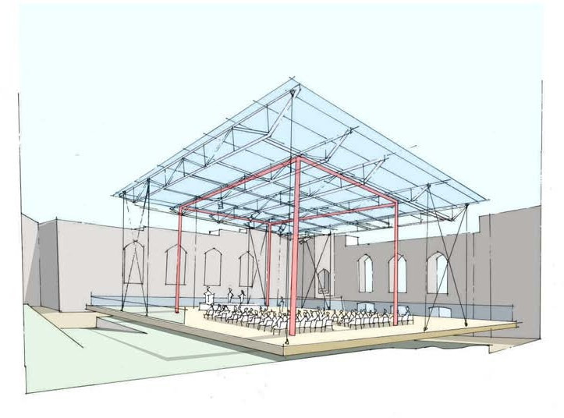

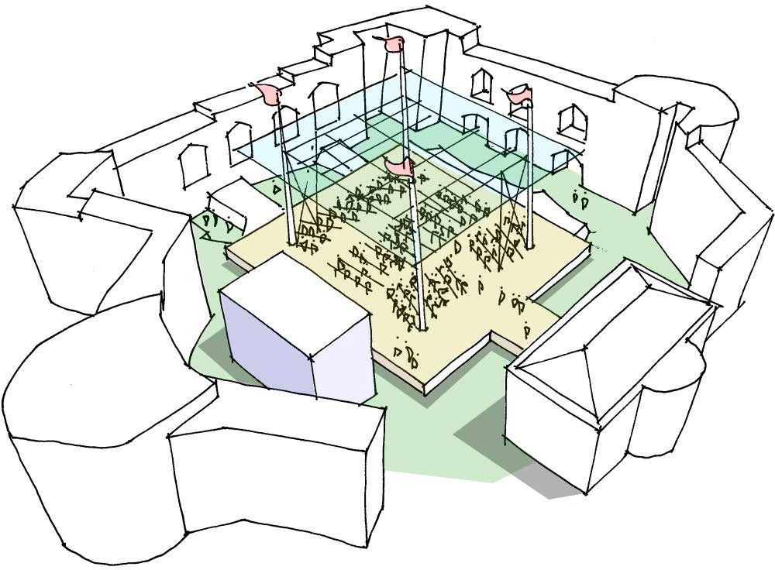
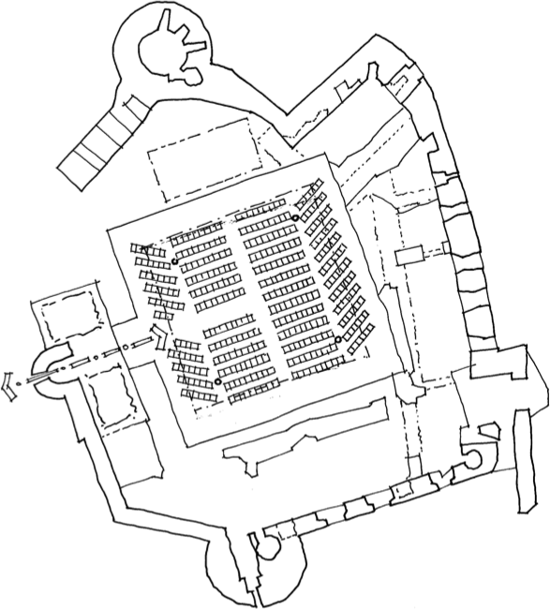

Considering the design parameters in relation to significance we proposed the following additions to the internal space;

  - Level platform – The inner ward of the castle currently has an undulating grass surface. This topsoil covering was created following the 1964 works and according to survey analysis and historic records is preserving further medieval remains. The space currently works well as an historic relic, however due to the changes in level and uneven surface it creates difficulties when hosting events or gatherings. Health and safety considerations would require safe access and control of visitors.

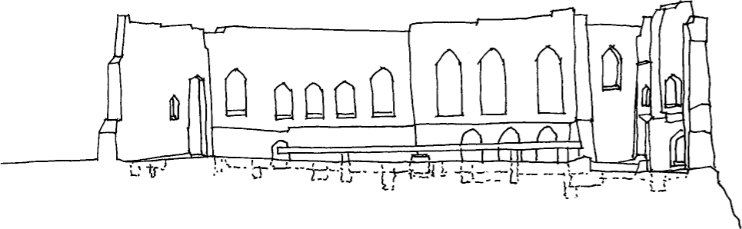

  - We propose the creation of a level surface, carefully located above the current topography. Foundations for this structure could utilize the buried 1888 foundations or affix to the bed rock which lies just beneath the current ground level. Any foundation location would be carefully analyzed to ensure there is no impact or connection to medieval remains. The level plane would be large enough to host community events, but leave ample space between the historic fabric and the new structure for undisrupted viewing of the original walls and details. It should be as far as possible removable to allow further excavation or interpretation in the future. The proposed platform will also allow new power distribution across the site without disturbing archeological remains.

  - Sheltered Space – Providing shelter to the level platform is an important client requirement as poor weather has in the past jeopardized events. Given the aesthetic significance of the space we proposed a series of permanent, lightweight vertical structural elements. This structure, like the level platform, would be carefully located so as not to impact upon any buried remains and provide anchoring points for a retractable tent structure. This tent structure would be stored in one of the ancillary buildings adjacent to the castle and be erected for large events. The design would allow for both roof and sidewall shelter or independent roof covering allowing 360 degree viewing of the historic remains.

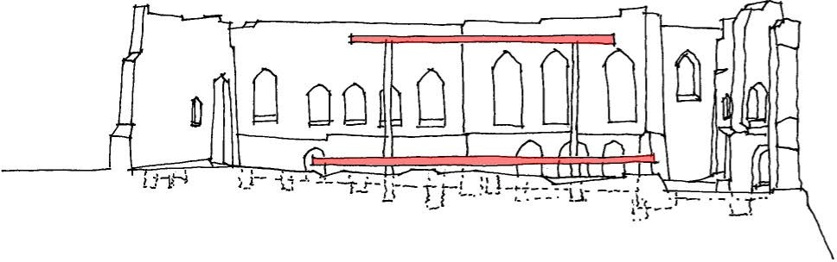

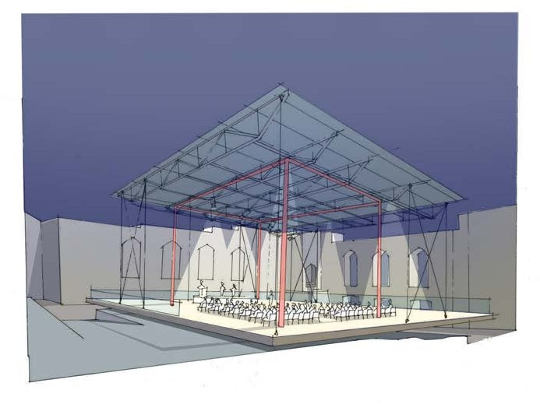

Appendix

Arial Photographs
Archive photographs from the Royal Commission on the Ancient Monuments of Wales – Photographs taken June 2009 by Toby Driver. Ref AP_2009_1303

Reference A1
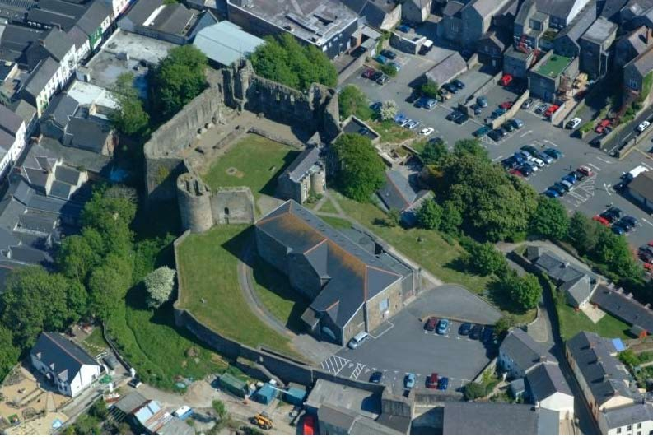

Reference A2
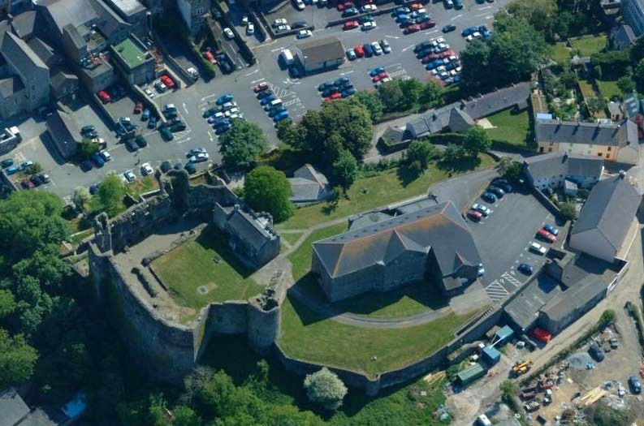

Reference A3
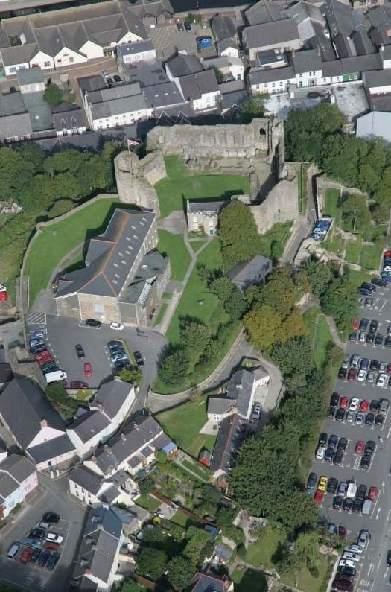

Reference A4
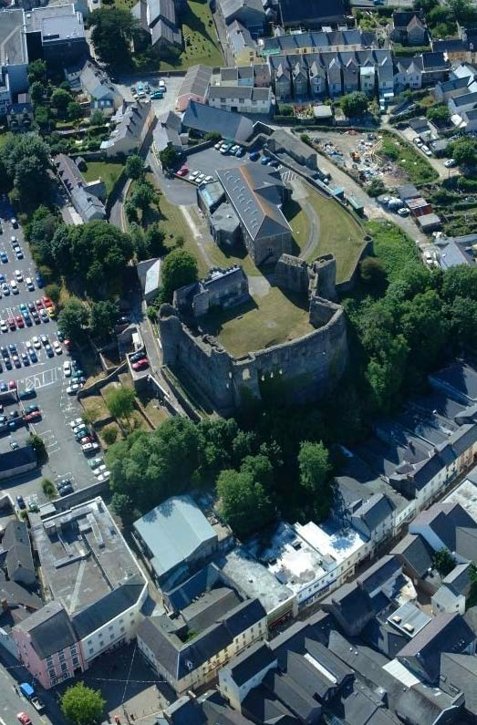

1964 Works Photographs
Archive photographs from the Royal Commission on the Ancient Monuments of Wales – Photographs taken by the Department of Environment 1968 Ref DI2011_2695

Reference B1
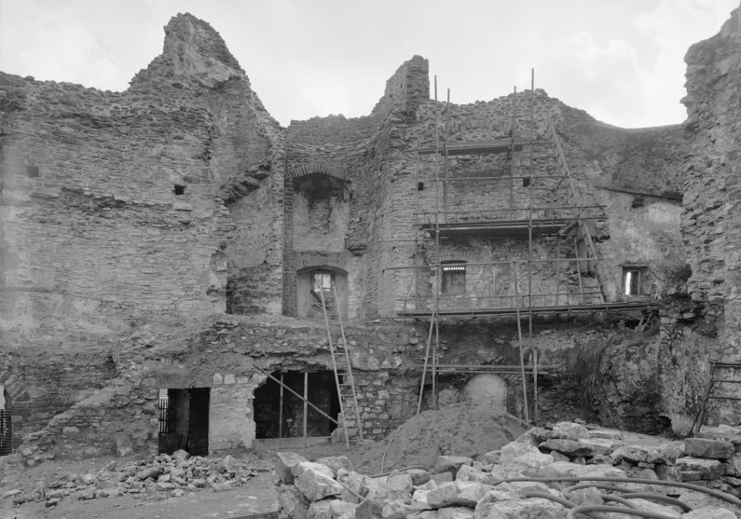
Reference B2
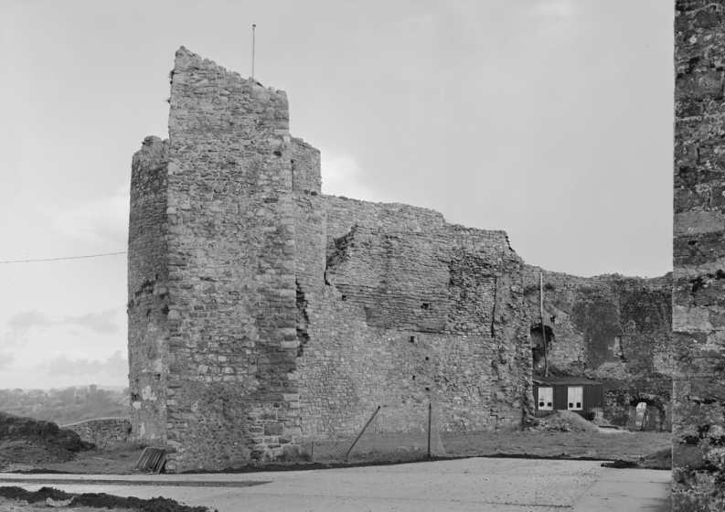

Reference B3
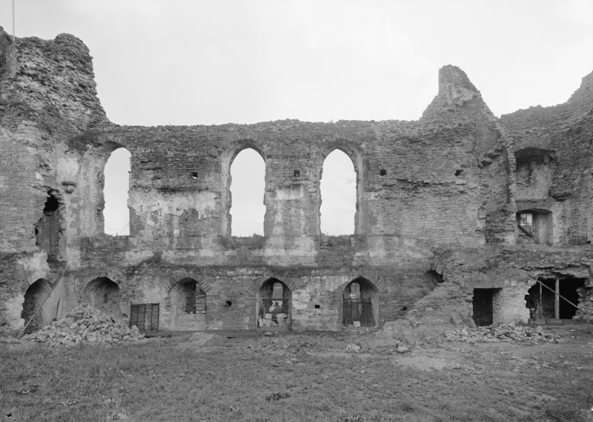
Reference B4
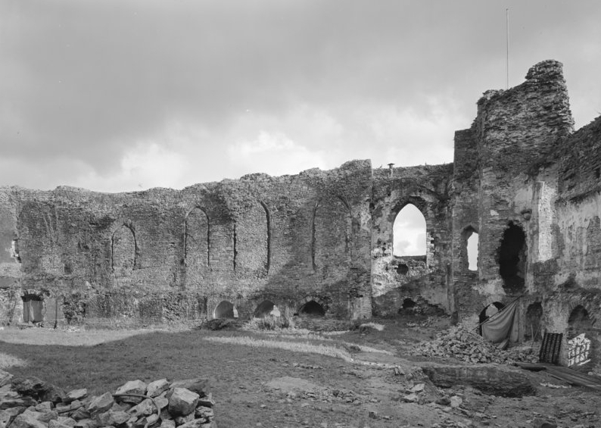

Reference B5
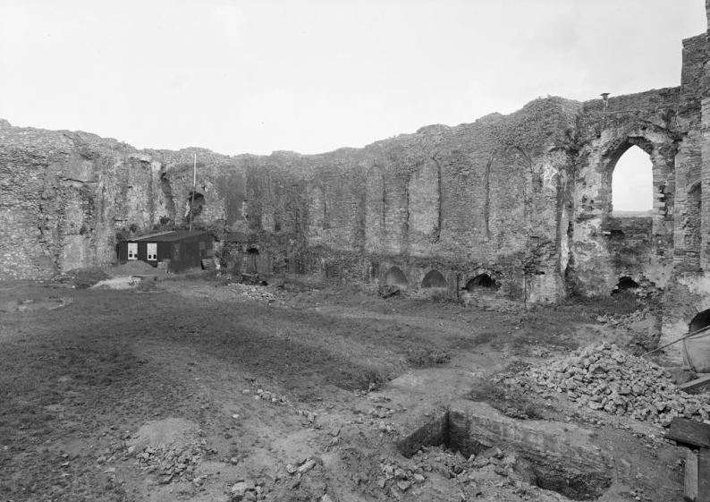

Reference B6
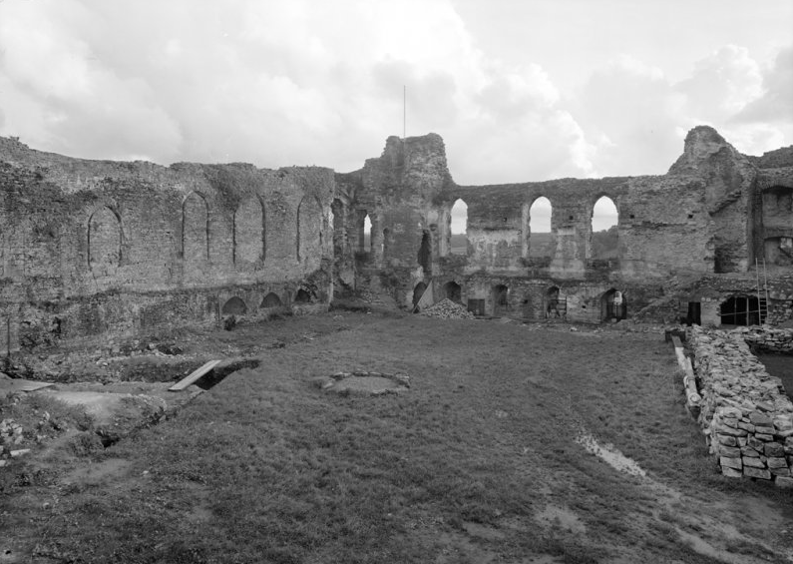

Reference B7
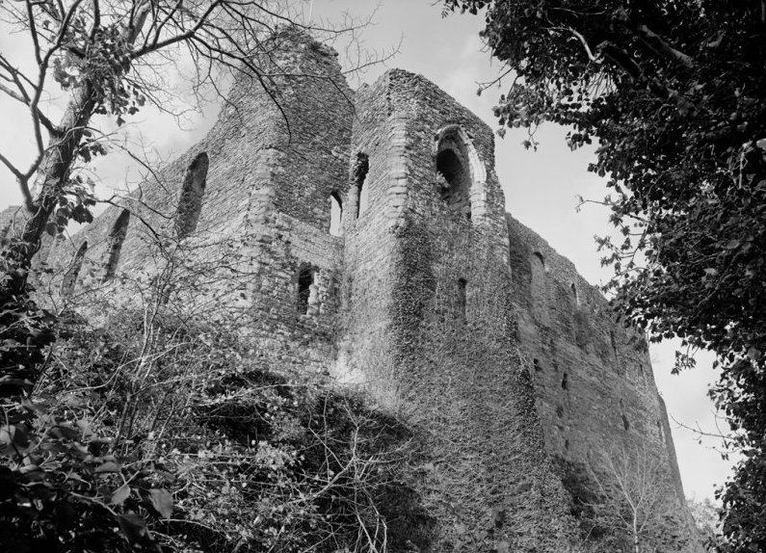
Reference B8
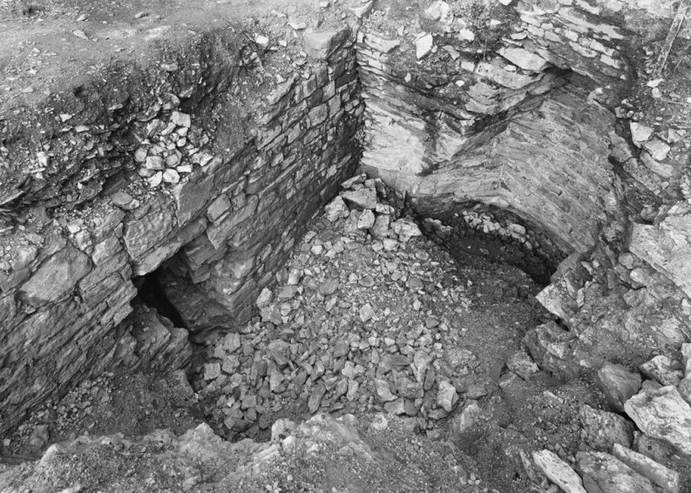

Reference B9
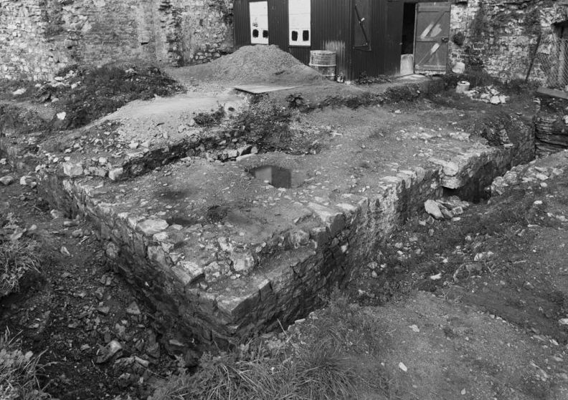

Reference B10
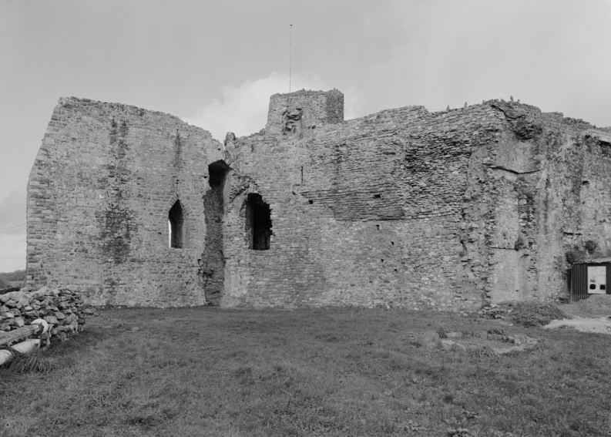

1964 Works Drawings
Archive drawings from the Royal Commission on the Ancient Monuments of Wales – Produced by County Architect1964 Ref NA/GEN/97/02SE

Reference C1
Survey of existing 1964 structure and proposed restoration works.
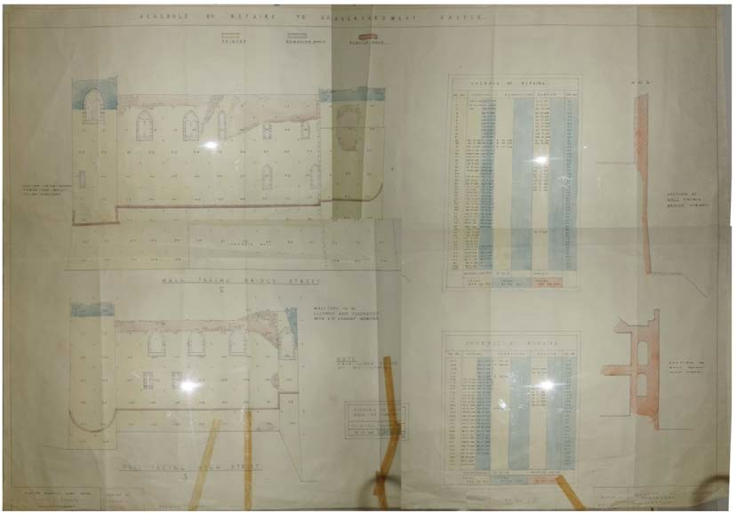

Reference C2
Location Plan – 1889 Archive map from the Royal Commission on the Ancient Monuments of Wales
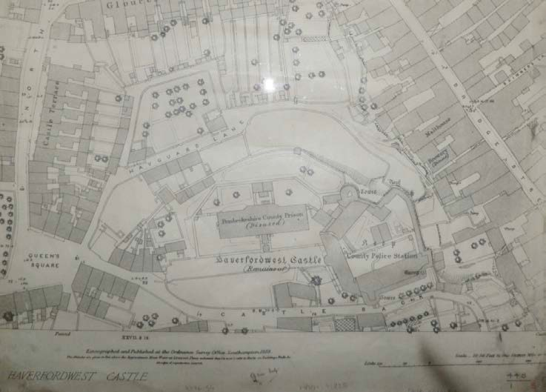

Reference C3
Diagrammatic drawing illustrating historic castle. Drawing part of 1964 restoration works – Site Plan
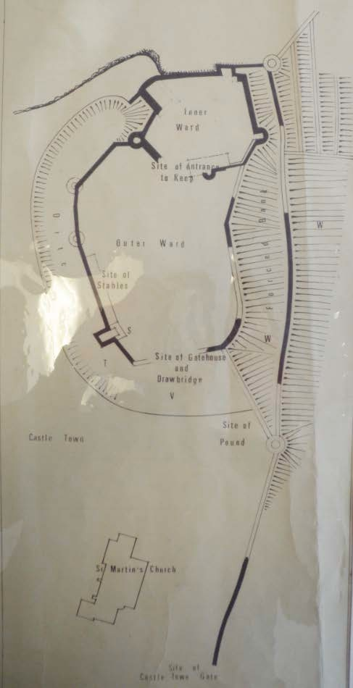

1888 Survey Drawings
Reference D1
Archive drawings from the of County Museum Archive – Haverfordwest
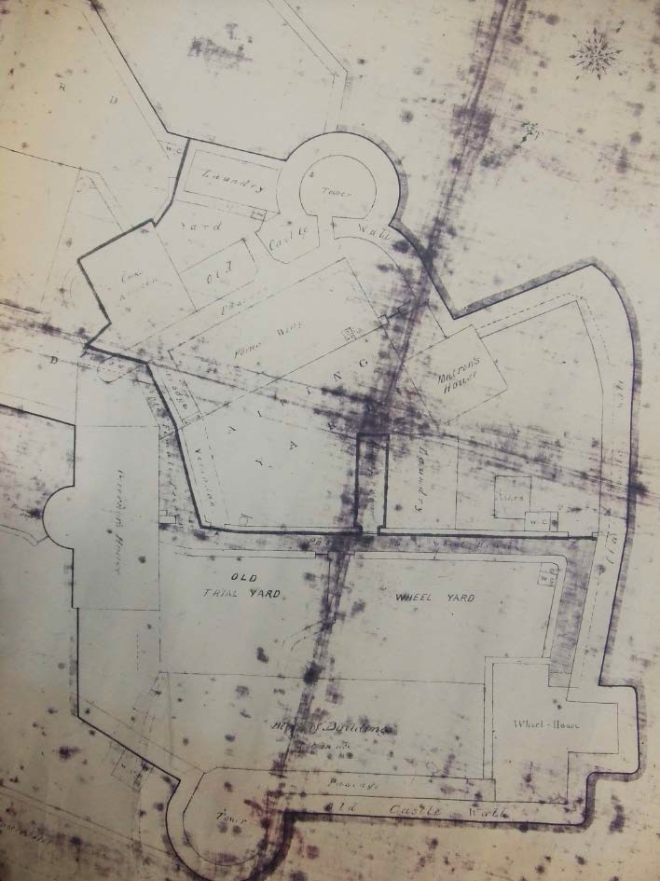

Reference D2
Archive drawings from the of County Museum Archive – Haverfordwest
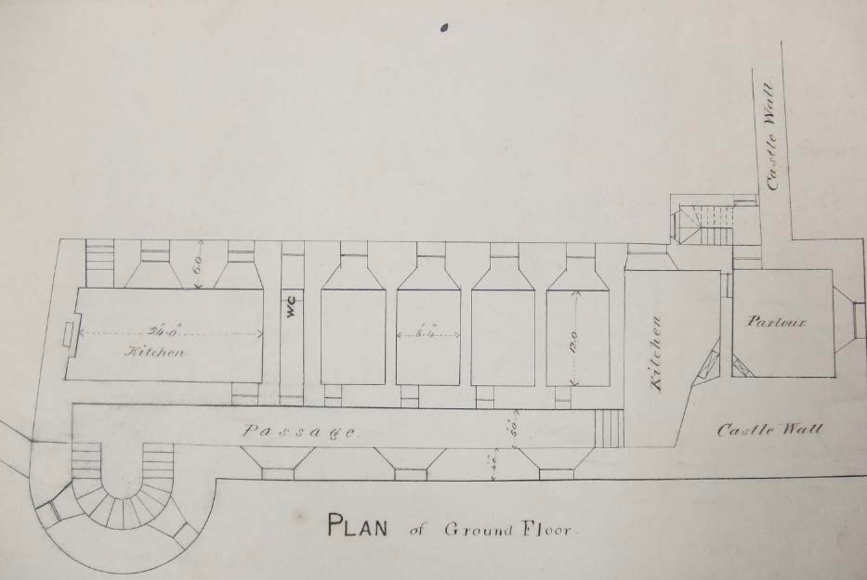
Reference D3
Archive drawings from the of County Museum Archive – Haverfordwest
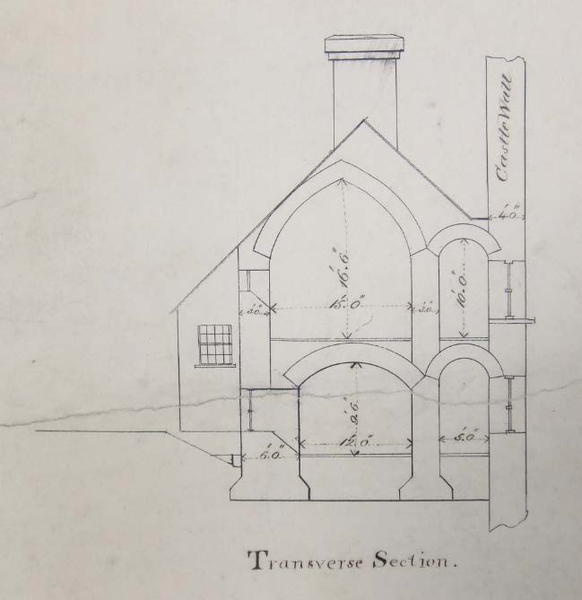

Paintings
Reference E1
Painting by E.M Taggert – Scolton Manor Museum, Haverfordwest
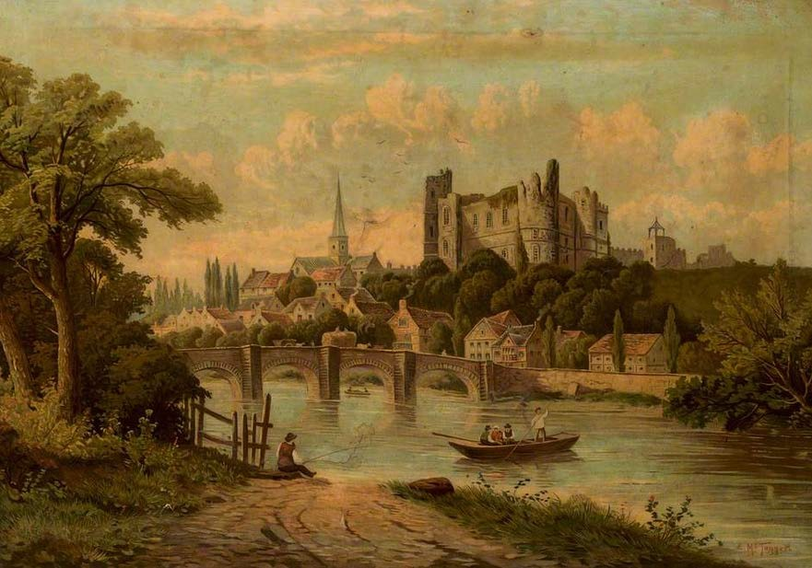

Reference E2
Painting by William Pitt – Haverfordwest town museum
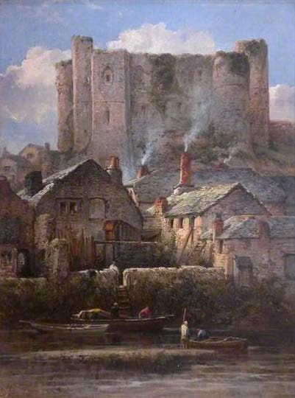

Reference E3
Artist Unknown – National Library of Wales Archive
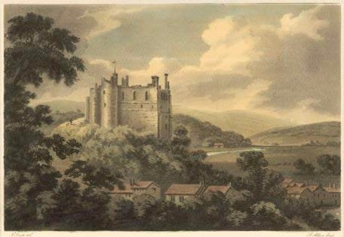

Reference E4
Artist David Lindley – Pembrokeshire County Council – County Hall
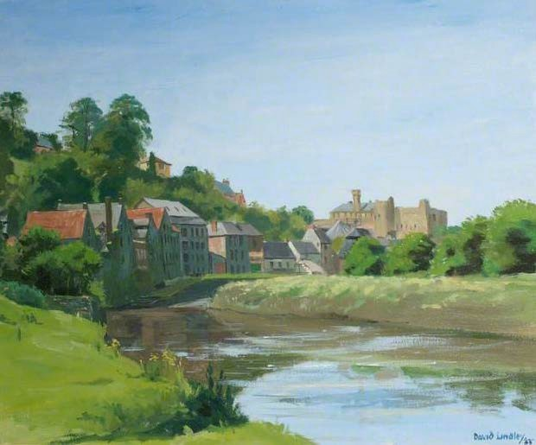

2015 Diagrams
Reference F1
1888 Plan – Prison Layout
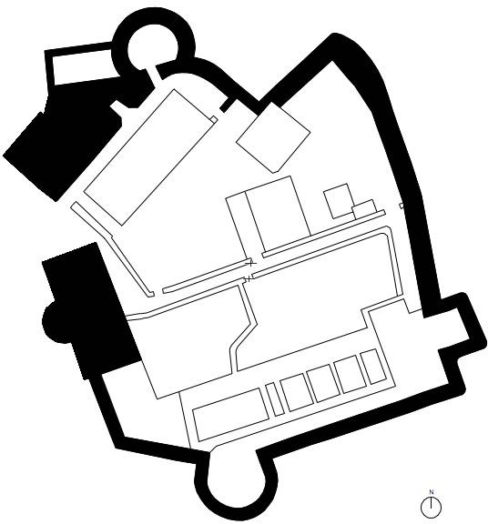

Reference F2
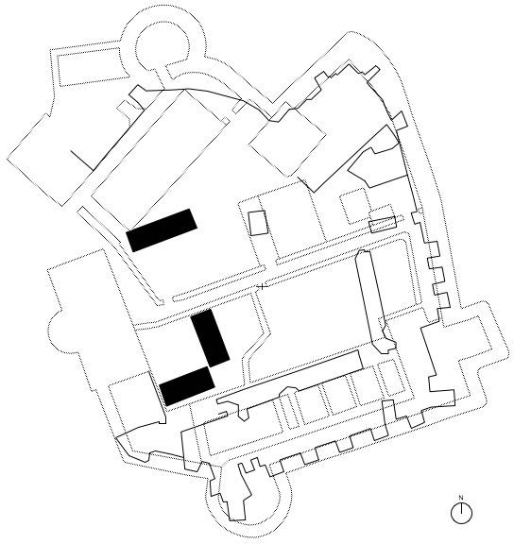
MW Survey & Trial Hole locations from 2008 archeological investigations

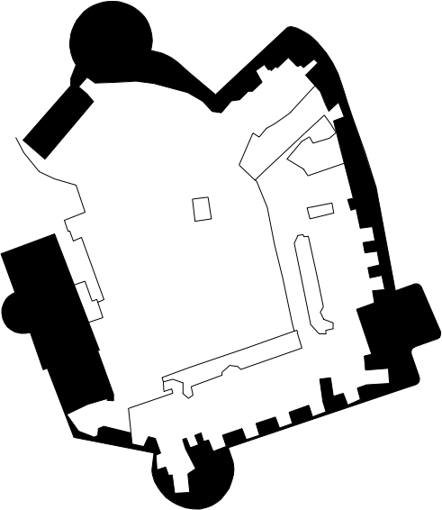
Reference F3 2015 GPS Survey
Reference F4
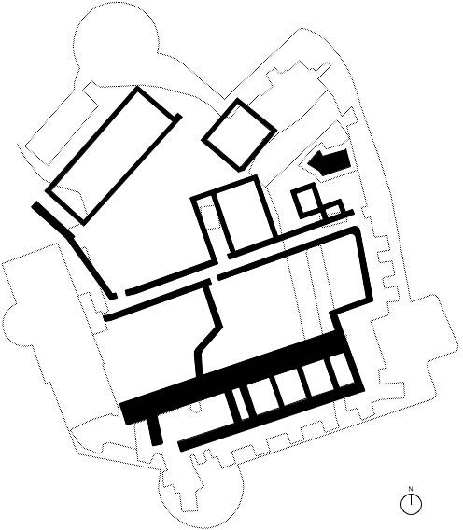
Potential layout of buried remains. Diagram base upon findings from 2008 archeological investigations and historic survey drawings.

Reference F5
Diagrammatic survey sections of 2015 visible building fabric.
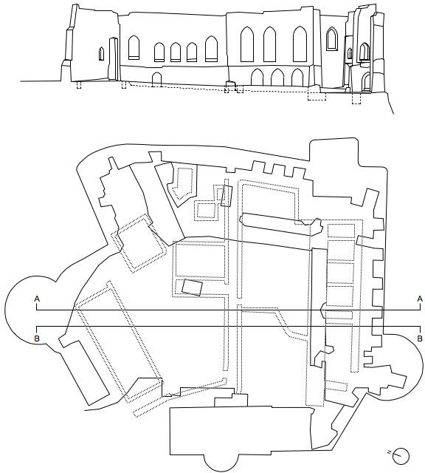

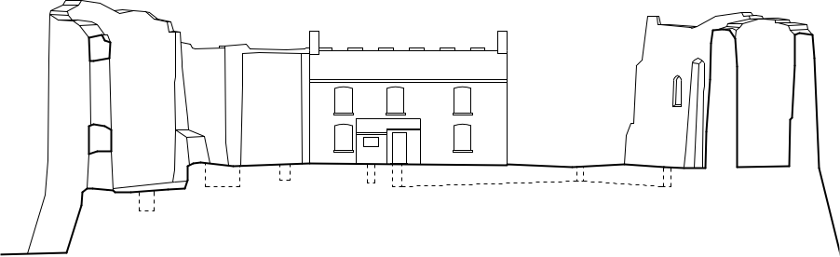

Reference F6
Diagrammatic survey based on 1964 visible building fabric.

1960’s Photographs
Reference G1
1960 photograph of prison building prior to 1964 demolition.
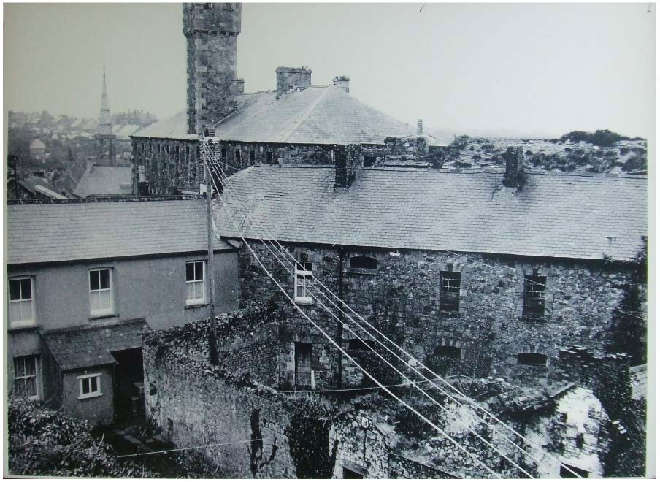

2008 Archeological Investigation
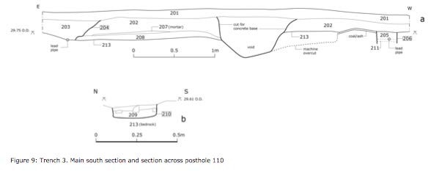
Drawings and photographs taken from the 2008 Archeological survey. Reference H1

Reference H2

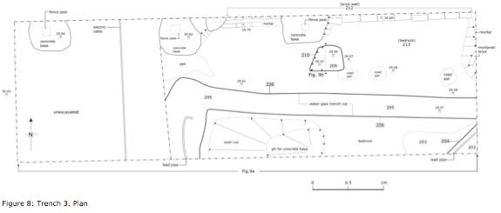

Reference H3
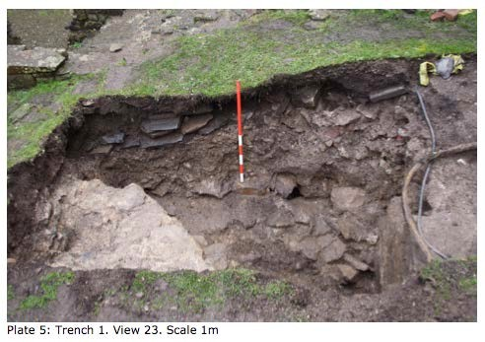

Reference H4
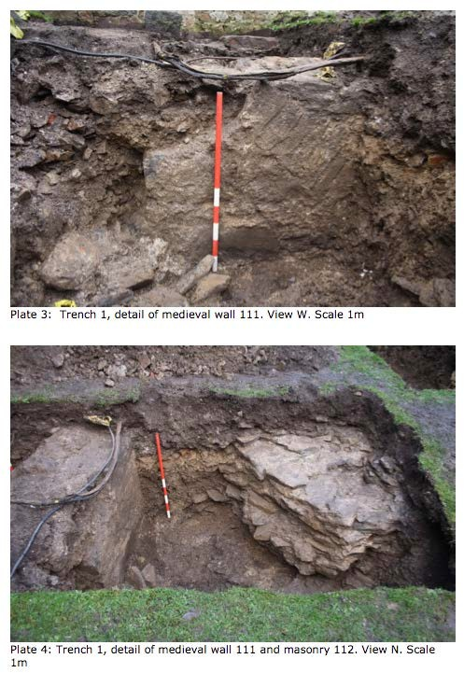

Reference H5
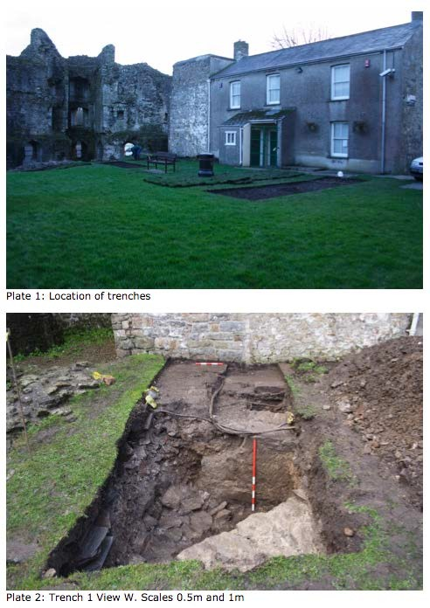

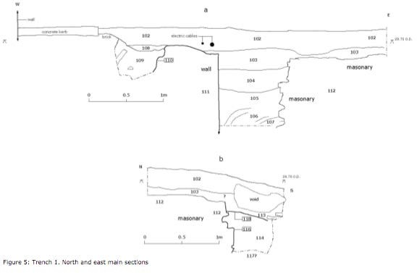
Reference H6

Reference H7
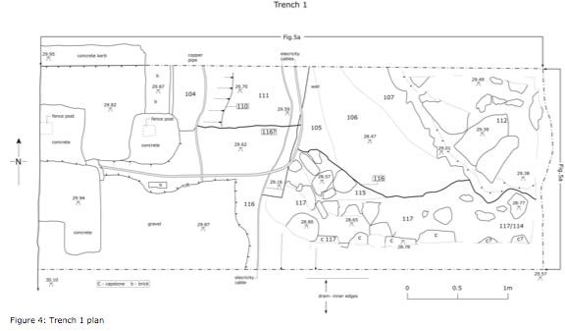

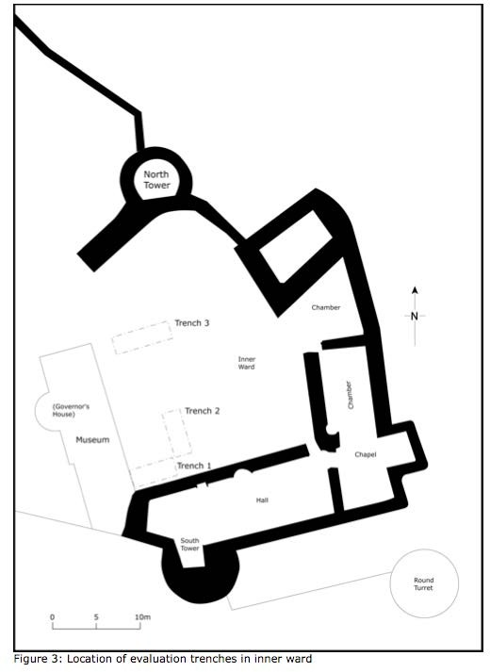
Reference H8

