Workshop Georgia McKie Oct ^{9th} 2025
ACE: Swags, Ribbons, Frills
Make Draw Make Draw Make Draw Repeat

Make ribbons
Make bows
Make ruches and swags
Make frills
Create volume, drape and drama

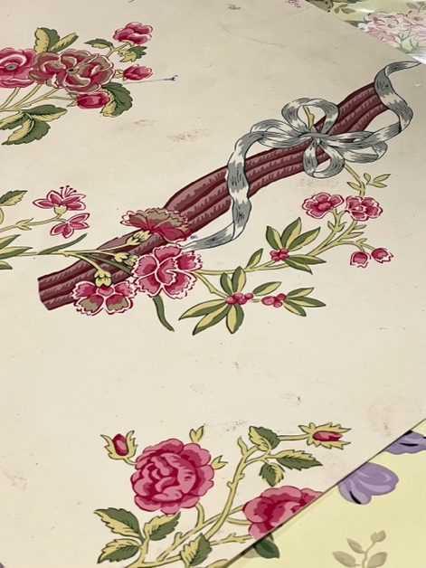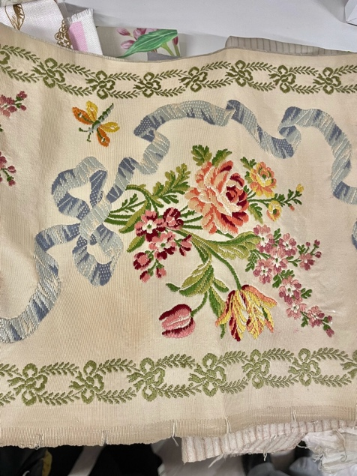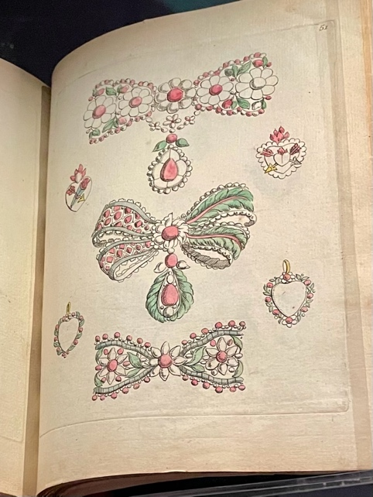

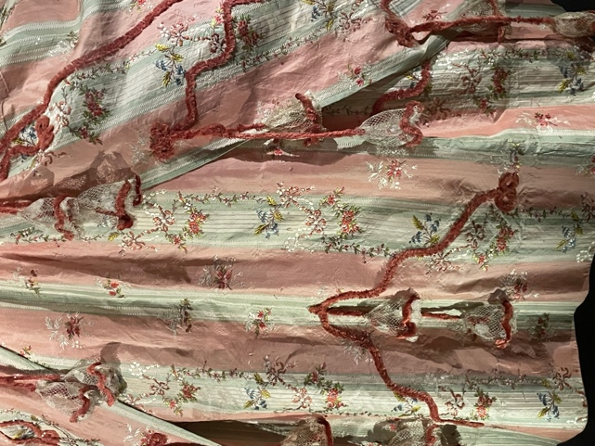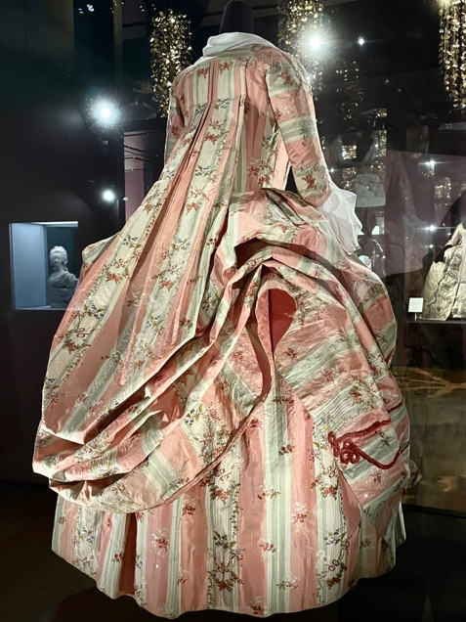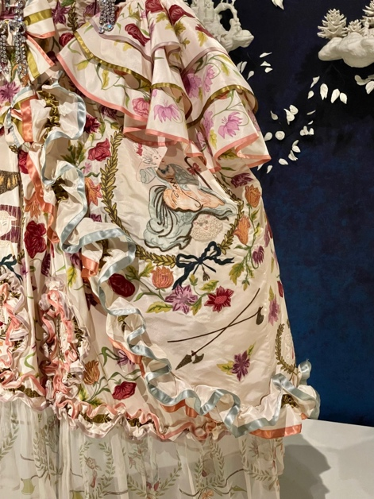

Prep grounds in watercolour and inks – considering what palette will work as the base layer. You may need to subvert the palette of your actual observational subject.
- Paint fine stripes, vary tone of the lines for interest, create rhythms
- Paint micro polka dots – regular spot repeat, random tiny dots

Respond to Bows, Swags and Ruched Forms
- Gesturally respond to the volume and drape achieved in making the swags, ribbon and frill forms.
- Scale up, use energetic expressive forms, painterly qualities and ink line.
- Soft media and collage.
- Look for the contrasts of light and shade

Inspiration
- Laura Ashley archive
- Marie Antoinette
- Trompe L’oeil

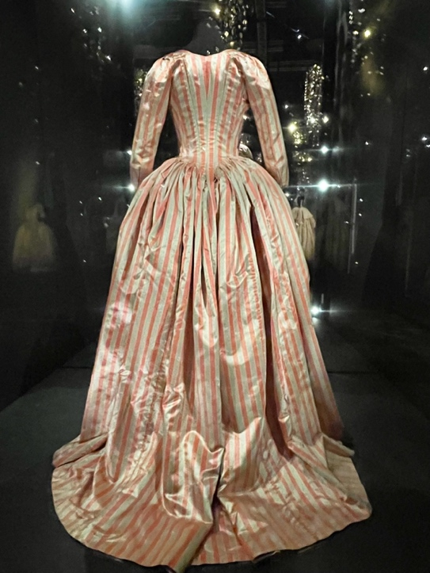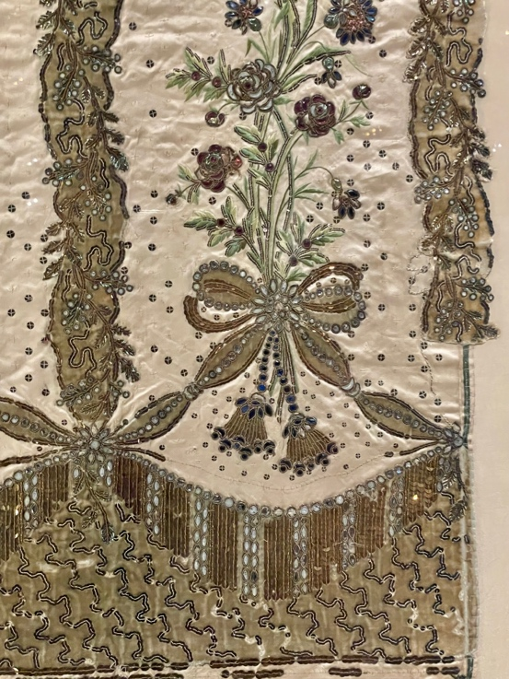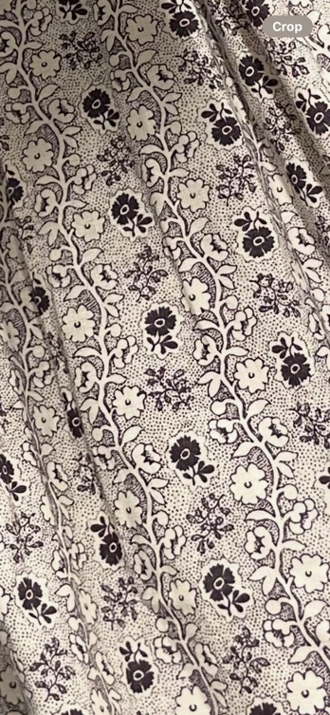

Swags ribbons bows

