

Module name: Marketing Fundamentals
Module code: LCBB4004
Lecturer: Piyumika Kithulgoda Gamage
Name: Ceapa Sorina
Student ID: 2123039

Introduction
Hays Travel Limited is one of the most reputed organisations, located in Sunderland, England. This company has been offering its services for more than 40 years with around 450 branches (HaysTravel, 2023). It is the largest independent travel agency in the United Kingdom. The company was started by John Hays in Seaham, County Durham in 1980 (Haystravelig, 2023). The business strategy of this organisation is quite interesting. In 1995, Hays Travel decided to help independent travel companies become successful. It decided to provide its technology, back-office expertise and buying power. It also allows these independent companies to have their own identity and to manage their business independently.
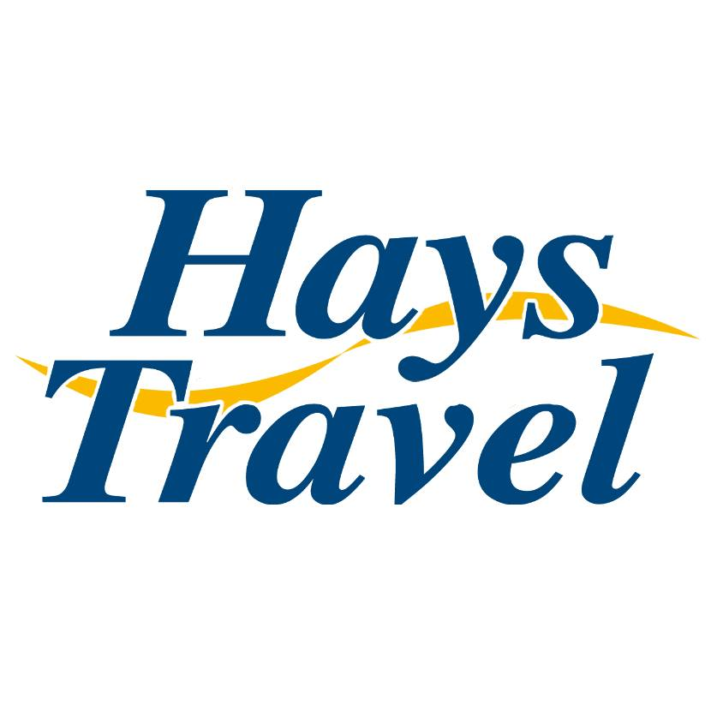
Figure: HaysTravel
Source: (CoventryCityCentre, 2023)

The study will focus on the process of the STP framework concerning the mentioned company. Hays Travel's approach to the market will also be presented in this study. A 4P marketing mix of the stated establishment will also be introduced in this discussion.
STP analysis
Three important considerations are there in the STP framework; segmentation, targeting and positioning. With the help of this STP framework, companies segment their market, target their customers and position their offerings to all segments (Sender, 2023). With the help of this STP framework, customers of a company can be broken into smaller divisions. According to the needs and requirements of these smaller groups, companies can develop effective strategies to deliver their offerings (Kalam and Kalam, 2020). Through this perception of the framework, it becomes easy for business organisations to reach and engage all targeted audiences.
Hays Travel deals in the hospitality industry and provides services to visitors. It is one of the largest Travel agencies located in the UK. Through segmentation, the concerned company has successfully divided its customers into separate categories.
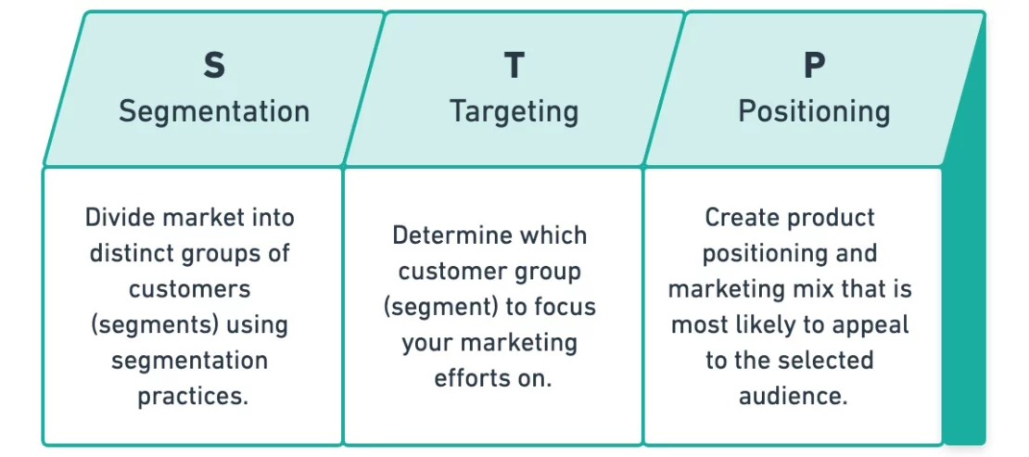
Figure: STP analysis
Source: (Wright, 2022)
Segmentation: As mentioned earlier, Hays Travel offers a wide range of facilities to its customers. The company has a clear understanding that each customer has specific requirements and wants a tailored service.
Demographic, geographic and psychographic segments are all considered by the mentioned company. Hays Travels analysed its demographic segmentation based on age, gender, needs, preferences and behaviours. Offering facilities provided by the mentioned company are provided based on these evaluations. The geographic segmentation of the mentioned company is also considered by this company. Hays Travels has a strong 40 years of presence in the market. Due to this presence, it successfully gathered a lot of experience in the market. Thus, this company has flexible pricing for low-income individuals as well.
Psychographic segmentation is another important consideration (Davras and Caber, 2019). The lifestyle and values of people helped it to measure segments effectively. The company provides its services in aviation, rail and car as well. As per the preferences, people can choose and use them.
Above segmentations done by the mentioned company have multiple benefits. It helped Hays Travels to divide its customers and provide necessary facilities to improve its services for future growth.
Targeting: Since the mentioned company is in the hospitality industry, it targets people from all age groups. Comfortability is the primary aspect that is considered by people if they come to a resort or hotel. Based on the segments the company has decided its targets in the market. The segments mentioned in the above discussion indicate the target of the mentioned establishment. The process of targeting can be termed as the process of selecting market segments in which a company can focus to grow and develop in the market. Hays Travels, targeting, for example, based on mass marketing. Though the focus of the mentioned organisation is mainly focused on young people, it considers all age groups. The company wishes to provide a convenient experience to all of its customers. Considering the demographic segments, Hays Travels, targets to attract people who want to experience quality in their voyage.
Positioning
Positioning is a crucial part of the STP framework. With the help of this process, a unique perception or image is created in the mind of the customers (Kaleka and Morgan, 2019). Thus, offerings of a business establishment, in this case, play a crucial role. Hays Travel has multiple offerings for its customers, through which it successfully managed to create a special and unique place in people’s minds.
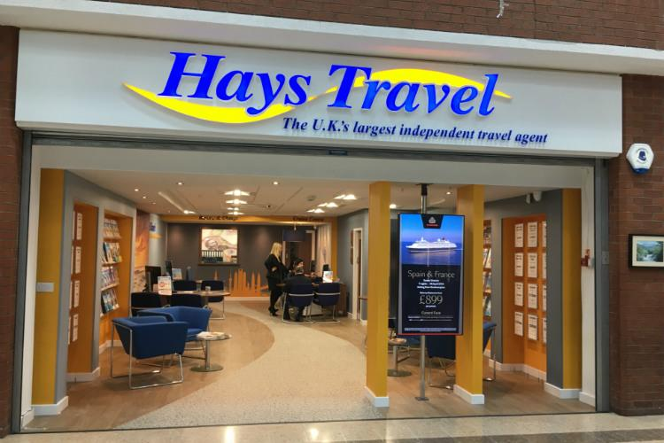
Figure: Hays Travel
Source: (TTG, 2023)
People like to have better services in less time and save money. Hays Travels provides cost-effective and diverse services 24/7 throughout the year. Based on the demand and the requirement of this company the company decided to provide its services through multiple ways. Services are provided through air, rail, hotel, hiring cars, visas, self-booking tools and others. The mentioned organisation has access to 10 million airfare technology. It also has the latest technology that is available to customers at competitive pricing. In air facilities, there is a creative ticketing facility that helps to find the best fares. Hays Travel also has an online rail booking system. By utilising the strength, the concerned company offers negotiable hotel rates for over 25000 properties in the world (Haystravel, 2023). 3 and 5-star hotels are also included in this list.
Marketing mix
The 4P marketing strategy considers four important elements of marketing. Through these four marketing tools, a company can influence the people in the market and attract them towards their offering and retain them for a longer time. Multiple factors are addressed by this 4P marketing mix (Kwok et al. 2020). It helps to understand the requirements and needs of customers. The cause of failure of a product or service can also be identified with the help of this marketing mix. It also helps to find ways to solve issues and change opinions related to service. The four elements of the 4P marketing mix are; product, price, promotion and place.
This 4P marketing mix analysis of Hays Travel will help to understand the current marketing mix strategies taken by the mentioned company.
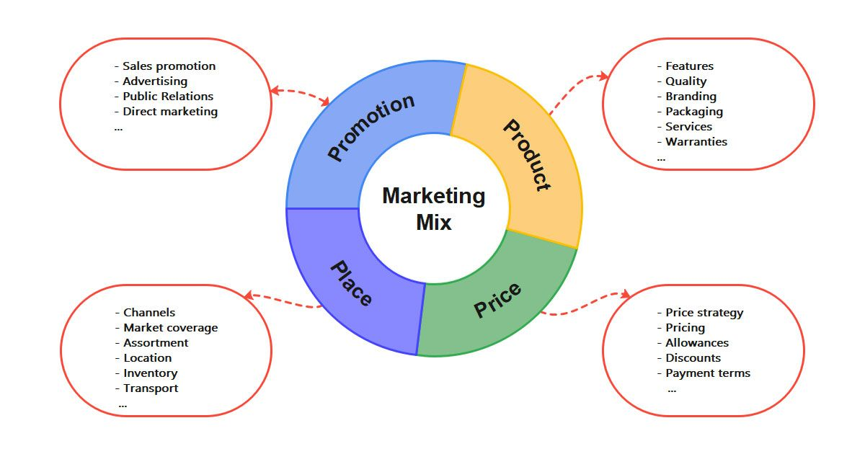
Figure: 4P marketing mix
Source: (Edrawsoft, 2023)
Product: Products or services of a company are the most powerful element (Sudari et al. 2019). It is responsible for creating the market of a company. It is also the first thing that is noticed by the people. Hays Travel offers multiple facilities to travellers so that they can have a good and reliable experience. It provides several facilities and offers related to hotels, vehicles, ticket pricing, visa and others. With the help of these services, the needs and desires of the customers are fulfilled. Not only the quality of services but other aspects like packages, after-sale services and refunds also play a crucial role in this case. The mentioned company takes care of these factors effectively.
Price: Pricing of the services or products is the second most important consideration of the people (Othman et al. 2019). Customers want to spend less money on valuable products or services. Hays Travel offers value for money offers in its services. A noticeable amount of discount can be seen in the offers of hotel bookings and ticket pricing of the mentioned company. The pricing of the services offered by the companies is quite flexible. Thus, these services can be utilised by the customers easily. However, multiple facts are there that affect the pricing of these services. Factors like seasonal discounts, supply cost and competitor's pricing affect the prices offered by Hays Travel.
Place: Place is the third consideration of this marketing mix analysis. It indicates where the service or a product will be sold. Distribution channels are also included in this consideration (Ravangard et al. 2020). The concerned organisation offers its services through online platforms. The website of the mentioned company is available 24*7*365. User-friendly interface of the website allows customers to buy services. The distribution channels of the mentioned company also play a significant role. Services in airlines, rail and car booking are there in the service list of the company.
Promotion: Promotion is the last aspect of this marketing analysis. It involves decisions in salesforce, direct marketing, public relations, budgets, advertising and others. Companies use these techniques to attract customers and let them know the services and offers available in a business platform. The promotion aims to let the market be aware of the products and services available in the company. Both online and offline promotions come in handy in this case. Online promotion, for example, includes sharing news of the offers and services on social media platforms is one of the processes initiated by Hays Travel. Since social media has been one of the most popular platforms, a large number of people can be informed. Hays Travel has a presence on Instagram, Facebook and Youtube as well. There are around 31.4k followers of the company on Instagram. (Instagram, 2023) Offline promotions like pamphlets and banners are also used by the mentioned company to attract customers.
Conclusion
It can be stated from the above discussion that Hays Travel is a popular travel agency company located in the United Kingdom. It has been present in this market for 40 years. The experience it gathered throughout these years has a strong positive impact on the business strategies taken by the mentioned company. The study has considered the two most effective business tools that successfully evaluated the current business strategies of the mentioned establishment. An STP analysis and a 4P marketing mix have been conducted throughout the study. Segmentation of the mentioned company helped it to divide customers based on the consideration of gender, needs and others. Demographic, geographic and psychographic segmentation has been considered by the company before conducting its market segmentation. Based on these segmentations, targeting has been selected by Hays Travel. Through various services mentioned above, the company has successfully made a strong presence in people's minds. The 4P marketing mix considered 4 different dimensions of services, prices, places and promotions offered by Hays Travel.

Reference list
CoventryCityCentre (2023) Hays Travel, Coventry City Centre. Available at: https://www.coventrycitycentre.co.uk/directory/shop/hays-travel/ (Accessed: 11 July 2023).
Davras, Ö. and Caber, M., (2019). Analysis of hotel services by their symmetric and asymmetric effects on overall customer satisfaction: A comparison of market segments. International Journal of Hospitality Management, 81, pp.83-93.
De Veirman, M., Hudders, L. and Nelson, M.R., (2019). What is influencer marketing and how does it target children? A review and direction for future research. Frontiers in psychology, 10, p.2685.
Edrawsoft (2023) 4Ps of marketing template, Edrawsoft. Available at: https://www.edrawmind.com/templates/4-ps-of-marketing-template.html (Accessed: 11 July 2023).
HaysTravel (2023) Book with confidence, Hays Travel. Available at: https://www.haystravel.co.uk/#:~:text=Operating%20for%20over%2040%20years,the%20holiday%20of%20your%20dreams. (Accessed: 11 July 2023).
Haystravel (2023) Services, Business Travel by Hays Travel. Available at: https://www.haystravel.co.uk/business-travel/services.phtml (Accessed: 11 July 2023).
Haystravelig (2023) About Us, About us | Hays Travel Independence Group. Available at: https://www.haystravelig.co.uk/about-us#:~:text=In%201980%2C%20with%20only%20a,UK’s%20largest%20independent%20travel%20agent. (Accessed: 11 July 2023).
Instagram (2023) Login • instagram. Available at: https://www.instagram.com/haystravel/?hl=en (Accessed: 11 July 2023).
Kalam, K.K. and Kalam, K.K., (2020). Market segmentation, targeting and positioning strategy adaptation for the global business of Vodafone Telecommunication Company. International Journal of Research and Innovation in Social Science, 4(6), pp.427-430.
Kaleka, A. and Morgan, N.A., (2019). How marketing capabilities and current performance drive strategic intentions in international markets. Industrial Marketing Management, 78, pp.108-121.
Kwok, L., Tang, Y. and Yu, B., (2020). The 7 Ps marketing mix of home-sharing services: Mining travelers’ online reviews on Airbnb. International Journal of Hospitality Management, 90, p.102616.
Othman, B., Harun, A., Rashid, W., Nazeer, S., Kassim, A. and Kadhim, K., (2019). The influences of service marketing mix on customer loyalty towards Umrah travel agents: Evidence from Malaysia. Management Science Letters, 9(6), pp.865-876.
Ravangard, R., Khodadad, A. and Bastani, P., (2020). How marketing mix (7Ps) affect the patients’ selection of a hospital: experience of a low-income country. Journal of the Egyptian Public Health Association, 95(1), pp.1-8.
Sender (2023) STP Marketing: Segmentation, targeting, positioning model, Sender. Available at: https://www.sender.net/blog/stp-marketing/ (Accessed: 11 July 2023).
Sudari, S., Tarofder, A., Khatibi, A. and Tham, J., (2019). Measuring the critical effect of marketing mix on customer loyalty through customer satisfaction in food and beverage products. Management Science Letters, 9(9), pp.1385-1396.
TTG (2023) Hays travel to take on Freedom Bookings, TTG. Available at: https://www.ttgmedia.com/news/hays-travel-to-take-on-freedom-bookings-19433 (Accessed: 11 July 2023).
Wright, M. (2022) The Complete Guide to STP Marketing: Segmentation, targeting & positioning, Yieldify. Available at: https://www.yieldify.com/blog/stp-marketing-model/ (Accessed: 11 July 2023).

