ACDA5025A BEng Electrical & Electronic Engineering
January 2026
Gareth E John 2413461
ACDA5001 Electrical Engineering

Table of Contents
1 Abstract 1
2 Introduction 1
2.1 Background information 1
2.1.1 Alternating Current (AC) 1
2.1.2 RLC Circuit 1
2.1.3 Power Factor 2
2.1.4 Resonance Frequency 2
2.1.5 Maximum Power Transfer 2
3 Method 2
3.1 Proteus RL Circuit design 2
3.1.1 RL Graph 3
3.1.2 Active, Reactive, Apparent Power 4
3.1.3 RL Phase difference 5
3.1.4 Phase Angle and Power Factor 5
3.1.5 Phasor Diagram from RL circuit 6
3.2 RLC circuit design 8
3.2.1 RLC Graph 9
3.2.2 Graph of Power Factor against Capacitor Value 9
3.2.3 Graph of phase angle against capacitor value 10
3.2.4 Describe the energy stored in the capacitor and inductor. 10
4 Results 10
4.1.1 Phase difference at 25Hz below resonance Frequency 11
4.1.2 Phase Angle and Power Factor 12
4.1.3 Calculations for Capacitive, Inductive Reactance and Impedance 13
4.1.4 Calculations for Current across the Capacitor and Load 13
4.1.5 Phase angles 14
4.1.6 Table with different Frequency 15
4.1.7 Phasor Diagrams 16
5 Discussion 17
5.1.1 Analysing the Results 17
5.1.2 Explaining Resonance, Achieving maximum Power transfer and Energy efficiency. 18
5.1.3 Why use three phases? 18
6 Conclusion 19
7 Reference 19

Abstract

This report explains how to calculate the capacitor value from the phasor diagram using information from the student identification number. The identification then breaks down into the following categories.
student number: 2413461
- Rsrc = 2.4 Ω
- Load inductor value = 134 mH
- Load resistor value = 61 Ω
- Connect the circuit to a 300 Vrms, 50 Hz sinusoidal source.
The information above can be used to calculate the capacitor value and to assess how the circuit benefits from having a capacitor in parallel with the Load. This report also shows why Power factor correction will improve maximum power transfer and efficiency.

Introduction

This section explains what each compound is used for in the circuit, how it affects current and voltage, and how power is transferred.

Background information

Alternating Current (AC)

AC is the standard form of mains electricity in the UK, operating at 50Hz. This AC power comes from several sources, such as power stations and renewable sources such as solar power, Wind turbines, and hydro turbines. This electricity passes through a series of step-up transformers to minimise losses over long distances.[1] Then step down the transformers to 400V 3-phase.[2] The standard colours for the 3-phase are Brown, Black and Grey.[3].

RLC Circuit

Resistor
A resistor reduces the flow of current. The higher the Current, the lower the resistance and vice versa. Current and Voltage are in Phase with each other.
Inductor
An Inductor Stores energy internally in a magnetic field when Current flows through it[4]. Current lags Voltage.
Capacitor
A capacitor stores energy in an electric field when currents flow through it.[5]. Current Lead Voltage.

Power Factor

Power factor is a measure of how effectively electrical power is used. This will indicate the amount of actual power consumed in the circuit. When the circuit is 100% efficient, then the power factor is unity, 1 [6].

Resonance Frequency

Resonant frequency is the frequency at which the Current drawn from the source is minimum. The inductive and capacitive reactance are equal, practically cancelling each other out.[7]. Also, the Power factor must be 1 so that the Voltage and Current are in phase.[8].

Maximum Power Transfer

Maximum power transfer occurs when all power is transferred from the source to the load. This happens when the load impedance equals the source's internal resistance. [8].

Method

This section demonstrates how the design stage is used to calculate the circuit capacitance and to improve power efficiency.

Proteus RL Circuit design

Figure 1 shows the Proteus design, with the component values listed in the Abstract.
Figure 1 - Proteus Drawing without Capacitor

RL Graph

Figure 2 below shows two waveforms: the green line for the Voltage and the Red line for the Current. As shown, the Voltage is leading the Current. The Maximum Peak Voltage is shown in Figure 3 at 424V, and the Maximum Peak Current is 5.64A.
To get the Vrms value across the load, the following equation is used.
Equation 1-Calculation for Vrms
$$Vrms=\frac{Vm (Peak Voltage)}{\sqrt{2}} \\ Vrms=\frac{424V}{\sqrt{2}} \\ Vrms=299.81V$$
To get the Irms value, the following equation is used.
Equation 2- Calculation for Irms
$$Irms= \frac{Im(Peak Current)}{\sqrt{2}} \\ Irms=\frac{5.64A}{\sqrt{2}} \\ Irms=3.99A$$

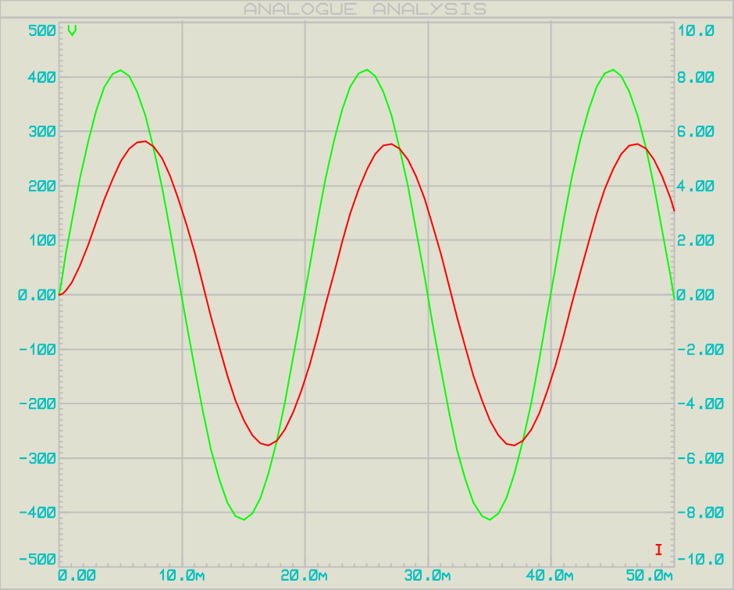
Figure 2-Graph showing the waveform of the Voltage and Current
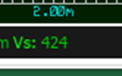
Figure 3- Max Peak Voltage and Current

Active, Reactive, Apparent Power

Active Power
Equation 3 - Active Power formula
$$Power \left(P\right)=Voltage*Current*Cosϕ \\ P=299.81V*3.99A*Cos 34.2° \\ P=989.39 W$$

Reactive Power
Equation 4 - Reactive Power formula
$$Q=V*I*Sin ϕ \\ Q=299.81V*3.99A*Sin 34.2° \\ Q=672.81Var$$

Apparent Power
Equation 5 - Apparent Power formula
$$S=Voltage*Current \\ S=399.81V*3.99A \\ S= 1196.24VA$$

RL Phase difference

To calculate the Phase differences from Voltage to Current. The time value will be taken from the graph above at zero Voltage/Current.
Time with Voltage at 0V is shown in the figure below.

Figure 4- Time Voltage at 0V

Time with Current at 0A is shown in the figure below.

Figure 5-Time Current at 0A

Equation 6-Formula for Time delay.
$$Time delay \left(∆t\right)=Current time-Voltage time \\ ∆t=11.9ms-10ms \\ ∆t=1.9ms$$
This means that the current is out of phase by 1.9ms.

Phase Angle and Power Factor

To calculate the phase angle, use the following equation. Using Figure 2, the time per cycle is 20ms.
Equation 7-Phase angle Formula.
$$Phase angle\left(ϕ\right)=\frac{t(time difference)}{T(time cycle)}*360 \\ ϕ=\frac{1.9ms}{20ms} *360 \\ ϕ=34.2°$$

To calculate the Power factor (P.F.), use the following formula.
Equation 8- Power Factor Formula.
$$P.F=Cos ϕ \\ P.F=Cos 34.2° \\ P.F=0.83$$

Phasor Diagram from RL circuit

Phasor diagrams are needed to determine the capacitor current IC because AC quantities have phase angles, and the current through the capacitor leads the voltage by 90°[10].
The only Value that is given is the Phase angle of 34.2 °in equation 7, and the ILR = Irms = 3.99A in equation 2. Figure 6 below shows the Phasor diagram. To determine the Capacitor value, the following 6 Steps, starting with a trigonometric equation, must be performed to calculate the current flowing through the capacitor.
Step 1
Equation 9 - Trigonometry to find the Current across the Capacitor.
$$Sin ϕ=\frac{Opposite(IV)}{Hypotenuse(ILR) } \\ Sin 34.2°=\frac{IV}{3.99A} \\ IV=3.99A*Sin⁡(34.2°) \\ IV=2.24A$$
Now that the opposite (IV) value is calculated, the new step is to find the Adjacent line (IR)
Step 2
Equation 10- Trigonometry to find the Current across the Resistor
$$Cosϕ= \frac{Adjacent (IR)}{Opposite (IV)} \\ Cos 34.2°= \frac{IR}{2.24A} \\ IR=2.24A*Cos 34.2° \\ IR= 1.85A$$

The next step is to find the Current (I) value from the Power factor of 0.95
Step 3
Equation 11- Phase angle from PF of 0.95
$$ϕ={Cos}^{-1}\left(0.95\right) \\ ϕ=18.2°$$

Equation 12 -Trigonometry to find the Current with PF 0.95
$$Cosϕ=\frac{Adjacent (IR)}{Hypotenuse (I)} \\ Cos18.2°= \frac{1.85A}{I} \\ I= \frac{1.85A}{Cos 18.2°} \\ I=1.95A$$
The next step is to find the IC value.
Step 4
Equation 13- Trigonometry to find the IC value
$$Sinϕ=\frac{Opposite}{Hypotenuse (I)}$$
$$Sin18.2°= \frac{Opposite}{1.95A}$$
$$Opposite=1.95A*Sin18.2°$$
$$Opposite=0.61A$$
$$IC=2.24A- 0.61A$$
$$IC= 1.63A$$

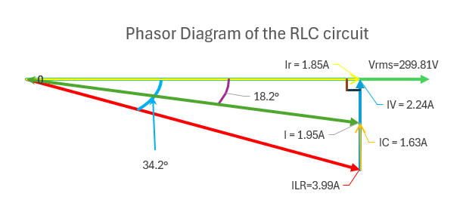
Figure 6- Phasor Diagram of the RL Circuit.

Step 5
The following formula is used to determine the Capacitive reactance (XC, Ω) from the results above.
Equation 14- Capacitive Reactance Formula.
$$Ic=\frac{Voltage}{XC} \\ 1.63A=\frac{299.81V}{XC} \\ XC=\frac{299.81V}{1.63A} \\ XC=183.93Ω$$
Step 6
The final equation is used to determine the Capacitor value in Farads. Figure 1 shows that the frequency is 50Hz, and the capacitive reactance is calculated using equation 7.
Equation 15 - Capacitor Value formula
$$XC=\frac{1}{2πFC} \\ 183.93Ω= \frac{1}{2π*50Hz*C} \\ C=\frac{1}{2π*50Hz*183.93Ω} \\ C=17.31µF$$

RLC circuit design

Figure 7 below shows the circuit design with a Capacitor added.
Figure 7 - RLC circuit drawing.

RLC Graph
Figure 8 - Waveform shows the Voltage and Current in phase.

Graph of Power Factor against Capacitor Value

The graph below shows the Power factor against the Capacitor value. As shown in Figure 8, when a capacitor is connected in parallel with the load, the current becomes nearly in phase with the voltage. However, when adding a capacitor with higher Microfarads (μF), the current becomes out of phase.
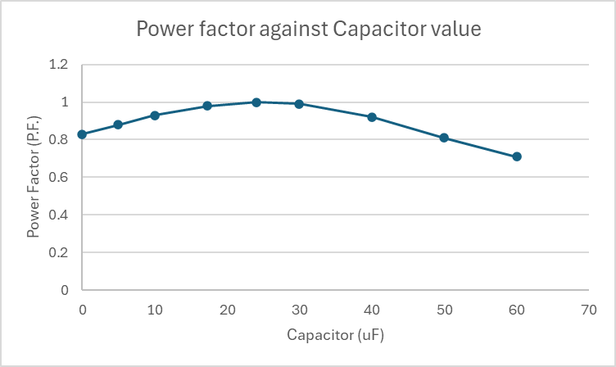

Figure 9 - Power Factor against the Capacitor Value

Graph of phase angle against capacitor value

The graph below shows the phase angle against the Capacitor Value.
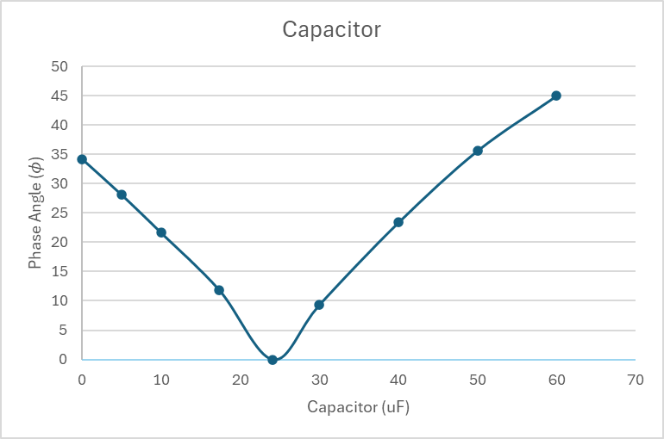
Figure 10- Phase Angle against the Capacitor Value.

Describe the energy stored in the capacitor and inductor.

When the power factor increases to 1, the circuit becomes purely resistive. This means the reactive effects of the capacitor and inductor cancel each other out and act like an open circuit. As a result, very little energy is stored and returned by the electric and magnetic fields, and most of the energy is dissipated in the resistive elements[11].

Results

This section presents results for the frequencies listed in Table 1, including the Resonance Frequency.
The results from equation 12 will be used to calculate the Capacitive reactance (XC), Inductive Reactance (XL), and the Load impedance (ZLR). The Current across the Capacitor and Inductor will then be calculated, followed by the Phase angle of that Current, and finally the total Current.
The following calculation is for 25Hz below the Resonance Frequency, which gives the value of 50.71 Hz. See Table 1 for all the resonance frequencies.

Phase difference at 25Hz below resonance Frequency

The following equation is used to calculate the Resonance frequency from the component used in Figure 8 above.
Equation 16 - Resonance frequency formula.
$$Fr=\frac{1}{2π}\sqrt{\frac{1}{LC}- \frac{R^{2}}{L^{2}}} \\ Fr=\frac{1}{2π}\sqrt{\frac{1}{{134x10}^{-3}*17.31{x10}^{\begin{aligned}-6 \\ \end{aligned}}}- \frac{{61}^{2}}{{{134x10}^{-3}}^{2}}} \\ Fr=0.16\sqrt{431119.96-207228.78} \\ Fr= 0.16\sqrt{223891.18} \\ Fr= 75.71Hz$$

Figure 11 - Waveform at 50.71Hz

To calculate the Phase differences from Voltage to Current. The time value will be taken from the graph above (Figure 12) at zero Voltage/Current.
Time with Voltage at 0V is shown in the figure below.
Figure 12 - Voltage time at 0V

Time with Current at 0A is shown in the figure below.
Figure 13 - Current time at 0A

Equation 17 - Formula for Time delay.
Time delay (∆t) =Current Time-Voltage time
∆t=20.31ms-19.72ms
∆t=0.59ms

Phase Angle and Power Factor

The cycle time is shorter than that of the 1st task due to the frequency change to 50.71Hz.

Equation 18 - Phase angle Formula.
$$Phase angle\left(ϕ\right)=\frac{t(time difference)}{T(time cycle)}*360 \\ ϕ=\frac{0.59ms}{19.74ms} *360 \\ ϕ=10.76°$$

To calculate the Power factor (P.F.), the following formula is used.

Equation 19 -Power Factor Formula
$$P.F=Cos ϕ \\ P.F=Cos 10.76° \\ P.F=0.98$$

Calculations for Capacitive, Inductive Reactance and Impedance

Capacitive Reactance
Equation 20 - Capacitive Reactance (XC)
$$Xc= \frac{1}{2πfC} \\ Xc= \frac{1}{2π*50.71Hz*17.31{x10}^{\begin{aligned}-6 \\ \end{aligned}}} \\ Xc=181.31Ω$$
Inductive Reactance
Equation 21 - Inductive Reactance (XL)
$$Xl= 2πfL \\ Xl= 2π*50.71Hz*134x{10}^{-3} \\ Xl=42.70Ω$$

Impedance
Equation 22 - Impedance Formula
$$ZLR= \sqrt{(R^{2}+ {Xl}^{2)}} \\ ZLR= \sqrt{({61}^{2}+ {42.7}^{2)}} \\ ZLR=74.46Ω$$

Calculations for Current across the Capacitor and Load

The peak voltage is shown in Figure 15 below.

Figure 14 -Peak Voltage

Equation 23 - Vrms Formula
$$Vrms=\frac{Vm (Peak Voltage)}{\sqrt{2}} \\ Vrms=\frac{423V}{\sqrt{2}} \\ Vrms=299.11Vrms$$

Current across the Capacitor
Equation 24 - Current across the Capacitor
$$Ic= \frac{Vrms}{Xc} \\ Ic= \frac{299.11V}{181.3Ω} \\ Ic=1.65A$$
Current across the Load
Equation 25 - Current across the Load
$$ILR=\frac{Vrms}{ZLR} \\ ILR=\frac{299.11V}{74.46Ω} \\ ILR=4.01A$$

Phase angles

Phase angles in RL
Equation 26 - Calculation to find the Phase angle of RL
$$ϕLR=\tan^{-1}(\frac{Xl}{R}) \\ ϕLR=\tan^{-1}(\frac{42.7Ω}{61Ω}) \\ ϕLR=34.99°$$

Phase angles in RL-C
Equation 27- Calculation to find the Phase angle of RL-C
$$ϕLR-C=\tan^{-1} \frac{{ILR SinϕLR}^{\sim Ic}}{ILR CosϕLR} \\ ϕLR-C=\tan^{-1} \frac{{4.01Sin34.99°}^{\sim 1.65}}{4.01Cos34.99°} \\ ϕLR-C= \tan^{-1} \frac{0.65}{3.29}$$$ϕLR-C=11.18° [Lagging]$

Total Current for the Circuit
When the Current of IC is 1.65A and ILR is 4.01A, that means $IC<ILR{sinϕ}_{LR}$ So the Current is lagging the Voltage.
If $IC>ILR{sinϕ}_{LR}$ Then the current leads the Voltage.
Equation 28 - Formula to find the Current of the Circuit.
$$I= \sqrt{{\left(I_{LR}{cosϕ}_{LR}\right)}^{2}+{\left(I_{LR}{{sinϕ}_{LR}}_{\sim IC}\right)}^{2}} \\ I= \sqrt{{\left(4.01Cos34.99°\right)}^{2}{+\left({4.01Sin34.99°}^{\sim 1.65}\right)}^{2}} \\ I=3.35A$$

Table with different frequencies

Table 1, which uses the same formula steps shown above (Equations 17-28), also presents the results.

Table 1 - Shows are the results with the same equations from 25Hz below the Resonance

Phasor Diagrams

Below are four Phasor Diagrams for each of the frequencies from Table 1. Those graphs provide clear evidence of whether the current lags or leads the Voltage.
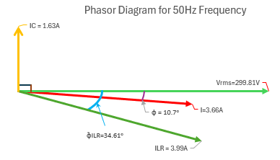
Figure 15 -Phasor Diagram for 50Hz Frequency
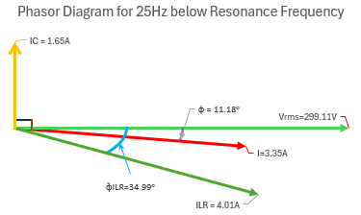
Figure 16 - Phasor Diagram for 25Hz Below Resonance Frequency
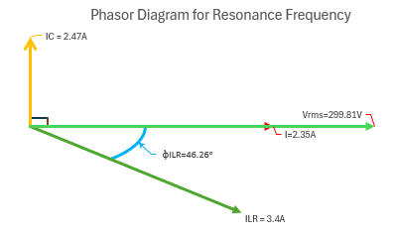
Figure 17 - Phasor Diagram for Resonance Frequency
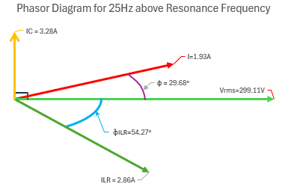
Figure 18 - Phasor Diagram for 25Hz Above Resonance Frequency

Discussion

Analysing the Results

After collecting all simulation results in Proteus, this will demonstrate the importance of a capacitor in a circuit such as an Inductor Motor. Without the Capacitor, the Power factor (PF) is 0.83 from Equation 8, which is common for an inductor Motor[12]. However, adding a capacitor in parallel with the load can improve the circuit. This is called Power factor correction.[13] [14].
The phase angle of the PF was calculated from the time difference between the Voltage and Current in Figure 2. This is important to calculate the capacitor value to improve the circuit and PF. As shown in Figure 6, an IC was needed to calculate the Capacitor value. Equations 9 to 15 show the steps to achieve a value of 17.31 μF; a capacitor was added in Proteus, as shown in Figure 8. The graph in Figure 9 shows that the current lags the Voltage slightly by 0.61ms, as shown in Table 1 (50Hz column). This indicates that the capacitor enhances the circuit, power transfer, and efficiency.
In practice, there will be losses, and it will not achieve 100% energy efficiency. The following points to take into consideration[15].
- Cables
- Components
- Ambient temperature
Worth mentioning that the Total current is less when the Current leads the Voltage, as shown in Table 1 column above the resonance frequency. This is because the IC and ILR are mutually exclusive. The Load current cancelled most of the IC, so the Resistive component still needs to be supplied from the Source. The Circuit behaves like a capacitive circuit.

Explaining Resonance, Achieving maximum Power transfer and Energy efficiency.

Resonance and Energy Efficiency
When the circuit is at the resonance frequency shown in Table 1, the Currents at the capacitor (IC) and the inductor (IL) cancel each other out, and all power from the source goes directly to the Load without any reactive Power. The Following Calculation is used to determine the Power efficiency.
Equation 29 - Power Efficiency
$$Efficiency \left(η\right)= \frac{Useful Output Power}{Input Power}*100\%$$

Maximum Power Transfer
Conditions must be met before maximum power transfer can be achieved.
• Power factor = unity 1
• Voltage and Current are in phase.
This is the case with the resonance Frequency, but these conditions don’t mean energy is efficient. The energy efficiency at maximum power transfer is 50%, and 50% is wasted due to source/internal resistances.[16].

Why use three phases?

Three phases are standard in the UK. Each phase, L1 (Brown), L2 (Black), and L3 (Grey), is spaced at 120° [17] when the load is balanced, so they do not require a Neutral Core.
There are several reasons for the 3 phases rather than 6 or 9[18].
- Cheaper to Run
- Cheaper to maintain
- Fault finding
- Less cable to transport electricity over Pylons
- Three-phase motors are cheap and efficient
- Easier to design
That said, there are drives/motors with more than 3 phases, which are limited to specialised applications where high reliability is required. The benefits are[19]
- Lower current per phase
- Reduce harmonic current
- Higher reliability.

Conclusion

This report presents the effects of power factor correction and resonance on an inductive motor-type Load using Proteus simulation. Initially, the circuit was operated at a lagging power factor of 0.83, which is typical for an industrial induction motor. To improve the efficiency of the circuit and also make it cheaper to run. [20], [21] is to add a capacitor in parallel with the Load by calculating the required value. Results of Reactive Power were reduced from 672.81Var to 203.73Var, and the Active Power had increased from 989.39W to 1078.23W, meaning more useful Power is being used and not wasted. To forget, the Apparent Power decreases from 1196.24 VA to 1097.3 VA.
At Resonance, the inductive and capacitive currents cancel each other out, resulting in a unity power factor and purely resistive line current. All power from the source is transferred to the load without any reactive power, but in practice, this is difficult to achieve due to losses. Resonance should not be confused with the Maximum power transfer condition, which is limited to 50% efficiency due to internal resistance.

Reference

[1] ‘DC Realisation in the 21st Century’. Accessed: Dec. 30, 2025. [Online]. Available: https://electrical.theiet.org/wiring-matters/years/2021/88-november-2021/dc-realisation-in-the-21st-century/
[2] J. O. Bird, Bird’s electrical and electronic principles and technology, Seventh edition. Abingdon, Oxon New York, NY: Routledge, 2021, p-459.
[3] Requirements for electrical installations: IET wiring regulations, eighteenth edition BS 7671:2018+A2:2022. Institution of Engineering and Technology, 2022, p-134.
[4] P. Horowitz and W. Hill, The art of electronics, Third edition, 21st printing with corrections. Cambridge, New York: Cambridge University Press, 2024, p-18.
[5] P. Horowitz and W. Hill, The art of electronics, Third edition, 21st printing with corrections. Cambridge, New York: Cambridge University Press, 2024, p-28.
[6] J. O. Bird, Bird’s electrical and electronic principles and technology, Seventh edition. Abingdon, Oxon New York, NY: Routledge, 2021, p-371.
[7] X. Wu, ‘The Role of Passive Filter in Harmonic Suppression’, Int. Core J. Eng., vol. 11, no. 1, p. 161, 2025.
[8] J. O. Bird, Bird’s electrical and electronic principles and technology, Seventh edition. London New York: Routledge, Taylor & Francis Group, 2022, p-296-267.
[9] J. O. Bird, Bird’s electrical and electronic principles and technology, Seventh edition. Abingdon, Oxon New York, NY: Routledge, 2021.
[10] J. O. Bird, Bird’s electrical and electronic principles and technology, Seventh edition. Abingdon, Oxon New York, NY: Routledge, 2021, p-362.
[11] ‘DOE-HDBK-1001/3-92; DOE Fundamentals Handbook Electrical Science Volume 3 of 4’. Accessed: Jan. 03, 2026. [Online]. Available: https://www-mdp.eng.cam.ac.uk/web/library/enginfo/textbooks_dvd_only/doe_handbooks/elecsci3.pdf?utm
[12] ‘AGN-087_C-Power-Factor.pdf’. Accessed: Jan. 02, 2026. [Online]. Available: https://www.stamford-avk.com/sites/stamfordavk/files/AGNs/AGN-087_C-Power-Factor.pdf
[13] D. Mohanraj, D. Samithas, P. K. Balachandran, and M. A. A. Mohd Zainuri, ‘An Improved Power Factor Correction Converter for Switched Reluctance Motor Drive Performance Analysis’, IEEE Access, vol. 13, pp. 71187–71196, 2025, doi: 10.1109/ACCESS.2025.3561335.
[14] K. Abe, H. Haga, K. Ohishi, and Y. Yokokura, ‘Fine Current Harmonics Reduction Method for Electrolytic Capacitor-Less and Inductor-Less Inverter Based on Motor Torque Control and Fast Voltage Feedforward Control for IPMSM’, IEEE Trans. Ind. Electron., vol. 64, no. 2, pp. 1071–1080, Feb. 2017, doi: 10.1109/TIE.2016.2614270.
[15] W. Li, Q. Liu, Z. Zhang, and Q. Wang, ‘High power factor high power density high voltage converter based on AC link’, IET Power Electron., vol. 10, no. 7, pp. 826–834, 2017, doi: 10.1049/iet-pel.2016.0225.
[16] S. Singer, S. Efrati, M. Alon, and D. Shmilovitz, ‘Maximum Electrical Power Extraction from Sources by Load Matching’, Energies, vol. 14, no. 23, p. 8025, Dec. 2021, doi: 10.3390/en14238025.
[17] J. O. Bird, Bird’s electrical and electronic principles and technology, Seventh edition. Abingdon, Oxon New York, NY: Routledge, 2021,p-458.
[18] J. O. Bird, Bird’s electrical and electronic principles and technology, Seventh edition. Abingdon, Oxon New York, NY: Routledge, 2021,p-470.
[19] G. K. Singh, ‘Multi-phase induction machine drive research—a survey’, Electr. Power Syst. Res., vol. 61, no. 2, pp. 139–147, Mar. 2002, doi: 10.1016/S0378-7796(02)00007-X.
[20] ‘ECA’. Accessed: Jan. 03, 2026. [Online]. Available: https://www.eca.co.uk/CMSPages/GetFile.aspx?guid=38d1e6c8-ad78-4e99-8745-9fe589d4ef3d
[21] F. Zheng and W. Zhang, ‘Long term effect of power factor correction on the industrial load: A case study’, in 2017 Australasian Universities Power Engineering Conference (AUPEC), Nov. 2017, pp. 1–5. doi: 10.1109/AUPEC.2017.8282382.

