Design, conduct, and write up a research report examining differences in attitude between two groups toward Veganism.

Abstract
Veganism is a lifestyle and dietary choice that abstains from the consumption of animal products and by-products, embracing a plant-based diet. Research suggests that females may be more inclined to embrace veganism for ethical reasons, driven by concerns about animal welfare and environmental sustainability with higher levels of empathy and compassion towards the treatment of animals in the food industry (Costa et al., 2019). In contrast, males may be drawn to veganism for health and fitness-related reasons, emphasising benefits such as weight management and overall well-being (Stanley et al., 2023). Results suggest no significant difference in meat-eating justification scores between males (M = 156.25, SD = 30.18) and females (M = 144, SD = 30); t(0.73) = 0.24, p < 0.5. Future research could explore broader population samples and additional factors that may contribute to gender differences in dietary attitudes and behaviours.
Keywords: Veganism, Male, Female, and Masculinity.

Introduction
Veganism, as a dietary and lifestyle choice, has evolved from a niche movement to a global phenomenon with profound ethical, environmental, and health implications. Its roots can be traced back to the early 20th century when individuals began abstaining from animal products for ethical reasons, driven by concerns about animal cruelty and exploitation. Over the decades, veganism has expanded its influence, gaining momentum as environmental awareness increased with scientific studies highlighting the potential health benefits of plant-based diets. However, little is known about how gender influences the adoption and perceptions of this plant-based lifestyle. By examining the interplay between ethical considerations, health motivations, societal expectations, and gender norms, this research aims to contribute to a deeper understanding of the factors influencing the diverse attitudes towards veganism across genders.
The adoption of veganism is deeply influenced by a complex interplay of societal norms, cultural expectations, and peer pressure. Societal norms often shape perceptions of what is considered a conventional diet, with meat consumption traditionally associated with strength and masculinity (Rothgerber, 2013). Throughout history, cultural ideologies have often portrayed meat as a symbol of virility and power, promoting the idea that consuming animal products is essential for building and maintaining physical strength (Fiddes, 1989). This narrative has been perpetuated through various mediums, including advertising, literature, and media representations, reinforcing the concept that meat is synonymous with robustness and vitality (Song, 2022). Additionally, societal expectations regarding gender roles have influenced dietary norms, particularly in defining what is considered appropriate or desirable for men versus women (Higgs, 2015). Meat-heavy diets have traditionally been associated with masculinity, reflecting deep-seated beliefs about the relationship between food choices and gender identity (Stanley et al., 2023). Men, in particular, have been encouraged to consume ample amounts of protein from animal sources to fulfil societal ideals of strength and athleticism (Love & Sulikowski, 2018). Peer pressure plays a pivotal role, as individuals may conform to dietary choices prevalent within their social circles to align with perceived norms and avoid social isolation (Cruwys et al., 2015). Conversely, in social circles that embrace plant-based diets or veganism, individuals may experience positive reinforcement for adopting similar dietary practices (Gulliksen, 2018). Male peer groups may reinforce meat consumption by engaging in activities centred around meat, such as barbecues or sports events (Nath, 2011). In contrast, females may experience peer pressure related to body image and health, with emphasis placed on maintaining certain dietary patterns to conform to societal beauty standards (Paquette & Raine, 2004).
The adoption of veganism among women and men reflects distinct motivations and considerations shaped by ethical, environmental, and health factors, underscoring the evolving landscape of dietary choices and lifestyle preferences. Female veganism often stems from a combination of ethical, environmental, and health considerations. Many women are drawn to veganism due to a strong sense of empathy and compassion towards animals, expressing concerns about the treatment of animals in the food industry (Costa et al., 2019). The ethical dimension of veganism, which rejects the exploitation of animals for food, resonates deeply with females who may be more inclined to prioritise the welfare of living beings (Randler et al., 2021). Additionally, environmental sustainability is a significant factor for women embracing veganism, as plant-based diets are recognised for their lower ecological footprint compared to animal agriculture (Lacour et al., 2018). Health considerations, such as weight management and the perceived benefits of a plant-based diet, also play a role in attracting women to veganism (Paquette & Raine, 2004). The interconnectedness of these factors contributes to a holistic approach to dietary choices, making veganism an appealing lifestyle for females seeking alignment with their ethical values, environmental consciousness, and personal well-being. Male veganism is often motivated by a combination of health, fitness, and environmental concerns. Many men are drawn to a plant-based lifestyle for its perceived benefits in promoting overall health and well-being (Fehér et al., 2020). Embracing a vegan diet is viewed by some as conducive to maintaining optimal weight, improving cardiovascular health, and reducing the risk of certain chronic diseases (Łuszczki et al., 2023). Research suggests a "protein paradox" where men are more likely to consume high-protein diets, driven by societal expectations related to masculinity and muscle-building ideals (Parasecoli, 2005). This preference for protein-rich foods may influence dietary choices among men, impacting their overall nutritional intake. Additionally, the plant-based movement has gained traction in fitness and bodybuilding communities, challenging the traditional association of protein with animal products (Sandua, 2024). Men may be attracted to the idea that plant-based diets can support muscle building and athletic performance (Shaw et al., 2022). Furthermore, the environmental impact of animal agriculture has become a significant consideration for men adopting veganism, as they recognise the role of plant-based diets in reducing greenhouse gas emissions and promoting sustainability (Lacour et al., 2018). These multifaceted motivations reflect a shifting paradigm where males and females are increasingly embracing veganism not only for ethical reasons but also for personal health and environmental consciousness.
In conclusion, the multifaceted influences on the adoption and perception of veganism across genders, is a complex interplay of societal norms, cultural expectations, and gender-specific motivations. Research suggests that while both men and women are drawn to veganism for ethical, environmental, and health reasons, the motivations and considerations driving their dietary choices often differ. Women frequently embrace veganism out of empathy for animals, ethical concerns, and a desire for environmental sustainability, aligning with their values and holistic approach to well-being. In contrast, men often gravitate towards veganism for its perceived health benefits, including weight management and athletic performance, while also acknowledging the environmental impact of animal agriculture. Existing studies on gender and dietary preferences reveal intriguing patterns, such as the "protein paradox," highlighting how societal expectations related to gender roles can significantly influence dietary choices and nutritional intake. This research aims to explore the justification of meat consumption between men and women. The hypothesis is that men will score higher in meat eating justification than women.

Method

Participants
25 undergraduate psychology students were recruited via EMS to take part in this study, however 22 data points were included in the analysis following the removal of three sets of data due to undeclared gender and no responses for scale (4 males, and 18 females). Participants ranged in age between 18 and 58 (M = 28, SD = 10.3).

Design
A between-subject design was used with IV being gender and DV being meat-eating justification score. A t-test will be used for analysis.

Materials
To measure meat eating justification, the Meat-Eating Justification (MEJ) Scale (Rothgerber, 2013) was used through the program Qualtrics (Qualtrics, 2020). This questionnaire contains 27 items such as “I enjoy eating meat too much to ever give it up”. Each item is scored on a 9- point Likert scale anchored between 1 = Strongly Disagree to 9 = Strongly Agree. Total scores on the scale can range between 27 and 243, with higher scores indicating stronger endorsement or justification of meat consumption beliefs and behaviours.

Procedure
Participants were recruited through the Experiment Management System (EMS) and initiated the study on laptops or online, where a Qualtrics link was loaded and ready for access. The participants were presented with an information sheet (see appendix 1) detailing the study's purpose and consent form (see appendix 2) was administered, ensuring participants were fully informed and willing to proceed. Demographic data was then collected to provide context for subsequent analyses which included age and gender. Participants completed a comprehensive questionnaire via Qualtrics. Participants then underwent a debriefing session (see appendix 3), providing them with information about the study's objectives and addressing any questions or concerns. A sincere expression of gratitude for their participation concluded the study, acknowledging the valuable contribution of each participant to the study.

Results
An independent samples t-test was conducted in order to explore differences in gender and meat eating justification between participants. Results show that levels of meat eating justification were not significant but slightly higher for males (M = 156.25, SD = 30.18) than females (M = 144, SD = 30); t (0.73) = 0.24, p < 0.5. The hypothesis of the study must therefore be rejected.

Discussion
Veganism has evolved significantly from a niche lifestyle to a global movement impacting ethics, the environment, and health. Originating in the early 20th century as a response to concerns about animal cruelty, veganism has gained momentum due to increasing environmental awareness and scientific evidence supporting plant-based diets. This movement advocates abstaining from all animal products—meat, dairy, eggs, and honey—in favour of plant-based alternatives. Ethically, veganism promotes principles of compassion and non-violence towards animals, and its environmental impact reduces greenhouse gas emissions, water usage, and deforestation linked to animal agriculture. Plant-based diets are also associated with health benefits, including reduced risks of chronic diseases like heart disease and diabetes.
The literature on veganism reveals intriguing insights into gender differences in dietary preferences and motivations. Studies have highlighted how societal norms and cultural expectations, shape dietary choices, influencing the adoption of what can be termed as "feminine veganism" and "masculine veganism." Feminine veganism often stems from ethical concerns related to animal welfare, with women expressing greater empathy towards animals. Additionally, environmental sustainability and health considerations, such as weight management and disease prevention, play significant roles in women's decisions to embrace veganism. Women's dietary choices are also influenced by societal and cultural factors, aligning with values that prioritize compassion and sustainability. In contrast, masculine veganism is often motivated by health and fitness benefits, driven by increasing awareness of environmental issues and ethical considerations surrounding animal agriculture. Changing perceptions of masculinity, where strength and protein consumption were traditionally linked to meat-based diets, have evolved to embrace plant-based alternatives within fitness and bodybuilding communities.
The findings of this study regarding meat-eating justification and gender among undergraduate psychology students provide valuable insights into the complex interplay of factors influencing dietary attitudes and behaviours. Despite the initial hypothesis that men would exhibit higher levels of meat-eating justification compared to women, the results indicated no significant gender differences in the endorsement of meat consumption beliefs and behaviours. This unexpected outcome prompts a deeper examination of potential explanations and implications within the context of existing research on dietary preferences and gender dynamics. The lack of gender differences in meat-eating justification aligns with recent studies that challenge traditional stereotypes associated with dietary preferences based on gender roles. While historical and cultural narratives have often portrayed meat consumption as a symbol of masculinity and strength, contemporary shifts in societal norms and evolving perceptions of food and health may be reshaping these associations. The findings suggest that among younger generations, attitudes toward meat-eating may be more diverse and nuanced, reflecting individual beliefs and values rather than rigid gender-based norms.
It is important to acknowledge the limitations of this study, particularly the small sample size and specific demographic characteristics of the participants. Interpretation of the non-significant findings could be attributed to the specific characteristics of the sample used in this study. The participants were primarily undergraduate psychology students, representing a relatively homogenous group in terms of age and educational background. It is plausible that within this demographic, other factors such as personal values, ethical considerations, or health motivations may have played a more influential role in shaping attitudes toward meat consumption, overshadowing the impact of gender. Furthermore, the MEJ Scale utilised in this study, while established as a reliable measure of meat-eating justification, may not fully capture the nuanced motivations and attitudes underlying dietary behaviours. Future studies could benefit from incorporating qualitative methods or exploring additional psychosocial factors that could contribute to variations in meat-eating justification across genders. The non-significant findings also raise questions about the evolving landscape of dietary trends and the role of gender in shaping food preferences. As societal awareness of ethical, environmental, and health considerations associated with meat consumption continues to grow, individuals may be reevaluating their dietary choices based on personal values and global concerns rather than conforming to traditional gender stereotypes. One intriguing aspect to consider is the potential influence of cultural shifts and media representations on dietary attitudes. Modern media platforms and celebrity endorsements of plant-based diets may be reshaping perceptions of food and health, transcending traditional gender-based narratives around meat consumption (Song, 2022). Future research could explore how media exposure and cultural influences impact dietary beliefs and behaviours across diverse demographic groups.
In conclusion, while this study did not find significant gender differences in meat-eating justification among undergraduate psychology students, the findings contribute to a nuanced understanding of the complex factors shaping dietary attitudes and behaviours. The evolving discourse surrounding food and gender challenges traditional stereotypes, highlighting the importance of considering individual values, ethical concerns, and health motivations in the context of dietary choices. Future research should continue to explore the intersection of gender, culture, and media influences on dietary preferences to inform interventions and public health initiatives aimed at promoting sustainable and health-conscious dietary practices.

References
Costa, I., Gill, P. R., Morda, R., & Ali, L. (2019). “More than a diet”: A qualitative investigation of young vegan Women's relationship to food. Appetite, 143. https://doi.org/https://doi.org/10.1016/j.appet.2019.104418
Cruwys, T., Bevelander, K. E., & Hermans, R. C. (2015). Social modeling of eating: A review of when and why social influence affects food intake and choice. Appetite, 86, 3-18. https://doi.org/https://doi.org/10.1016/j.appet.2014.08.035
Fehér, A., Gazdecki, M., Véha, M., Szakály, M., & Szakály, Z. (2020). A Comprehensive Review of the Benefits of and the Barriers to the Switch to a Plant-Based Diet. Sustainability, 12(10). https://doi.org/https://doi.org/10.3390/su12104136
Fiddes, N. (1989). Meat: a natural symbol. Routledge.
Gulliksen, J. (2018). The trend of being vegetarian: A comparative case study of how social norms affect meat-consuming behavior. Lund University.
Higgs, S. (2015). Social norms and their influence on eating behaviours. Appetite, 86, 38-44. https://doi.org/https://doi.org/10.1016/j.appet.2014.10.021
Lacour, C., Seconda, L., Allès, B., Hercberg, S., Langevin, B., Pointereau, P., & Kesse-Guyot, E. (2018). Environmental impacts of plant-based diets: how does organic food consumption contribute to environmental sustainability? Frontiers in nutrition, 5, 307640. https://doi.org/https://doi.org/10.3389/fnut.2018.00008
Love, H. J., & Sulikowski, D. (2018). Of meat and men: Sex differences in implicit and explicit attitudes toward meat. Frontiers in psychology, 9. https://doi.org/https://doi.org/10.3389/fpsyg.2018.00559
Łuszczki, E., Boakye, F., Zielińska, M., Dereń, K., Bartosiewicz, A., Oleksy, L., & Stolarczyk, A. (2023). Vegan diet: nutritional components, implementation, and effects on adults’ health. Frontiers in Nutrition, 10, 1294497. https://doi.org/https://doi.org/10.3389/fnut.2023.1294497
Nath, J. (2011). Gendered fare? A qualitative investigation of alternative food and masculinities. Journal of Sociology, 47(3), 261-278. https://doi.org/https://doi.org/10.1177/1440783310386828
Paquette, M. C., & Raine, K. (2004). Sociocultural context of women's body image. Social science & medicine, 59(5), 1047-1058. https://doi.org/https://doi.org/10.1016/j.socscimed.2003.12.016
Parasecoli, F. (2005). Feeding hard bodies: Food and masculinities in men's fitness magazines. Food and Foodways, 13(1-2), 17-37. https://doi.org/https://doi.org/10.1080/07409710590915355
Qualtrics. (2020). Provo, Utah, USA. https://doi.org/https://www.qualtrics.com
Randler, C., Adan, A., Antofie, M. M., Arrona-Palacios, A., Candido, M., Boeve-de Pauw, J., & Vollmer, C. (2021). Animal welfare attitudes: Effects of gender and diet in university samples from 22 countries. Animals, 11(7), 1893. https://doi.org/https://doi.org/10.3390/ani11071893
Rothgerber, H. (2013). Real men don’t eat (vegetable) quiche: Masculinity and the justification of meat consumption. Psychology of Men & Masculinity, 14(4), 363. https://doi.org/https://doi.org/10.1037/a0030379
Sandua, D. (2024). The plant based revolution. David Sandua.
Shaw, K. A., Zello, G. A., Rodgers, C. D., Warkentin, T. D., Baerwald, A. R., & Chilibeck, P. D. (2022). Benefits of a plant-based diet and considerations for the athlete. European journal of applied physiology, 122(5), 1163-1178. https://doi.org/https://doi.org/10.1007/s00421-022-04902-w
Song, G. (2022). “Little fresh meat”: The politics of sissiness and sissyphobia in contemporary China. Men and Masculinities, 25(1), 68-86. https://doi.org/https://doi.org/10.1177/1097184X211014939
Stanley, S. K., Day, C., & Brown, P. M. (2023). Masculinity matters for meat consumption: An examination of self-rated gender typicality, meat consumption, and Veg* nism in australian men and women. Sex Roles, 88(3), 187-198. https://doi.org/https://doi.org/10.1007/s11199-023-01346-0

Appendix

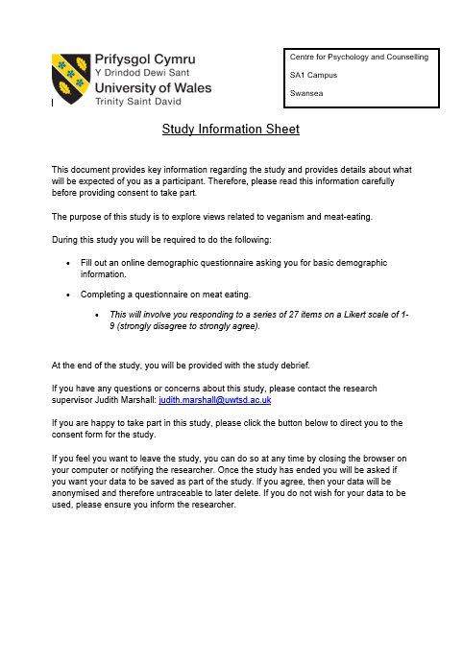
Appendix 1 - Study information sheet

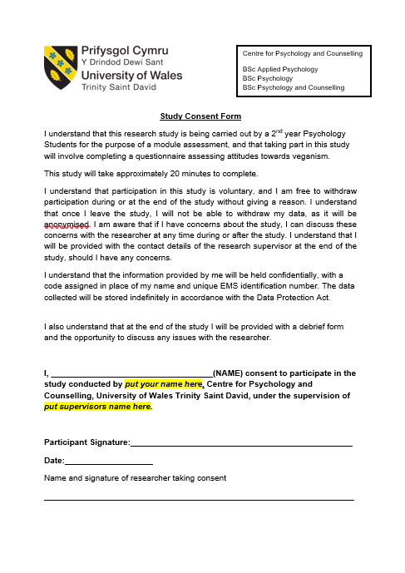
Appendix 2 - Study consent form
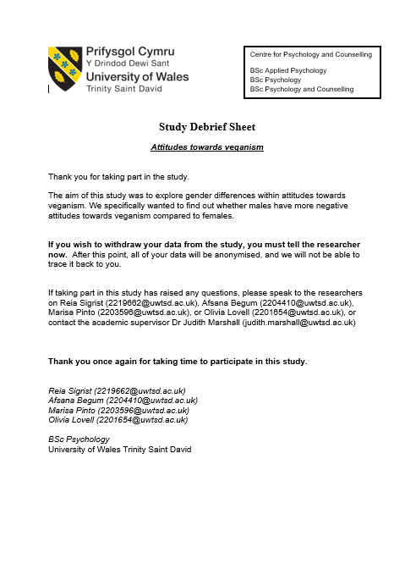
Appendix 3 - Study debrief sheet
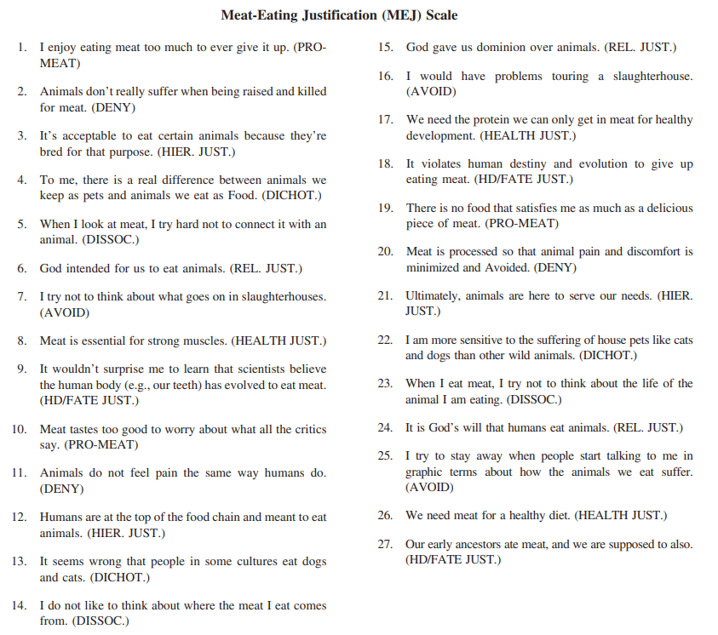
Appendix 4 - Meat eating justification questionnaire

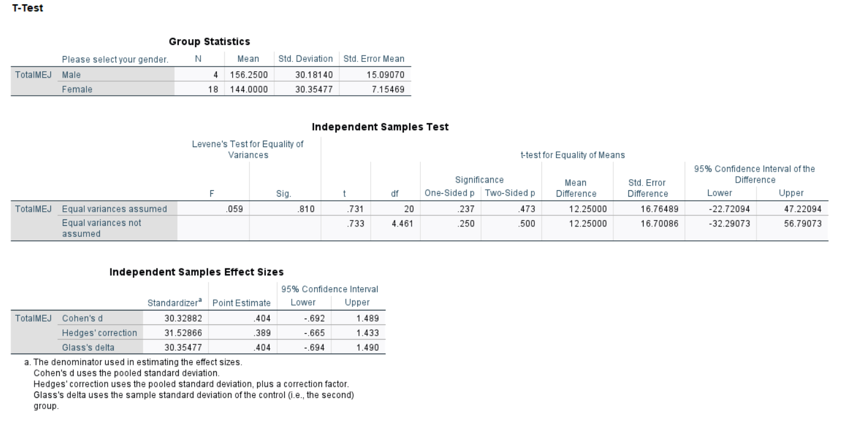
Appendix 5 - SPSS output
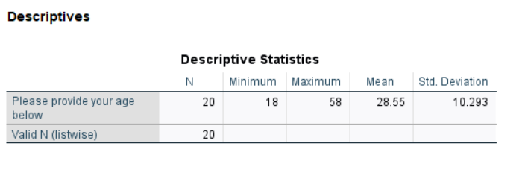
Appendix 6 - Descriptive statistics SPSS

