LCLM6004 – Research Methods for Business

Name: Ionela-Diana Bojila
Student ID: 2121819

Assignment title: Component 1- Business research proposal: The Effect of Digital Transformation on Leadership Skills: Adapting Management Practices in the 21st Century Workplace

Contents

1. Identification of a Business Problem with Background and Rationale 3
1.1. Background of the study 3
1.2. Problem statement 3
2. Research Aim, Objectives and Questions 3
2.1. Research Aim 3
2.2. Research Objectives 4
2.3. Research Questions 4
3. Preliminary Literature Review 4
4. Research Methodology and Design 7
4.1. Research Approach 7
4.2. Data Collection Methods, Sampling Strategies, and Ethical Considerations 8
5. Business Relevance and Practical Implications 8
5.1. Impact of Findings on Business Practices 8
5.2. Informing Decision-Making, Management Strategies, and Industry Developments 9
6. Plan of Work and Time Schedule 10
7. References 11

1. Identification of a Business Problem with Background and Rationale

1.1. Background of the study
Digital transformation is redefining organisations, work processes and even the nature of leadership at rocket speed. A key emerging issue across most sectors is the simple fact that current executive competencies are woefully misaligned with the needs of a digitally enabled workplace. The command-and-control school leaders simply do not have-in most cases-the agility, tech know-how and muscle memory for adaptation that will be increasingly required to lead effectively in fast, data-driven environments.
This misalignment creates operational inefficiencies, resistance to change, and diminished competitiveness within the organisation. Northouse (2021) argues that effective leadership is about the alignment of competencies with context. However, organisations frame their struggles in developing leadership frameworks suited to a digital context as a challenge of contextualisation.

1.2. Problem statement
The AI and automation technologies and remote work collaboration have intensified this challenge by requiring new forms of strategy thinking, digital acumen, and transformational leadership (Westerman et al., 2018).
This is a major problem since organisations that carry out such training eventually lose leaders to competitors do not have any choice but to embrace digital leadership at all levels. The academic debate appears centred on either the adaptation of traditional leadership models or totally new emergent frameworks (Kotter, 2021). Recent discourse proposes hybrid leaders who develop from inside knowledge workers able to display emotional intelligence and possess tech acumen plus inclusivity skills required to manage distributed teams (Gratton, 2022). This paper discusses ways in which leadership has to change to enable it address the composite challenges presented by a 21st-century workplace.

2. Research Aim, Objectives and Questions

2.1. Research Aim
To conduct a critical assessment of the impact of digital transformation on leadership skills and management practices, and an evaluation of methods through which organisations can adjust to develop leadership abilities suitable for the 21st-century workplace. The study conducts an analysis of essential adaptive leadership competencies in a technologically driven environment of change, reviewing present models for developing leaders and suggesting ways to synchronise leadership development with digital transformation. Thus, blending academic theory with contemporary management practice, this paper seeks to provide insight as to how organisations may articulate the gap between traditional conceptions of leaders and emerging imperatives associated with agility, innovation,

2.2. Research Objectives
To critically analyse how digital transformation is reshaping leadership roles and competencies.
To evaluate the adequacy of present leadership development models in the context of supporting digital adaptation.
To suggest strategies for enhancing leadership skills to meet digital transformation challenges.

2.3. Research Questions
How has digital transformation redefined leadership skills and competencies in the 21st-century workplace?
How adequate are existing leadership development models for supporting digital adaptation?
What strategies can organisations adopt to build adaptive leadership capabilities in digital contexts?
What role does organisational culture play in facilitating or hindering digital leadership transformation?
How can ethical and human-centred approaches enhance leadership effectiveness during technological disruption?

3. Preliminary Literature Review

In the 21st century, digital transformation has redefined paradigms of leadership and practices at the organisational level. Rapid infusion of artificial intelligence (AI), automation, data analytics, and hybrid working models comprise technologies that have significantly redefined the way leaders motivate, communicate, and make decisions (Avolio, Walumbwa and Weber, 2018). This literature review discusses effects brought about by digital transformation on leadership skills and management practices within adaptive, transformational, and strategic leadership frameworks (Schein and Schein, 2019).
According to Gratton (2022), with the rise of hybrid and flexible work models, leaders are increasingly responsible for managing teams that are physically and virtually dispersed. They must keep such teams engaged and productive.[1] Kotter (2021) observes that digitally maturing organisations typically possess adaptive leadership cultures where experimentation is encouraged, a shared vision exists, and there is continuous learning.[2] Hence, digital era leadership is not solely about steering technological adoption. It involves developing human adaptability and fostering psychological safety amidst disruption.
Avolio, Walumbwa, and Weber (2018) state that digital transformation blurs the boundaries between leadership and technical aspects. They introduce a concept of e-leadership where “technology-enabled communication, collaboration, and decision-making systems” serve as channels mediating leadership effectiveness. Competencies of successful digital leaders include techno-literacy, emotional intelligence, and strategic acumen.
Daft (2020) further adds that leaders of today’s organisations must be efficient in transactions while being inspiring transformation. Therefore, even though the digital systems make easy the streamlining of processes and measuring performance towards objectives, leaders have to inspire creativity, commitment, and trust building within teams. Hence, successful leadership in a technologically driven environment should be defined by both digital intelligence and emotional intelligence (Hitt, Ireland and Hoskisson, 2021).
Northouse (2021) provides a contextualization of digital leadership within theoretical constructs. He believes that the components of transformational leadership-vision, inspiration, intellectual stimulation, and individual consideration-remain pertinent but should be reinterpreted in the digital context. For example, a transformational leader has to utilize digital means to build trust, articulate vision, and empower employees over virtual platforms. The real test lies in displaying authenticity and sustaining an interpersonal connection through a mediated channel.
Leaders need to be competent in digitally fluent, agile, and strategically oriented ways. Easterby-Smith, Thorpe, and Jackson (2021) emphasized the fact that leaders should be capable of mastering “learning agility” — the capability to rapidly acquire technological knowledge under conditions of uncertainty and apply it within practice. They further emphasize the need to promote reflective practice among professionals as a means of harnessing digital leadership capacity.
Avolio et al. (2018) insist that techno-integration competencies are to be woven with the fabric of human relations competencies. Leaders should have knowledge not only about digital systems but also about how these manifest psycho-dynamically and psychosocially among workers (for example, anxieties and resistance that may be provoked by the introduction of automation and artificial intelligence). Empathy techno-integration leaders will then become a sine qua non in sustaining morale and confidence (Goleman, 2022).
Gratton (2022) adds to this aspect by emphasizing human-centred digital leadership, where employee well-being becomes the core of technological transformation. With more hybrid working environments, leaders are supposed to acquire competencies in digital communication, inclusiveness, and boundary management to ensure that technology sustains and does not erode positive experiences by employees.
Leader behaviour and organization culture create mutual reinforcement in digital transformation. Kotter (2021) noted that successful digital change needs a dual operating system—one of hierarchical stability and another agile network. This allows leaders to coordinate innovation meanwhile maintaining governance and accountability.
Leaders must serve as cultural architects, shaping values and norms that include innovation, risk-taking, and psychological safety (Daft, 2020). It is important for leaders to remember that the learning experiment comprises losing tolerance for failure; hence, digital transformation through an experimental culture is contingent upon leadership learning to tolerate failure as a form of learning. Bell, Bryman, and Harley (2019) observe faster technological adoptions in organizations with collaborative and transparent organizational cultures.
Gratton (2022) further states that leaders should develop a “socially connected digital culture” making everyone feel included regardless of where they are sitting. This hybrid working redefines the communication rhythms, accountability, and even digital etiquette. Her writing and other literature underline leadership’s cultural influence on whether digital tools become innovation-enablers or alienating sources.
Gratton (2022) suggests hybrid leadership learning allows flexible and inclusive access to global networks and different points of view. Northouse (2021) similarly affirms that mentorship and peer collaboration, supported by digital platforms, can sustain leadership growth and cross-functional integration.
The reviewed literature redefines leadership competencies. Leaders must integrate techno- logical knowledge with emotional and ethical intelligence to manage hybrid workplaces and data-driven systems. The themes of adaptability, continuous learning, and people-centred management appear in all the sources (Gill, 2020).
However, gaps remain. First, while existing studies conceptually explore leadership adaptation, few provide empirical evidence on long-term leadership development outcomes in digital environments (Creswell and Creswell, 2018). Second, the literature gives more attention to large corporations than to SMEs and public sector leadership contexts. Lastly, the integration of AI ethics and psychological well-being in leadership research remains underdeveloped (Zenger and Folkman, 2020).

4. Research Methodology and Design

4.1. Research Approach
A qualitative approach supported by descriptive and interpretivist perspectives will be adopted regarding how digital transformation influences leadership skills and management adaptation in contemporary workplaces. The secondary research facilitates conducting an intensive review of academic literature, reports, and case studies therein to discover emerging patterns and theoretical insights without imposing any constraints through primary data collection (Saunders et al., 2019).
The reason behind choosing a qualitative design is because the study aims to explore human behaviour in leadership and organisational change which are more appropriate to be interpretatively explored than measured numerically (Bryman,2018). This research will conduct a content analysis of previous studies to synthesise themes around leadership agility, emotional intelligence, and technological adaptability in digital business environments.
Secondary qualitative research permits the triangulation of data from several highly credible sources such as journal articles, business case studies, government publications, and industry white papers. This allows the formation of conceptual insight into how leaders acquire new competencies to respond to technological disruption (Creswell and Creswell, 2018).
The research takes an interpretivist epistemology, seeking the subjective meaning leaders and organisations attach to digital transformation. This allows a fine understanding of the nuances in how leaders have adapted, beyond statistical generalisation (Bell et al., 2019). The reasoning process is largely inductive and will allow for the emergence of themes through thematic analysis, such as recurring concepts of innovation mindset, digital communication and data-driven leadership.

4.2. Data Collection Methods, Sampling Strategies, and Ethical Considerations
Due to the secondary qualitative nature of this study, data collection will be based on documents and literature. Academic journals and books, organizational reports, and government publications shall provide the bulk of the primary data. The researcher shall systematically search databases that include Google Scholar, Emerald Insight, and ScienceDirect among others using keywords such as digital transformation, leadership adaptation toward technological change, and 21st-century management.
The purposive sampling strategy shall target sources published between 2017 and 2024 to make them relevant in the present modern digital era. The inclusion criteria will capture studies reporting leadership behaviour in digitally transforming industries, while the exclusion criteria remove outdated or non-peer-reviewed materials (Easterby-Smith et al., 2021). The paper can therefore be selective to ensure analytical depth and academic validity.
The data will be analysed by coding the themes which recur in ideas and frameworks and leadership attributes discussed with respect to digital transformation. Themes such as adaptive decision-making, techno- logical competence, and change-oriented communication will provide the basis on which conclusions are synthesis (Saunders et al., 2019).
Ethical considerations play a critical role even in secondary research. This study follows the British Educational Research Association (BERA) ethical guidelines on maintaining integrity, accuracy, and transparency of data (Bell et al., 2019). It will give full citations and referencing to acknowledge all information used so as to avoid plagiarism. Since there are no human participants involved in this study, there can be no risk pertaining to violation of privacy or informed consent

5. Business Relevance and Practical Implications

5.1. Impact of Findings on Business Practices
Findings from this study will have significant implications on contemporary organisations aiming to succeed within the digital economy. Competencies that management and staff within human resource departments must possess in order to achieve successful digital transformation, as encapsulated by the new leadership competencies brought about through digital transformation, will inform businesses in fine-tuning their management development frameworks and workforce strategies (George, Sims, McLean and Mayer, 2021).
As industries become more data-driven and automated, remote collaboration tools continue to keep operations running, leaders must be digitally fluent and emotionally intelligent with an ability to quickly adapt. The research will show how these competencies help to inspire engagement, productivity, and innovation among workers (Northouse, 2021). Businesses can use these insights in developing a new design for leadership training programs that would ensure the accommodation of technology integration and constant evolution (Bennett and Lemoine, 2022).
In bigger organizations, results can help HR departments fine-tune succession planning and leadership pipelines to highlight digital skills and transformational capabilities. At the end of the day, by aligning digital adoption with human capital growth, the research links technology investment with management preparedness for sustainable competitive advantage in a swiftly changing business landscape (Kotter, 2021).

5.2. Informing Decision-Making, Management Strategies, and Industry Developments
The study will enable executive leaders against a background of cross-industry heterogeneity in the provision of new conceptual and empirical knowledge on the mechanisms by which digital transformation invokes emerging management paradigms. It will articulate academic theory with real-world insight to emphasise how change is driven through new modes of management (Alvesson and Spicer, 2019).
For decision-makers, the study will focus on emphasising the need to align technology adoption with agile leadership. A manager who understands digital ecosystems is better positioned to make informed decisions based on information and enhance responsiveness and innovation within a flatter organisation that is decentralised (Teece, 2020).
The research will recommend a management strategy in which firms remain receptive to flexible modes of leadership that integrate collaborative, adaptive, and participatory approaches. It discusses how digital leaders embody traditional management principles while also developing new competencies in areas such as remote communication, data analysis, and collaboration with different functional areas (Easterby-Smith et al., 2021).

6. Plan of Work and Time Schedule

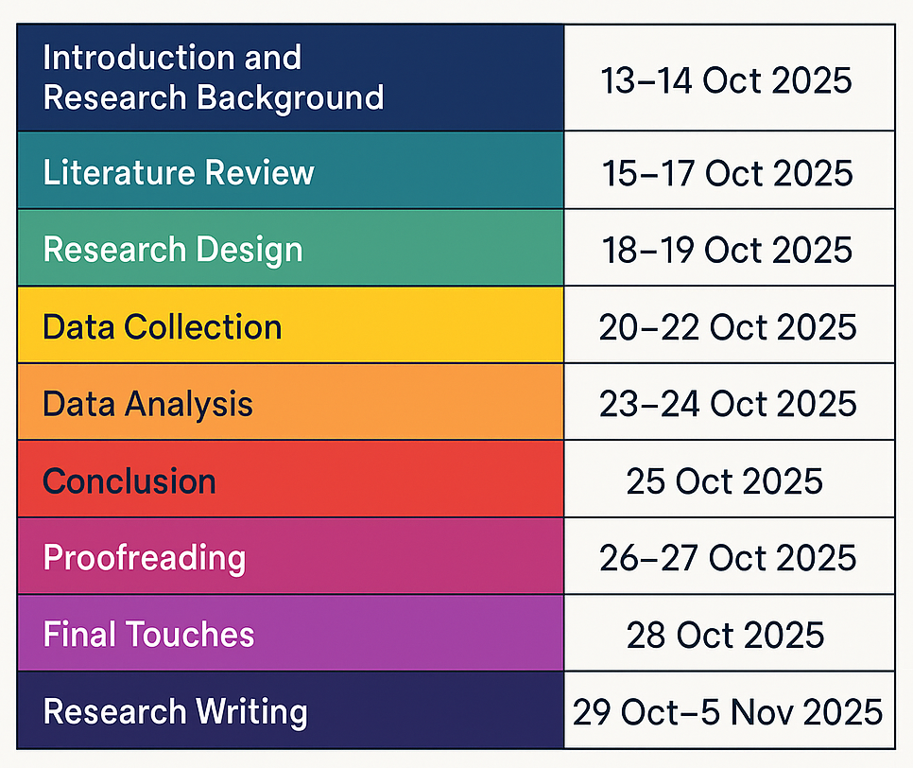

7. References

Alvesson, M. and Spicer, A. (2019) The Stupidity Paradox: The Power and Pitfalls of Functional Stupidity at Work. London: Profile Books.
Avolio, B., Walumbwa, F. and Weber, T. (2018) Leadership in a Digital Age. New York: Routledge.
Bell, E., Bryman, A. and Harley, B. (2019) Business Research Methods. 5th edn. Oxford: Oxford University Press.
Bennett, N. and Lemoine, G.J. (2022) Leadership in the VUCA World: Developing Dynamic Capabilities for Uncertainty. New York: Routledge.
Bryman, A. (2018) Social Research Methods. 5th edn. Oxford: Oxford University Press.
Collis, J. and Hussey, R. (2021) Business Research: A Practical Guide for Students. 6th edn. London: Palgrave Macmillan.
Creswell, J.W. and Creswell, J.D. (2018) Research Design: Qualitative, Quantitative, and Mixed Methods Approaches. 5th edn. Thousand Oaks: Sage Publications.
Daft, R.L. (2020) The Leadership Experience. 8th edn. Boston: Cengage Learning.
Easterby-Smith, M., Thorpe, R. and Jackson, P. (2021) Management and Business Research. 6th edn. London: Sage Publications.
George, B., Sims, P., McLean, A.N. and Mayer, D. (2021) Authentic Leadership: Rediscovering the Secrets to Creating Lasting Value. Boston: Harvard Business Review Press.
Gill, R. (2020) Theory and Practice of Leadership. 3rd edn. London: Sage Publications.
Goleman, D. (2022) Emotional Intelligence in the Digital Age: Rethinking Leadership for the Future of Work. New York: Bantam Books.
Gratton, L. (2022) Redesigning Work: How to Transform Your Organisation and Make Hybrid Work for Everyone. London: Penguin.
Hitt, M.A., Ireland, R.D. and Hoskisson, R.E. (2021) Strategic Management: Concepts and Cases: Competitiveness and Globalization. 14th edn. Boston: Cengage Learning.
Kotter, J.P. (2021) Change: How Organisations Achieve Hard-to-Imagine Results in Uncertain Times. New York: Scribner.
Northouse, P. (2021) Leadership: Theory and Practice. 9th ed. London: Sage.
Saunders, M., Lewis, P. and Thornhill, A. (2019) Research Methods for Business Students. 8th edn. Harlow: Pearson Education.
Schein, E.H. and Schein, P.A. (2019) Organizational Culture and Leadership. 5th edn. Hoboken: Wiley.
Teece, D.J. (2020) Dynamic Capabilities and Strategic Management: Organizing for Innovation and Growth. Oxford: Oxford University Press.
Ulrich, D., Kryscynski, D., Brockbank, W. and Ulrich, M. (2019) Victory Through Organisation: Why the War for Talent is Failing Your Company and What You Can Do About It. New York: McGraw-Hill.
Westerman, G., Bonnet, D. and McAfee, A. (2018) Leading Digital: Turning Technology into Business Transformation. Boston, MA: Harvard Business Review Press.
Yukl, G. (2020) Leadership in Organisations. 9th ed. Harlow: Pearson.
Zenger, J.H. and Folkman, J. (2020) The New Extraordinary Leader: Turning Good Managers into Great Leaders. New York: McGraw-Hill Education.

