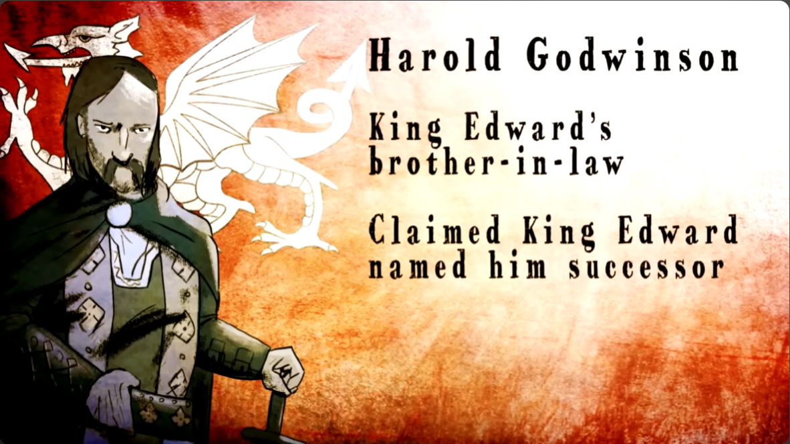
Battle of Stamford Bridge
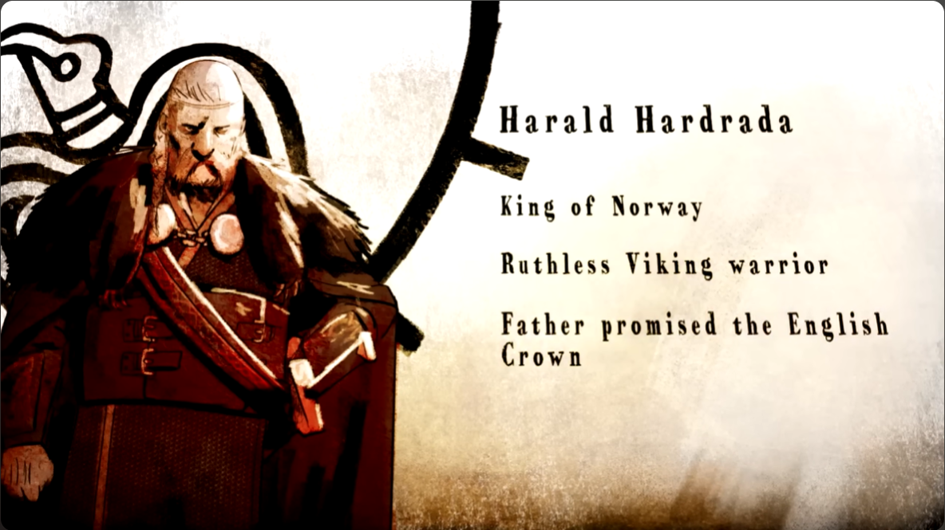
1066: Battle of Stamford Bridge (3/6) | History – The Norman Conquest is a learning tool made by BBC History. An animated video intended for teachers of key stages 2-3 and GCSE students and part of a series of videos covering the Norman conquest of Britain and the battles of succession preceding it in 1066. This video, as per the title, details the Battle of Stamford bridge during which Harold Godwinson, King of England defeats Harold Hardrada, King of Norway. The narrator does not seem to be credited but is presumably an employee of BBC as of 2016 when the video was posted to the BBC Teach channel on YouTube.
Screencap at 1:00
Following the Battle of Fulford in which Hardrada defeated the army of Earls Edwin and Morcar, Hardrada was celebrating the victory at Stamford Bridge while awaiting hostages. Hostages intended as a show of loyalty after he won the Battle of Fulford, he is however, ambushed by Godwinson's army that had marched 300 kilometres (180 – 200 miles) in five days, from London to York. The opposing armies were separated by a bridge, where Godwinson’s army was held back by a lone Viking Berserker until an English soldier crept under the bridge and speared the Berserker through the slats. There was a brief attempt at negotiation where Harold Godwinson attempted to bring his brother Tostig back onside, only when Harold said that Hardrada would receive nothing in return for the efforts, did the battle ensue.
Screencap at 1:16

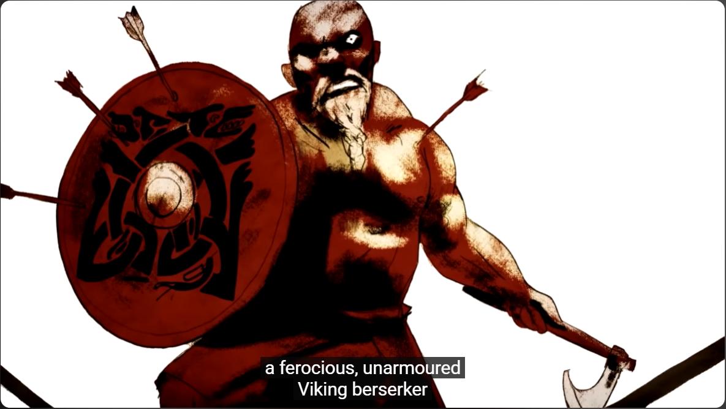
With their armour on the boats sitting 25 kilometres (15 miles) away and messengers riding to alert the reserve army, Hardrada’s men go into battle with weapons but without their armour and Hardrada goes with them. Hardrada is killed by an arrow to the throat, and his army is thoroughly defeated, Hardrada’s son, Olav, surrenders to Godwinson and he lets what is left of the army go with an oath of loyalty and a promise to never attack them again. The Norwegian army left the battle so defeated that of 300 ships that brought the army across to England, only 25 were required to take the remainder back.
Screencap at 3:13

The Anglo-Saxon Chronicles is named as the source for the events of this battle, specifically the account of Florence of Worcester (an English Monk) covers the surrender of Hardrada’s son to Godwinson. The Chronicles themselves are accounts of events in Anglo-Norman England from the 9th century CE, compiled from seven manuscripts over the course of 300 hundred years, with the longest covering up until 1154 CE. Even then the quality and completeness of these manuscripts vary, with some being a useful source for some events, like the Battle of Stamford Bridge (Florence of Worcester) and the very same manuscript being barren for other periods of time.
Some prior knowledge of the events in this video is likely expected due to its placement in a series of videos detailing The Norman Conquest however, the video gives a brief recap of each of the main players and their motivations, namely Harold and Tostig Godwinson and Harald Hardrada with Harold and Harald both making individual claim to the throne.
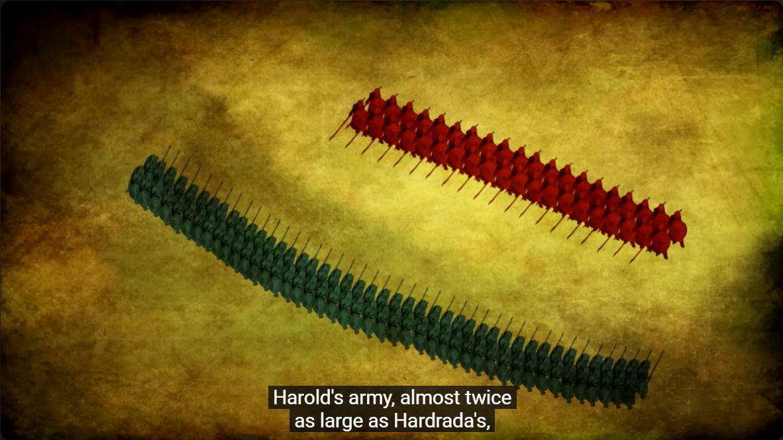
Whiles this video is an animation, the illustrations themselves are primarily still rather than going through frames to seem as though they are moving, the video gets closer and somewhat more detailed in some scenes such as the brief attempt at negotiation whereas others scenes zoom out and are more simplified, such as the scene that visually represents the shield wall tactic used during the battle. The art utilises a mostly, neutral earthy colour palette, primarily browns and reds with blue used for the English to distinguish between armies. Though the art is relatively simple, it has an aesthetic quality to it that can keep the viewers' attention and interest, especially when paired with the audio used in the video.
Screencap at 3:50
A clear female voice narrates the events shown in the video, explaining the battle and referencing the source from which the material comes. She keeps pace with the events in the animation, her tone of voice reflecting the tensions of the scenes and creating drama that keeps the viewer interested. As this is paired with both background music; a sombre track that emphasises the seriousness of the battle being taught and sound effects such as swords clashing and men shouting during the scenes that narrate the actual battle. Even with all these moving parts the video is harmonious and complements each other to keep the attention of the viewer as well as being easy to follow, understand and remember.
Despite being a useful resource, the pace of the video is somewhat slow, narration included. Though this is likely for clarity’s sake and understandable if it is so, the pace may cause some viewers attention to wane especially when targeted at highschoolers. Speeding it up would of course make an already short video of 6 minutes even shorter. The ‘issue’ of attention span is one easily solved as YouTube offers a setting to speed up the video, up to two times speed. You can also slow down the video as far as 0.25 times speed though this is non-applicable to this criticism, it is good to note for viewers with different learning speeds.
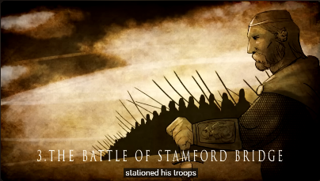
In conclusion this video does what it sets out to do as a learning resource, providing a short but comprehensive narration of the Battle of Stamford Bridge. It caters to its intended audience and does so in a manner that is engaging without being overwhelming, discordant, or forgetful. Though recommended for GCSE, it is a resource that could act as a good starting point even for older students wanting to do further research into the topic or for younger ages as well – with consideration to the minimal amounts of violence portrayed in the video, the age it is appropriate for may vary regardless, it is a good resource.
Screencap at 0:12

Bibliography
BBC Teach (2016a). 1066: The Battle of Fulford (2/6) | History – The Norman Conquest. [online] www.youtube.com. Available at: https://www.youtube.com/watch?v=m9NdbxQWdJ8 [Accessed 9 Mar. 2024].
BBC Teach (2016b). 1066: The Battle of Stamford Bridge (3/6) | History - The Norman Conquest. [online] www.youtube.com. Available at: https://www.youtube.com/watch?v=qtW7H7yPZLg [Accessed 9 Mar. 2024].
The Editors of Encyclopaedia Britannica (2025). Anglo-Saxon Chronicle. [online] Encyclopaedia Britannica. Available at: https://www.britannica.com/topic/Anglo-Saxon-Chronicle [Accessed 18 Feb. 2026].
The Editors of Encyclopaedia Britannica (2026). Florence Of Worcester | Anglo-Saxon, Chronicler, Monasticism. [online] Encyclopaedia Britannica. Available at: https://www.britannica.com/biography/Florence-of-Worcester [Accessed 18 Feb. 2026].

BBC Teach (2016a). 1066: The Battle of Fulford (2/6) | History – The Norman Conquest. [online] www.youtube.com. Available at: https://www.youtube.com/watch?v=m9NdbxQWdJ8 [Accessed 9 Mar. 2024].
The Editors of Encyclopaedia Britannica (2026). Florence Of Worcester | Anglo-Saxon, Chronicler, Monasticism. [online] Encyclopedia Britannica. Available at: https://www.britannica.com/biography/Florence-of-Worcester [Accessed 18 Feb. 2026].
The Editors of Encyclopaedia Britannica (2025). Anglo-Saxon Chronicle. [online] Encyclopedia Britannica. Available at: https://www.britannica.com/topic/Anglo-Saxon-Chronicle [Accessed 18 Feb. 2026].

