ELIZABETH LINE SUCCESS AND CROSSRAIL 2
Noemi Bregolin
2030799

TABLE OF CONTENTS
INTRODUCTION 2
A CULTURE BASED ON WORK 2
INCREASED OF TRANSPORT OF PEOPLE………………………………………………………………………..………..3
ACCESSIBILITY FOR EVERYONE………………………………………………………………………..……………………..4
SUSTAINIBILITY………………………………………………………………………..……………………………………………..5
OTHER CHALLENGE CROSSRAIL 2………………………………………………………………………..………………….7
THE SUCCESS OF THE ELIZABETH LINE………………………………………………………………………..………….8
FACTORS TO CONSIDER DURING THE IMPLEMENTATION OF CROSSRAIL 2…………………………….8
CONCLUSION………………………………………………………………………..………………………………………………10
REFERENCES. ………………………………………………………………………..……………………………………………..11

INTRODUCTION

Project management has been linked to several functional activities, each of which must be completed more efficiently to achieve the intended project goals and objectives. One such report centres on the review of the Crossrail project, for which Crossrail Limited has agreed to take responsibility for both the construction works and delivery of the Elizabeth line. Several factors were analysed as to how and why the Elizabeth project was not fully completed within budget. However, the project has led to significant benefits, including major cost-effectiveness. This effort aimed to bring about greater efficiency so that more services could be provided to society while also solving real-world problems. This section requires carrying out a thorough investigation of the project based on the previous analysis to understand whether it is a success or a failure and how the mistakes made can be improved in future projects. Consequently, the objective of this document is to share critical information and understand how its implementation has also led to various benefits.

A CULTURE BASED ON WORK
As already mentioned in the first assignment, project management plays the most crucial role in the various activities in such a project workflow so as to produce the completion of the operations and maintenance process. This same responsibility is therefore essential for planning and controlling the various activities as well as making changes based on the external situation of the project (Ellahi et al. 2022). However, the achievement of the work phases also strongly depends on the workforce and their technical knowledge. Elizabeth's line mainly demonstrates that Cross rails limited appears to be intensely focused on creating an influential work culture by attempting to remove internal and external uncertainties and risks to project operations. By attracting workers, as a result, staff members have already been supported across the UK.
61% of supplier contracts were awarded to companies based outside London; moreover, most contractors were in the UK, precisely 96%. The vast production chain has allowed the involvement of thousands of workers and the deepening of the experience of many engineers. (Transport for London, 2022). Precisely the Cross-rail project created 55,000 jobs (TfL Press Office, 2022).

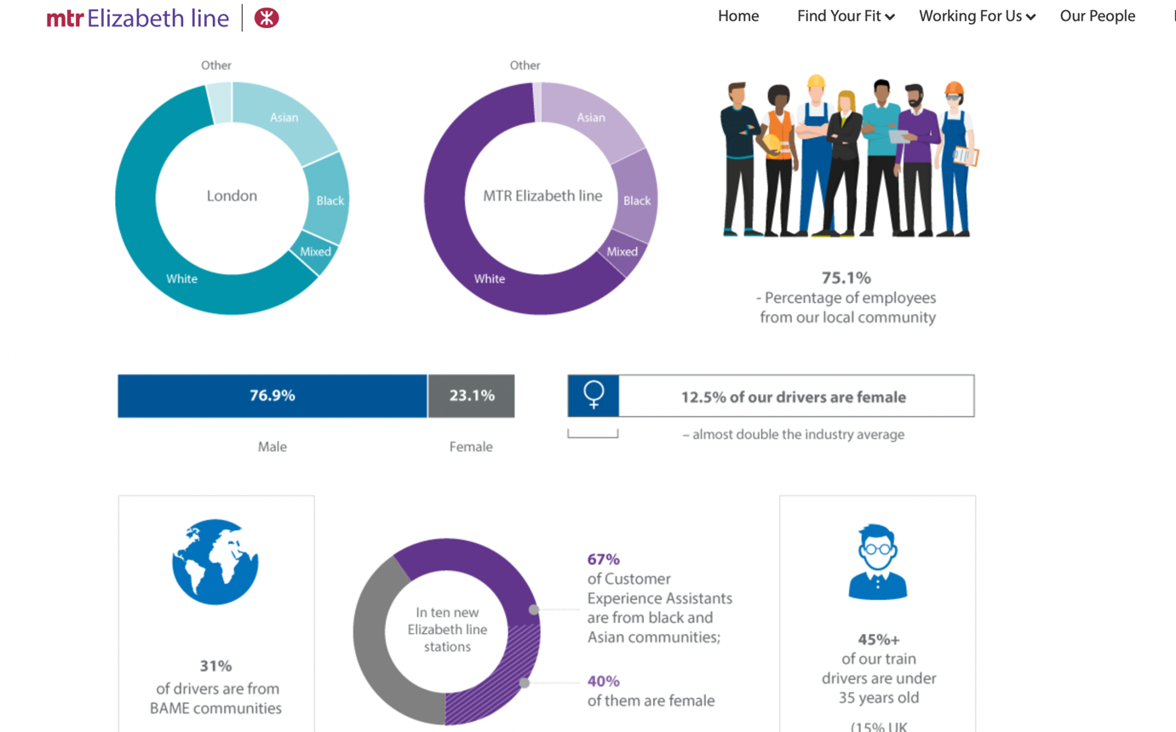

Work culture is not only based on statistics but also on moral concepts.
Indeed, the program includes an improvement of diversity within the workplace by creating opportunities by releasing barriers and inclosing under-represented groups. The Elizabeth line project has achieved almost double than the transport industry average of female drivers. 45% of the drivers are under 35 years old and 75.1% of the workers are local.
As well 67% of the customer service workforce is Asian and black.
(MTR Elizabeth Line Careers, 2023)
The initiative paired with multiple partnerships, like ENEI, Disability Confident, Stonewall, working mums, and Young London Working (MTR Elizabeth Line Careers, 2023). The organizations aim to represent in the workspace also the groups that are usually underrated like mothers, young workers, and people with disabilities.
.
INCREASE IN TRANSPORT OF PEOPLE

Indeed, the Elizabeth Line will increase the capacity of rail transport in the British capital, thus responding to the growing demand for mobility of citizens. The increased capacity will therefore improve not only commute times but also the safety and comfort of commuters.
Once fully operational, the line will serve 41 stations (10 of which are built from scratch) and will handle at least 24 journeys per hour in both directions, for a total of around half a million passengers per day.
The idea is possible thanks to three factors: the increase in train capacity, the improvement of the connections between areas of London, and frequency and speed. One such high-speed rail line is projected to transfer 200m visitors per year, going to represent a 10% increase in the town's Central implies of supply. It would provide more frequent and productive train service for the City's expanding population and contribute approximately £42.01 billion to the UK economy (Paris and Mellings, 2021).
From Reading and Heathrow throughout the hinterlands to the East Midlands but instead Old Oak Common throughout the east, England's newest railway provides 41 pathways. Even though, once fully implemented, this same Elizabeth boundary will increase central London's capacity for demonstrations by 10%, attempting to bring an additional 1.5 million people within 45 minutes of something comparable to the city. Ten of either the 41 stations, including South Station and Old Oak Common, appear to be unique and hidden below the surface (Crossrail Ltd, 2022).
A possible increase in infrastructure planned for this project has been tailored to future station increases.
Strictly related to transport is also the decrease in the time taken to travel the same routes. In fact, the line includes the city's key destinations and Canary Wharf to cut time, making it well integrated with the rest of the TFL services.
(Crossrail Ltd, 2022).

ACCESSIBILITY FOR EVERYONE
With the Crossrail Project, London has been engaged for some time in the progressive removal of architectural barriers present in the urban area to ensure the best usability of mobility services for citizens with temporary or permanent disabilities (Transport for London, 2022).
In order to continue, in a proactive, organic, systematic, and progressive manner, the process of eliminating architectural, communication, and perceived barriers is necessary to guarantee people with disabilities the whole usability of surface services, underground lines, and railways. (MTR Elizabeth Line Careers, 2023).
Crossrail is involved in some infrastructure design, construction, management processes, and specific dedicated services. As a result, the railway line is secured and accessible to everyone. Clarity and consistency are ensured through signage, handrails, escalators, and lifts. (Crossrail Ltd, 2022).

SUSTAINIBILITY

The project management team within this cross-rail project also denotes that risk estimation and risk correction are the main areas of concern to establish an effective process for implementing the project activities. This construction project includes numerous external and internal risks, and the project manager's responsibility is to identify any initial or existing uncertainties within the procedure so that a reasonable action plan can be developed regarding prevention and reduction.

Active flood protection measures

Knowing the possible risks of climate change, from fires to catastrophic flooding and the global change in temperatures, Crossrail can prevent incidents. Flooding could intact not only a part of the rail but also underground tunnels as the lines are also connected underground.
From this, it foresees the search for measures aimed at flood protection, such as floodwall protection and rail elevations. Active measures are instead stopped logs, or barriers (Paris and Mellings, 2021).

Energy Efficiency Design

The project's collaboration with stakeholders and local authorities has made it possible to resize external environments, replacing old components.
The focus is not only on urban areas but also on the maintenance of natural areas and wildlife, such as Stockley Junction. Optimization of materials, efficiency in procuring scraps, and design for future constructions have revolutionized the construction process. The main component was the concrete which could be recycled through substitutes such as granulated ground blasts (Paris and Mellings, 2021).

Construction Emission

The Crossrail project also concentrates on decreasing construction emissions by setting a target of 8%. LED Lighting towers, hydrogen-fuelled solar panel noise monitors, hybrid excavators, and equipment are some of the factors that have helped achieve savings of more than 18% in carbon, equating to more than £2 million(Paris and Mellings, 2021).

Light trains of up to 350 tons help save on missions. Reconnecting to the topic of the contractors outside London, the design of the trains weighing 319 tons was a success achieved precisely by the design of partners (Paris and Mellings, 2021).

Lightining

The lighting system is also connected to natural lighting through the glass walls as in Paddington station. Furthermore, using solar panels is another opportunity, located at the Whitechapel station and Old oak common (Paris and Mellings, 2021). The integration of sustainability options into the Elizabeth line has already resulted in several social, organizational, and environmental aspects. As a result of initiatives such as the construction and deployment of the Elizabeth Line and its contractors (as already mentioned in the paragraph on culture based on work), energy needs have actually been significantly reduced. LED lighting is 62% more energy efficient than regular lighting.

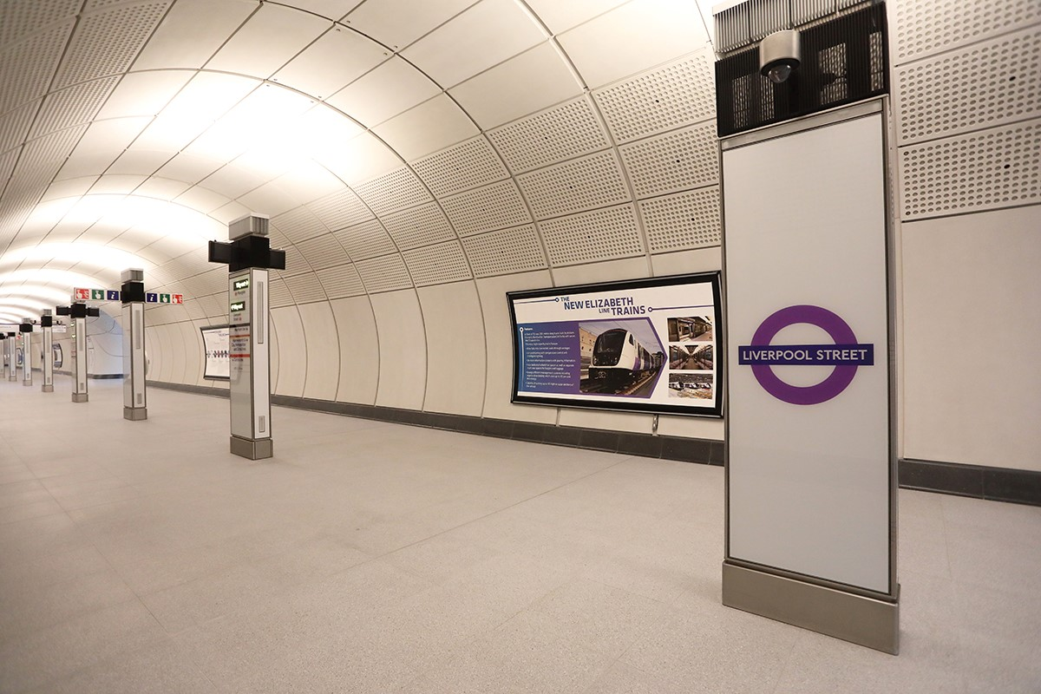

The implementation of environmentally friendly practices is successful: including an emphasis on natural light in all terminals, the implementation of LED bulbs instead of fluorescent lighting, light rail lines, and even more for power generation. Even glass laminated signalling has been installed at the bottom of the stairs, to avoid any false signalling due to glares (Doyle, 2022). This also changes the passenger experience, accustomed to poor lighting and gloomy metropolitan environments.

THE SUCCESS OF ELIZABETH LINE
Considering many aspects, the Cross-rail Elizabeth line project, compared with the other lines, can be regarded as successful. Despite the delays and increased budget, the line shows a futuristic design given by a project of considerable complexity. Furthermore, the Elizabeth line will significantly improve the city's public transport coverage by substantially reducing journey times by providing additional transport capacity and making the city more accessible. As already mentioned, the project is also a £42 million benefit to the UK economy. Personally, the project's success is quite astonishing, and it is the most liveable underground line compared to means of transport in other countries.

OTHER CHALLENGE: CROSSRAIL 2

With a similar purpose to the Elizabeth line, Crossrail 2 is to boost passenger carrying capacity from East to West London, which is currently the most developed area. National Rail Network in Surrey, with destinations to Shepperton, Hampton Court, Chessington South, and Epsom, and in Hertfordshire, via Wimbledon. The project will be connected to the London Underground, Overground, and National Rail services. Above all, this line will facilitate travel in London and throughout the South-West, a significantly developing area.

An increase in transport capacity of approximately 270,000 passengers is expected, and a substantial decrease in congestion on other lines. In addition, a reduction in journey times will be ensured by connecting 35% UK rail network with direct journeys provided by the project.

The scheme will also provide for an increase in infrastructure, 60,000 jobs, and consequently, in the long term, an increase in the development of new housing areas.

However, the planned Budget covers 33bn pounds, the main problem of the implementation of the project. (Tunnicliffe, 2022)

FACTORS TO CONSIDER DURING THE IMPLEMENTATION OF CROSSRAIL 2

It can be concluded that project management has been linked to several functional activities, each of which must be completed more efficiently to achieve the set objectives. According to the Elizabeth line project, this same essential responsibility of the manager is to plan and control various activities as well as make changes to the procedure based on any external problems. Learning from the negative experience and the project's positive results, a margin of flexibility within the operations, and an analysis of the external conditions are fundamental enrichment of the plan.

The possible risk of the budget appears to be an internal uncertainty and a different utilization of it is a determining factor. A reallocation of resources can modify phases of the plan to such an extent as to save on the budget. The previously listed factors that led to the project's sustainability are fundamental in future projects' implementation, especially if Crossrail 2 is projected for 2030 (Tunnicliffe, 2022).
Also, the correct management of the workforce, consequently, is the responsibility of the project manager, increasing the value of the production process and a more significant iteration among the members.

The conflict between the groups and counteractors who are part of the production process would slow down the state of the project. Greater control of the production chain for the functioning of the various departments is essential. Also, a careful choice of contractors forms a significant difference. Crossrail 2 is another project that can create competitiveness in acquiring partners. The typical procedure for obtaining items and services is to promote offers according to the relevant regulations (Montiel et al. 2021). The Rail Network and the Design Department require basic contractual processes and terms. By finding suitable offers, construction companies are also assigned to a third-party supplier because it is not the primary responsibility for the project. However, the representatives in this contribution are subject to CRL policies (Crossrail Ltd, 2023). Having teammates knowledgeable in all policy development elements could work and manage and begin to reduce misconceptions (Montiel et al. 2021).

Other economic risks that a budget increase could experience are higher inflation. In addition, an increase in material costs can cause problems in cost management.
Consequently, in terms of economic measurements, the project engineer role is affiliated with negotiating a strategic service contract. Based on the works of the Cross-rail limited construction projects to structure the Elizabeth line, the legitimate risk is related to significant external uncertainty, especially during factors like the pandemic (Rajenthira et al. 2021). Therefore, initiating the project during a stable macroeconomic situation is essential to safeguard the budget.

CONCLUSION

Elizabeth's line was controversial as the problems encountered in the project did not reflect the plan's ambition. However, because the project plan contained innovative elements and because of its aim, the results were still a success.
The most critical phases, planning, and execution of the project must be concise. On the other hand, designing a meticulous plan takes time and details. The executive stage also requires coordination between the departments and their commitment to following the scheduled times.
As for the project Crossrail 2, since its planning covers an even more substantial budget than the Elizabeth line, more meticulous planning needs to be done to avoid the inconveniences that arose with Crossrail 1. Factors leading to conflict and disharmony relate to various areas of performance, teamwork, scope, communication, and personality differences (Rajenthira et al. 2021).
More excellent communication between contractors will ensure a more realistic project planning (including budgeting) and an online execution phase, respecting the deadlines and finding solutions quickly to possible incidents.

REFERENCES

Crossrail Ltd (2022). Crossrail in numbers - Crossrail. [online] web.archive.org. Available at: https://web.archive.org/web/20221228162721/https://www.crossrail.co.uk/news/crossrail-in-numbers [Accessed 10 Jan. 2023].
Crossrail Ltd. (2023). Transparency. [online] Available at: https://www.crossrail.co.uk/about-us/transparency/ [Accessed 12 Jan. 2023].
Doyle, S. (2022). LED lights illuminate London’s Elizabeth Line. [online] eandt.theiet.org. Available at: https://eandt.theiet.org/content/articles/2022/08/lighting-up-londons-elizabeth-line-with-leds/ [Accessed 10 Jan. 2023].
Ellahi, A., Rehman, M., Javed, Y., Sultan, F. and Rehman, H. (2022). Impact of Servant Leadership on Project Success Through Mediating Role of Team Motivation and Effectiveness: A Case of Software Industry. SAGE. doi:1d0o.i.1o1rg7/71/02.1157872/24145082424101222171242774.
Montiel, I., Cuervo-Cazurra, A., Park, J., Antolín-López, R. and Husted, B.W. (2021). Implementing the United Nations’ Sustainable Development Goals in international business. Journal of International Business Studies, 52(5), pp.999–1030. doi:10.1057/s41267-021-00445-y.
MTR Elizabeth Line Careers. (2023). MTR Elizabeth Line Careers. [online] Available at: https://jobs.mtrel.co.uk/jobs/diversity/ [Accessed 10 Jan. 2023].
Paris, R. and Mellings, L. (2021). Sustainability of the Elizabeth line. [online] www.youtube.com. Available at: https://www.youtube.com/watch?v=8-eGHCIYdnI.
Rajenthiran, N., Siriwardhana, S., Samaraweera, A., Dissanayake, D. and Kumarasiri, D. (2021). Managing Intragroup Conflicts in Cross-Cultural Teamwork in Construction Projects in Sri Lanka. [online] Available at: http://ir.lib.ruh.ac.lk/xmlui/bitstream/handle/iruor/3705/21_121_Author%20proof_HRM.pdf?sequence=1&isAllowed=y [Accessed 12 Jan. 2023].
TfL Press Office (2022). Direct Elizabeth line services into central London from Reading, Heathrow, and Shenfield start today - Crossrail. [online] web.archive.org. Available at: https://web.archive.org/web/20221228172235/https://www.crossrail.co.uk/news/articles/direct-elizabeth-line-services-into-central-london-from-reading-heathrow-and-shenfield-start-today.
Transport for London (2022). Elizabeth Line Evidencing The Value. [online] Available at: https://content.tfl.gov.uk/tfl-elizabeth-line-benefits-framework.pdf [Accessed 10 Jan. 2023].
Tunnicliffe, A. (2022). The Elizabeth Line is a success: so what about Crossrail 2? [online] Railway Technology. Available at: https://www.railway-technology.com/features/the-elizabeth-line-is-a-success-so-what-about-crossrail-2/ [Accessed 10 Jan. 2023].

