ABSTRACT
The ever-evolving digital marketplace has placed pressure on businesses to implement sound data security, governance, and compliance structures. This report examines the challenges faced by NatureGarden, an international company reliant on extensive cloud services, wireless networks, and personal devices. Utilizing frameworks such as ISO 27000 and ITIL, this paper will provide an all-encompassing approach in securing the information assets of NG, developing better governance practices, and assuring compliance to international standards. Critical discussions on the need for renovated regulations and standards will be underpinned by a systematic application of theory into practice. Tables, diagrams, and charts enrich proposed solutions for clarity and depth.

1. INTRODUCTION
The increasing reliance on interconnected systems and cloud based technologies in the digital age revolutionized the way business is done while exposing organizations to some major cybersecurity risks. NatureGarden (NG) provides health and wellness solutions in a highly dynamic and connected environment, where 95% of the network is on wireless infrastructure. Other vulnerabilities are even arising from the fact that the organization takes advantage of several Bring Your Own Device (BYOD) practices that put organization, customer and employee data privacy and intellectual property protection worth billions of dollars at risk.
These risk factors are exacerbated by the fact that the use of NG IMDs requires security policy to be well defined, so it is crucial that the frameworks for security, governance and compliance, which are associated with high adherence, are applied to the use of NG IMDs. This paper attempts to introduce a modified security model adapted given the challenges of the NG. The report also highlights the need to conform with rapidly changing standards and regulations to protect NG’s operations throughout its global presence while being in regulatory compliance.

2. RESEARCH ON SECURITY FRAMEWORKS AND MODELS
2.1. ISO 27000 Series
An ISMS represents a methodical approach to risk management, encompassing controls that address the three pillars of information security: people, processes, and technology. The family consists of 46 individual standards, of which ISO 27000 provides an introduction to the series and defines key terms and concepts. You do not need to have vast, in-depth knowledge of all ISO standards to understand how the series works, and some will not apply to your organization, but here are a few core ones to be aware of.
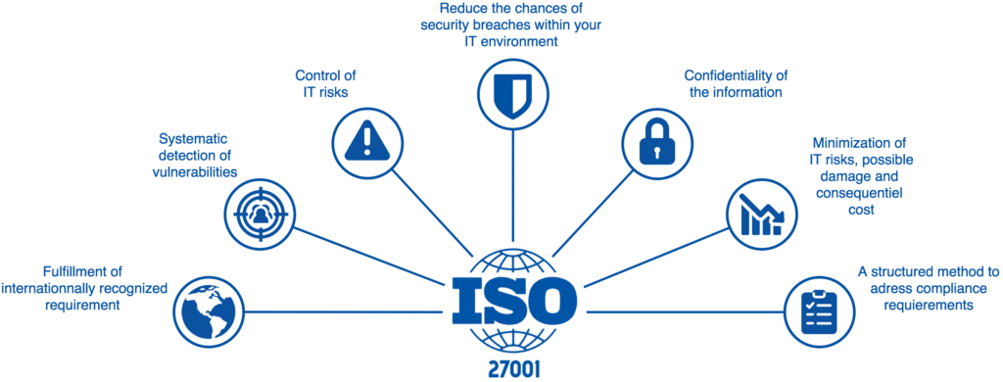 FigAlex stewart Understanding ISO 27000: The International Standard for Cyber Security 2024

2.2. Information Technology Infrastructure Library (ITIL)
The Information Technology Infrastructure Library (ITIL) is a set of concepts and policies for managing Information Technology (IT) infrastructure, development and operations.
ITIL is published in a series of books, each of which covers an IT management topic. The names ITIL and IT Infrastructure Library are registered trademarks of the United Kingdom's Office of Government Commerce (OGC). ITIL gives a
detailed description of a number of important practices with detailed checklist, activities procedures that can be adapted to any IT organisation ITIL is the most widely accepted
Approach of IT Service Management in the world: ITIL Provides a coherent set of best practice, drawn from the public and private sectors internationally.
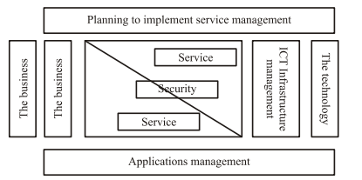
Fig 1

2.3. COBIT (Control Objectives for Information and Related Technologies)
Although many frameworks, standards and documents are available that deal with the control of IT, COBIT is focused on aligning the use of IT with achieving organizational goals. COBIT is an extensive all-encompassing framework consisting of 34 control objectives that has been formulated from “41 international source documents” and validated internationally to help balance IT risk against investment in IT controls. The control objectives have been organized into a hierarchy of processes and domains that are designed to help bring about the alignment of business and IT objectives, by identifying the requirements for IT resources and information associated with 318 detailed control objectives. IT processes are grouped into four domains: planning and organization, acquisition and implementation, delivery and support and monitoring. As the framework considers all aspects of information
and its supporting IT, management can use COBIT to help provide an appropriate control system for IT. COBIT has been implemented in many countries since its introduction in 1996. One explanation for COBIT's popularity is that its extensive Executive Summary, Framework, Control Objectives, Management Guidelines and Implementation Tool Set are free of charge. Payment is required only for the Audit Guidelines. Organizations where COBIT has been adopted include Daimler-Chrysler in Germany, New South Wales Department of Health in Australia, Royal Philips Electronics in the Netherlands, Curtin
University of Technology in Australia, Blue Cross Blue Shield of Michigan in the USA and Department of Defense, USA. That COBIT seems to be becoming an influential framework for the control and governance of IT is attested to by the significance and diversity of the organizations in which it has been used. Moreover, since COBIT is already in its 3rd edition and a version for Small to Medium Sized Enterprises called CobiT Quickstart is due for release in mid–2003, such developments further illustrate COBIT's impact.
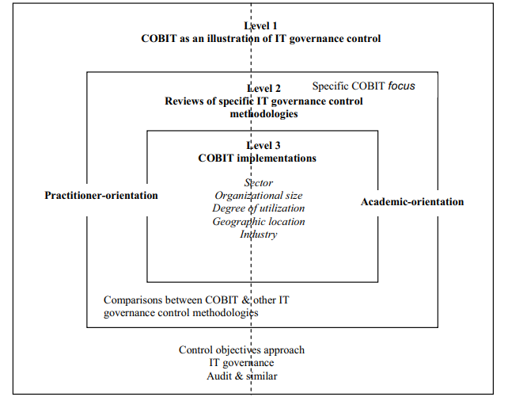
Fig 2Framework of COBIT and its Implementation

2.4. NIST CYBERSECURITY FRAMEWORKS
This paper discusses the NIST Cybersecurity Framework (CSF) which is a useful tool that can be used as a guide to managing the cybersecurity in organizations due to its flexibility and risk based methodology. The five core functions that include Identify, Protect, Detect, Respond, and Recover give shape and direction to NG on how to handle cyber threats. The importance of the monitoring and adaptation applied within the framework provides a stable defence against potentially new threats, which gives value to the integration of the framework into NG’s security systems. The NIST CSF is a collection of optional structures, sources for guidance, and suggested practices in organization-level cybersecurity and risk communication. The targets behind implementing the CSFl are to develop a common language, a substantial set of criteria and simple to accomplish sequence of objectives that help to enhance cybersecurity and reduce the exposure to cybersecurity episodes. NIST has comprehensive information about the CSF on its site that includes links with frequently asked question, industries, and other relevant information to facilitate an enterprise for transition into the CSF environment.( NIST Cybersecurity Framework: A Cheat Sheet for Professionals, megan crouse, 2024)

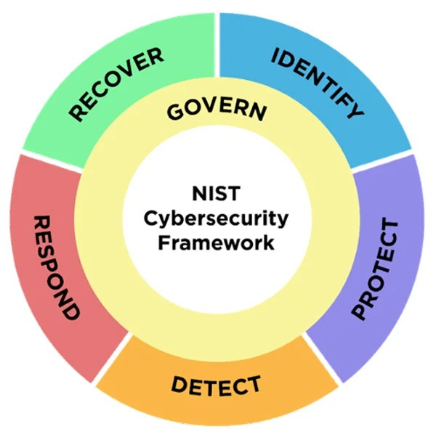
Fig

2.5. ZERO TRUST ARCHITECTURE
In fact, zero trust architecture is a way for implementing the cybersecurity principles in the furthering of the network of the organizational establishment based on the zero-trust security concept. As a prerequisite, the Zero Trust model is based on the belief that no part of a network is trusted inherently. Or, in layman’s terms, an organization should not believe in any request without confirmation, regardless of whether the request is intramural or extramural. The Zero Trust model was derived in an attempt to reduce the risks of being attacked on a network and thereby elevating the security status of the network. For NG, this approach addresses vulnerabilities in its wireless and cloud networks by ensuring strict access controls and user authentication. Implementing Zero Trust principles enhances protection against insider threats and external attacks, particularly in a BYOD environment.
(Cybersecurity, zero trust architecture, 2021, Giannis Nazrridis)

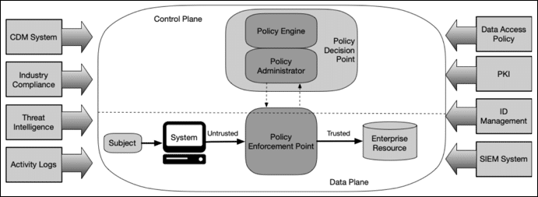
Fig

3. PROPOSED APPROACH OF NG
3.1. GOVERNANCE STRUCTURE
This paper proposes that the NG’s board of directors’ formulation focuses on designing a well-coordinated corporate governance system that enhances transparency, accountability, direction, and control of the security and compliance undertakings in relation to the business objectives of the organization. They are Executive Security Committee to manage decisions making procedures and map to NG’s objectives. As important and sensitive data will be protected and regulation such as GDPR will be adhered to, there will be a Data Protection Officer (DPO). Governing boards will conduct periodic governance audits to check compliance with the laid down policies and practices in order to build more coherent governance practice every time. A best practices security structure that relies on familiar standards such as ISO 27001, as well as ITIL, ensures that security is integrated and maintained proactively alongside regulatory requirements. (ISO (2022), ITIL Foundation (2021)
Objectives: Establish Accountability and oversite mechanisms
- Executive Security Committee: Oversees strategic decision-making and ensures alignment with business objectives.
- Data Protection Officer (DPO): Responsible for compliance with data protection laws and safeguarding sensitive information.
- Regular Governance Audits: Conduct periodic reviews to ensure compliance with established policies and procedures.
3.2. SECURITY POLICIES
NatureGarden (NG) needs to put into place comprehensive security policies to address the dynamic challenges of information security. A Bring Your Own Device (BYOD) policy with Mobile Device Management (MDM) will be enforced to provide strict security configurations in place over personal devices on company network. It mitigates authorized risks with malware and unauthorized access. We will introduce data classification categorizing information into bits like Public, Internal, and Confidential and controlling the data exposure with access controls based on user roles. Additionally, an Incidence Response Plan structured in accordance with ISO 27035, will serve to sharpen the companies’ aptitude for intercepting, relay and minimize the damage caused by security breaches. The combined policy set is intended to bolster the security of NG data while allowing for business flexibility. (Smith (2022), NIST (2020) )
- Device Management: Implement a Bring Your Own Device (BYOD) policy supported by Mobile Device Management (MDM) systems to enforce security configurations on personal devices.
- Data Classification: Introduce a tiered data sensitivity system (e.g., Public, Internal, Confidential) with access controls based on roles and responsibilities.
- Incident Response Plan: Develop a structured plan based on ISO 27035 to streamline detection, reporting, and mitigation of security breaches.

3.3. RISK MANAGEMENTS
To address the ability to protect itself against potential vulnerabilities of its wide-ranging wireless networks and cloud services, NatureGarden (NG) requires effective risk management. Risk assessments within the framework of FAIR (the Factor Analysis of Information Risk) should be performed semi-annually to assess the risks, evaluate and prioritise those risks. They will give insights into threat vectors, and if they impact your business, what their resources and intents might be. To reduce identified risks, NG is obliged to deployed the advance security tools like Intrusion Detection Systems (IDS), Virtual Private Networks (VPNs), and multi factor authentication (MFA). These measures help decrease the chance of accidents or unauthorized access, and a powerful defense against cyber attacks. A risk management built into NG’s overall governance framework enables it to respond proactively to emerging threats and maintain an operational resilience. (Deloitte (2023), König & Schulte (2021)
- Risk Assessment: Conduct semi-annual assessments using frameworks like FAIR (Factor Analysis of Information Risk) to evaluate potential vulnerabilities.
- Mitigation Measures: Deploy advanced security tools such as Intrusion Detection Systems (IDS), Virtual Private Networks (VPNs), and multi-factor authentication (MFA).
3.4. COMPLIANCE MEASURES
To be able to keep adherence of international legal and ethical standards and meanwhile be able to keep sensitive data safe, compliance measures are important for NatureGarden (NG). To achieve this, NG needs to ensure that the ways it houses, and processes their data, abide by the General Data Protection Regulation (GDPR), including the principles of data minimization, accountability, and lawful processing. It will strengthen customer trust and substantially cut legal risk. The company also needs to periodically benchmark its praxis versus industry standards such as ISO 27001 and SOC 2 to keep security controls and privacy these in line. Both periodic compliance audits and staff training programs will be carried out to ensure constant compliance with changing regulatory requirements and enhanced organizational awareness. ( Williams (2023), European Union Agency for Cybersecurity (ENISA) (2023)
3.5. COMPLIANCE (LAWS AND ETHICS)
It means compliance with legal and other regulatory requirements that dictate the processes of handling and safeguarding information. One may include GDPR when collecting data from the EU, HIPAA for data from the USA’s healthcare, or data privacy with PCI DSS. Ethical compliance transcends the legal standards as it also ensures fairness; understands accountabilities and respect to individuals. Policies include, Training and regular audits should be done to ensure compliance aims at reducing legal risk and to ensure organization has the trust of stake holders.
4. DISCUSSION ON REGULATIONS AND STANDARDS
Rules and norms continuously represent important supports for organizations, which are attempting to safeguard their digital domains, as well as ethic and legal requirements. In the case of NatureGarden (NG) the application of global frameworks guarantees compliance and high performance in responding to new cyber threats.
The Role of Regulations
Rules like the General Data Protection Regulation (GDPR) help a lot in protecting some sensitive information since they compel organizations to provide strong forces in protecting such data. The adoption of GDPR mandates is relevant to NG’s operations because of their global reach and a large customer database of millions of users. Likewise, NG needs to abide by the legal requirements stated in the U.S Cloud Act about dealing cross-border data.
The Importance of Standards
ISO 27001 and SOC 2 are standards for information security management systems which define how ISMS can be developed, implemented and maintained to an appropriate level of security. For example, ISO 27001 focuses on risk management and continual improvement that are keys for NG to have a reasonable chance to adapt in the dynamic threat landscape. However, SOC 2 deals more with trust service criteria like security, availability and confidentiality offering a perfect fit for NG given the need to secure intellectual property and customer data.

Adapting to Evolving Threats
Cybersecurity standards are not changeless, as standards evolve to cover new technologies and new threats. As example, the Cybersecurity Act of the European Union puts emphasis on certification frameworks to enhance perception of security provided by cybersecurity products and services. As part of this regulatory evolution organizations like NG have to take a proactive approach in monitoring and incorporating new updates.
Case Example
Since the implementation of GDPR, data protection policies across the world have shifted and non- compliance has penalties up to 4% of business turnover. This adds weight to the fact that there are considerably financial and repute losses that companies suffer because of not adhering to regulations; this is an important perspective that NG has to understand in order to appreciate the relevance of the regulations in the business.
Strategic Advantage of Compliance
Besides the reason of avoiding penalties, compliance with regulations and standards restores confidence between the company and stakeholders, improves organizational image and cultivates customer loyalty. Periodic external compliance audits, as well internal staff training sessions are advised to maintain compliance awareness and to stay abreast future changes.
References: The following are EU regulations and International standards: European Union Agency for Cybersecurity (ENISA) (2023), International Organization for Standardizations (ISO) (2022), Williams (2023), Deloitte (2023) When it comes to the continuous dynamic in nature of cyber threats and technologies, new regulations and standards have to be employed. NG must stay abreast of updates to:
- Recognize newly developing risks such as the AI in the cyber-attacks.
- Improve trust of stakeholders by being compliant and making it visible.
- Implement early the best of practices to attain competitive advantage.
Case Example: New certification rules adopted by EU’s Cybersecurity Act aim at raising the levels of cybersecurity and demonstrate the need to advance standard implementation.
5. ASSUMPTIONS
This report is based on several defined assumptions to address the specific challenges faced by NatureGarden (NG):
- Operational Infrastructure
All processing and storage in NG’s facilities are integrated through the cloud services and available through wireless networks.
- Resource Availability
The expenditures are reasonable enabling the management to undertake the proposed security, governance, and compliance programmes.
- Leadership Commitment
The company’s leadership has total endorsing of security sense and involved for the security threats and compliance issues.
- User Adaptability
Multi method authentication and BYOD policies are accommodating by both customers and the Members’ staff team.
- Regulatory Awareness
NG also knows and willing to fulfil new international standards like GDPR or standards that are as important as ISO 27001.
- Risk Tolerance
Management of NG has a set limit of risks that can be accommodated, and this company addresses high-impact risks primarily.
The above assumptions are the basis from which recommendations and strategies presented in this report are developed.
As previously mentioned, all operations in NG are linked through cloud services.
There is sufficient funding and resource for the purpose of security measures.
The management of the company is very much aware of the importance of the security functions in all its operations.
6. CONCLUSION
The security, governance, and compliance challenges that NatureGarden (NG) faces are significant as the digital landscape is evolving. A strong governance framework around information security is necessary for a global leader in healthy living industry like NG because of its dependence on cloud services, wireless networks and personal devices. This report suggests with the proposed comprehensive strategy in which it has combined internationally recognized frameworks such as ISO 27000, ITIL, and COBIT to determine what would effectively address these challenges. It then recommends an Executive Security Committee to create clear accountability and oversight for the recommended governance structure and the appointment of a Data Protection Officer. These roles are key to aligning security and compliance focus areas with NG’s strategic goals. Additionally, the implementation of full security policies such as BYOD management, data classification and incident response planning helps NG increase their ability to protect sensitive data and intellectual property.
Risk control is a central component of the proposed framework where risk is to be assessed semi-annually using the FAIR method and existing advanced technology tools and systems including IDS and VPNs. Such measures help NG give attention to vulnerabilities in order to reduce future risks that may lead to disruptions of its operations. Obeying the act such as the General Data Protection Regulation or adhering with frameworks like ISO 27001 and SOC 2 adds up to the faith that NG has for its stakeholders besides meeting legal requirements. This is through conducting audits, training to its staff and revising its policies to deal with different threats as well as to meet the laid down regulations in line with its operation.
Thus, the proposed strategy is as efficient in guarding NG from the current and potential threats as it is effective from the viewpoint of further steady development. Therefore, by following this strategic and highly assertive approach, NG can improve its operational activities, gain better credibility and become one of the top global manufacturers that can withstand a growing number of digital threats.
An answering to NG’s security, deployment, and compliance issues, as well as its prospects and prospects for the future, must be approached systematically and dynamically. By adopting frameworks, which include ISO 27000 and ITIL in advance governance strategies, NG will be able to protect its assets and build up sustainable structures. Updates for the policies and refreshing them against the current standards will provide a guarantee that the existing compliance and the company’s operations will remain effective.

