Network & cybersecurity essentials
ACCA4024 Assignment
Jenson Davies (2316793)

Contents
Introduction 2
Identification of Threats 3
Security Policy Framework 4
Threat Mitigation Measures 5
Monitoring & Response 7
Training and Awareness 9
References 10

Introduction

In a continuously evolving digital world, cyber security has become a significant concern across the globe. As the reliance for digital services and tools increases; businesses, users and many more are more concerned with the cyber threats than ever before. With many businesses bringing in remote working and the use of internet-connected networks for work, transactions and communication, the potential for serious cyber-attacks has grown. To combat this robust cyber-security infrastructures have become something businesses have adopted, to operate in the current digital landscape.

FineSecure LTD (FSL) is a medium-sized financial services company, that has recently faced a plethora of cyber security related incidents, including phishing attacks and unauthorized access attempts to the companies' network. These attacks have alluded to the fact that the company needs to improve upon its cyber security infrastructure. As a result of this, the board has called for the development of a comprehensive security policy, that will aim to mitigate the internal and external threats that they are currently facing. This report will aim to achieve this and to minimize potential future threats that may be present.

Identification of Threats
To develop effective policies for FineSecure LTD (SFL), it is essential to identify the potential threats towards the organisation. These risks can be categorised into internal or external threats.
External Threats:

These are threats where the origin is based outside of the organisation’s network and is usually conducted by individuals or groups with malicious intent [1].
- Phishing attacks: This is a type of social engineering attack, that involves the attack presenting themselves as a legitimate service, such as an email provider. The attacker sends the fraudulent emails or messages to organisations in order to trick them into receiving personal information from them, this could include a user’s login details for a platform or service [1].
- Malware attacks: Malware, otherwise known as malicious software, is a type of software that is designed to cause damage to a computer system or network. This could be through viruses, ransomware or trojans [1].
- Distributed Denial-of-Service (DDoS) attacks: A DDoS attack refers to when a number of machines bombard a network with traffic. This causes the network to become overwhelmed and as a result cannot respond to service requests [2].
- Unauthorised Access: This refers to when individuals gain access to an organisation’s network, systems or devices without granted permissions. This can compromise a network’s integrity or lead to data loss [7].
- Password attacks: Hackers will obtain passwords without access by sniffing the connection to a network to find passwords within it. This will allow them to have access to the network and will be a gateway for further hacks [2].

Internal Threats:
These are threats that occur within an organisation, they will commonly involve authorised users who have access to the network and its devices [1].
- Poor Password Management: Weak passwords will make the organisation more susceptible unauthorised access to their networks. This may be in the form of repeated passwords, or easy guess passwords [1].
- Malicious insiders: A malicious insider is a currently working employee, who engages in activities that cause damage within an organisations network, out of malicious intent. These activities could involve, altering or deleting crucial data sets, or revealing sensitive information [3].
- Privilege abuse: This refers to when an authorised individual with higher privileges, such as a network administrator, uses their access to harm the network. This can be done by removing accounts from the network or installing malicious software [1].
- Negligent Behaviour: This is when employees disregard security policies and good practices and as a result put the network at risk. This could be leaving sensitive information open in a public place or accessing unsecured Wi-Fi networks to access the organisation’s network [1].
- Data Breaches: This involves employees accessing sensitive information without authorization. This could subsequently result in, privacy violations, data misuse and exposure of personal information [4].

Security Policy Framework

FineSecure Ltd recognises that as a financial service company it is imperative to protect our sensitive data, whilst striving to operate within a safe cyber environment. With this notion in mind, and due to recent security related incidents, the following security policy framework has been implemented to help mitigate internal and external threats.

- Acceptable Use Policy:
- Data & Information systems can be accessed for business use only.
- Accessing inappropriate websites, unauthorised software and pirated content is not allowed.
- Sensitive content/data is prohibited from email communication [5].
- Password Management Policy:
- Password must contain specific levels of complexity (at least 1 special character, 1 number, 5 characters).
- Passwords will be resets every 90 days, with reuse being prohibited.
- Passwords must not be shared with anyone [5].
- Security Awareness and Training Policy:
- Security awareness & training must be completed during onboarding and every 6 months onwards.
- Training will contain an overview of policies and procedures, along with an assessment of understanding [5].
- Data Management Policy:
- Data can only be accessed by authorised users.
- All data must be encrypted when not in use.
- Outdated data is deleted, following both the business and legal requirements.
- Access Control Policy:
- Access will follow the principle of least privilege; this means that access will be granted in a way that will allow the user to carry out their direct jobs and functions [6].
- Multi-Factor Authentication is required for all accounts.
- Access will be removed from accounts with 6 months of no access.
- Remote Access Policy:
- To connect to the network remotely, Multi-Factor Authentication is required.
- Remote users’ activity will be monitored to identify potentially dangerous acts within the network.
- Remote access will be secured using SSH key management [5].
- Network Security Policy:
- Intrusion detection systems and firewalls must always be active.
- VPN connection must be active when connecting to network, and connections must be MFA secured.
- Vendor Management Policy:
- One-time or temporary access will be provided to access critical systems if required.
- Vendor activity will be monitored to identify whether appropriate systems and sites are being accessed.
- Vendor contracts will include confidentiality clauses, to avoid data leaks.
- Removable Media Policy:
- Sensitive data can not be stored on removable media.
- Personal removable media is not allowed and is restricted to authorized personnel only.

Threat Mitigation Measures

External Threat Mitigation Measures:
- Phishing Attacks:
- Email security software to block known malicious domains and antivirus software [8].
- Conduct phishing training and simulations to give employees an opportunity to grow their awareness [8].
- Discourage employees from opening emails and attachments from unknown senders [8].
- Educate employees on red flags that may allude to a phishing attempt [8].
- Malware Attacks:
- Implement network segmentation to reduce the risk of complete network attacks. This can be done by department [9].
- Back up data to have a fallback when an attack occurs. This will help prevent data loss.
- Update the frontline defences. Make sure that they adhere to the policies and best practices for application, system, and appliance security.
- DDoS Attacks:
- Implement rate limit, this will restrict the number of requests a server can accept within a specific period [12].
- Implement a web application firewall, this is a reverse proxy and will create a shield between the internet and the network [12].
- Unauthorised Access:
- Implement multi-factor authentication, so that an extra level of verification and security is present [10].
- Ensure Wi-Fi networks are encrypted with a strong encryption such as WPA3 and making the network name not available to the public [10].
- Ensure all passwords adhere to the password policies to make sure they reach a suitable level of complexity [10].
- Conduct regular security checks and assessments to identify and fix weaknesses that may allow unauthorised access [10].
- Passwords attacks:
- Ensure passwords can not be reused, as it could leave multiple accounts vulnerable if a breach occurred [11].
- Passwords must be reset every 2 months.
- Multi-factor authentication must be implemented, as it will mean multiple forms of verification will be required to enter the network.
Internal Threat Mitigation Measures:
- Poor Password Management:
- Passwords must meet the specified complexity stated within the password management policy.
- Passwords must not be repeated amongst multiple accounts.
- If passwords are stored, they must be encrypted, to avoid leaks.
- Malicious Insiders:
- Establish audit logs so that malicious activity can be identified.
- Encourage employees to report potential security threats, as they understand best practices [13].
- Privilege Abuse:
- Establish access based on the jobs that the employee needs to carry out.
- Continuously monitor privileged accounts activities within the network [14].
- Negligent Behaviour:
- Conduct security awareness training programs, to ensure all employees are understanding when it comes to the organisation’s security protocols and best practices [15].
- Implement role-based access control, to ensure employees can only carry out what they are required to.
- Data Breaches:
- Encrypt all data, especially when not in use.
- Delete data when it is classed as outdated, by the business and legal requirements.

Monitoring & Response

To secure FineSecure Ltd’s (FSL) network from both internal and external threats, a monitoring and response framework has been developed. This will cover how the network will be monitored for potential threats as well as how FSL will respond to the threats.
- Network Intrusion Detection System (NIDS):
- FSI will implement a NIDS to its network with the purpose of monitoring network traffic and searching for known threats and suspicious activities, so that the cyber security team can be notified. The NIDS will be deployed on various points across the network, to identify malicious traffic across the network. This will allow prevention measures to be conducted before a malicious attack is conducted on the network [16].
- DNS Filtering:
- FSI will implement DNS in an act to prevent potential phishing attacks from occurring. This will allow the network administrators to block domains, subdomains, FQDNs, hostnames and IP addresses. This will prevent devices within the network from accessing malicious sites and systems [17].
- Network Auditing:
- Network Auditing will be implemented; this is the process of collecting data from a plethora of network parameters, so that it can be analysed to gather insights on the network’s status and health. The audit will include user activities and access levels, which will allow FSL to monitor if users are using the network appropriately and if they have the necessary access level within it [18].
- Incident Response Plan:
- In regard to incident response, the following process will be followed [19]:
  - Preparation: Employees are trained on the policies and best procedures. Documentation will also be created based on threats that have been identified and resolved.
  - Detection & Analysis: Audit logs, DNS Filtering and NIDS systems will alert network administrators when an incident occurs.
  - Containment, Mitigation and Eradication: Affected systems will be shut down, and threats will be dealt with immediately.
  - Recovery: Systems will be reactivated, and backups will allow damaged data or systems to be restored.
  - Post-Incident Activity: Policies and incident documentation will be updated to be in line with how the threat was handled.

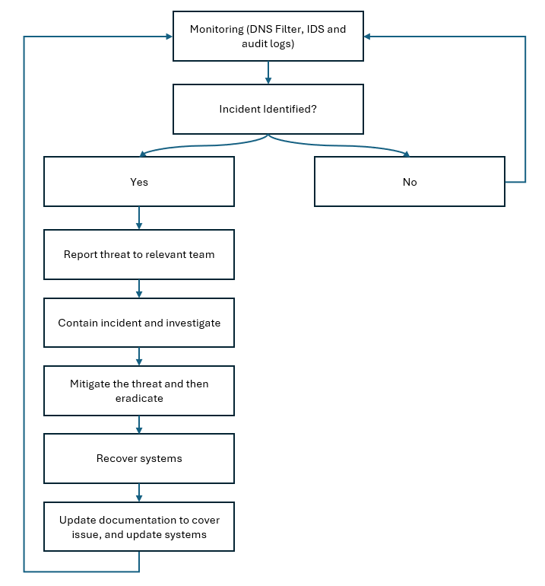

Training and Awareness

According to ‘Insecurity Magazine’ 95% of data breaches in 2024 were attributed to human error [20]. To reduce the risk of human error within the FSL network, a training and awareness program will be introduced, with the aim to educate employees on potential threats and how to deal with operational procedures in the network.
The security awareness program will be conducted at various levels. New employees will have to complete a mandatory security training during their induction period. This program will aim to provide an understanding of basic cyber security procedures that will be essential within their job, such as an awareness of phishing, password creation, reporting incidents [21]. An example of a potential course that could be implemented is the National Cyber Security Centre’s ‘Top tips for staff’ course which covers a plethora of these topics.
To ensure that staff are aware of the current policies and procedures, as well as threats that they could face, a cybersecurity review course will be conducted every 6 months. This will encompass a refresher of the current security procedures and measure that FSL are operating under, as well as possible threats that are present within the industry.
Moreover, to direct address phishing attack concerns simulated phishing attacks will be conducted on staff, to identify whether they are suspectable to trusting phishing attempts. Those who do fall for the simulations will be instructed to completed further mandatory cyber security training to ensure that is does not reoccur.

References

[1] WithSecure, “External and Internal Threats | WithSecure,” www.withsecure.com, Apr. 24, 2023. https://www.withsecure.com/en/expertise/blog-posts/external-and-internal-threats
[2] ERMProtect, “External vs. Internal Cybersecurity Risks: Know the Difference,” Cybersecurity and Training, Jan. 31, 2020. https://ermprotect.com/blog/external-vs-internal-cybersecurity-risks-know-difference/
[3] A. Simpson , “11 Real-Life Insider Threat Examples | Cyber Threats,” Mimecast, Jan. 16, 2025. https://www.mimecast.com/blog/insider-threat-examples/
[4] E. Etheridge, “Cyber security measures: Secure your business with digital signatures,” Dataguard.co.uk, vol. 1, no. 1, 2024, Available: https://www.dataguard.co.uk/blog/what-is-a-digital-signature-and-how-it-can-secure-your-business/#which-industries-need-digital-signatures-most
[5] A. Khachatryan, “Information Security Policies: 10 Examples, Features, and Benefits | Syteca,” Syteca, Apr. 12, 2024. https://www.syteca.com/en/blog/information-security-policies
[6] Liudmyla Pryimenko, “How Can Using the Principle of Least Privilege Help Save Your Data? | Syteca,” Syteca, Dec. 06, 2023. https://www.syteca.com/en/blog/the-principle-of-least-privilege
[7] Cynet, “Unauthorized Access: 5 Best Practices to Avoid Data Breaches,” Cynet, Jul. 01, 2019. https://www.cynet.com/network-attacks/unauthorized-access-5-best-practices-to-avoid-the-next-data-breach/
[8] Valimail, “Complete Guide to Phishing: Techniques & Mitigations - Valimail,” www.valimail.com, May 03, 2022. https://www.valimail.com/resources/guides/guide-to-phishing/
[9] “Protect Your Future with Cisco Duo,” Cisco, Mar. 2025. https://www.cisco.com/site/us/en/learn/topics/security/how-to-prevent-malware-attacks.html
[10] A. Novikava, “How to prevent unauthorized access: 10 best practices,” nordlayer.com, Aug. 30, 2024. https://nordlayer.com/blog/how-to-prevent-unauthorized-access/
[11] A. Trevino, “How to Prevent Password Attacks,” Keeper Security Blog - Cybersecurity News & Product Updates, Dec. 19, 2022. https://www.keepersecurity.com/blog/2022/12/19/how-to-prevent-password-attacks/
[12] Canadian Centre for CyberSecurity, “Defending against distributed denial of service (DDoS) attacks – ITSM.80.110,” Canadian Centre for Cyber Security, Jan. 09, 2024. https://www.cyber.gc.ca/en/guidance/defending-against-distributed-denial-service-ddos-attacks-itsm80110
[13] L. Watts, “17 Ways To Prevent Insider Threats: Steps, Tips & Tools,” Teramind, May 01, 2024. https://www.teramind.co/blog/how-to-prevent-insider-threats/
[14] “How to Prevent Privilege Misuse? | Kron,” krontech.com, 2022. https://krontech.com/how-to-prevent-privilege-misuse
[15] “The Role of Cyber Negligence in Insider Threats and How to Fix It | Proofpoint UK,” Proofpoint, May 15, 2023. https://www.proofpoint.com/uk/blog/insider-threat-management/role-of-cyber-negligence-in-insider-threats-how-to-fix
[16] “What is Intrusion Detection Systems (IDS)? How does it Work?,” Fortinet. https://www.fortinet.com/uk/resources/cyberglossary/intrusion-detection-system
[17] V. Team, “What is DNS Filtering?,” Vercara, Jul. 08, 2023. https://vercara.digicert.com/resources/glossary-dns-filtering
[18] M. communications @manageengine.com, “Network Configuration Management by ManageEngine Network Configuration Manager,” ManageEngine Network Configuration Manager. https://www.manageengine.com/network-configuration-manager/network-audit.html
[19] “What is an incident response plan and how to get started,” Palo Alto Networks. https://www.paloaltonetworks.co.uk/cyberpedia/incident-response-plan
[20] J. Coker, “95% of Data Breaches Tied to Human Error in 2024,” Infosecurity Magazine, Mar. 11, 2025. https://www.infosecurity-magazine.com/news/data-breaches-human-error/
[21] “Top tips for staff,” www.ncsc.gov.uk. https://www.ncsc.gov.uk/training/top-tips-for-staff-scorm-v3/scormcontent/index.html#/

Appendix.

‌Link to the presentation: Cybersecurity Policies & Mitigation Measures.pptx
Screenshots of presentation:






