Section 1

Data Handling & Business Intelligence

BA Business Management LCBB5000_BIRM Abdallah Naser Inna Hristova Student number 2230343

You are working as a data analyst intern with a well-known research centre. This research institute is focused on analysing the daily coffee consumption habits of a selected group of individuals. The research study, titled " student performance ", has collected a comprehensive dataset over a considerable period, ensuring the data is as detailed and accurate as possible. This dataset, handed over to you for detailed analysis, features information regarding daily coffee intake in cups, categorised by each individual participant, alongside a corresponding health index and diagnostic results.
The centre possesses a licensed copy of Microsoft Excel. They have been using this software for their basic data processing and analysis needs. However, for a more detailed, statistically significant study they recently acquired SPSS data mining statistical software. As a data analysis expert, your role is to explore the dataset using the both MS Excel and newly-acquired SPSS software. By fostering a strong collaborative relationship and working closely with the team, your combined efforts will pave the way to new insights about the impacts of coffee consumption on human health, potentially informing future dietary recommendations. Conduct the following tasks and produce a report for your team.

(a) Using the Excel or SPSS statistical software, you need to discuss and analyse the student performance dataset (provided) to evaluate the following:

- What is the mean value for reading score?

The metric you are most likely most familiar with is the arithmetic mean, sometimes known as average.
The mean is calculated by adding up a group of numbers and then dividing the sum by the count of those numbers (Cheusheva., 2023)
For instance, to find the mean of the numbers {1, 2, 2, 3, 4, 6}, add them all up, divide the total by 6, and the result is 3 (1+2+2+3+4+6)/6=3.
One of the following functions in Microsoft Excel can be used to determine the mean: Average, which yields the average of the numbers:
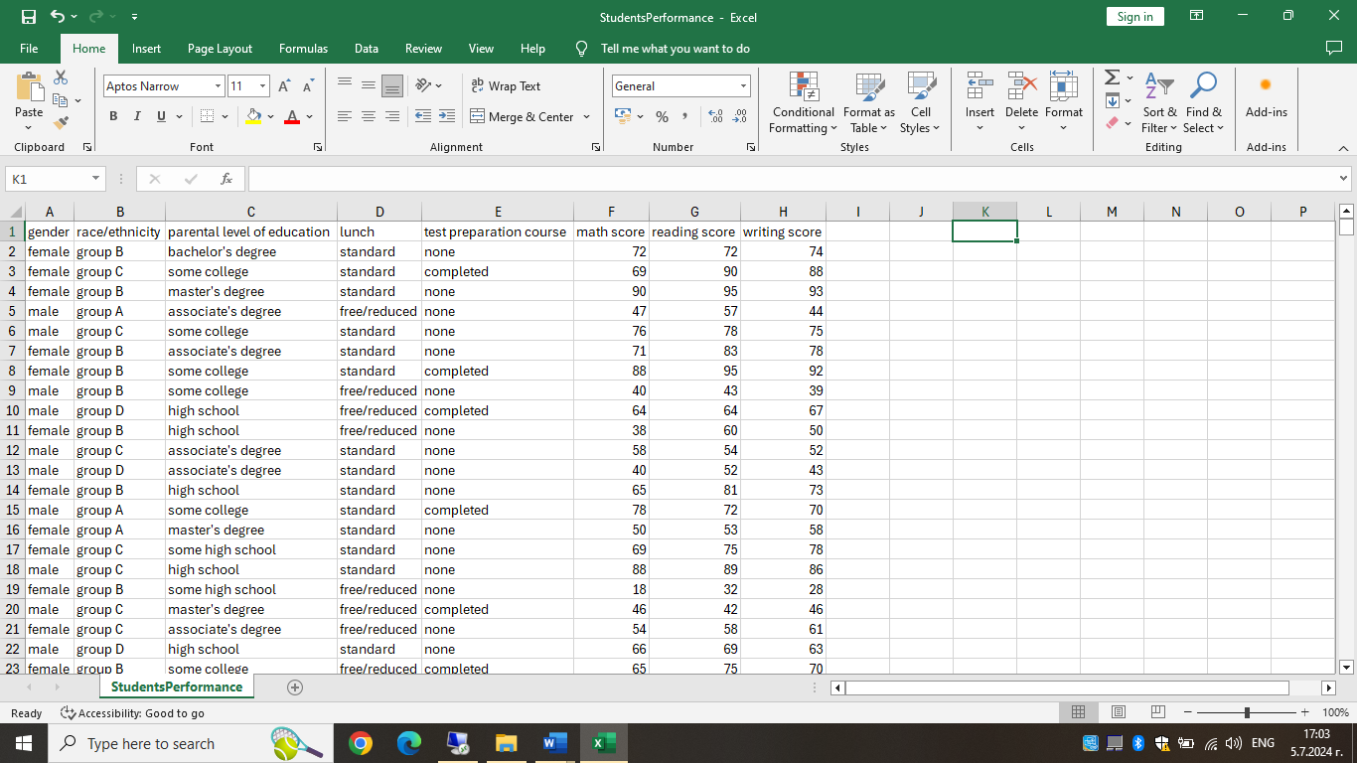

To create the formula in Excel we can use the Fx button or just to type = and the first letter of the function, as shown below:

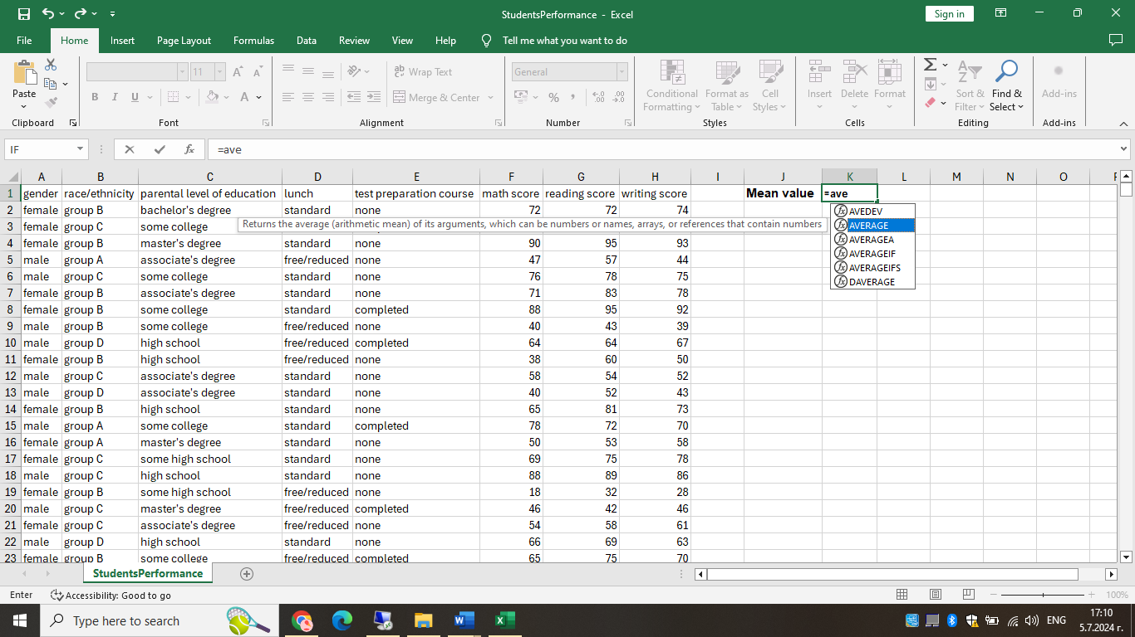
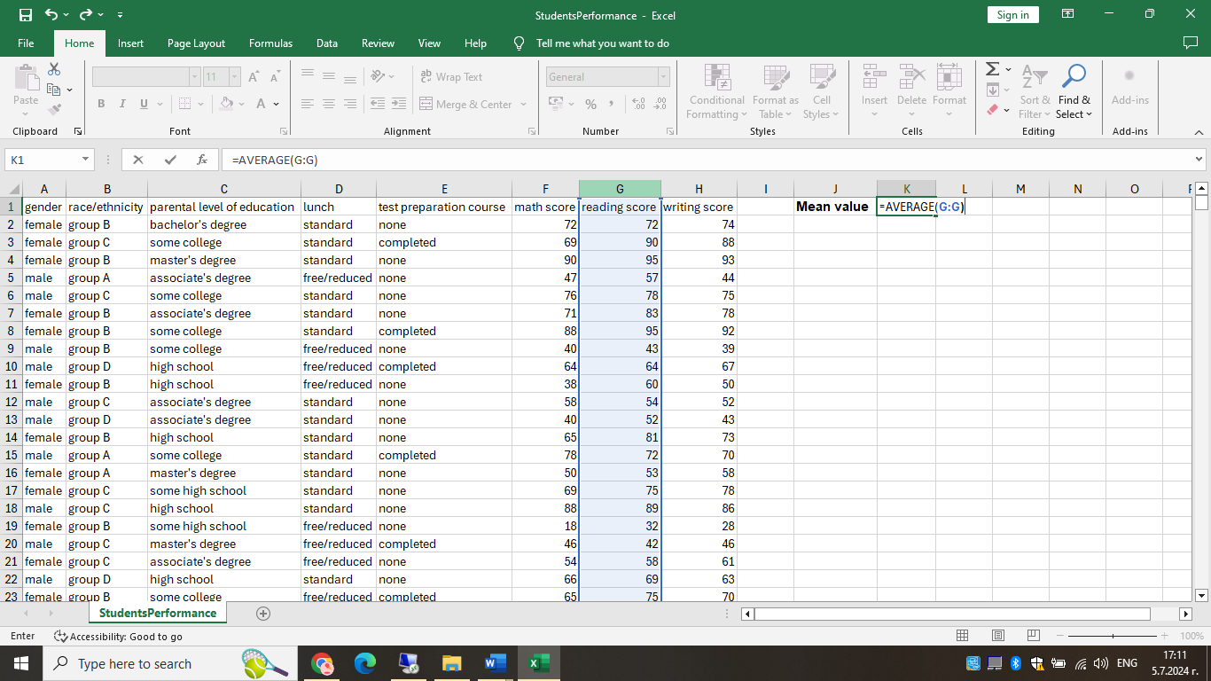

After selecting the data and closing the brackets we just need to press Enter, so we can see the result:

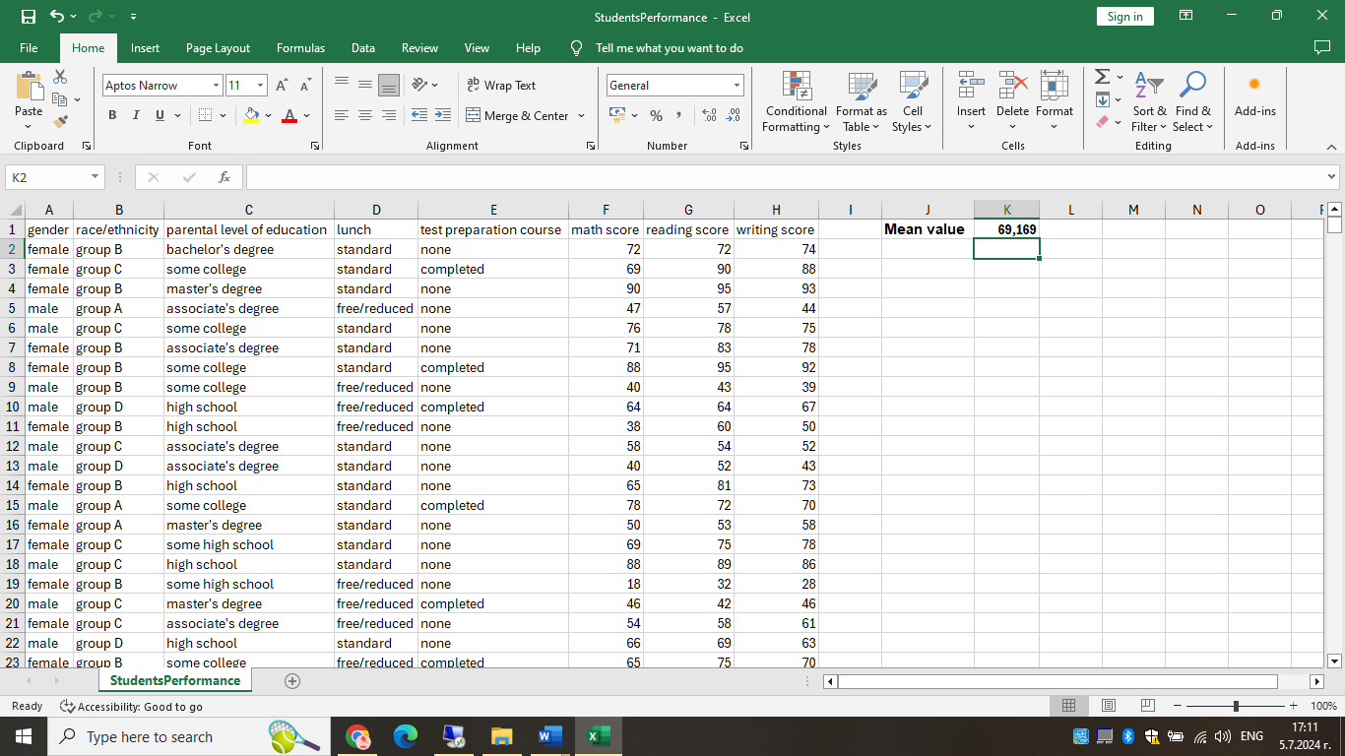
In our case the Mean value of the reading score is 69,169.

- What is the median value for reading score?

Median is the middle value in a group of numbers, which are arranged in ascending or descending order, i.e. half the numbers are greater than the median and half the numbers are less than the median (Cheusheva., 2023).
For instance, the data set {1, 2, 2, 3, 4, 6, 9} has a median of 3.
The MEDIAN function in Microsoft Excel is used to generate a median.
The Median function can be created the same way as the Average one, please see below the screenshots:

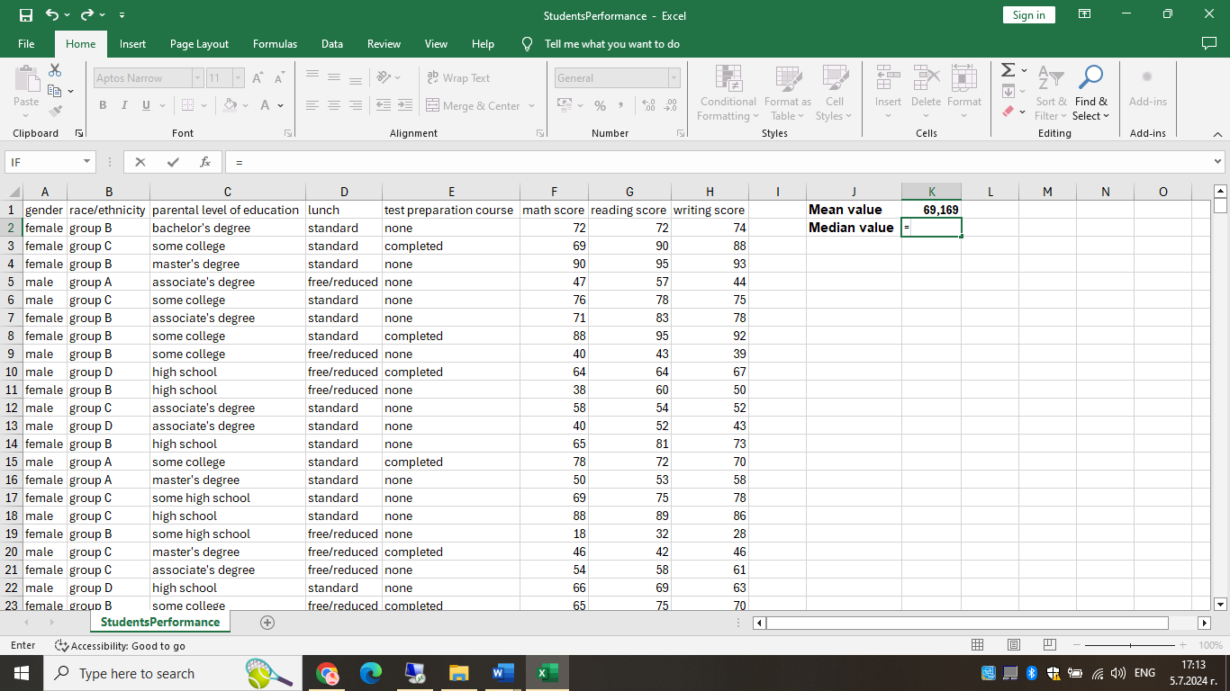

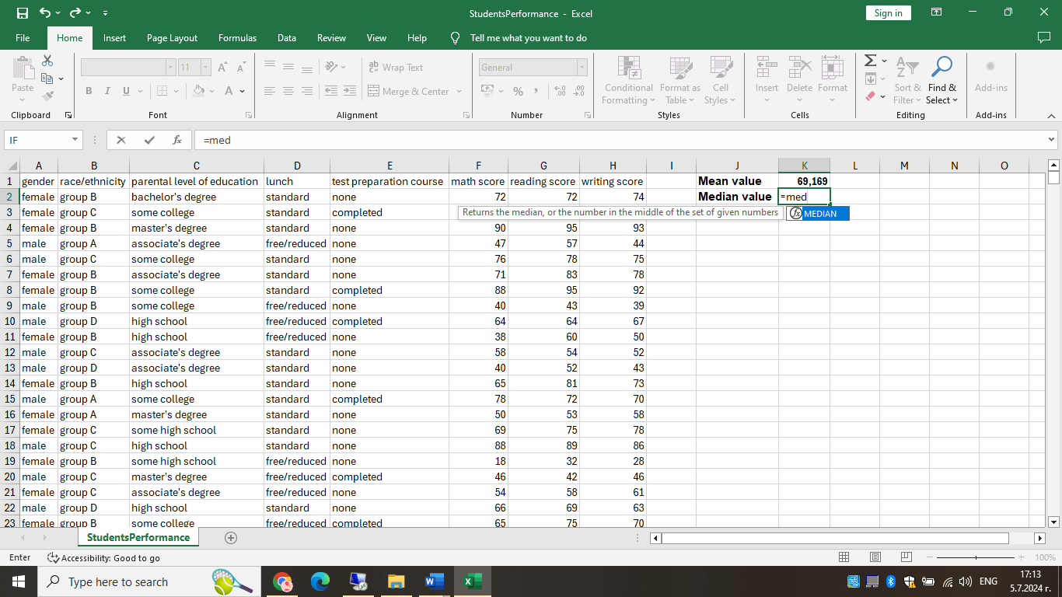

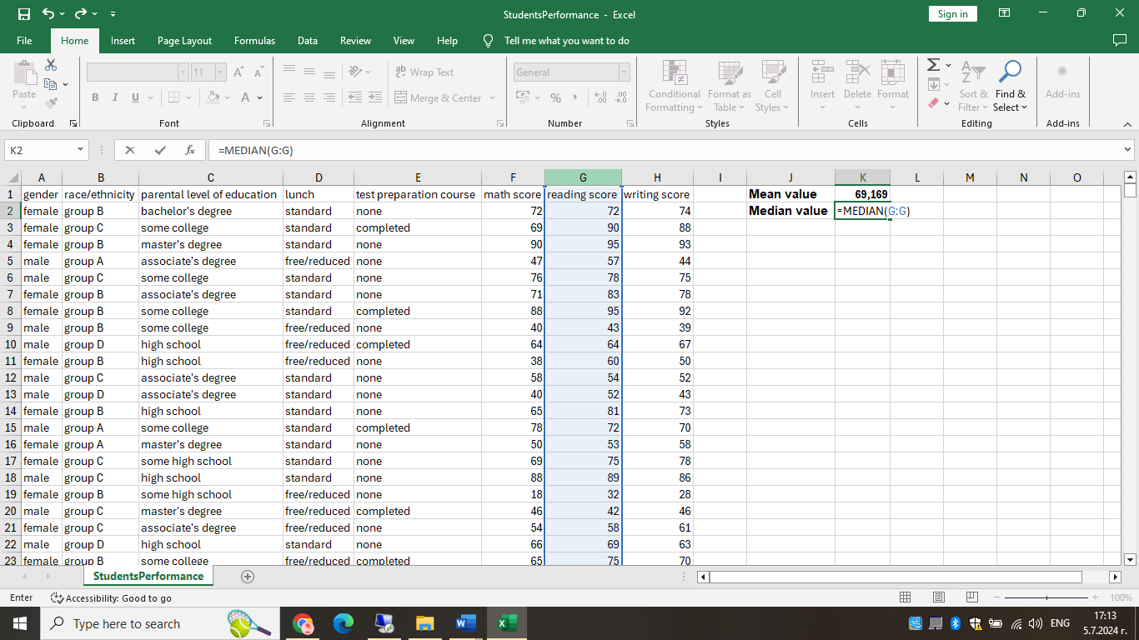

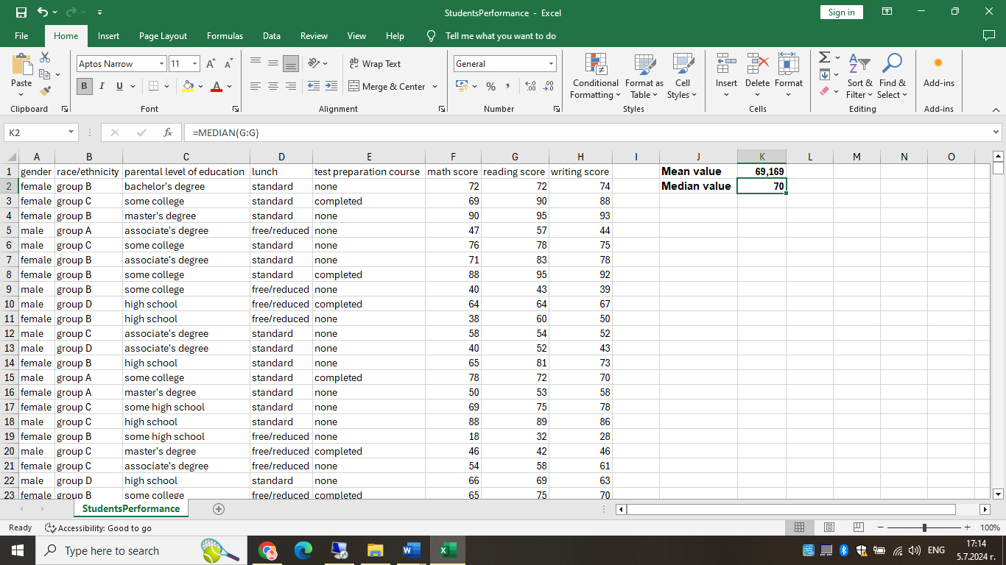

In our case the median value for reading score is 70

- What is the mode of the reading score?

Mode is the most frequently occurring value in the dataset. While the mean and median require some calculations, a mode value can be found simply by counting the number of times each value occurs (Cheusheva., 2023).
As an illustration, the integer 2 represents the mode of the set {1, 2, 2, 3, 4, 6}. The MODE function, which has the same name in Excel, can be used to calculate a mode.
And again, the Mode function can be made the same way as the Average and the Mean function, please see below the screenshots:
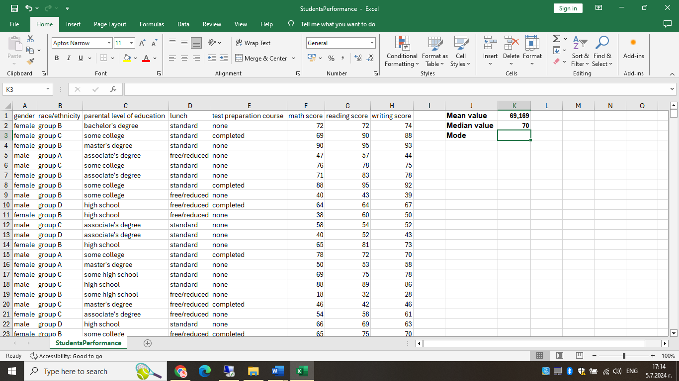

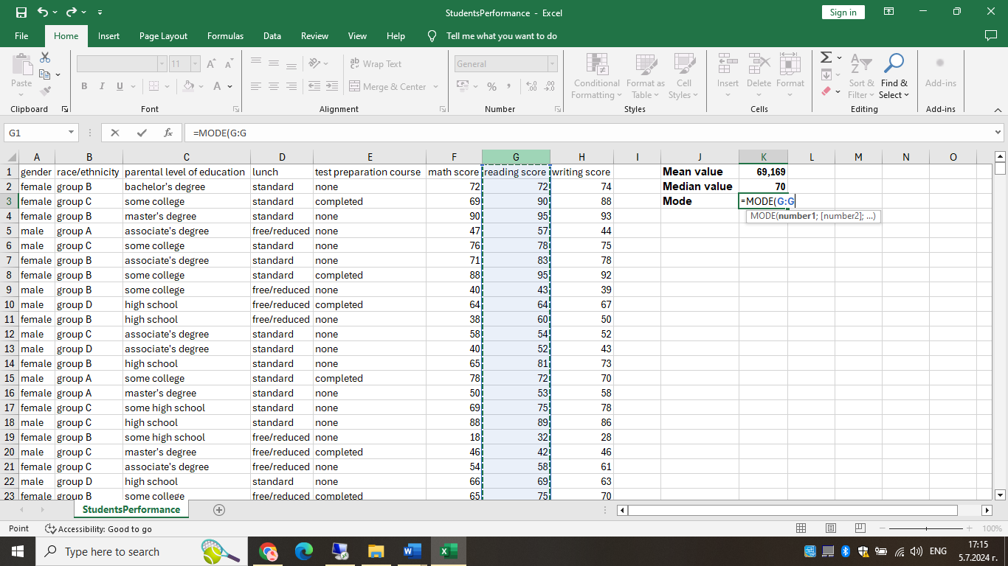

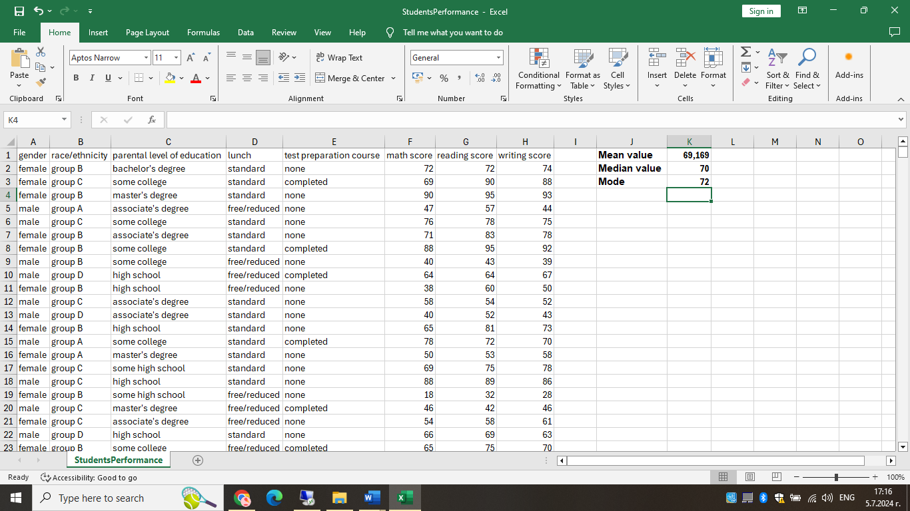

In our case the mode of the reading score is 72.

- What is the standard deviation for writing score?

The standard deviation is a measure that indicates how much the values of the set of data deviate (spread out) from the mean. To put it differently, the standard deviation shows whether your data is close to the mean or fluctuates a lot. (Lewis, 2019)
The purpose of the standard deviation is to help you determine if the mean really produces "typical" data or not. When the standard deviation is close to zero, the data variability is decreased and the mean is more reliable. When the standard deviation is zero, every value in the dataset is exactly equal to the mean. The higher the standard deviation, the more erratic the data are and the less trustworthy the mean.
We can get the standard deviation by using the function STDEV in Excel, as shown below:
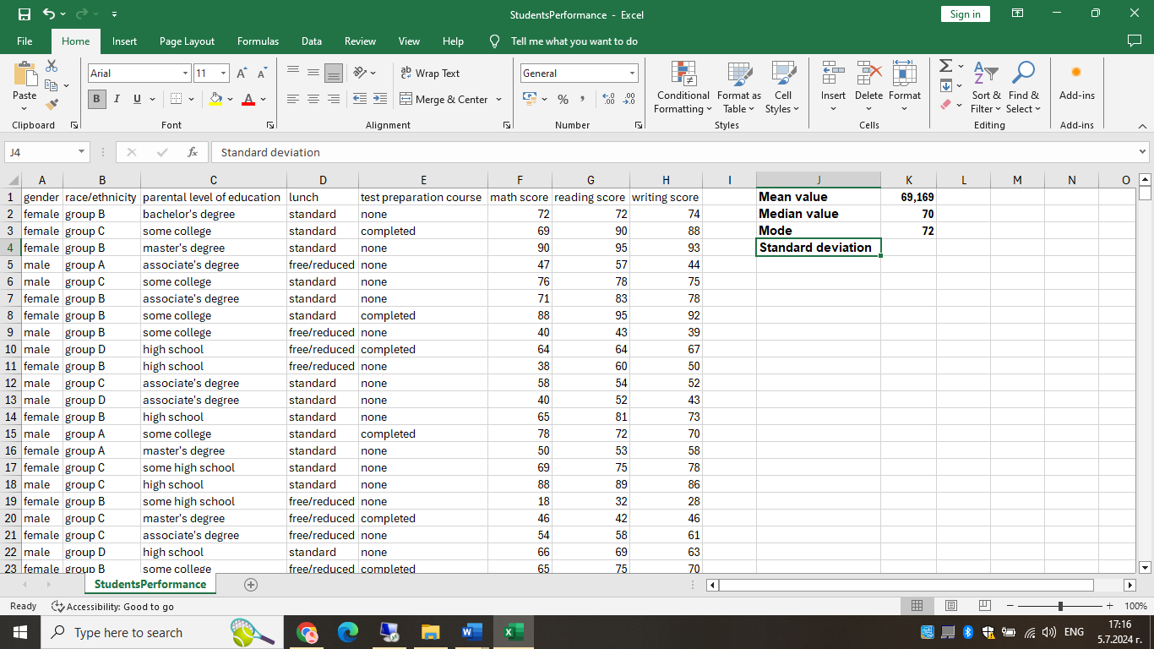

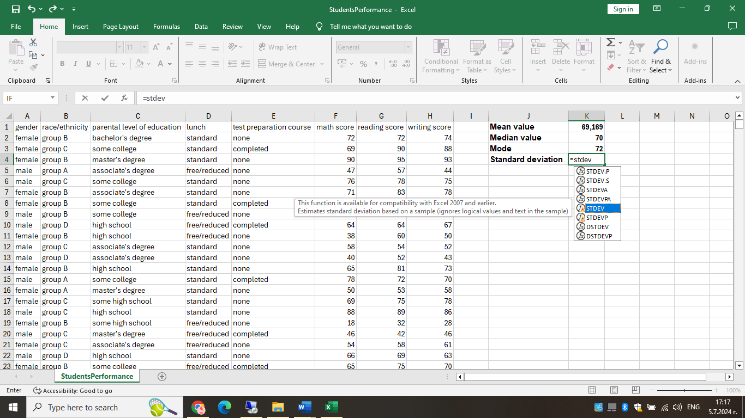

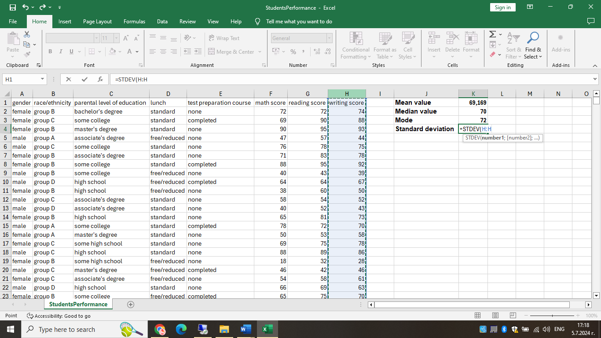

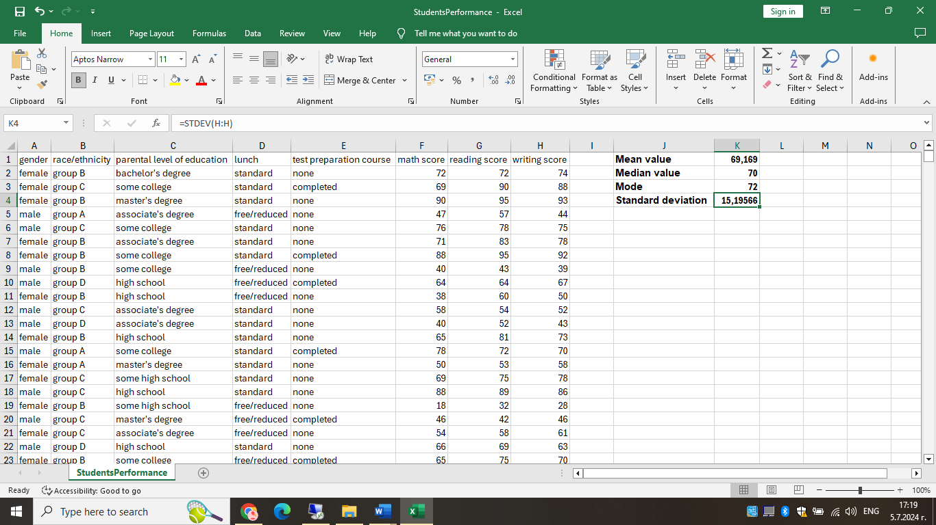

In our case the standard deviation for writing score is 15,19566.

- Which one of the variables has a larger variance?

To find out which one of the variables has a larger variance we will use SPSS instead of Excel, as shown on the screenshots below:

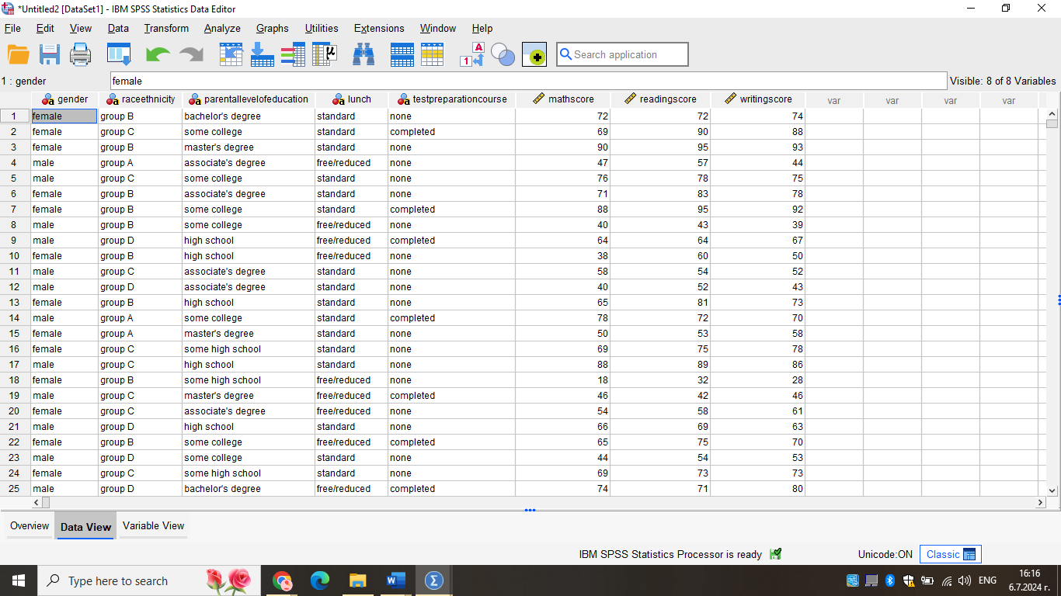

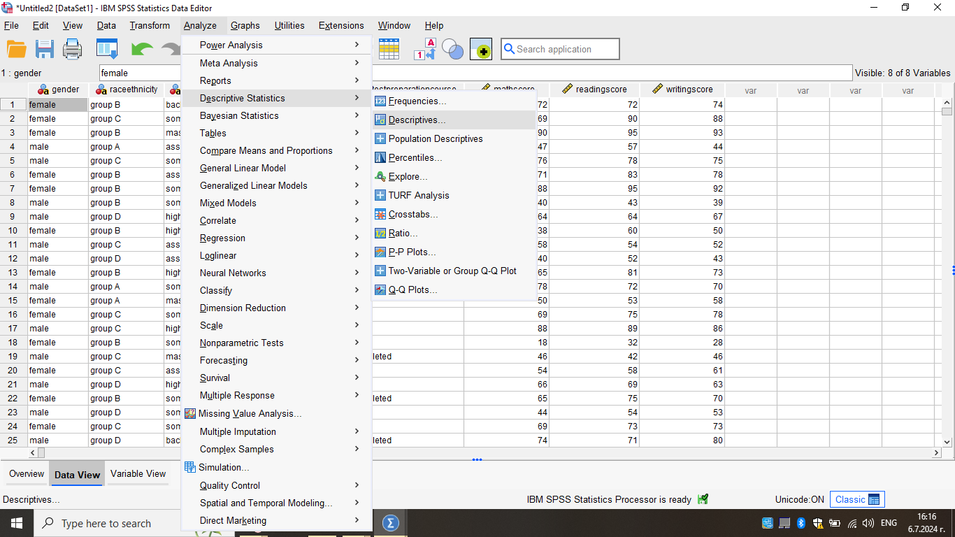
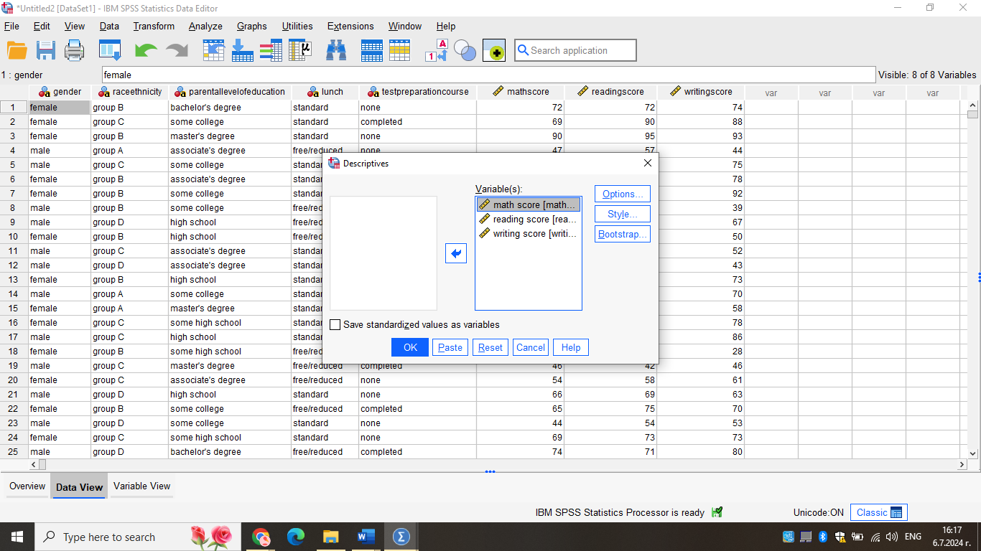

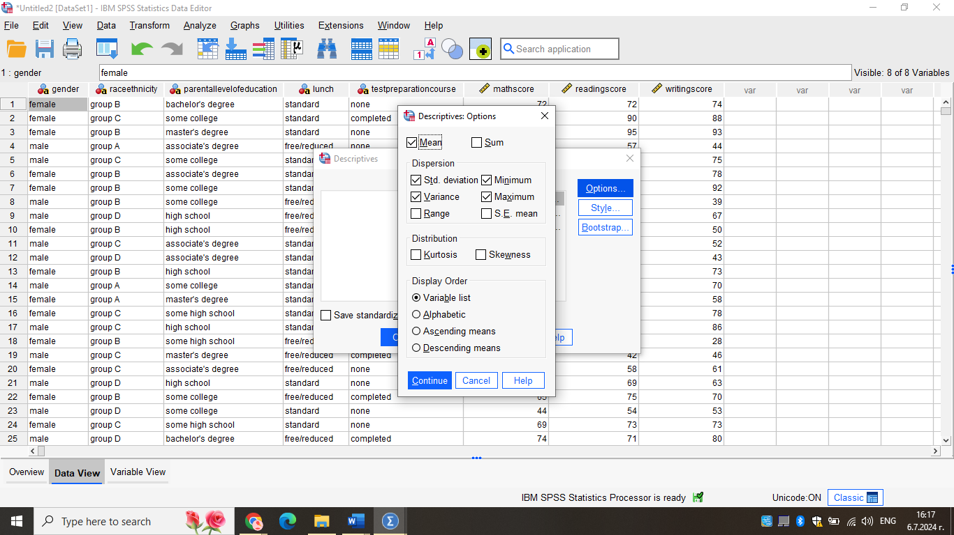

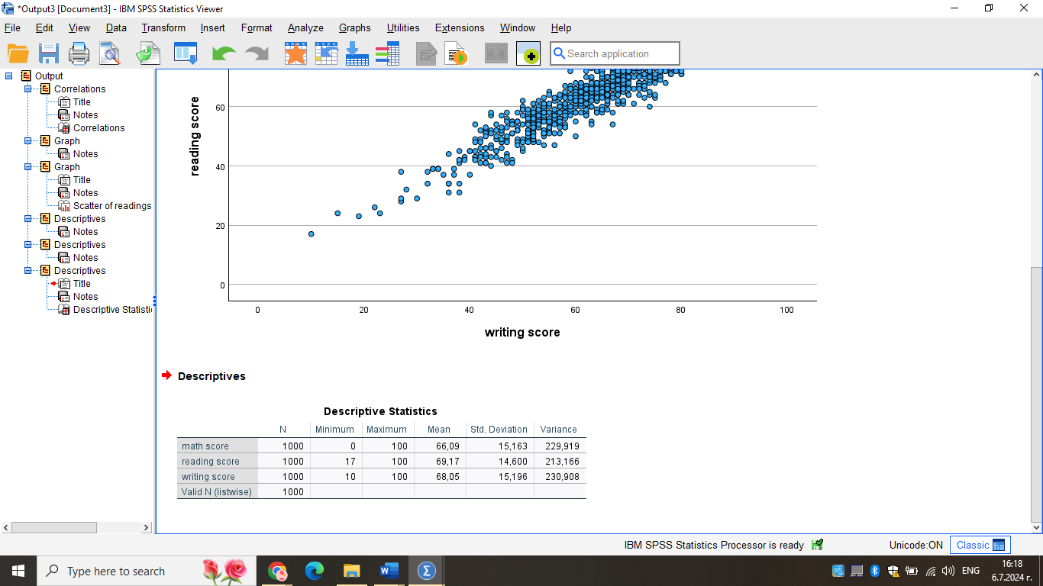

- Which one of the variables has a larger standard deviation?

The standard deviation, abbreviated as σ, quantifies the degree of dispersion of the data with respect to the mean. Data with a low standard deviation, or small standard deviation, are closely grouped around the mean, whereas data with a big standard deviation, or large standard deviation, are widely dispersed. When the standard deviation is around zero, it signifies that the data points are in close proximity to the mean; when it is more, it implies that the data points are dispersed further from the mean.
The larger standard deviation can be found again in SPSS the same way we find the larger variance, please see below:

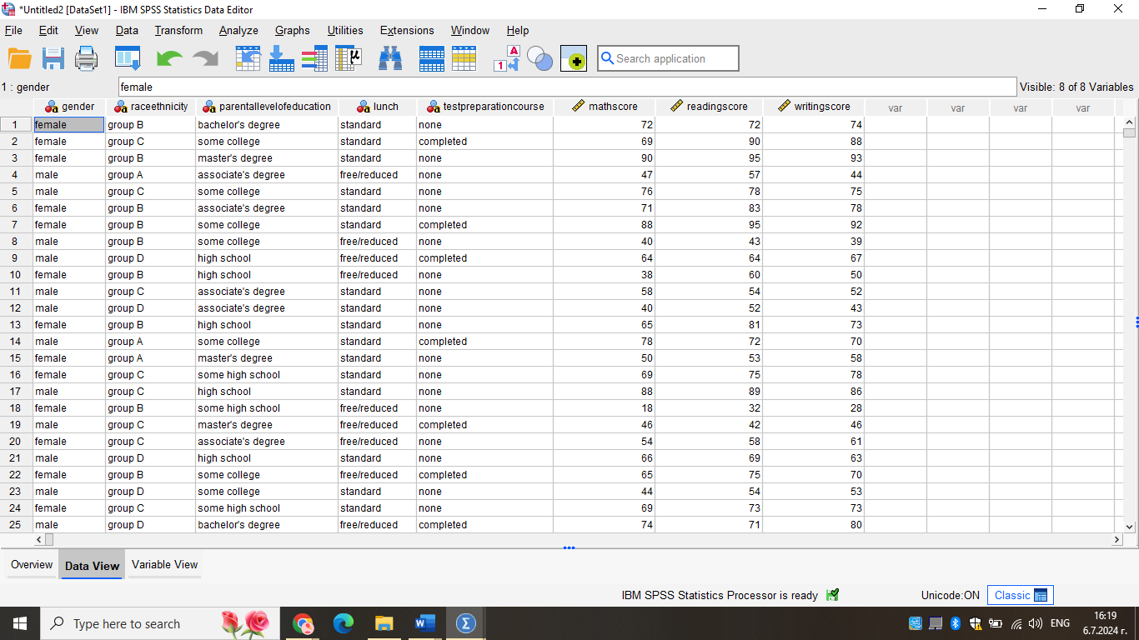

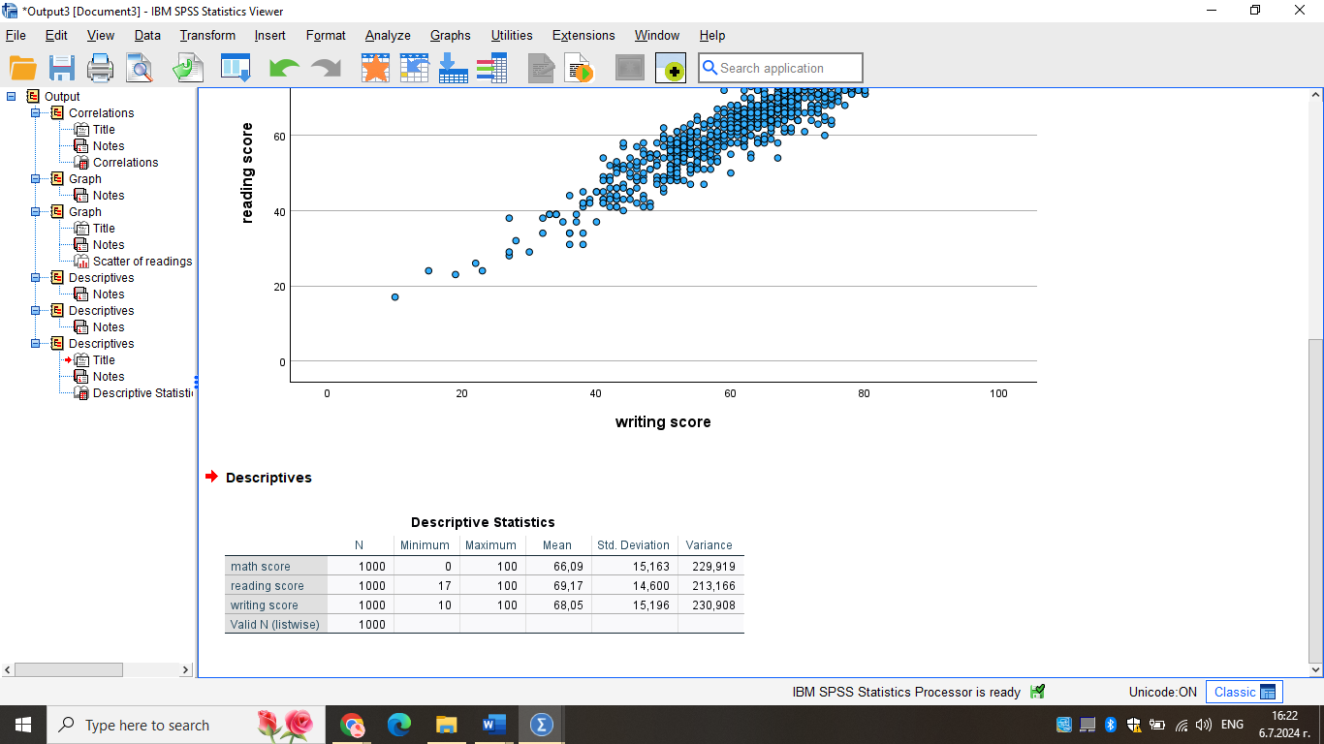

- Can you interpret the last three outcomes?

A statistical measure of a dataset's dispersion with relation to its mean is called the standard deviation. Within the data collection, there is a bigger deviation if the data points are farther from the mean. The variance's square root is used to calculate it.
When applied to an investment's annual rate of return, the standard deviation, a statistical metric used in finance, provides insight into the investment's historical volatility.
The process of calculating variance involves taking the mean of the data points, deducting the mean from each data point separately, squaring each of these answers, and then taking an additional mean of these squares. The variance's square root is the standard deviation. Software such as Excel can be used to swiftly complete all these computations.
The variance helps determine the degree of data dispersion when comparing the data to the mean value. As the variance rises, there may be a greater disparity between two data values, which also increases the data values' volatility. If every data value is close to every other value, the variance will be smaller. However, variances are more difficult to interpret than standard deviations since they represent a squared result that may not be effectively expressed on the same graph as the original dataset.
Generally speaking, standard deviations are simpler to understand and use. Unlike variance, which isn't always the case, standard deviation is expressed in the same unit of measurement as the data. Statisticians can use the standard deviation to ascertain whether the data has a normal curve or some other type of mathematical relationship.
Sixty-eight percent of the data points will lie within one standard deviation of the average, or mean, data point if the data follow a normal curve. More data points fall beyond the standard deviation when variances are larger. More data points that are near average are produced by smaller variations.

(b) Using MS Excel you need to demonstrate how you can present the data in your report with the use of any one of Excel functions such as: IF, PIVOT TABLES, CHARTS AND GRAPHS. (Show your workings with full screenshots).

A pivot table is a statistics tool that summarizes and reorganizes selected columns and rows of data in a spreadsheet or database table to obtain a desired report. The tool does not actually change the spreadsheet or database itself, it simply “pivots” or turns the data to view it from different perspectives (Davidson, 2024)
When dealing with vast volumes of data that would take a long time to calculate by hand, pivot tables come in extremely handy. One of the data processing tasks that a pivot table may accomplish is locating outliers, averages, ranges, and sums. The information is then arranged in the table in a straightforward, significant structure that highlights important values.
Pivot table is a generic term, but is sometimes confused with the Microsoft trademarked term, PivotTable. This refers to a tool specific to Excel for creating pivot tables.

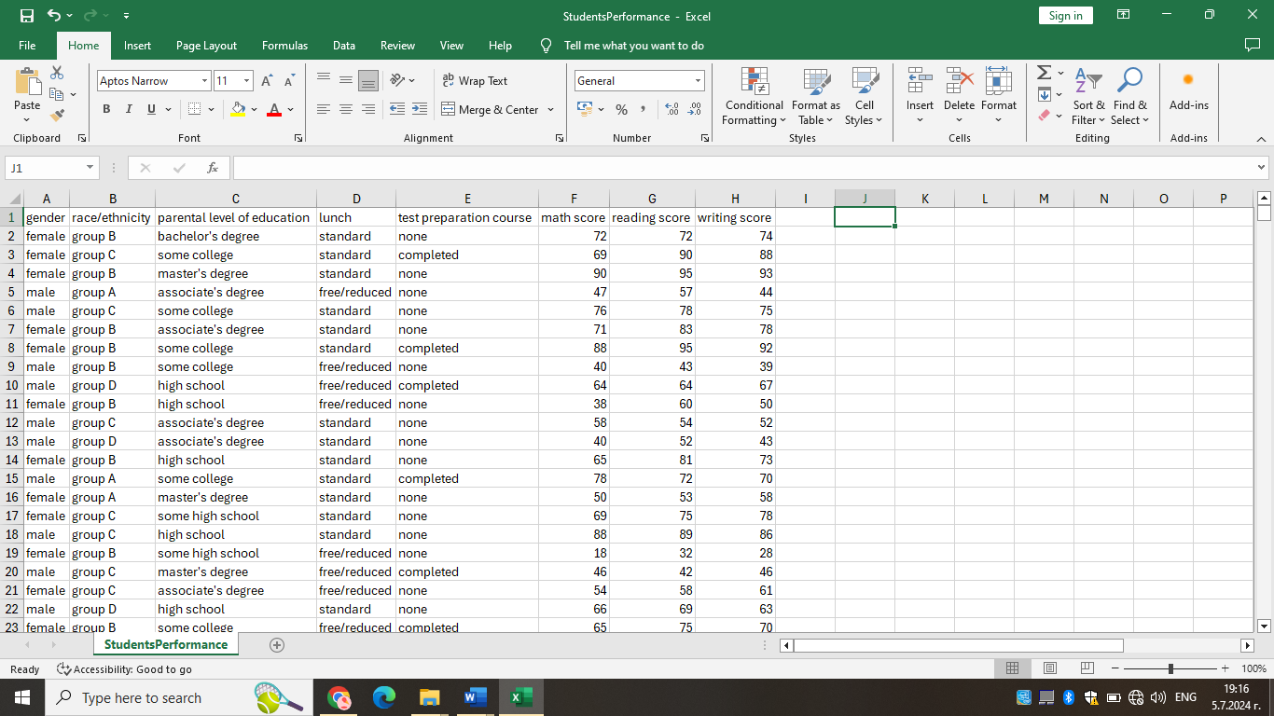

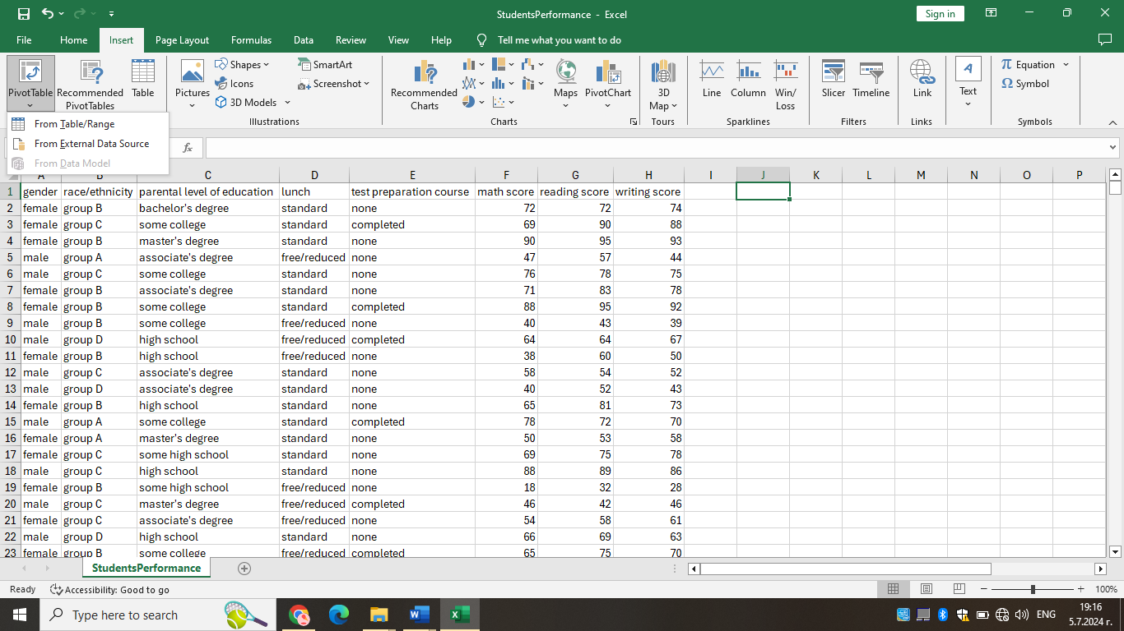
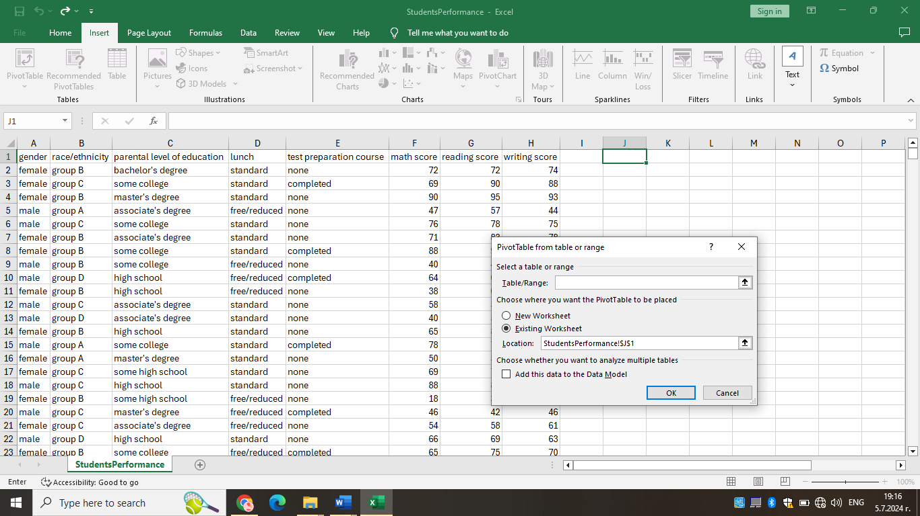

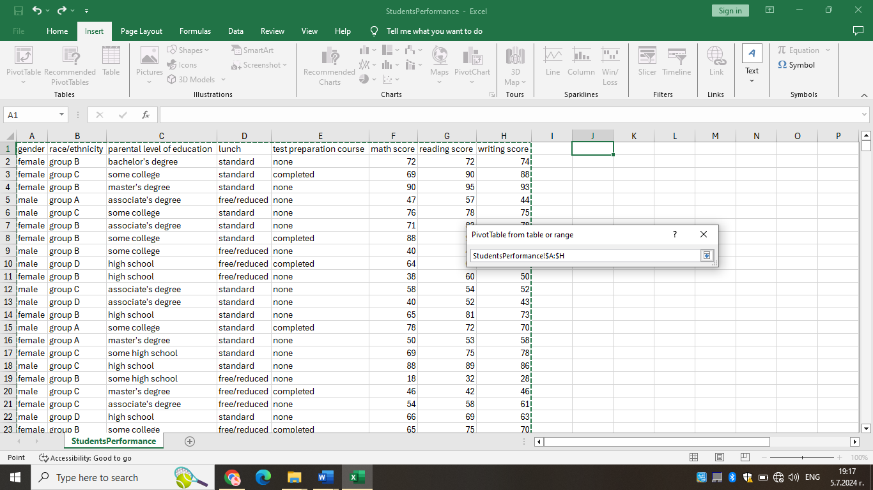
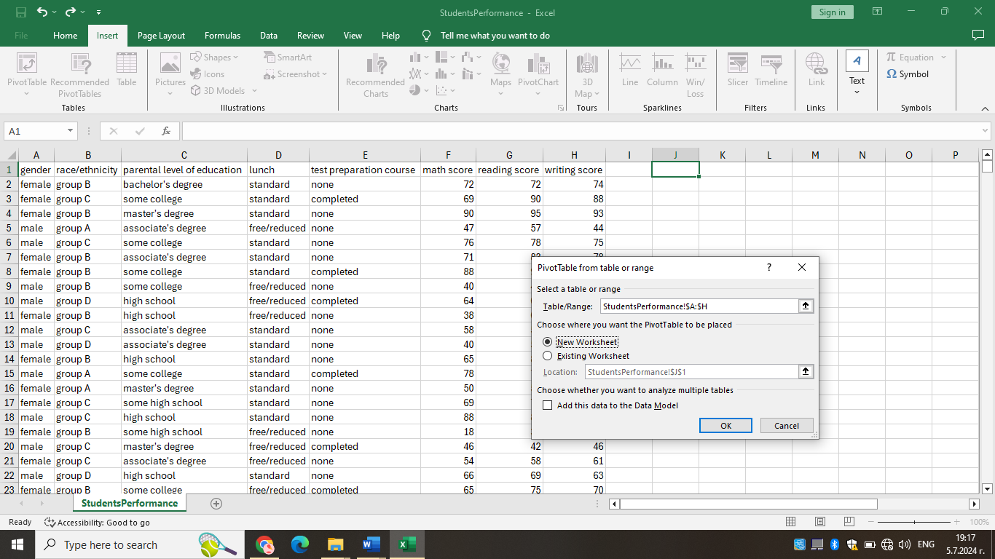

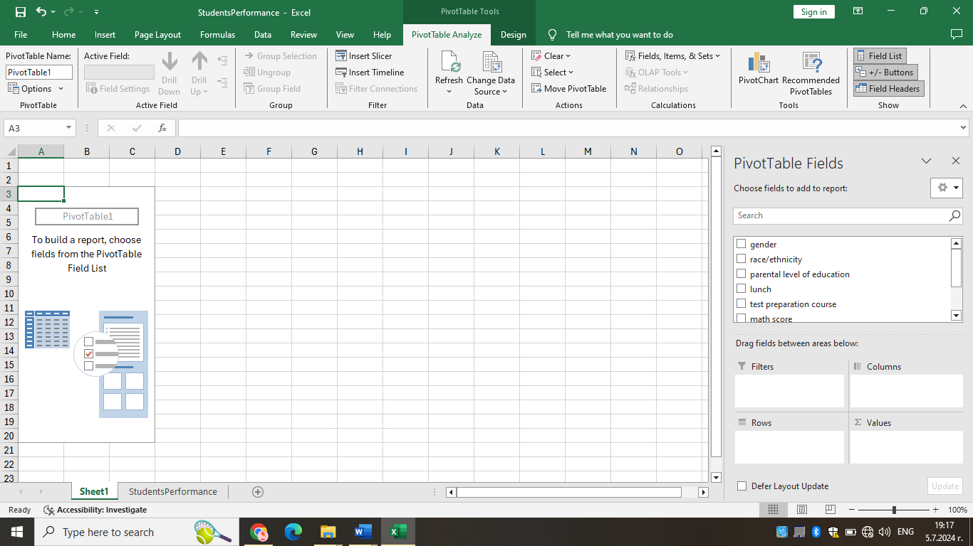

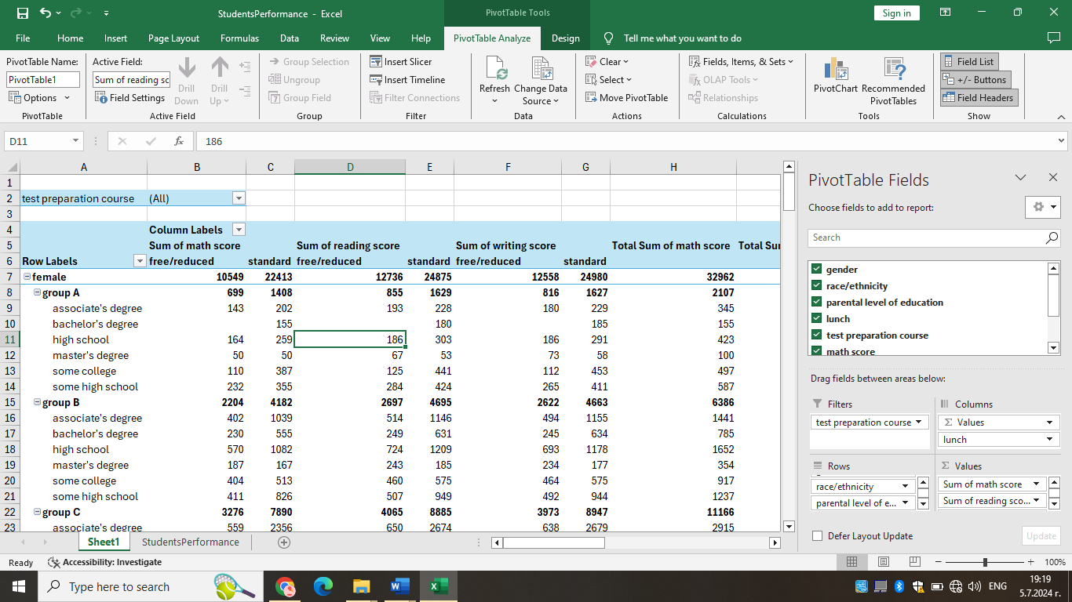

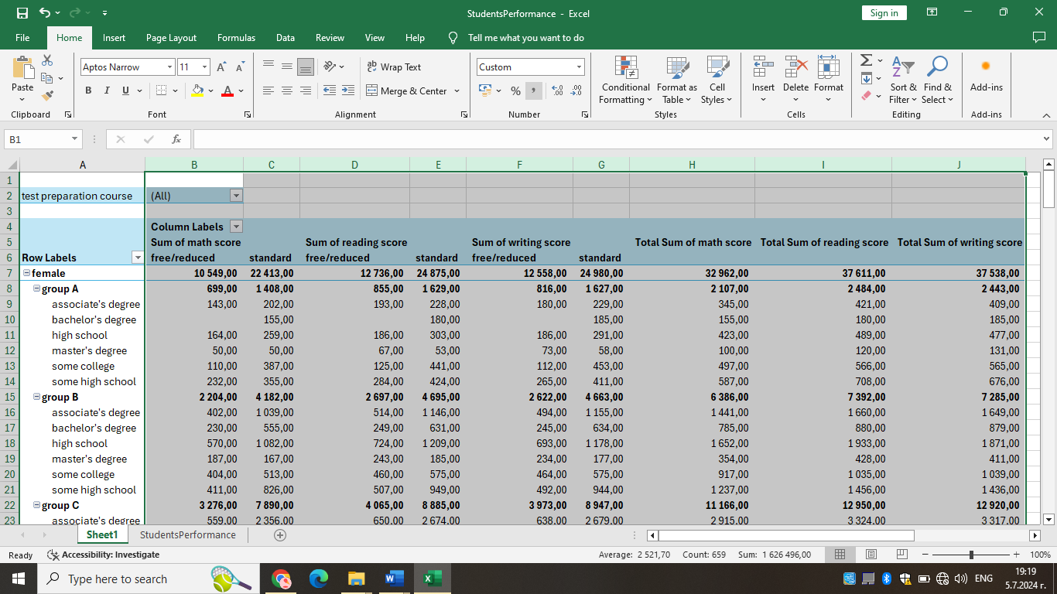

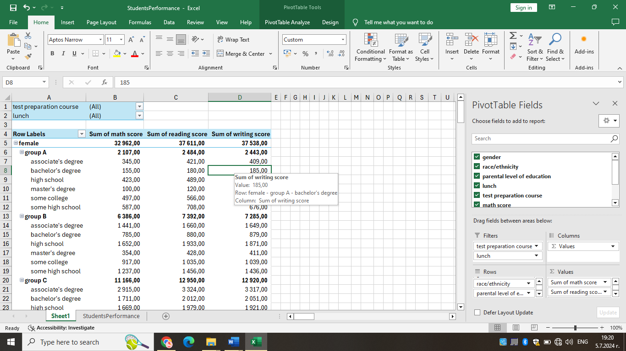

OR:

An Excel chart or graph is a visual representation of a Microsoft Excel worksheet’s data. These graphs and charts allow you to see trends, make comparisons, pinpoint patterns, and glean insights from within the raw numbers. Excel includes countless options for charts and graphs, including bar, line, and pie charts. (Davidson, 2024)

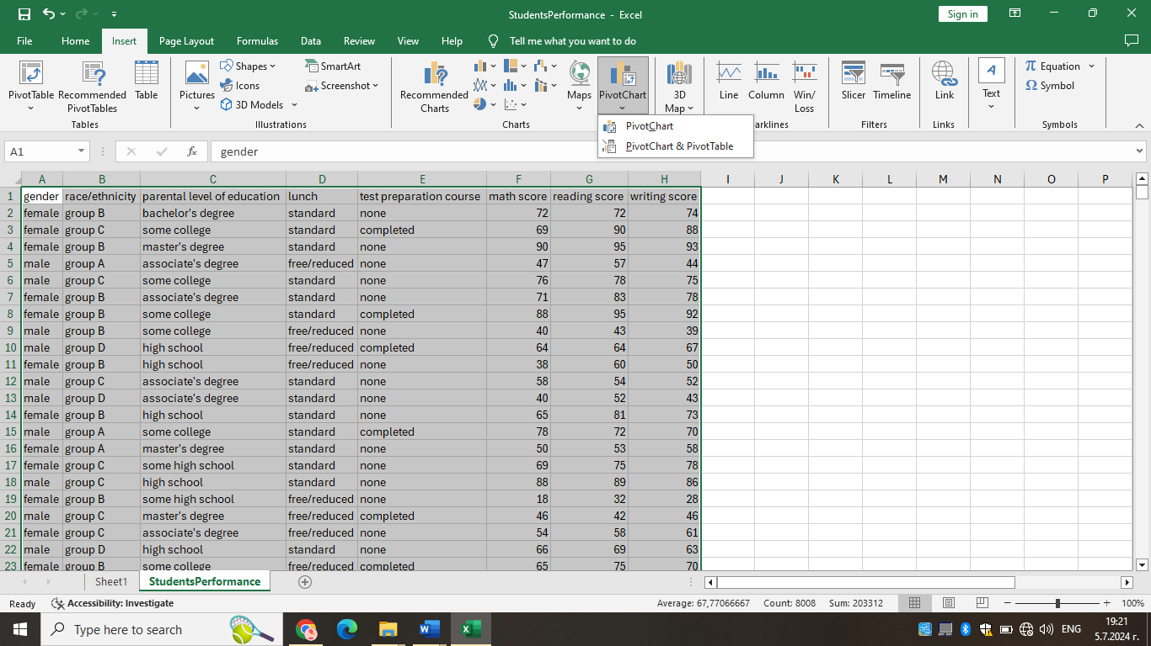

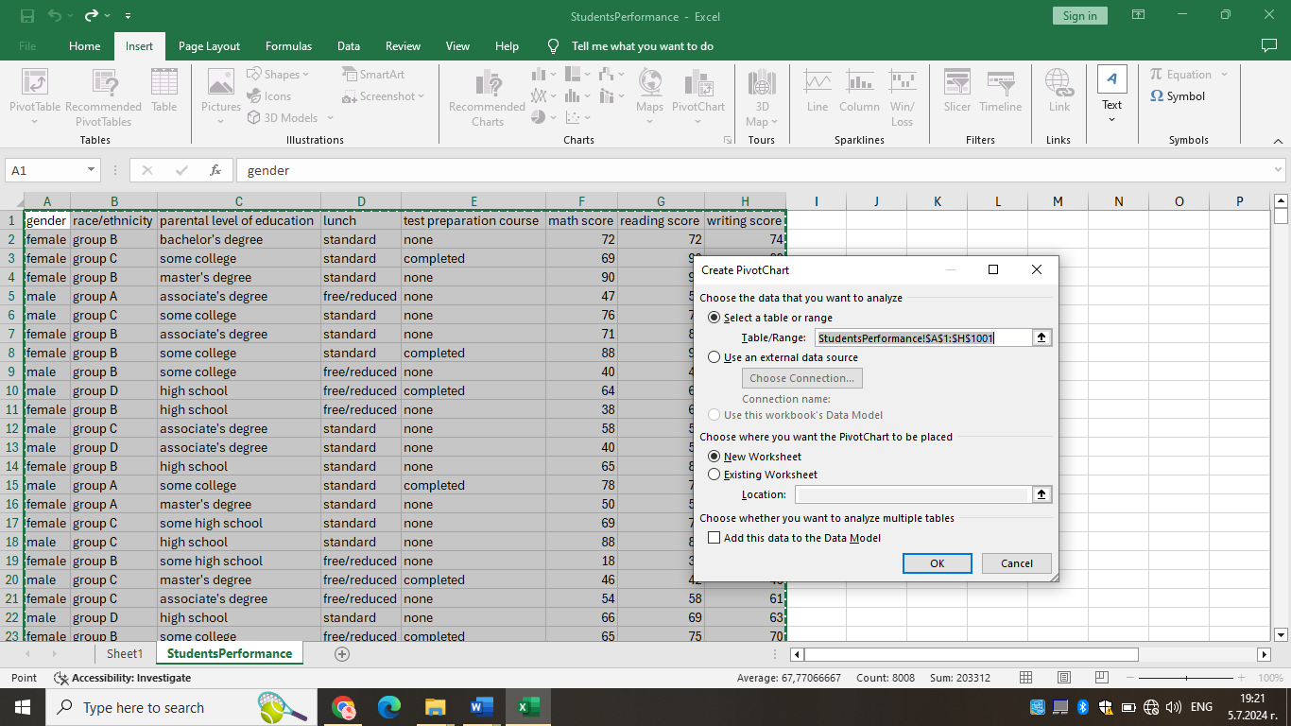
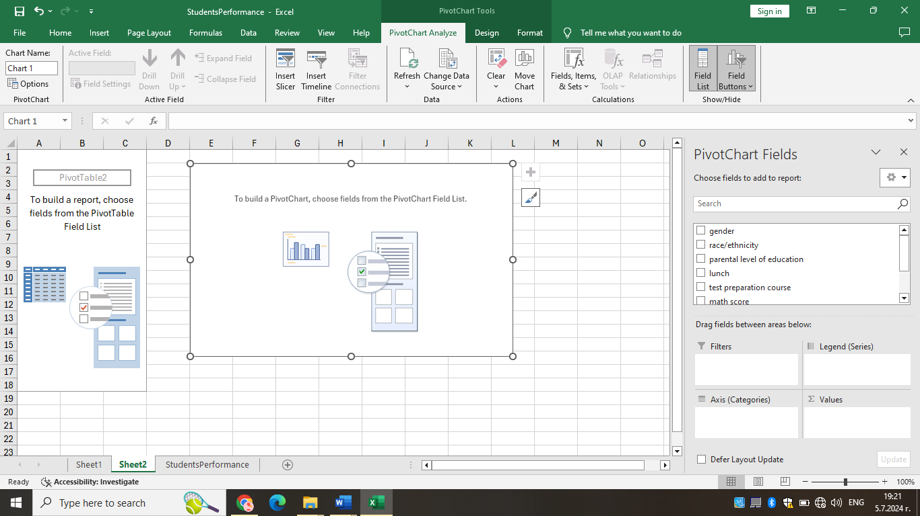

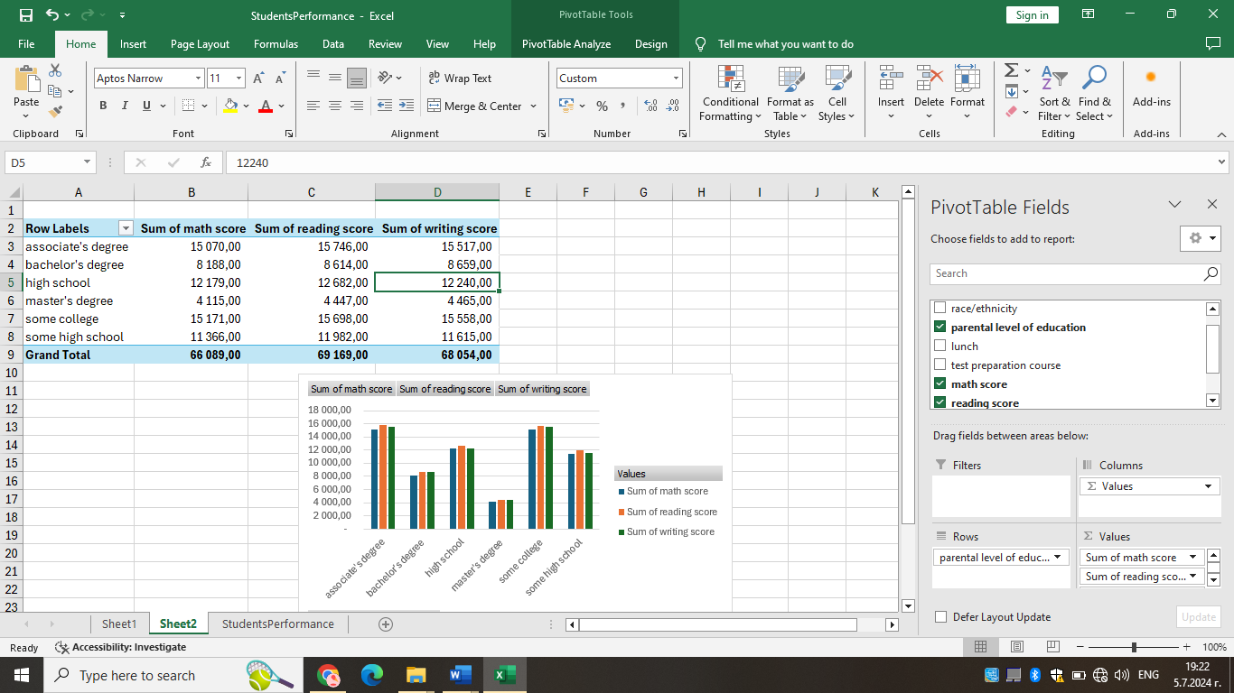

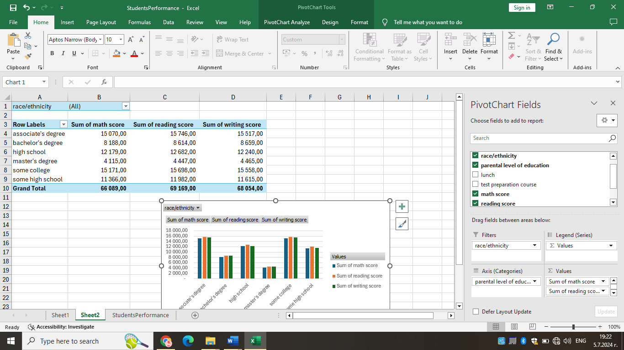

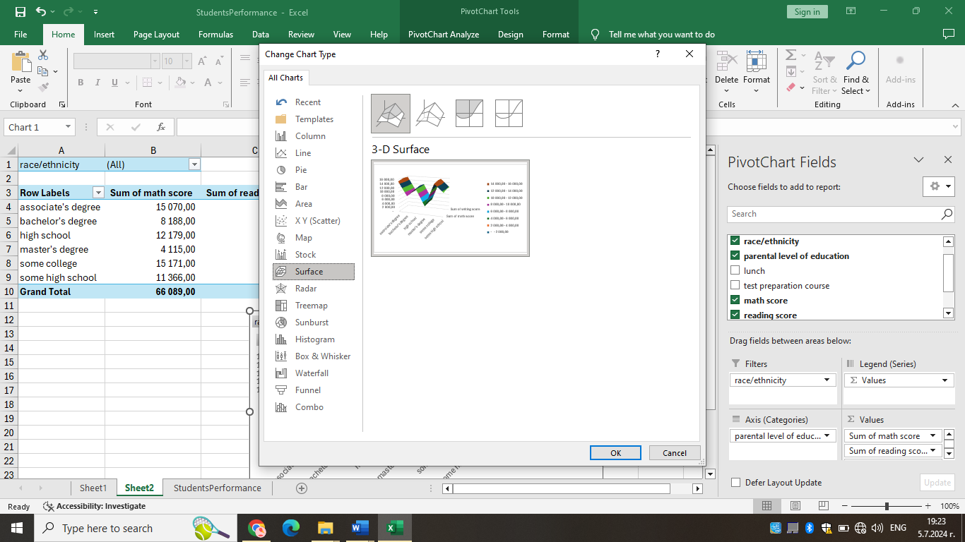

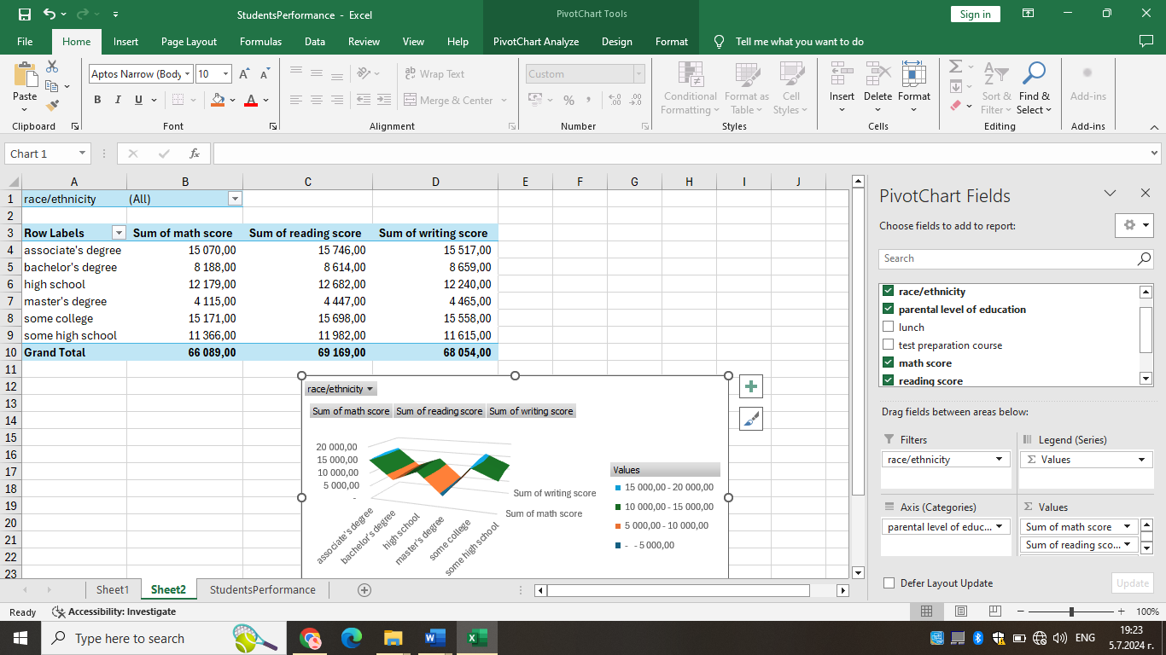

(c) Using SPSS –

1.Find out what is the correlation between writing score and reading score? (Show your workings with full screenshots).

Correlation coefficients provide a numerical summary of the direction and strength of the linear relationship between two variables. The two main correlation coefficients are: - Pearson product-moment correlation: for continuous variables, or one continuous variable and one dichotomous variable. - Spearman rho: for ordinal level or ranked data. The sign of the correlation coefficient indicates the direction of the correlation: a positive correlation indicates that as one variable increases, so does the other; a negative correlation indicates that as one variable increases, the other decreases. The strength of the relationship is given by the numeric value: 1 indicates a perfect relationship; 0 indicates no relationship between the variables.

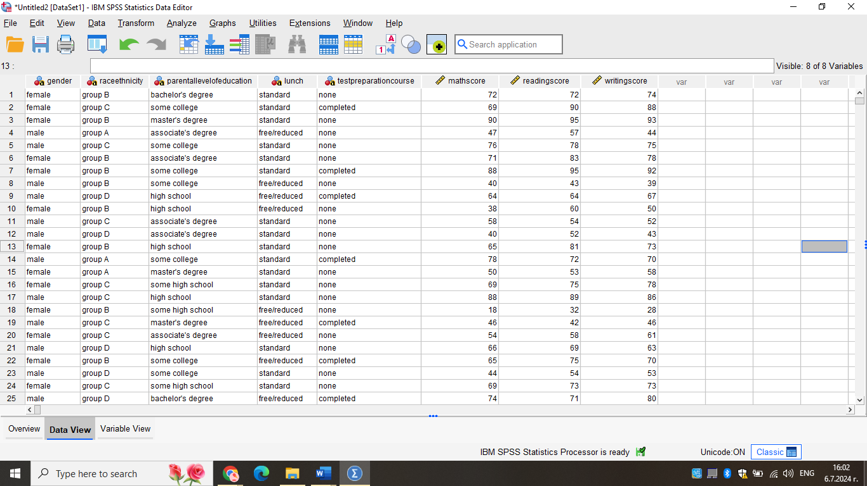

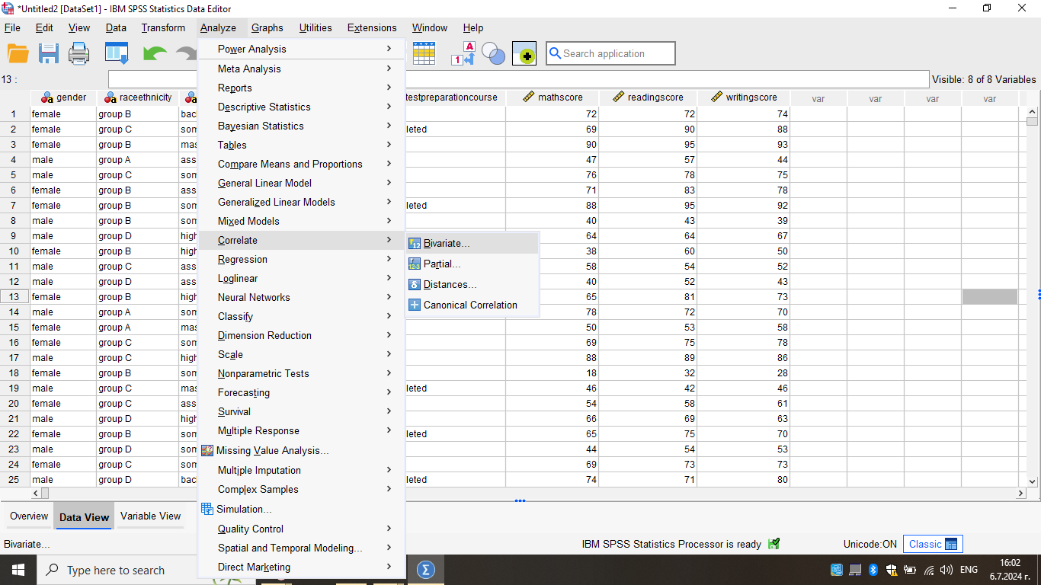
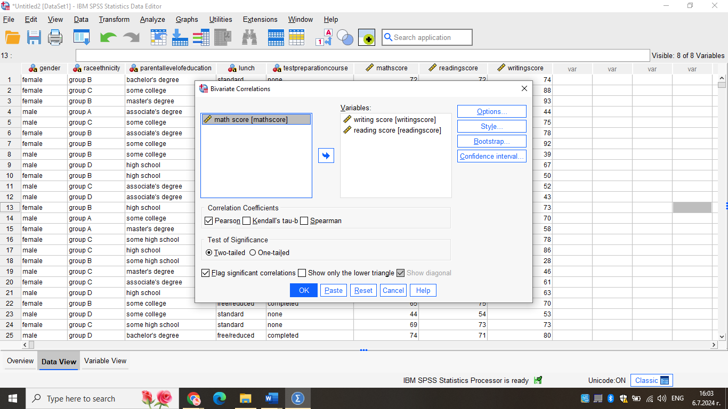

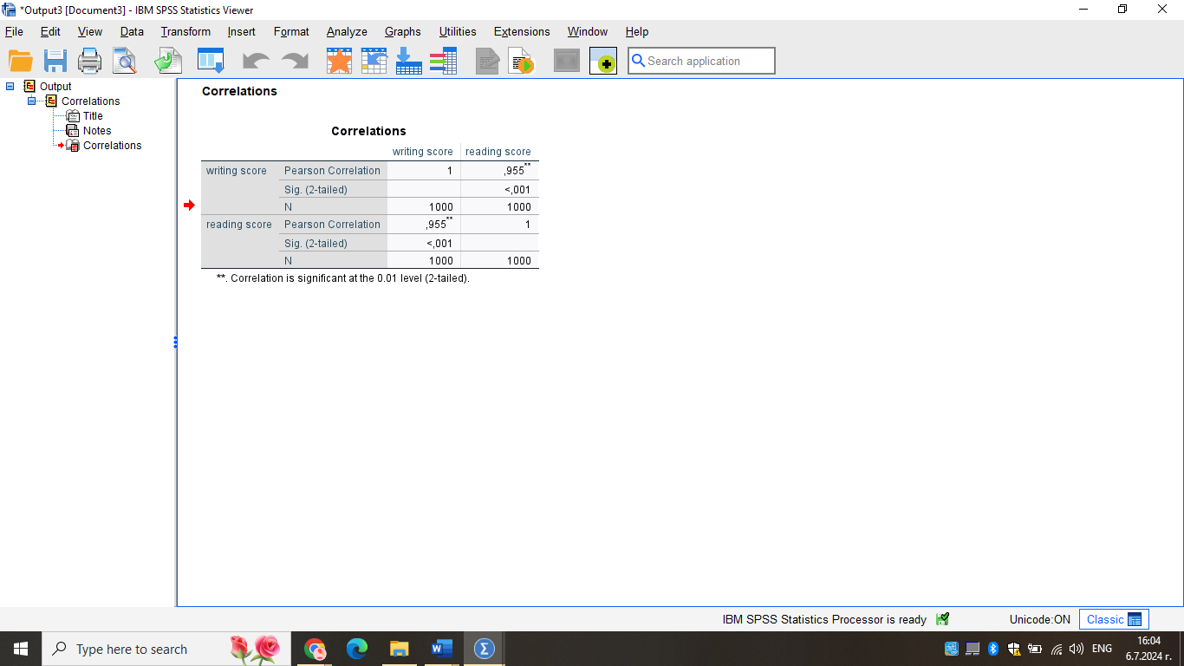

2.Produce a scatterplot of the two variables. Use writing score on the horizontal axis and reading score on the vertical axis and comment on the graph. (Show your workings with full screenshots).

Correlation is a statistical technique that shows how strongly two variables are related to each other or the degree of association between the two. For example, if we have the weight and height data of taller and shorter people, with the correlation between them, we can find out how these two variables are related. We can also find the correlation between these two variables and say that their weights are positively related to height. Correlation is measured by the correlation coefficient. It is very easy to calculate the correlation coefficient in SPSS.

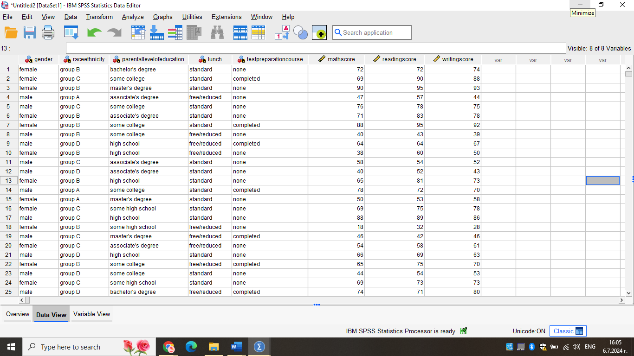

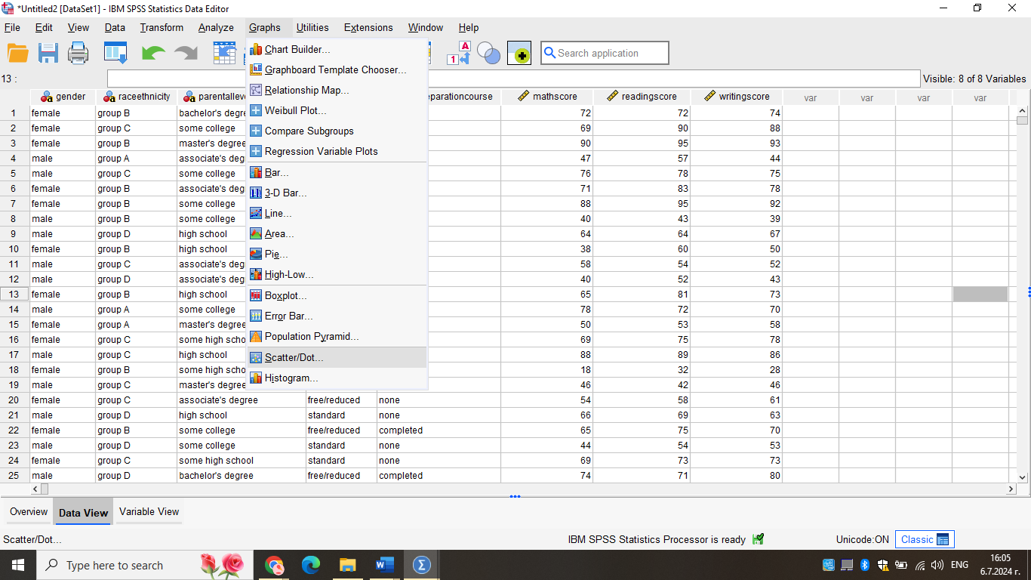
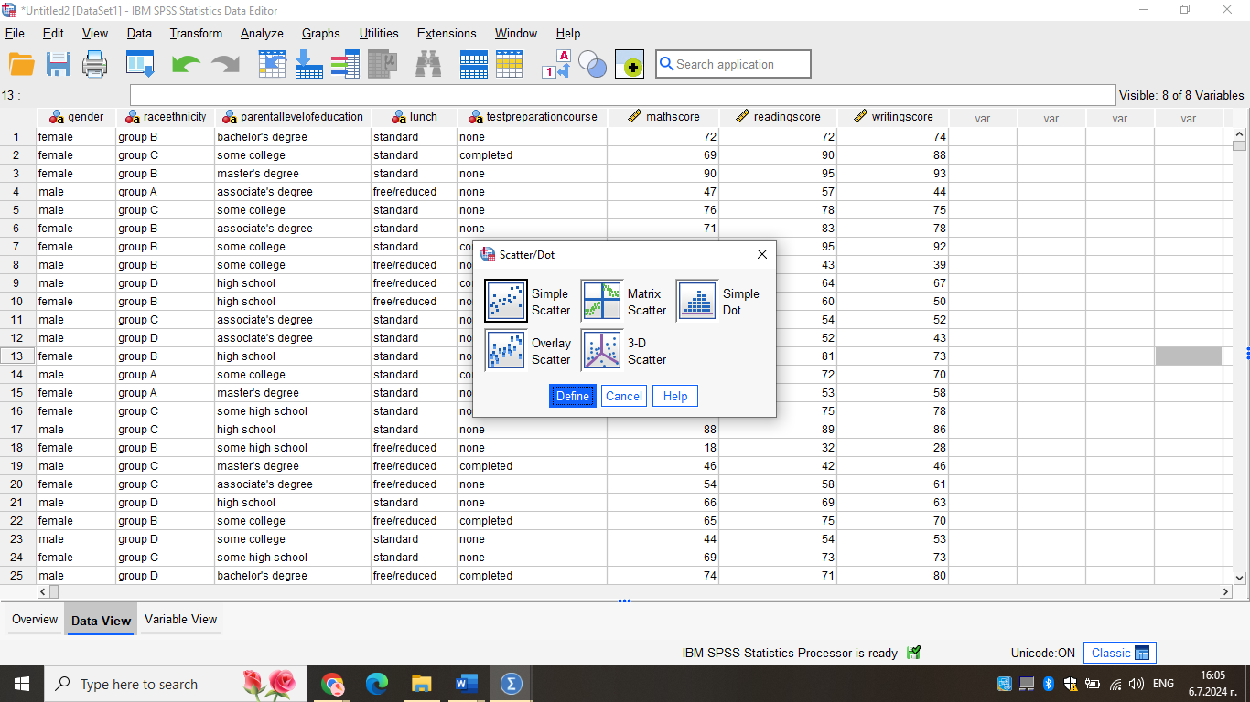

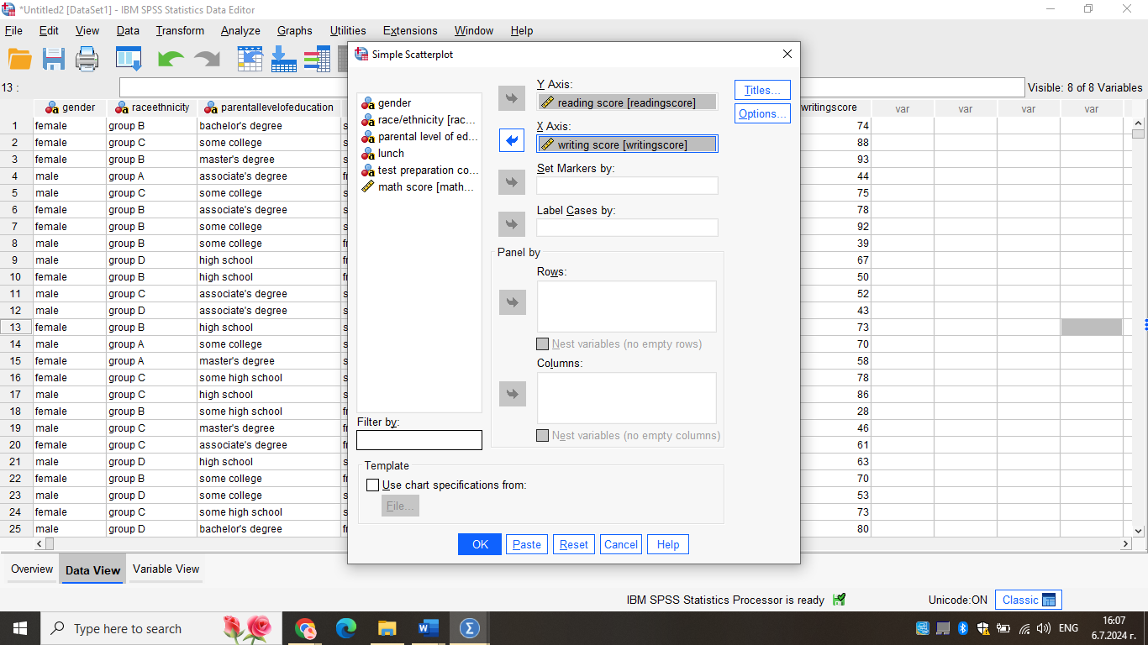

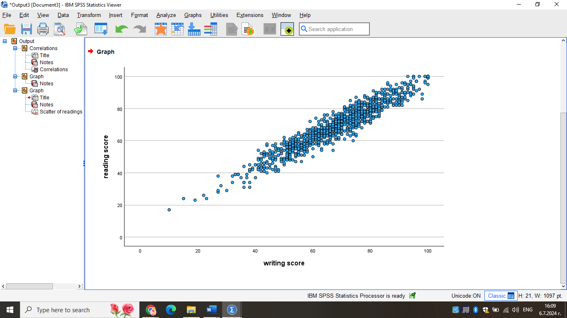

Section 2

(a) Advantages and Disadvantages of using SPSS

Currently, IBM’s SPSS is a comprehensive statistical package designed for social science, marketing, and healthcare research studies. This makes it one of its key strengths that offers extensive coverage of complex statistical analyses, making it a powerful tool for large-scale research in many fields, be it psychology, sociology, or epidemiology (IBM, 2023). For instance, a researcher conducting a public health on the relationship between socio demography and health state may employ SPSS in executing other complicated analysis such as multiple regression analysis, factor analysis and structural equation modeling. As a result of this, the software can be easily utilized by researchers who may not be programmers since it operates from a menu driven system. It has made SPSS popular especially in learning institutions where it forms the basis of the software tool used in the quantitative research methods course.
The third advantage of SPSS is the ability to manipulate and handle data in various ways. According to Ozgur et al (2025) they found that the software offers many features for data cleaning, recoding and transformation, which are important in data preparation. For instance, a market researcher who is dealing with a large consumer survey dataset could effortlessly transform categorical variables, derive new variables from the existing ones, and also manage missing data by using SPSS data transformation options. Moreover, SPSS provides options for customized output so the results can be in more presentable formats such as tables and graphs which can then be exported for reporting. It is especially useful for scholars who are working on manuscripts for publication or for consultants who are developing reports for clients.
Yet, it is not devoid of some drawbacks as well. The one major disadvantage that cannot be overlooked is the high cost of using it especially for an individual researcher or an organization with a limited budget (Masuadi et al., 2021). Due to the high cost, institutions are likely to buy few licenses which makes the availability of resources limited for some users. In addition, although the graphical user interface in SPSS is rather intuitive and easy to use for simple analyses, writing more complex scripts may require substantial time and effort. This could take a lot of time in the case of first-time users and more time may be needed for more advanced uses of the software may need further training. The third and final general drawback of SPSS is its relatively restricted data visualization capabilities when compared to dedicated visualization software. As for the chart and graph creation, SPSS can generate standard types of charts and graphs but may leave users who require more complex or perhaps even animated charts and graphs unsatisfied.
(b) Meaning and Importance of Data Mining Cycle

The Data Mining Cycle or the Knowledge Discovery in Databases (KDD) represents a step-by-step procedure of knowledge discovery from large databases. It consists of several interconnected stages: These are Problem Definition, Data Collection, Data Preprocessing, Data Transformation, Data Mining, Pattern Evaluation, and Knowledge Presentation (Mimon et al., 2010). This cycle offers a check list like approach to the handling of complex data analysis that helps to avoid missing important steps in the process. Also, because it is cyclic, correction and optimization at each stage lead to higher accuracy and value of the results obtained. In this way, the cycle helps analysts to check data quality and validation of the results through the preprocessing and evaluation phases. The structured approach also aids in resource planning and allocation across the duration of the project, and in improving the replicability of the results, thus making it useful in both scientific and business contemporary purposes.
In practice the Data Mining Cycle can be exemplified with a case where a telecommunications company wants to predict customer churn (Ahmad et al., 2019). This would be followed by a formulation of the problem of identifying customers likely to switch to competitors. This data would include customer data such as demographics, usage patterns, customer service call records, and churn records. During data preprocessing, data cleaning would be performed where missing values would be addressed, duplicates removed, and inconsistencies dealt with. Data transformation can include the process of converting categorical variables into numerical format, normalizing numerical features in the dataset, and generating new derived features, such as average monthly usage. The data mining stage would involve using algorithms like logistic regression or random forests to develop a model. Pattern evaluation would enable the determination of the accuracy of the model through the measurement of the accuracy, precision, and recall rates, and through the use of cross validation. Lastly, knowledge presentation could entail the development of an executive dashboard that displays churn risk scores of customers and other factors that have influenced the churn risk.
One more example of how the Data Mining Cycle works is banking fraud. The problem definition would concern the identification of potentially fraudulent transactions in real-time. Data collection would involve collection of historical transaction data in terms of amount, location, time and incidences of fraud. Preprocessing would take care of missing data, the removal of outlying values since fraudulent transactions are usually the minority. Data transformation could produce new variables like frequency of transactions, average size of transaction, and days to the next transaction (Amanze and Onukwugha, 2018). The data mining stage could use anomaly detection methods or supervised learning methods such as the support vector machines to flag the suspicious transactions. In the case of pattern evaluation, the detection of new patterns of fraud would involve the use of measures such as false positive rate and detection rate among others, and alterations would be continually made to the model as new patterns are identified. Implementation of knowledge presentation could include creating an application for the fraud detection team in the bank to alert them to specific transactions and why they should be suspicious.
In conclusion, it can be inferred that although SPSS of software can be used for data analysis and visualization, its proper applications depends on several factors such as the complexity of the analysis, the availability of funds, the level of expertise of the user or the requirements of the particular project. The Data Mining Cycle is rather beneficial in the sense that it offers a linear guideline on how the information should be analysed in the most effective way possible. When implemented in this cycle, one can derive meaningful knowledge from raw data that enhances decision-making across the organizational spectrums and other fields of practice including business, healthcare, and scientific studies.

Reference List

- ‌ Ahmad, A.K., Jafar, A. and Aljoumaa, K. (2019). Customer churn prediction in telecom using machine learning in big data platform. Journal of Big Data, [online] 6(1). doi:https://doi.org/10.1186/s40537-019-0191-6.
- Amanze, B. and Onukwugha, C. (2018). Data Mining Application in Credit Card Fraud Detection System. International Journal of Trend in Research and Development, [online] 5(4), pp.2394–9333. Available at: https://www.ijtrd.com/papers/IJTRD16726.pdf [Accessed 13 Jul. 2024].
- IBM (2023). SPSS software. [online] IBM. Available at: https://www.ibm.com/spss.
- Masuadi, E., Mohamud, M., Almutairi, M., Alsunaidi, A., Alswayed, A.K. and Aldhafeeri, O.F. (2021). Trends in the Usage of Statistical Software and Their Associated Study Designs in Health Sciences research: a Bibliometric Analysis. Cureus, [online] 13(1). doi:https://doi.org/10.7759/cureus.12639.
- Oded Maimon, Lior Rokach and Springerlink (Online Service (2010). Data Mining and Knowledge Discovery Handbook. New York, Ny: Springer Us. https://www.researchgate.net/publication/225835494_Chapter_1_-_Introduction_to_Knowledge_Discovery_in_Databases
- Ozgur, C., Kleckner, M. and Li, Y. (2015). Selection of Statistical Software for Solving Big Data Problems. SAGE Open, [online] 5(2), p.215824401558437. doi:https://doi.org/10.1177/2158244015584379.
- Svetlana Cheusheva, (updated on March 20, 2023), https://www.ablebits.com/office-addins-blog
- Sarah Lewis, (August 2019) https://www.techtarget.com/searchdatamanagement/definition/pivot-table
- Sara Davidson, (February 29, 2024 ) https://blog.hubspot.com/marketing/how-to-build-excel-graph

