Module:
ACCB6017 Usability Engineering
Lecturer: Coushik Modak
Full Interface & Testing
University of Wales Trinity Saint David London Campus
Mindaugas Levinskas (2226067)

Table of Contents
Introduction 2
2. Overview of the Storyboard Approach 2
3. Visual Design, Graphics, and Colour Scheme 2
3.1 Colour Palette 2
3.2 Accessibility Considerations 3
3.3 Typography and Iconography 3
4. Full-Colour Storyboard Screen Descriptions 4
Screen 1: Splash and Loading Screen 4
Screen 2: Home and Main Menu 4
Screen 3: Game Setup with Players and Mode 5
Screen 4: Character Selection 5
Screen 5: Campus Selection 5
Screen 6: Main Game Screen 6
Screen 7: Suggestion Screen 6
Screen 8: Accusation Warning Screen 6
Screen 9: Notes and Clue Tracking 7
Screen 10: Settings and Accessibility 7
Screen 11: Tutorial Overlay 7
Screen 12: Game End and Results Screen 8
5. Usability Testing and Feedback Collection 8
5.1 Methodology 8
5.2 Participant Coverage 8
5.3 Feedback Summary 8
6. Data Collection in a Working Version 8
7. Usability vs User Experience Reflection 9
8. Conclusion 9
Bibliography 10

Introduction

Cluedo is a well-known mystery board game where players move around a mansion, collect clues, and try to work out who committed a murder, what weapon they used, and where it happened. This project transforms the classic Cluedo idea into a mobile phone game set at the University of Wales Trinity Saint David (UWTSD). The story follows a dramatic question: Oh no! The Vice-Chancellor has been murdered! Who did it?
In the first assignment, basic wireframes were created to explore layout and functionality. This second assignment develops those wireframes into full-colour storyboards showing how the finished app would look and feel, focusing on visual design, usability, accessibility, and user experience.
This report explains the final storyboard designs, describes the visual and interaction choices made, evaluates usability testing feedback, discusses potential data collection, and reflects on the design process using established usability theories.

2. Overview of the Storyboard Approach

‘’A UX storyboard is a visual tool—one that illustrates a user's experience with a product or service. Designers use storyboards to understand and address user needs as they move forward in the UX design process.’’ [1] Storyboards show not just what individual screens look like, but also how users move between them to complete tasks. Unlike wireframes which focus on structure using simple shapes, full-colour storyboards include colour, fonts, icons, and feedback states. This allows designers to evaluate how users might feel when using the app and whether the design is accessible to everyone.
The storyboards are designed for mobile phones first, considering limited screen space and the need for touch-friendly controls. The complete set created with Figma can be found in the in the Chapter 4, and all screens will be discussed in the following sections. [2]

3. Visual Design, Graphics, and Colour Scheme

3.1 Colour Palette

The main colour is deep navy blue, chosen because it is used by the main UWTSD website and suggests seriousness, intelligence, and mystery, fitting the crime-solving story. Navy blue is easier on the eyes than pure black and makes text easier to read. A secondary gold accent colour reinforces the academic UWTSD theme and highlights selected options and progress indicators.
Colours convey consistent meanings throughout the app. Blue is used for suggestions and safe actions, red for accusations and warnings, gold for highlights and progress, and grey for inactive elements. This follows Nielsen's principle of consistency and standards. [3]


Figure 1. UWTSD web page colours

3.2 Accessibility Considerations

All text and elements meet WCAG 2.1 contrast requirements. Colour is never the only way of
conveying information, with icons and text labels used alongside colour to support users with colour blindness. A colour-blind mode and dark mode are included in the settings screen, allowing users to adjust the interface to suit their individual needs and preferences. The colour-blind mode adjusts the colour palette to use colours that are distinguishable even for users with common types of colour blindness. The dark mode uses light text on dark backgrounds, which some users find easier to read and which can help reduce eye strain in low-light conditions. Large touch targets and generous spacing between interactive elements also help users who have motor difficulties or visual impairments, making it easier to tap the right button without accidentally hitting something else. [4]

3.3 Typography and Iconography

A clean sans-serif font ensures readability on small screens, with larger headings creating visual hierarchy. Icons are simple, familiar, and paired with text labels, supporting recognition over recall. Icons are simple, familiar, and paired with text labels throughout the interface. This design decision supports recognition over recall, meaning users can recognise what things do rather than having to remember from previous use. This is especially helpful for new or occasional players who might not use the app every day. The icons use a consistent visual style and are sized large enough to be easily understood even on smaller phone screens. Common icons like home, settings, and back arrows follow standard conventions that users will already be familiar with from other apps. [5] [6]

4. Full-Colour Storyboard Screen Descriptions

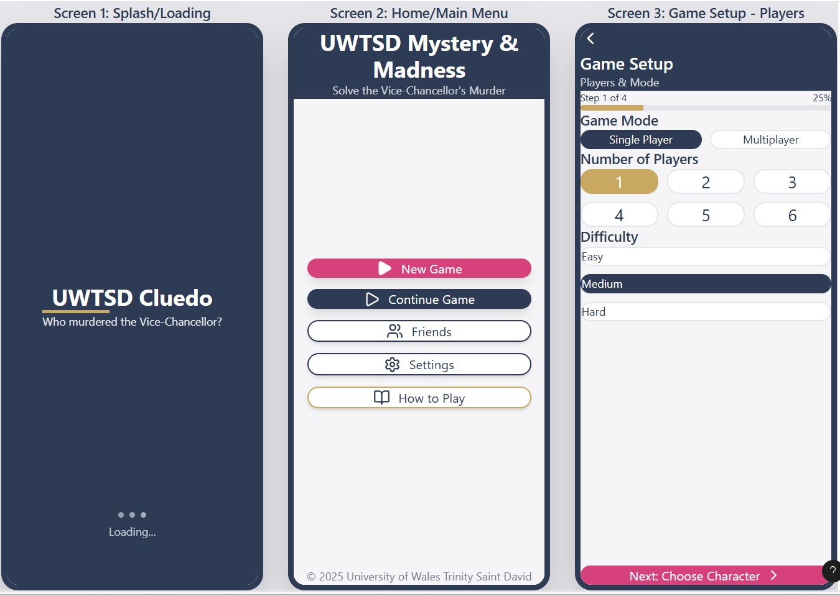
Figure 2. Screen 1, Screen 2 and Screen 3

Screen 1: Splash and Loading Screen
The splash screen is the first thing users see when they open the app, so it plays an important role in setting up the game's visual style and story atmosphere from the very beginning. The title "UWTSD Cluedo" and subtitle "Who murdered the Vice-Chancellor?" immediately introduce the storyline and capture the player's interest. The dark, mysterious colour scheme establishes the mood before gameplay even begins. A loading indicator shows that the app is working and making progress, which reduces uncertainty and frustration while the game resources load in the background.

Screen 2: Home and Main Menu
The Home Screen serves as the main navigation hub from which users can access all other parts of the app. Primary actions such as New Game and Continue Game are made visually prominent using larger buttons and bolder colours, while secondary options like Friends, Settings, and How to Play remain easy to find but are given less visual emphasis. This visual hierarchy helps users quickly find what they are looking for. Large buttons and icons make the interface easy to use on touchscreens and reduce the chance of accidental taps on the wrong option.

Screen 3: Game Setup with Players and Mode
This screen allows users to select the game mode, number of players, and difficulty level before starting a new game. A progress indicator showing "Step 1 of 4" helps users understand where they are in the setup process and how many more steps remain. This gives them a sense of control over the process, which is particularly important for less experienced users who might otherwise feel lost or uncertain. The setup process is broken into clear steps to avoid overwhelming users with too many choices at once. [7]

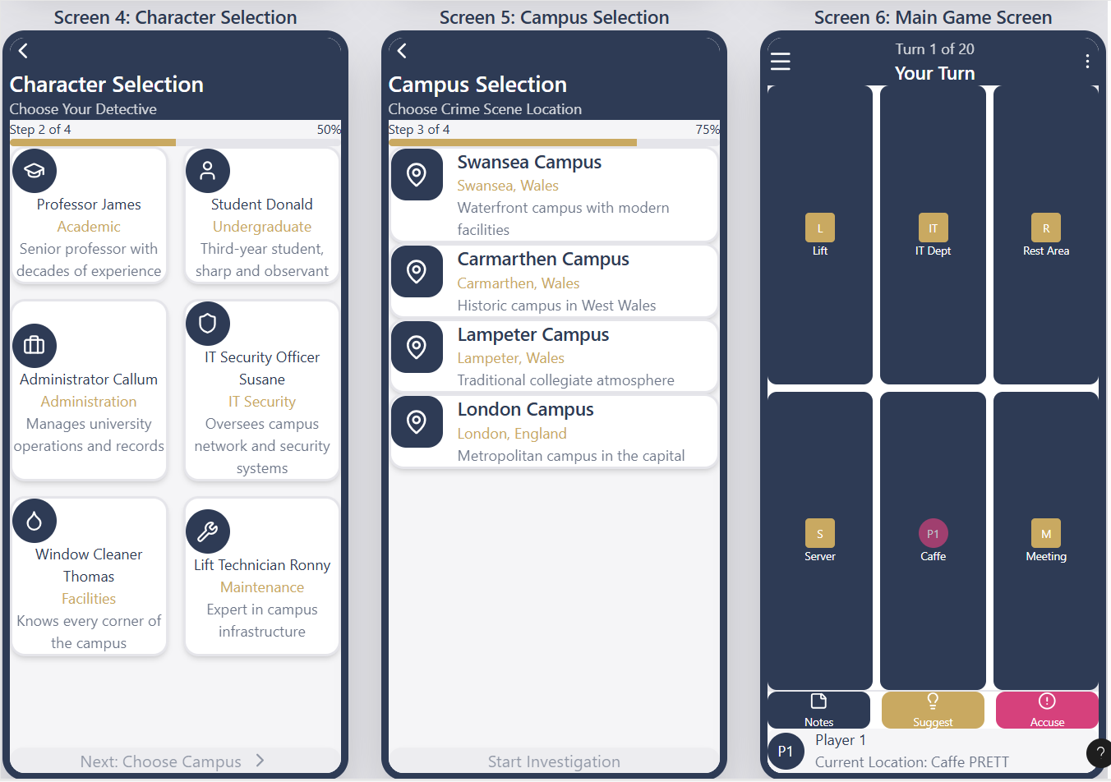
Figure 3. Screen 4. Screen 5 and Screen 6

Screen 4: Character Selection
Players choose from university-themed characters such as Professor James, Student Donald, and IT Security Officer Susane. These characters were designed specifically for the UWTSD setting to make the game feel authentic and connected to university life. Each character comes with a short description of their role and personality, which helps players feel emotionally connected to their choice and more engaged with the story. The character selection screen uses card-based layouts that are easy to browse and compare.

Screen 5: Campus Selection
Users select the campus where the crime takes place from the four UWTSD locations. Card-based layouts present the Swansea, Carmarthen, Lampeter, and London campuses with brief descriptions of each location. This maintains a consistent design style with the previous selection screens, creating a smooth and predictable user experience. Including all four real UWTSD campuses adds authenticity and allows students from any campus to feel included in the game.

Screen 6: Main Game Screen
This is the central gameplay screen where most of the action takes place. The campus map takes up the main area of the screen, with clear location labels and markers showing where each player is positioned. A visible turn indicator saying "Your Turn" keeps users informed about the current game state so they always know when it is their time to act. Action buttons for Notes, Suggest, and Accuse are placed at the bottom of the screen for easy thumb access, following common mobile app conventions that users will find familiar. [7]

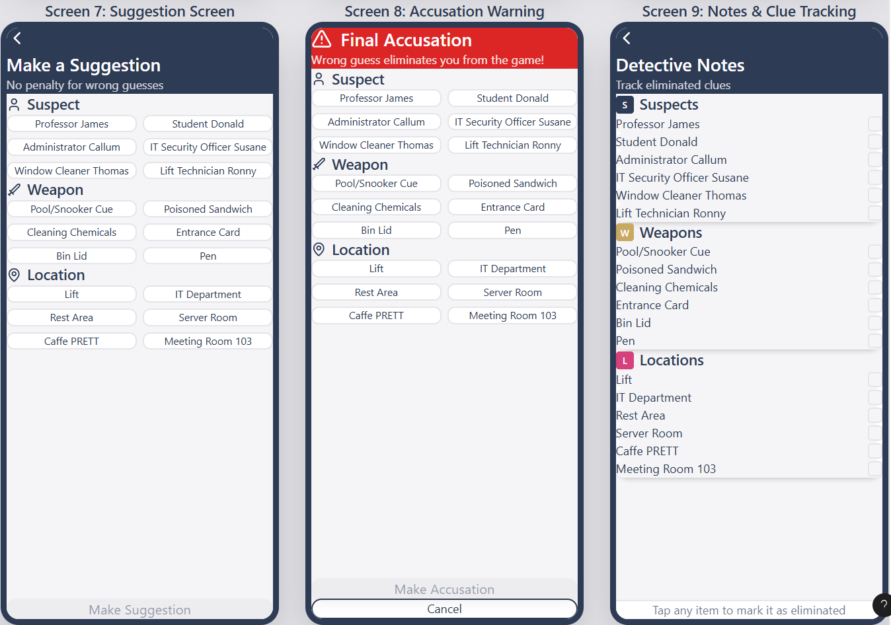
Figure 4. Screen 7, Screen 8 and Screen 9

Screen 7: Suggestion Screen
The suggestion screen allows players to make non-final guesses by selecting a suspect, weapon, and location. Suggesting is a core part of Cluedo gameplay that allows players to gather information without risk. The calm visual design and neutral colour scheme reinforce that this action carries no penalty if the guess is wrong, encouraging players to experiment and gather clues without fear. Clear dropdown menus and selection controls make it easy to make choices quickly.

Screen 8: Accusation Warning Screen
A red warning banner clearly communicates the seriousness of making a final accusation, which in Cluedo results in losing the game if the accusation is wrong. Users must confirm their choice before proceeding, which applies Norman's principle of error prevention by reducing the chance of accidental irreversible actions. The warning text explains the consequences clearly, so users understand what they are committing to. This two-step confirmation process protects users from mistakes while still allowing them to make accusations when they are ready.

Screen 9: Notes and Clue Tracking
This screen allows players to keep track of which clues have been eliminated using simple checklists. In the physical board game, players typically use paper and pencil to track this information, but the digital version makes this process easier and more organised. This feature helps players remember important information without having to keep it all in their heads, reducing the mental effort required during gameplay. Icons and labels ensure the screen is accessible and the layout is intuitive even for first-time users. [7]

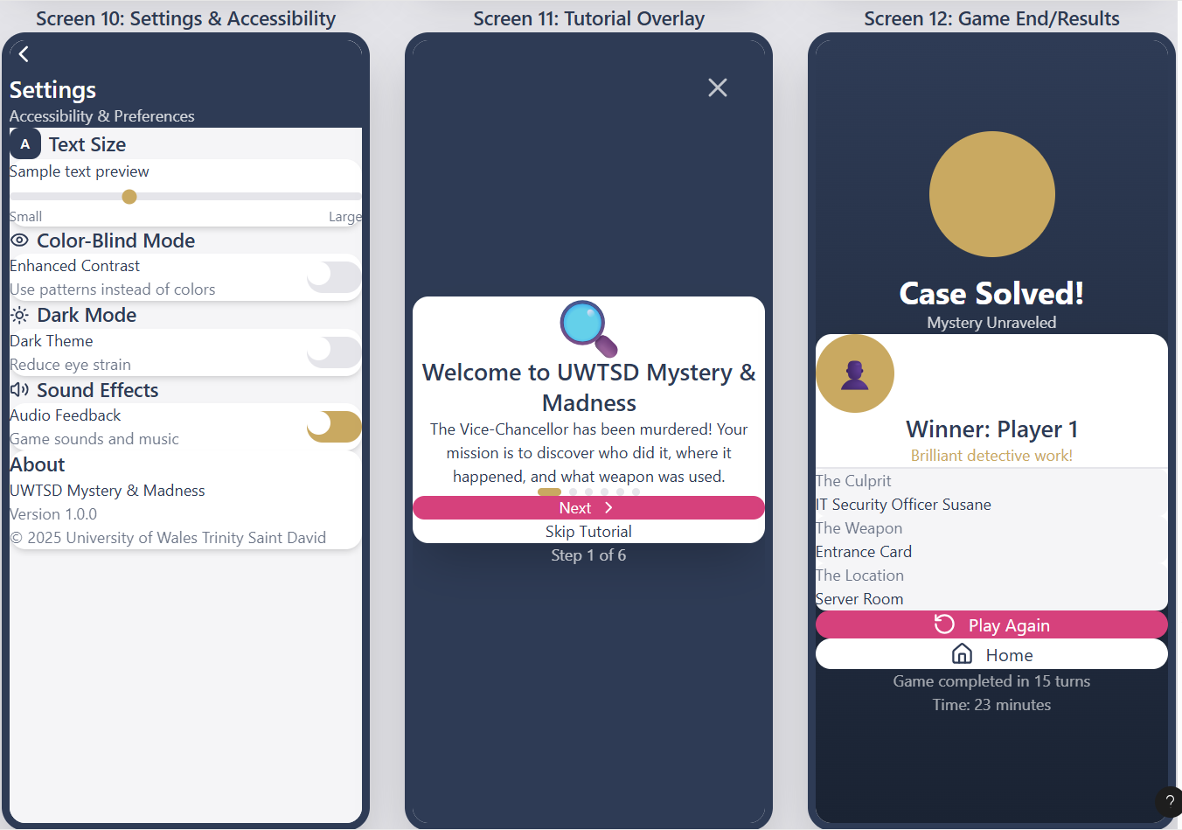
Figure 5,Screen 10, Screen 11 and Screen 12

Screen 10: Settings and Accessibility

The settings screen provides users with control over their experience. Users can adjust text size to make reading easier, enable colour-blind mode for better colour distinction, turn on dark mode for comfortable viewing in low light, and control sound effects and music volume. Simple toggles and sliders keep the interface clear and easy to use, allowing users to make changes quickly without confusion. Each setting is clearly labelled with a brief explanation of what it does.

Screen 11: Tutorial Overlay

The tutorial provides step-by-step guidance for new players, explaining the basic rules and how to use the interface. At the same time, it allows experienced users who already know how to play to skip it entirely with a single tap. This balances the need to support new users who need help getting started while respecting the time of those who already know how to play and just want to begin. The tutorial uses highlighting and arrows to draw attention to specific parts of the screen being explained.

Screen 12: Game End and Results Screen

The results screen wraps up the game by revealing the correct solution and announcing the winner. This provides narrative closure and a satisfying conclusion to the mystery. The screen shows who the murderer was, what weapon they used, and where the crime took place. Clear options to play again immediately or return to the home screen encourage players to continue using the app and try another round. Statistics about the game, such as number of turns taken, add interest and replay value. [7]

5. Usability Testing and Feedback Collection

5.1 Methodology

Usability testing was carried out using interactive prototypes created in Figma. Participants completed realistic tasks such as starting a game, making suggestions, viewing notes, and adjusting settings. Observations and verbal feedback were collected during each session.

5.2 Participant Coverage

Five participants were selected to match the personas from Assignment 1, including an experienced gamer, a social multiplayer-focused student, a busy casual player, a mature new gamer, and a user with visual accessibility needs. This ensured feedback came from people with different abilities and expectations.

5.3 Feedback Summary

Positive feedback highlighted the clear navigation, strong university theme, helpful tutorial, and good accessibility options. Negative feedback noted that the notes panel was initially overlooked and experienced players wanted faster interaction methods. Based on this, the notes button (screen 6) was made more prominent and tutorial overlays were improved to highlight secondary features. [8]

6. Data Collection in a Working Version

If the game were released to the public, both numerical and descriptive data would be collected to help improve the app over time. Usage data gathered automatically would include session length, feature usage frequency, error rates, and task completion times. This information would help identify which parts of the app work well and which need improvement.
Emotional response data would be collected through optional in-app surveys, such as the Self-Assessment Manikin, to measure enjoyment, frustration, and confidence. Emotional data differs from usage data because it requires users to actively provide input and give consent. All data collection would be anonymised and follow ethical standards to protect user privacy. [9]

7. Usability vs User Experience Reflection

If the app had been designed purely from a usability perspective, focusing only on efficiency and error prevention, the interface could feel less engaging and enjoyable. For example, confirmation dialogs slow down gameplay but prevent costly mistakes. In this project, warning messages were limited to high-risk actions only, finding a balance between usability and user experience.
This shows the importance of combining both usability and user experience considerations rather than treating them as competing goals. A game that is perfectly usable but boring will not succeed, just as a beautiful game that is confusing will frustrate players. The best designs are both usable and enjoyable. [10]

8. Conclusion

This project successfully demonstrates the progression from basic wireframes to full-colour storyboards for a mobile Cluedo-style game set at UWTSD. By applying user-centred design principles, usability theory, and repeated testing with real users, the final designs work well for a wide range of people while maintaining strong story engagement and visual appeal.
The process highlighted important lessons about effective mobile application design. Accessibility must be considered from the beginning rather than added later. User feedback is invaluable for identifying problems that designers might miss. Finding the right balance between usability and user experience requires careful thought. Overall, this project demonstrates how thoughtful, user-centred design can transform a simple concept into a polished and engaging mobile experience.

Bibliography

[1] | M. Soegaard, “UX Storyboards: Ultimate Guide,” Interaction Design Foundation, 03 2025. [Online]. Available: https://www.interaction-design.org/literature/article/ux-storyboards?srsltid=AfmBOorURQ3aPnXJLPje2WS1oaaSRgNeXrHnF1eARVJFXOPmO0QJ-qtQ.
[2] | Figma, “Seven essential UI design principles + how to use them,” Figma, [Online]. Available: https://www.figma.com/resource-library/ui-design-principles/.
[3] | J. Nielsen, “Enhancing the explanatory power of usability heuristics,” CHI '94: Proceedings of the SIGCHI Conference on Human Factors in Computing Systems, pp. 152-158, 1994.
[4] | W3C, “Web Content Accessibility Guidelines (WCAG) 2.1,” 25 May 2025. [Online]. Available: https://www.w3.org/TR/WCAG21/.
[5] | Figma, “https://www.figma.com/resource-library/typography-in-design/,” Figma, [Online]. Available: https://www.figma.com/resource-library/typography-in-design/.
[6] | R. Lisandro, “Typographic Hierarchy: Improve Readability in Design,” Medium, 06 2024. [Online]. Available: https://medium.com/design-bootcamp/typography-hierarchy-improve-readability-in-design-c77e8a4ca486.
[7] | Figma, “How to make a storyboard for UX design in 5 steps,” Figma, [Online]. Available: https://www.figma.com/resource-library/how-to-create-a-ux-storyboard/.
[8] | K. Moran, “Usability (User) Testing 101,” 01 12 2019. [Online]. Available: https://www.nngroup.com/articles/usability-testing-101/.
[9] | A. &. V. P. Betella, “The Affective Slider: A Digital Self-Assessment Scale for the Measurement of Human Emotions.,” PLOS ONE , 2016.
[10] | R. Dias, “Usability vs User Experience: Let’s get the differences straight shall we?,” UX Planet, 06 12 20121. [Online]. Available: https://uxplanet.org/usability-vs-user-experience-lets-get-the-differences-straight-shall-we-e81d5759b4ce.

