
MBA – Master of Business Administration
Human Resource Management
LCMB7000

Assessment – 1

Student Name: Honey Shinoy
Student ID : 2218830

Executive Summary

The labor market in the UK is covered in this study. This research describes the current scenario, the causes of the crisis, and the state of HRM in the UK. The report also includes a situational analysis. It has to do with how the UK labor market is evolving. In-depth analyses of the impact of the Covid-19 epidemic, Brexit, and significant foreign companies operating in the UK market as well as their reactions to organizational changes are also included in this paper. The main foundation of this research has been a discussion of the basic pandemic effects and Brexit implications, such as poorer productivity, poor employee engagement, supply chain disruption, and significant restrictions on the business. The significant strategic adjustments made by the report's key results have been characterized as HR departments adapting to logistical needs, changing company models, and rising technological expenditures.

Table of Contents
1.0 Introduction 5
1.1Objectives…………………………………………………………………………………………………………………………………………..5
1.2 Purpose and Importance of the study……………………………………………………………………………………………..5
1.3 Research and Methodology……………………………………………………………………………………………………………..5
1.4 Nature and Study………………………………………………………………………………………………………………………………5
1.5 Area of the Study………………………………………………………………………………………………………………………………5
1.6 Period of Study………………………………………………………………………………………………………………………….…….5
2.0 The current state of the labor market in UK 6
2.1 Labor force framework 6
2.2 Trends in labor market in UK 7
2.3 Employment 7
2.4 Unemployment 10
2.5 Earnings 11
2.6 People in the labor market 11
3.0 The emerging changes in Human Resourcing (HR) Strategies in the post Covid, post Brexit external environment 14
3.1 HR strategies in the post Covid period 14
3.2 HR strategies in the post Brexit period 16
4.0 Conclusion 18
References 19

Table of figures

Figure 1: Labor force framework
Figure 2: Employment rate in UK
Figure 3: Full-time v/s part-time workers in UK
Figure 4: Statistics of employees and self-employees
Figure 5: Comparison of public and private sector employment in UK
Figure 6: Vacancies related to each sectors in UK
Figure 7: Unemployment rate shows gradual decrease
Figure 8: Earnings observed
Figure 9: UK Employment profiles by gender and employment status 1981-2027
Figure 10: Employment rate of young people in UK
Figure 11: Employment rate by nationality in UK
Figure 12: Disability gap
Figure 13: 'New normal' during post-covid period
Figure 14: Analysis of UK's economic growth
Figure 15: Key issues and the implications faced during post-Brexit period

1.0 Introduction
A successful country depends upon several factors and challenges faced by the labor markets despite the fact that whether the nation is developed or developing. Inadequate employment, under-employment, mismatch of skills, poverty and gender discrimination are some of the challenges faced across the labor market of a country. Therefore, the first part of the report will cover the current status of the labor market in United Kingdom (UK) along with suitable industrial examples. Meanwhile, the next part of the report will consist of the emerging changes in Human Resourcing Strategies in the post Covid and post Brexit external environment with appropriate evidences from industries.
1.1 Objectives
- To analyse the current state of the labor market in the UK
- To know about the emerging changes in human resourcing strategies in the post Covid, post-Brexit and external environment.
1.2 Purpose and Importance of the Study
• To learn more about the UK work market today.
• To be aware of post-COVID human resource initiatives.
• To be aware of the changes occurring in the wake of Brexit.
•A thorough awareness of the post-Brexit foreign environment
1.3 Research and Methodology.
The precise process or approach used to find, choose, process, and analyze the topic is known as research methodology. The methodology portion of a research paper gives the reader the chance to assess the general validity and reliability of the study.
1.4 Nature of the Study.
The sort of study is conducted in a variety of contexts, including research papers, reference, etc.
1.5 Area of the Study.
The area of study was taken place at the online library of the University of Wales Trinity Saint David
1.6 Period of study
The period of study was 10 weeks
2.0 The current state of the labor market in UK

2.1 Labor force framework
It is the framework which categories a country’s population into different groups based upon the employment status of the individuals (Pitchman et al., 2016).
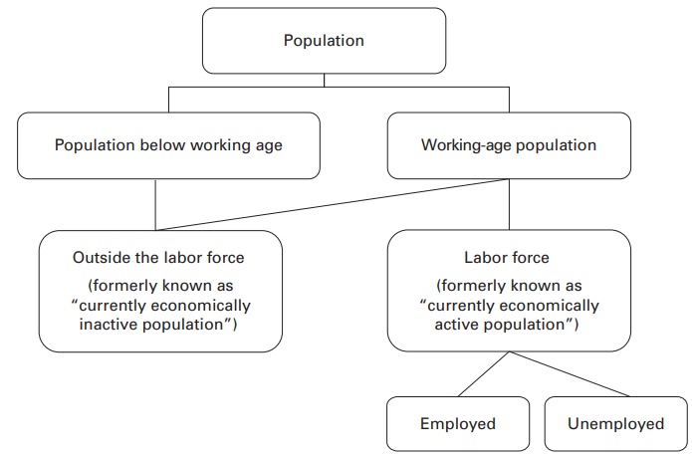
Figure 1: Labor force framework (Source: Pietschmann et al., 2016).

Table 1: Categories and descriptions of persons in the labor force framework (Source: Pietschmann et al., 2016).
Categories in labor force framework | Description
Working-age population | Age limit for working depends on the rules and regulations of a particular country such as the schooling age, minimum age for employment and extent of child labor.  Generally, people with 15 years and older are considered as working age-population.
Labor force | Active population who is able to work.
Employed force | Employed people are normally referred as people who work, where they are not restricted to gender or age in order to produce goods/services which benefits other people in one or several ways as well as gains profit for oneself or for the overall organization.
Unemployed force | Unemployed people are those currently in the working-age population who does not occupy any works and willing to take up suitable jobs when give the opportunity.
Outside the labor force | This category consists of people with employment age or not seeking any job opportunities.  Reasons for unemployment include personal reasons (own illness, disability, studies); family-related reasons (pregnancy, presence of small children, refusal by family); lack of infrastructure (assets, roads, transportation, employment services); other sources of income (pensions, rents); and social exclusion.

2.2 Trends in labor market in UK
It is observed that through the recent years, the low unemployment status along with high vacancy levels depicts that the labor market is tight thereby making the recruitment is more difficult (Powell and Francis-Devine, 2022). The main reason for this is the growth in the number economically inactive people during the rise of the Covid in 2020. In addition, low net migration and increase in high immigration from the European Union has also increased the number of people in the labor market in UK (Wadsworth, 2018).
However, the scholars states that although the labor market tightness is more common due to minimal wages which causes an upward pressure in inflation. But, this is contrast to the recent inflation due to increase in global energy and prices of goods (Powell and Francis-Devine, 2022). Moreover, the labor market is expected to remain tight but loosen over time according to the Bank of England. Because, due to high prices, the demand for goods and services are more likely to slow down but, depends upon the persistence of the economy’s inactivity (Bank of England, 2022).

2.3 Employment
According to the statistics obtained as of August to October 2022, the UK’s employed people were considered as 32.77 million people. This is nearly 75.6% of the country’s population aged from 16 to 64 years. However, according to the data obtained, the employment rate showed a gradual increase from 2011 till the pre-Covid period where it reached a highest recorded rate of 76.6% beginning in 1971. In contrast, during March 2020 upon the spread of pandemic, the rate fell down to 32.13 million at the end of 2020. Nevertheless, upon recovery of pandemic the employment rate rose up to 75.5% which is closer to the rate of 76.3% which was in pre-pandemic time.
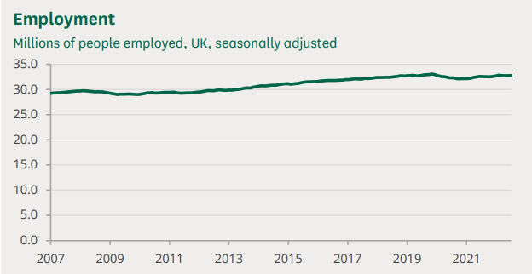
Figure 2: Employment rate in UK (Source: ONS, 2022).

2.3.1 Type of employment
Full time versus Part time: According to the data obtained as of August-October 2022, 24.60 million people were working in a full time basis whereas 8.17 people were working in a part time basis. Meanwhile, it has been observed that the full-time workers have greatly increased comparative to the part-time workers. In addition, there is a reduction in men who are working as a full-time whilst the women fails to work in part-time (Powell and Francis-Devine, 2022). Likewise, these statuses suggest that workers whoever willing to work in part-time, full-time is expected to be stable until 2027 (Wilson et al., 2020).
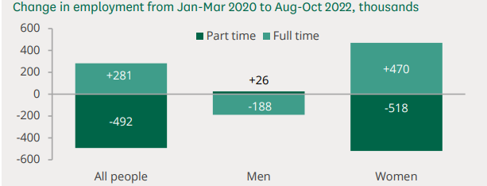
Figure 3: Full-time v/s part-time workers in UK (Source: ONS, 2022).
Employees versus self-employed: 28.41 million people were considered to be working as employees whereas nearly 4.23 million people were considered as self-employed. However, the rise in employees was observed from 2011 wherein, the rise of self-employers had also seen an increase gradually. However, upon the start of pandemic, the rise have fallen down to almost 362,000 (Powell and Francis-Devine, 2022). After the financial crisis in 2008, self-employment is expected to fall down thereby having a 10% in all jobs by 2027 (Wilson et al., 2020).
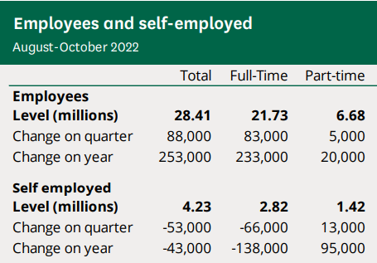
Figure 4: Statistics of employees and self-employees (Source: ONS, 2022).
Public versus private sector: In 2022, 27 million people were employed in the private sector whilst 5.77 million people were employed in the public sector. However, both the private sector and public sector has seen a downfall of 313,000 and 307,000 respectively March, 2020 to September, 2022. Likewise, it shows that there is an increase in the private sector more than the public sector (Powell and Francis-Devine, 2022).
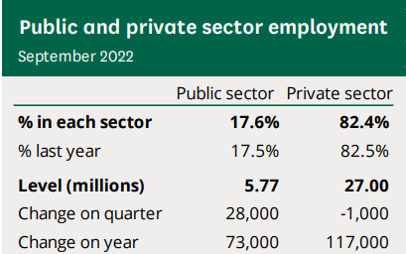
Figure 5: Comparison of public and private sector employment in UK (Source: ONS, 2022).
Vacancies: When it comes to vacancies, the number has reduced to 1.19 million in September to November, 2022 which is still 391,000 higher than January, 2020. Nevertheless, when comparing the vacancies and the number of unemployed people in August-October, it is more likely similar (Powell and Francis-Devine, 2022). This suggests that highly qualified people are more likely to grow with the overall demand for even simple qualified jobs within industries. As a result, there is a great qualification intensity in majority of the jobs especially for those who do not have prior experience in the industry (Wilson et al., 2020).
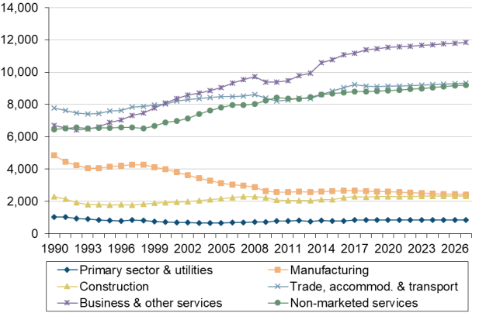
Figure 6: Vacancies related to each sectors in UK (Source: Wilson et al., 2020).

2.4 Unemployment
The unemployment status was seen falling down from 4% to 3.7% when compared with the pandemic year and as of October, 2022. This accounts for 1.25 million of UK’s overall population. However, this is comparatively lower compared to post-recession period of 2008’s financial crisis which accounted for 8.5%. After the implementation of the job retention scheme, there is a steady fall of unemployment rates compared to 2019 (Powell and Francis-Devine, 2022).
The unemployment rate was seen to be highest in the West Midlands where it accounted for 4.9% wherein South West (2.0%) was considered to be lowest (ONS, 2022). According to Bank of England forecasted that the unemployment rate will be lower in the coming months, but, there will be an increase from the end of 2023. 4% unemployment rate is expected to rise by the end of 2023, while it is expected to rise by 5.9% and 6.4% by the end of 2024 and 2025 respectively (Bank of England, 2022).
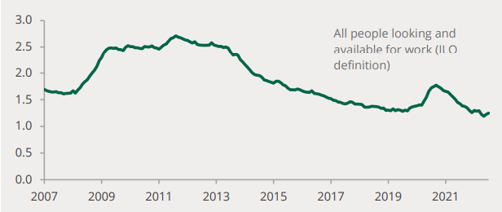
Figure 7: Unemployment rate shows gradual decrease (Source: ONS, 2022).

2.5 Earnings
Earnings or wages can be given on a monthly, weekly, daily or hourly basis which excludes, overtime payments, bonuses, rewards, allowances and other social security payments. Hence, analysis on earnings are important to provide insights into labor productivity and standard of living (Pietschmann et al., 2016). As mentioned earlier, a tight labor market is observed in the recent years due to nominal wage growth. From the studies, it was observed that there was a strong growth in average in cash terms until October, 2022. In contrast, real-term growth for earnings has reduced thereby made the CPI inflation to 10.4% (Powell and Francis-Devine, 2022).
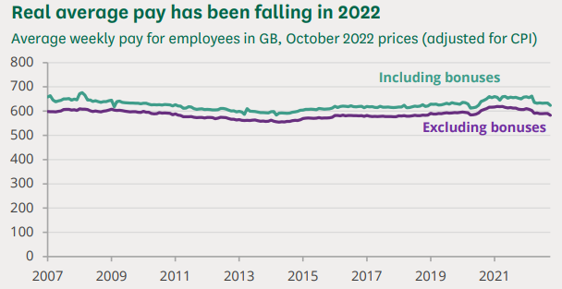
Figure 8: Earnings observed (Source: ONS, 2022).

2.6 People in the labor market
Women and men: When comparing both genders, the opportunities for men are higher compared to women. Because, 17.13 million men were worked whilst 15.64 million women were at work in October, 2022. Thus, nearly 79% of men were employed and 72.2% of women were employed. However, the gap rates were observed to narrow down steadily because of the number of women who are economically inactive. Because, the economic inactivity of women in 2022 was 25.1% compared to 17.9% of men (Powell and Francis-Devine, 2022).
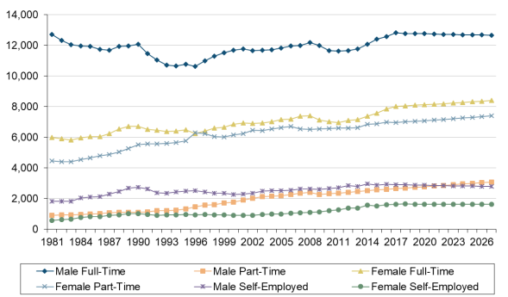
Figure 9: UK Employment profiles by gender and employment status 1981-2027
Young people: Nearly, 431,000 people who are aged 16-24 were unemployed which accounts for 10.5%, yet the unemployment standards remains low for these people. In the early 2020, there was a large fall in the employment levels thereby increased the unemployment. However, after September, 2020 the unemployment levels decreased. However, the employment of young people were lower compared to other categories (Powell and Francis-Devine, 2022).
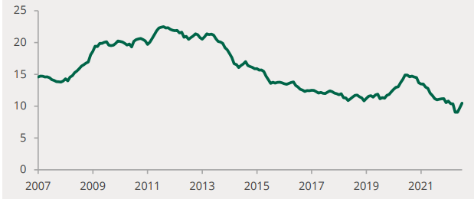
Figure 10: Employment rate of young people in UK (Source: ONS, 2022).
Nationality: 75.2% employment rate was seen for non-UK nationals and 75.6% were observed for UK nationals. Thus, EU nationals possessed 80.9% employment rate which is higher than non-EU nationals, where they had only 69.5%. In a broader aspect, nearly 2.11 million people were nationals from 27 EU countries whilst 1.83 million were nationals outside the EU countries (Powell and Francis-Devine, 2022).
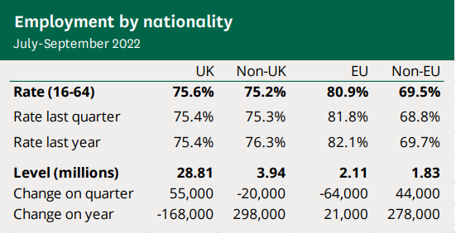
Figure 11: Employment rate by nationality in UK (Source: ONS, 2022).
Disability: According to the statistics, 29.8% of gap difference was seen among employment rate for disabled people (52.6%) versus the people who are not disabled (82.5%) in 2018, which recorded the highest gap in the history. However, from 2013 to 2022, the disability gap difference reduced to 4.4% which suggests that the rate for disabled people was rising heavily (Powell and Francis-Devine, 2022).

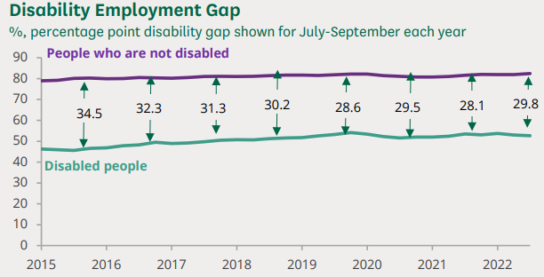
Figure 12: Disability gap (Source: ONS, 2022).

3.0 The emerging changes in Human Resourcing (HR) Strategies in the post Covid, post Brexit external environment

3.1 HR strategies in the post Covid period
Due to the spread of COVID-19 virus, several countries and companies have imposed necessary regulations to stop the spread of it. These include lockdown measures, quarantines, temporary closure of schools, universities and small-scale businesses, travel and flight restrictions, prohibition of mass gatherings and public events (Gourinchas, 2020). However, during the mid of the pandemic, several companies have reopened to recover from the economic shock with extreme and cautious rules and regulations (Hamouche, 2021). In this context, the pandemic has lead the human resource management practices to be challenging and difficult. As a result, the companies had to undergo several changes in order to fight with the crisis effectively and efficiently.
Due to the COVID-19, it has altered the working conditions greatly. For instance, for the business continuity, most organization should ensure that they operate in remote working conditions thus, allowing the workers to work from home (Gourinchas, 2020). However, this condition cannot be applicable to all the workforce in UK, as majority of them work in manufacturing industries or health care, where they need their physical location to work (Koirala and Acharya, 2020). As a result, of those who cannot work from home are more likely to lose their jobs according to the studies conducted by Adams-Prassi and colleagues (2020). These factors drives the HR managers to restructure their working conditions to allow the employees to work efficiently despite the spread of the disease. For instance, some companies in UK allowed the remote work on alternate days/weeks and on a rotating basis, where the employees should visit the company on particular days of the month. Or else, some organizations worked on work-from-anywhere model, where the employees who wish to work remotely yet, can visit the company if there are any requirements (Przytula, Strzelec and Koscianska, 2020). The Boston Consulting group said that nearly 25% of their work-force worked remotely before the pandemic and it is expected to rise up to 50% or more in the post-covid period (Boston Group, 2020).
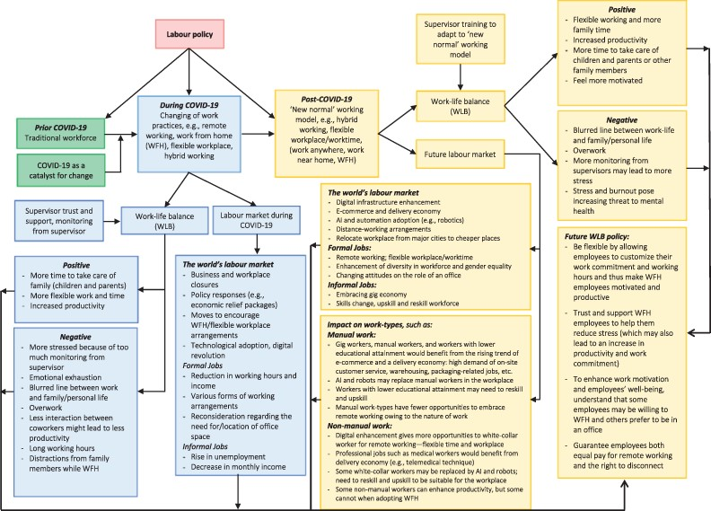

Figure 13: 'New normal' during post-covid period (Source: Hamouche, 2021).
New opportunities have been created due to the implementation of digitalization and technology which allowed to overcome the difficult situations like pandemic. It has also provided new work opportunity like “work from home” ability to the employees without going to the physical locations. As a result, it has effectively responded to crises (Guo et al., 2020). For example, in 2019, the KPMG Company was planning to invest on HR technology which will enhance their HR analytics and automation in the next two to three years. But, after the spread of the virus, the strongly believe that technology will be a significant change in the HR strategies. Nearly 60% of their employees agreed for new innovation through digitization (KPMG, 2020).
Moreover, it is important that HR managers adapt to rapidly changing environment and to implement new skills to suit those environment and allow the employees to better suit new roles and regulations. As a result, reskill and up skill procedures will have a positive impact on the post-pandemic era to deliver new business models and ideas (Przytula, 2018). Notably, respondents of McKinsey and company stated that 87% of them are going through skill gaps. As a solution, nearly 56% of them agreed to hire or build up new skills to overcome these challenges in the post-pandemic time (McKinsey and Company, 2020).

3.2 HR strategies in the post Brexit period
According to the analysis of PWC (2016), the Brexit impacts the UK to remain relatively large and growing economy. However, it is not as large as if the UK were to remain in the EU.
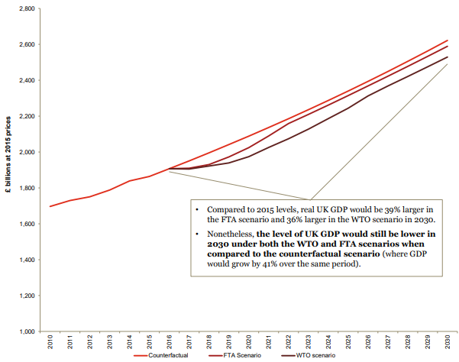
Figure 14: Analysis of UK's economic growth (Source: PWC, 2016).
However, since exist of UK from the EU, several companies are facing uncertainties which requires them to prepare for a wide range of post Brexit scenarios. The key issues in each of the sectors in UK and the major implications of them are provided in Figure. 15. In this context, HR management in the companies of UK are critically facing a challenging environment so as to enhance their business.

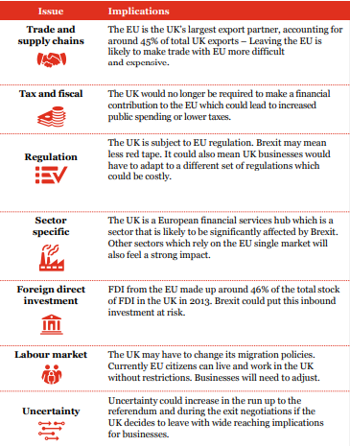
Figure 15: Key issues and the implications faced during post-Brexit period (Source: PWC, 2016).
With the implementation of Brexit, labor, capital, goods, and services between UK and EU have been restrained which creates a stress among the workforce in UK. Therefore, the major role of HR department is to reduce this stress among their employees while keeping the internal communications as transparent as possible (Abbot, 2019). In addition, identification of immigrants who are potentially affected by Brexit and providing them with targeted support plays a significant role in the management (Azevedo, 2019).
For certain companies, a changed market focus maybe required because of the changes in the trade and investment flows due to Brexit. As a result, these companies could move their operations in the EEA to access only the local and a single market whilst some may shift outside the EEA to access foreign markets (PWC, 2016). For example, uncertainties are most commonly seen among large banks and small financial organizations. Thus, allowing the chances for transfers of financial white-collar jobs to Frankfurt, Dublin, Zurich or Paris (Azevedo, 2019).
Another challenging effect of Brexit is its long term impact on talent and labor markets. In order to assess these challenges, analyzing the dependence on EEA and Swiss nationals, in terms of who the managers directly employ and the impact of that population has on wages and labor availability are crucial factors (PWC, 2016). Although UK is considered as an important and dynamic market in the global arena, its participation could be greatly affected. Especially through Asian economies, which include China as a major country which produces innovative, productive and high growing business models. Despite the fact that Europe and America are finding numerous sustainable routes to withstand in the economies, the promotion of Brexit greatly impact the British businesses and the population (Azevedo, 2019: CIPD, 2018). In order to mitigate this risk, the HR strategies should focus on working collaboratively with other companies and through trade associations which offers potential recruits (Abbot, 2019).
On top of all these factors, leadership is a major priority of HR strategies in which it helps how the organization will react and behave to any challenges faced in its external environment. The main responsibility of such leaders is to have the confidence, target goals, positive attitude and focused mind in overcoming the challenges in the future. Thus, the HR strategies should focus on reinforcing the company’s values, diversity, openness and tolerance. Meanwhile concentrate on HR systems, processes, procedures, and policies of the organization and the nation (CIPD, 2018: PWC, 2016).

4.0 Conclusion
One of the major aims of the report was to discuss about the labor market in UK. In this manner, the report concentrated on the employment, unemployment, and type of employment, earnings and the type of labors in the context of labor market found in UK. In addition, it provided the real data statistics which suits the relevant points aforementioned in the report. The next aspect of the report is to focus on the human resourcing strategies during the post-Covid and post Brexit period. In such a way, the report focused about various factors which influence these two events and how the HR leaders should focus. Hence, it provided an in-depth understanding to overcome various challenges in the future.

References

Abbot, R., 2019. Hiring Strategies After Brexit. Through Leadership. Available at: https://blog.v-hr.com/blog/hiring-strategies-after-brexit (Accessed: 5th Dec 2022).
Adams-Prassl, A., Boneva, T., Golin, M. and Rauh, C., 2020. Inequality in the impact of the coronavirus shock: Evidence from real time surveys. Journal of Public economics, 189, p.104245. Available at: https://www.econstor.eu/bitstream/10419/216495/1/dp13183.pdf (Accessed: 10th Dec 2022).
Azevedo, G., 2019. International HR management in times of Brexit. Available at: https://www.thehrdirector.com/features/cultural-change/hr-management-in-times-of-brexit/ (Accessed: 5th Dec 2022).
Bank of England, 2022. Monetary Policy Report - November 2022. Available at: https://www.bankofengland.co.uk/monetary-policy-report/2022/november-2022 (Accessed: 5th Dec 2022).
Boston Consulting Group, 2020. What 12,000 Employees Have to Say About the Future of Remote Work. Boston. Available at: https://www.bcg.com/publications/2020/valuable-productiv-ity-gains-covid-19. (Accessed: 8th Dec 2022).
CIPD, 2018. Preparing for Brexit through Workforce. Available at: https://informi.co.uk/wp-content/uploads/2019/09/CIPD_Brexit_Workforce_Planning.pdf (Accessed: 5th Dec 2022).
Gourinchas, P.O., 2020. Flattening the pandemic and recession curves. Mitigating the COVID economic crisis: Act fast and do whatever, 31(2), pp.57-62. Available at: http://viet-studies.net/kinhte/COVIDEconomicCrisis.pdf#page=38 (Accessed: 10th Dec 2022).
Guo H, Yang Z, Huang R, Guo A., 2020. The digitalization and public crisis responses of small and medium enterprises: Implications from a COVID-19 survey. Front Bus Res China, 14(1), pp.1–25. Available at: https://fbr.springeropen.com/articles/10.1186/s11782-020-00087-1 (Accessed: 10th Dec 2022).
Hamouche, S., 2021. Human resource management and the COVID-19 crisis: Implications, challenges, opportunities, and future organizational directions. Journal of Management & Organization, pp.1-16. Available at: https://www.cambridge.org/core/journals/journal-of-management-and-organization/article/human-resource-management-and-the-covid19-crisis-implications-challenges-opportunities-and-future-organizational-directions/6857481FD64558659EE4C17C6DAE9AB9 (Accessed: 8th Dec 2022).
Koirala, J. and Acharya, S., 2020. Dimensions of human resource management evolved with the outbreak of COVID-19. Available at: https://papers.ssrn.com/sol3/papers.cfm?abstract_id=3584092 (Accessed: 10th Dec 2022).
KPMG, 2019. Future of HR 2020: Which path are you taking?. Available at: https://assets.kpmg/content/dam/kpmg/xx/pdf/2019/11/future-of-hr-2020.pdf (Accessed: 10th Dec 2022).
McKinsey and Company, 2020. Beyond hiring: How companies are reskilling to address talent gaps. New York. Available at: https://www.mckinsey.com/~/media/McKinsey/Business Functions/Organization/Our Insights/Beyond hiring How companies are reskilling to address talent gaps/Beyond-hiring-How-companies-are-reskilling.ashx (Accessed: 8th Dec 2022).
Office for National Statistics (ONS), 2022. Earnings and employment from Pay As You Earn Real Time Information, UK: February 2022. Available at: https://www.ons.gov.uk/employmentandlabourmarket/peopleinwork/earningsandworkinghours/bulletins/earningsandemploymentfrompayasyouearnrealtimeinformationuk/february2022
Pietschmann, I., Kapsos, S., Bourmpoula, E., Sajaia, Z. and Lokshin, M., 2016. Key Labor Market Indicators: Analysis with Household Survey Data. Available at: https://www.ilo.org/wcmsp5/groups/public/---dgreports/---dcomm/---publ/documents/publication/wcms_519717.pdf (Accessed: 8th Dec 2022).
Powell, A. and Francis-Devine, B., 2022. UK labor market statistics. House of Commons Library. Available at: https://researchbriefings.files.parliament.uk/documents/CBP-9366/CBP-9366.pdf (Accessed: 5th Dec 2022).
Przytuła, S., 2018. Global labor market trends and their signicance for the future employees’ competences. Journal of Intercultural Management, 10(4), pp.5–38. Available at: https://www.researchgate.net/publication/350773238_Global_Labor_Market_Trends_and_Their_Significance_for_the_Future_Employees'_Competences (Accessed: 10th Dec 2022).
Przytula, S., Strzelec, G. and Koscianska, K., 2020. Re-vision of Future Trends in Human Resource Management (HRM) after COVID-19. Journal of Intercultural Management, 12(4), pp.70-90. Available at: https://www.researchgate.net/publication/348730561_Re-vision_of_Future_Trends_in_Human_Resource_Management_HRM_after_COVID-19 (Accessed: 8th Dec 2022).
PWC, 2016. Brexit – A key role for HR. People and organisation issues to consider following the EU referendum. Available at: https://www.pwc.co.uk/eu-referendum/po-summary-of-brexit-and-hr-related-issues-september-2016.pdf (Accessed: 5th Dec 2022).
Wadsworth, J., 2018. Off EU Go? Brexit, the UK Labour Market and Immigration. The Journal of Applied Public Economics. Available at: https://onlinelibrary.wiley.com/doi/abs/10.1111/1475-5890.12177 (Accessed: 8th Dec 2022).
Wilson, R., Barnes, S., Giilings, M., Patel, S. and Bui, H., 2020. Working Futures 2017-2027: Long-run labour market and skills projections for the UK. Available at: https://assets.publishing.service.gov.uk/government/uploads/system/uploads/attachment_data/file/863506/Working_Futures_Main_Report.pdf (Accessed: 8th Dec 2022).

