Student Name: Samuel Filipe Torres da Silva
Student ID: 2107485
Module Code and Title: BMSW4005 - Task 3 – Reflective portfolio
Assignment Title: Professional Career Development
Lecturer Name: Buddhi Pathak



Table of content
Introduction 3
1). Before Identifying the job of my choice 3
a. Let’s talk more about me 3
b. My career options 5
c. My research options and what are the relevant sources 6
d. As the workplace world evolves, I must be aware of developing trends. 6
2). Assessing the concepts, I have learned from this module 8
- Setting goals and objectives (SMART) 8
- UK Employment law and career development 8
- Learning theories 9
- Self-awareness methods 10
- Mock interview and open book experience 11
- With all these concepts, it is time to describe why are they useful. 12
- How these concepts have developed me as a professional? 12
3). Conclusion 13
4). References 14
5). Appendix 16
Figure 1 Samuel Torres career motivation test 16
Figure 2 Samuel Torres learning style result 16
Figure 3 BMA analysis of NHS England Consultant-led Referral to Treatment Waiting Times statistics 17
Figure 4 NHS Staff absences 17
Figure 5 Table 5.1 Balancing learning styles 18
Figure 6 Johari Window Model for Samuel Torres 18
Figure 7 Samuel Torres personal SWOT analysis 19

Introduction

In this report I will write about myself, my motivations, plans for my career path as a Health Care Assistant (HCA) and the strategies I will be using to define a progression plan to reach my goals.
In the end, I would share my learnings with the experience gained from this reflective report and the many points of reflection I used in this module to get to my conclusions.

1). Before Identifying the job of my choice

Let’s talk more about me

How do I know more about myself?
Jesus once said ‘’ And why do you look at the speck in your brother's eye but do not consider the plank in your own eye?’’ written by the Apostol Saint Mathew in Matthew 7:3 mentioned by Case, (1997)
With great wisdom, independent of whether we have a belief or not, Jesus was referring to how easy it is to identify the strengths and flaws of the people around you with enough time and effort but how difficult it is to look into ourselves and become self-aware of our strengths and flaws.
There are several tools nowadays that we can use to get to know ourselves, like meditation. Writing about priorities and plans, making use of psychometric tests (which currently we have easy access to the internet like Predictive Index or Myers-Briggs), asking the closest friends or family members and/or asking for feedback at work regularly.
So far, as much as I am aware, I am a person that loves to help others, and that has a natural curiosity to try to find the best solution to a problem but on the other hand, I know that I am a person that needs to be bolder when the opportunities appear and less foolish just to try to please others.
Going through an online career motivation test, my test come out that the majority of my career motivation would be a financial motivation, a little bit more than half, a 60% to be more exact, so although the financial part is a big part of my career motivation, it still is not all that moves my will to progress in my career.

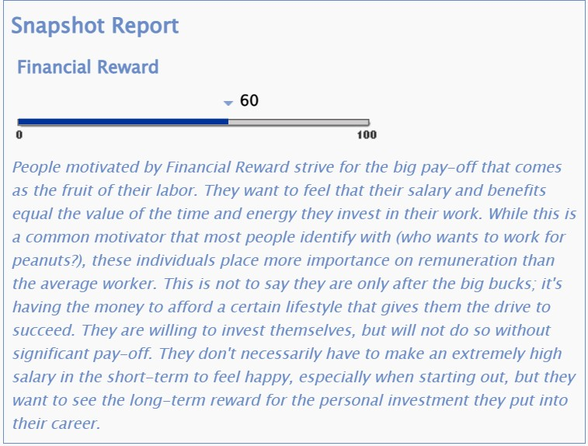
Figure 1 Samuel Torres career motivation test

Part of the reason for the 60% being financial is because I am a Family man that carries the responsibility of taking care of a family and so the financial side must be assured, but other reasons impulse my career success, like the opportunity to use my career services for a common good and be able to impulse a caring and sustainable progression not only to me but to the majority of people possible.

My career options

Based on my type of personality, I strongly believe that my carrier options would be better suitable in the area of Care.
From a very young age, I have been involved in several volunteer works in several countries like Portugal, Spain and the United Kingdom. The feeling of helping the ones in need always gave me a sense of purpose in this world and a great joy to see the expressions of relief of a person that was suffering.
Adding to my experience I worked with people with motor and mental disabilities as my last job was as a support worker in the community, especially with experience taking care of people with dementia, autism and also all the challenges that arise to work with people that unfortunately have to battle with those conditions’ day by day.
I am a very confident and quiet person in situations of danger or distress I keep my brain thinking about the best possible solution to every situation without getting into a panic state. I consider myself a humble person that tries to always be on the other person’s side.
I like to observe how people react and try to always with positivity and humour bring the best out of the people that surround me.
I undertake an online learning style test and my learning style comes out as Tactile, with an Auditory score of 20%, a Visual score of 35%, and a Tactile score of 45%.

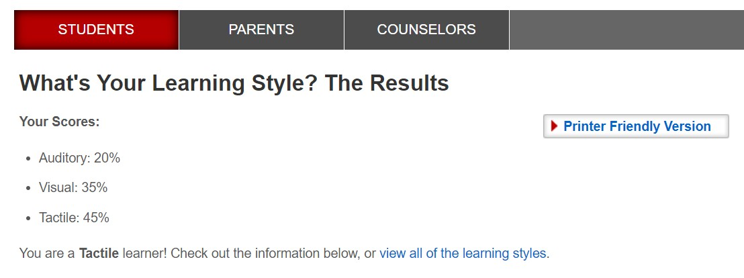
Figure 2 Samuel Torres learning style result
Indeed, I do think I got the personality, learning style and skills to develop my career in Care furthermore, specifically, into an HCA.

My research options and what are the relevant sources

Throughout the NHS job site, I manage to search for several job applications as an HCA, so my strategy would be to start applying for the job applications closer to my current residence and the NHS Trust that offers the best options for career development programs so I can have the option to progress into my Care career, learning additional skills and ways to improve the life of the people I support.

As the workplace world evolves, I must be aware of developing trends.

It is assured to say that the trend for the NHS is an expansion of the workforce to cope with demands. Buchan, et all, (2019).
The last pandemic left over several NHS services, especially in patient care needs, as the number of cases arises, consultations got delayed so, more urgent treatments needed to be performed to attend to all the patients and NHS users were left waiting or on hold.
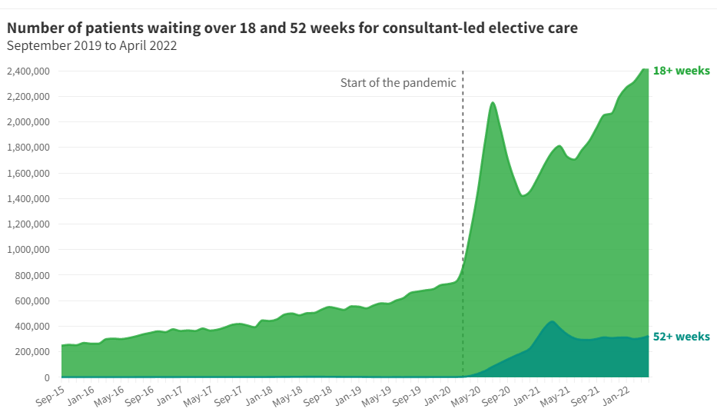
‘’ N. of patients waiting for 18 and 52 weeks for consultant-led elective care’’ by BMA. (2022)
Figure 3 BMA analysis of NHS England Treatment Waiting Times statistics

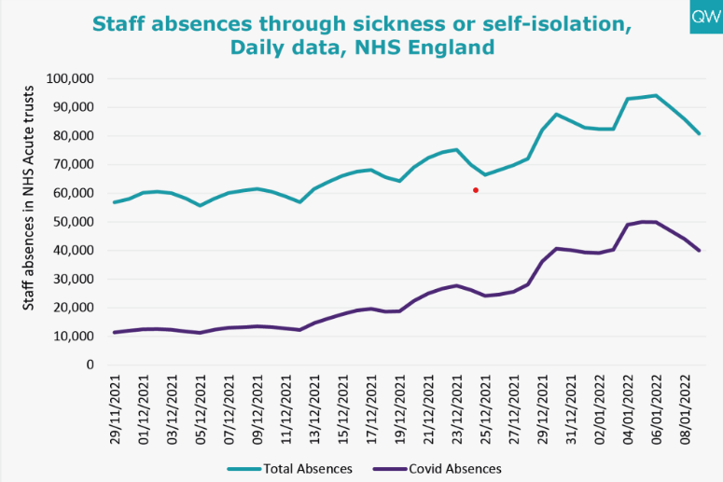
‘’ Staff absences’’ by Sophie, (2022)
Figure 4 NHS staff absences

As shown in the graphics above this trend just opens more opportunities to improve my skills and so, I should be flexible to maybe consider progress into other career areas like becoming a Registered Nurse, Paramedic, or other opportunities in the future. ‘’The Future of Work: Jobs and Skills in 2030’’ UKCES. (2014)

2). Assessing the concepts, I have learned from this module

- Setting goals and objectives (SMART)

It is important to set SMART goals (SMART stands for Specific, Measurable, Achievable, Realistic, and Timely). As a result, a SMART goal integrates factors to help me focus my efforts and boost my chances of success. There is a strong connection between the results I aspire to, due to the habit of setting goals.
Goals are essential in all aspects of business because they offer a perception of direction, and underline priority. Goal setting gives me an objective to aim for.
A SMART objective is intended to assist and guide goal planning. Lawlor, K. B. (2012).
If I am not setting goals, probably my competitors are, and they are being successful, so that’s why I should make my goals not only in my mind but materialise them in a piece of paper or a document and review it from time to time, otherwise they would likely just stay in my mind and won’t be achieved. Paul, (2022)

- UK Employment law and career development

Employment laws come to regulate the relationship between employees and employers.
Comes to defend my rights and the company’s rights if I am at flaw with the company or vice versa, establishing what we should expect from each other.
Employment law comes to play a role to decide on how the recruitment is, the contract details, GDPR, entitlement to annual leave, working times, health and safety, discrimination/bullying, dismissals and discipline. Seb of Revorec. (2020).

- Learning theories

Furthermore, I will look at the most important tools for my learning and long-term development in workplace learning driven by three major factors:
• Firstly, I want to align my values with those of the work organisation so that I can work efficiently.
• Second, allow me to advance professionally, either within or out of a company, throughout the short- to medium-term.
• Third, for my long-term professional development - enhancing my long-term possibilities to match my objectives. Neugebauer, and Evans-Brain, (2016)
In this overview of learning styles, we can see that we need different styles for fully productive students.
This allows me to take full advantage and develop my work environment, and the style I chose for work. My learning style is not only important for understanding how I will improve, but provides a good indicator. It is worth considering my learning style: If I have a weakness, look for opportunities to find it in the workplace and with this, find a new balance. Table 5.1 gives some practical ideas on how to manage it.
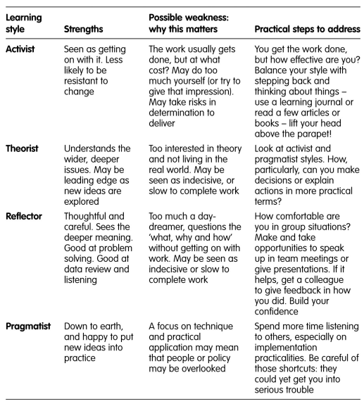
Shaw and Marlow, (1999).
Figure 5 Table 5.1 Balancing learning styles

- Self-awareness methods

The methods of self-awareness learned in this module like Johari Window which I request from my colleagues and family to enhance my self-awareness in a group, where through this method I could expand my open area and become more transparent at work within a group and where is an excellent tool to realise things about me through others about myself that I might not have noticed and so have the opportunity to show how I am to dismiss misconceptions about me.
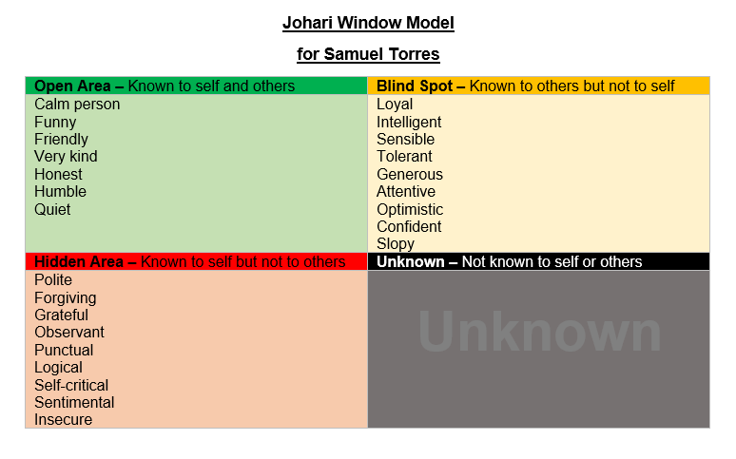
Jack and Smith, (2007).
Figure 6 Johari Window Model for Samuel Torres

Let me mention as well the method of personal SWOT Analysis as this tool is useful to look into myself regarding what I think my strengths are, so I can keep maintaining them throughout my life and realize what are my weaknesses so I can work to change them into strengths.
The personal SWOT Analysis is useful to me so I can identify possible opportunities and the threats associated with those opportunities in my career. Addams and Allfred, (2013).
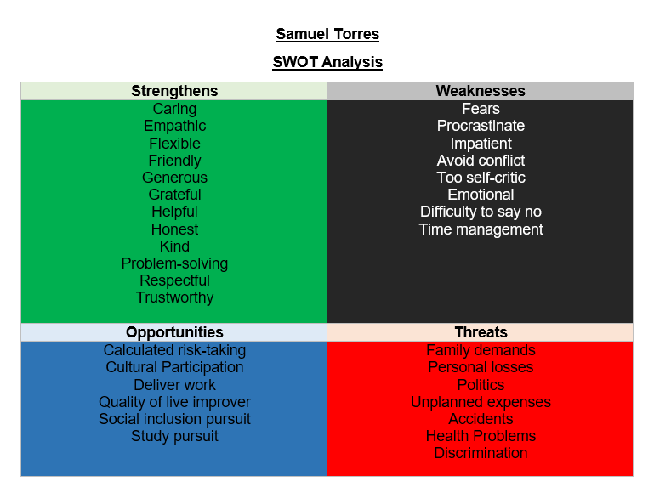
Humphrey, (1960)
Figure 7 Samuel Torres personal SWOT analysis

- Mock interview and open book experience

Moreover, the mock interview, crucially made me aware of details to consider when answering a job interview and preparing.
It is easy to fall into the trap of anxiety and become prone to do mistakes or act in a way that does not represent the way I really am and consequently lose the opportunity.
These interviews became a reference for how prepared I am for the interview.
By reviewing it, I can detect the flaws of my interview and work to improve it even more until I feel confident enough and prepared for the real one.

In the open book experience, I was able to view and analyse a real-world scenario of an employee that did not attend to the company rules of behaviour, and even after being allowed to change his behaviours the employee decided to not follow the rules and was fired for obvious reasons.
Furthermore, the employee decided to take the case into court with false accusations with no foundations to prove the accusations the employee did to the company.
Through this experience, I could take notes on what not to do and if it is granted an opportunity to change my behaviours for the best.

- With all these concepts, it is time to describe why are they useful.

Nowadays, in a professional society that constantly requires more skilled labour, if I want to improve my chances of career success, I have to make use of these concept tools.

- How these concepts have developed me as a professional?

Reflecting on how these concepts impact my professional life I have to admit that they are valuable tools to make me aware of my flaws, awareness of not only myself but as well of others and the changing business trends, so I could be able to detect valuable opportunities that would increase my career success and gratification.
Finally, I see how my career can be not only one way of earning money but also a way to fulfil a gap in society's needs.

3). Conclusion

My career success path goes through a real understanding of the need to look into me, not only to my qualities but with special attention to my flaws and learn to promote self-awareness, understanding what are my real career motivations, so this way I can look into the options to choose.
Understanding my way of learning makes it easy to adapt my learning style to a new job, and be able to identify and adapt to new trends.
Goals are essential to focus my efforts and boost my chances of success towards my competitors in a ‘’SMART’’ way and a mock interview is great to boost my possibilities to get the job or position that will guarantee my career aspirations based in the UK work legislations to make it fair to both employers and employees.

4). References
- Addams, L., & Allfred, A. T. (2013). THE FIRST STEP IN PROACTIVELY MANAGING STUDENTS'CAREERS: TEACHING SELF-SWOT ANALYSIS. Academy of Educational Leadership Journal, 17(4), 43.
- BMA. (2022) Number of patients waiting over 18 and 52 weeks for consultant-led elective care. Published at BMA. Available at: URL https://www.bma.org.uk/advice-and-support/nhs-delivery-and-workforce/pressures/nhs-backlog-data-analysis (Accessed: 27/07/2022).
- Buchan, J., Charlesworth, A., Gershlick, B., & Seccombe, I. (2019). A critical moment: NHS staffing trends, retention and attrition. London: The Health Foundation.
- Case, P. W. (1997). Potential sources of countertransference among religious therapists. Counseling and Values, 41(2), 97-106.
- Dosher, M., Benepe, O., Humphrey, A., Stewart, R. and Lie, B., (1960). The SWOT analysis method. Mento Park, CA: Stanford Research Institute.
- Jack, K., & Smith, A. (2007). Promoting self-awareness in nurses to improve nursing practice. Nursing standard, 21(32), 47-54.
- Lawlor, K. B. (2012). Smart goals: How the application of smart goals can contribute to achievement of student learning outcomes. In Developments in business simulation and experiential learning: Proceedings of the annual ABSEL conference (Vol. 39).
- Neugebauer, J., & Evans-Brain, J. (2016). Employability: Making the most of your career development. Sage.
- Paul D. (2022) Setting S.M.A.R.T. goals. Place of publication: Podcast audio. Available at: URL. https://uwtsd.careercentre.me/resources/elearning/hub.aspx?redirect=/e-learning/asset/view/208/7/0&redirectUrl= (Accessed: 30/07/2022)
- Seb of Revorec. (2020) Employment Rights UK - Know Your Employee Rights. Place of publication: YouTube. Available at: URL https://www.youtube.com/watch?v=pduzE87NQwY (Accessed: 30/07/2022).
- Shaw, G., & Marlow, N. (1999). The role of student learning styles, gender, attitudes and perceptions on information and communication technology assisted learning. Computers & education, 33(4), 223-234.
- Sophie F. (2022) NHS performance summary: November - December 2021. Published at Nuffieldtrust: Available at: URL https://www.nuffieldtrust.org.uk/news-item/nhs-performance-summary-november-december-2021 (Accessed: 27/07/2022).
- Z_punkt The Foresight Company The Centre for Research in Futures and Innovation. (2014). The future of work: jobs and skills in 2030. UKCES, Wath-upon-Dearne, England.

5). Appendix

Figure 1 Samuel Torres career motivation test

Figure 2 Samuel Torres learning style result

Figure 3 BMA analysis of NHS England Consultant-led Referral to Treatment Waiting Times statistics
https://www.bma.org.uk/advice-and-support/nhs-delivery-and-workforce/pressures/nhs-backlog-data-analysis

Figure 4 NHS Staff absences
https://www.nuffieldtrust.org.uk/news-item/nhs-performance-summary-november-december-2021#planned-hospital-care-and-diagnostics

Figure 5 Table 5.1 Balancing learning styles

Figure 6 Johari Window Model for Samuel Torres

Figure 7 Samuel Torres personal SWOT analysis

