BMPF7018 Managing Work-based Projects

By Lynsey Edwards
2226193

Component 2: Essay

Introduction
This assignment will reflect on how to plan and design a project management process for the workplace, utilising the Hybrid approach combining the Waterfall and LEAN methodologies, in the context of a previous European Social Fund Project delivered by the University under the Convergence funding. It will be carried out by using Rolfe’s reflective model (2010).
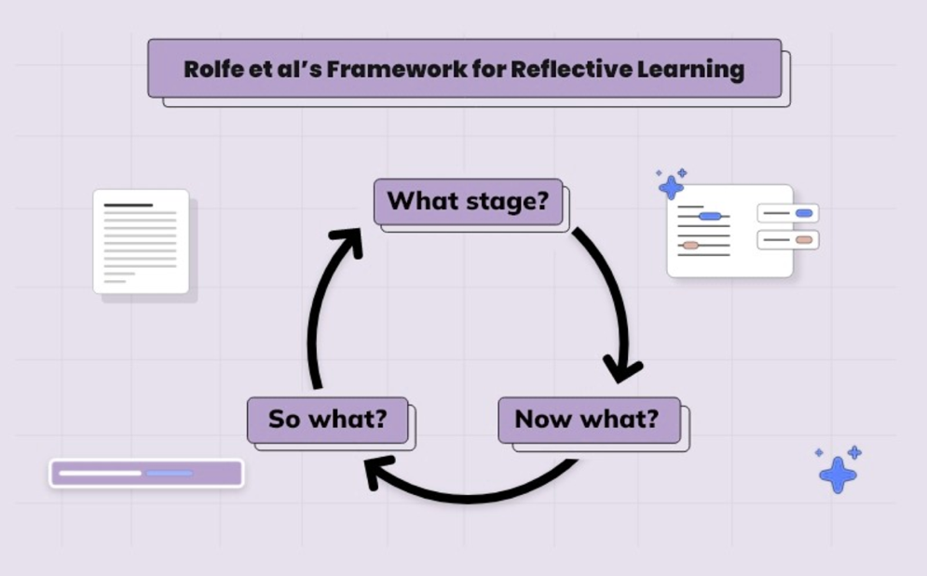
Fig.1 Denis (2024) Rolfe’s Reflective Model.

About the Project
This was developed in partnership with two local Further Education providers to meet the needs of Work-Based Learning for employers in the convergence areas, providing course subsidies to employers. The Programme Management Unit (PMU) for the programme was delivered by a separate university who were the Grant Recipient Body (GRB), managing the funds for the region based on the Welsh European Funding Office (WEFO) Guidance Delivery models, which applied the Waterfall approach based on the Prince2 methodology for the programme and the projects in the portfolio.
A formal evaluation found that the target deficit resulted from a series of connected theories relating to the project delivery model. This was exacerbated by external influences comprising the economic environment and uncertainty following the EU referendum, as well as the business performance and uncertainty of a large steelwork employer central to the project's development. These factors are thought to have adversely impacted wider business confidence and interest in training.

Initiation
The project benefited from the rigorous guidance laid out by WEFO for the pre-planning stage (WEFO, 2018a). In collaboration with the research and development unit staff completed an Operation Logic Table (OLT). The OLT aimed to understand specifically what the anticipated project intended to deliver against the programme objectives and how it would be achieved. This considers the PMU’s aims and regulatory requirements. However, there was no formal protocol or project approval process to ensure the project meets the university needs and requirements.
A Project Initiation Document (PID) is crucial to establish, to inform an effective project team. The PID should provide clear guidelines and expectations, which help align the team’s efforts. Similarly, Tuckman’s (1965, Tuckman and Jenson,1977 cited in Bonebright, 2010) five stages of small-group development highlight the importance of creating a team charter. This charter is valuable for guiding the group’s productivity and ensuring successful outcomes. By clearly defining roles, responsibilities and objectives, the team can operate with a shared understanding, minimising ambiguity and enhancing overall performance (Natvig and Stark, 2016; Bonebright, 2010). The Waterfall approach was predictable and well-defined aspects of the initiation and provided structured risk management timelines and planned activities. Without the benefit of the LEAN methodology, there was limited flexibility for adaptation to address the evolving user and stakeholder requirements. The initial setup was also done, for the most part, by members of staff who weren’t part of the project team moving forward.
By utilising a PID from an organisational perspective would have further clarified roles and responsibilities from the beginning for the project. As the team evolves through distinct stages, Tuckman’s (1965) theory enhances team and individual performance (Natvig and Stark, 2016). Having greater awareness of this framework for establishing a new project team would have significantly benefited this project, as it would have given the project manager a framework to manage the team through these stages with understanding and ease. Going forward by using a Hybrid approach of Waterfall and LEAN these pitfalls could have been avoided, as LEAN encourages regular feedback and continuous improvement, leading to higher-quality outcomes. This Hybrid approach is especially beneficial for projects where iterative cycles are required (Douglas, Antony and Douglas, 2015).

Planning and Design
The project’s focus on Foundation Degrees shaped key budget and profiling decisions and was a factor that impacted success due to the low uptake in the region. As recruiting students at the start was essential due to the duration of the qualification relative to the project timeline. The evaluation found, in retrospect, that adjusting upfront development work would have been beneficial, such as scaling staff recruitment. The evaluation also found that the project developed process groups too late in the project to have an impact.

The project began confidently due to the approval of a detailed plan using the structured Waterfall approach, recommended by WEFO (2014) effectively defining project requirements and risks early on. However, uncertainties around team management and leadership soon emerged. Poor communication and challenging team dynamics led to confusion and conflict. While the stable project plan was a positive aspect, ineffective leadership and communication resulted in delays and disengagement, undermining the project's overall success. When discussing leadership in a university context, often a Laissez-Faire leadership approach is taken, giving autonomy to the project staff, which lead to insufficient clarity around responsibilities, causing confusion and a lack of motivation for the team (Munna, 2021).

There is evidence to suggest that projects related to learning and recruitment would benefit from an optimal hybrid approach in this phase (Albuquerque, Torres and Berssaneti, 2020; Klein et al., 2021; Douglas, Antony and Douglas, 2015). This combined hybrid approach benefits from the clarity of Waterfall and LEAN’s flexibility, ensuring both compliance and adaptability. Adair (2022) found that successful leaders focus on the task, the team, and the individual team members; continuing without fostering a positive team environment leads to the team losing motivation. On reflection action-centred leadership offering a functional approach to address the individual, team and task needs would be the best contemporary leadership style to adopt for future projects (Adair, 2005; CMI, 2014). PMBOK (2021) highlights the need for considering the different mapping models to be utilised during the different project phases and performance domains at an early stage.

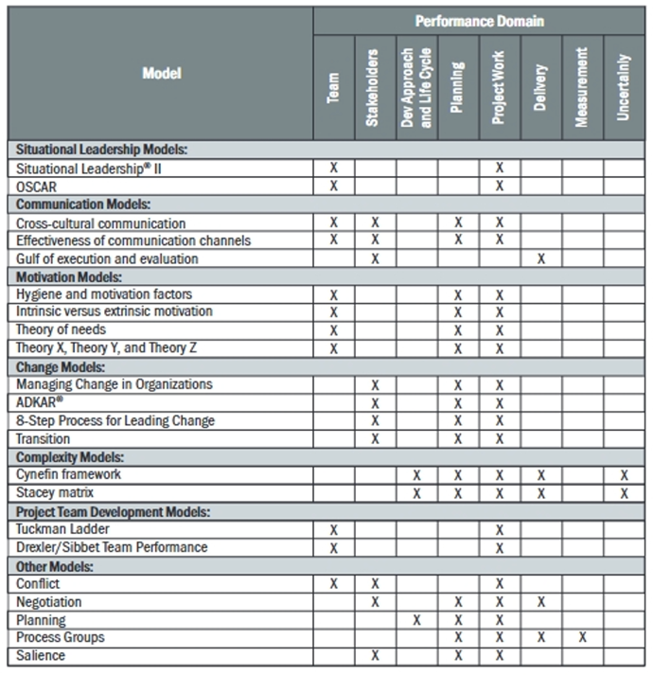
Fig.2 PMBOK (2021) Mapping of Models Likely to be used in each Performance Stage.
The above table (PMBOK, 2021) indicates where each of these models can appropriately be used and adopted. The project manager and team should ensure the correct model for the organisational culture and project is implemented from the outset. Creating process groups earlier, including a management team outside of the project board that provides business direction, insight and checkpoints internally, will be integral to future endeavours.

Execution
The evaluation recognised that processes, course content and resources were documented as high quality. However, there was no evident market for the varied modules and qualifications. The administrative management of project execution, the development of internal systems and customer care were considered effective and showed improvement over time. However, the project was perceived to lack a commercial viewpoint, formal direction and a specific role responsible for leadership and strategic direction. Additionally, while having other educational institutions and employers on the project board maintained relationships and provided opportunities for collaboration, the nature of the funding limited their ability to provide strategic input. This was due to the requirement for decisions to be made at a high level within WEFO and the university, which undermined the authority of the board.

The project's success is dependent on the processes used to achieve the work defined in the project management plan. However, common challenges were encountered during the execution phase, such as unsuccessful leadership, lack of team unity and inadequate change management (Sommer, Dukovska-Popovska and Steger-Jensen, 2014). These challenges suggest the need for a more structured and responsive approach to leadership and team management.

Considering the challenges faced, McGregor’s Theory X, Y, and Z, particularly Theory Z, which Maslow viewed as motivating staff through self-actualisation, becomes relevant when considering project management (PMBOK, 2021). In a university context, a Laissez-Faire leadership approach, which often gives autonomy to project staff, can lead to unclear responsibilities, confusion and a lack of motivation (Munna, 2021). Adair (2022) found that successful leaders focus on the task, the team, and individual team members. Projects that fail to foster a positive team environment often leads to demotivated teams. For future projects, adopting action-centred leadership that addresses individual, team, and task needs would be effective (Adair, 2005; CMI, 2015). By allowing team members to establish improvement methods during the execution phase, the Project Manager can focus on fulfilling their LEAN responsibilities. This includes effective communication with non-development teams and removing obstacles that hinder progress (Cornelius, 2014). A key aspect is managing stakeholder and customer relationships efficiently, aligning with step three of LEAN's five guiding principles: "Create Flow" (PMI, 2022). This approach ensures a smoother execution process, enhancing overall project success.
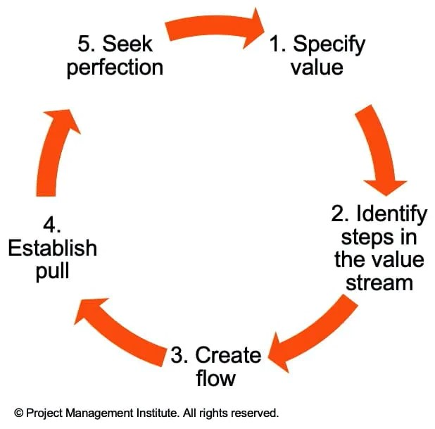
Fig.3 PMI (2022) LEAN's five guiding principles.

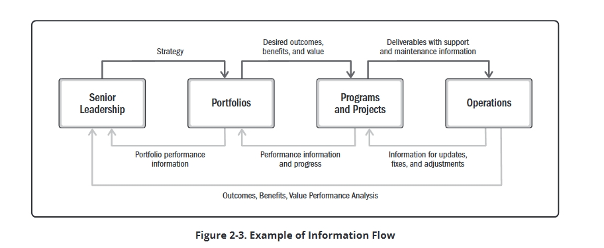
Fig.4 PMBOK (2021) Example of Information Flow.

The above illustrates the need for information flow between senior management and the project team to align with university goals, remove obstacles and efficiently escalate unresolved issues (PMBOK, 2021).

Monitoring and Controlling
The monitoring and controlling process managed and tracked the project, allowing potential difficulties to be recognised so that corrective action can be taken using the project management plan (PMBOK, 2021). Milestones, progress reports and meetings with the team and stakeholders were used to monitor these activities, utilising tools such as project reviews and highlight reports. Standardised templates are valuable tools for managing and monitoring these activities effectively (Iqbal, 2024). These templates provided a framework for team members, promoting consistent language and practices and enhancing efficiency and best practices (Iqbal, 2024) (see Appendix 1). During this phase, change is inevitable. However, the project was halted early partly due to the lack of a change management approach. The evaluation highlighted slow response to factors, such as business changes, market changes and a lack of strategic direction as an issue. These issues led to significant budget and target reprofiling, resulting in the project underachieving against some of the initial milestones and outcomes.

The evaluation revealed that while the Waterfall methodology effectively managed the linear elements of the project and the initial setup, it was less effective in assigning risks requiring individuals to take responsibility. This was partly due to the leadership and change management approach used, which contributed to challenges in holding individuals accountable. The lack of stakeholder involvement and project board authority during the initiation and execution phases resulted in a disjointed approach, which may have exacerbated accountability issues of the identified risks and issues.

The Waterfall approach effectively managed project monitoring and control according to PMU and ESF regulations but lacked flexibility and integration into the wider university. PMBOK emphasises the importance of overlapping general management principles, highlighting the need for a university-wide change management framework. Lewin's Change Model (Bell, 2020), with its unfreeze, change, and refreeze stages, could provide a structured approach to handling project changes, as could models like Kotter’s 8 Steps or ADKAR (PMBOK, 2021).
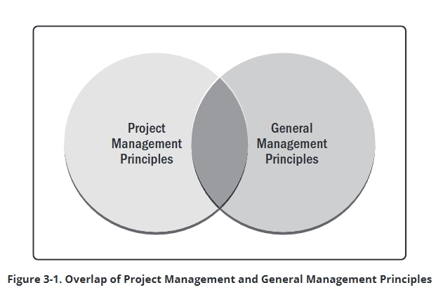
Fig.5 PMBOK (2021) Overlap of Project Management and General Management Principles.
Clear role definition through a RACI matrix would enhance accountability and support long-term project success. It would allow the PM to fulfil their role during monitoring, which is to oversee quality, costs, and risks while ensuring smooth project execution (PMBOK, 2021).

Delivery, Closing and Control system
Project closure is an overlooked part of project management. PMI (2022) states closing a project means finishing all the agreed activities, splitting up the project team, and signing off on the project with the sponsor, in this case, WEFO.
The project closure report communicated how well the project performed in relation to its original business case, quality measures, cost, duration and tolerances (PMBOK, 2021). The team completed a lessons-learned report to share important information and pass on valuable learning that can be applied to future projects (PMBOK, 2021).
In line with the WEFO (2018b) project closure guide, the project was systematically closed, including procured tenders, staff redundancies/reallocation and the handover of resources and assets to the university all project documentation was fully audited and archived appropriately. A main contact from the Research, Enterprise and Innovation Team who supported the project through the lifecycle was formally handed over responsibility.
Implementing the Waterfall method to close and handover the project proved to be an effective methodology; however, opening the internal strategic information flow listed by PMBOK (2021) would have improved the overall success and accountability.

Conclusion
Whilst the project did not reach the scale initially anticipated, it successfully delivered positive outcomes for many learners in terms of personal development, including increased confidence, improved well-being and enhanced motivation to advance their career or their business. The project impacted self-employed learners, enabling the diversification of business offerings. The lessons learnt included the need for a timely review of project delivery models for future projects, to respond more effectively to changing demands and the external environment. The impact of not reviewing the delivery models effectively at the outset, evidently had a large impact on each of the delivery phases and all involved. By implementing this change, future projects will benefit from stronger strategic leadership and proactive information flow between the project and the university.
Due to the strict funding requirements and regulations, meeting the needs of the funders took priority over the needs of the employers. The methodology utilised didn’t consider that a more comprehensive approach might be required to deliver this project effectively. At the time, Waterfall and Prince2 were considered standard in the public sector despite their lack of adaptability and less focus on involvement and communication.
By way of analysis, the structured nature of the Waterfall methodology helped manage the predictable aspects of the project, such as the budgeting and scheduling; however, the rigidity of the Waterfall likely clashed with the need for flexibility in the delivery of the project outcomes, especially in terms of communication which proved ineffective. The absence of a team-orientated risk management approach, meant that potential issues became risks, leading to difficulty in responding to the market's external changing needs.
The proposed hybrid approach also provides an action plan that will allow balance and flexibility, ensuring that mapping models are appropriate to each of the phases and performance domains are considered at an early stage. This step will be impactful in addressing all the key issues discussed around the need to improve motivation, leadership, change management, risk accountability and process groups encompassing a communication plan and information flow map, ensuring strategic buy-in and support from the beginning.
In conclusion, by reviewing and applying the appropriate models and ensuring the staff had the relevant skills to deliver the project, the university could have reduced the risk of project failure. By applying the proposed hybrid methodology in future, the project can benefit from the predictive security of the Waterfall methodology without the linear constraints. Utilising LEAN’s adaptive approach allows for more flexibility and functionality with a focus on the importance of team and stakeholder communication and strategic involvement.

WORD COUNT:2405

Reference List
Adair, J. (2022) Develop Your Leadership Skills: Fast, Effective Ways to Become a Leader People, Want to Follow, Kogan Page. (Accessed: 28 August 2024).
Albuquerque, F., Torres, A. S., and Berssaneti, F. T. (2020) ‘Lean product development and agile project management in the construction industry’. Revista de Gestão, 27(2), pp. 135–151. Available at: https://doi.org/10.1108/rege-01-2019-0021. (Accessed: 29 July 2024).
Bell, M. (2020) Lewin's Change Management Model. Available at: https://www.mindtools.com/ajm9l1e/lewins-change-management-model (Accessed: 30 August 2024).
Bonebright, D.A. (2010) ‘40 years of storming: a historical review of Tuckman’s model of small group development’, Human resource development international, 13(1), pp. 111–120. Available at: https://doi.org/10.1080/13678861003589099 (Accessed: 20 August 2024).
CMI (2014) Stakeholder Analysis and Management. Available at: https://www.managers.org.uk/wp-content/uploads/2020/03/CHK-234-Stakeholder-analysis-and-management-1.pdf (Accessed: 20 August 2024).
Cornelius, D. A. (2014) The PM role in a lean and agile world. Paper presented at PMI® Global Congress 2014—North America, Phoenix, AZ. Newtown Square, PA: Project Management Institute.
Douglas, J., Antony, J. and Douglas, A. (2015) ‘Waste identification and elimination in HEIs: the role of Lean thinking’. International Journal of Quality & Reliability Management, 32(9), pp.970-981. Available at: DOI:10.1108/IJQRM-10-2014-0160. (Accessed: 29 July 2024).

Iqbal, U. (2024) Importance of Project Management Documents & Templates in Project Management. Available at: Importance of Project Management Documents & Templates in Project Management (linkedin.com) (Accessed: 4 September 2024).

Klein, L.L., Tonetto, M.S., Avila, L.V. and Moreira, R. (2021) ‘Management of lean waste in a public higher education institution’ Journal of Cleaner Production, 286, pp.1-14. Available at: https://doi.org/10.1016/j.jclepro.2020.125386. (Accessed: 29 July 2024).

Munna, A. S. (2021) ‘Strategic Management, Leadership and Staff Motivation: Literature Review’. International Education and Culture Studies, 1(1), pp. 21-29. Available at: https://repository.uwtsd.ac.uk/id/eprint/1857/ (Accessed: 28 August 2024).
Natvig, D. and Stark, N. L. (2016) ‘A Project Team Analysis Using Tuckman’s Model of Small-Group Development’, The Journal of Nursing Education, 55(12), pp. 675–681. Available at: https://doi.org/10.3928/01484834-20161114-03 (Accessed: 28 August 2024).
Project Management Institute (2022) The Five Principles of Lean. Available at: https://www.pmi.org/disciplined-agile/lean/principles#:~:text=The%20five%20principles%20of%20lean%20are:%20Specify%20value%20from%20the (Accessed: 14 September 2024).
Project Management Institute (2021) A Guide to the Project Management Body of Knowledge (PMBOK® Guide) – Seventh Edition and The Standard for Project Management (ENGLISH). Newtown Square, Pennsylvania: Project Management Institute (PMBOK® Guide). Available at: https://search-ebscohost-com.ezproxy.uwtsd.ac.uk/login.aspx?direct=true&db=nlebk&AN=2942429&site=ehost-live (Accessed: 12 June 2024).
Rolfe, G., Freshwater, D. and Jasper, M. (2010) Critical reflection in nursing and the helping professions: a user's guide. London: Palgrave Macmillan.
Sommer, A.F., Dukovska-Popovska, I. and Steger-Jensen, K. (2014) ‘Barriers towards integrated product development — Challenges from a holistic project management perspective’, International journal of project management, 32(6), pp. 970–982. Available at: https://doi.org/10.1016/j.ijproman.2013.10.013.
Tuckman, B. W. (1965) ‘Developmental sequence in small groups’. Psychological Bulletin, 63(6), p. 384.
Tuckman, B.W. and Jenson, M.A. (1977) Stages of small-group development revisited. Group and Organization Studies, 2, no. 4, pp. 419–27.
Welsh European Funding Office (2018a) Applying for EU Funding – Part 1: The Pre Planning Stage. Available at: https://www.gov.wales/sites/default/files/publications/2019-09/applying-for-eu-funding-part-1-the-pre-planning-stage.pdf (Accessed: 17 September 2024).
Welsh European Funding Office (2014) Applying for EU Funding – Part 2: The Business Planning Stage. Available at: https://www.gov.wales/docs/wefo/publications/140926applyingforfundingpart2en.pdf (Accessed: 17 September 2024).
Welsh European Funding Office (2018b) Best Practice Guide Preparing for Project Closure. Available at: https://www.gov.wales/docs/wefo/publications/180405-project-closure-guide-en.pdf (Accessed: 17 September 2024).

Bibliography
Wyss, S. (2014) Successful agile integration into existing methodologies. Paper presented at PMI® Global Congress 2014—EMEA, Dubai, United Arab Emirates. Newtown Square, PA: Project Management Institute.

Figure List
Fig.1 Denis, K. (2024) Rolfe et al’s Framework for Reflective Learning. Available at: https://writeoddly.com/rolfe-reflective-model (Accessed: 17 September 2024).
Fig.2 PMBOK (2021) Mapping of Models Likely to be used in each Performance Stage. Available at: https://search-ebscohost-com.ezproxy.uwtsd.ac.uk/login.aspx?direct=true&db=nlebk&AN=2942429&site=ehost-live (Accessed: 17 September 2024).
Fig.3 PMI (2022) LEAN's five guiding principles. Available at: https://www.pmi.org/disciplined-agile/lean/principles#:~:text=The%20five%20principles%20of%20lean%20are:%20Specify%20value%20from%20the (Accessed: 17 September 2024).

Fig.4 PMBOK (2021) Example of Information Flow. Available at: https://search-ebscohostcom.ezproxy.uwtsd.ac.uk/login.aspx?direct=true&db=nlebk&AN=2942429&site=ehost-live (Accessed: 17 September 2024).

Fig.5 PMBOK (2021) Overlap of Project Management and General Management Principles. Available at: https://search-ebscohostcom.ezproxy.uwtsd.ac.uk/login.aspx?direct=true&db=nlebk&AN=2942429&site=ehost-live (Accessed: 17 September 2024).

Appendices

Appendices redacted due to confidentiality.

