Rhys Whatty (1900045)

Coffeecapulus – Solution to cyber security and byoD
ACCA4018 - Internet Technology and Security
Synthesize a solution to a potential real-life scenario

Contents
Introduction 2
Literature Review 3
Bring your Own Device (BYOD) 3
Mobile Device Management (MDM) 3
Design Overview 5
Current Situation 5
Risks and Challenges 5
Implementation 7
Network Structure 7
MDM software 8
Results 9
Findings 9
Discussion 9
Conclusion 11
Recommendations 11
References 12

Introduction

In the modern world, security is major concern for anyone who makes use of online services, with the amount of threats that exist online can bring a company crashing down if it does not have adequate protection to combat it. The threat is pushed to its limits further with younger generations wanting to be able to make use of their own devices as part of the workplace so that they may complete work tasks outside of the office, such as at their home. Allowing this means the personal and sensitive data of the company is no longer secure inside servers within the company building.

Literature Review

Bring your Own Device (BYOD)

Bring your own Device, which also can be known as Bring your own Technology (BYOT), is a system in which employees are able to make use of personal devices such as personal laptops or even their own smartphones as a means of accessing company networks without needing a separate company device by use of an internet connection. This will be done often by allowing employees to access an internet connection within the company building, which will then give the user access to the company’s database, meaning they have access to the data they need. When logging into the internet connection, they will use a given login and password which will then provide them with a level of accessibility that only allows them access to privileges that are relevant to them. BYOD comes with advantages and disadvantages, however.
Making use of BYOD services have been seen to make improvements to productivity, efficiency, morale and has reduced hardware costs, which was found in a survey conducted in 2015. The same survey also said that 70% of businesses already make use of BYOD services and agree to the improvements listed above. [1]
Although, there are also disadvantages that come with using BYOD, which mainly covers the concerns of security. The main problem that arises with all BYOD systems is the concerns of data integrity now it is essentially no longer confined to the buildings, as staff are now free to take the data from the servers and have it remained on their device when they leave the company building. A major issue will arise if something happens to that device once it has left the building, such as it being damaged or destroyed, stolen or infected with malware. Malware can also be problematic as having it on a device that is hard of BYOD in a company means that malware can then make it onto the company server and cause major issues for the company, depending on the type of malware. [2]

Mobile Device Management (MDM)

Mobile Device Management Software (MDM) is a solution to the security threats of BYOD that were stated above. MDM is a system used by companies to limit what devices that are connected to the network can access on their system. This can include limiting websites that haven’t been approved or aren’t permitted by the company, not allowing downloads to be made while on a company connection either at all or without permission from a server administrator. [3]
One feature that is often prohibited on a lot of devices under MDM networks for general safety reasons rather than for the safety of company data, especially on smartphones, is the camera feature. It is most often against regulations to take photos within a workplace on a personal device. [4]
Within a private company however, another risk that MDM is able to control is a user potentially recording a meeting with sensitive information that they could then access at a personal desktop. This would allow anyone who has access to the user’s login credentials, even if they aren’t employees of the company, to access that recording. The problem is increased further if the user makes use of a cloud storage, as that means that other people wouldn’t need to be on the employee’s personal device to access the recording. [4]

Design Overview

Current Situation

CoffeeCapulus is a Coffee Company who sell a highly sought-after blend of Coffee; Blue Mountain Peak. Within its inner workings, CoffeeCapulus’ network is 95% wireless based and uses cloud services to deliver IT services to staff and clients, which makes it a large target for not only security attacks, but risks of staff leaking information accidentally. Aside from its major wireless and internet-based workings, the company uses social media extensively to promote itself and has a major online presence.

The current problem set out by CoffeeCapulus is its increased pressure by staff and customers to allow use of personal devices when accessing the company’s network and resources. This has the potential to introduce a lot of security risks to staff and client personal data, which is a major concern of the company, and also risks the company’s intellectual properties, which is worth billions and would be highly sought-out information by competitors.

Risks and Challenges

The introduction of a system where staff and clients can access the company’s network with their own personal devices is going to raise a number of risks, and thus will mean there will be a number of challenges that will have to be overcome to ensure a safe, functional system for staff and customers to make use of personal devices on the company network.
The main risk to the company is people leaving the building with sensitive information of either the company’s intellectual properties or personal data of staff or clients still stored on their mobile devices. This information could be in several forms, either a downloaded file, an audio recording of a meeting in which sensitive information was mentioned directly or an image taken by a staff or customer of information viewed on another device. The fact that data is leaving the company building and network means that it is now much easier for the data to be retrieved by others as the mobile device could potentially get lost or stolen and fall into wrong hands. Having mobile devices connect to the company network will also cause major issues if the device has some form of malware on it, as that malware would then have access to the main servers.
These are issues that are protected by an MDM system, with a good system being able to prohibit a lot of actions being made on a personal device while connected to a company network. This can include taking photos, videos and audio recordings, and can also prohibit access to files that the user would not need access to. It would be recommended that sensitive information be securely protected on its own by having documents be protected by a password that is needed to view the information, meaning anyone who does not know the password cannot access the information. Users who would be taking advantage of a BYOD system would be expected to install and keep up to date an anti-virus software and malware protection to greatly reduce the chance of malware gaining access to the main servers.

Implementation

Network Structure
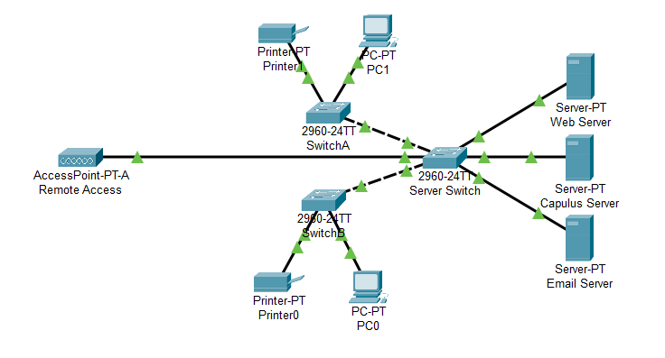
Above is an image of a suggested network layout for the company to use. The network layout has several servers linked together via a switch. This switch is then linked to other switches that would be in separate rooms in the main building that gives the pieces of tech in that room (PCs and printers) also access to the network directly. Also connected to the switch network is a remote access point which can allow a wireless connection to the system, which can allow data to be sent to a cloud storage for people to use should they have the correct accessibility to the cloud service.
The general assumptions that have been made are that the main office of the company has 3 physical servers in which their main data is stored on, as well as several PCs and printers located within that same office
To access the network from a remote location through the access point, users will be given a username login and password which will be saved onto the server. Using a unique login for various people means that only information relevant to them will be available for them to see and view, increasing security of a lot of data on the server. Documents can also be password protected and a separate password can be placed on these so that users cannot see the contents of the document without the correct password.
It will be important to ensure that documents are also encrypted on the server if they are going to be sent from the server to remote locations onto personal devices under the off chance that they may get intercepted. Asymmetric encryption is highly recommended for this, especially if the encryption key is going to be made public knowledge. Asymmetric encryption is recommended due to the fact that the encryption key and decryption key will be different and reversing the encryption key will not decrypt the encrypted document, making it a much more secure and sensible method when the documents that are encrypted can be worth millions. [5]

MDM software
As has been mentioned previously, if the company is looking to adopt a BYOD system, then it should also ensure that it makes use of an MDM software to combat the safety issues that allowing employees to make use of personal portable devices for professional use brings up.
Based off the briefing and situation of CoffeeCapulus, a recommended MDM software that the company can use is a software called Intune. Intune is a software from Microsoft that works on iOS, macOS, Android and Windows devices, meaning that it can go on any type of device that workers wish to use for professional use within or outside the company premises. It can manage security and IT efficiencies over the cloud as well, which is extremely useful due to the high amount of usage of cloud services that the company uses. The software cost $6 per user per month, which is reasonable for what is being offered, and that you can guarantee quality since it is a Microsoft software product.

Results

Findings
To help improve the security of the servers and main system of the company, there are several security guidelines that the staff members should follow while making use of a personal device for professional use.
- Ensure the devices have up-to-date security measures installed such as Firewalls and anti-virus software to greatly reduce the chance of malware infecting the device and thus being able to gain access to the network.

- Ensure the devices have strong secure password to access so that the computer cannot easily be accessed by people who do not have authorisation to see if the information stored on the device. Devices that need to be unlocked using fingerprint, retina or facial recognition increase the security of these devices.

- Do not perform any downloads from non-trustworthy websites so as not to potentially have a virus download onto the device as well, especially while on the company network.

- Do not follow the instructions of suspicious looking emails, as this could allow malware such as Trojans gaining access to the network, especially while on the company network.

- Avoid keeping company data on your device when leaving the office, and if you do, ensure that it is securely locked behind a password so no one unauthorised can access it.

Discussion
The following points are potential concerns that can arise of using the systems that will be put in place, and thus an answer will be required for each of them.
- How the blending of personal and business usage will be achieved while the personal devices are in office
- The strategies that will be deployed to deal with various brands of devices.
- The strategies that will be deployed to deal with different Operating System platforms.
- The mitigating strategies that will be deployed when the owner of a participating device leaves their employment, or the device is lost or stolen.

When blending personal and business usage of personal devices while in the office, it is recommended to forbid access to social media sites and other websites that may allow sharing of media in any form, as well as blocking any form of downloads while on the company network. Dealing with different brands of devices and OS’s is solved since the recommended MDM software is compatible with all types of mobile devices and all OS types.
If a person leaves the employment or their device is lost or stolen, then there are steps that the company should take in order to ensure the integrity of the data that may be stored on the device. The steps are outlined on the below Data Flow Diagram.

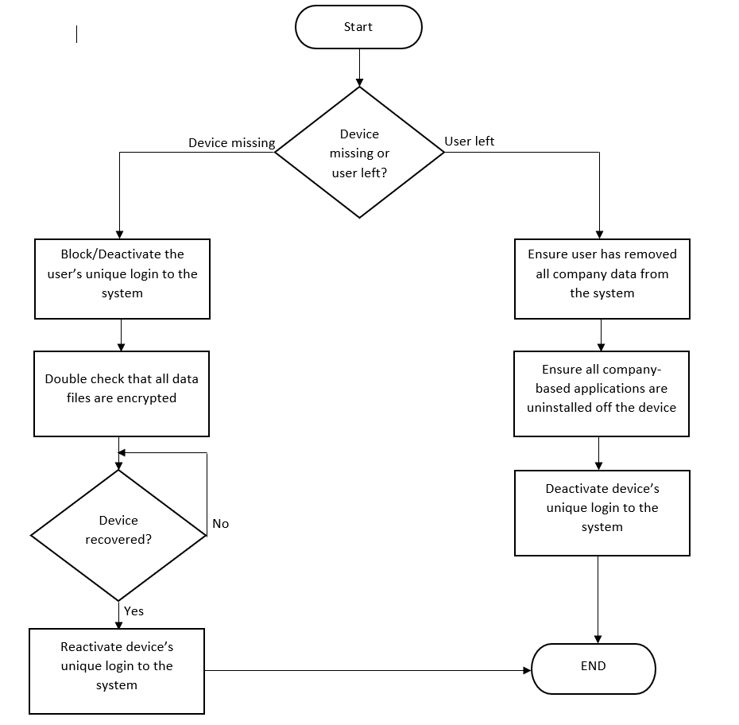

Conclusion
To conclude, CoffeeCapulus can successfully run a network with personal devices connected for professional use if they follow the guidelines set out in this report on how to allow personal devices without threatening the integrity of the intellectual properties of the company.
CoffeeCapulus will need to ensure that they have a working and reliable Mobile Device Management software, such as Intune, if they want to make use of a BYOD system so that users don’t put the information on the company servers at risk.
CoffeeCapulus will also have to ensure that precautions are taken on security such as enforcing the use of strong and secure passwords on devices and sensitive documents to greatly reduce the chance of someone accessing this data without authorisation. The data files should be securely encrypted so that they can only be read by people with access to a decryption key. They will also need to enforce the use and regular upkeep of anti-malware software such as firewalls and anti-viruses, as no or an outdated anti-virus could allow malware to access the data.
Finally, CoffeeCapulus need to ensure it quickly ensures the steps outlined in the data flow diagram are followed if a device is reported lost or stolen, or if an employee leaves the company, as not doing so could potentially compromise the company’s intellectual properties.

Recommendations
When implementing the system into the company, a high recommendation would first be to choose a select number of employees to trial the BYOD system being put in place to ensure that it works effectively and efficiently. Once and if the system proves effective for the company, then they can begin to gradually implement the system to everyone within the company. A gradual implementation after pilot testing will make it easier to pinpoint any issues that occur during implementation as it will be easier to pinpoint exactly when problems in the network began occurring.

References

[1] | K. &. B. M. Downer, “BYOD Security: A New Business Challenge,” in 2015 IEEE International Conference on Smart City/SocialCom/SustainCom together with DataCom 2015 and SC2 2015, NSW, Australia, 2015.
[2] | B. &. A. H. Alotaibi, “A Review of BYOD Security Challenges, Solutions,” IEEE, Jeddah, 2018.
[3] | M. &. K. S. &. P. Y. &. H. Y. J. Ji, Mobile Device Management System with Portable Devices, Seoul: IEEE, 2015.
[4] | J. &. E. I. Toit, “Location Aware Mobile Device Management,” in Location Aware Mobile Device Management, Johannesburg.
[5] | Hitachi ID Systems, Inc, “Definition of Asymmetric Encryption,” Hitachi ID Systems, Inc, 2020. [Online]. Available: https://hitachi-id.com/resource/itsec-concepts/asymmetric_encryption.html. [Accessed 3 April 2020].

marking criteria and Student FEEDBACK

This section details the assessment criteria. The extent to which these are demonstrated by you determines your mark. The marks available for each criterion are shown. Lecturers will use the space provided to comment on the achievement of the task(s), including those areas in which you have performed well and areas that would benefit from development/improvement.

Common Assessment Criteria Applied (Assignment 1) | Marks available | Marks  awarded
1. Engagement with Literature Skills
Extent of research and/or own reading, selection of credible sources, application of appropriate referencing conventions.
You have covered key concepts. However, your work need to engaged more with academic literature; areas lacking referencing, more range of sources can be used.  (Grade mark: 50.00%) | 15 | 7.5
2. Knowledge and Understanding Skills
Extent of knowledge and understanding of concepts and underlying principles associated with the discipline.
You have demonstrated knowledge and understanding. However, see comment above which is lacking in this report. You have used the IEEE report formatting; very good. (Grade mark: 53.33%) | 15 | 8
3. Cognitive and Intellectual Skills
Analysis, evaluation and synthesis; logic, argument and judgement; analytical reflection; organisation of ideas and evidence
Your report discuss all the relevant areas for this assignment; policy, DFD, network design, etc. and a written conclusion. . (Grade mark: 70.00%) | 40 | 28
4. Practical Application Skills
Deployment of methods, materials, tools and techniques; application of concepts; formulation of innovative and creative solutions to solve problems.
Though you discuss security measures in your report for your design. Your design has no security consideration and the devices are not configured. (Grade mark: 40.00%) | 20 | 8
5. Transferable Skills for Life and Professional Practice
Attributes in professional practice: individual and collaborative working; deployment of appropriate media; presentation and organisation.
Your report written well. It could be justify align to make it looks very professional.  (Grade mark: 65.00%) | 10 | 6.5

Assignment Mark (Assessment marks are subject to ratification at the Exam Board. These comments and marks are to give feedback on module work and are for guidance only until they are confirmed. ) | Late Submission Penalties (tick if appropriate) |  | 58%
 | Up to four weeks late |  | 58%
 | First Attempt? |  | 58%

