James Denning (P151597)

Managing a Hardware/Software Project for Disaster Recovery
[Document subtitle]

Table of Contents
Risk evaluation 2
Risk to altered schedule 3
Code of practice: sustainability issues 6
First order 6
Second order 7
Third order 7
Code of practice: ethics and legal issues 8
Including IEEE code of conduct. 8
Including digital Brexit report 9
Quality assurance issues 10
Products operation (Demo). 11
References 15

Risk evaluation

The various risks that could inflict or impact the project have been documented and evaluated to determine the risks intensity against the project’s progression.
To analyse each risks potential and frequency of accruing, a “Risk evaluation matrix” has been applied.
Methods will be stated on how to counteract the potential risk to the project.
Project clarification
The project idea is to assemble an electronic device (in the format of a prototype) that could replace physical dice. This device is intended to give a random number from a digital display and used as a counter to hold a value then write or note that value at a digital display.

The potential risks of this project, dose not put in danger those who may be involved with the production of the prototype, therefore harm to persons present in the work place are not greatly focused.
The risks that concern the project’s development are: [1]
- Risk to altered schedule.
- Software errors and Production mishaps.
- Design risk.
- Budget constraints.
- Stakeholders risk.
- Sponsors risk.
- missing market standards.
The following “Risk management matrix” will indicate the frequency and impact of the risk then imply the level of risk, distinguishing risks from others, to priorities countermeasures to prevent the risk.
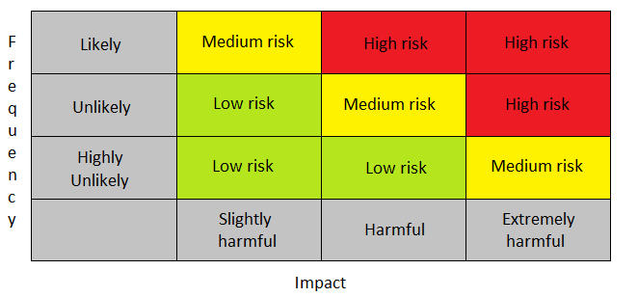
Table 1: “Risk management Matrix”
This section focuses on the potential risks that are considered a “High” risk, that could greatly disrupt the progress of the project.
Using the matrix table, the risks in this segment have been determined as high risk.

- Risk to altered schedule.
If a potential risk is inflicted to the development of this project, the schedule may need to be pushed back, to resolve the issue.
With the amount of potential risks that are relevant to the Electronic project, there is a likely chance of either one or two risk may occur. If a great number of the risks, with individual influences did occur, the collective impact would interfere with the project’s progression.
Classified: likely + harmful = High risk.
Solution: create a means to plan a project with set goals and milestone then evaluate potential risks.

- Software errors and Production mishaps.
While code is being applied and altered to set the parameters and function of the device, the instruction (code) may be incorrect or may not operate in the correct manner. Depending on the coding language and which code is used, the problem may be inverted.
Once practical assembly can commence, components, wires and the microcontroller can be connected to produce a prototype. During assembly, a fault may occur, involving in; faulty-component, poor wire link or “incorrect-predetermined-component”.
Classification: likely + slightly harmful = Medium risk.
Solution: create flow-chart for code with code examples, map out circuit and ensure individual optimization. Both require skills and experience for both aspects.

- Design risk.
Earlier mishaps may accrue with early development in the pre-production of the product. Resulting in later misshape or problems with finished product, achieving large time consumption and resources spent, returning back to the design stage of production.
Classification: likely + harmful High risk.
Solution: create simulations and sampled prototyped in different stages of the products development cycle.

- Budget constraints.
While in the process of planning the project, the material and equipment should be taken in to account to set a project budget. Even with a predetermined budget set, prices may increase, creating complications for funds.
Classification: likely + slightly harmful = Medium risk.
Solution: consider multiple suppliers in case of risk accruing or request increased budget.

- Stakeholders risk.
Those who are a part of the development’s operation may become unreliable or become absent. This would reduce the speed of development forcing to look for alternative or bush back deadline.
Classification: unlikely + harmful = Medium risk.
Solution: evaluate their reliability and performance.

- Sponsors risk.
A Sponsors supporting the development and resource to the project could drop the support, leaving the project with limitation in resource.
Classification: unlikely + harmful = Medium risk.
Solution: contact multiple alternative sponsors to fall back on.

- missing market standards.
If the product dose not meet the standard of the market, than the product would fail resulting the loss of faith within the project/product for future continuation and development.
Classification: likely + harmful = High risk.
Solution: investigate into extensive market research such as analysing the target audience looking at existing products e.c.t.

Code of practice: sustainability issues

First order
The impact of Electronic-waste affecting the environment throughout its life cycle, is a concerning matter. Although methods have been but in place to recycle/salvage materials and components, problems of E-waste are still present. [2]
Reclaiming E-wastes can be a concern itself, for retrieving materials and components by exposing hazardous materials within E-waste can be harmful to a person’s health.
Not all counties can offer protection of extracting re-usable materials. Those who live in such places would not have easily access to safety gear or suitable facilities. [3] [4]
The components that would produce E-waste, use in the development are as follows…
E waste hazords
Individual resisters: The common “surface-mount” resister consists of a Carbon film that surround a ceramic carrier. [5] [6]
The Carbon, considered being insignificant hazard in its solid state, contact with the material in the form of dust is a risk to health. [7]
Liquid crystal display (LCD): consists of small amount of Mercury that should be managed at a products end-of life cycle, large quantities of the substance is harmful to those exposed.
Integrated circuit; integrated components contain such materials such as silicon, Aluminium and Boron. [8] [9] [10]
These element that are within integrated components are not lethal in the small amounts. But could cause health problems in large quantities and within long durations. [8] [9] [10]

If the prototype was distributed as a product, casing of this would be plastic and would be a concern as well.
The devices operation to produce a digital number is minimal, therefore the consumption on energy is insignificant.

Second order

The impact of social sustainability with the product applied, is considered insignificant due to the product being a mere electronic dice generator.
No great impact has been made due to the following
- The products function has been already achieved through other systems such as an application on the phone or other digital/electronic systems. With the evidence of similar products on the market, there has been no great demand for this function or expansions for this feature.

- The circuitry and coding applied to create this product are common with no relative revolutionise technology or coding structure.

The demand for this would be from persons who require a mean to produce a random number for table games that require dice, others could potentially use this a mean to gamble to replace other games of gambling, if other game were not available.

Third order

Due to other products existing longer with in the market, it indicates that there has been little impact to areas that require a dice and is an example for future impact of this product.
A majority of people still use conventional dice in table games and gambling, indicating the idea of an electronic random number not popular. The idea of an electronic or digital has court some interest to show that there is an existing market.
Although this product has two (multi) features, this product idea has not brought anything new to the market, that other products already don’t obtain.
with the product’s current features (random number generator and storing a number) supported by its technical operation, there is little to do with this concept and no new technical methods that could make changes in electronic.
If current impacts in electronics could be implemented, such as wireless connection with the “Internet of thing” operation, then there could be a new unique selling point that could possibly attract a greater ordinance/market. Connecting other devices to expand gameplay or communicate with each other.

Code of practice: ethics and legal issues

Including IEEE code of conduct.
A code of conduct is a document that consists of agreed standards and behaviour that must be upheld by those who are with within the boundaries of the “Institute of Electrical and Electronic Engineers”, such as an electronics engineer.
The contents with in the code of conduct are listed below;
- Respectful to other;
those who are part of IEEE must act in a proficient manner will working with other in a working environment.
The risk of those not following this, could lead to persons within the workplace showing mistreating behaviour, following aggression to one another. Creating an unworkable environment slowing progression.
- Treat people fairly;
tolerance for harassing persons in any manner such as verbal or physical dos not excite within the work place, along with forms of discrimination.
No following this also would create a tensional environment where those who are excluded may have difficulty meeting work demands, creating a unfair scenario between person under the same institutional body.
- Avoid injuring others, their property, reputation or employment;
Intentional injury to others including their property, employment or personal reputation will mot be overlooked, concerning ever may be involved.
Ignoring this could lead to interfering with the progression of a person’s work or any form of plagiarism.
Damage to persons property is classed as aggressive behaver, therefore a form of unfair treatment to others, including reputational sabotage upon others.
- Refrain from retaliation;
Person within the IEEE, must not retaliate agent others who’s report reflects such persons, negative behaver or performance within the workplace or otherwise.
With this not set in place, persons may use aggressive harassment to falsify their states amongst the workplace, therefore giving the assumption that there is no misconduct amongst each other and no distortion of their progress.

All of these are risks to the progression of a project, reducing; productivity, motivation and safe work environment.

Including digital Brexit report

Note the following text is an alteration of text to show understanding of the document analysed.
The digital Brexit report by BCS, consists of concerns that must be addressed before Brexit is passed.
The BCS has discussed with its members, stockholders awhile reanalysing previous policy issue to capture important area to construct a plan after the vote for Brexit. Many policy’s that involve Britten’s exit need to be addressed and are still under debate. this report is to give a clear view on what options the UK need to make to reach its aspirations of the digital area. [11]
- Data-driven future
Policy’s for corporations and industries working together, to share and store data is a matter to resolve. [11]
“Great Britain best interests are to become a leader and innovation in data protection, this will permit seeing personal data relationships as a strategic opportunity and apply resources to create data frame work for social and commercial goal” [11]
This would affect my company, if I needed to safely interact with partners by exchange (sharing) data such as customer profile / market analysis, with no negative backlash. [12] [11]
- Digital capable future
The UK’s growth is supported by those who have such digital capability’s to operate in department such as transportation, finance and retail. [11]
“For such persons to be obtained, reduction in barriers for practitioners and academics who work in the UK with professional standard must be reduced or monitored.” [11]
This could have an effect of difficulty on acquiring new or greater workforce to expand or just continue.

- A secure digital future
Security of a business’s information and data need to be structures to its maximum capability. International relationship will change due to the split form the EU, creating alternate security and policy’s in information exchange.
“Great involvement in cyber protection/security development and with encouraged interactions with others would be an beneficial for the UK.” [11]
If these policy’s are not applied to help protect those in the UK, it would discourage firms to reach market cooperation outside of Britton.
- A connected future
“The UK’s current infrastructure is currently being evaluate against other companions. Creating a new infrastructure and strategy for cooperative communication must be set in place.” [11]
Avoiding newly placed strategies, would produce greater difficult to expand the market of the electronic product.

Quality assurance issues

This section identifies the quality characteristics that are relevant to the electronic product in development.
performance;
The product must work to full optimisation. Little error must affect each feature’s operation of the product. The quality of performance can also be measured by its duration of operation or time. [13] [14]
Product example: the device should be able to execute a random dumber and be able to hold a number for long durations, extract and add a number to the device without mistake.
Features;
This is measured by what capabilities the product has, how great these features are in use, detail and efficiently, and the amount of features of the product. [14]
Product example: the device have multi-operations such as random number and number storage.
Reliability;
This dimension of quality focuses on how reliable the product is in operation and frequency of error. The product must work for long durations giving an ideal ratio of the product having faults. [14]
Product example: non-ideal frequent error in calculation, number display and storage.
Durability;
This is determined by the product’s Physical tolerance. How long can the product withstand constant use and how many time can it be used before meeting its end. [14]
This could also be affected by the quality of the materials used in the manufacture of the product. To indicate its life-span. [14]
Product example: components and the integrate.

Products operation (Demo).

To recap; this is a circuit simulation of a electronic number generator with the ability to store a fixed number of twenty.

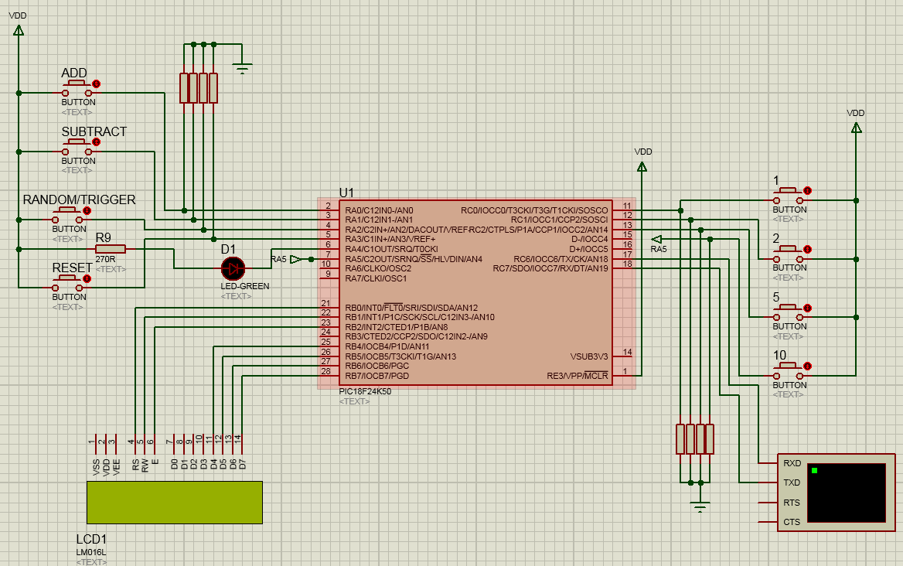
To the left are four push buttons that control the option to…
- Add a number
- Subtract a number
- Call up random number
- Reset counter/stored number

The first two buttons to the left ( add and subtract), require the use of the other push buttons to the right to add or subtract a value. With either add or subtract pressed down will command what operation to execute while one buttons to the right is pressed down simultaneously.
the value will be determined by pressing one of the four buttons pressed and will give a value either 1, 2, 5 or 10 that will result in an addition or subtraction to the stored value of twenty. Two buttons must be pressed to execute a calculator operation.
The button labelled random/trigger command the device to produce a random number and display it to the LCD screen.
The button titled Reset, will return the stored number back to twenty.
The LCD screen will display both the random number and the stored but potentially altered number.
Here is the code that labels, defines titles and sets the integrated-circuit’s function operation

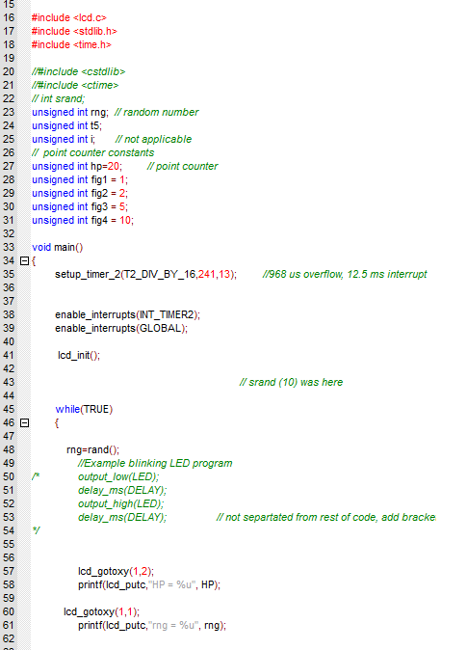
First set of code defines what header files to use, set and title stored variables.
The next set controls the internal timer that help produce a random number, followed by code that instruct the values, where to be displayed on the LCD.

This I an example of the code that is used to add and subtract the stored number

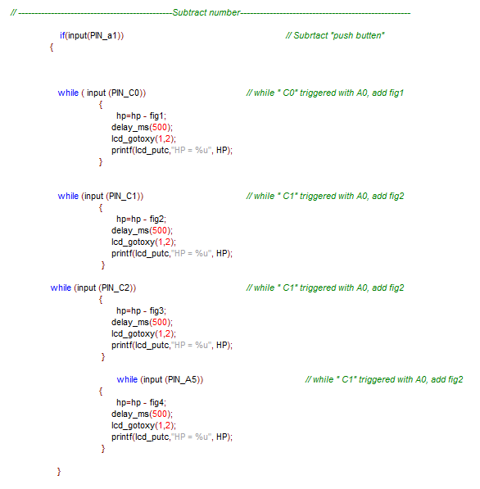
If pin “A1” or subtract is pressed, while one of the for such as pin “C0” or 1 is pressed as well, the value stored at hp (20) will be subtracted by the value define at Fig1 (1) and display new value stored at hp.
This operation of code is nearly identical to the additional code excepted that is adds the number to the stored value at hp.

This is the code that controls the random number to display.
If “A2” or Random/trigger is pressed, the integrated-circuit will read the a number from the timer, while still counting and place that number in the seed-random instruction to help give a random number.
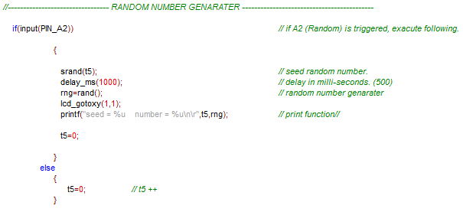

The random function, operate by using is a fixed mathematical expression that will give the same set of random number if the same number or seed is applied to the random function.
The chip will read what value is at the timer and place this value in to seed-random function, giving new number to the fixed mathematical excretion then print the “random-number to the display.

References

[1] | J. Spacey, “39 Examples of Project Risk,” 29 11 2015. [Online]. Available: https://simplicable.com/new/project-risk-examples. [Accessed 27 01 2019].
[2] | Thwink.org, “Sustainability,” [Online]. Available: http://www.thwink.org/sustain/glossary/Sustainability.htm. [Accessed 30 01 2019].
[3] | World Health Organization, “Children's environmental health,” [Online]. Available: https://www.who.int/ceh/risks/ewaste/en/. [Accessed 30 01 2019].
[4] | L. Poppenheimer, “E-Waste Health Hazards and Environmental Impacts,” Green groundswell, 29 05 2013. [Online]. Available: https://greengroundswell.com/e-waste-health-hazards-and-environmental-impacts/2013/05/29/. [Accessed 30 01 2019].
[5] | Resistorguide.com, “Carbon film resistor,” [Online]. Available: http://www.resistorguide.com/carbon-film-resistor/. [Accessed 31 01 2019].
[6] | ResistorGuide.com, “Resistor materials,” [Online]. Available: http://www.resistorguide.com/materials/. [Accessed 31 01 2019].
[7] | Monash University, “Carbon fibre composites - OHS information sheet,” 02 2009. [Online]. Available: https://www.monash.edu/ohs/info-docs/safety-topics/chemical-management/carbon-fibre-composites-ohs-information-sheet. [Accessed 31 01 2019].
[8] | Lenntech, “Silicon - Si,” [Online]. Available: https://www.lenntech.com/periodic/elements/si.htm. [Accessed 31 01 2019].
[9] | Lenntech, “Aluminum - Al,” [Online]. Available: https://www.lenntech.com/periodic/elements/al.htm. [Accessed 31 01 2019].
[10] | Lenntech, “Boron - B,” [Online]. Available: https://www.lenntech.com/periodic/elements/b.htm. [Accessed 31 01 2019].
[11] | The British Computer Society, “Digital Brexit,” The British Computer Society, Swindon, 2017.
[12] | Data protection network, “DATA SHARING,” [Online]. Available: https://www.dpnetwork.org.uk/opinion/data-sharing-customer-video/. [Accessed 01 02 2019].
[13] | Definition.com, “Performance quality,” [Online]. Available: http://the-definition.com/term/performance-quality. [Accessed 01 02 2019].
[14] | University of Cambridge, “Quality Framework,” [Online]. Available: https://www.ifm.eng.cam.ac.uk/research/dstools/quality-framework/. [Accessed 01 02 2019].

