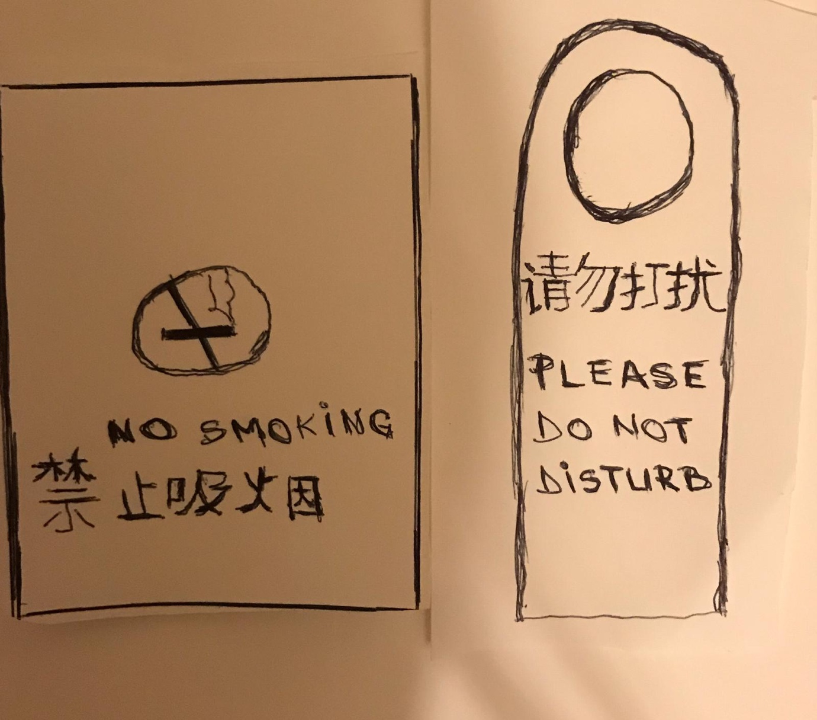
International hotel management

Foreign Languages and Cultural Awareness

Submitted by: Alina Capitanescu
Student number: 1715249
Submitted to: Jinping Li

This assignment requires a caution board, which includes caution or danger picture, caution sentence in Chinese and a caution sentence in English.

