7/31/2026
Rabia Naeem (2310492)

BSc Applied Computing
Data Warehousing & Data Mining

Abstract
This report examines the application of data mining techniques for predicting customer churn using the Telco Customer Churn dataset and the WEKA tool. During preprocessing, the customerID attribute was removed, while Churn was retained as the target variable. Four classification algorithms—J48 Decision Tree, Random Forest, Random Tree, and Logistic Regression—were applied and evaluated using 10-fold cross-validation. Their performance was assessed based on accuracy, precision, recall, and ROC area. Among the models, Logistic Regression produced the highest accuracy of 80.22%, making it the most effective approach for churn prediction. The results highlight how data mining can enable organisations to identify customers at risk of leaving and support retention strategies through informed, data-driven decision-making.

Contents
Abstract 1
Introduction 3
1.1 Purpose and Practice of Data Mining 4
1.2 Dataset Description and Exploration 4
1.3: Data Pre-processing and Post-processing 7
1.4 Sample Runs and Analysis Methods 8
1.4.1 J48 8
1.4.2 Random Forest 9
1.4.3 Random Tree 10
1.4.4 Logistic Regression Model 11
Table 1 Comparison Table 12
1.5 Business Recommendations 12
1.6 Reflective Commentary 13
References 13

Introduction
Data mining involves examining large volumes of data to uncover useful patterns, relationships, and trends that support informed business decisions. By converting raw data into actionable insights, organisations can enhance operational efficiency, forecast future outcomes, and gain a competitive edge. In the retail industry, data collected from customer purchases, transactions, and interactions can be analysed to better understand customer behaviour, detect buying patterns, and anticipate customer churn. These insights help businesses design targeted marketing strategies, improve customer satisfaction, and strengthen customer retention.
This report focuses on analysing the Telco Customer Churn dataset using the WEKA data mining tool. The main aim is to explore the dataset, apply suitable preprocessing techniques, and implement classification algorithms to predict whether a customer is likely to leave the company. Various machine learning models, including J48 Decision Tree, Random Forest, and Logistic Regression, are tested and compared using evaluation metrics such as accuracy, precision, recall, and ROC area. Based on the results, the report offers recommendations to help retail organisations reduce customer churn and enhance overall business performance through data-driven decision-making.

1.1 Purpose and Practice of Data Mining
Data mining refers to the process of examining large datasets to discover significant patterns, trends, and relationships that aid informed decision-making. It integrates methods from statistics, machine learning, and database management to convert raw data into meaningful business insights. Organisations across various sectors utilise data mining to enhance efficiency, minimise costs, forecast future trends, and maintain a competitive advantage. In the retail industry, data gathered from customer purchases, demographics, browsing activity, and service interactions can be analysed to better understand customer behaviour and support strategic planning.
A key application of data mining in retail is customer churn prediction, which focuses on identifying customers who are likely to stop using a company’s products or services. By analysing past customer data, organisations can detect patterns linked to potential churn. Classification algorithms such as Decision Trees, Random Forest, and Logistic Regression are commonly used to predict churn by evaluating factors like contract type, monthly charges, tenure, and customer satisfaction. These predictions allow businesses to take proactive actions, including offering personalised promotions, implementing loyalty programmes, and enhancing customer support, to improve retention.
Research by Shu-li et al. [1] proposed an integrated framework that combines customer churn prediction with customer segmentation, enabling organisations to identify high-risk customer groups more effectively and develop targeted retention strategies.
Similarly, Zhang and Zhang [2] demonstrated that advanced deep learning models can improve customer churn prediction while simultaneously analysing customer satisfaction, allowing organisations to make more accurate and timely customer relationship management decisions.
Additionally, data mining facilitates customer segmentation by categorising customers based on shared characteristics and purchasing behaviours. This enables businesses to create targeted marketing strategies, refine product recommendations, and allocate resources more efficiently. Kostić et al. [3] demonstrated that analysing customer relationships through social network analysis can improve churn prediction by identifying influential customer connections and behavioural patterns within telecommunication networks. In this report, the Telco Customer Churn dataset is examined using the WEKA data mining tool to explore the data, perform preprocessing, apply classification techniques, and assess their performance. The findings provide valuable insights that can assist retail organisations in reducing churn, improving customer satisfaction, and making data-driven business decisions.

1.2 Dataset Description and Exploration
The dataset utilised in this study is the Telco Customer Churn dataset, which is commonly used in churn prediction research. It consists of 7,043 customer records and 21 attributes, with each entry representing an individual customer. The dataset includes details such as demographic information, account data, subscribed services, billing details, and a churn indicator showing whether the customer has left the company. The target variable is Churn, which has two possible values: Yes and No, making it appropriate for supervised classification using machine learning techniques.
The dataset contains a mix of categorical (nominal) and numerical attributes. Categorical variables include gender, Partner, Dependents, InternetService, Contract, PaymentMethod, and Churn, while numerical variables include SeniorCitizen, tenure, MonthlyCharges, and TotalCharges. Before applying classification methods, the dataset was imported into the WEKA Explorer to review its structure, attribute types, and overall distribution. As shown in Figures 1 and 2, the dataset structure and attribute distributions were examined before preprocessing and model development.
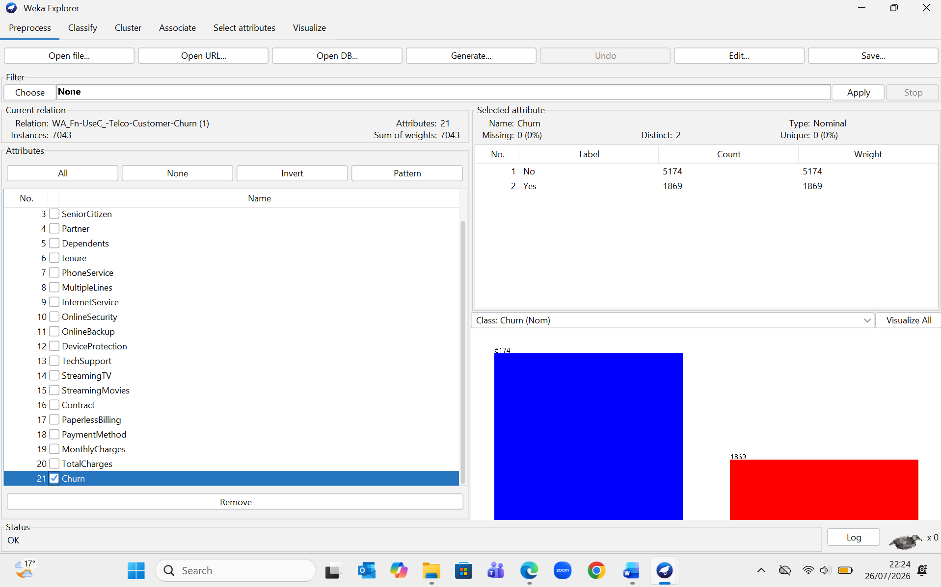
Figure 1. Telco Customer Churn dataset loaded in WEKA Explorer showing 7,043 instances, 21 attributes, and the class distribution of the Churn attribute.
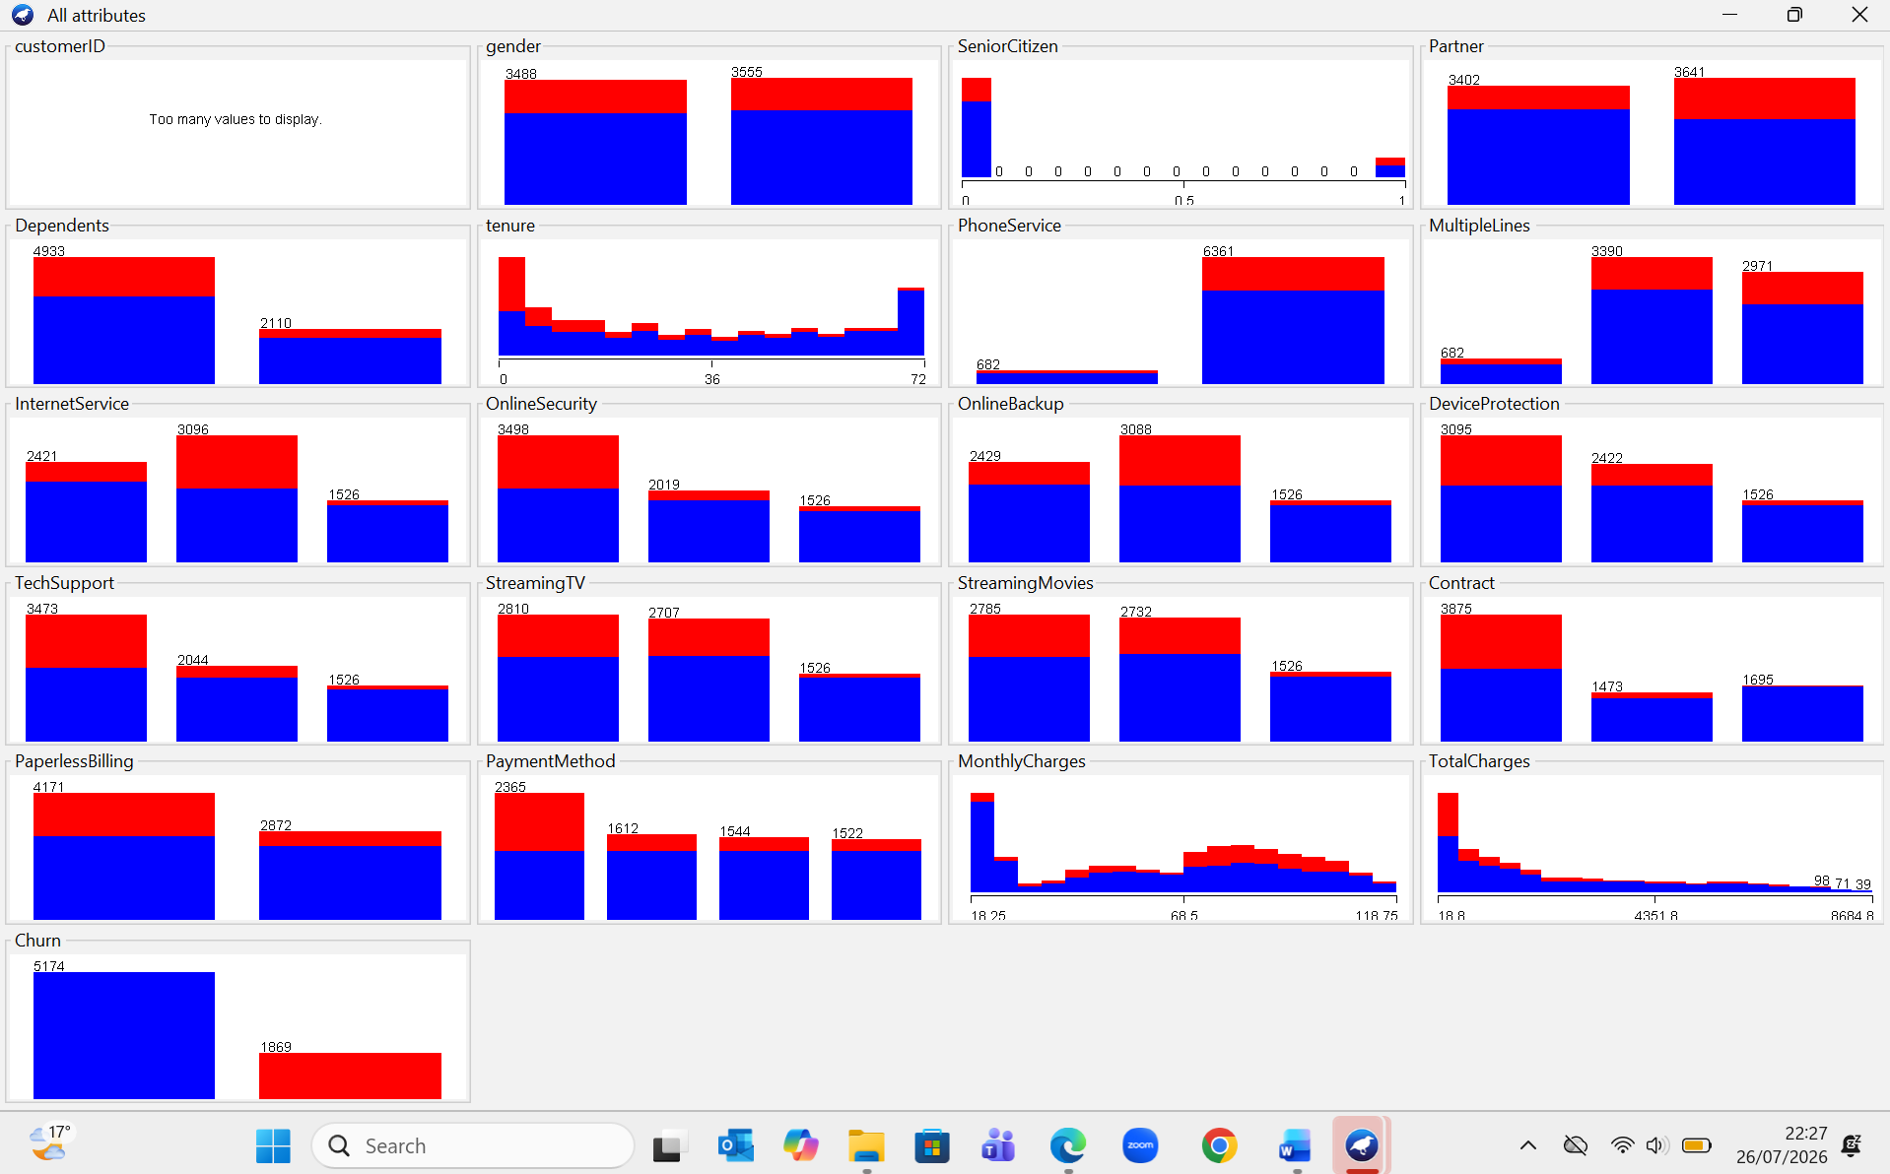
Figure 2. Attribute distributions for the Telco Customer Churn dataset displayed using the WEKA Visualize All feature.
Figure 2 presents the distribution of all attributes in the dataset, allowing patterns, value frequencies, and potential class imbalances to be examined before preprocessing and model development.
Sana et al. [4] emphasised that data transformation and feature selection are essential steps in customer churn prediction because they improve data quality, remove irrelevant attributes, and enhance the predictive performance of machine learning models. Therefore, exploring the dataset before model development helps identify the most informative features and supports more accurate classification results.
Preliminary analysis indicated that the dataset was well structured, with no significant inconsistencies. The customerID attribute was removed since it serves only as a unique identifier and does not contribute to churn prediction. Further exploration using WEKA's attribute statistics and Visualize All tools suggested that attributes such as Contract, tenure, MonthlyCharges, and InternetService were strongly associated with customer churn. Customers with shorter contract durations and higher monthly charges appeared more likely to leave the company, making these attributes important predictors.
The Visualize All feature in WEKA was used to examine the distribution of each attribute and detect any unusual trends or class imbalances. Analysing the dataset prior to model development is essential, as it ensures that suitable preprocessing and classification methods are chosen. The prepared dataset provided a solid basis for building and evaluating churn prediction models using J48 Decision Tree, Random Forest, and Logistic Regression algorithms.

1.3: Data Pre-processing and Post-processing
Data preprocessing is a crucial step in the data mining process, as it enhances the quality of the dataset before applying machine learning algorithms. Raw data often includes redundant features, inconsistencies, or irrelevant information that can negatively affect the performance of classification models. Techniques such as data cleaning, feature selection, and data transformation are used to prepare the dataset for analysis, leading to more accurate and dependable prediction outcomes. Sana et al. [4] noted that appropriate preprocessing and feature selection improve the effectiveness of customer churn prediction models by ensuring that only relevant information is used during model development.
In this study, data preprocessing was performed using the WEKA Explorer. The customerID attribute was eliminated using the Remove filter, as it is a unique identifier and does not contribute to predicting customer churn. As illustrated in Figure 3, removing this attribute reduced the total number of attributes from 21 to 20 while retaining all 7,043 customer records. The Churn attribute was kept as the class variable since it serves as the target for the classification models. Figure 3 illustrates the dataset after preprocessing, confirming that only the customerID attribute was removed while all customer records and the target class were retained.

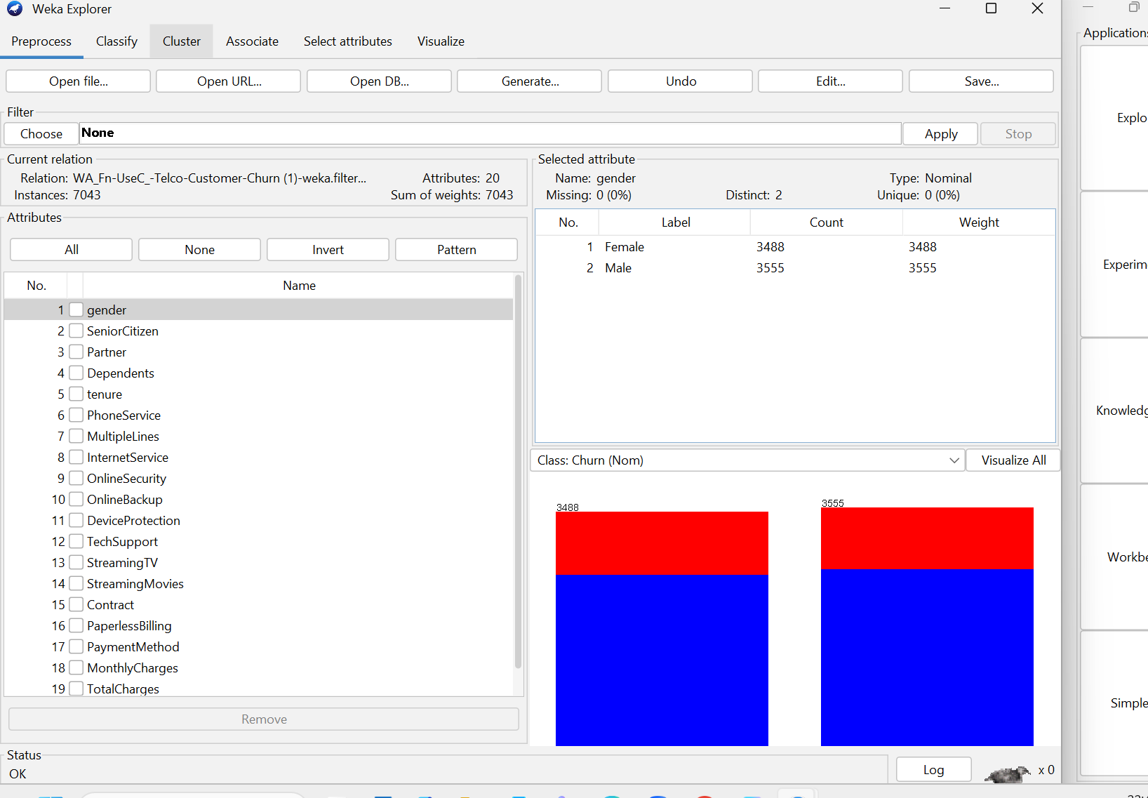
Figure 3. Dataset after removing the customerID attribute using the WEKA Remove filter while retaining the Churn attribute as the target class.

The Telco Customer Churn dataset required only minimal preprocessing, as it was already well organised and contained consistent attribute values. Initial analysis did not reveal any major data quality issues, such as duplicate entries or missing values, that required further cleaning. As a result, additional preprocessing methods like data normalisation or standardisation were not necessary prior to model development. Instead, the emphasis was placed on removing irrelevant attributes that could negatively impact the performance of classification algorithms.
Following preprocessing, the dataset maintained all 7,043 customer records along with 20 predictive attributes, ensuring that important customer information was preserved for training the models. Keeping the original attribute values enabled the machine learning algorithms to detect meaningful relationships between factors such as contract type, monthly charges, tenure, internet services, and customer churn. This approach ensured that the models were trained using relevant data while avoiding unnecessary computational overhead.
After completing preprocessing, the refined dataset was used to build and evaluate classification models in WEKA. The dataset was analysed using J48 Decision Tree, Random Forest, and Logistic Regression algorithms. The performance of each model was evaluated using metrics such as accuracy, precision, recall, and ROC area, allowing for a consistent comparison of their effectiveness under the same dataset conditions.

1.4 Sample Runs and Analysis Methods

1.4.1 J48

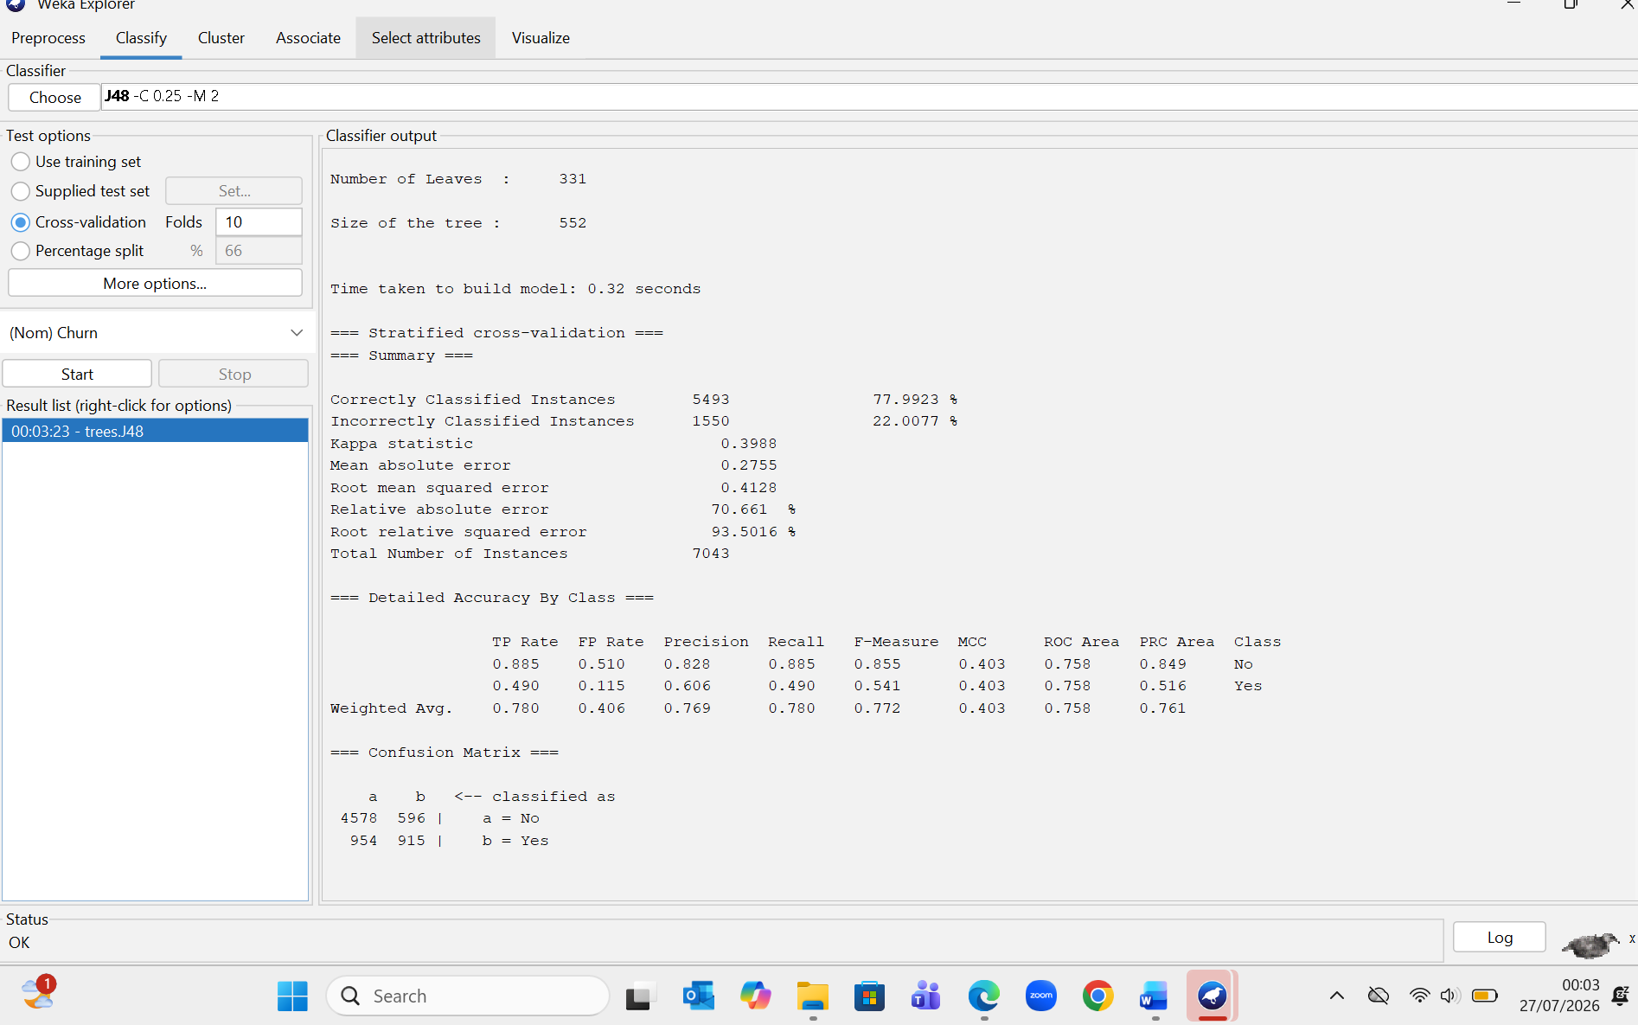
Figure 4. J48 Decision Tree classification results using 10-fold cross-validation in WEKA.
The J48 Decision Tree algorithm was implemented on the preprocessed Telco Customer Churn dataset using 10-fold cross-validation in WEKA. J48 is a supervised classification method that builds a decision tree by selecting attributes that most effectively divide the data into distinct classes. It is commonly used due to its ability to produce models that are easy to interpret. As illustrated in Figure 4, the J48 model correctly classified 5,493 out of 7,043 instances, resulting in an accuracy of 77.99%. The model achieved a weighted precision of 0.769, a recall of 0.780, and an ROC area of 0.758. These outcomes suggest that J48 served as a dependable baseline for predicting customer churn while maintaining simplicity and interpretability.
The performance of the J48 algorithm in this study is consistent with previous research. Hermawan et al. [5] compared J48, Random Tree, and Random Forest using an in-vehicle coupon recommendation dataset and found that J48 achieved higher classification accuracy than Random Tree while maintaining a relatively simple and interpretable model. Their study also reported that Random Forest produced the highest classification accuracy among the three algorithms, demonstrating its ability to improve predictive performance through the use of multiple decision trees. These findings support the results obtained in this study, where J48 provided reliable performance, while Random Forest achieved higher classification accuracy than J48 and Random Tree. However, Logistic Regression produced the highest overall classification performance in this study. Although J48 produced reliable classification performance, additional machine learning algorithms were evaluated to determine whether higher predictive accuracy could be achieved.

1.4.2 Random Forest
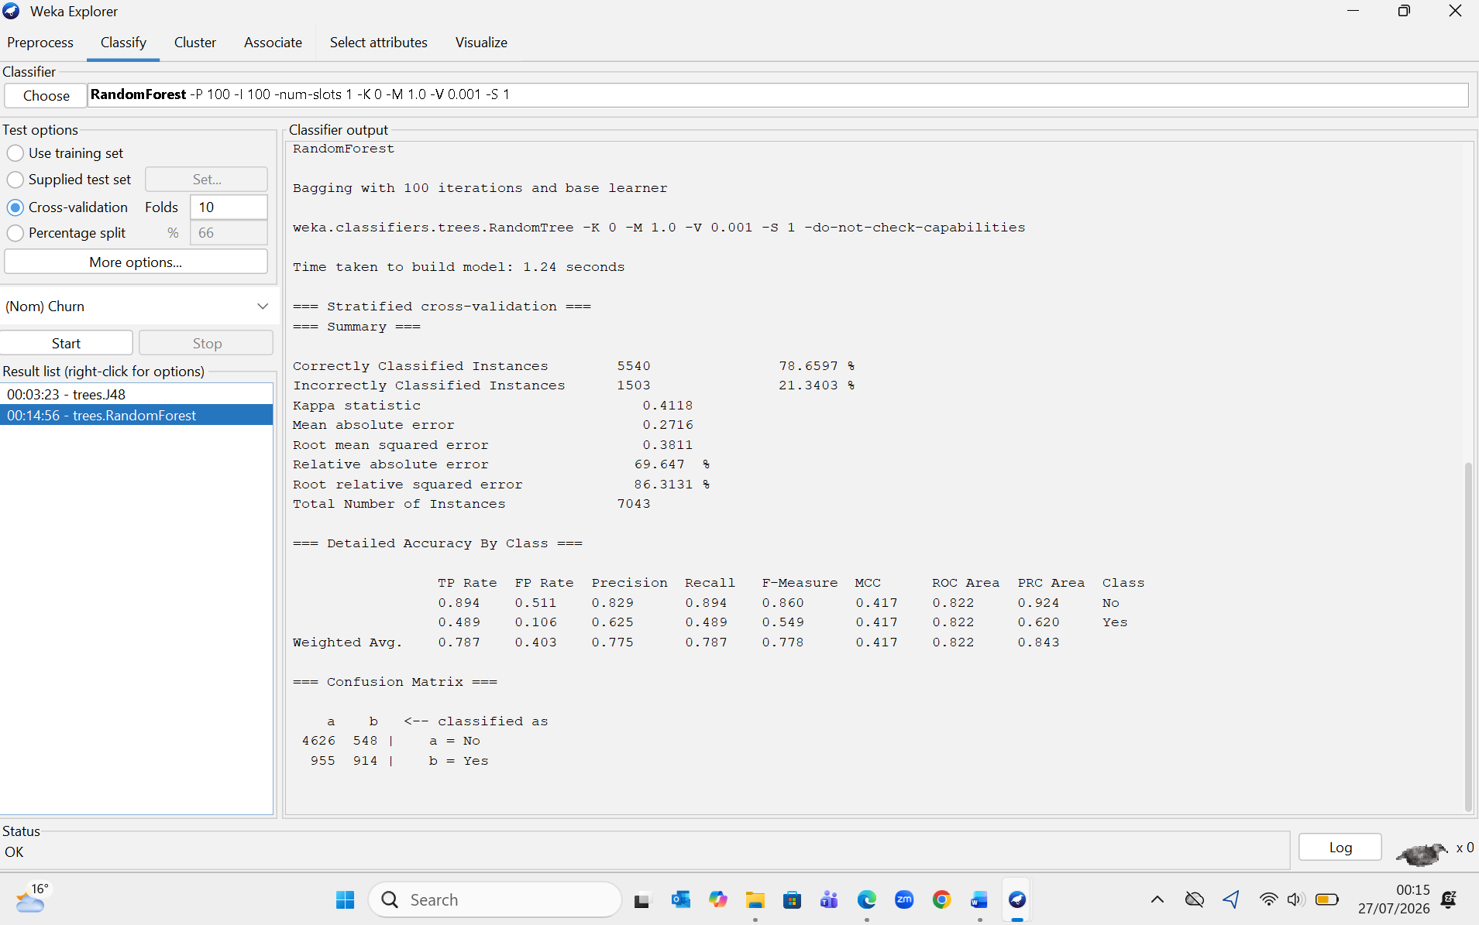
Figure 5. Random Forest classification results using 10-fold cross-validation in WEKA.
Random Forest is an ensemble machine learning algorithm that constructs multiple decision trees using randomly selected subsets of the training data and predictor variables. The final prediction is obtained by combining the outputs of all decision trees through a majority voting process. This approach reduces overfitting, improves classification accuracy, and enhances the model's ability to generalise to new data. According to Salman et al. [6], Random Forest is widely used for classification because of its robustness, high predictive performance, and ability to process complex datasets containing many attributes.
In this study, the Random Forest model correctly classified 5,540 of the 7,043 customer records, achieving an overall accuracy of 78.66%. It obtained a weighted precision of 0.775, a recall of 0.787, and an ROC area of 0.822. When compared with the J48 Decision Tree, Random Forest demonstrated superior performance across all evaluation metrics. However, Logistic Regression achieved the highest overall classification performance in this study, indicating that it was the most effective model for predicting customer churn.
These results align with the findings of Hermawan et al. [5], who similarly observed that Random Forest outperformed both J48 and Random Tree in terms of classification accuracy. This suggests that the use of multiple decision trees can lead to more accurate and robust models for prediction tasks.
Overall, Random Forest delivered strong predictive performance among the decision tree algorithms evaluated. However, Logistic Regression achieved the highest overall classification accuracy and the best evaluation metrics in this study.

1.4.3 Random Tree
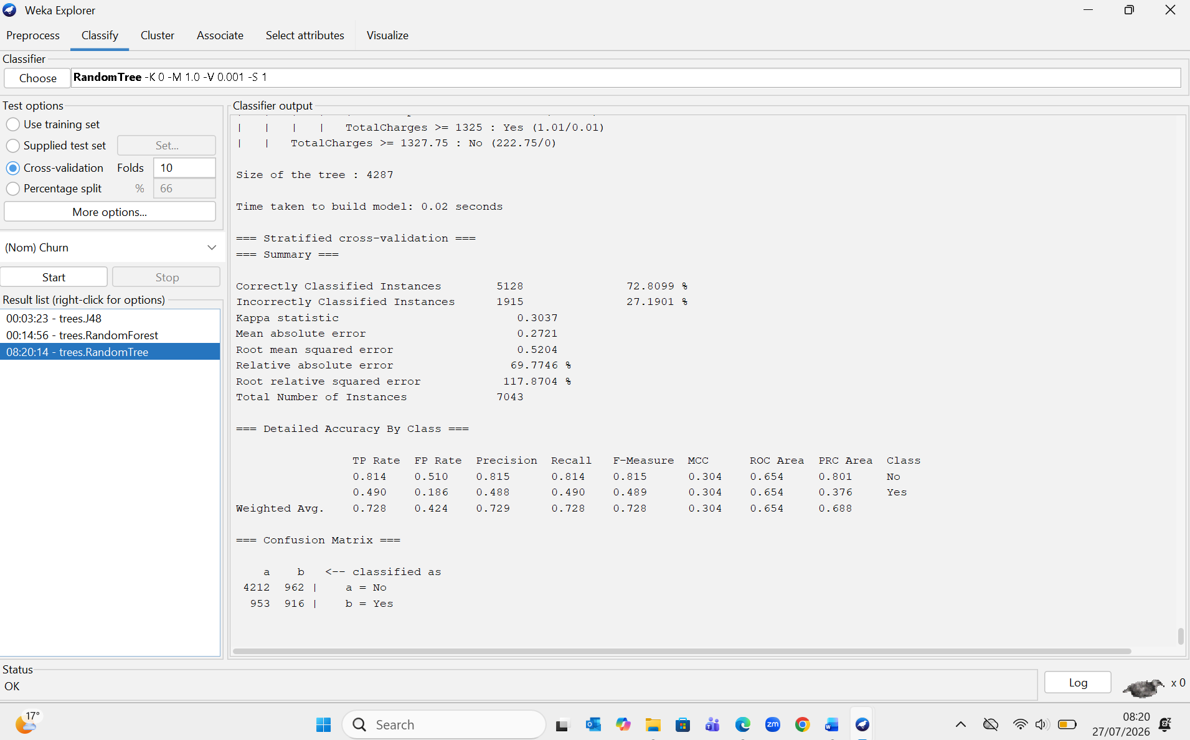
Figure 6. Random Tree classification results using 10-fold cross-validation in WEKA.
The Random Tree algorithm was also tested using 10-fold cross-validation in WEKA. Random Tree is a decision tree method that selects attributes randomly during the tree-building process, unlike Random Forest, which combines multiple trees. While this approach allows for faster model construction, it can lead to lower prediction accuracy since the model relies on a single randomly generated tree. As illustrated in Figure 6, the Random Tree model correctly classified 5,128 out of 7,043 customer records, resulting in an accuracy of 72.81%. It achieved a weighted precision of 0.729, a recall of 0.728, and an ROC area of 0.654. These outcomes were lower than those of both the J48 Decision Tree and Random Forest models, suggesting that Random Tree was less effective for predicting customer churn in this dataset.
Although the Random Tree model had the shortest training time (0.02 seconds), its lower accuracy and ROC area indicate that faster model construction does not necessarily lead to better predictive performance. The results suggest that relying on a single randomly generated decision tree limited the model’s ability to capture complex patterns within the customer data. As a result, Random Tree was the least effective among the three algorithms evaluated in this study. These findings are consistent with Hermawan et al. [5], who also found that Random Tree produced lower classification accuracy compared to both J48 and Random Forest.

1.4.4 Logistic Regression Model
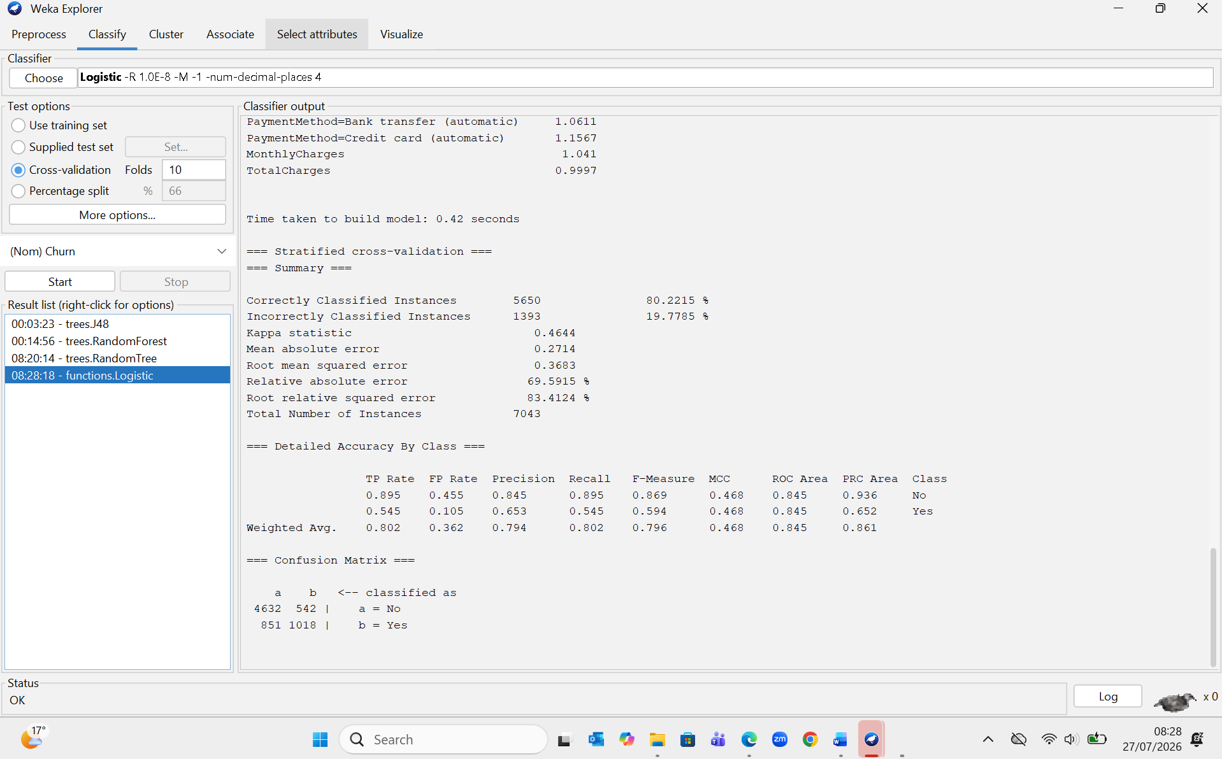
Figure 7. Logistic Regression classification results using 10-fold cross-validation in WEKA.
The Logistic Regression algorithm was also assessed using 10-fold cross-validation in WEKA. Logistic Regression is a supervised learning method that calculates the probability of a data instance belonging to a specific class through a logistic function. It is commonly applied to binary classification tasks due to its computational efficiency, interpretability, and effectiveness when relationships between variables are relatively linear. As illustrated in Figure 7, the Logistic Regression model correctly classified 5,650 out of 7,043 customer records, achieving an overall accuracy of 80.22%. The model produced a weighted precision of 0.794, a recall of 0.802, and an ROC area of 0.845. These findings show that Logistic Regression achieved the best predictive performance among all the algorithms evaluated in this study.
When compared to J48, Random Forest, and Random Tree, Logistic Regression achieved the highest values for accuracy, precision, recall, and ROC area, while also maintaining a relatively short training time of 0.42 seconds. These results indicate that the model effectively captured the relationships between customer attributes and churn outcomes. Based on these evaluation metrics, Logistic Regression appears to be the most appropriate algorithm for predicting customer churn in this dataset.

Table 1 Comparison Table
Performance Comparison of Classification Algorithms
Algorithm | Accuracy (%) | Precision | Recall | ROC Area
J48 Decision Tree | 77.99 | 0.769 | 0.780 | 0.758
Random Forest | 78.66 | 0.775 | 0.787 | 0.822
Random Tree | 72.81 | 0.729 | 0.728 | 0.654
Logistic Regression | 80.22 | 0.794 | 0.802 | 0.845
Table 1. Performance comparison of the classification algorithms used for customer churn prediction.
Table 1 shows that Logistic Regression delivered the highest performance, with an accuracy of 80.22%, precision of 0.794, recall of 0.802, and an ROC area of 0.845, making it the most effective algorithm for predicting customer churn in this study. Random Forest achieved the second-best results, benefiting from its ensemble learning approach, while J48 provided a reasonable trade-off between accuracy and interpretability. Although Random Tree had the fastest training time, it produced the lowest predictive performance. Based on these results, Logistic Regression is recommended as the most suitable method for customer churn prediction using the Telco Customer Churn dataset.

1.5 Business Recommendations
The results of this study show that data mining can play an important role in supporting customer retention strategies. Among the evaluated classification algorithms, Logistic Regression achieved the highest predictive performance, making it the most effective model for identifying customers who are likely to churn [1], [2]. Organisations can use this model to detect high-risk customers in advance and apply targeted retention measures before they decide to discontinue their services.
Based on the analysis, businesses should prioritise customers who exhibit characteristics linked to a higher risk of churn, such as shorter contract durations, higher monthly charges, and certain types of internet service plans. Tailored retention approaches, including loyalty programmes, discounts on contract renewals, flexible payment options, and enhanced customer support, can be implemented to improve customer satisfaction and minimise churn [1], [4].
The predictive model should also be incorporated into the organisation’s customer relationship management (CRM) system to enable continuous monitoring of customer risk levels. This integration would support data-driven decision-making, more efficient allocation of marketing resources, and ongoing evaluation of retention strategies. Furthermore, organisations should regularly update and retrain the model using new customer data to ensure it remains accurate as customer behaviour evolves. Applying these recommendations can help improve customer retention, reduce revenue loss, and promote sustainable business growth through informed decision-making [2].

1.6 Reflective Commentary
This data mining project offered valuable hands-on experience in applying machine learning techniques to a real-world business problem. Throughout the project, I gained a deeper understanding of the full data mining process, including data exploration, preprocessing, model building, and performance evaluation using WEKA. Prior to this work, my practical experience with classification algorithms was limited; however, implementing and comparing J48 Decision Tree, Random Forest, Random Tree, and Logistic Regression enhanced my understanding of how different models perform in customer churn analysis.
One of the key challenges faced during the project was interpreting the evaluation metrics generated by WEKA, particularly precision, recall, and ROC area. By consulting academic sources and comparing results across different algorithms, I developed greater confidence in understanding these metrics and selecting the most suitable model. I also recognised the importance of data preprocessing, as removing irrelevant attributes such as customerID ensured that the models focused on meaningful features rather than unnecessary information.
Overall, this project strengthened both my technical and analytical capabilities. It improved my ability to assess machine learning models, interpret results, and present findings in a clear and structured academic format. In future work, I aim to explore additional data mining techniques, such as feature selection, parameter tuning, and more advanced algorithms, to further enhance prediction accuracy. The skills and experience gained from this project will be beneficial for future academic studies and for addressing real-world business challenges using data mining methods.

References
- W. Shu-li, W. Yau, T. S. Ong, and S.-C. Chong, “Integrated Churn Prediction and Customer Segmentation Framework for Telco Business,” Ieee Access, vol. 9, pp. 62118–62136, 2021, doi: 10.1109/access.2021.3073776.
- H. Zhang and W. Zhang, “Application of GWO-attention-ConvLSTM model in customer churn prediction and satisfaction analysis in customer relationship management,” Heliyon, vol. 10, no. 17, p. e37229, 2024, doi: 10.1016/j.heliyon.2024.e37229.
- S. M. Kostić, M. Simić, and M. V. Kostić, “Social Network Analysis and Churn Prediction in Telecommunications Using Graph Theory,” Entropy, vol. 22, no. 7, p. 753, 2020, doi: 10.3390/e22070753.
- J. K. Sana, M. Z. Abedin, M. S. Rahman, and M. S. Rahman, “A novel customer churn prediction model for the telecommunication industry using data transformation methods and feature selection,” Plos One, vol. 17, no. 12, p. e0278095, 2022, doi: 10.1371/journal.pone.0278095.
- D. R. Hermawan, M. Fahrio Ghanial Fatihah, L. Kurniawati, and A. Helen, “Comparative Study of J48 Decision Tree Classification Algorithm, Random Tree, and Random Forest on In-Vehicle Coupon Recommendation Data,” in *2021 International Conference on Artificial Intelligence and Big Data Analytics (ICAIBDA)*, Bandung, Indonesia, 2021, pp. 1–6, doi: 10.1109/ICAIBDA53487.2021.9689701.
- H. A. Salman, A. Kalakech, and A. Steiti, “Random Forest Algorithm Overview,” Babylonian Journal of Machine Learning, vol. 2024, pp. 69–79, 2024, doi: 10.58496/BJML/2024/007.

