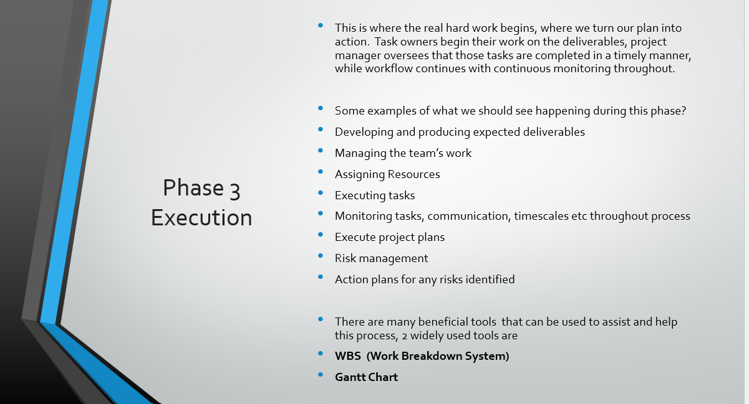After the planning phase, comes phase 3 of the project management lifecycle the Execution of the project. During this phase, the team will construct their deliverables and present them to the customer and key stakeholders. This is usually the longest and most demanding phase of the project management lifecycle. The key purpose is to complete the work defined in the project planning and meeting the key objectives. At this stage you will need to manage Developing and producing of expected deliverables, the team’s work, assigning Resources, executing tasks, monitoring communication, timescales, task completions etc throughout the process, risk management and action plans for any risks identified. These are just a few main examples noted as projects vary. There are many beneficial tools that can be used to assist and help the process in the execution phase, two commonly used tools are Work Breakdown System (WBS) and the Gantt Chart, (Caietti,2022).

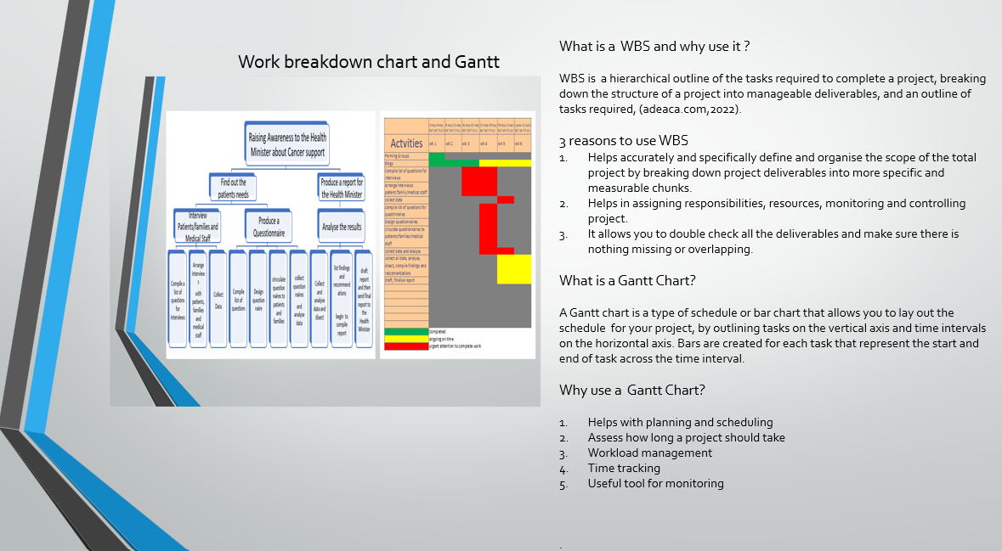
WBS is a hierarchical outline of the tasks required to complete a project, breaking down the structure of a project into manageable deliverables, and an outline of tasks required, (adeaca,2022).
WBS helps accurately and specifically define and organise the scope of the total project by breaking down the project deliverables into more specific and measurable pieces, assists in assigning responsibilities, resources and helps with monitoring and controlling of the project, allowing you to double check all the deliverables and make sure there is nothing missing and overlapping.

Once you have completed WBS this then enables you to draw up a Gantt Chart.
A Gantt Chart is type of schedule or bar chart that allows you to lay out the schedule for your project, by outlining your tasks on the vertical axis and time intervals on the horizontal axis. Bars are created for each task that represent the start and end of task across the time interval. The Gantt chart helps with planning and scheduling, easy visible access for how long a project should take, highlights the workload, enables you to monitor and time track your project, (APM,2022).

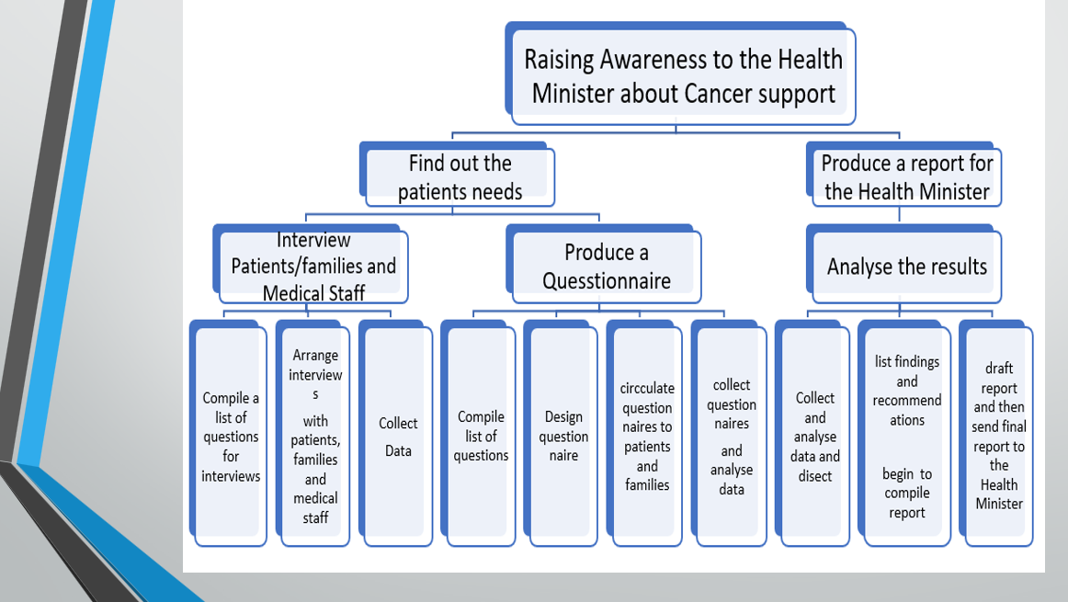

Above is the WBS we created for our project, we used the top-down approach for our project, building on from our Quad chart, starting at the top with our aim, then to our objectives, then our desired end results and lastly listing the tasks/activities required to meet the desired end results.
As we created our WBS we became extremely aware of the scale of the project for our timeframe our next step was to from our WBS create a Gantt chart ….
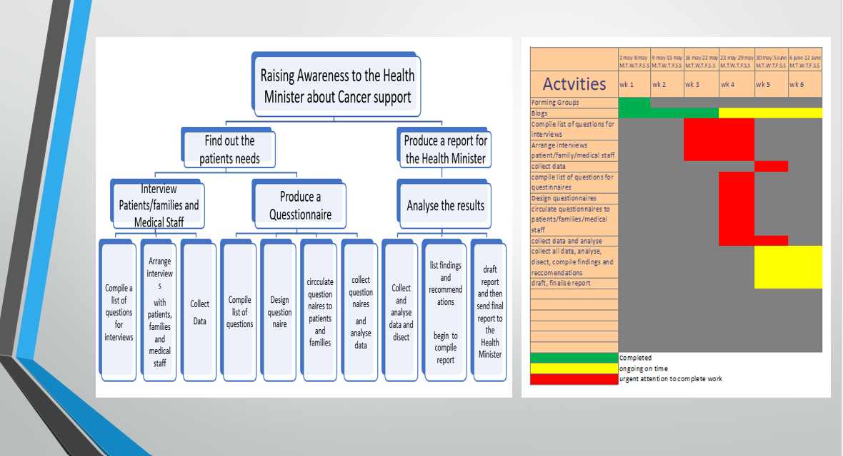

Taking from the WBS the task/activities we created our Gantt chart allocating task and time scales, we assigned tasks to team members and deadlines for completion.

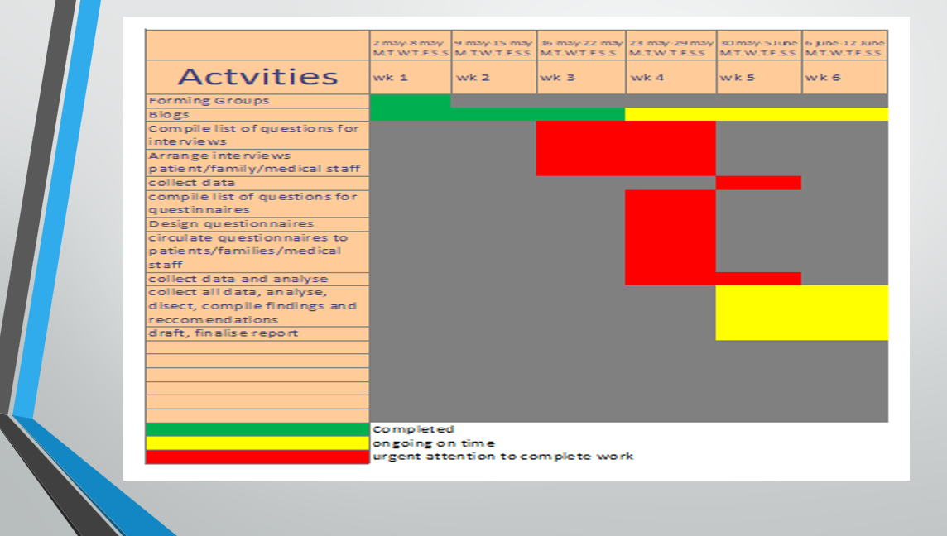

As you can see on our chart there is a lot of red highlighting many tasks needing our attention and action required urgently to avoid complete failure to our project. Both the WBS and Gantt chart proved extremely beneficial to our project as easily visible on both tools were problems arising for us to act on as soon as possible. At This stage we would need to do a risk analysis and identify the highest risks and take mitigating action.
References
Adeaca, (2020) What is a Work Breakdown Structure?
Available at: https://www.adeaca.com/blog/faq-items/what-is-work-breakdown-structure/
(Accessed 10th June 2022).
APM, (2022) What is a Gantt Chart?
Available at: https://apm.org.uk/resources/find-a-resource/gantt-chart/ (Accessed 10th June 2022).
Caiettie,N (2022) Top 10 Project Execution Strategies
Available at: https://ww.projectmanager.com/blog/project-execution (Accessed 10th June 2022).

