Summary on essential academic and employment skills

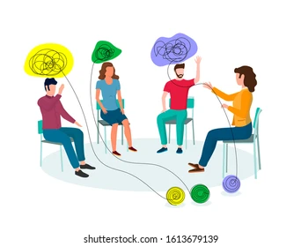
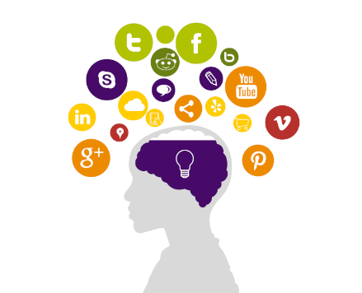
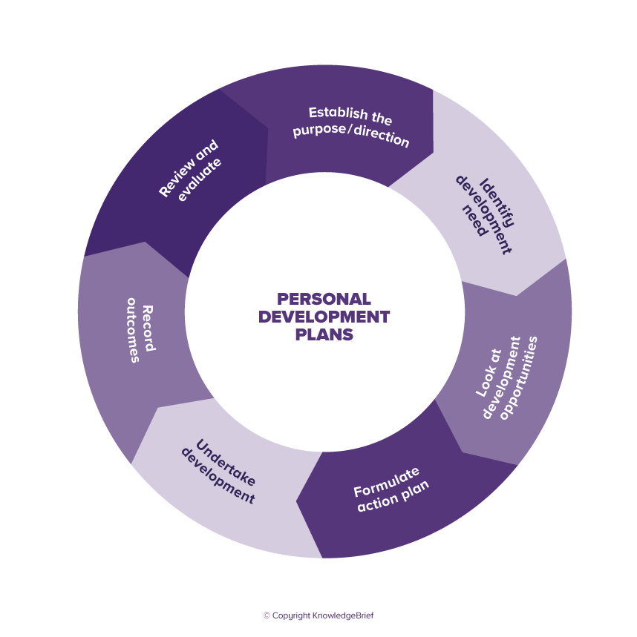
In this summary I will discuss the importance of such skills, how they can be applied to a job, and what are some of the key skills that employers look for when hiring. A personal development plan will help set a base line and focus on areas where improvement is needed [1]. As technology becomes more integrated in our personal and professional lives, digital literacy is becoming increasingly important [2]. Good communication skills are vital to success in any profession. Problem solving, creative and critical thinking, excellent time management, and effective teamwork are important set of skills to possess while study or job seeking. Academic writing allows you to create a professional and comprehensive Curriculum Vitale therefore increasing your odds to stand out in front of potential employers. Positive attitude, taking responsibility, empathy towards others, and patience are part of the necessary interpersonal skills one should possess [3]. Furthermore, persistent self-improvement should be considered alongside with feedback from colleagues, co-workers, or employees. Employability or soft skills are the building blocks of all careers. Most businesses and organizations invest money and resources to further improve their staff in areas where the skilled gained can be applied to a wide range of professions [4]. In conclusion, is essential in the modern world for people to be up to date with the required skills when entering the job market as they have changed over the years. Further education and skills development should also be considered during employment and throughout the career.
Figure 1 Digital Literacy
Figure 2 Personal Development Plan

Figure 3 Interpersonal Skills

References

[1] | S. Cottrell, The Study Skills Handbook, London: Bloomsbury Publishing Plc, 2019.
[2] | M. I. B. D. Iordache C, “Developing Digital Skills and Competences: A Quick-Scan Analysis of 13 Digital Literacy Models,” Italian Journal of Sociology of Education, vol. 9, no. 1, pp. 6-30, 2017.
[3] | SAGE Publications, The SAGE Handbook of Interpersonal Communication., United States: SAGE Publications., 2011.
[4] | D. V. (. I. Symonds, “What Are Employability Skills and Why Are They Important?,” 16 July 2022. [Online]. Available: https://symondsresearch.com/employability-skills/. [Accessed 18 11 2022].

