

Student Name and Id: jayvirkumar kantibhai Patel(2210454)
Module: Human Resource Management (LCMB 7000)
Main Topic : Change management
Sub Topic : Impect of change management on TESCO

TESCO



Change Management In Tesco Company

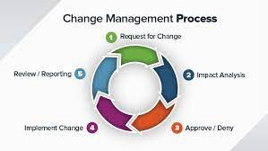
🞄 A systems approach to interacting with the change or
modification of an organizational mission, mechanisms, or technological advances is known as change management (Galli, 2018).

Change Management
🞄 The goal of change management is to develop
strategies for affecting change, attempting to control change, and assisting people in adapting to change.
🞄 Significant organizational transitions can be
challenging. It frequently necessitates multiple levels of involvement and may include many unbiased enterprises within an organization.
🞄 Creating a formalized change approach is essential to
ensuring a successful transition while making the transition (Galli, 2018).

Figure: Change management

Source: Awadari and Kanwal, 2019

🞄 Tesco's effective acceptance and utilization of change
is driven by organizational change.

Change management Impact Tesco Company
🞄 It helps employees understand, devote to, and
perform productively during the change (Awadari and Kanwal, 2019).
🞄 Project groups that are confused with or responsive
to all those operations may face significant challenges in establishing how to greatest implement the organizational changes necessary for successful implementation of the project.
Change management assists Tesco in ensuring that
modifications are carried out in a synchronized approach (Awadari and Kanwal, 2019).

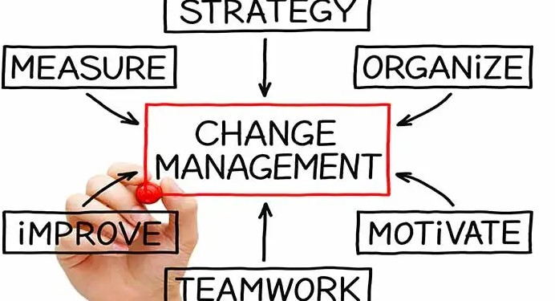

Figure 1. Change Management Source: (Awadari and Kanwal, 2019)

Positive Impact of Change management on Tesco

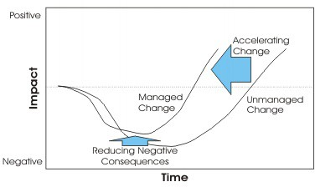
Figure 2. Impact of Change management
Source: (Yue, 2022)
🞄 Change management requires Tesco to
recognize its existing market situation in order to redirect its course of action for future income (Yue, 2022).
🞄 Change management impacts the
overall performance of Tesco by providing the insights about the external factors.
🞄 It also impacts the management
practices of the Tesco organization by managing all the functions and operations of the company (Yue, 2022).

Negative Impact of Change management on Tesco
🞄 Change can have an adverse effect on morale,
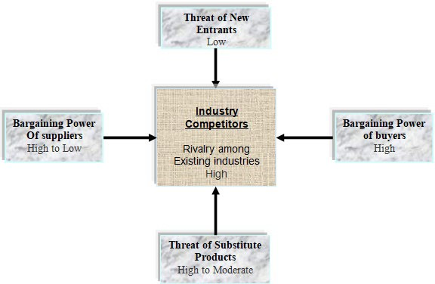
enhance absenteeism and presenteeism, and even burst losses in business relations at Tesco (Belisari et al., 2019).
🞄 Some Staff members could decide to leave rather
than endure the hurricane.
🞄 It has the potential to harm Tesco's operations due to a lack of executive encouragement and
active endorsement deals.
🞄 It has an impact on Tesco's teams because a
failure to communicate effectively has resulted in misalignment (Belisari et al., 2019).

🞄 Figure: Negative impacts
🞄 Source: Awadari and Kanwal, 2019

Future Positive Impacts of Change management on Tesco Company
🞄 The future of organizational change will be
engendered by a convergence of person can make a difference, future technologies, and operational processes (Yue, 2022).
🞄 Agile development of software has infiltrated many other fields, which include change
management. This method for change management can assist Tesco company in remaining sensitive, reactionary, and adaptive (Yue, 2022).
🞄 Change prompted by technology is still
centered on the human being. Today, it is critical to leverage technological solutions such as digital adoption systems for Tesco.

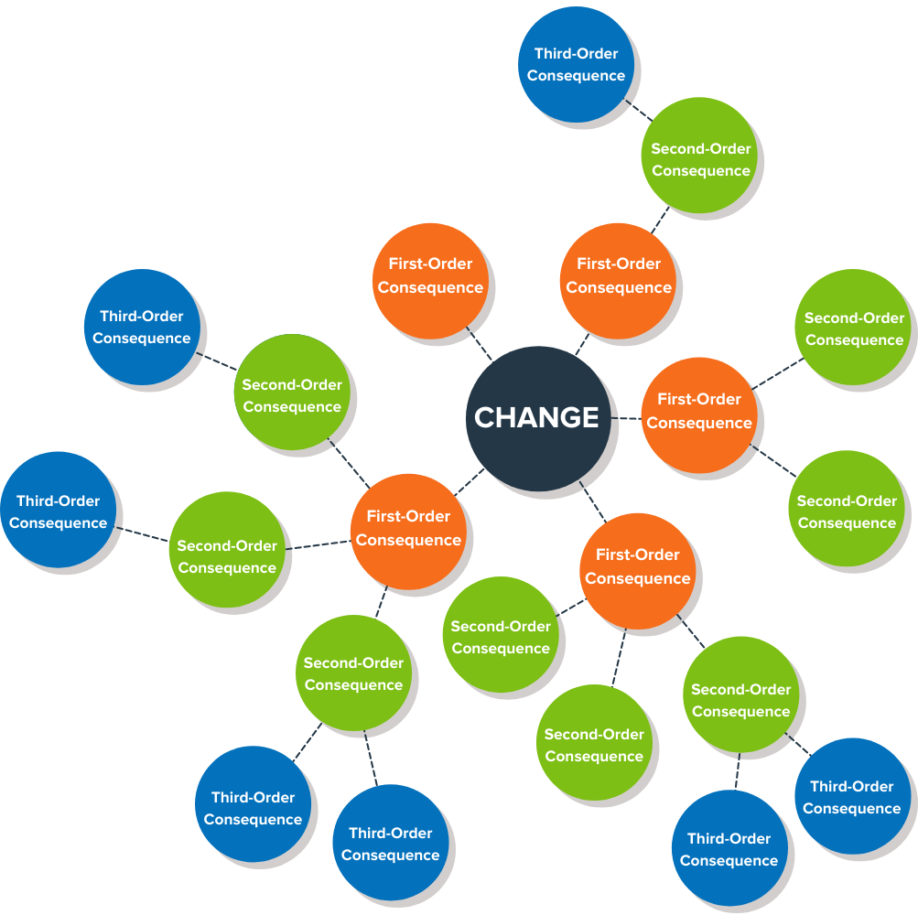
Figure 3. Future Wheels for Change Management Source: (Yue, 2022)

Future Negative Impacts Of Change management On Tesco Company
🞄 Economic factors is an impact that can arise in

future and have a direct relationship with earnings, which is among the most significant variables that influence organizational change in Tesco (Belisari et al., 2019).
🞄 In response to future customer demand for other items such as clothing, electronics, and mobile
phones, Tesco has expanded its product offerings to include non-food items as well.
🞄 Technology is a major factor that drives Tesco company to adopt transformation as a result of
scientific breakthroughs. If customers are happy and drawn to you, your core audience will grow (Belisari et al., 2019).

🞄 Figure: Impacts of change management
🞄 Source: Awadari and Kanwal, 2019

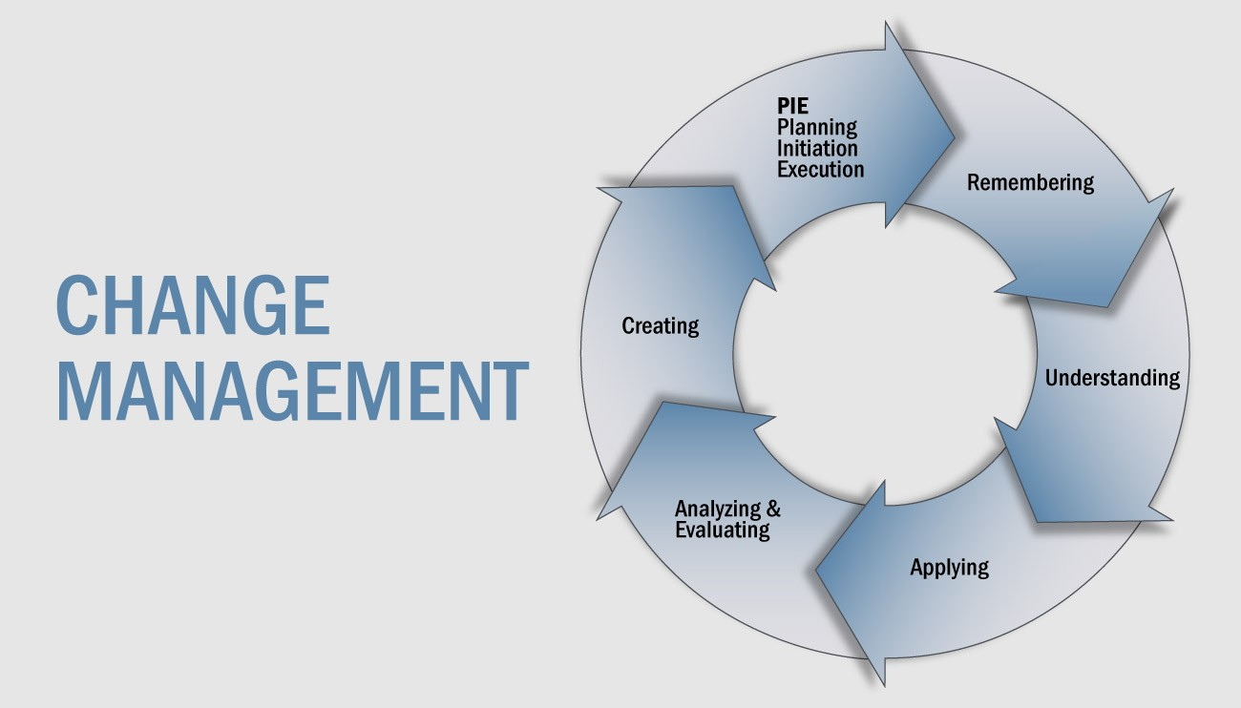
🞄 Communication is crucial for the success of
any change management initiative (Qutubuddin and Parveen, 2019).

Importance of Change Management
🞄 It contains better communication, improved
efficiency, less anxiety, and good decision.
🞄 Change management can also improve an organization's employees ’ morale and
establish a more positive workplace environment.
🞄 Managing change effectively empowers an
enterprise to make sound decisions. It leads to higher productivity, cuts down, and contributes to an organization's earnings
(Qutubuddin and Parveen, 2019). Figure: Importance
Source: (Lehn, 2020)

Change Management Model Of Tesco
According to Lewin change management model, most people who oppose change in the Tesco organization. Management teams must take additional steps to make the change happen in the company (Sapiens, 2018).

🞄 Unfreeze
🞄 Transition
🞄 Refreeze

Figure: Lewin Change management Model Source: (Sapiens, 2018)

🞄 Galli, B.J., 2018. Change management models: A comparative analysis and concerns. IEEE
Engineering Management Review, 46(3), pp.124-132.
🞄 Awadari, A.C. and Kanwal, S., 2019. Employee participation in organizational change: A case of Tesco PLC. International Journal of Financial, Accounting, and Management, 1(2), pp.91-99.

References
🞄 Yue, C.A., 2022. Fostering employees’ positive change reactions: the role of bridging and
buffering strategies. Journal of Public Relations Research, 34(3-4), pp.152-174.

🞄 Belisari, S., Appolloni, A. and Cerruti, C., 2019. Positive and negative impacts of the adoption of e-procurement solutions: The Italian market case. International Journal of Procurement Management, 12(2), pp.219-241.
🞄 Qutubuddin, M.K. and Parveen, S., 2019. A Case Study On Understanding The Importance Of Socio-Cultural System In Transformative Leadership And Change Management. Think India Journal, 22(14), pp.13170-13174.
🞄 Sapiens, H.R., 2018. Change Management. Change.

Reference
🞄 Awadari, A.C. and Kanwal, S., 2019. Employee participation in organizational change: A case of Tesco PLC. InternationalJournal of Financial, Accounting, and Management, 1(2), pp.91-99.

🞄 Lehn, D.V., 2020. Digitalization as “an Agent of Social Change” in a Supermarket Chain: Applying Blumer's Theory
of Industrialization in Contemporary Society. Symbolic Interaction, 43(4), pp.637-656.

