Module: Management Engineering Projects
Title: Applying Project Management Techniques
Module Code: ACEA7009
Student Name: Sukhada Kulkarni (2213994)

Table of Contents
Introduction and Project Background 3
Introduction 3
Project background 4
Construction of Network diagram, Gantt chart and critical path 5
Construction of Network diagram 5
Construction of Gantt chart 6
Critical Path Method 7
Role of Communication 10
Application of PERT analysis and Risk management techniques 11
PERT analysis 11
Risk management techniques 13
Cost of individual activities and total project cost 13
Individual activity cost 13
Total project cost 14
Application of crash costing techniques 14
Consideration of project handover issues 17
Conclusion 17
References 19

Introduction and Project Background

Introduction
Project management is one of the important concepts that has been used for managing the project in a company by the process of planning and organisation of its resources in a certain manner for achieving their task, events and also completion of all the responsibilities (Alam, 2019). This can be implemented in both one-time project and also in the real time events. The complex tasks in any project sector can be managed efficiently and completed at the specified time duration by using the project management techniques. This process also helps to achieve the objectives in an ordered manner. It is very important for the project manager to possess the skills of project management for analysing the performance of the project. in this report we have to discuss on the process of project management in an organisation by launching a new product to its already existing services for the purpose of improving the performance of the company (Julius Mansa, 2021). A brief discussion on the background of the project is provided. the activities that are involved in the launching services are analysed and the precedence is also identified for constructing a network diagram which helps in easily identifying the project phases. The various tasks that are needed for implementing the new products are identified, along with the period of completion and they are represented by using the Gantt chart. We have also performed the critical path method for analysing the overall duration and cost of making those changes in the project. the major role of communication in achieving the expected outcomes in the project have been discussed and we have also conducted the PERT analysis for identifying the various risks that might encounter in the project during the process of enhancing the project activities. Based on the identified risks we have provided the risk management techniques in order to overcome the issues and challenges within the network (Corrado Battisti, 2020). Based on analysing the resources that are needed for the modification of existing project, we have to identify the cost of individual activities which helps in obtaining the overall cost of the project. we have also discussed on the crash costing techniques that helps in estimating the profit of the company after the launching of new products and services in the company. Finally, we have discussed on the issues that are faced by the project manager in the event of project handover in an effective manner. All these process helps in improving the efficiency of the project by using the project management concepts, techniques, and tools in an effective manner.

Project background
It is very important for the project management concept to outline all the plans that are required for the project from its initial to final stage. The project must be developed within the budget constraint and time period and this is also achieved by using the project management tools. There are some critical factors that are to be considered for the project and this might vary from one project to another based on the scope of the project, risks, roles and responsibilities, team communication, and visibility of the project (IGOR V. KONONENKO, 2022). in this project we have to introduce new products feature into the already existing facilities of the company. this helps to improve the performance of the company and increase its profit. Hence the company has decided to set out an initiative for building and launching the new feature in a successful manner.
The main objective of the company is to provide a digital collaboration tool for the project managers, executives and all the members for the purpose of effective planning and execution processes. The process of managing tasks by communicating with the stakeholders to minimise the risks in delivering a new product feature within the specified time period is achieved by the project management tool (Cooper, 2019).
In order to complete the project with improved efficiency, it is very important for the project to undergo various phases and they are represented as follows.
- At the Initiation phase, the project is identified as the process of launching new product features. The desired outcome of the project is to deliver the new product feature in a successful manner.
- At the planning phase, we have decided the project management methodology to be used for achieving the objectives and it is identified as the lean methodology that helps is providing the expected outcomes.
- In the execution phase, the tasks that are required for achieved the objectives are listed and the activities were executed based on the milestones and schedules allocated for the successful completion of project.
- Finally in the closing phase, the project thus completed is reviewed by various stakeholders and manager for analysing its performance and they are approved for the launch day (Theo Thesing, 2021).

Construction of Network diagram, Gantt chart and critical path

Construction of Network diagram
In case of project management, it is very important to represent the workflow of the project in a visual manner and this is achieved through the network diagram. In this diagram, the various tasks or activities of the project are mentioned in the boxes, then the schedules are mapped by using the arrows and this indicates the sequence of completing the work in the project execution phase. This diagram helps in analysing the progress of each and every phase of the project until its completion phase (Anabela Tereso, 2019). The scope of the project is usually illustrated in this network diagram by collecting all the activities, milestones, and the deliverables. Both Critical path method and program evaluation and review techniques can be used for analysing the implementation of network diagrams in the concept of project management. These methods help in estimating the project duration and develop the schedules in an effective manner.
Activities | A | B | C | D | E | F | G | H | I | J | K | L | M | N | O | P | Q | R | S | T | U | V | W
Predecessors | - | A | A | A | B | B | B | D | D | C | C | E | F | G | H | I | J | K | P, Q, R | L, M | M | V | T, U, V, O,S
Table 1. Constructing network diagram
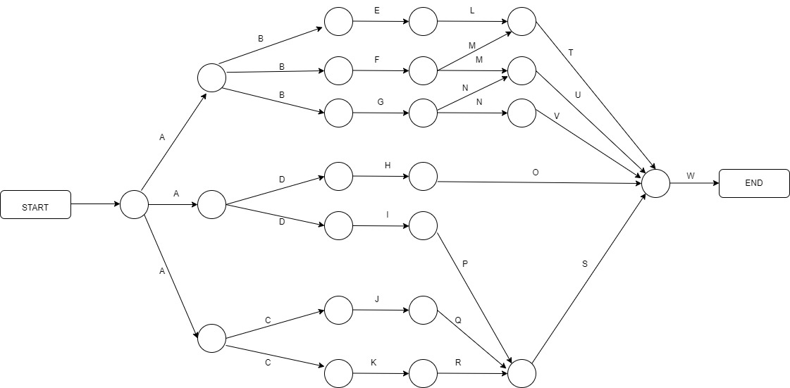
Figure 1. Network diagram

Construction of Gantt chart
A project management tool that is used for creating a project schedule by the project managers is known as the Gantt chart. This includes the task list and the bar timeline that helps in improving the plan, schedule and tracking of completed project work effectively. This also helps in allocating the resources and track the progress of the project. this tool helps to identify the task name, priority, duration, task dependencies, percentage of activity completed. Critical path activities and so on in an effective manner. The process of scheduling the project activities, allocating resources, setting the cost baselines and scope baselines, and also identifying the critical path are achieved effectively by the project managers (Young Illies, 2020). We have listed the various tasks that are involved in the launching of a new product feature in the project along with its start and end date in the following tabular representation (Alam, 2019). Based on the table, we have generated the Gantt chart shown below.
S.No | Task | Start date | End date | Duration
1 | Marketing and product promotion | 01-04-2023 | 21-04-2023 | 20
2 | Identifying a creative concept | 01-04-2023 | 04-04-2023 | 3
3 | Content for marketing and promotion | 05-04-2023 | 10-04-2023 | 5
4 | Documenting New requirements | 08-04-2023 | 10-04-2023 | 2
5 | Materials for Product specification | 11-04-2023 | 13-04-2023 | 2
6 | Sales presentations | 13-04-2023 | 16-04-2023 | 3
7 | Communication needs | 17-04-2023 | 19-04-2023 | 2
8 | Complete content structure for marketing | 20-04-2023 | 21-04-2023 | 1
9 | Projection planning | 22-04-2023 | 25-04-2023 | 3
10 | Release based on promotion plan | 22-04-2023 | 25-04-2023 | 3
11 | Production | 26-04-2023 | 28-04-2023 | 2
12 | Preparing for huge production | 26-04-2023 | 28-04-2023 | 2
13 | Sales process | 29-04-2023 | 09-05-2023 | 10
14 | Group staffing | 29-04-2023 | 04-05-2023 | 5
15 | Planning for group training | 03-05-2023 | 06-05-2023 | 3
16 | Maintaining sales objectives | 04-05-2023 | 09-05-2023 | 5
17 | Product support | 10-05-2023 | 13-05-2023 | 3
18 | Maintaining sales objectives | 10-05-2023 | 13-05-2023 | 3
19 | Customer servicing | 12-05-2023 | 13-05-2023 | 1
20 | Supplying the updated requirements | 14-05-2023 | 18-05-2023 | 4
21 | Supplying the updated budget | 17-05-2023 | 18-05-2023 | 1
22 | Submission of latest plans | 19-05-2023 | 23-05-2023 | 4
23 | Submission of latest Budget | 21-05-2023 | 23-05-2023 | 2
Table 2. Work breakdown structure
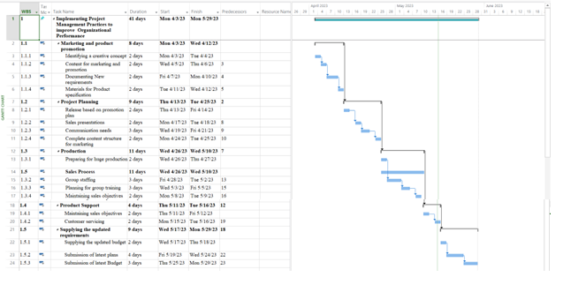
Figure 2. Gantt chart representation

Critical Path Method
This is a project management software used for calculating the critical path of the project in an automatic manner. This represents the longest sequence of activities that are required for completing the project. an accurate schedule of the project can be created by using this technique. The task sequence of the introducing a new product feature in the project are represented by using the CPM formula and the network diagram. It is possible to identify the critical path if the task sequences and their duration are identified properly (Roseke, 2022). This technique helps in estimating the total duration of the project, individual task duration, task dependencies, risks, and schedules in an accurate manner.
In the CPM formula, it is very important to understand the earliest start, latest start, earliest finish, latest finish, and float values to calculate the critical path (Manager, 2023). This can be achieved by collecting the activities of the project, identifying the task dependencies, creating the network diagram, estimating the time line, using the critical path formula, and identifying the critical path.
Activities | Duration | Precedence
A | 20 | NONE
B | 3 | A
C | 5 | A
D | 2 | A
E | 2 | B
F | 3 | B
G | 2 | B
H | 1 | D
I | 3 | D
J | 3 | C
K | 2 | C
L | 2 | E
M | 10 | F
N | 5 | G
O | 3 | H
P | 5 | I
Q | 3 | J
R | 3 | K
S | 1 | P, Q, R
T | 4 | L, M
U | 1 | M
V | 4 | V
W | 2 | T, U, V,O,S
Table 3. Calculating critical path
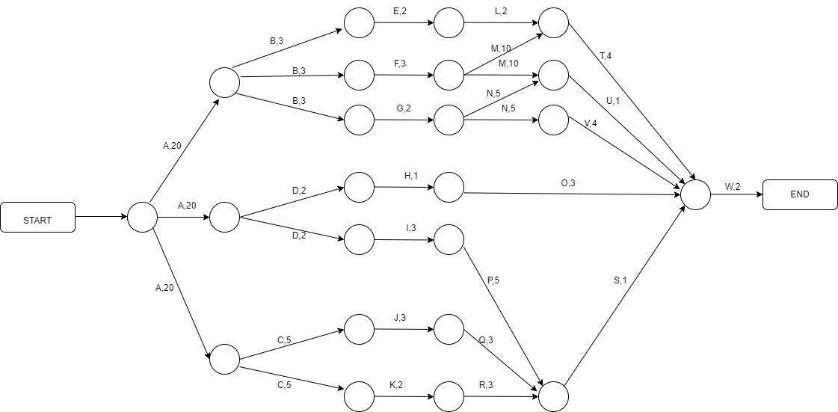
Figure 3. Critical path method
To find the critical path,
A-B-E-L-T-W = 20+3+2+2+4+2 = 33
A-B-F-M-T-W = 20+3+3+10+4+2 = 42
A-B-F-M-U-W = 20+3+3+10+1+2 = 39
A-B-G-N-U-W = 20+3+2+5+1+2 = 33
A-B-G-N-V-W = 20+3+2+5+4+2 = 36
A-D-H-O-W= 20+2+1+3+2 = 28
A-D-I-P-S-W= 20+2+3+5+1+2 = 33
A-C-J-Q-S-W= 20+5+3+3+1+2=34
A-C-K-R-S-W= 20+5+2+3+1+2=33
Hence the critical path is, A-B-F-M-T-W and the critical duration is 42 (Hamzah Abdul Ba'Its, 2020).
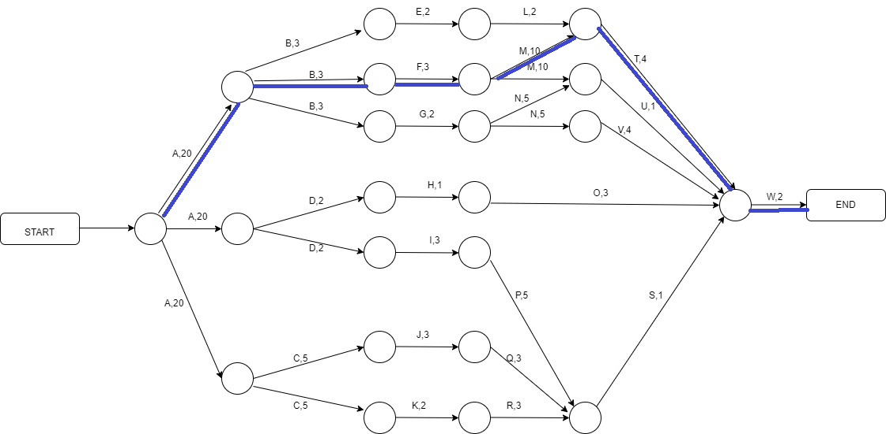
Figure 4. Critical path analysis

Role of Communication
The progress of the project is based on the contribution of every individual in the project team. The main key to organise and coordinate the information within the project team is achieved through effective communication. The lack of communication might impact the project performance resulting in redundancy, misallocation, and misunderstanding which does not provide the expected outcomes. The ideas, and information regarding project development are exchanged among the team members through communication. Communication plays a major role in achieving the project milestones and improves the project quality (Tejas S. Fanse, 2022). If the team members lack the skills if understanding the requirements and specifications of the project then, it results in project failure. Hence role of communication is very important in the project management technique.
There are several types of communication that helps to improve the project performance but the effective communication method preferred by the project managers is communicating through meetings, emails, phone calls, surveys, discussion boards, presentations, memos, and project plans. An effective communication in project management starts by project planning and ends by providing best results (Ahmad Salman, 2021). This is obtained as follows.
- Project planning
- Establishing a proper method of communication
- Sharing the goals of the project
- Listening to the suggestion of team members
- Keeping everyone in the team updated with project activities
- Monitoring the performance of the employees.

Application of PERT analysis and Risk management techniques

PERT analysis
A network diagram that is used for creating the project schedules by the project managers is known as PERT chart. This might indicate the timeline of the project, duration of the tasks, identify the dependencies in the task and obtain the critical path. The time duration can be estimated by coordinating the tasks based on the estimates like optimistic, pessimistic, and most likely (Hamzah Abdul Ba'Its, 2020). PERT charts can be used in the planning phase of the project lifecycle which helps in determining the critical path of the project and schedule the tasks based on their priority. This can be achieved by using the following procedure.
- The project scope is break down
- PERT chart is created.
- The project duration can be calculated.
- The critical path and slack are identified
Activity | Resources | Duration (Days)
1 – 2 | 1M, 2C, 1L | 20
2 – 4 | 2L | 8
4 – 5 | 2L | 2
5 – 6 | 1C | 2
6 – 9 | 1M, 1C | 6
10 – 12 | 1M, 1C | 8
12 – 13 | 1C | 2
13 – 14 | 1C, 1L | 10
14 – 15 | 1L | 5
15 – 17 | 2L | 8
3 – 8 | 2C, 2L | 15
9 – 12 | 1L | 8
12 – 14 | 1L | 2
18 – 19 | 1L | 3
19 – 20 | 1L | 1
20 – 21 | 2C | 4
21 – 22 | 2C, 2L | 1
22 - 23 | 1M | 4
Table 4. PERT analysis
Let as consider the cost of 1M = 150 per day, 1C = 250 per day and 1L = 95 per day in dollars and M, C and L represents different types of resources like man power, capabilities, liabilities and so on. The value of PERT time can be calculated by using the following formula,
PERT time = (OT+4M+PT)/6
Where,
OT= Optimistic time
M= Most likely time
PT= Pessimistic time
Activity | Optimistic time | Most likely time | Pessimistic time | PERT time
1 – 2 | 18 | 20 | 22 | 20
2 – 4 | 6 | 8 | 10 | 8
4 – 5 | 1 | 2 | 3 | 2
5 – 6 | 1 | 2 | 3 | 2
6 – 9 | 4 | 6 | 7 | 5.833333
10 – 12 | 7 | 8 | 10 | 8.166667
12 – 13 | 1 | 2 | 3 | 2
13 – 14 | 8 | 10 | 12 | 10
14 – 15 | 4 | 5 | 6 | 5
15 – 17 | 7 | 8 | 9 | 8
3 – 8 | 12 | 15 | 18 | 15
9 – 12 | 6 | 8 | 10 | 8
12 – 14 | 1 | 2 | 2 | 1.833333
18 – 19 | 2 | 3 | 4 | 3
19 – 20 | 1 | 1 | 2 | 1.166667
20 – 21 | 3 | 4 | 5 | 4
21 – 22 | 1 | 1 | 2 | 1.166667
22 - 23 | 3 | 4 | 5 | 4
Table 5. Calculating PERT time

Risk management techniques
The risks that are associated with the project performance might include the aspects of environment, technical, sales and marketing, investment, data system, health and safety and so on. Risk management techniques are actions that are implemented for reducing the consequences of risk occurrence in a project. this is usually achieved by using the activities like identification, assessment, and control of risks (Martin Hirman, 2019). The risk can be managed in a project based on the key player involvement, risk identification, classification of risks and using the cost benefit analysis for justifying the activities of risk mitigation. The risks can also be identified by SWOT analysis, benchmarking criteria and brainstorming methods. the risks can be identified by the type of resources and this might include people, money, equipment, materials, time and so on. By using the risk criticality matrix, it is possible to identify the risks and manage them appropriately based on their probability of occurrence and level of impact.

Cost of individual activities and total project cost

Individual activity cost
The cost estimation of the project helps in identifying the success of the project. there are several costs that occur during the life cycle of project. by using an accurate cost estimation method, it is very easier to classify the success and failure of the project. the risks that occur during the project life cycle also results in unexpected costs thereby resulting issues related to cost management. The budget for achieving the new product feature implementation is added along with the planned cost for all the individual activities, labour cost and so on in an accurate manner (Safaei, 2020). The estimation of project cost might include, direct costs, indirect costs, and other miscellaneous costs. Based on these costs the budget is calculated for analysing the projects performance and its success criteria. This can be achieved by using the cost breakdown structure that determines the cost of all the individual activities in the project (Scott, 2020). this is considered as an important step during the planning phase of the project as it is added to the project budget for achieving the objectives of the project. the project cost can be managed by using the following steps.
- Resources are planned
- Costs are estimated
- Cost budget is determined
- The costs are controlled (scrum, 2020).
The cost of the project might vary based on the size and budget of the project and hence it is very important to complete the project within the estimated budget without affecting the project quality and performance.

Total project cost
The total cost of the project can be calculated by adding all the cost of individual activities. This helps in analysing whether the project exceed the budget or else remains within the estimated budget (Scott, 2020). The total project cost can be obtained by using the following formula,
Total cost of project = total fixed cost of project + total variable cost of the project

Application of crash costing techniques
A technique used for speeding the timeline of the project by the addition of additional resources to the project which does not alter the project scope is known as the project crashing technique. This might also include the extra or additional tasks into the project activities in order to complete the project in a quick manner but it might require paying of additional costs and so this impacts the cost of the project. this might represent the cost that is linked with the project completion by using the crash time or duration (Berniz, 2022). The crash time represents the minimum time taken by the project for completing all of its activities.
Activity | Normal duration | Crash duration | Normal cost | Crash cost | Crash increase | Crash increase | cash cost per day
A-B | 20 | 15 | 8000 | 12000 | 5 | 4000 | 800
B-C | 3 | 2 | 2000 | 3000 | 1 | 1000 | 1000
C-D | 5 | 3 | 2500 | 3500 | 2 | 1000 | 500
D-E | 2 | 2 | 1500 | 2500 | 0 | 1000 | 0
E-F | 2 | 2 | 1500 | 2500 | 0 | 1000 | 0
F-G | 3 | 2 | 2000 | 3000 | 1 | 1000 | 1000
G-H | 2 | 1 | 1500 | 2500 | 1 | 1000 | 1000
H-I | 1 | 1 | 750 | 750 | 0 | 0 | 0
I-J | 3 | 2 | 1500 | 2500 | 1 | 1000 | 1000
J-K | 3 | 2 | 1500 | 2500 | 1 | 1000 | 1000
K-L | 2 | 1 | 750 | 1500 | 1 | 750 | 750
L-M | 2 | 1 | 750 | 1500 | 1 | 750 | 750
M-N | 10 | 8 | 4000 | 6000 | 2 | 2000 | 1000
N-O | 5 | 4 | 2500 | 3500 | 1 | 1000 | 1000
O-P | 3 | 2 | 1500 | 2500 | 1 | 1000 | 1000
P-Q | 5 | 3 | 2500 | 4000 | 1 | 1500 | 1500
Q-R | 3 | 2 | 1500 | 2500 | 1 | 1000 | 1000
R-S | 3 | 2 | 1500 | 2500 | 1 | 1000 | 1000
S-T | 1 | 1 | 750 | 750 | 0 | 0 | 0
T-U | 4 | 2 | 1500 | 2500 | 2 | 1000 | 500
U-V | 1 | 1 | 750 | 750 | 0 | 0 | 0
V-W | 4 | 2 | 1500 | 2500 | 2 | 1000 | 500
Table 6. Crash costing techniques
To find the crash cost sequence,
Activity | cash cost per day | Normal duration | Crash duration | Time saved | Cumulative project cost increase
D-E | 0 | 20 | 15 | 5 | 0
E-F | 0 | 3 | 2 | 1 | 0
H-I | 0 | 5 | 3 | 2 | 0
S-T | 0 | 2 | 2 | 0 | 0
U-V | 0 | 2 | 2 | 0 | 0
C-D | 500 | 3 | 2 | 1 | 500
T-U | 500 | 2 | 1 | 1 | 1000
V-W | 500 | 1 | 1 | 0 | 1000
K-L | 750 | 3 | 2 | 1 | 1750
L-M | 750 | 3 | 2 | 1 | 2500
A-B | 800 | 2 | 1 | 1 | 3300
B-C | 1000 | 2 | 1 | 1 | 4300
F-G | 1000 | 10 | 8 | 2 | 6300
G-H | 1000 | 5 | 4 | 1 | 7300
I-J | 1000 | 3 | 2 | 1 | 8300
J-K | 1000 | 5 | 4 | 1 | 9300
M-N | 1000 | 3 | 2 | 1 | 10300
N-O | 1000 | 3 | 2 | 1 | 11300
O-P | 1000 | 1 | 1 | 0 | 11300
P-Q | 1500 | 4 | 2 | 2 | 14300
Q-R | 1000 | 1 | 1 | 0 | 14300
R-S | 1000 | 4 | 2 | 2 | 16300
Table 7. Finding crash costing sequence
The crash sequence is C-D, T-U, V-W, K-L, L-M, A-B, B-C, F-G, G-H, I-J, J-K, M-N, N-O, O-P, P-Q, Q-R, R-S

Consideration of project handover issues
The project handover might represent the process of passing the control from one person to another person. A good project might perform effectively even if it is hand overed to other person without degrading its performance. Completing a project in a successful manner is very complex because there are possibilities of delay issues and occasional challenges that are connected with this phase. But it is possible to overcome those issues by using some management techniques (Ahmad Salman Khan, 2018). The main aim of project handover might include the reliable communication of all the project activities in an accurate manner and ensures the working of the project in a safe and effective manner. The major issue is the delay which obviously increases the budget estimated for the project. there are possibilities of improper functioning of the project if they are implemented in other platform. Hence the project developed must be independent of platform. The issues in project handover can be resolved by using the following techniques.
- The handover objectives must be set in a clear manner.
- The customer must be kept up to date.
- Short daily meetings must be conducted.
- The benefits and utility of the project must be shown
- The stakeholders must be met
- The support must be provided whenever in need (Wagner, 2017).
It is also necessary to consider that the project scope must not get deviated in maintaining and dealing with these issues. All these factors must be considered in order to avoid the issues in project handover and deliver a project with best quality within the budget constraints.

Conclusion
In this report, we have discussed on the project management concept that considers a project that launches a new product feature in its existing project. at first the tasks needed for making these changes are identified and ordered in sequence for analysing various metrics of project management. Through network diagram, Gantt chart and critical path we have analysed the tasks involved in this project, its precedence, its starting and ending date, the total cost of the project, and so on in an effective manner. We have also discussed on the importance of communication in the project development activities. The PERT analysis is also done for analysing the cost of the budget and also the risks associated with the project development. we have used the risk management techniques for overcoming those issues that arise during the project execution phase. The total cost of the project is calculated based on the resource requirements and its cost estimation methods (Alam, 2019). we have used the crash costing methods for minimising the project duration and calculated the total cost of the project. finally, we concluded the report by discussing of the project handover issues and the methods used for overcoming those issues in an effective manner without impacting the project quality and performance.

References
Ahmad Salman Khan, M. K.-M., 2018. Core Handover Problems. https://www.diva-portal.org/smash/get/diva2:504444/FULLTEXT01.pdf.
Ahmad Salman, M. J. S. M. D. M. S. A. M., 2021. An Empirical Investigation of the Impact of the Communication and Employee Motivation on the Project Success Using Agile Framework and Its Effect on the Software Development Business. https://journals.sagepub.com/doi/pdf/10.1177/2278533720902915, 9(1), pp. 46-61.
Alam, S., 2019. An Innovative Project Management System. https://ieeexplore.ieee.org/abstract/document/8843768.
Anabela Tereso, P. R. G. F. I. L. M. F., 2019. Project Management Practices in Private Organizations. https://journals.sagepub.com/doi/pdf/10.1177/8756972818810966, 50(1), pp. 6-22.
Berniz, A., 2022. Crashing the project schedule. A step by step guide. https://projectmanagers.org/management/recovery/schedule-crashing/.
Cooper, R. G., 2019. The drivers of success in new-product development. https://www.sciencedirect.com/science/article/abs/pii/S0019850118300476, Volume 76, pp. 36-47.
Corrado Battisti, G. P. F. R. L. P., 2020. Small Environmental Actions Need of Problem-Solving Approach: Applying Project Management Tools to Beach Litter Clean-Ups. https://www.mdpi.com/2076-3298/7/10/87, 7(10).
Hamzah Abdul Ba'Its, I. A. P. A. F. B., 2020. Combination of Program Evaluation and Review Technique (PERT) and Critical Path Method (CPM) for Project Schedule Development. https://publisher.uthm.edu.my/ojs/index.php/ijie/article/view/4207, 12(3).
IGOR V. KONONENKO, M. F. K., 2022. Applying the Project Portfolio Management Maturity Level Selection Method to an Organization. https://www.researchgate.net/profile/Igor-Kononenko/publication/361652711_Applying_the_Project_Portfolio_Management_Maturity_Level_Selection_Method_to_an_Organization/links/62ebbb42505511283e8d90a6/Applying-the-Project-Portfolio-Management-Maturity-Level-.
Julius Mansa, H. D. J., 2021. Project Management: What It Is, 3 Types, and Examples. https://www.investopedia.com/terms/p/project-management.asp.
Manager, P., 2023. Critical Path Method (CPM) in Project Management. https://www.projectmanager.com/guides/critical-path-method.
Martin Hirman, A. B. F. S. J. T., 2019. Project Management during the Industry 4.0 Implementation with Risk Factor Analysis. https://www.sciencedirect.com/science/article/pii/S2351978920302092, Volume 38, pp. 1181-1188.
Roseke, B., 2022. A Critical Path Method Example. https://www.projectengineer.net/a-critical-path-method-example/.
Safaei, M., 2020. Sustainable Survival Pyramid Model to Balance Four Factors of Cost, Quality, Risk and Time Limitation in Project Management under Uncertainty. https://pjsor.com/pjsor/article/view/3203, 16(2).
Scott, B., 2020. IMPORTANCE OF PROJECT SCHEDULE AND COST CONTROL IN PROJECT MANAGEMENT. https://www.globalknowledge.com/ca-en/resources/resource-library/articles/importance-of-project-schedule-and-cost-control-in-project-management/.
scrum, O., 2020. Budgeting & Cost Control. https://www.orangescrum.com/tutorial/real-world-element-of-project-management/budgeting-and-cost-control.
Tejas S. Fanse, A. V. S., 2022. Organizational Behavior Entity: Communication Modes in Project Management. https://www.researchgate.net/profile/Tejas-Fanse/publication/360181900_Organizational_Behavior_Entity_Communication_Modes_in_Project_Management/links/62670d15bca601538b679c8d/Organizational-Behavior-Entity-Communication-Modes-in-Project-Management.pdf, 5(2).
Theo Thesing, C. F. M. B., 2021. Agile versus Waterfall Project Management: Decision Model for Selecting the Appropriate Approach to a Project. https://www.sciencedirect.com/science/article/pii/S1877050921002702, Volume 181, pp. 746-756.
Wagner, R., 2017. Handover in projects – some pitfalls and good practices. https://ipma.world/handover-projects-pitfalls-good-practices/.
Young Illies, M. S. A., 2020. Improving students’ teamwork experience: Evaluating a project management application.. https://psycnet.apa.org/record/2019-44066-001, 6(1), pp. 46-52.

