The little gardeners community

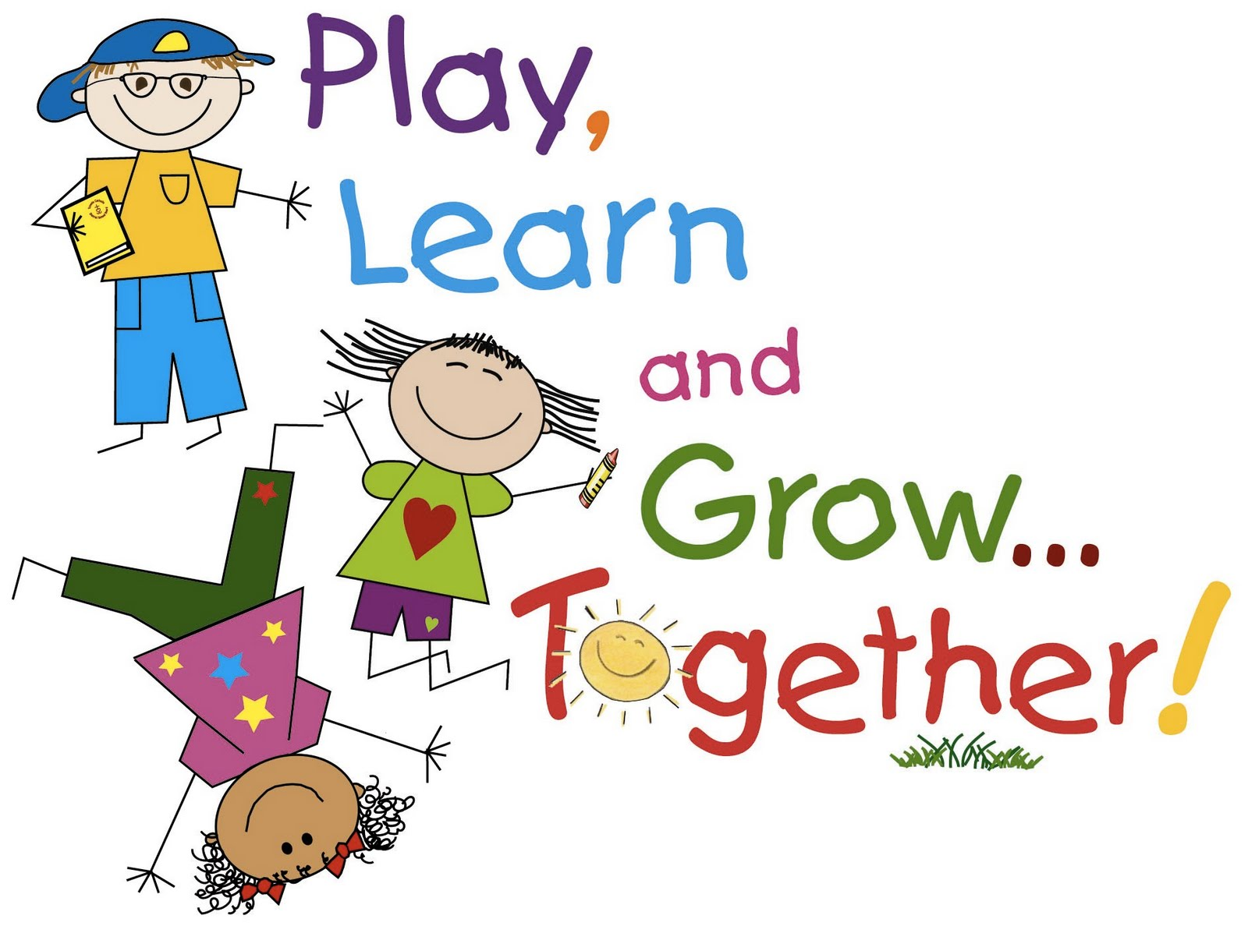

Business plan

Business idea
The little gardeners community is a new exciting and innovative company. It is a not for profit organisation that offers a complete support package for schools and early years settings to create and maintain a growing space within their setting. Gardening, growing and outdoor learning supports children’s cognitive, physical and social development (Ryan-Kraus, 2018). I appreciate that this is not an unique idea as there are many early years settings that do have successful allotments or growing projects and are benefiting from them. What makes this company unique and innovative is that it is based on research and aims to make growing opportunities accessible to all children to address current issues and going forward it’s focus on creating communities to support the projects it will be sustainable. Ward (2010) acknowledges that schools are understanding the benefits of bringing gardening into the early years curriculum however there is currently very little support for practitioners and early years settings working with under 5’s to start gardening projects. The Royal Horticultural Society (No date) agree they claim that just 1 in 4 teachers are using gardening to deliver the curriculum. They believe that the benefits to children’s learning and development are so vast that all schools should offer it, they maintain that it is essential to get more teachers to participate. Kacan et al. (2017) found that teachers claimed that there are too many barriers preventing them from gardening with children the main ones being lack of space, money and professional training. I carried out my own market research which consisted of interviewing local practitioners and carrying out an online national survey. What the results told me is that most practitioners feel they lack the skills and knowledge to deliver the Foundation Phase effectively through gardening activities. Finances and time is also an issue. There are two phases to the project the first phase will be to develop an allotment at Lots of Tots. This will enhance the existing services providing the children with It will offer opportunities for parents/carers, families and the local community to ….with the setting. Gill (2019) suggests that to address the barriers to quality outdoor play there should be a collective approach to creating a supportive culture and environment, they suggest involving the whole community would have a greater impact on providing children with high quality outdoor environments and opportunities. The allotment will be used to benefit the children at Lots of Tots…. Engaging parents/ careres and the community, there will be lots of ways in which they can get involved including The allotment will also showcase what can be achieved in an early years setting, practitioners will be able to book visits to the allotment to see how it works in practice. I hope that this will motivate practitioners to use our services to develop and sustain their own growing projects.

About myself, Education, training and experience.
I am an early years practitioner with 23 years experience in the early years sector, including 4 years working with Flying Start. I am currently a room leader and outdoor learning lead at Lots of Tots day nursery. I have a level 3 diploma in children’s care, learning and development. I am currently studying towards a degree in early years education and care. During my career I have undertaken a wide range of continuous professional development including achieving a level 2 award in outdoor learning practice and a level 2 award in community food and nutrition skills for early years. I am a passionate gardener and have been growing fruit and vegetables since childhood. I also have an interest in nutrition, healthy eating and physical exercise.
I believe that I have the passion, skills and drive to create an amazing allotment at Lots of Tots that benefits children’s development and to create and manage the company. I believe that I can empower and enable practitioners to …..

Benefits to young children’s development
The organisation will support practitioners to deliver the current Foundation Phase curriculum (Welsh Government, 2015a) and the new curriculum which has been developed following the Donaldson report (2015) which will be taught in schools from September 2022.
According to Welsh Government (2018) a healthy and active body helps children’s physical, emotional, mental health and well-being and cognitive development……agrees that a healthy and balanced diet is essential for children’s development. Research suggests that growing fruit and vegetables increases children’s intake of healthy foods (Burton and May, 2016: Bornstein, 2017).

Marketing
I will be developing a promotional powerpoint presentation to introduce the project and the benefits to children and the setting. The presentation will be shown to potential schools/nurserys, parents funders, volunteers and local businesses. It will be promoted on the Lots of Tots social media platforms. I will create a Facebook and Twitter account to promote the organisation and to create a social media community.

Financials
I have secured a grant of £25,000 from the National Lottery community fund. One of the most fundamental aims of the business is to be responsible and sustainable therefore we will be reusing and recycling as many materials as we can. We will also be asking parents, the community and local business to donate materials, tools and plants. The funding will cover the initial start up costs of the allotment, marketing and promotion and development of the website. We will be looking for volunteers …I have also secured a grant of £18,000 from Mynydd Y Betws wind farm community fund which will …to employ a qualified outdoor learning practitioner on an initial 12 month contract to assist with the website and provide accredited outdoor practitioner courses. The business is a not for profit business, all income generated will be reinvested in the company to meet the objectives and develop the company.

Stakeholders
Children, families, schools, settings, local community, funders and supporters, local authority, the government and future generations are all stakeholders in the company, and it is important that their needs are considered and valued. All stakeholders play an important role in increasing the opportunities for children to benefit from gardening activities. Institute for Outdoor Learning (2019) claim that the greater the stakeholder’s involvement the greater the opportunities for benefits. The organisation supports Welsh Government (2017) Prosperity for All strategy. NEFR (2010) states that gardening projects can be demanding for unpaid workers therefore to be sustainable it needs to be managed well so that it suits the needs of the individuals.

Challenges and barriers
Recruiting volunteers with the right knowledge, skills and experience.
Promoting the business.
Attaining funding and making an income to keep the business viable.

Strategic planning
The company has the potential to

Part two
The purpose of this essay is to critically analyse the impact of the proposed business on the development of young children. It will compare the proposal to what is currently available to children and how it links to current Welsh Government policies. The purpose of the proposed business is to create a company that promotes the benefits of gardening with children and supports practitioners to develop and maintain a gardening project within their setting. According to Ryan-Kraus (2018) gardening offers opportunities to develop children’s social, language, motor development, physical, emotional, and promotes health.
Gardening offers so many opportunities that it can be used to facilitate learning across all the seven areas of learning in the current Foundation Phase curriculum. The Welsh Government (2015a) states that children should have opportunities both indoors and outdoors for first hand experiences that are fun, exciting, safe, promote their development and allow them to explore and be naturally curious. This idea supports the current curriculum in Wales however it is important to acknowledge that the curriculum in Wales is currently changing following the Successful Futures review of education in Wales (Donaldson, 2015). The new curriculum will be taught from September 2022 therefore the project needs to be forward thinking to be adaptable for the new curriculum. The new curriculum will have a greater focus on raising children’s attainment and providing them with the skills, knowledge and experience to be ambitious and capable learners, to be healthy and confident individuals. The project will also support the new curriculum as it encompasses the three cross curriculum areas of literacy, numeracy and digital competence (Welsh Government, 2017). The Digital Competence Framework Welsh Government (2018) has been implemented in some schools from 2016, from sept 2022 all schools will have to implement the DCF on a cross curricular basis.
The project also supports Education for Sustainable Development and Global Citizenship Department for Children, Education, Lifelong Learning and Skills (2008) outdoor learning and gardening offers opportunities to explore all the themes of ESDGC enabling children to learn about a range of issues relating to climate change, the natural environment, enabling them to consider and understand the human impact on the natural environment. Wells and Lekies (2006) believe that supporting and encouraging children to participate in activities such as gardening may result in pro environment attitudes and behaviours in adulthood supporting The Well-being of Future Generations (Wales) Act 2015 Welsh Government, (2015b) which aims to drive sustainable growth and combat climate change to benefit current and future generations.
Welsh Government (2017) Prosperity for all: the national strategy states that it is essential that health awareness and well-being is embedded in early years practice. This project supports practitioners to develop a creative and innovative approach to promote children to be more physically active and improve nutrition which is an aim of Prosperity for all.
The Welsh Government (2011) Healthy and Sustainable Pre-school Award promotes the use of growing in early years settings to encourage children to try healthy food and promote physically activity and healthy life choices.
Research has shown that early years settings benefit from partnerships with parents and the local community (Campbell-Barr and Leeson, 2016). Bornstein (2017) suggests that gardening is good for bringing communities together and promoting greater community collaboration. (Froebel citied in Welsh Government, 2008) saw parents as children’s first educators and believed that it is important that parents have a close involvement in their child’s education. He believed that the community provided a link between schools and the family. Focuses on the environment, community etc Bronfenbrenner (1979 citied in Underdown, 2007) his ecological theory believed that children’s development is affected by their social relationships and everything in their environment his theory consists of five environmental systems which the child interacts. The individual child is at the centre the microsystem, the mesosystem, the exosystem, the macrosystem and the chronosystem. Engaging with parents and getting them involved can be challenging especially when working in areas of deprivation (Whalley, 2007) This project actively aims to engage parents and members of the community it offers many different opportunities for parents to get involved, Parents can contribute as much or as little as they want. Starbuck and Olthof (2008) agree that gardening projects offer unique opportunities for settings to develop sustainable relationships with families and communities. Siraj and Hallet (2014) advocate a collaborative approach to partnership working with parents. Gill (2019) agrees that a collective approach is essential to create play environments that are high quality and support children’s needs.
McClure et al. (2017) planting in early childhood allows children to develop a deep understanding of science concepts, problem solving and critical thinking skills, these are all essential skills children need to develop for life and the future world of work according to (Donaldson, 2015). However, Passey at al. (2010) found that teachers felt that they did not have the knowledge and experience to embed gardening in the curriculum or the time to plan lessons. This was identified as a challenge and measures were put in place to overcome these issues.
According to the National Children’s Bureau (2013) children living in areas of deprivation are nine times less likely to have access to quality outdoor spaces and the benefits they bring however Aronsson et al. (2014) states that schools are in a position to offer all children the opportunity to access quality outdoor spaces regardless of their socioeconomic background.
In Wales 1 in 4 children of reception age are overweight or obese (Welsh Government, 2015c). This is not an issue just in Wales but a global issue as the World Health Organisation (2018) states there are 41 million under 5’s globally who are either overweight or obese. (A Little about this) The project aims support the holistic development of children as Smithers et al. (2012) suggests diet and academic ability are interlinked, a healthy balanced diet in the early years has a significant impact on cognitive development and academic achievement supporting young children to achieve in school is important for long term achievement as (Welsh Government, 2017) state the foundations for lifelong well-being are laid down in the early years and effect how they perform at school and the adult they become. Poor academic achievement contributes to a life cycle of underachievement. Research carried out by Christian et al. (2014) concluded that low level gardening interventions have an insignificant impact on raising children’s intake of fruit and vegetables however they did suggest that there is evidence that if gardening intervention is of a high standard and follows a holistic approach incorporating other activities such as and parental involvement there is potential to increase children’s intake of fruit and vegetables. Ryan-Kraus (2018) agrees that gardening supports a healthier diet as it encourages children to try the eating the food they have grown.
Burton and May (2016) suggest that even though parents are aware of the importance of eating a healthy diet and that the government recommend everyone should consume 5 portions of fruit and vegetables a day they said that their families did not consume the recommended 5 a day. They claimed that they were concerned that their children were not eating enough fruit and vegetables and blamed cost, time and lack of knowledge as the main reasons. Bornstein (2017) agrees that due to poverty parents find it difficult to buy quality healthy foods however she disagrees that parents are aware of the importance of healthy eating she claims that the lack of nutritional knowledge is contributing to obesity.
As well as a healthy diet physical activity is also vital for children’s development. The Scottish Government (2011) suggest that to encourage children to spend more time outdoors and reverse the present decrease in physical activity in childhood they need access to outdoor spaces that are challenging, build resilience and allow them to take risks. They also agree that practitioners need to support the development and maintenance of a healthy diet.

Lester and Maudsley (2007) believe that play in nature leads to shaping positive environmental attitudes and behaviours for life.
According to Starbuck and Olthof (2008) gardening supports children’s physical development as they use both gross and fine motor skills to carry out tasks. Carson and Predy (2019) conclude that there is clear evidence that there is a relationship between the amount of time children spend outdoors and how physically active they are. They also believe it is important that children spend time outdoors everyday in all weather conditions.
Dawson et al. (2013) for sustainability practitioners and stakeholders need support to remain enthusiastic and maintain the initiatives. According to Johnson (2015) A visionary leader who shares their vision with others motivates and empowers them to achieve the vision.
As we have seen so far gardening and growing provides many benefits to children’s development however if outdoor space is limited then using the space for gardening may mean that there is no outdoor space available for unstructured child-initiated play. The Convention on the Rights of the Child (United Nations, 1989) Article 31states that children have the right to rest and leisure, they should have opportunities to engage in play and recreational activities of their choosing. There is a risk that if the setting concentrates too much space on the gardening it limits the children’s opportunities for play. This essay has shown the benefits to children’s learning and development from gardening however play is also essential to children’s learning and development. Rogers (2010) states that children should have control over their play and not be led by practitioners and their intentions for learning outcomes. Broadhead and Burt (2012) suggest that it is important that both the indoor and outdoor environment is flexible and offers children the opportunity to change and adapt the environment and to move resources in order to support their interests and allow them to extend their play. The allotment offers some flexibility in that the children can chose what they plant and how much they are involved however there are limits to how it can be used. It does not give children autonomy and it could stifle children’s imagination and creativity.
In Conclusion the proposed business has the potential to make a significant difference to the lives of young children and their future. It supports the development of children, promotes health and well-being and provides children with the opportunities to develop the essential skills needed to lead a healthy and fulfilling life. The concept can be copied and implemented across the early years sector nationally and globally as Ryan-Kraus (2018) states gardening is a global activity that supports children’s development and health.

