Student name: Maryna Hurak
Student ID: 2327119
Module Code: LCLM4001 – Academic Skills ( Feb 2024)
Lecturer Tim Hopkins
Reflective report

Table of contents

Table of contents 2
1.Introduction 3
2. Reflection 4
2.1. Summarising 4
2.3. Time management 6
3.Conclusion 8
4. Reference 9
4. Appendices 10

1.Introduction
During studies and professional development, we all come across skills that can be crucial for our future. During the period of study from February 2024 - April 2024, I learned a lot of new useful information for myself. Also, after analysing and processing the information I learned, I was able to identify the most useful 3 types for myself: Summarising, Paraphrasing and Time management. Reflecting on my journey, I'm reminded of the profound words of Benjamin Franklin, who astutely noted, ‘Lost time is never found again[1]. This is because the ability to summarise information clearly and concretely, the ability to paraphrase, and effective time management are among the key aspects of work and study. Franklin's timeless wisdom serves as a poignant reminder of the significance of effective time utilisation. Moreover, the profound impact of summarising and paraphrasing skills on comprehension and communication cannot be overstated [2]. To write this report, I used information that I studied during February 2024 - April 2024, notes taken during this period, and I also used online resources to take academic information. This reflective report aims to examine and analyse my own experience in employing these skills-summarising, paraphrasing, and time management. Carefully reflecting on my personal experience concerning these aspects not only contributes to a deeper understanding of their nature but also nurtures the continuous development of these skills. I chose Gibb's Reflective Cycle to assess the 3 types in detail. Choosing Gibb's Reflective Cycle for writing a reflective report on Summarising, Paraphrasing, and Time Management offers several advantages. Here are some reasons why it's a good fit:

- Structured Approach: The model provides a structured framework with six stages, guiding you through a systematic reflection process. This organization helps in presenting your thoughts and experiences coherently.
- Focus on Experience: Gibb's Reflective Cycle allows you to focus on specific aspects of your experience, such as feelings, thoughts. This enables a deeper understanding of your responses to learn about Summarising, Paraphrasing, and Time Management.
- Critical Analysis: Each stage of Gibb's model encourages a thorough analysis of your experience. It helps you identify which aspects of Summarising, Paraphrasing, and Time Management you've mastered, and which areas require further improvement.
- Self-Critique Engagement: Gibb's Reflective Cycle stimulates critical thinking and self-reflection, encouraging you to evaluate your strengths and weaknesses in learning these skills. It facilitates the development of strategies for ongoing improvement.
Utilizing Gibb's Reflective Cycle can assist you in crafting a comprehensive and insightful reflective report on Summarising, Paraphrasing, and Time Management, showcasing your personal exploration and understanding of these topics. In summary, the purpose of this report is to reflect on my progress and development in mastering summarising, paraphrasing, and efficient time utilisation skills, and to identify possible avenues for further improvement.

2. Reflection

2.1. Summarising
During my academic journey, I frequently encountered situations where the summarisation of intricate information was essential for facilitating comprehension and communication. I recently had an opportunity to practice my summarizing skills at my class. The task was to break down the rest amount of information into key point using summarizing strategy: read, write, check, revise, give reference [UWSTD, 2024]. At first, I felt unsure of my abilities. It was difficult for me to make only a short key content from a large text. But then, focusing on the task I managed to do it and I felt more confident and happier. What was good for me during this assignment that I still minimally understood how to do summarising and how to choose keywords. The bad thing for me was not enough time and practice to perfect these skills. Upon analysis of my summarising experience, I realise that my struggles were primarily rooted in hesitation and lack of confidence. I realised that my fear of oversimplifying the content resulted in verbose summaries, lacking in clarity and focus. This analysis highlights the importance of striking a balance between thoroughness and brevity in summarising. Looking ahead, my goal is to build confidence in my summarising capabilities and devise methods to streamline the process without compromising accuracy. This entails regular practice summarising shorter texts, soliciting input from peers and instructors, and engaging in self-reflection after each summarising task. By implementing these strategies, I am confident that I can refine my summarising skills and improve my ability to distil complex information effectively. Summarizing all this, I plan to improve my summarising skills in the future. Practicing summarising skills starting with simpler tasks, gradually changing them to more complex to have better achievements. I will seek feedback, soliciting input from peers and instructors, and engaging in self-reflection after each summarising task. To enhance my summarising skills, I plan to: regularly practicing summarising shorter texts will help enhance confidence and effectiveness in this skill, after each summarising task, it's essential to reflect on the process to assess progress and adjust strategies accordingly. I will try to learn more useful information. Will also try to find more useful ways to improve my summarising.
2.2. Paraphrasing

Paraphrasing is writing the ideas of another person in your own words [UWSTD, 2024]. During my academic pursuits, I frequently encountered situations where I had to reword complex texts to enhance comprehension and ensure originality. One of the moments where I managed to try my paraphrasing skills was in my Academic Skills classes. Where we had the activity to paraphrase the text. When I was assigned this task, I felt mixed emotions. I had a feeling of uncertainty when I was faced with the problem of expressing ideas in my own words but retaining the correct meaning. However, when I gained more practice, completed more tasks, I felt more confident and the negative feelings disappeared. In summary, the act of paraphrasing stirred various emotions within me, spanning from initial anxiety to eventual pride, all of which played a role in fostering my personal growth and progress . Initially, my commitment to accuracy and clarity served me well. It was useful and good for me that I was able to practice my skills, to paraphrase information while preserving its original meaning. However, my initial hesitancy and fear of altering the original text hindered my progress. I was overly cautious, often sticking too closely to the original wording out of fear of misinterpretation. As I advanced, I discovered the importance of balancing faithfulness to the original text with the necessity for expressive creativity. Analysing how I performed these tasks. I was able to understand that my indecision prevented me from completing the tasks. I tried to use 5 paraphrasing techniques: using synonyms, changing word order, changing word form, using active / passive voice, using positive/negative that we studied in our class to be more confident in solving the problem correctly [UWSTD, 2024]. Upon reflection, I understand that finding the balance between fidelity and creativity is essential in effective paraphrasing. While accuracy is paramount, it is equally important to imbue paraphrases with originality and expression to truly make them your own. Utilizing my personal experiences and the knowledge acquired from scholarly literature about paraphrasing, I enhance my comprehension of this intricate skill. Academic sources offer essential guidance on effective paraphrasing methods, including altering sentence structures, replacing words with synonyms, and condensing main concepts. Moreover, receiving input from peers and instructors can provide invaluable insights and pinpoint areas requiring enhancement. I gained a deeper understanding of the complexities involved in paraphrasing and the necessity of developing confidence and proficiency in this skill. To handle a task like this better in the future, I need to further develop my skills in creative expression and critical thinking. For the future, I may try to explore a wide range of resources and strategies for effective paraphrasing, such as practicing with different types of texts and experimenting with different paraphrasing techniques. If encountering a similar task in the future, I would tackle paraphrasing with increased assurance and imaginative flair. To develop paraphrasing skills for effective paraphrasing, I will try to practice regularly and look for additional resources and guidance. This may include practicing paraphrasing different types of texts and experimenting with different paraphrasing techniques.

2.3. Time management

We all face time management daily. Time management refers to the practice of organizing and prioritizing tasks efficiently to make the most of available time (Robbins, S. P., Coulter, M., & DiCenzo, D. A., 2017). It involves setting goals, planning activities, and employing strategies to optimize productivity while minimizing wasted time. The decision to organize my time management came when I had many deadlines and unfinished business. Realizing that I can't handle all things at the same time, I decided to set priorities and allocate time for individual tasks. To properly organize this, I decided to use my notes that I made during the class. I used two techniques: Pomodoro and The Eisenhower Matrix. At first, I felt overwhelmed by the sheer volume of tasks that needed to be completed. I felt anxious that I would not be able to decide and properly organize my time.

But when I started using time management techniques like prioritizing tasks and making time for breaks, my feelings changed from feeling stressed to feeling in control and empowered. I felt more confident and determined knowing that I had a plan to help me. Successful organization of time and completion of tasks brought a sense of satisfaction and reduced the overall level of stress. I felt the ability to effectively manage my time and navigate future challenges with greater ease. Using time management strategies has made me approach tasks in a more organized and structured way. By prioritizing tasks and allocating specific time slots for each activity, I was able to increase productivity and use my free time efficiently. Using time management strategies has made me approach tasks in a more organized and structured way. By prioritizing tasks and allocating specific time slots for each activity, I was able to increase productivity and use my free time efficiently. This led to a greater sense of accomplishment and reduced stress levels as I successfully met deadlines and achieved my goals. The bad thing was that there were moments when it was difficult for me to stick to the schedule, not to be distracted and to be focused on the task. Distractions worsened my process and caused me to delay and stick to the set plan. Analysing my experience with time management, I can understand the situation, recognizing the importance of balance and prioritization. Using these strategies has at times allowed me to approach tasks with greater organization and productivity, but also faced challenges that required flexibility and adjustment. What contributed to the success of my business? Several factors played a significant role. Firstly, establishing priorities enabled better organization of work and concentration on essential tasks. Moreover, dividing large tasks into smaller, more manageable segments has prevented feelings of being overwhelmed and has led to enhanced productivity. Why didn't I succeed? Despite some success, there were times when my time management failed. This happened because of inadequate planning or underestimating the time required for certain tasks, resulting in time constraints and difficulties in completing everything as planned. The lack of flexibility in the schedule made it difficult to effectively adapt to unforeseen changes. Reflecting on my experience with time management, I recognize the need to further develop certain skills to handle similar situations more effectively in the future. I need to improve my ability to anticipate unexpected disruptions or distractions and learn to manage them effectively. Additionally, improving my delegation skills and learning to ask for help when needed can help lighten the load and ensure that tasks are completed effectively. I could take a few extra steps to improve my time management approach. For example, implementing more effective strategies to minimize distractions. Also, seeking mentorship or guidance from people with strong time management skills could provide valuable information and strategies for improvement. To ensure that I can handle similar situations more effectively in the future, I will implement the following action plan. I will work on my ability to adapt to unexpected changes and disruptions by practicing flexibility in my approach to time management. I will focus on improving my delegation skills to effectively distribute tasks and responsibilities. This may include identifying tasks that can be delegated to others and learning to trust colleagues or team members to handle them effectively.

3.Conclusion
This reflective report on summarizing, paraphrasing, and time management has provided valuable insights that will shape my future actions as a student, in professional situations, and in life. As a student, I have learned the importance of effectively summarizing and paraphrasing information to enhance understanding and avoid plagiarism. I will apply the strategies and techniques discussed in this report to improve my academic writing and research skills, thereby achieving better grades and academic success. In professional environments, the capability to succinctly summarize intricate information and accurately rephrase concepts is essential for fostering efficient communication and collaboration. Strengthening these competencies will equip me with the means to articulate thoughts with clarity and persuasion across diverse professional contexts, thereby enhancing my prospects for career progression and accomplishment. Additionally, the understanding acquired from this report regarding time management will profoundly influence both my personal and professional spheres. I intend to apply the discussed time management methodologies to prioritize responsibilities, enhance productivity, and attain a more harmonious equilibrium between work and personal life. Through proficient time management, I anticipate achieving greater success and fulfilment across various aspects of my life. In summary, this reflective report has empowered me with the knowledge and skills necessary to excel as a student, in professional situations, and in life. By applying the lessons learned, I am confident that I will achieve my goals and realize my full potential in all aspects of my life.

4. Reference
- Moon, J. (1999). Reflection in Learning and Professional Development: Theory and Practice. Routledge.
- Rolfe, G., Freshwater, D., & Jasper, M. (2001). Critical Reflection in Nursing and the Helping Professions: A User’s Guide. Palgrave Macmillan.
- UWSTD. (2024). Moodle slide W7 [9-10]. University of Wales Trinity Saint David.
- UWSTD. (2024). Moodle slide W4 [2]. University of Wales Trinity Saint David.
- UWSTD. (2024). Moodle slide W7 [6]. University of Wales Trinity Saint David.
- Robbins, S. P., Coulter, M., & DiCenzo, D. A. (2017). Fundamentals of management (10th ed.). Pearson.

4. Appendices
Summarising
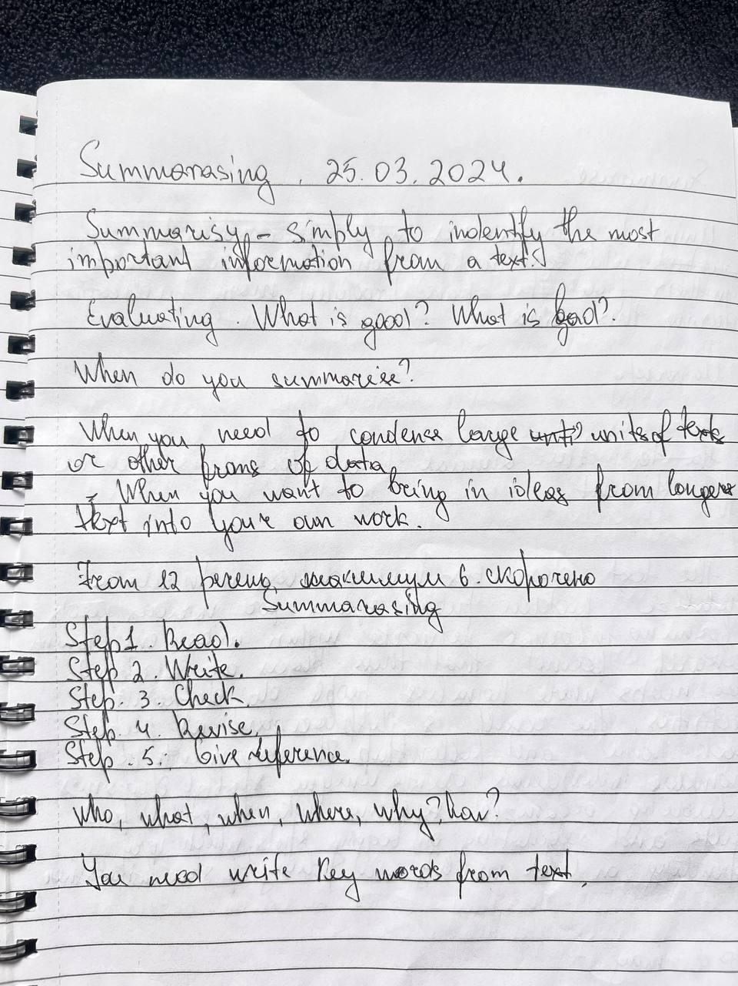
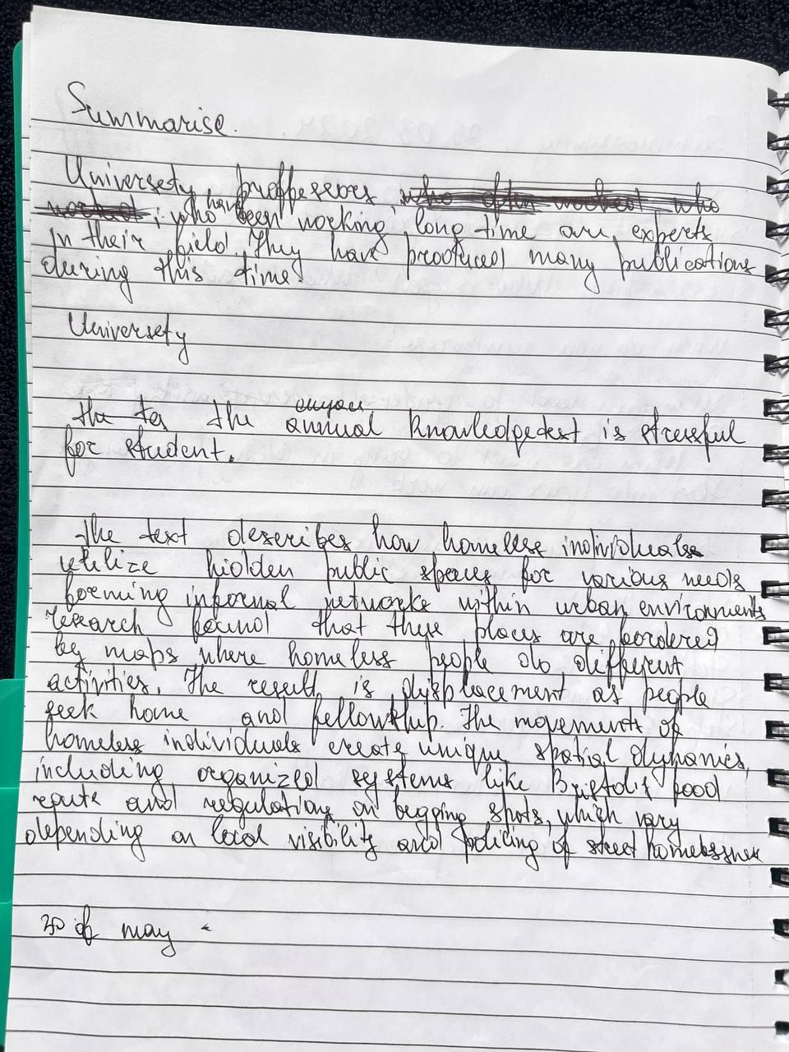

Paraphrasing
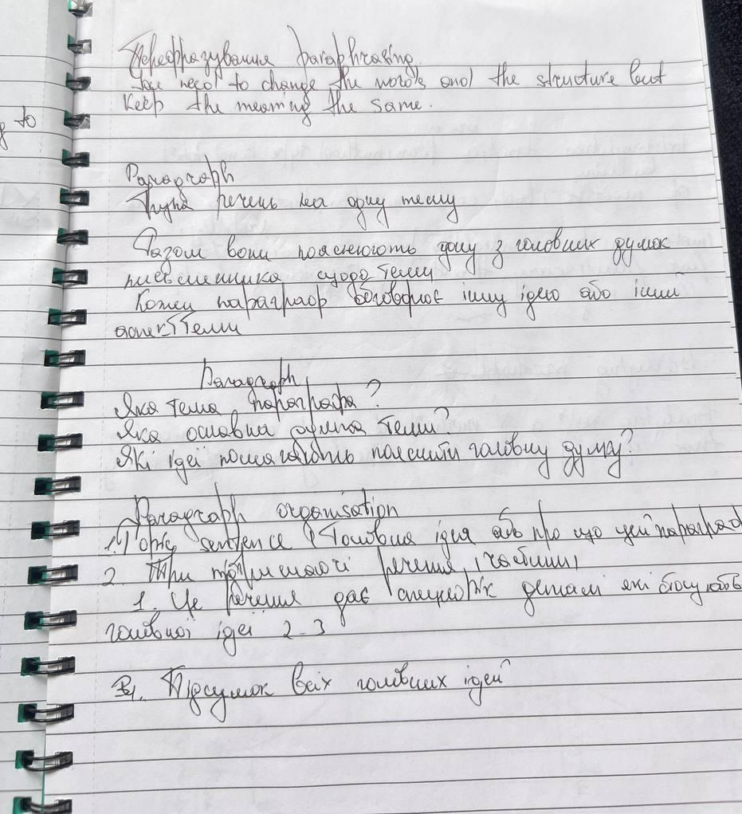

Time management


