Module: Changemakers: Building your Personal Brand for Sustainable Employment
Module code: BMHP5015

Student Name: Sharm Gill
Student Id: 2322794
Table of Contents
Task 1 3
Task 2 5
Task 3 7
Task 4 9
Task 5 11
Task 6 12
Task 7 13
Task 8 14

Task 1
Introduction
My skills, values and professionalism are known to the employers through personal branding. I have to establish a positive personal brand that will help me become more hireable, professionally respectable and help me achieve my future ambition of becoming a Healthcare Assistant.
Main Body
The personal brand that I have today is one that demonstrates my caring attitude, responsibility, respect and my desire to learn. I suppose these attributes are important to provide caring care and an adequate rapport with patients, colleagues, and families. I am polite, can collaborate successfully, and can stay calm in the face of adversities (Gorbatov et al., 2019). Nevertheless, I understand that I have to work on my confidence, leadership skills, and digital skills to respond to the growing requirements of contemporary healthcare practice. To build my own brand, I will make sure that I gain practical experience through placements, full professional training, and never hesitate to get constructive feedback from my supervisors. The lifelong learning and self-assessment will improve my competence, professionalism, and preparedness to a successful career in healthcare (Dwivedi et al., 2021).
Conclusion
Making my brand will also enhance my employability and build my professional identity. Through continuous learning and having a hands-on experience, I will be in a better position to realise my dream of becoming a Healthcare Assistant.
References
Dwivedi, Y.K., Hughes, L., Ismagilova, E., Aarts, G., Coombs, C., Crick, T., Duan, Y., Dwivedi, R., Edwards, J., Eirug, A., Galanos, V., Ilavarasan, P.V., Janssen, M., Jones, P., Kar, A.K., Kizgin, H., Kronemann, B., Lal, B., Lucini, B., Medaglia, R., Le Meunier-FitzHugh, K., Le Meunier-FitzHugh, L.C., Misra, S., Mogaji, E., Sharma, S.K., Singh, J.B., Raghavan, V., Raman, R., Rana, N.P., Samothrakis, S., Spencer, J. and Williams, M.D. (2021). Artificial intelligence (AI): Multidisciplinary perspectives on emerging challenges, opportunities, and agenda for research, practice and policy. International Journal of Information Management, 57, 101994. https://doi.org/10.1016/j.ijinfomgt.2019.08.002
Gorbatov, S., Khapova, S.N. and Lysova, E.I. (2019). Get noticed to get ahead: The impact of personal branding on career success. Frontiers in Psychology, 10, 2662. https://doi.org/10.3389/fpsyg.2019.02662

Task 2
Part 1
Future Healthcare Assistant
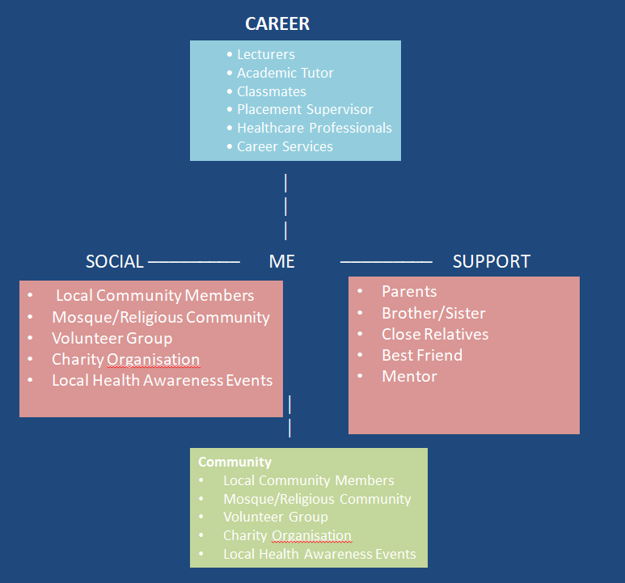
Part 2
a) Type of Network
My network can be characterised as a hybrid network since it is a combination of close personal ties with few professional and community ties. My family, friends, colleagues and lecturers are all supportive, advising, and consoling me throughout my education. These relationships help me to gain confidence, communication and teamwork skills. Nevertheless, my working relationships in the health and social care field are still minimal, which means that I cannot learn more about experienced practitioners and enhance my knowledge of the profession. My network thus consists of close personal and new professional acquaintances (Claridge, 2018).
b) My Network Weaknesses
The major weakness of my network is a small amount of bridging and linking social capital. Despite the fact that I possess a high level of bonding relationships with family and friends, I am very unfamiliar with healthcare providers, managers or organisations that may help me get career advice or a place to work. This could limit my industry knowledge, mentoring and development prospects. I will be participating in healthcare career events, volunteering in health and social care facilities, building relationships during placements and using LinkedIn to connect with healthcare professionals to build my network. These will widen my professional circle, enhance my employability, and increase my objective of becoming a Healthcare Assistant, as well as enhance my social capital (Smith et al., 2022; Claridge, 2018).
References
Claridge, T. (2018). Dimensions of social capital – bonding, bridging and linking social capital. Social Capital Research, 1(1), pp. 1–7. https://doi.org/10.5281/zenodo.8013758
Smith, R., Clegg, S. and Lawrence, E. (2022). Professional networking, employability and career development: A systematic review. Education + Training, 64(8/9), pp. 1203–1221. https://doi.org/10.1108/ET-08-2021-0316

Task 3
Digital Health Literacy: Support of older adults to get better healthcare.
Target Audience: Elderly people and their family carers
Introduction
Did you ever struggle to make a GP appointment online or use a healthcare app? These are some of the problems that the majority of the elderly have to face in their lives. As the degree of digitalisation of healthcare services increases, the possibility of using web-based health information and services is turning into a necessity. By facilitating access to health care, making informed decisions, and living healthier and more independent lives, older adults can use digital health literacy.
Why is Digital Health Literacy Important?
Digital health literacy is the ability to find, understand and use health information with digital technologies. A number of medical centres, such as appointment bookings, prescription and health counselling, can be done online. Nevertheless, not all older adults are digitally competent, so it is challenging to take advantage of these services. According to research, the greater the level of digital health literacy, the greater the trust in online health information and informed healthcare decisions (Paige et al., 2018; van Kessel et al., 2022).
There is a significant role that families, carers and healthcare professionals can play towards improving digital inclusion. The older adults can be provided with easy training sessions, user-friendly healthcare websites, and individual assistance to feel more confident with using digital services. Face-to-face support should also be provided to less technology-savvy members of the community by community organisations and healthcare providers. Studies point out that enhancing digital health literacy will help decrease health disparities and encourage more people to use healthcare services (Norman and Skinner, 2006).
With the further development of digital healthcare, it is important to make sure that older adults can also access such services equally. Digital skills can be applied in enhancing access to healthcare, as well as enhancing independence and improved health outcomes among the elderly.
Conclusion
Digital health literacy has become one of the skills of modern healthcare. Families, communities and healthcare providers can minimise barriers to care by offering older adults training and guidance, and by offering easy-to-use digital services. Should you be supporting an older family member, you can advise them to investigate local digital skills programmes or enquire with their GP practice about what support is available.
Image:
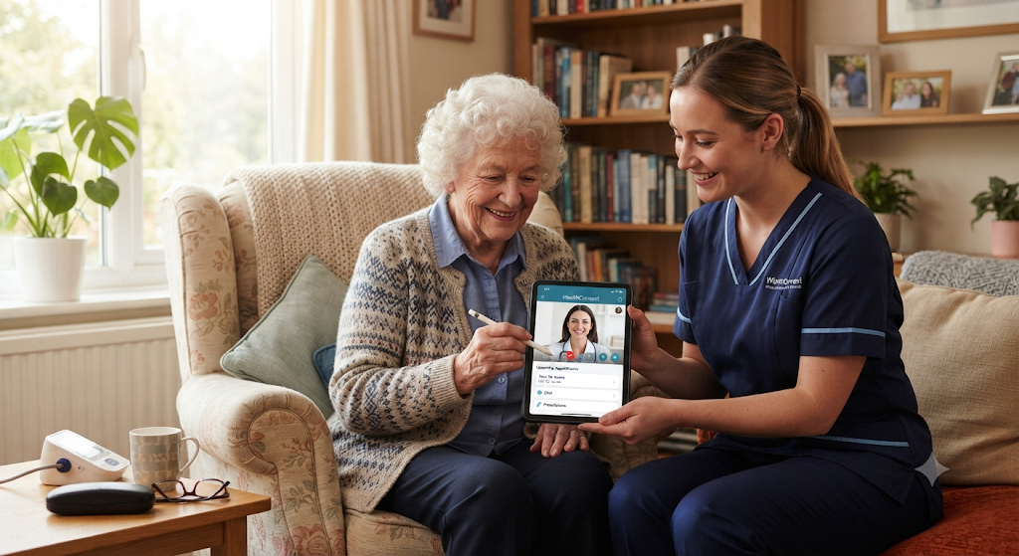
References
Norman, C.D. and Skinner, H.A. (2006). eHealth literacy: Essential skills for consumer health in a networked world. Journal of Medical Internet Research, 8(2), e9. https://doi.org/10.2196/jmir.8.2.e9
Paige, S.R., Krieger, J.L. and Stellefson, M. (2018). The influence of eHealth literacy on perceived trust in online health communication channels and sources. Journal of Health Communication, 23(1), pp. 53–65. https://doi.org/10.1080/10810730.2017.1410188
van Kessel, R., Wong, B.L.H., Clemens, T. and Brand, H. (2022). Digital health literacy as a super determinant of health: More than simply the sum of its parts. Internet Interventions, 27, 100500. https://doi.org/10.1016/j.invent.2022.100500

Task 4
1. What is the primary goal of the NHS Equality, Diversity, and Inclusion Improvement Plan?
The primary goal of NHS Equality, Diversity and Inclusion Improvement Plan is to make the workplace a fair, inclusive and respectful place and to be able to treat all employees equally and allow them to realize their potential without discrimination.
2. How does the NHS EDI Improvement Plan propose to tackle the gender pay gap?
To narrow the gender pay gap, the NHS will ensure that it is more transparent in its pay reporting, increase fair recruitment practices, and increase access to promotion and career development opportunities.
3. What is meant by the term ‘intersectionality’ as used in the NHS EDI Improvement Plan?
Intersectionality is the intersection of numerous aspects of an individual's identity, like age, gender, ethnicity and disability, which may result in various experiences of disadvantage or discrimination.
4. Why is it important for the NHS to create a psychologically safe work environment?
The significance of psychological safety is that it enables the NHS employees to communicate freely, share their concerns and confess their errors without fear of any consequences, which has a positive impact on the well-being of the employees and patient safety.
5. How does the NHS EDI Improvement Plan suggest improving the experience of internationally recruited staff?
To make sure that the recruited staff, who are internationally hired, feel valued and included, the NHS recommends that the support should be enhanced by offering a better induction programme, mentoring, language and cultural support and explaining career development pathways.
6. What role does leadership play in advancing EDI objectives according to the NHS Improvement Plan?
Leadership is important in that it helps to establish the tone of inclusion behaviour, that policies are based on equality and that the EDI goals are followed throughout the organisation at all levels.
7. Identify one way the NHS EDI Improvement Plan aims to reduce health inequalities within the workforce.
By offering equal and fair access to training, development opportunities and progression to all staff groups regardless of their background, the NHS will be able to minimise inequalities.
8. Why does the NHS EDI Improvement Plan emphasise the importance of collecting and analysing data on protected characteristics?
Gathering information about guarded attributes assists the NHS in detecting disparities in equality, tracking workforce diversity, and gauging advancement in enhancing inclusion and minimising discrimination.
9. Explain how flexible working policies can contribute to equality and inclusion in the NHS workforce.
Flexible working promotes equality since it enables employees to balance work with their personal commitments, like childcare or health conditions, which enhances retention and job satisfaction.
10. What is one strategy mentioned in the NHS EDI Improvement Plan to combat bullying and harassment in the workplace?
To ensure that bullying and harassment are addressed in the workplace in a timely and fair manner, the NHS has efficient reporting standards, anti-bullying regulations, and zero-tolerance measures.

Task 5
Dear Younger Me,
It is in a more informed state of emotional intelligence and resilience that I am writing this letter to you, an aspect I think you ought to have known at that difficult time when your well-being was at its lowest, and you were stressed and overwhelmed. At that time, your emotions were also rather difficult to control and even little things seemed so big, even though they were.
Reflectively, now I am aware that emotional intelligence is a matter of recognising, understanding and controlling emotions in individuals and groups. This is something that you should have mastered at an earlier age, so that you would have been better placed to deal with the pressure in a more composed way, rather than being anxious and frustrated. You would have also expressed yourself better, which would have assisted you in getting the support of others.
Resilience is another skill that I consider important and useful at this point. The capacity to overcome troubles and continue to move on despite the challenges is key. You would have viewed setbacks as not lasting moments had you been stronger then. You would have believed more in your capacity to cope and develop out of hard experiences.
I would have you know, not only good to fight, but not to fight single-handed, to seek help. By building strong emotional intelligence and resilience, you will be able to deal with the stresses of the future in a more constructive way. The skills will also help you in your future profession in health and social care, where you have to comprehend emotions and remain strong when in a state of pressure.
Today, I am a stronger individual due to the experiences that I have encountered, but I would like you to know that your well-being is important, and by learning how to be emotionally intelligent and resilient, you will become a more confident and balanced individual.
Be mindful of yourself,
Me

Task 6
Personal Development and Career Planning
My development plan is an individualised plan, which focuses on improving my employability skills to achieve my dream of being in the field of health and social care as a Healthcare Assistant. I would like to enhance my communication, teamwork, and time management abilities since they are necessary to deliver safe and effective patient care. I will also strive to develop my self-confidence at the workplace.
I will engage in voluntary work, participate in workshops, and get tutor and supervisor feedback to do this. The experiences will assist me in attaining practical skills and professional behaviour. I will also take a look back to know what I need to improve on and what my strengths are, so that I can continue to improve.
Career planning will be significant as it will help me be focused and ready for future opportunities. By having specific objectives, I will be able to monitor my progress and make sure that I am acquiring the appropriate skills in my selected career.
It has been found that personal development planning can enhance employability and career success through enhancing self-awareness and goal setting (Cottrell, 2019; Jackson, 2021).
References
Cottrell, S. (2019). Skills for success: Personal development and employability. Palgrave Macmillan.
Jackson, D. (2021). Developing employability skills through personal development planning. Journal of Education and Work, 34(3), pp. 1–15. https://doi.org/10.1080/13639080.2021.1891203

Task 7
Introduction
A care planning system will be implemented in a care home environment where I will adopt a digital system to enhance the accuracy of records, communication and efficiency. The importance of such change is that it will reduce the number of mistakes in paperwork and improve the quality and safety of resident care.
Planning the Change
The proposed change is the replacement of the paper-based care records by a digital care planning system. This will be done in stages using the Change Theory by Lewin: unfreezing the current practices, training and refreezing of the new system. To minimise resistance, staff will be engaged in meetings and training. The need for change is because paper records are slow, inconsistent and prone to error. Electronic systems enhance communication among the workers and real time information on how the residents need care. To monitor the progress and provide ongoing aid during the transition, managers will be utilised.
Skills Required
I need to have good leadership, communication, and digital skills as a way forward to this change. Time management is also important to organise training sessions and implementation stages. The competencies needed in conflict management would aid in the resolution of the staff problems and opposition in the change process.
Barriers and Solutions
Staff resistance to work with a new technology due to the lack of confidence or fear of something new may be considered one of the major barriers. Digital skills and time constraints can also be limiting factors to implementation. In order to fight this, the staff need to be involved in planning and provided with the necessary training and support. The other obstacle is the lack of resources, which can be overcome through the gradual implementation and the technical assistance of IT departments. Weiner (2020) claims that the most important is the organisational preparedness and the support of the leadership, which will help the resistance prevail in the healthcare setting and implement the change successfully.
Conclusion
To sum up, a digital care planning system can greatly enhance efficiency and quality of care in a care home. This change can be effectively introduced and maintained in the daily practice with appropriate planning, leadership, and staff support.
References
Burnes, B. (2017). Kurt Lewin and the planned approach to change: A re-appraisal. Journal of Management Studies, 54(4), 1–23. https://doi.org/10.1111/joms.12228.
Weiner, B.J. (2020). A theory of organizational readiness for change. Implementation Science, 15(1), 1–15. https://doi.org/10.1186/s13012-020-01021-4.

Task 8
Final Reflection
The module has assisted me in understanding the idea of my personal brand and employability in the health and social care industry better. I have become more aware of my strengths (communication, teamwork, empathy) and weaknesses (confidence and professional networking), and have been working on them. The portfolio tasks have helped me to reflect on my future career goals and how I can achieve these through lifelong learning and the acquisition of skills. I have learned now more about how to establish a professional identity and advance to becoming a Healthcare Assistant in a well-structured and self-assured manner.

