Professional career development

Student name: Oana Olari
Student Id: 1818224
Module name: Professional career development
Module code: BMSW4005_LON

Lecturer name: Mary March

Table of contents
Contents
Introduction 1
Role play 3
Smart task 4
SWOT ANALYSIS 5
Definition of swot analysis 5
Learning stiles 6
Professional development plan 6
Conclusion 7
References 7
Appendix1 8
Appendix 2 8
Appendix 3 8

Introduction

Since I have started this university, I learned so many things about me that I did not new before, after a long break from school I start learning again. My goal it is to make a career in health and social care I am really motivated because I want what is best for me and my family. This school will help me to develop my knowledge and learn new things like academic skills [writing, reading]. My strengths are the communication with other people. I am competitive in reaching my goals. I must split my-self in two imagine that. I will explain, I have three kids and a husband, so I must take care of my family as well and need to find time for my studies because are important for me and for my confidence. My family is supporting me in what I do and what I want to do. At the first I wanted to do lots of things that I did not do before and I did not know how, and I have been really upset about. Because I have this big opportunity of learning in United Kingdom I am going to do my best to achieve all the goals I have propose to do and for this I am gone attend all the classes and pay attention to all what lecturer are saying. I have chosen Health and Social care because I have been doing volunteer at school and I really enjoyed spending time with the kids from reception and year one. I always listening them, make sure they receive the right attention, for all they need, and it is interesting to find all their ideas. I am doing this module (professional career development) because it gone help me to understand better children and adults, it gone help me to give them good advice.
In the first term we learn how to manage our time how to plan our primary and secondary thinks. Also, I discovered myself by doing a self-motivation questionnaire, a VARK questionnaire and how I like to learn, how motivated I am in doing all those things. I am gone start to explain all the questionnaire we made in class and about what lecturer explain to us. My personal reflection on the role play and about the feedback what I have received from others. I learn about SWOT analysis, smart task how to complete an application form, about job description, person specification and role play.

Module of reflection Kolb’s

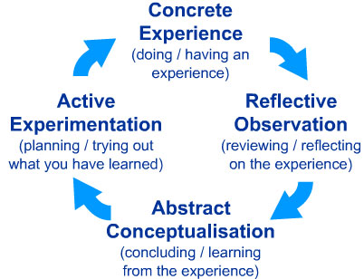(McLeod,2017)

This type of module it talking about the experience you had or still have, about reflection of your past experiences that you had this can be bad or god, so we have to reflect what we have done wrong , what can we do to improve and what has improved bay doing that things. It also talking about what have you learnt from this or that experience and at the end what are your plans. Now I am going to talk about my experience with this module, Professional Career Development
As I said on my introduction this is a big opportunity to me and I try to demonstrate that I am capable to apply everything I have learnt by now, because I did not have any experience in this area, (Health and Social Care).
In the first term I learnt about Life line and how to create one I never did that in my life and was interesting to put all the good and bad things on the paper and look at them, after I have learnt about SWOT Analysis which again made me think to all my weaknesses may strengths and also what are my opportunities and my treats, I have discovered lots of things about me. I have learnt how to create my smart task which is god to have one so I can manage my time better, I am going to explain about Smart Task down below. Since I have done that, I have everything planned, what are the first plan to finish that mean the important and urgent things and after the rest which are not so important. Another important thing that I have learnt is the Personal Development Plan.

Role play
I had my role play which was interesting because I never interviewed someone, and I did like that. After being the interviewer I have change the roles and I was the interviewed and at the start I was a bit stressed because this was my second interview in my life, but wants I have started to talk I became more confident and more secure in all the answers I gave to the employer. Our lecturer formed a group for this role play and the other students had to give feedback to the interviewed about how this was during the interview. All papers with feedback that I have received from them I am going to attach it in appendix.
Now I am gone discuss about those feedback that I have received.
Overall, I had an excellent feedback from everyone, I still need to work in some areas and improve my weaknesses but for my second interview I did excellent. Some of the students which they gave me feedback they think that I still need to work on my confidence to be more focused on my strengths, to be more enthusiastic but not to overreacted other think that my role was perfect, and I did a good job.
I am going to attach on appendix the feedback from the role play.

Smart task

Definition of Smart tasks:
The smart tasks it is a guide to achieve your goals ,that means what are your skills and were you have to work to improve and to set a time when you start and when you gone finish (Doran, 1981).
For my personal goals I have used this task and I finish all in time, so it is very good to have a goal or more and at the end to see that you did, and you have realised something.
Here we have the 5 smarts business goals:
- Specific – what you want to improve and learn.
- Measurable- this means how long it is going to take to achieve your goals.
- Agreed- this means if you have the necessary skills and tools to do that.
- Realistic- this means if you think that your goals are important.
- Time-bound- the period and how long it is gone take to accomplish your goal.
In the first term I started to see what I know, and which are the areas that I must improve. I have worked hard to achieve all the knowledge that I have now, in writing reports, essay. It took me couple of months to learn all about communication and all the academic things but at the end I have managed to understand and be able to explain to other that do not know. I have set my goals and most of them I have achieved.

SWOT ANALYSIS

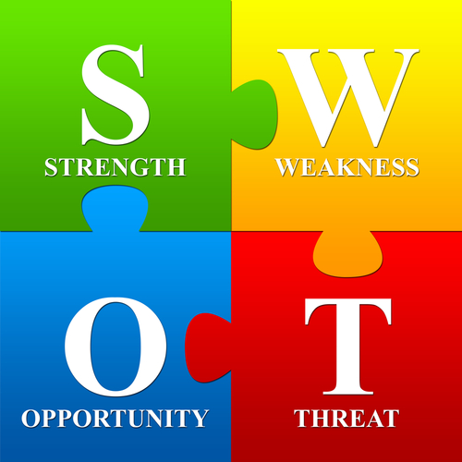
Taylor (2015)

Definition of swot analysis

Swot analysis is defined as an effective process of identification of people, especially it is used in various companies to find out about their weaknesses, what strengths they have, about opportunities and what treats they can face (Quast, 2013).
- S- Strengths
- W- Weaknesses
- O- Opportunities
- T- Threats
My personal Swot analysis helped me to find out more about what weaknesses and where I am really good and I did not knew, I have learned what opportunities I can have if I am gone finish this year of school and also what kind of threats it may come during or after my goals or in my personal life. I find that my weaknesses were to talk in front of people and my academic writing as well. But with this I learned, and I have improved my weaknesses and I turned them in a strength now. My opportunities were that I had a chance to start school again and to do something with my life, because since I came in UK I worked in cleaning and like a nanny and I want to do something more than that. Regarding the threats, yes out there can be lots because I do not know what to expect regarding Brexit what are the laws that are going to come or change after this.

Learning stiles

Learning styles are defined by different types of learning, each person has their style to learn, we are all different at how we understand better and easy, how we are processing, how quick we understand the idea. I am going present couple of types of learning. We have the Vark model which it show us the four primary styles of learning, (visual, auditory, reading/writing and kinesthetic, Nakano (2016).
I have done the VARK Questionnaire and I discovered that my type of learning is Read/Write and Kinesthetic, which is true, I learn and understand better if I read and if I have someone to explain to me and always take notes. I have also done the self- motivation test and my score was 40, and I discovered that I can do more to achieve what I want. I must try to increase my motivation factors and work more on my weaknesses and make them strengthen.

Professional development plan

What is a Personal Development Plan (PDP)?
Self-awareness arranging empowers people to assume responsibility for their own learning. Learning turns intro proactive just as a receptive procedure, structured and organized to help quick improvement needs just as long-term desire.
A self-awareness plan empowers you to recognize key regions of learning and improvement action that will empower you to either get new or create existing aptitudes and conduct qualities for the accompanying purposes:
- Improve your skills in your job
- Talk about changes in your current job
- Talking about what you wish to be and to do in future, (reed.co.uk, 2019)
Mi Personal Development Plan it is about mi life and about my career what I am going to try to achieve and what I have already achieved based on what I have learned. In my academic learning I have improved in everything, writing, reading and in talking without shaking in front of people. Since I have started this school, I have improved my digital skills by practising and watching YouTube videos to learn quicker. I do not have experience in Health and Social Care, but I like to work with children and elderly people. When I am there to help them or just talk with them, I feel god and I really want to continue to learn how to take care of them better.
Because till now I did not looked for a job which require an interview I have learned that when I am applying for a job I have to read the job description and what that person it looking from me, and then if I have what they looking for I can apply for that job.

Conclusion
In conclusion this module helped me to know my-self better that I have knew before and to learn so many things and discover how I can apply for a job and all the tips that I need to get accepted. I also I had the opportunities to interview a person and to see how it feel and that was the most exciting part and I really enjoyed. In the future I plan to go ahead with study and try to apply for a job in hospital like a nurse because I really like to take care of people.

References
McLeod, S. (2017)” Kolb's Learning Styles and Experiential Learning Cycle” (online) available at: https://www.simplypsychology.org/learning-kolb.html
accessed on 16th December 2019.
Mind tools content team, (2019) “ SMART Goals How to Make Your Goals Achievable”( online) available at : https://www.mindtools.com/pages/article/smart-goals.htm
accessed on 20th December 2019.
Reed.co.uk, (2019),” Personal development planning: What you need to know” (online) available at:
https://www.reed.co.uk/career-advice/personal-development-planning-what-you-need-to-know/ accessed on 21 December 2019
Taylor, I. (2015)” A SWOT Analysis Template For The Overwhelmed Marketer” (online) available at: https://www.questionpro.com/blog/a-swot-analysis-template-for-the-overwhelmed-marketer/ accessed on 21 December 2019.
Overview of learning styles - Learning Styles Online.com (2019), Available at: https://www.learning-styles-online.com › overview Accessed on 21 December 2019
Nakano C. (2016) The Four Different Types of Learners, And What They Mean to Your Presentations [INFOGRAPHIC] “Available at: ttps://blog.prezi.com/the-four-different-types-of-learners-and-what-they-mean-to-your-presentations-infographic/
Accessed on 21 December 2019

Appendix1

Appendix 2

Appendix 3

