Coexistent Perspectives
ADAA7000
MA Illustration

Student: Louis Burrows
Student Number: 2104668
Word Count: 3609

Q. How does the work of Rachel Whiteread and the artwork of Salvador Dail challenge the ideas of time and memory?

Introduction

This essay will explore the work of Rachel Whiteread and the artist Salvador Dail, and how their work challenges the idea of time and memory. With the work of Rachel Whiteread we will explore how her physical works, such as sculptures can shape a person's memory and how the passage of time can affect those memories of that place. We will also explore the work of Salvador Dali and how his painting The Persistence of Memory can relate to time and memory and challenge these ideas. We will explore key themes and theorists behind the philosophical question of time and memory and how this relates to both Rachel Whiteread and Salvador Dali.
In this essay there will be four main questions:
- What is the philosophy time?
- What is the philosophy of memory?
- How can they be related to the work of Salvador Dail?
- How can they be related to the work of Rachel Whiteread?
- How can all of these questions be related together?

Memory
The first question we must ask is what is a memory? Is it just the way that humans record events happening around them, and do memories shape us as people?
Memory is a core function of the human experience. It is one of the most vital functions that help us to understand and process our world and our identity. Without it how do we know who we are? In the book Time and memory issues philosophy and psychology, there is a term used to call memories an ‘autobiographical memory’:

the Term ‘autobiographical memory’ used by some cognitive psychologists to describe memory for personal events, seems to imply a particular metaphor: that memory is like narrative of one’s life, organized by chronology, much as the sequence of chapters and pages of book might reflect the order in which the events of a life unfold
(Horel and McCormack 2001, p. 139)
Essentially autobiographical memory is how well people can remember their personal experiences and how they organise in our minds. There are some parts of this that can be said that our memories are like pages in a book, and with each new memory, a new chapter of our lives is made.
The problem with this term, is that how do we remember reliably? If we take this idea of memories being like a book and that we can pick a chapter to recall specific memories in time, then we’d also be limited by the time itself and also aging. As we age our memories can fade or become more difficult to retrieve. Our “day-to-day experience” (Cohen, Kiss and LeVoi, 1993, p. 15) becomes faded and distorted, and so we seek to rely more on recorded memories. Memories that have become more artificial with the modern times we live in.
Now that we have access to phones, photos, videos and the internet then we can recall all sorts of memories artificially instead of naturally, “These artificial memories have not only supported, relived and occasionally replaced natural memory” (Draaisma, 2000, p. 3). It could be that art can be considered in the same way, not in the ‘artificial’ sense but in how we can record or capture a moment in time. For example, Whiteread’s sculptures could be considered objects that have captured memoires of people, because essentially that is what memory is, it’s a record of past experiences.
Time
What is time? How to describe something that’s so large and infinite? Does it have a beginning, or an end? How does it effect a person? And how does it affect art?
To a normal person time is straightforward. It’s linear. The past, present and future. A scientist would give a long explanation about time and its many theories, how it is vastly infinite or a philosopher might ask what is time, how does it affect us, “The different ways in which we use the word should be enough to show that we don’t have a precise definition for it” (Groom, 2013, p. 12). There are many ways a human measures time, we look to the proverbial clock to tell us what the time is with the hands that strike every hour of time, and we look to a calendar to tell us what days have pass, and what years come and go.

To some thinkers in the ancient world, the answer was that time is simply the measure of change. What is real is a changing universe; time is conceptual scheme that describes motion and other changes.
(Bradon 2024, p. 7)
Time is a series of motions where one event follows to the next from the past, present and future. Why do we care so much about time as humans? We do not have an infinite lifespan, our lives are fragile. We experience time in many different ways but there is one connection that we all have with time and that is that we are born and then we die. But ultimately time frames everything we do as humans, it effects the time we wake, to when eat, to the time we go back to sleep. It shapes our memory’s and if we follow this linear depiction of time by living in the present, in the here and now, it raises the question of whether this is an accurate portrayal of time or a humans conception of it. In the documentary with Brian Cox’s, there is a part where Cox talks about the present time it can be drawn from the past, the example he gives “light coming from distant things into your eye takes time to get there” (Brian Cox’s Adventures in Space and Time, 2021). Could it be that once we see something, it is then recorded in our memory and placed in the past. So do we truly live in the present when even something like light takes time for our eyes to record it. Does that mean our memories are always going to be shaped by the past. Can the same be said about art or a sculpture are they all ways going to be shaped by the past.

Rachel Whiteread
Rachel Whiteread is an English artist that specialize in sculptures. She was born in 1963 in Ilford, Essex. Whiteread works are physical sculptures with many of the works being domestics objects. They are made using concrete or plaster cast, and many of her sculptures appear to capture a moment in time. They appear as though some sort of memory has been placed on the work or implies that there is some sort of memory that can be held in their space. In the book, Rachel Whiteread Shedding Life, she writes “they hold and occupy space, speaking to the viewer and to each other of the domestic landmarks of human experiences” (Krauss and Bradley, 1996, p. 8) and it is that human experience that can define the notions of time and memory because what are humans without their memories.
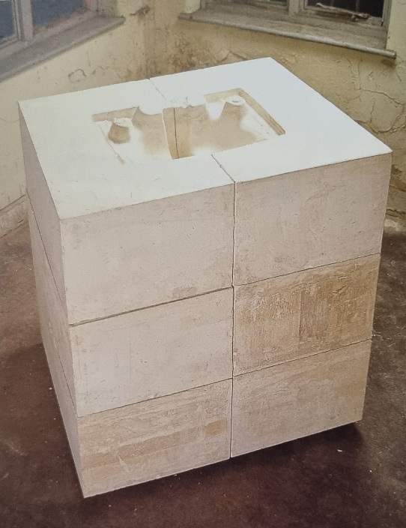

Fig. 1 Untitled (Square Sink), Rachel Whiteread 1990
To begin with we will look into Rachel Whiteread’s untitled series and how these sculptures capture these ideas of time and memory. Fig 1. To the viewer it could seem like they are viewing something that is made from the past. It appears to be a captured moment in time, therefore in the past and not the present because we are not there to see the cast being made in real time. We see only the evidence of these pieces. The square sink is a sculpture that captures a mundane moment in time that we all experience, it’s a memory of a daily activity that everybody can connect with or have some memory of. But unlike memories, this sculpture is literally captured in time within its cast. It’s forever preserved. It’s sculpted to remain in the present.

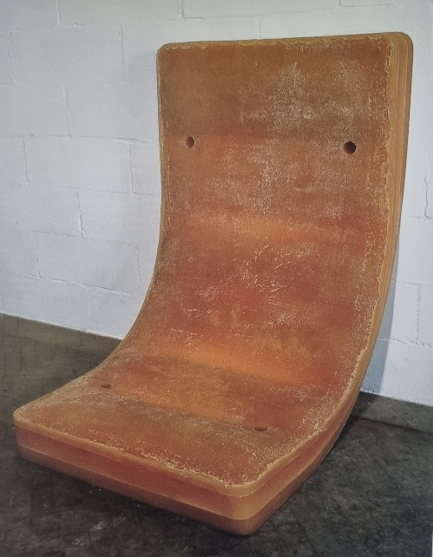
Fig. 2 Untitled (Amber Bed), Rachel Whiteread 1991
This next work by Whiteread is a bed cast made of rubber, and an example of a visually aged piece that was made to remain bent and upright, as though it were just propped there by someone only moments ago. It represents a captured moment in time and can even bring forth memories of the bed you once had as a child or its propped position could even remind you of moving house perhaps. This sculpture can “force us to look more closely, for it is easier to tell that some alteration has taken place” (Krauss and Bradley, 1996, p. 24).

Ghost

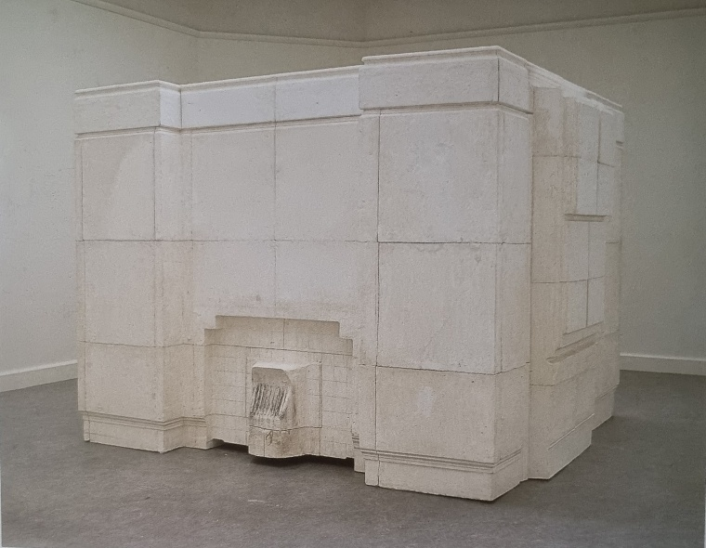
Fig. 3 Ghost, Rachel Whiteread 1990
In 1988 Rachel Whiteread had her first exhibition in Carlisle Gallery in Islington. This is where she showcased her plaster cast furniture. After making these pieces of work she turned her attention to what would be her biggest piece of work for its time, and widely considered as her breakout pieces. That being Ghost (fig 3). It was a plaster cast of a Victorian living room, and it captured a section of the house that took over three months to complete. The aim was to “mummifying the air in the room and making it solid” (Carley, p. 26). Ghost (fig 3) does more than just mummify the room, it creates this eerie, almost haunting look to the sculpture. “Ghost is frequently described as appearing uncanny” (Ferris, 2003 p. 53). Ghost also shares the same familiar traits with some of Whiteread’s other works, like Untitled (sink) (fig 1), and Untitled (Amber Bed) (fig 2) whereby those sculptures also share similar traits to do with time and memory, and that they have all been touched by humans in some way. The bed is for resting or a captured moment of alteration, the sink is to wash, and Ghost is where people lived. Ghost led Whiteread onto a much larger project.

House
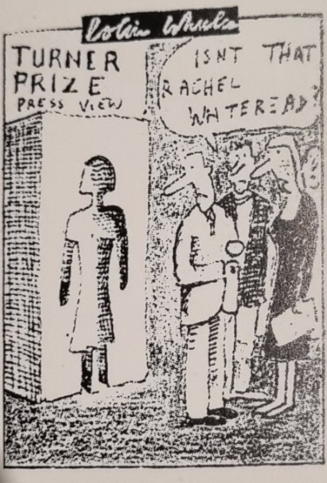
Rachel Whiteread’s House was created in 1993 with the support of the London art organisation Artangel. The house that was used to create the case of the inside of the house was a “building within a building” (Rachel Whiteread, 2002). The house that they chose was at 193 Grove Road which was sighted to be demolished as it was one of the few remaining Victorian terrace houses left standing. House was completed around October 25, 1993 and it was awarded the Turner Prize 1993 before it was demolished in 1994.

Fig. 4 Colin Wheeler, cartoon, The Independent, November 3, 1996
During 1993 and around the time of House’s reveal, it was voted by the neighbourhood councillors that it should be destroyed, “From that moment, the debate which swirled around House became increasingly adversarial; in the press, on television and, in more good humoured way, in front of the sculpture itself” (Lingwood, 1995, pp 7-8). When House was revealed to the public in 1993, it was the subject to media attention fig.4. due to complicated opinions of the neighbourhood, being that many of them were unhappy with the attention it was getting. (Fig 4) An illustration by Colin Wheeler from the Independent, shows what can be presumed is a cast of a female shape, more likely Rachel Whiteread herself. The illustration can be considered in poor taste, because Whiteread was one of the first female artists to win the Turner prize and is maybe an attempt at diminishing her achievements.
House also revealed a series of issues that the city were facing around this time. In the book, Rachel Whiteread Shedding Life, it’s mentioned that House “Raises more political issues in contemporary society: the right to have a home, control of property and the demise of areas of free access in the urban context” (Krauss, 1996, p. 66). What can be taken from this, is that House raised many different concerns, particularly from those in the surrounding neighbourhood of the sculpture. But in doing so, it pointed out the issues the neighbourhood was facing, which could also be seen as a good thing. Here art is responsible for raising questions. When looking at House one can’t help but initially see it as concrete block layered upon each other, but beyond the raised questions, complaints and judgements, once we look at it more closely as a closed architectural form and an open memorial. It evokes an emotional response and invites people to talk and feel almost nostalgic about it.

House has focused on memory, on the first temporal – disruption of space-time which it works. In articles, in interviews, in letters to newspapers, people talk of the sculpture ‘bringing back memories’, of ‘making them (memories) real’, of commemorating memory itself, of the evocation of emotional response of absence/ sadness/ the transience of things. There is much reference to nostalgia for specific place and time.
(Carley, 2008, p. 37)

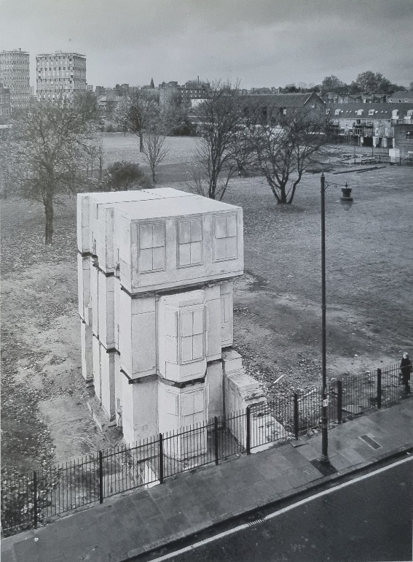

Fig. 5 House, Rachel Whiteread
Fig 5 shows House in all its form. At 193 Grove Road where House was made, it was one of the few remaining Victorian houses remaining. By turning it into a cast sculpture it captured a part of this house in a moment in time and can invoke feelings of nostalgia and sadness even if you have no memories associated with the time. It also makes you imagine what might have gone on in the house who might have lived there and how it’s sad that it is now empty and no longer a home. As a lot of Victorian houses were bombed during World War Two, it’s another reason why this cast sculpture House became such a famous piece, as it also represented a memory of an era long past as well as a memorial for a brutal moment in British history, ‘Some people have seen the work as memorial to the kind of life lived in the area, as a survival from the Blitz, as an embodiment of tenacious hanging on’ page 838. This is what people would have seen when visiting House. They experienced it as a sort of gateway into the past and how some things can be captured in the present by artistic methods.

Salvador Dali
Salvador Dali was a Spanish artist who received his education in Madrid. Dali made paintings, sculptures and Dali’s work boarded on the strange, almost eerie with Dalis work it could almost be that he saw the world in different light. He was a man with a different vision, it was “his very special vision and energetic imagination quickly won him a place at the Surrealists’ table” (Radford, 1997, p. 5). It was this special vision that very much got him involved with the surrealist movement. Surrealist was a movement to push the cultural norms of that era, they were very interested in the works of Freud. Surrealism is an art form that was first introduced in the 1920s but “The terms, first coined by the art critic and poet Guillaume Apollinaire in 1917” (Wood, 2007, p. 2). When we think about surrealism, we tend to think of Salvador Dail with his long Mustache but was Dali was a true surrealist. In the book The shameful life of Salvador Dail it is written that the critic Rafael Benet was foremost among the critics who insisted that Dail had indeed joined surrealist, ranks, while the painter’s friends and colleagues on L’Amic de le Arts, Gasch and Montanya, firmly maintained the opposite.
Was this because they did not like the surrealist movement? But “Gash had been hostile to Surrealism for over a year” (Gibson,1998, p.171). But there is no denying that when we think of Surrealism we think of Salvador Dail and probably his most famous piece of artwork that comes to mind is his The Persistence of Memory.

Salvador Dali’s The Persistence of Memory
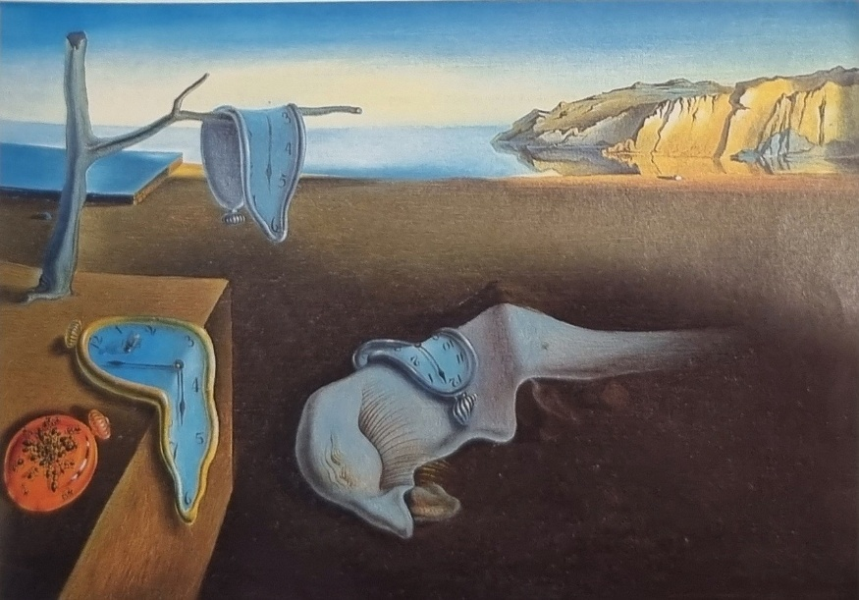
Fig. 6 The Persistence of Memory Oil on canvas (Dail, 1931)
Salvador Dali The Persistence of Memory is a small painting, roughly around the same size as a piece of paper. The medium which was used to make the painting was oil on a canvas, it is filled with imagery that could be said was pulled straight out of Dalis mind, it is one of the most iconic pieces of work to come out during the surrealist movement.
The painting depicts an almost dreamlike state but what is more interesting about the painting is how almost real some of the objects are. In fig 6 you can see the clock hanging off the branch, how it almost looks like it is in a state of dissolution or melting when a watch would be normally a sold object, Dali’s is draped over the branch. You have the mountains in the far background that make the painting look like it is from a faraway land or “unknown planets” (Radford, 1997, p. 146). There is other worldly vibe that painting gives off but how does the painting relate to time and memory?
Firstly, you can see from fig 6 there is a physical presence of time in the painting with the watches. The watches appear to symbolize the way time slowly ticks away and the further that time drags on the more we lose. The painting (fig 5) could also be representing how the melting clocks could signify that time is experienced by people in different ways. But how does fig 5 relate to memory that is the question. Unlike Whiteread House which can be clearly seen as a representation of something from the past made into physical space, Dali’s painting takes on a much more nuanced approach to memory, that being this painting could be a representation of a period of Dali’s life because when this painting was being made, Dail was living in a small fishing settlement in Cadaques. This was just after “his father banished him from the family home” (Radford, 1997, p. 146). Given that Cadaques was where Dali spent most of his formative years what we could be seeing is an unconscious view into the memoires of Dails mind. It’s an interesting take to look at memories from the unconscious mind using the painting The Persistence of memory (fig 6) as sort of road map into the mind of Salvador Dali.
Conclusion
In conclusion the work of Rachel Whiteread and the work of Salvador Dali have challenged the idea that we have about time and memory in new ways, but the question still remains in how do all of these ideas and artist works comes together in the end.
From what I have come to understand about time and memory is that our memories are nothing without a physical sense of time. Because time gives our memories substance, we could look at our memory as the glue that holds our past together and they “do not exist in space, only in time, in the past” (Allen, 2023, p. 202). With that understanding we can link this with the works of the two artists.
Rachel Whiteread challenges the ideas of time and memory by capturing these ideas in physical forms such as sculptures. Her sculptures were all in some way related to objects that all humans have encountered at some point in our lives, whether that be a sink, bed, room or a house. These are all objects that we have some memory of and within each sculpture they can also invoke memories, or questions about the time they’re from or to represent. House is a perfect example of something that captures both time and memory because it represents an era in the past, given that “The past manifest in the present through memory” (Hoy, 2012, p. 101). And its through that manifestation that House remains in some people memories whether that be what House used to be before it was cast in plaster, when it was a Victorian house and one of the few houses in that area of London left standing after the bombings during the Second World War. That is a link not only to the time but to the memory of an event that people of certain age share.
In comparison, Salvador Dali has a more surrealist take when linked with time and memory. The painting The Persistence of Memory is a slightly different case where (fig 5) it is more about how we interpreted our understanding of the objects that resides within the painting. For example, when looking to the mountains in the background of fig 5 we can see that the “have been identified as the coast of Catalonia, Dalis’s hometown” (Dotson 2020). So, we could interpret this as if we are seeing a glimpse into part of Dali’s mind into a memory or a moment in time where we could imagine him longing for home. It was mentioned that this was a period of Dali’s life where he did not live at home, and this could be an image of longing. The watches in (fig 5) can symbolise time, and the movement of time such as the past, present and future with almost an eerie and hallucinatory feel, “when Dali’s Surrealist painting really work, they surely produce something close to this hallucinatory” (Radford, 1997, p. 147).
With this understanding of how the two artists challenged the notions of time and memory, we can see they both have two different takes on them but there is one common link to their work in that they challenge our understanding of art. They can also take moments from the past, whether that be memories we had or the artists memories. Their art makes us question and delve deeper into our own understanding of what it means to be human and our experiences of time and memory

References list/Bibliography
Allen, B. (2023) Living in Time: The Philosophy of Henri Bergson. 1st edn. New York: Oxford University Press. Available at: https://doi.org/10.1093/oso/9780197671610.001.0001.
(Accessed: 9 January 2025)
Bardon, A. (2024) A brief history of the philosophy of time. Second edition. New York, NY: Oxford University Press. Available at: https://doi.org/10.1093/oso/9780197684108.001.0001. (Accessed: 2 January 2025)
‘Brian Cox’s Adventures in Space and Time’ (2021) BBC 2, 31 August. Available at: https://www.bbc.co.uk/iplayer/episode/m000x9v4/brian-coxs-adventures-in-space-and-time-series-1-4-what-is-time (Accessed: 2 January 2025)
Carley, R. (2008) ‘Domestic Afterlives: Rachel Whiteread’s Ghost’, Architectural design, 78(3), pp. 26–29. Available at: https://doi.org/10.1002/ad.670. (Accessed: 5 January 2025)
Cohen, G. et al. (1993) Memory: current issues. 2nd.ed. Open University.
Dotson, S. (2020) Artsy. Available at: https://www.artsy.net/article/artsy-editorial-understanding-the-persistence-memory-salvador-dalis-surrealist-masterpiece (Accessed: 2 January 2025)
Draaisma, D. (2000) Metaphors of memory: a history of ideas about the mind. Cambridge: Cambridge University Press.
Gibson, I. (1998) The shameful life of Salvador Dali. London: Faber.
Groom, A., Whitechapel Art Gallery. and Whitechapel Art Gallery. (2013) Time. London: Whitechapel Gallery.
Hoy, D.C. (2012) The time of our lives: a critical history of temporality. Cambridge, Mass.; MIT Press.
Krauss, R.E. et al. (1996) Rachel Whiteread: shedding life. London: Tate Gallery Publishing.
Lingwood, J., Artangel Trust. and Artangel Trust. (1995) Rachel Whiteread: House. London: Phaidon, in association with Artangel.
‘Rachel Whiteread’s “House”’ (1993) Burlington magazine, 135(1089), pp. 836-. Available at https://www-jstor-org.ezproxy.uwtsd.ac.uk/stable/885798?seq=2 (Accessed: 2 January 2025)
Radford, R. (1997) Dalí. London: Phaidon.
Whiteread, R. (2002) The EYE. Rachel Whiteread. London, England: Illuminations Television.
Wood, G. (2007) Surreal things: surrealism and design. London: V&A.

List of Images
Figure 1
Krauss, R.E. et al. (1996) Rachel Whiteread: shedding life. London: Tate Gallery Publishing.
Figure 2
Krauss, R.E. et al. (1996) Rachel Whiteread: shedding life. London: Tate Gallery Publishing.
Figure 3
Krauss, R.E. et al. (1996) Rachel Whiteread: shedding life. London: Tate Gallery Publishing.
Figure 4
Radford, R. (1997) Dalí. London: Phaidon.
Figure 5
Krauss, R.E. et al. (1996) Rachel Whiteread: shedding life. London: Tate Gallery Publishing.
Figure 6
Radford, R. (1997) Dalí. London: Phaidon.

